A Novel Characterization of Emitted Aerosol Velocity Profiles from Metered Dose and Soft Mist Inhalers (pMDI and SMI)

Linda (Lingzhi) Liao¹, Karina Ramos¹ & Dino Farina¹

¹Proveris Scientific Corporation, Two Cabot Road, Hudson, MA, 01479, USA

Summary
In a recent FDA guidance document[], characterization of the emitted aerosol spray velocity profiles (spray velocity) was proposed as an alternative approach to comparative clinical endpoint bioequivalence (BE) studies. The spray velocity has been reported as an important parameter for drug-device combination products such as pMDIs and SMIs[]. This paper describes a clear methodology for measuring the spray velocity with the leading edge of the plume and presents results from four (4) US approved inhalation products. In this study, we extended the well-established SprayVIEW® technique for providing time-synchronized plume characterization in a novel way to determine the spray velocity from pMDI and SMI test samples available in the USA.
The test products were selected to demonstrate the new measurement methodology and investigate the effects of product type (pMDI/SMI), propellant type (HFA-134a/HFA-227a), formulation type (suspension/solution) and number of excipients on the performance. General conclusions are as follows for the products tested: 1) the emitted aerosol spray velocity from the SMI (average of 1.55 m/s) was significantly lower than all of the pMDI products (average of 4.31 – 9.47 m/s); 2) pMDIs with HFA-227a propellant had higher spray velocities (average of 9.47 m/s) compared to those with HFA-134a propellant (average of 4.31 m/s and 5.41 m/s respectively); 3) Products with higher spray velocity have shorter spray durations, which is another parameter that could affect the pulmonary delivery efficiency; and 4) the formulation type and number of excipients had minimal effects on the spray velocity.

Key Message
A novel characterization method for determining the emitted aerosol velocity profiles from pMDI and SMI products was introduced with sufficient sensitivity to distinguish between different types of products, propellants and formulations.
----------------------------------------------------------------------------------------------------------------------------------------------------

Introduction
It is generally accepted by industry and global regulatory bodies that tremendous time, resources and effort are required to develop new and generic aerosol drug products, with a number of generic products failing in vivo bioequivalence. While there has been success in other markets, for example in Europe, to this day there are still no approved generic pMDI products in the USA. These high failure rates have been associated, in part, with a lack of correlation between existing in vitro test results and in vivo performance from clinical endpoint bioequivalence studies[, ]. In May 2019 product specific guidance document for beclomethasone dipropionate^{[1]}, FDA acknowledged this difficulty for generic applicants and proposed alternative approaches using new, supportive in vitro characterization studies that were more representative and/or predictive of the clinical effect at the local sites of action in the human respiratory tract, including the deep lungs. One of these recommended alternative approaches is the characterization of spray velocity. However, no details and/or measurement methodology is provided in the guidance.
It is well known that drug efficacy and lung deposition are directly related to the aerodynamic performance of the emitted aerosol from an inhalation product. However the link between aerodynamic performance and spray velocity has only been studied to a limited extent and primarily by point-wise techniques such as phase doppler anemometry^{[2]}, and qualitatively-oriented high speed photography[].
In this study, we extended the basics of the well-established SprayVIEW technique (which produces calibrated, time-synchronized image sequences of the entire aerosol plume and duration) with a novel measurement method to study and quantify the emitted spray velocity and duration from commercially available pMDI and SMI product samples.

Experimental Methods
Materials:
Three (3) commercially available pMDIs, and one (1) SMI drug product were studied. Detailed information about the formulation type, API type, other inactive ingredients, and propellant are listed in Table 1, noting that product names have been purposely omitted. The study was intended to include multiple effects including dosage form (pMDI and SMI), propellant type (HFA-134a and HFA-227), and formulation type (API type and number of excipients).
For each device type, 3 devices from a single lot were measured, and 3 replicate measurements were collected per device for the velocity profile analysis at the beginning of lifestage. All samples were stored and measured under normal ambient laboratory conditions (approximately 25 °C, 55% RH).
Table 1 Detailed formulation information for the 3 pMDI and 1 SMI drug product
Device Type | Formulation type | API Type | Other inactive ingredients | Propellant
pMDI 1 | Solution | Mono API | has 1 excipient | HFA-134a*
pMDI 2 | Suspension | Mono API | has 1 excipient | HFA-134a
pMDI 3 | Suspension | Combo API | has 2 excipients | HFA-227**
SMI | Solution | Mono API | has 4 excipients | N/A
* HFA-134a: 1,1,1,2-tetrafluoroethane
** HFA-227: 1,1,1,2,3,3,3-heptafluoropropane

Method:
The overall methodology for this study consisted of two steps: 1) data collection and instrument setup to provide the time-synchronized image sequences of the aerosol plume; and 2) applying a novel analysis method to the image sequences to determine the emitted aerosol spray velocities from the test samples.
Data collection and instrument setup: Raw image sequences of the aerosol plume were obtained using a standard SprayVIEW measurement system (Proveris Scientific Corporation, Hudson, MA). This non-impaction measurement system uses a laser-light sheet and high-speed digital camera to collect calibrated images of the plume along with detailed timing information. The SprayVIEW system was configured with a Vereo® SFMDx automated actuator (Proveris Scientific Corporation, Hudson, MA) whose angle was adjusted to produce horizontal aerosols from the pMDI products, while a Vereo OSx automated actuator was used for the SMI products. Optimized method settings (camera and laser) were used for the devices while actuation parameters (velocity, hold time and acceleration) were kept identical for all the pMDI samples across the study. 5 seconds of shaking was applied for all the suspension pMDI (pMDI 2 and 3), and the product was actuated immediately after the shaking finished. A wait time of 1 minute was used between every spray for temperature equilibration for all the pMDI samples.
Emitted aerosol spray velocity determination: The time-synchronized plume image sequences were analyzed frame by frame as follows and as shown by example in Figure 1: 1) the intensity along a certain distance from the mouthpiece edge of the device was profiled (yellow line) to determine the intensity signature of the leading edge of the plume as a function of time starting with “time zero” (the time when the plume first appears at the mouthpiece edge (far left image in Figure 1, noting that the mouthpiece edge has a distance of 0); 2) a minimum peak intensity threshold along the yellow line was applied to determine the movement of the plume leading edge relative to the mouthpiece edge in subsequent images using the calibrated scale provided in the image sequence by the SprayVIEW system; 3) the distance and associated time was recorded for each image in the sequence until the leading edge moved outside of the camera’s field of view (far right image in Figure 1); 4) a linear regression was applied to the relative distance vs. time data and the slope of the linear region is reported as the velocity of the spray with the R² value to indicate the “goodness” of the linear fit.
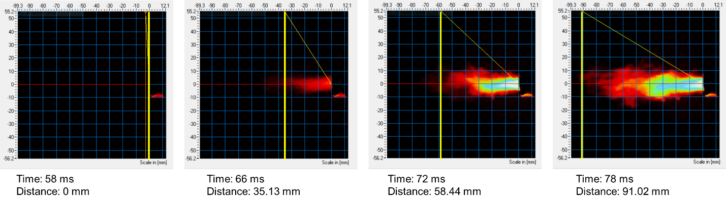
Figure 1 - An example of obtaining distance vs. time of the leading edge plume based on calibrated, time-synchronized plume image sequence analysis (pMDI2 as an example).
Additionally, spray duration was determined by subtracting the end time from the start time as shown in Figure 2 which shows an example time-averaged plume geometry results with its intensity profile (average intensity of the whole field of view versus time) indicating the start (58 ms) and end time (304 ms) of the spray.
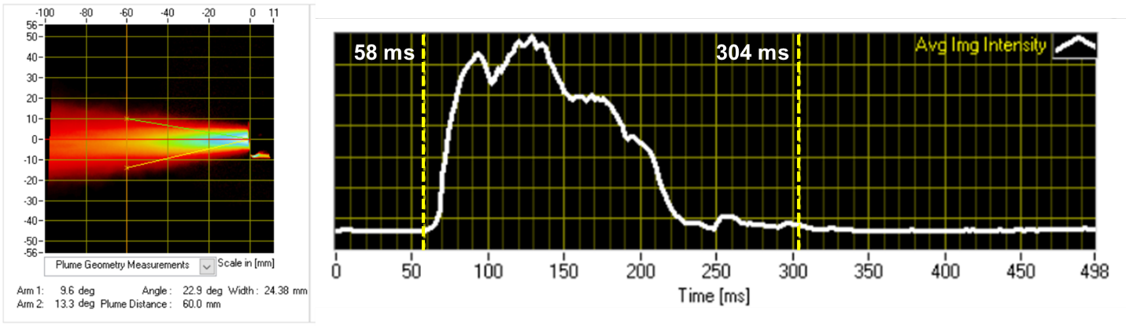
Figure 2 - An example of time-averaged plume geometry results (left) with time-synchronized intensity profile (right, white curve) indicating the spray duration (58 ms to 304 ms)

Results and discussions
As shown in Figure 3, relative distances versus time for the 9 sprays collected for each device type is displayed. Based on the trend of the curve, pMDI 3 with propellant HFA-227 has the highest velocity (most steep slope); pMDI 1 and 2 with propellant HFA-134a have similar velocity, and as it gets further from the mouthpiece edge, the pMDI 2 (suspension formulation) gets slower compare to pMDI 1 (solution formulation); SMI has the slowest velocity, as expected, and the distance vs. time curve plateaued after 80 mm from the mouthpiece edge. Thus, for the velocity analysis for SMI, linear regression was only applied to distances smaller than 80 mm from the mouthpiece edge.
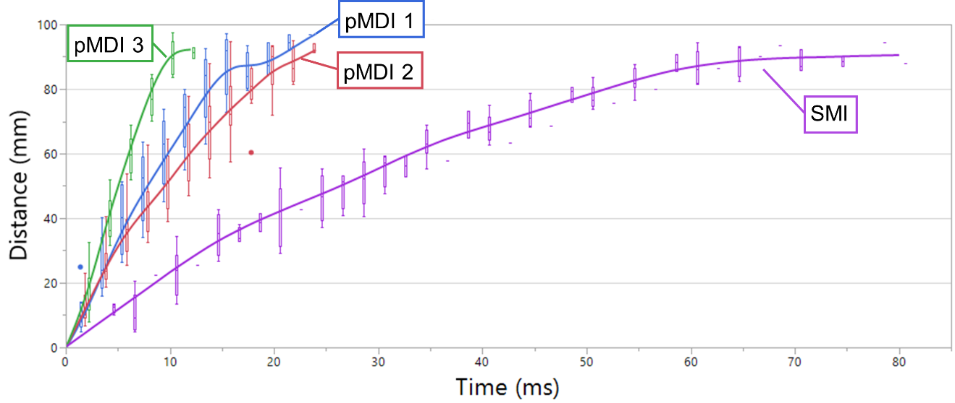
Figure 3 - An overlay of the distance vs. time for all the samples (pMDI 1 in blue, pMDI 2 in red, pMDI 3 in green, and SMI in purple)
The linear fit velocity results (9 sprays per device type) are illustrated in Figure 4 with the average velocity value for each device type, and the summarized velocity and spray duration results are shown in Table 2. We found that pMDI 1 and 2 with propellant HFA-134a has similar spray velocity (5.4 m/s and 4.3 m/s) and RSD% (13.85% and 13.75%), and are more variable compared to pMDI 3 with propellant HFA-227 and SMI. Another interesting observation is that devices with higher velocity has shorter duration: SMI has the longest duration (~ 1.5 s) compared to pMDI (0.2 – 0.3 s).
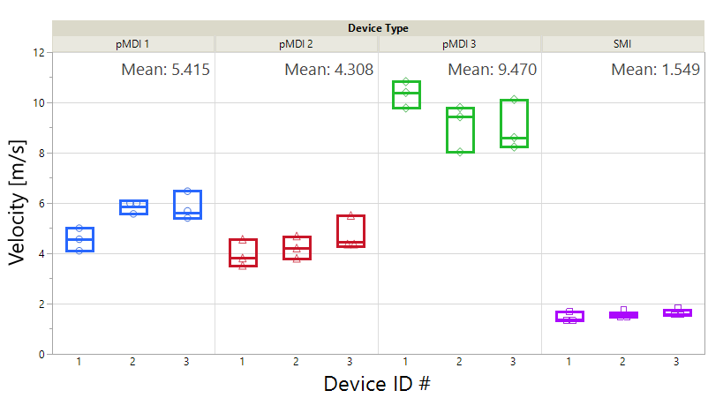
Figure 4 - The velocity results for all the samples (pMDI 1 in blue, pMDI 2 in red, pMDI 3 in green, and SMI in purple)

Table 2 Velocity results and average plume duration for all the samples
Device Type | Average velocity (m/s) | RSD (%) | Average R² | Velocity range (mm/s) | Average Plume Duration (ms)
pMDI 1 | 5.41 | 13.85% | 0.98 | 4.10 – 6.47 | 260.67
pMDI 2 | 4.31 | 13.74% | 0.98 | 3.51 – 5.50 | 276.89
pMDI 3 | 9.47 | 10.36% | 0.99 | 8.03 – 10.83 | 205.33
SMI | 1.55 | 9.21% | 0.96 | 1.33 – 1.74 | 1471.33

Moreover, other factors such as ambient temperature and humidity, the device design (canister, valve, actuator) could also affect the airflow dynamics, thus the spray velocity.

Conclusion
In this study, a methodology based on an immediately available SprayVIEW technology was proposed to evaluate spray velocity. The velocity profile of three pMDIs, and one SMI drug product were measured and analyzed. It is concluded that the aerosolization mechanism (mechanical driven vs. propellant driven) is the major factor for the spray velocity, and formulation (propellant, API, and excipients) could also impact the spray velocity: pMDI 3 with propellant HFA-227 has the highest spray velocity, compared to pMDI 1 and 2 with propellant HFA-134s, and SMI has significantly lower velocity compared to all three pMDIs. Samples with higher velocity tend to have shorter spray duration, which could affect the drug delivery efficacy due to the patients’ breathing capability and actuation-breathing coordination.

FDA Beclomethasone dipropionate Inhalation Aerosol Metered NDA 207921 PSG Page RC May 2019
Xiaofei L, William D, Changning G, Evaluation of metered dose inhaler spray velocities using Phase Doppler Anemometry (PDA), International Journal of Pharmaceutics 423 (2012) 235 – 239
Parkins, D. (2010). Use of In Vitro vs In Vivo Data To Conclude Equivalence of Two Inhaled Products ( A CMC Perspective ). In EUROPEAN EQUIVALENCE CONSIDERATIONS FOR ORALLY INHALED PRODUCTS (OIPS) FOR LOCAL ACTION (pp. 1–29). Frankfurt, Germany.
Li, B. V., Jin, F., Lee, S. L., Bai, T., Chowdhury, B., Caramenico, H. T., & Conner, D. P. (2013). Bioequivalence for Locally Acting Nasal Spray and Nasal Aerosol Products: Standard Development and Generic Approval. The AAPS Journal, 15(3), 875–883. https://doi.org/10.1208/s12248-013-9494-2
Nitesh K, Julia H, Sebastian G, Patricia M, Ramesh C, Sanjay K, Paven M, A novel approach to study the pMDI plume using an infrared camera and to evaluate the aerodynamic properties after varying the time between actuations, International Journal of Pharmaceutics 526 (2017) 41 – 49

