Investigating the effect of nasal suspension rheology on API particle size and dissolution properties

Gonçalo Farias, Abel Garcia Penas, William Ganley, Robert Price, Benedicte Grosjean & Jagdeep Shur
Nanopharm Ltd, an Aptar Pharma Company, Cavendish House, Hazell Drive, Newport, NP10 8FY

Summary
Demonstrating bioequivalence of nasal suspension sprays is a challenging task. The application of analytical tools are required to determine particle size of the active pharmaceutical ingredient (API) and formulation structure. This study investigated, the utility of the Morpologi-M4-ID to investigate the particle size distribution (PSD) of API formulated nasal sprays. Rotational rheometry was used to investigate formulation structure. A systematic approach was utilised to develop a robust method for the analysis of the PSD of Mometasone fuorate in five test formulations containing different concentrations of Avicel. Rheometric measurements were sensitive to variations in the Avicel content and at lower concentration than Nasonex exhibited different gel-like and shear thinning properties. Together, these analytical methods may facilitate the determination of critical material and process attributes that may affect drug product quality.

Key Message

Four nasal suspensions with different concentrations of Avicel were formulated. The concentration of Avicel has a major impact on the rheology properties and particle morphology of the formulations and, consequently, on the droplet size distribution. No effect was observed for API particle size distribution and dissolution profile.

Introduction

Nasal suspension drug products consist of API particles suspended in an aqueous system in the presence of a range of different excipients. For suspension nasal products, the API particle size, usually between 1-5µm, is a key critical material attribute, which will affect emitted API and regional deposition of API in the nose. In addition, the particle size of the API will affect the rate of dissolution and permeability at site of deposition in the nasal epithelium and thereby systemic exposure of the API from the nose. The paucity of validated methods for characterising API-specific drug particle size and particle size distribution (PSD) in nasal formulations has resulted in limited understanding of the relationship between API PSD, regional deposition in the nasal cavity, dissolution and absorption of the API from the nose.

Although drug particle size distribution (PSD) can be readily determined by a number of methods prior to formulation into a finished product, the primary challenge has been to determine the PSD of the drug substance in the finished nasal aqueous suspension products in the presence of undissolved excipients. Excipients such as microcrystalline cellulose typically have a median particle size that is larger than the API. However, excipients often exhibit a broad PSD and a substantial number of excipient particles may exist in the same size range as the drug substance, thus complicating drug substance particle size determination.

Morphology-Directed Raman Spectroscopy (MDRS) is a promising approach for characterising particle size of API in aqueous nasal spray suspension formulations. This approach potentially allows the chemical identification of API in situ within complex nasal formulations which can directly benefit the BE requirements for ANDAs.

The device, formulation, and manner by which the patient actuates the nasal spray pump are the three factors that generally determine the properties of the emitted spray. Aqueous suspension nasal sprays exhibit the behaviour of shear thinning, which is as result of the cross-linking of microcrystalline cellulose (MCC) and carboxymethyl cellulose (CMC) in aqueous media. The interaction between MCC and CMC help to aid suspension of the API in the formulation, which form a gel-like consistency that breaks down under the shear generated during dose delivery through the nasal spray pump nozzle. Hence, variation in the rheology of nasal suspension formulations will affect the gel-like state of the formulation, its shear thinning properties when actuated through the pump and re-building of the formulation structure to that of a gel post dose delivery. Measurement of the rheological characteristics of test and reference formulations may help to ensure that the formulation structure between products are similar, which also therefore ensures drug product critical quality attributes between test and reference products are similar.

Experimental Methods
An aqueous solution of the Polysorbate 80 (0.01% w/w, Spectrum, UK) was prepared into which Mometasone Furoate (0.05% w/w, Sterling, Perugia, Italy) was dispersed by homogenisation. In separate mixing vessel, the Avicel (0.5 – 4.0% w/w, Avicel ® RC-591, FMC Biopolymer, Belgium) was dispersed in purified water. Avicel is the commercial designation for the combination of microcrystalline cellulose and carboxymethylcellulose and this suspending agent was formulated with concentrations ranging from 0.5-4.0% w/w to cover the range of Avicel concentration on marketed nasal corticosteroids. These two suspensions were combined by continuous stirring. Other agents such as Benzalkonium Chloride, Sodium Citrate Dihydrate and Citric Acid Monohydrate were added to the formulation (Merck KGaA, Darmstadt, Germany). Formulations with different concentrations of Avicel were filled into white HDPE bottles and fitted with a screw-on VP3 pump (18/415, Aptar Pharma, France).
The Malvern Spraytec (Malvern PANalytical, Worcestershire, UK) was used to determine the droplet size distributions of the formulations prepared with different Avicel concentrations.
In-situ Particle Sizing and Morphology Analysis of Nasal Suspensions using Morphologi-M4-ID
The morphology and particle size of API as-received and formulated into nasal suspension formulations was characterized using a Morphologi M4-ID morphologically directed Raman system (Malvern PANalytical, Worcestershire, UK). The method development route for analysis of as-received API and nasal formulations is shown in Figure 1, and utilises the approach of optimising sample preparation, threshold and filter setting, morphological and chemical analysis by Raman.
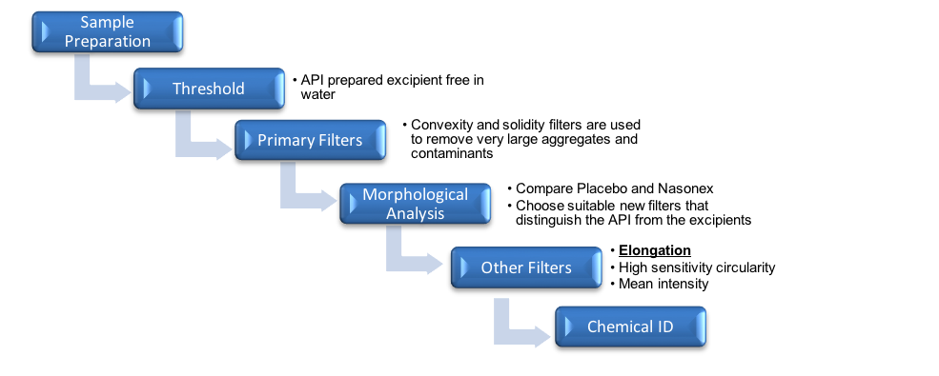
Figure 1. Process diagram of the method development stages for the particle sizing of nasal suspension formulations.
Before the chemical analysis, a nasal formulation was compared with a placebo in order to identify particle morphology filters that could be used to improve the targeting of API particles with chemical analysis. Figure 2 shows that increasing the Avicel content increased the presence of elongated particles, but did not change the requirement of the filter to be set between 0.30 – 0.46.
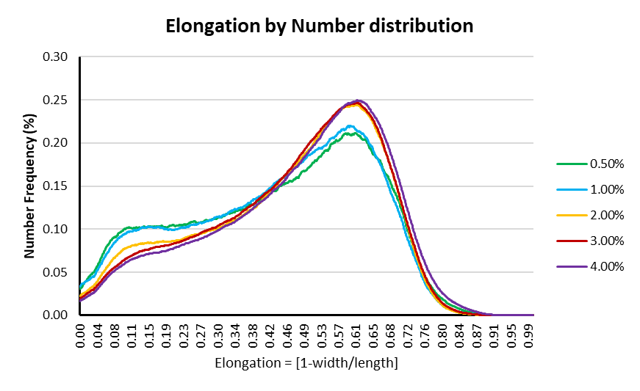
Figure 2. Comparison of the elongation distribution graph of formulations containing different Avicel concentrations.
Upon applying these filters, the chemical analysis was carried out using the Kaiser Optical Systems RamanRxn1 Spectrometer integrated in the Morphologi M4-ID equipment. The Raman spectrum for each of the particles of the same scanning area was collected using 60 s of exposure time with excitation at a wavelength of 785 nm over the spectral range of 100–1825 cm⁻¹ at a resolution of 4 cm⁻¹.
Characterisation of Nasal Spray Formulations Using Rotational Rheometry
The rheology of test formulations with different Avicel concentrations was evaluated at 25 °C using a Malvern controlled stress rheometer with concentric cylinder geometry (Kinexus, Malvern PANalytical, Worcestershire, UK). The elastic modulus and phase angle for the formulation was measured. Equilibrium viscosities at constant shear rates of 10 sec⁻¹, 100 sec⁻¹, or 1200 sec⁻¹. For all experiments, the nasal spray was directly sprayed on to the plate directly. The sample was left to rest in the rheometer for 5 min, and the test was repeated.
Results and Discussion
Investigation of the Microstructure of Nasal Suspensions
The rheological characteristics of test formulations containing different amounts of Avicel are shown in Table 1. These data suggest that at Avicel concentrations of 0.5 and 1.00% the formulations have low elastic and viscosity contributions. Therefore, at these concentrations the formulations do not display thixotropic properties. At concentrations above 2.0% Avicel, the formulations have a significant elastic and viscosity component and therefore display thixotropic properties. Droplet size distribution data shown in Figure 3 suggests that higher concentrations of Avicel result in larger droplet particle sizes, which is related to the thixotropic properties of the formulations containing higher Avicel concentrations.
Table 1. Mean rheology properties of four batches of aqueous nasal suspension formulations with different amounts of Avicel 0.5-4 (n=3).
Formulation | Shear modulus (viscous component)(Pa) | Shear modulus (elastic component)(Pa) | Phase angle(°) | Shear viscosity(Pa s)
0.50% | 0.09 | 0.14 | 33.41 | 0.09
1.00% | 0.28 | 1.04 | 14.83 | 2.64
2.00% | 0.74 | 3.84 | 10.96 | 12.97
3.00% | 2.16 | 15.47 | 7.94 | 85.94
4.00% | 4.37 | 31.42 | 7.92 | 128.70

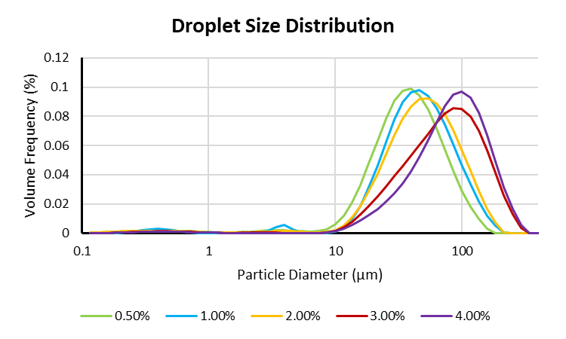
Formulation | Dv(10) | Dv(50) | Dv(90) | %V < 10µ
0.50% | 15.11 | 34.67 | 74.32 | 4.53
1.00% | 18.82 | 41.84 | 90.86 | 3.13
2.00% | 18.96 | 45.40 | 98.99 | 3.10
3.00% | 23.43 | 68.38 | 150.91 | 1.52
4.00% | 28.17 | 78.17 | 159.70 | 1.22

Figure 3. Mean droplet size distribution of four batches of aqueous nasal suspension formulations with different amounts of Avicel 0.5-4% w/w (n=3).

Investigation of the Particle Size of API Dispersed by MDRS and Dissolution
The particle size distribution of the formulations containing different concentrations of Avicel was measured by MDRS. In addition, the dissolution properties of these formulations were also investigated. These data are summarised in Figure 4. There were no significant differences in the dissolution of the API in the formulations made with different Avicel concentrations. Indeed, MDRS data found no significant differences in the measured particle size of the API. These data therefore suggest that no API agglomeration was observed after actuating the nasal spray even with lower amounts of suspending agent (0.5% w/w).
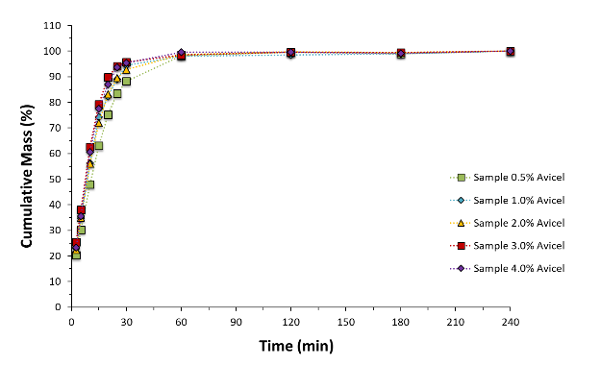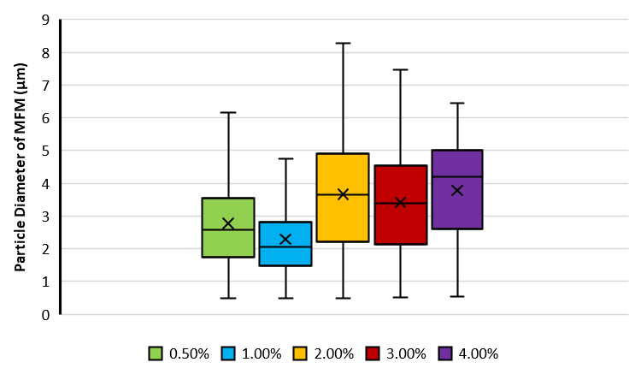
Figure 4. Mean Dissolution analysis (left) and mean MDRS particle size distribution (right) of four batches of aqueous nasal suspension formulations with different amounts of Avicel 0.5-4% w/w (n=3).

Conclusion
The proportion of Avicel in an aqueous nasal suspension will determine the rheology properties of the formulations and have a direct influence on the Droplet Size Distribution and particles morphology. However, the state of agglomeration of the API in the short term was not affected in this study.
The application of rheology and morphology studies combined with API PSD evaluation through MDRS and dissolution enables greater understanding of the structure of the formulated product and can also aid BE studies. Together, these analytical methods may facilitate the determination of critical material and process attributes that may affect drug product quality and give scientific support to changes in the manufacturing process.

References
1. Li BV, Jin F, Lee SL, Bai T, Chowdhury B, Caramenico HT, Conner DP: Bioequivalence for Locally Acting Nasal Spray and Nasal Aerosol Products: Standard Development and Generic Approval. AAPS J 2013, 15:875–883.
2. Doub WH, Adams WP, Wokovich AM, Black JC, Shen M, Buhse LF: Measurement of drug in small particles from aqueous nasal sprays by Andersen Cascade Impactor. Pharmaceutical Research 2012, 29:3122–3130.
3. Doub WH, Adams WP, Spencer JA, Buhse LF, Nelson MP, Treado PJ: Raman chemical imaging for ingredient-specific particle size characterization of aqueous suspension nasal spray formulations: a progress report. Pharmaceutical Research 2007, 24:934–945.
4. Rygg A, Hindle M, Longest PW: Absorption and Clearance of Pharmaceutical Aerosols in the Human Nose: Effects of Nasal Spray Suspension Particle Size and Properties. Pharmaceutical Research 2015:1–13.
5. Mitchell J, Bauer R, Lyapustina S, Tougas T, Glaab V: Non-impactor-Based Methods for Sizing of Aerosols Emitted from Orally Inhaled and Nasal Drug Products (OINDPs). AAPS PharmSciTech 2011, 12:965–988.
6. Sharpe SA, Sandweiss V, Tuazon J, Giordano M, Witchey-Lakshmanan L, Hart J, Sequeira J: Comparison of the flow properties of aqueous suspension corticosteroid nasal sprays under differing sampling conditions. Drug Dev Ind Pharm 2003, 29:1005–1012.
7. Shur J, The development of predictive dissolution methods for orally inhaled drug products. Available at http://ipacrs.org/assets/uploads/outputs/02_UoB_JS_Final_HOv2.pdf.

