Investigating the microstructure of dry powder inhalers using orthogonal analytical approaches

Gonçalo Farias¹, William Ganley¹, Debbie Huck-Jones², Paul Kippax², Jagdeep Shur¹ & Robert Price¹
¹Department of Pharmacy and Pharmacology, University of Bath, UK.
²Malvern Instruments Limited, Grovewood Road, Malvern, UK.

Summary
With several patent expirations of innovator DPI products looming, the major challenge for generic entry is understanding and demonstrating bioequivalence (BE) with respect to the innovator reference product. BE of locally acting drugs has been a long-standing challenge for the introduction of generic DPI drug products, which do not rely on the systemic circulation for targeting the site of action. The FDA has conceived a concept for demonstrating BE of topical products, which is called Q3-equivalence. This term describes structural similarity between test and reference product and refers to the arrangement of matter and state of aggregation of the product. However, demonstrating Q3-equivalence between test and reference DPI products is challenging due to the complexity of DPI dosage forms. Therefore, there is a requirement of in-vitro analytical tools that maybe employed orthogonally to demonstrate Q3-equivalence of the microstructure of test and reference DPI drug products.
The differences in the physical microstructure of a formulated DPI blend may not only impact the aerosol dispersion performance within a device but could also affect other factors within the lung. Hence, investigations into the state of aggregation for the resulting arrangement of the dispersed dose could be vitally important in demonstrating structural similarity and BE between DPI products.
Our proposed approach utilizes a combination of orthogonal techniques to support characterization of DPI formulations. These techniques include morphology directed Raman spectroscopy (MDRS) and UniDose-enabled dissolution testing. In this study, we have investigated the microstructure of the aerosolised dose of Seretide and Advair DPIs using UniDose and MDRS.

Introduction
With several patent expirations of innovator dry powder inhaler (DPI) products looming, the major challenge for generic entry is understanding and demonstrating bioequivalence (BE) with respect to the innovator reference product. BE of locally acting drugs has been a long-standing challenge for the introduction of generic DPI drug products, which do not rely on the systemic circulation for targeting the site of action. Current FDA guidance utilizes a “weight of evidence approaches to help determine BE between test and reference DPI products. This approach combines in vitro studies to determine comparable aerodynamic particle size distribution (APSD) and in vivo equivalence using pharmacokinetic (pK) and pharmacodynamic (PD) studies ^{[1]}.
The FDA had already classified, for bioequivalence testing of locally-acting topical dosage forms, that differences between the same components (Q1) in the same concentration (Q2) under a non-equilibrium state is related to the arrangement of matter or its state of aggregation. The FDA have termed this need for structural similarity as Q3. For transdermal suspensions, creams, gels etc., if Q1 and Q2 are identical the only potential difference between formulation “microstructure” are related to Q3^{[2]}. The differences in the physical microstructure of a formulated DPI blend may not only impact the aerosol dispersion performance within a device but could also affect other factors within the lung. These include local dose variations, co-localisation differences and changes in the wettability and dissolution kinetics of the drug within the volume limited lung fluid, and, thus, its absorption behaviour.

Such an approach warrants the application of advanced analytical tools to characterise material properties at the mesoscale and provide analysis of formulation microstructure. This “microstructure” is a function of the surface interfacial interactions between components of the formulation and the blending conditions, which define how the surface interfacial forces created upon aerosolization are transferred through the microstructure to aid particle re-suspension and therefore, aerosolization performance. Hence, analytical tools to support Q3-equivalence of DPI formulation must form a relationship between the microscopic and macroscopic properties of the formulation systems. In this study, we combine orthogonal techniques to support characterization of the microstructure of Seretide™ Accuhaler™ and Advair Diskus® DPI products using UniDose-enabled dissolution testing of DPI formulations and morphology directed Raman spectroscopy (MDRS).

Experimental Methods
Seretide™ Accuhaler™ and Advair Diskus® (Lot No.: 5ZP2673, Exp: 04/2017) was sourced from a wholesale pharmacy. These batches were investigated in terms of the dissolution of the FP in each product and the agglomerate structure using MDRS.
The impactor stage mass (ISM) aerosol dose of each product was collected via the UniDose system at 60 L/min over 4L inhalation volume. The UniDose collection system has been developed to uniformly deposit the whole impactor stage mass (i.e. below stage 2 of an NGI) onto a glass microfibre filter membrane (Fig. 1). Once the ISM dose has been collected on to the filter the cassette can either be placed into a USP II dissolution bath for dissolution determination or placed into the MDRS system for investigation of chemical classification of the agglomerates present in the ISM dose.
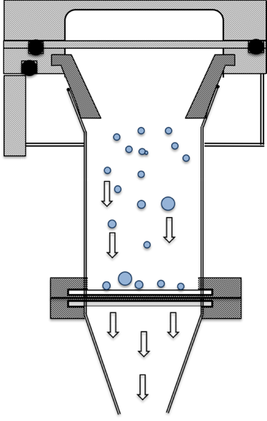
Figure 1: Schematic representation of the UniDose collection system housed at stage 2 of an NGI.
For dissolution measurements, the filter was placed into a purpose-built cassette for Paddle over Disk dissolution measurements. All dissolution studies were undertaken using 300ml PBS pH 7.4 + 0.2% SDS in a USP Apparatus II at 37ºC. For all studies, sink conditions were maintained within the vessel.
Morphology-directed Raman Spectroscopy (MDRS) was performed on the ISM dose collect on the glass fibre filter using UniDose, which enabled the characterisation of the ISM dose of Seretide and Advair using a Morphologi G3-ID (Malvern Instruments, Worcestershire, UK). Upon applying morphological filters, the chemical analysis was carried out using the Kaiser Optical Systems RamanRxn1 Spectrometer integrated in the Morphologi G3-ID equipment. The Raman spectrum for each of the particles within the same scanning area was collected using 60s of exposure time with excitation at a wavelength of 785 nm over the spectral range of 100–1825 cm⁻¹ at a resolution of 4 cm⁻¹.
Results and Discussion
We have previously described the sensitivity of the UniDose aerosol collection system and the resulting in vitro dissolution release profiles to possible structural differences of the collected dose. The aerosol collection system was specifically engineered to address the fundamental challenges of current in vitro dissolution testing of orally inhaled drug products^{[3]}. The system was built to collect a representative respirable lung dose for dissolution studies. The ISM dose of Seretide and Advair was validated against the ISM dose collected for increasing number of actuations of a DPI product via a conventional next generation impactor (data not shown). The design of the collection system increased the ruggedness, reliability and discriminatory capability during dissolution testing by uniformly distributing the aerosol dose over a large surface area filter. The resulting dissolution release profiles were shown to be able to detect changes in the finished product’s dissolution characteristics that may potentially alter the rate and bioavailability of the drug in the dosage form.
The dissolution of the FP component of the aerosolised ISM dose of Seretide and Advair is shown in Fig. 2. These data suggested that the dissolution rate of FP in Seretide was slower than that of FP in Advair. This finding suggested that differences in the in vitro dissolution of the aerosolized form of the product maybe be directly related to dissolution differences observed within the formulated product. Whilst the source of these difference was unknown, they are likely to be related to differences in the physicochemical properties of the API/excipient ingredients in the formulation, physical or chemical attributes of the finished preparation, manufacturing variables between sites, shipping and storage, age and other critical-to-quality characteristics.
The sensitivity in the rate and extent of dissolution between the formulated powder structure and the resulting aerosolized dose suggested that the drug-drug and drug-lactose interactions within the formulated powder dominates both aerosol performance and drug release within the lung. It is well known for solid oral dosage forms that increased dispersion of a low soluble drug within a soluble matrix upon blending can significantly increase the dissolution of sparingly soluble drugs. To understand this behaviour in more detail, MDRS studies of the ISM dose of Seretide and Advair were also investigated.

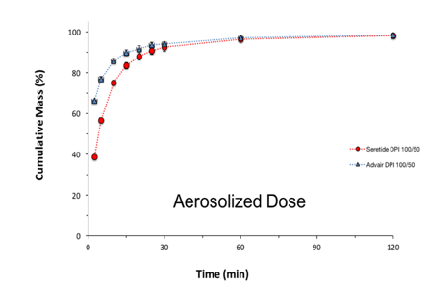
Figure 2: USP Apparatus V Paddle-over-Disk (POD) dissolution release profiles of the aerosolized ISM dose of fluticasone propionate from a EU Seretide 100/50µg Accuhaler DPI product and a US Advair 100/50µg Discus DPI product.
Our investigations using the morphology directed Raman spectroscopy (Malvern Morphologi G3 ID) system into the microstructure differences of the ISM dose of a commercial US Advair Discus DPI 100/50µg and its equivalent European formulation Seretide Accuhaler DPI 100/50µg, has enabled analysis of the possible differences in the state of mixed agglomerates within the aerosolized dose. As shown in Figure 3, the percentage of stand-alone FP was greater in Seretide than Advair. Moreover, the percentage of particles of FP agglomerated with SX and/or lactose was greater in Advair than Seretide. Hence, the faster rate of dissolution of FP in Advair maybe due to the a greater number of FP particles agglomerated with particles of lactose and salmeterol, which may aid improved wettability of the FP and thereby increase the dissolution of FP. These data therefore, highlight that recent developments in Raman spectroscopy may offer a quantitative insight into the structural comparison between DPI formulations.
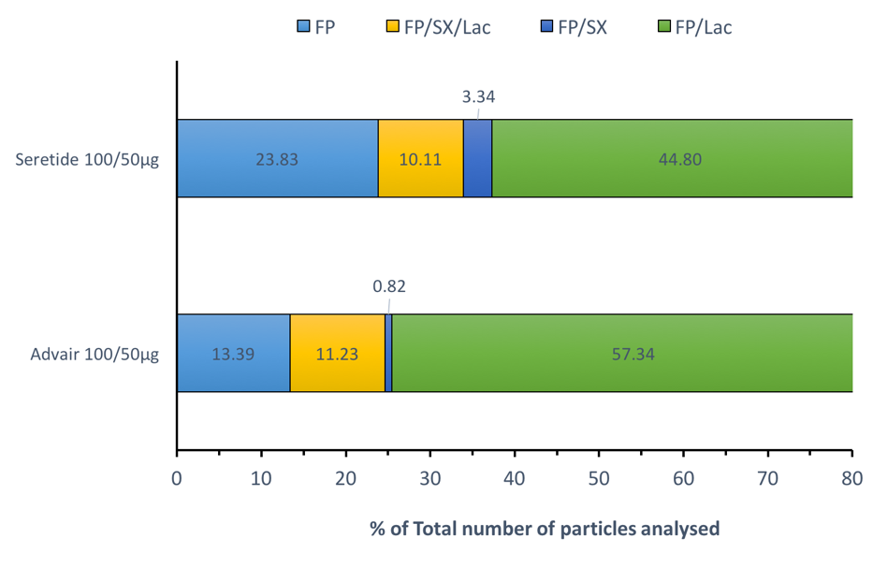
Figure 3. Structural analysis of the state of agglomeration as a percentage of the total number of fluticasone propionate particles as free standing or agglomerated with lactose, SX and SX-lactose.
These data have supported the possible role that in vitro dissolution testing of the aerosolized forms of sparingly soluble respirable compounds may be a suitable orthogonal based technique for investigating the integrated effect of variability in critical material attributes and critical processing conditions on formulation microstructure. Based on sound scientific principles, these performance tests have been shown to be reproducible and reliable. They may also provide assurance of Q3 equivalence between test and reference as well as for RLD DPI products that have undergone post-approval raw material changes, relocation or change in manufacturing site and even the possibility of detecting variability between batches.

Conclusions
We have shown that the dissolution kinetics of FP are slower in Seretide than in the Advair DPI drug product. Moreover, through the application of MDRS we have been able to link these differences to the extent of agglomeration of the FP to other components of the formulation, which may help to increase the materials dissolution kinetics. Hence, our proposed approach of combining orthogonal techniques such as MDRS and UniDose-enabled dissolution testing of DPI formulations may help to de-convolute the microstructure of the aerosolised dose, which may provide a systematic approach to quantify and compare the microstructure of DPI formulation systems. This may therefore enable the demonstration of Q3-equivalence of DPI formulations.

References
1. Lee SL, Raw A, Adams WP, Bing L-V, Conner DP, Chowdhury, BA, Lawrence Y: In Vitro Considerations to Support Bioequivalence of Locally Acting Drugs in Dry Powder Inhalers for Lung Diseases. AAPS J 2009, 11:414–423.
2. Chang R-K, Raw A, Lionberger R, Lawrence Y: Generic Development of Topical Dermatologic Products: Formulation Development, Process Development, and Testing of Topical Dermatologic Products. AAPS J 2013, 15:41–51.
3. Shur J, The development of predictive dissolution methods for orally inhaled drug products. Available at http://ipacrs.org/assets/uploads/outputs/02_UoB_JS_Final_HOv2.pdf.

