Investigation of the Impact of Particle Size and Patient Factors on the Nasal Deposition of a Life-Saving Epinephrine Product (Nasdepi®)

Brian Taubenheim¹, Matthew J. Owen², Gonçalo Farias³, Heli Chauhan⁴, Chris G. Kloc², Maxence Pringault³, Michael Smalley², Nathalie Hauchard³, David Wilcox², Scott Lyman¹ & Alan B. Watts²

¹Belhaven Biopharma, 150 Fayetteville Street, Suite 2300, Raleigh, NC 27601 USA

²Pulmonary and Nasal Division, Catalent Pharma Solutions, 160 Pharma Dr. Morrisville, NC 27560 USA

³Aptar Pharma, Route des Falaises, Le Vaudreuil, 27100, France

⁴MSP, a Division of TSI, Minnesota, USA

Summary
Intranasal drug delivery is a well-established route of administration currently being used for a wide range of treatments, including emergency treatments such as hypoglycaemia. This paper presents two in vitro nasal cast deposition studies investigating the impact of particle size and simulated real-life patient factors on the anatomical deposition profile of an intranasal administration of a powder formulation of epinephrine for the treatment of Type 1 allergic reactions including anaphylaxis (Nasdepi®, BBP01).
Nasdepi is a combination product consisting of the Aptar Unidose Powder Spray System and a novel epinephrine powder formulation. The powder utilises lactose as a carrier and was specifically engineered for use in the device to deliver a consistent dose and deposition distribution in the nasal cavity with a focus on minimising the potential for introduction into the lungs. Understanding the impact of powder particle size and patient variables associated with real-world administration has on deposition are critical to assessing performance and reliability. The Alberta Idealized Nasal Inlet model was used to assess powders with Dv(50) ranging from 5.25 to 17.9 µm. The Aeronose™ model was run through a matrix of conditions including: vertical and horizontal orientation, with and without airflow, and coated with 12 to 80 cP solution to mimic mild to moderate rhinorrhea. In all cases the deposition distribution remained consistent with ≤ 5% of the powder bypassing the nasopharynx.

Key Message
The results of these studies obtained for Nasdepi support that the physicochemical characteristics of a powder engineered for a delivery system can provide a reliable treatment in a life-threatening medical emergency under a wide range of situations.

Introduction
The intranasal (lN) route of administration is increasingly being utilised for rapid-onset systemic therapies in emergency use scenarios. It provides numerous opportunities for improving drug delivery due to its non-invasive nature with high bioavailability, by reducing degradation from first-pass metabolism and providing a highly vascular point of delivery, while utilising intuitive applicators. This is particularly evident when compared to more complicated, invasive and expensive injectable devices [1]. Intranasal administration of Nasdepi to a patient during an anaphylactic event can be achieved by a layperson with little to no training and allows for rapid absorption into systemic circulation. Powders, as opposed to liquid formulations, offer an added advantage of chemical stability prolonging shelf-life and are tolerant to both extreme hot and cold temperature exposures [2].
During development of an emergency use combination product the study of device useability and reliability is equally important to pharmacokinetics. The powder-device combination must deliver a consistent dose distributed within the nasal cavity. A viable product will account for the physicochemical characteristics of the powder during processing and the products shelf-life as well as accommodating real-world situations (e.g. patient sitting or prone) where the device would be deployed.
In this paper we present two studies that assess the impact on delivered dose and powder distribution in the nasal cavity when administered with a Unidose Powder Spray System (UDSp) (Aptar Pharma, Le Vaudreuil, France). Study A utilised the Alberta Idealized Nasal Inlet (AINI) model (supplied by MSP, MN USA) to examine the effect of spray dried drug (SDD) particle size and drum vacuum pressure used for device filling on deposition. The Aeronose™ model (supplied by Aptar/DTF/Univ. of Tours) was used in Study B to evaluate patient administration variables.

Materials
Study A and B utilised a SDD of epinephrine with lactose as a carrier. SDD-1 was produced at pilot plant scale and shipped to Catalent (Morrisville, NC USA) for Study A. SDD-2 was produced in commercial scale equipment and shipped to Aptar Pharma (Le Vaudreuil, France) for Study B as well as Catalent for Study A. Particle size distribution (PSD) was determined by wet dispersion in 0.1% w/v Span80 in Hexanes with laser diffraction using a Malvern Mastersizer 3000 (Table 1).
Table 1. Test material particle size distribution
SDD Identifier | Dv(10)(µm) | Dv(50)(µm) | Dv(90)(µm)
SDD-1 | 1.8 | 5.3 | 13.4
SDD-2 | 4.6 | 17.9 | 42.1

Methods
In Study A two methods were evaluated for the filling of the UDSp devices. SDD-1 was filled using the Mettler Toledo Quantos Filler, equipped with QH012-LNMP dosing head and target fill weight of 17.5 mg ± 3%. SDD-2 powder was filled to a target fill weight of 23.5 mg ± 3% using a tabletop drum filler (Harro Hoefliger, Allmersbach im Tal, Germany) equipped with a 15 mm³ bore size drum at blowout pressure of 400 mbar and vacuum pressure of 200 mbar (low vacuum) or 600 mbar (high vacuum). UDSp devices were manually filled in the laboratory with 30 mg of SDD-2 for use in Study B.

Emitted Particle Size Distribution
Emitted particle size distribution (ePSD) was measured upon actuation of the UDSp. Analysis was performed using a Spraytec® laser diffraction system (Malvern Panalytical, Malvern, UK) equipped with a 300-mm lens. Parameters for analysis included 150.0 ms rapid measurement at a 1kHz acquisition rate. Transmission (%), Dv10 (µm), Dv50 (µm), Dv90 (µm), %<10 µm (%), and Span were measured. Study A utilised a Proveris NSx (Proveris Scientific, Hudson, MA, USA) as an automatic actuation station. Each actuation consisted of a 12mm stroke length, 70 mm/sec velocity, 5000 mm/sec² acceleration, and a symmetric actuation profile. In Study B five devices were actuated at 70 mm/s at 4 cm from the laser.

Aerodynamic Particle Size Distribution
Aerodynamic particle size distribution was performed using a next generation impactor (NGI) (Copley Scientific, UK) with coated cups (5% by volume Tween 20 in Methanol) and attached to a glass expansion chamber at 15 L/min. The analysis was performed in triplicate with three UDSp powder devices per NGI. The percentage below 10 µm was interpolated with Inhalytix® software (Copley Scientific, UK) based on the epinephrine recovery from the different NGI stages.

Alberta Idealized Nasal Inlet Model
A coating solution of 60 g of Brij-35 and 400 mL of ethanol was applied to the model. Introduction of SDD-1 and SDD-2 via UDSp into the AINI model was performed in triplicate. Briefly, the coated AINI oriented vertically was placed a-top of a terminal filter composed of a pre-separator and glass fibre filter. The nozzle of the device was positioned approximately 1 cm into the nostril at a 45 $°$ angle. A continuous flow rate of 7.5 L/min using a TPK flow controller and vacuum source was utilised for drug product testing. Extraction of the deposited powder from nostril, olfactory, turbinates, and nasopharynx of the AINI and pre-separator portion of the terminal filter was performed using 10 mL of diluent. The glass fibre filter was extracted with 5 mL. The extracted drug product solution was vialed and analysed for epinephrine content via HPLC [3]. A student’s t-test was used for statistical analysis of resulting data.

Aeronose™ Model
The in vitro deposition of Nasdepi was characterised in an adult male nasal cast (Aeronose) with HPLC quantification. The nasal cast model used was designed from computed tomography images of a plastinated head model, which was previously validated as a predictive model for nasal aerosol deposition [4]. Five different configurations were evaluated with the nasal cast model, which are presented in Table 2. One device per nostril was manually actuated into each nostril of the nasal cast with an accurately defined insertion depth of 10 mm, a delivery angle (horizontal plane) of 45° and a fixed angle from the centre wall of 5°. When not coated with different viscosity formulations (configuration 1-3) the nasal cast was humidified with water with a nebuliser (AMGH, DTF, France) for 10 min at 3 L/min (nebuliser output) to prevent powder bouncing. For configurations 4 and 5, the nasal cast was coated with an excess of liquid (to simulate rhinorrhoea) composed by mixture of glycerol/water at two different levels of viscosity to cover a wide range of nasal mucus viscosities (12 and 80 cP) by adding 50 mL of this mixture into the nasal cast; rotating in all directions for 5 min and draining any excess of liquid [5]. The different regions of interest (vestibule and nasal valve, olfactory region, turbinates, rhinopharynx and filter (“lungs”) were rinsed with the HPLC diluent. The analysis was performed in triplicate per configuration. Both NGI and nasal cast samples were then quantified by HPLC with a compendial method [3].
Table 2. Nasal cast configurations tested.
Configuration | Simulated use | Laboratory Testing
Configuration 1 | Standard | Vertical nasal cast position without airflow
Configuration 2 | Patient lying on the floor | Horizontal nasal cast position without airflow
Configuration 3 | Inhalation | Vertical nasal cast position with 15 L/min
Configuration 4 | Rhinorrhea | Vertical nasal cast position coated with 12 cP solution without airflow
Configuration 5 | Rhinorrhea | Vertical nasal cast position coated with 80 cP solution without airflow

Study A Results and Discussion
The PSD of the SDD as measured via liquid dispersed powder under laser diffraction (wet cell) is provided in Table 1. The two powders present two distinct distributions, where Dv(50) of SDD-2 is ~ 3-fold larger than SDD-1. In aerosolised products, differences in PSD will result in different deposition profiles when utilising cascade impaction, however, it is unclear if this will also apply if the powder is introduced via an anatomical nasal model from an applicator. To assess the effect on filling parameters, namely the vacuum levels during drum filling, two vacuum levels were utilised to fill UDSp devices. These are represented as SDD-2 Low Vacuum and SDD-2 High Vacuum. Drum vacuum is necessary to control the filling weight during a drum filling unit operation, however it is feasible that this vacuum could result in powder compression and changes in aerosol performance [6]. In theory, a higher vacuum could lead to larger ePSD due to powder compaction. The vacuum level does seem to moderately, although not statistically (p-value > 0.05), affect the ePSD, as revealed by the increase in Dv(50) and Dv(90) by 1.03 and 1.41-fold. These results confirm the assumption that when filling to the same fill weight a higher vacuum level utilized during the filling operation increases the ePSD by compacting the powder and inhibiting deagglomeration. The same experiment was conducted varying the SDD and utilising high vacuum to assess the effect of PSD on ePSD.
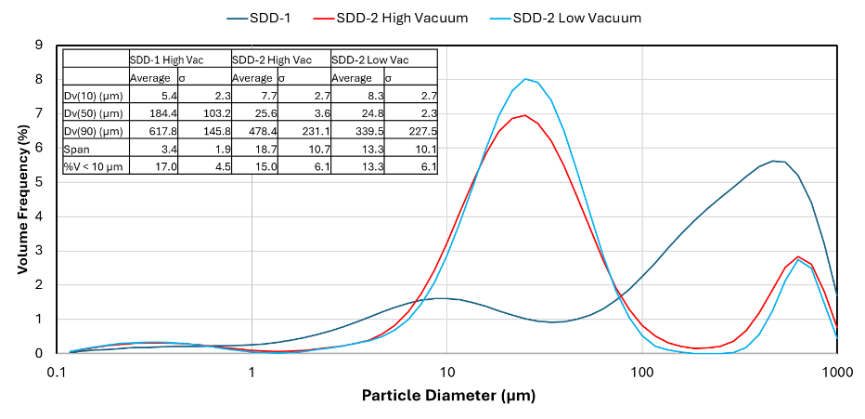
Figure 1: Mean emitted particle size distribution (n=3) of SDD-1 filled with a Quantos and SDD-2 drum filled into a UDSp utilising vacuum
A clear statistical difference (p<0.05) was observed in the ePSD of the two formulations in Figure 1. Bulk PSD Dv(50) of SDD-2 is more than 3-fold larger than SDD-1. However, following actuation the Dv(50) of SDD-1 is 7.2-fold larger than SDD-2. This could be due to a slightly higher moisture content (5.7% w/w) for SDD-1 than SDD-2 (5.3% w/w) and smaller, more cohesive particles. Generally, fine powders are more prone to cohesion, particularly if there is moisture instability.
To understand if either of these observations were meaningful in terms of drug delivery, the devices were injected into an AINI model. The AINI stage deposition including filter was plotted as a function of the percent emitted dose. Despite the difference in ePSD it can be seen that the nasal deposition between the two powders is not statistically different (p>0.05).
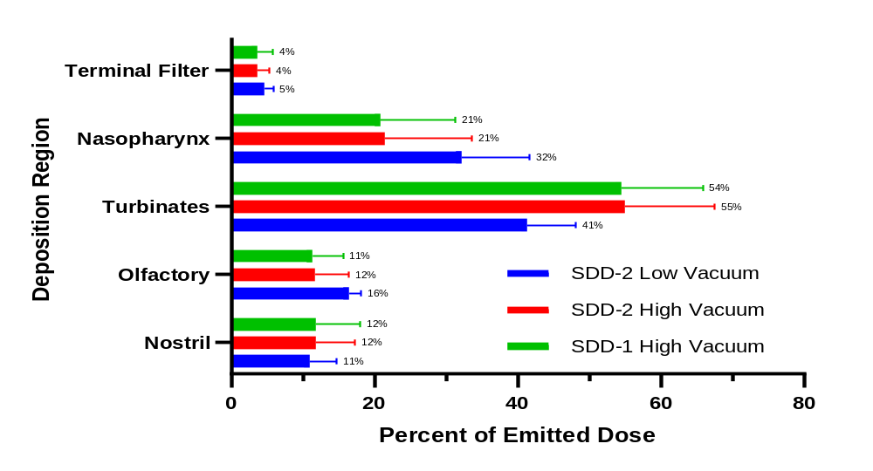

Figure 2: Deposition comparison in the Alberta Idealized Nasal Inlet of SDD-1 and SDD-2 with varying vacuum utilised for filling. Results are summarized as mean $±$ SD for n = 3 replicates.
Additionally, while emitted powders of both formulations have large fractions less than 10 µm in size (17 and 15% for SDD-1 and SDD-2 respectively), this did not translate into high levels of deposition on the terminal filter. Other studies have similarly concluded that bulk powders with large quantities of sub-10 µm spray-dried particles (4-39%) result in minimal “lung” deposition (<3%) in AINI testing [7]. For the powders tested the deposition was limited to <5%, which indicates minimal deposition into the lungs.

Study B Results and Discussion
Table 3 presents a comparison of the fraction of particles that could go into the lower respiratory tract as determined with different techniques. When comparing ePSD and APSD, a difference between the averages is observed. This difference can be attributed to intrinsic differences between both techniques, particularly regarding the different type of particle size that is evaluated for ePSD (geometric) and APSD (aerodynamic). The latter difference between both techniques coupled with the actuation mechanism of Nasdepi may contribute to an overestimation of small particles in ePSD. The UDSp powder device emits a high-velocity and high-pressure bolus of powder that is expected to deposit on the nasal cavity mostly by impaction with a low percentage of powder expected to join the airflow. Further, the powder formulation was optimised to achieve consistent dosing to the nasal passage. When evaluating the nasal cast deposition, the percentage of epinephrine expected to reach the lower respiratory tract was on average between 0-1% without airflow (four different configurations) and 5% on average with 15 L/min.
Table 3. Comparison of lower respiratory fraction with three different methods: ePSD, APSD and nasal cast configuration.
ePSD  % of particles < 10 µm | APSD  % of epinephrine < 10 µm | Nasal Cast  % of epinephrine deposition in the filter after the nasal cavity (“lung”)
10.3 ± 1.2 % | 0.9 ± 0.1 % | 5.4 ± 2 %
The simulated use in vitro nasal cast deposition data is presented in Figure 3. When evaluating all the configurations a stable deposition (74-84% on average) is observed for the main region of interest for systemic delivery, which corresponds to the upper, middle and lower turbinates (represented below as turbinates and olfactory region). The position (configuration 1 and 2) does not seem to have an impact on the regional deposition. When applying airflow or coating with different viscosity liquids, a slight reduction of deposition in the vestibule and nasal valve and an increase on deposition in the rhinopharynx is observed. Additionally, applying airflow increases the deposition in the “lungs”. Although deposition in the lower respiratory tract is statistically different (p<0.01), the percentage of product in this region remains negligible (maximum 5% on average when applying airflow) for all configurations.

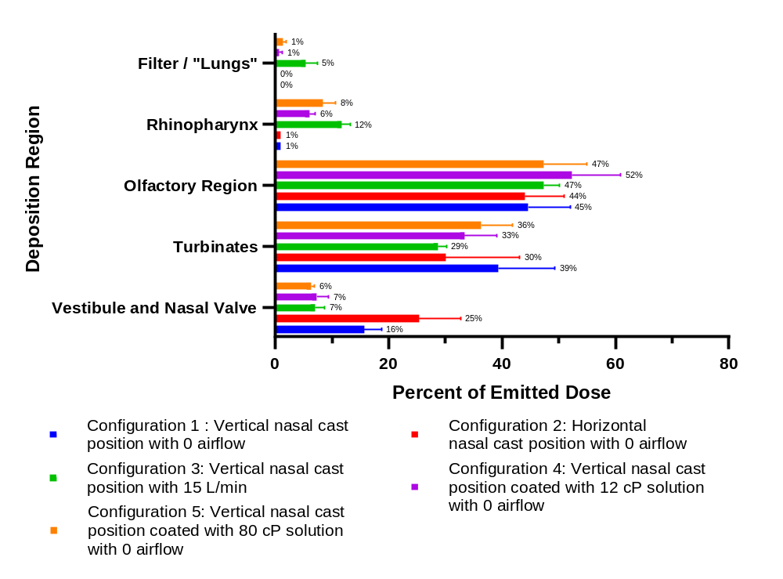

Figure 3. Deposition comparison in the Aeronose™ model at 45°/ 5° /10 mm with different orientations and conditions. Results are summarised as mean $±$ SD for n = 3 replicates.

Conclusion
In summary, the in vitro nasal cast deposition studies demonstrate that the intranasal administration of the developed SDD epinephrine formulation with a UDSp results in a consistent and stable deposition with more than 95% of the dose adhering in the nasal cavity. Positional configurations of the model, bulk powder particle sizes from Dv(50) 5.3 to 17.9 µm, and compaction from device filling with vacuum do not significantly alter the regional deposition patterns. Furthermore, variables such as airflow application or coating with different viscosity liquids only slightly influence deposition; however, possible deposition within the lower respiratory tract remains insignificant across all tested configurations. These findings underscore the potential for the efficaciousness of Nasdepi across a broad range of manufacturing process and environmental conditions.

References
[1] Scherließ R: Nasal Formulations for Drug Administration and Characterization of Nasal Preparations in Drug Delivery. Therapeutic Delivery 2020, 11(3): pp. 183–191
[2] Taubenheim B., Farias G., Landier Y., Hauchard N., Drai2 C., Lyman S.: Evaluation of Drug Product Stability of a Nasal Unit Dose Spray Dried Epinephrine Powder (Nasdepi®) (Abstract): Presented at DDL 2024, Edinburgh, Scottland, December 11-13, 2024, Drug Delivery to the Lungs 2024: in press
[3] United States Pharmacopeia (2024). USP Monographs, Epinephrine. USP-NF. Rockville, MD: United States Pharmacopeia.
[4] Williams G, Cabrera M, Graine L, Le Guelle S, Hauchard N, Jamar F, Pardessus J, Le Pennec D, Reychler G. In Vitro and In Vivo Assessment of Regional Nasal Deposition using Scintigraphy from a Nasal Spray and a Nasal Powder. Respiratory Drug Delivery 2021, 1: pp. 135–40.
[5] Passali D, Bellussi L, Lauriello M, Passali D. The rheological characteristics of nasal mucus in patients with rhinitis. European archives of oto-rhino-laryngology. 1995 Sep;252:348-52.
[6] Boeckl A J, Lord J D: Ensuring scalable filling of engineered powders: Quality by Design (Abstract): Presented at RDD 2014, Fajardo, Puerto Rico, May 4-8, 2014, Respiratory Drug Delivery 2014, 1, 2014: pp 267-276
[7] Penn L C, Ahad J, Potts J C, Lafferty I, Mason L M, Johnson R: Successful scale-up of a spray dried formulation for nasal drug delivery (Abstract). Presented at: RDD 2024, Tucson, AZ USA, May 5-9, 2024. Respiratory Drug Delivery 2024, 1 2024: pp 504-507

