A Method for Exploring the Evaporation of pMDI Propellant Droplets with Microsecond Time Resolution

Daniel Hardy¹, Victoria Legh-Land¹, Allen Haddrell², William Ganley³, Aurore Paul⁴, Gregoire Deraime⁴, Liangfeng Han⁵, Elizabeth Bielski⁵, Bryan Newman⁵, Jag Shur⁶
¹Microsol Ltd, 20-22 Wenlock Road, London, N1 7GU, United Kingdom

² School of Chemistry, University of Bristol, Cantock's Close, Bristol, BS8 1TS, United Kingdom

³Nanopharm Ltd., an Aptar Pharma Company, Franklin House, Grange Road, Cwmbran, NP44 3WY, UK

⁴Aptar Pharma, Av. des Falaises, 27100 Le Vaudreuil, France

⁵Office of Research and Standards, Office of Generic Drugs, Center for Drug Evaluation and Research, US Food and Drug Administration, Silver Springs, USA

⁶Theela Life Sciences, Bath, UK

Summary
The transition to low global warming potential propellants for pressurised metered dose inhalers (pMDIs) presents reformulation challenges and opportunities due to differences in the physicochemical properties of these new propellants. Controlling the performance of propellant-based formulations and demonstrating equivalence of reformulated products may require a deeper understanding of their evaporation kinetics. Single-droplet studies provide a route to precise measurements of evaporation rates. We present a multi-instrument approach, using an ultrafast stroboscopic droplet analysis method with µs time resolution and an electrodynamic balance, enabling measurements from droplet formation, over timescales equivalent to inhalation. This approach is applied to HFA 134a, HFA 152a, and HFO 1234ze, and resolves different initial evaporation rates of ~ 10,000, ~ 20,000, and ~41,000 µm²s⁻¹, respectively. Importantly, water condensation was observed at both 50 % and 90 % relative humidity (RH), meaning propellant droplets can maintain larger sizes than expected during inhalation, even for sub-saturated humidities. The data from the two methods are combined to provide a theoretical lower limit to the evolving size of droplets.

Key Message
Ultrafast measurements of pMDI droplet evaporation can resolve between propellant evaporation rates and, in combination with electrodynamic balance measurements, demonstrate that water condensation extends evaporative dynamics from ~10 ms to ~ 1 s.

Introduction
To address the environmental impact of pMDIs and regulatory pressures on markets, the use of hydrofluoroalkane (HFA) propellants with high global warming potentials (GWPs) in pMDIs is undergoing a phase-down [1]. Transitioning to new low GWP propellants presents challenges in existing product reformulation and demonstrating equivalent product performance to regulators, but also opportunities [2]. Current and new propellants have different physicochemical properties and so their solvent-drug interaction, aerosolization and evaporative behaviour differs [3]. Consequently, new propellant solvent capacity, surface charge, and resultant device performance has been investigated [2,4–6]. Factors including the vapour pressure, density, and surface tension affect both droplet formation and aerosol maturation processes [5,7]. Two low GWP propellants, HFA 152a and HFO 1234ze, have been investigated as viable alternatives to existing propellants, HFA 134a and HFA 227.
Droplet evaporation directly influences the efficiency of drug delivery as it governs the final properties of the formed aerosol. Propellant evaporation is commonly assumed to be extremely rapid, on timescales much shorter than inhalation, and can result in dried or semi-dried particles of formulation solutes and suspended materials [8]. However, laboratory measurements show that in elevated humidities water condenses onto evaporating droplets, modifying and sometimes preventing particle formation [9,10]. The presence of water extends the timescale for aerosols to act as dynamic droplets, undergoing further evaporation or hygroscopic growth. Lung deposition is a function of aerodynamic diameter, and thus particle shape and density, so understanding aerodynamic size, phase, and composition evolution of an inhaled aerosol is key to optimising drug deposition within the lung [11]. Thus, direct measurements of the evaporation kinetics and phase change of droplets of current and new propellants provide valuable insight for the reformulation of existing products and the design of novel formulations.
In this study, we present a novel stroboscopic droplet analysis (SDA) technique for single-droplet-scale measurements of propellant evaporation with sub-microsecond time resolution. It enables stroboscopic imaging of a stream of monodispersed droplets in the earliest stages of a droplet’s lifetime. With preliminary data, we demonstrate that this approach can resolve between the evaporation rates of three propellants, HFA 134a, HFA 152a, and HFO 1234ze. This technique is coupled with the electrodynamic balance (EDB) method presented by Legh-Land et al. to analyse droplet behaviour in elevated humidities over extended timescales [10]. This approach provides measurements that can help expedite the development of products based upon low GWP propellants, through direct in vitro assessments of droplet maturation.

Experimental Methods
To resolve processes ranging orders of magnitude in time (from milliseconds to seconds), a dual-measurement approach was used. The EDB provides robust aerosol kinetics data, but droplets are generated at the edge of a trapping chamber and take ~ 0.1 s to travel to a central measurement region. Thus, the rapid evaporation of propellants which occurs within ~ 10 ms is not captured [7]
SDA techniques have previously been deployed in spray drying, ink jet, and surface tension studies [12,13]. pMDI propellants are kept in pressurised containers, which are incompatible with the SDA droplet generation method. Chilled storage of samples prior to aerosolization provides a means of negating propellant evaporation at ambient pressure. In this study, an SDA instrument based on the work of Miles et al. was integrated with a chilled droplet generation system [10,13]. The EDB traps single droplets for analysis. In contrast, in the SDA method analyses a stream of uniform droplets, and the state of the multiple droplets is analysed via stroboscopic imaging at time-points corresponding to droplet age. This is achieved by capturing images at the same frequency as droplet generation (10-20 Hz). A high time resolution is achieved using a phase shift droplet generation and image capture. Thus, the SDA produces quasi-single droplet data, where data acquired from multiple droplets is representative of each droplet within the stream.
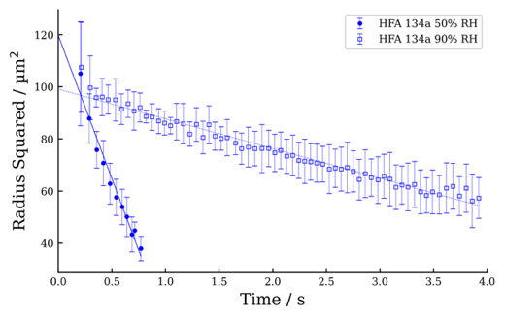
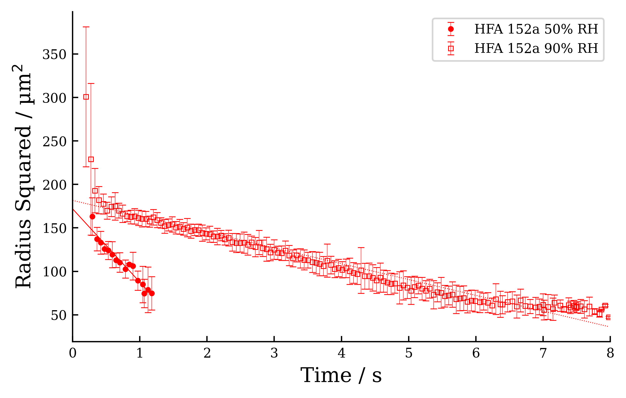
In this study, HFA 134a, HFA 152a, and HFO 1234ze propellants provided by Koura and Climalife are used and filled into 14mL Plain Aluminium canisters (C0842-P, H&T Presspart) crimped with Aptar 50 mcl valves by Aptar Pharma.
Figure 1. The evaporation of droplets of HFA 134a (top) and HFA 152a (bottom) measured using the EDB. A linear fit is applied to each dataset, enabling the extraction of an initial radius.

Results
The evaporation of HFA 134a and HFA 152a droplets, as measured with the EDB are presented in Figure 1. The evaporative behaviour of water is evident, with linear, steady-state evaporation observed between 1 – 4 s. The rate and magnitude of water evaporation is dependent upon the partial pressure of water in the gas phase, indicated by the RH. At 90 % RH, the thermodynamic driving force behind evaporation is reduced compared to at 50 % RH, and the resulting evaporation rate is lower. The evaporation of propellants is not captured by these measurements as it occurs prior to trapping. The data in Figure 1 do, however, demonstrate that at both 50 % and 90 % RH, condensed water extends the persistence of propellant-based droplets, which maintain larger sizes for a matter of ~ 1 s as opposed to completely evaporating within ~ 1-10 ms [7]. Trapping of HFO 1234ze droplets remains unachieved due to a lower dipole moment than the other propellants; further work will be performed to extend the EDB technique to novel propellants [3].
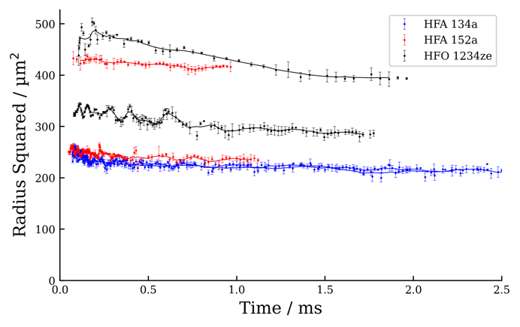
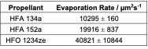
Figure 2 presents the initial evaporation of HFA 134a, HFA 152a, and HFO 1234ze droplets measured using the SDA technique. Droplet oscillations may be seen in the initial 0.5 ms of droplet lifetime, arising from the separation of droplets from the bulk. An elevated evaporation rate is noted over this period compared to the rest of the data, particularly for HFA 134a. The HFO 1234ze measurements are less self-consistent than other samples, likely due to variation in ambient conditions as droplets are exposed to the laboratory environment. Measurements show droplets of different initial size, but as evaporation rate is a size-independent parameter, it is comparable across datasets, and is calculated from the ‘R-squared’ law definition as the negative of the gradient of a linear fit to radius squared versus time. The results of these calculations are presented in Table 1.
Figure 2. Droplet evaporation of HFA 134a, HFA 152a, and HFO 1234ze measured with the SDA method at 50±5 % RH and 22±1 °C. Two droplets were measured per propellant (hence two lines of each colour) Lines show a 5-point rolling average.
Table 1. Evaporation rates from SDA measurements (mean ± standard deviation).

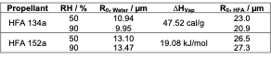
Discussion
Table 2. Initial radii, R₀, of aqueous droplets and the calculated initial radii of corresponding propellant droplets.
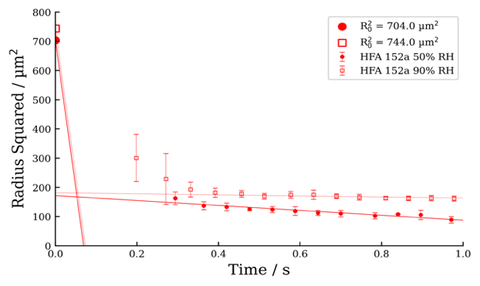
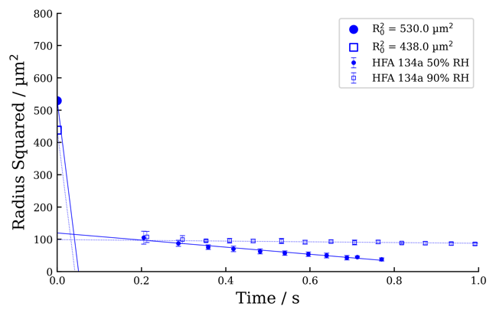
To relate the measured evaporation profiles to the initial propellant droplets created, energy balance calculations are performed, as presented in the literature [10]. The initial radius of the observed aqueous droplets is found via a linear fit (Figure 1) and the energy released through the condensation of this volume of water is equated to the energy needed for the initial volume of propellant to vaporise using the reported latent heat of vaporisation, ∆H_{Vap}, for each propellant [14,15]. This calculation ignores gaseous heat transfer, any kinetic limitations, temperature dependence of ∆H_{Vap} and chemical interactions that may modify the energy balance. However, it does provide an easily calculable lower limit on the initial propellant droplet size. The results of this calculation are presented in Table 2.
Figure 3. The evaporation behaviour for droplets of HFA 134a (top) and HFA 152a (bottom) at 22±1 °C and 50 % RH (solid markers and lines) or 90 % RH (hollow markers and dotted lines). EDB data and initial radii are marked.

Combination of the estimated initial droplet size and the calculated evaporation rates from the SDA method provides further insight into the evaporation of volatile propellant droplets. Assuming steady state evaporation, the reduction in size from the initial propellant droplet size can be plotted using the calculated evaporation rate. Figure 3 shows the results of this calculation for HFA 134a and HFA 152a using EDB and SDA data. For the droplets observed, the predicted propellant evaporation intersects with the linear trend of aqueous droplet evaporation between 10 and 50 ms after droplet generation. This analysis provides a lower limit for the initial droplet size and expected time to complete propellant evaporation. In practice, chemical interactions and temperature effects of condensing water may modify this behaviour and the concurrent evaporation of propellant and condensation of water will produce more gradual transition in evaporation rate than this prediction. This multi-regime behaviour is consistent with literature measurements but further work is required to understand the transition between the propellant and water dominated regimes [10,16].

Conclusion
A stroboscopic droplet analysis method is presented that enables the evaporation rates of propellant droplets to be measured. The evaporation rate of droplets of HFA 134a, HFA 152a and HFO 1234ze were found to be approximately 10,000, 20,000, and 41,000 µm²s⁻¹, respectively. This method is coupled with established EDB measurements to provide insight into the evolving state of propellant droplets when exposed to humid air. As an early method development study, further work is required to enable EDB studies of HFO 1234ze and increased control of the environmental conditions for SDA measurements. The approach presented provides a route to evaluating the performance of different formulations by quantifying the size of droplets over timescales relevant to inhalation. Furthermore, as the SDA method provides sensitive measurements of droplet size change, this approach offers an in vitro route to measuring aerosol maturation and is therefore a valuable tool in the context of the transition to low GWP propellants.
Acknowledgements: Funding for this work was made possible by the U.S. Food and Drug Administration (FDA) through Contract 75F40123C00186; views expressed in this publication are from the authors only and do not necessarily reflect the FDA’s official views or policies nor does any mention of trade names, commercial practices, or organization imply endorsement by the U.S. Government.

References
[1] J.N. Pritchard, Change is in the air - the new pressurized metered-dose inhaler propellants, in: Drug Delivery to the Lungs, 2022: pp. 25–29.
[2] F. Buttini, S. Glieca, F. Sonvico, D.A. Lewis, Metered dose inhalers in the transition to low GWP propellants: what we know and what is missing to make it happen, Expert Opin Drug Deliv 20 (2023) 1131–1143. https://doi.org/10.1080/17425247.2023.2264184.
[3] J. Shur, I. Rossi, W. Ganley, P. Kwok, R. Telford, R. Price, The Formulators Guide to Transitioning to Low Global Warming Potential pMDIs, in: Respiratory Drug Delivery, 2022: pp. 65–74.
[4] R.O. Williams, T.L. Rogers, J. Liu, Study of solubility of steroids in hydrofluoroalkane propellants, Drug Dev Ind Pharm 25 (1999) 1227–1234. https://doi.org/10.1081/DDC-100102292.
[5] I. Rossi, W. Ganley, P.C.L. Kwok, I. Zadrazil, G. Hassal, O. Michelet, S. Sarraih, G. Brouet, R. Price, J. Shur, Fundamental properties of propellant aerosols can guide transition to low global warming potential pMDIs: size, velocity and surface charge, in: Drug Delivery to the Lungs, 2021.
[6] D.J. Duke, B.J. Myatt, L. Rao, S. Vutlapalli, N. Marasini, H. Dowdle, P. Cocks, D. Schmidt, Optimizing Spray Formation in Solution and Suspension Low GWP Metered Dose Inhalers, in: Respiratory Drug Delivery, 2023: pp. 81–92.
[7] S.W. Stein, P.B. Myrdal, The relative influence of atomization and evaporation on metered dose inhaler drug delivery efficiency, Aerosol Science and Technology 40 (2006) 335–347. https://doi.org/10.1080/02786820600612268.
[8] P. Sheth, S.W. Stein, P.B. Myrdal, The influence of initial atomized droplet size on residual particle size from pressurized metered dose inhalers, Int J Pharm 455 (2013) 57–65. https://doi.org/10.1016/j.ijpharm.2013.07.061.
[9] P. Akhuemokhan, N.A. Green, A. Haddrell, D. Lewis, J.P. Reid, B. Forbes, How to engineer aerosol particle properties and biopharmaceutical performance of propellant inhalers, Int J Pharm 634 (2023). https://doi.org/10.1016/J.IJPHARM.2023.122676.
[10] V. Legh-Land, A.E. Haddrell, D. Lewis, D. Murnane, J.P. Reid, Water Uptake by Evaporating pMDI Aerosol Prior to Inhalation Affects Both Regional and Total Deposition in the Respiratory System, Pharmaceutics 2021, Vol. 13, Page 941 13 (2021) 941. https://doi.org/10.3390/PHARMACEUTICS13070941.
[11] R.O. Williams, T.C. Carvalho, J.I. Peters, Influence of particle size on regional lung deposition - What evidence is there?, Int J Pharm 406 (2011) 1–10. https://doi.org/10.1016/j.ijpharm.2010.12.040.
[12] H.J.J. Staat, A. van der Bos, M. van den Berg, H. Reinten, H. Wijshoff, M. Versluis, D. Lohse, Ultrafast imaging method to measure surface tension and viscosity of inkjet-printed droplets in flight, Exp Fluids 58 (2017) 1–8. https://doi.org/10.1007/s00348-016-2284-8.
[13] R.E.H. Miles, M.W.J. Glerum, H.C. Boyer, J.S. Walker, C.S. Dutcher, B.R. Bzdek, Surface Tensions of Picoliter Droplets with Sub-Millisecond Surface Age, Journal of Physical Chemistry A 123 (2019) 3021–3029. https://doi.org/10.1021/acs.jpca.9b00903.
[14] 1,1-Difluoroethane | C2H4F2 | CID 6368 - PubChem, (n.d.). https://pubchem.ncbi.nlm.nih.gov/compound/1_1-Difluoroethane#section=Autoignition-Temperature (accessed April 11, 2024).
[15] 1,1,1,2-Tetrafluoroethane | C2H2F4 | CID 13129 - PubChem, (n.d.). https://pubchem.ncbi.nlm.nih.gov/compound/1_1_1_2-Tetrafluoroethane#section=Stability-Shelf-Life (accessed April 11, 2024).
[16] H. Wang, J. Leal, M. Ordoubadi, Z. Minootan, K. Lachacz, N. Carrigy, D. Lechuga-Ballesteros, R. Vehring, Understanding the performance of pressurized metered dose inhalers formulated with low Global warming potential propellants, Aerosol Science and Technology 58 (2024) 115–133. https://doi.org/10.1080/02786826.2023.2296930.

