Semaglutide powder for inhalation, pre-formulation and in vitro characterization

Stefania Glieca¹, Antonella Grigoletto², Eride Quarta¹, Irene Rossi³, Maribel Bogalo⁴, Ross Blezard⁴, Andrea Silvestri⁵, Gianfranco Pasut² & Francesca Buttini¹

¹Food and Drug Department, University of Parma, Parco Area delle Scienze 27/a, Parma, 43123, Italy

² Pharmaceutical and Pharmacological Sciences Department, University of Padova, Via F. Marzolo 5, Padova, 35131, Italy

³Harro Höfliger, Helmholtzstraße 4, Allmersbach im Tal, 71573, Germany

⁴DFE Pharma, Klever Straße 187, Goch, 47568, Germany

⁵Sterling Via della Carboneria 30, Corciano, 06073, Perugia, Italy

Summary
Semaglutide (SMG) is a Glucagon-like peptide 1 derivative modified to prolong its bioavailability. It is weekly administered subcutaneously using autoinjectors stored under refrigerated conditions. For these reasons a more patient-friendly route, like inhalation, which does not require cold chain can be advantageous. The aim of this project was to formulate SMG as a spray-dried powder for inhalation maintaining the peptide stable and reaching satisfactory respirability. A pre-formulative study, at 40°C for up to 6h, was conducted on eight solutions which differed in buffer type (Tris and Phosphate) and concentrations (5-10 mM) and in the concentration of SMG, L-leucine and trehalose (0.5 or 0.8% w/w). No effect on the concentration of the peptide was observed by Reverse Phase High Pressure Liquid Chromatography, no aggregates were identified by Size Exclusion Chromatography and mass spectrometry did not show any evidence of chemical degradation. Two solution compositions were then chosen and spray-dried at fixed process parameters. Although different buffers were used, the powders obtained did not present any degradation of the peptide and had a similar water content (<4% w/w). However, the powder obtained from the Phosphate buffer showed a higher Fine Particle Fraction (59.8%) and higher Extra Fine Particle Fraction (21.6%), indicating a potential higher alveolar deposition, and, therefore, systemic absorption. Employing pre-formulative studies it was possible to readily obtain a dry powder which preserved the peptide and was respirable. Optimization of powder composition and spray drying process parameters as well as feasibility study focused on industrialising the DPI SMG product will be carried out.

Key Message
In this study we focused on pre-formulative studies to develop an inhalable more patient-friendly dry powder of Semaglutide. Peptide stability in different feed-stock solutions was assessed, and based on those results, two powders were initially spray-dried. The powder produced from Phosphate buffer showed to deposit deeply in the lungs.

Introduction

Glucagon-like peptide 1 (GLP-1) is a hormone that acts on the incretin system involved in the response to oral intake of nutrients [1]. To counteract the increase in blood glucose following a meal, GLP-1 acts directly on the pancreas β-cells, increasing the synthesis of insulin and slowing down gastric emptying, and on the central nervous system increasing the feeling of satiety, reducing appetite and consequently the food intake [1]. Given its physiological role, it could be useful for the treatment of diabetes or for weight reduction but its half-life of only 1-2 minutes [2] does not make it suitable for administration as a drug. Modifications to the N-terminal part of the hormone have allowed the synthesis of agonists less sensitive to enzymatic degradation, managing to reach a half-life of 180h, as in the case of semaglutide (SMG) [2]. Currently, semaglutide is approved for the treatment of type 2 diabetes administered subcutaneously or by oral administration. When administered subcutaneously, with a starting dosage of 0.25 mg weekly, increased to 0.5 mg after four weeks, it has proven to be the most potent GLP-1 agonist in the control of obesity [2]. However, this peptide, marketed under the name Ozempic®, requires weekly injection and storage under refrigerated conditions, which can be seen as patient unfriendly. On the other hand, the oral tablets of semaglutide administered once daily, formulated with the addition of an absorption enhancer, require a very high dosage (2.5 mg to 40 mg) due to poor bioavailability [3].

In order to overcome the problems of the storage and the poor bioavailability of the two routes of administration already considered, a more patient-friendly delivery such as dry powder for inhalation (DPI) could be an option. However, being a biological drug, aspects such as stability in solution, compatibility with excipients and protection during the spray drying process must be considered.
The aim of this project was to formulate SMG as a spray-dried powder for inhalation maintaining the peptide stable and reaching a satisfactory respirability. An initial pre-formulative study was carried out in order to identify the best conditions in terms of type of buffer and its concentration in the feed-stock solution and the right excipients to obtain a stable and respirable spray-dried SMG.

Experimental Methods
A pre-formulative study was conducted on eight solutions of SMG (Hangzhou Go Top Peptide Biotech Co., China) in the conditions reported in Table 1:
Table 1. Factors and range of values investigated for the pre-formulative studies.
Factor | Levels
Buffer type | Tris (pH = 7.8) | Phosphate Buffer (pH = 7.4)
Buffer amount (mM) | 5 | 10
Solid concentration (%w/v) | 0.5 | 0.8

In the solution, SMG and L-leucine had a fixed concentration of 1.25% w/w and 15% w/w, respectively; the amount of excipients to reach the 100% w/w was represented by BioHale(r) trehalose dihydrate (DFE Pharma, DE), considering also the weight of the salts.
To investigate the stability of the SMG in these solutions, the same were incubated at 40°C for up to 6 h. At different time points samples were withdrawn and analysed by reverse phase high pressure liquid chromatography (RP-HPLC), Size exclusion chromatography (SEC) and mass spectrometry (MS), to determine reductions in SMG concentrations, formation of aggregates and eventual chemical degradation of SMG peptide sequence.
Two feed-stock solution compositions were chosen from the pre-formulative studies to obtain powders for inhalation employing a Mini Spray-dryer B-290 (Buchi, CH). The following process parameters were kept fixed: feed rate of 3.5 mL/min, air flow rate of 600 L/h, aspiration of 35 m³/h, inlet temperature of 135°C and nozzle of 0.7 mm.
The active pharmaceutical ingredient (API), the SMG, content (% w/w) in the powders was determined using a verified HPLC-UV method (linearity 1.5-30 µg/mL, limit of detection 1.98 µg/mL and limit of quantification 6.0 µg/mL).
The residual water content in the powder was measured employing a thermogravimetric analyser (TGA, Mettler Toledo, USA) under a flux of dried nitrogen from 25°C to 160°C at a rate of 10°C/min by integrating the weight loss between 25 and 130°C.
The in vitro respirability of the powders was investigated employing a Next Generation Impactor (NGI, Copley Scientific Ltd, UK). In detail, a capsule of hydroxypropyl methylcellulose (HPMC) size 3 (Qualicaps Europe, ES) loaded with 20 mg of powder was aerosolized using a RS01 (Plastiape, IT) mid resistance inhaler at 65 L/min. The quantification by RP-HPLC of SMG deposited in each part of the impactor allowed the calculation of the aerodynamic parameters according to USP <601>: emitted dose (ED), fine particle mass (FPM< 5 µm), fine particle fraction (FPF) and mass median aerodynamic diameter (MMAD).

Results

Drying a peptide poses risk to their chemical and physical stability [4] and for this reason pre-formulation studies are required. They aim to investigate the composition of the buffers in which they are dissolved and the possible interaction with excipients added to protect the peptide from the physical stress to which they are subjected during spray-drying. The peptide stability study on the feed-stock solutions was conducted up to 6h to be sure that the peptide maintained its chemical characteristics for the entire duration of the spray drying process.

All the eight combinations tested showed no effect on the stability of the peptide, in fact the concentration remained stable over 6h as determined by RP-HPLC, no aggregates were formed as assessed by SEC and no evidence of chemical degradation were observed by MS.

Considering that the peptide remained stable with all the compositions investigated, we chose to spray-dried solutions with the smaller amount of buffer, i.e. 5 mM, as they are known to affect the process yield and respirability of the powder [5], and at the highest solid concentration, i.e. 0.8% w/v, to maximize the process outcomes.

Table 2. Composition of the two spray-dried powders, API content (%w/w) determined by HPLC-UV and water content (%w/w) determined by TGA (n=3, mean ± std. dev.)
Powder Code | Composition (%w/w) |  |  |  | API content  (%w/w) | Water content  (%w/w)
Powder Code | SMG | L-leucine | Salts | Trehalose dihydrate | API content  (%w/w) | Water content  (%w/w)
#SMG_TRIS | 1.25 | 15 | TRIS  7.95 | 75.8 | 1.47 ± 0.02 | 3.38 ± 0.01
#SMG_P | 1.25 | 15 | Phosphate  9.25 | 74.5 | 1.45 ± 0.02 | 3.94 ± 0.01

Nonetheless different buffers were employed, the powders obtained presented an API content which was close to the theoretical one (1.25 %w/w), indicating no evident degradation of the peptide. The water content was similar for the two powders and lower than 4%.

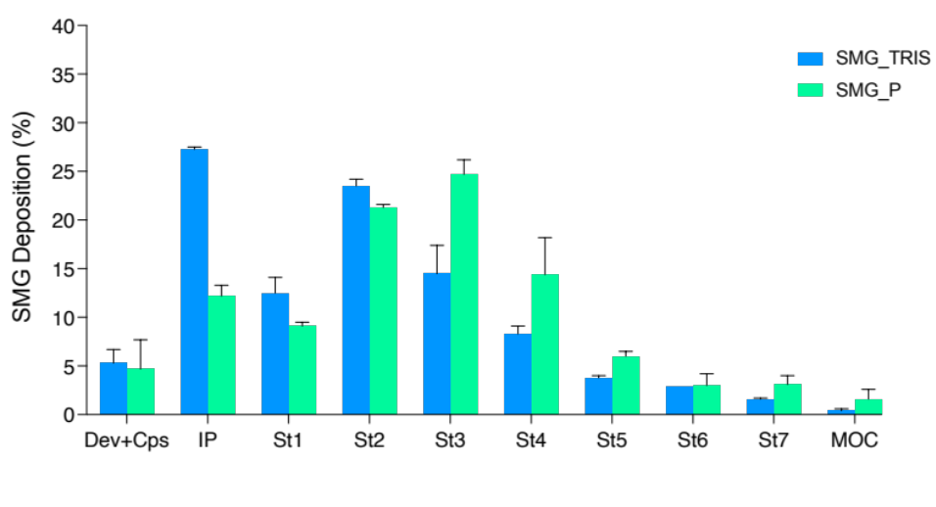
Figure 1: SMG deposition (%) in the various stages of the NGI: induction port (IP), stages 1 to 7 (St1-St7) and micro orifice collector (MOC) (n=3, mean ± std. deviation).
However, the aerodynamic deposition was different (Figure 1): the powder obtained from the solution in TRIS buffer (SMG_TRIS) showed a higher deposition in the induction port (IP) and in the first stages of the impactor (stage 1 to 2), determining a lower respirability. This may be due to the type of buffer employed. Solid state characterization is currently on-going to investigate this different aerodynamic behaviour observed.
Powder | Metered dose (µg) | Emitted dose (µg) | Emitted fraction (%) | MMAD (µm) | Fine Particle Dose (µg) | Fine Particle Fraction (%) | Extra-Fine Particle Dose (µg) | Extra-Fine Particle Fraction (%)
SMG_TRIS | 286.4±1.1 | 271.2±5.0 | 94.7±1.4 | 4.70±0.3 | 103.7±10.2 | 38.2±3.1 | 34.8±1.2 | 12.8±0.2
SMG_P | 295.2±8.9 | 281.1±0.4 | 95.3±3.0 | 3.56±0.15 | 168.1±10.1 | 59.8±3.5 | 60.7±9.4 | 21.6±3.4
Table 3. Aerodynamic parameters obtained by aerosolizing 20 mg of powder, containing approximately 290 µg of SMG, using RS01 into the NGI (n=3, mean±std. dev.).

Both powders had a high emitted fraction (>90%) (Table 3). Despite the higher salts concentration (9.25%) in powder SMG_P, this showed a higher FPF, of about 60%. In addition, the extra fine particle fraction was high for the least, indicating a potential higher alveolar deposition, and, therefore, absorption.
Conclusions
By applying a pre-formulative study, it was possible to readily obtain a dry powder for inhalation which preserved the semaglutide and was respirable. Optimization of powder composition and spray drying process parameters will be further investigated to maximize the deposition in the alveolar region for systemic absorption. Moreover, feasibility study focused on industrialising the DPI SMG product (i.e. powder automatic filling and product stability) will be carried out.

References
[1] Hinnen D. Glucagon-like peptide 1 receptor agonists for type 2 diabetes. Diabetes Spectrum 2017;30:202–10. https://doi.org/10.2337/ds16-0026.
[2] Chao AM, Tronieri JS, Amaro A, Wadden TA. Semaglutide for the treatment of obesity. Trends Cardiovasc Med 2023;33:159–66. https://doi.org/10.1016/j.tcm.2021.12.008.
[3] Davies M, Pieber TR, Hartoft-Nielsen ML, Hansen OKH, Jabbour S, Rosenstock J. Effect of oral semaglutide compared with placebo and subcutaneous semaglutide on glycemic control in patients with type 2 diabetes a randomized clinical trial. JAMA - Journal of the American Medical Association 2017;318:1460–70. https://doi.org/10.1001/jama.2017.14752.
[4] Pinto JT, Faulhammer E, Dieplinger J, Dekner M, Makert C, Nieder M, et al. Progress in spray-drying of protein pharmaceuticals : Literature analysis of trends in formulation and process attributes Progress in spray-drying of protein pharmaceuticals : Literature analysis. Drying Technology 2021;39:1415–46. https://doi.org/10.1080/07373937.2021.1903032.
[5] Glieca S, Cavazzini D, Levati E, Garrapa V, Bolchi A, Franceschi V, et al. A dry powder formulation for peripheral lung delivery and absorption of an anti-SARS-CoV-2 ACE2 decoy polypeptide. European Journal of Pharmaceutical Sciences 2023;191:106609. https://doi.org/10.1016/j.ejps.2023.106609.

