Assessing low dose aerosolised toxins using the Advanced Integrated Respiratory Model

Patrick He,^{1, 2} Hazel Lam,^{1,2} Hanieh M. K. Mahvizani,¹ Damien Chong,³ Shaokoon Cheng,² Patrick Spicer,⁴ Paul Young,² Lois Ledo,³ Vanessa Wilson,³ Daniela Traini,^{1,2} and Hui Xin Ong,^{1, 2}

¹Respiratory Technology, Woolcock Institute of Medical Research, Sydney, NSW, Australia. ²Macquarie University, Sydney, NSW, Australia. ³DSTG, Fishermans Bend, VIC, Australia. ⁴University of New South Wales, Kensington, NSW, Australia.

Summary
In this study the development of an advanced integrated respiratory (AIR) model, a bench-top platform to measure regional aerosol deposition, toxicity, and pharmacokinetics of inhaled aerosols is presented. This model simulates realistic inhalation and interaction of aerosols with human airway barriers under air-liquid interface (ALI) conditions. Lectin from Ricinus Communis (RCA I) were used as simulants for inhaled toxins. Initial studies on RCA I involved conventional cytotoxicity and barrier function assays on human respiratory alveolar cell line (H441) in solution. Subsequently, different doses of RCA I were aerosolised and their deposition in the lower airway evaluated using the AIR model integrated with H441 cells grown under ALI conditions. Additionally, a time course of the RCA I aerosol transport across the H441 cells at toxic and non-toxic concentrations were quantified using electric cell-substrate impedance sensing (ECIS). This integrated approach represents a significant advancement in the study of inhaled aerosol deposition, toxicity, and pharmacokinetics, offering a robust tool for predicting lung injury and enhancing the detection of a wide range of inhaled aerosols, including but not limited to toxins.
Key Message

The AIR model is an enhanced 3D-printed respiratory model that combines an in vitro lung system with the biological behaviour of respiratory cells to simulate an in vivo system.

Introduction
3D printed respiratory models are valuable tools for investigating particle deposition in the respiratory tract, addressing limitations of traditional in vitro and in vivo models. The current assumption in aerosol deposition in the lungs is that chemical concentration at its target site is homogenous and will determine the drug efficacy and/or toxicity. The lung is a complex organ with a branched architecture and specialized structures, leading to varied drug deposition across different regions, affecting pharmacokinetic (PK) processes and pharmacodynamic (PD) responses, and consequently, safety. Traditional in vitro cell-based models, such as lab-on-a-chip devices, do not account for the lung's complex geometry and respiratory mechanics. While in vivo models such as mice provide a more realistic result, they are often involved with ethical issues, maintenance, and interspecies anatomical and physiological differences [1]. In contrast, 3D-printed models allow the creation of personalized and intricate structures by translating medical body scans into computer-aided design (CAD) files, providing a more physiologically relevant simulation of the human respiratory tract.
This study aims to develop an Advanced Integrated Respiratory (AIR) model, a bench-top system designed to replicate respiratory aerosol deposition with high physiological relevance. It integrates air-liquid interface (ALI) human respiratory cell lines, enabling detailed studies of inhaled toxins and their effects on human respiratory cells, offering valuable insights into their in vivo behaviour. To validate the model, fluorescein Sodium (Flu-Na) was utilised as a simulant aerosol to first characterise the AIR model integrated with air interface model of H441 (alveolar) cells. The AIR model was then employed to study the effects of agglutinin RCA I from Ricinus Communis (castor bean) as a model of inhaled toxin. By understanding the interactions between the aerosolised RCA I and H441 cells in the ALI models, we aim to improve prediction of lung injury due to the inhalation of toxic aerosols.

Materials and Method
Development of the AIR Model
The AIR model consists of an upper airway model (oropharynx, uvula, epiglottis and soft palate) from average size healthy adult volunteers reconstructed using anatomical images acquired by Magnetic Resonance Imaging, combined with the lower airway model of 4 airway generations of the Weibel respiratory model [2]. The reconstructed airway model is fabricated using a 3D printed cast with optically transparent silicone. The silicone lower airway model is then placed into a plexiglass vacuum chamber to confine aerosols that exit the lower airways (Figure 1).
Assembly of the AIR Model
A vacuum chamber in then connected to a vacuum pump (Westech, UK) equipped with a filter at the outlet to capture aerosols. A flow meter 4040 (TSI, UK) is connected to the mouthpiece, and the airflow set to 15 L/min with the vacuum pump on.
Validation of Aerosol Deposition in the AIR Model using Flu-NA aerosols
Sodium Fluorescein (Flu-Na) was used as a model aerosol to validate the AIR model and determine mass aerosol deposition. Four empty Transwells with/without cells were connected to the lower airway (Figure 1E) AIR model. 1 mL Flu-Na solution in PBS (2.5 mg/mL) was transferred to a PARI LC® Sprint jet nebuliser connected to a PARI Turbo Boy S (Starnberg, Germany) and the solution was aerosolised into the AIR model at 15 L/min for 2 min.
Each AIR model component was placed in a suitably sized beaker and washed with Milli-Q water for Flu-Na quantification. Samples were transferred into a black 96-well plate for analysis. Fluorescence intensity was measured at 485 nm (excitation) and 583 nm (emission) using a SpectraMax M2 plate reader (Molecular Devices, USA). A calibration curve (R² = 0.999) was obtained using standards with concentrations from 0.0125 to 1.25 μg/mL.
Cytotoxicity assay of RCA1
To estimate the toxic aerosol dose of RCA I, a cytotoxicity assay was used to evaluate cell viability of H441 cells to a range of RCA I concentrations. H441 cells were seeded at 2.5 × 10⁵ in 96-well plates (100 µL) and incubated for 24 h. Following a 24 h treatment with RCA I (2.096 × 10⁻¹⁷ to 2.25 × 10⁻⁸ M)supernatant was removed, and cells were washed with phosphate buffered saline and incubated with MTS reagent (Promega, USA). Plates were incubated for 3 h prior and absorbance was read at 490 nm on a SpectraMax M2 (Molecular Devices, USA).
Integration of AIR model with H441 ALI model
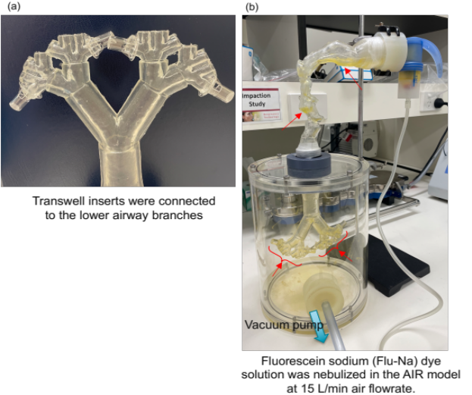
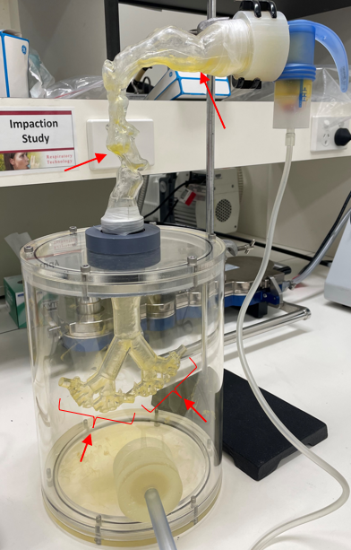
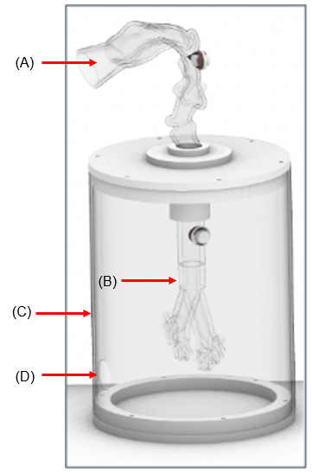
To culture H441 epithelial cells in an ALI model, confluent cells were seeded onto the apical chamber of Transwell polyester membrane inserts (0.33 cm², 0.4 µM pore size, Corning Costar) at a density of 3 × 10⁵ cells/cm² by adding 100 µL of cell suspension. The basolateral chamber received 600 µL of media. After 24 h of incubation, the apical chamber media was aspirated and basolateral chamber replaced with a differentiation media prepared with 1% Insulin-Transferrin-Selenium (Gibco, USA), 200 nM dexamethasone, RPMI 1640 (Gibco, USA), and 10% FBS. The basolateral chamber was replaced every 2 days for 14 days prior to experimentation. Four Transwell inserts were then connected to the medial and lateral lower airway branches as shown in Figure 1E and RCA I solutions (1.047 × 10⁻¹¹M - 4.19 × 10⁻⁹M concentrations) were nebulised using a PARI nebulizer into the AIR model over 2 min at a flow rate of 15 L/min. After deposition, the Transwell inserts were removed from the AIR model and transferred to a 24-well plate, where 600 µL of pre-warmed HBSS (37°C) was added to each well. The cells were incubated for 2 h at 37°C, 5% CO₂, and 95% relative humidity. Transepithelial electrical resistance (TEER) [3], paracellular permeability assay (P_{app}) [4] were measured and RCA I transport quantified using electric cell-substrate impedance sensing (ECIS) [5].
(E)
(F)

Figure 1. The primary components of the AIR model and testing set up. (A) silicone upper airway model (B) silicone lower airway model (C) plexiglass vacuum chamber, (D) connection to vacuum pump. (E) connection of the Transwell inserts to the lower airway. (F) complete experimental setup for simulating aerosol delivery by the AIR model. The annotated red arrows represent the highest observed deposition of Flu-Na dye solution nebulised in the AIR model at 15 L/min flow rate.
Results
As shown in Figure 1E, the transparent components of the AIR model allow for visualising the deposition pattern of the aerosols in the airways. The heterogenous deposition of aerosols inside the complex geometry of the upper airway, with the maximum deposition in the lower part of the oral cavity, epiglottis, as well as the deposition into the bifurcations of the lower airway can be observed.
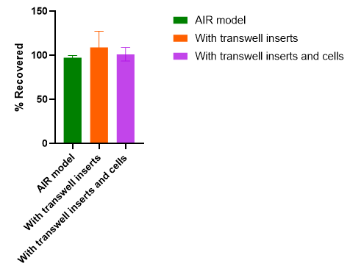
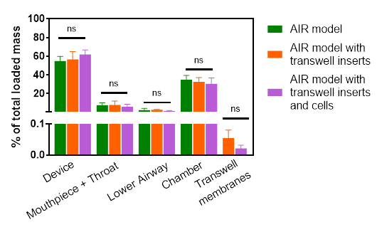
The deposited mass was calculated as a percentage of the total mass collected from the AIR model and shown in Figure 2. Most of the Flu-Na mass was deposited in the chamber, with a similar percentage deposited between the mouthpiece + throat and lower airway. The Transwell membranes were shown to have the lowest Flu-Na percentage deposition. The connection of Transwell inserts to the lower airway model (with and without cells) did not cause any significant difference in the mass of Flu-Na aerosol deposited in the components of the AIR model (0.1133 ≤ p ≤ 0.7074).
(B)
(A)

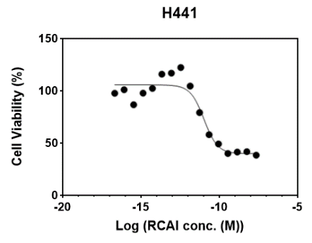
Figure 2. Flu-Na mass deposition in AIR model components with/without Transwell inserts (ALI H441 cells present/absent). (A) % recovered of Flu-NA aerosol mass (B) Mass deposition of Flu-Na in AIR model components measured by fluorescence at 486 and 583 nm. N=3, mean ± STD, ns (p > 0.05).
Cytotoxicity assay on a range of RCA I concentrations on H441 cells found that the inhibitory concentration IC (amount of drug required to inhibit the metabolic activity of cells by 10, 50 and 80%) for H441 was IC10 1.16 × 10⁻¹², IC50 1.047 × 10⁻¹¹, and IC80 4.19 × 10⁻¹¹ M, respectively, as shown in Figure 3. These values were then used for subsequent experiments in the AIR model.
Figure 3. The cytotoxicity profiles of H441 treated with RCA I at different concentrations. N=3, mean ± STD.
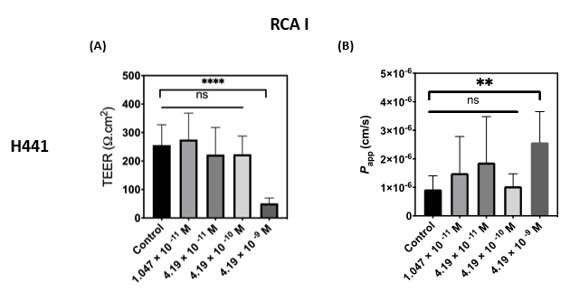
Four different concentrations of RCA I solutions were nebulised to determine the toxic dose on H441 cells (Figure 4). The initial two concentrations were chosen based on MTS results, with two more concentrations chosen by increasing one order of magnitude to attain a significant toxic dose. The highest concentration (4.19 ×10⁻⁹ M) of RCA I tested resulted in a significant drop in the TEER. The P_{app} for different concentrations showed a significant difference between the control cells and the cells exposed to the 4.19 × 10⁻⁹ M RCA I aerosol, however, no significant difference was observed between the control cells and the cells exposed to the other 3 concentrations. The observations in TEER and P_{app} assays together showed a toxic effect when 4.19 × 10⁻⁹ M of RCA I was aerosolised onto H441 cells.
Figure 4. The effect of RCA I aerosol delivered to the Transwell inserts with H441 attached to the lower airway of the AIR model. (A) TEER and (B) P_{app} results for H441. n=3, mean ± STD. *p < 0.05, ** p < 0.01, *** p < 0.001, and **** p < 0.0001; one-way ANOVA with Tukey’s multiple comparison test was performed.

Transport profiles of RCA I at toxic dose showed a higher rate of mass flux compared to non-toxic dose as most of the transport occurred in the first 45 min, which then plateaued until the end of the 2 h experiment (Figure 5).
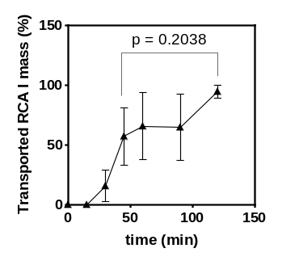
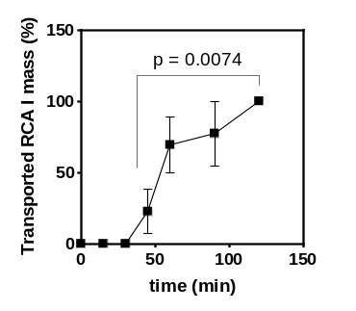
(A)
(B)
Figure 5. 2-h time course of the RCA I aerosol transport across the H441 cells at (A) toxic (4.19 × 10⁻⁹ M) and (B) non-toxic (1.047 × 10⁻¹¹ M) doses.

Discussion and Conclusion
Validation of the AIR model by aerosol deposition of Flu-Na on AIR model with/without Transwell inserts (presence/absence of H441 cells), showed the total recovery to be between 85-115% (Figure 2A) meeting the requirements for impaction studies according to the United States Pharmacopeia. The addition of Transwell inserts, whether containing cells or not, did not have a significant effect on the percentage of aerosol deposition across the different components of the AIR model (Figure 2B).
Evaluating the effects of inhaled toxins across the respiratory epithelium using the AIR model, revealed significant differences in toxic concentrations of RCA I compared to results obtained using the 2D cell model in the MTS assay for H441 cells. The TEER and P_{app} assays (Figure 4) showed IC80 values 3 magnitudes higher than that observed in the MTS assay (Figure 3). The transport profiles of RCA I show that delivery at the pre-determined toxic dose results in a higher transport rate across the epithelium compared to the non-toxic dose due to disrupted tight junctions that regulate solute transport. While the MTS assay focused on cellular metabolic activity, the current assay evaluates the epithelial barrier function, which is crucial for understanding the transport of inhaled substances into the systemic circulation. Additionally, MTS assay does not produce real time measurements from the same well, unlike the P_{app} assay performed using the AIR model integrated with H441 cells under ALI conditions. Therefore, the different toxicity profiles of RCA I aerosols on H441 cells using the AIR model highlight the importance of this experimental platform, which better mimics in vivo physiology and conditions and underscores the different evaluation parameters of the toxic response of the cells.
This study developed a physiologically relevant AIR model that mimics lung physiology and inhalation, enabeling the characterisation of aerosol interactions with human respiratory cells. The integrated AIR-ALI platform facilitates the determination of realistic toxic doses of inhaled aerosols.
References
[1] P.J. Thompson, Drug Delivery to the Small Airways, American Journal of Respiratory and Critical Care Medicine 157(5) (1998) S199-S202.
[2] Z. Ma, L. Milton-McGurk, P. Tang, H.-K. Chan, D. Farina, S. Cheng, A. Kourmatzis, An experimental study of the effect of individual upper airway anatomical features on the deposition of dry powder inhaler formulations, Journal of Aerosol Science 177 (2024) 106320.
[3] H. Gholizadeh, S. Cheng, A. Kourmatzis, D. Traini, P. Young, Z. Sheikh, H.X. Ong, In vitro interactions of aerosol formulations with human nasal epithelium using real-time monitoring of drug transport in a nasal mucosa-on-a-chip, Biosensors and Bioelectronics 223 (2023) 115010.
[4] M.N. Leslie, N. Marasini, Z. Sheikh, P.M. Young, D. Traini, H.X. Ong, Development of Inhalable Spray Dried Nitrofurantoin Formulations for the Treatment of Emphysema, Pharmaceutics 15(1) (2022).
[5] H. Gholizadeh, S. Cheng, M. Pozzoli, E. Messerotti, D. Traini, P. Young, A. Kourmatzis, H.X. Ong, Smart thermosensitive chitosan hydrogel for nasal delivery of ibuprofen to treat neurological disorders, Expert Opinion on Drug Delivery 16(4) (2019) 453-466.

