Fast screening of fine particle dose for a Dry Powder Inhaler and a pressurized Metered Dose Inhaler using the Refined-Fast Screening Impactor

Patrik Andersson¹, Simon Åslund¹, Marcus Skogevall¹, Stina Sjödin¹, Iain Fraser¹, Bodil Hakonen¹ & Jan Olof Svensson^{1,2}

¹Inhalation Product Development, Pharmaceutical Technology & Development, AstraZeneca, Gothenburg, Pepparedsleden 1, SE-43183 Mölndal, Sweden

²Chalmers University, Analytical Chemistry, Division of Chemistry and Biochemistry, Gothenburg, Sweden

Summary
In this study we introduce a modified Fast Screening Impactor, the Refined-FSI (R-FSI), in which the fine particle dose <5 µm (FPD) is collected on a Respirgard filter (303EU Airlife). This modified method speeds up FPD determinations further compared to the ordinary FSI. With this method we have characterized two formulation batches in a multidose Dry Powder Inhaler (DPI) and two batches of a combination product pressurized Metered Dose Inhaler (pMDI), comparing with the FPD results obtained using a Next Generation Impactor (NGI) for the DPI or an Andersen Cascade Impactor (ACI) for the pMDI. For both the DPI and the pMDI, the FPD_{<5µm} as determined by the R-FSI are in good agreement with the Cascade impactor results. The agreement depends slightly on the interpolation method used for calculating the FPD_{<5µm} for the cascade impactors. In summary, this study demonstrates the potential of the R-FSI (or FSI or an automated FSI) as a viable alternative to pharmacopeial cascade impactors for determining FPD_{<5µm} in DPIs and pMDIs. It also highlights the importance of interpolation method used for FPD_{<5µm} and the potential for removing the impactor mass balance criteria by using this non-complex equipment and thereby also moving towards automated FPD determinations.
Key Message
This study shows good agreement in FPD_{<5µm} between the R-FSI and the cascade impactor NGI (for DPI) or ACI (for pMDI). The results could be a driver for implementing the R-FSI (or FSI or an automated FSI) into QC-release testing for FPD_{<5µm}.

Introduction
Abbreviated impactor measurements (AIM) have been investigated intensively the last two decades. However, none of the abbreviated impactors are as of today included in pharmacopeias, which limits its usage as a QC-equipment. The fast screening impactor (FSI) is a single stage impactor where the FPD passing the single cut-off stage is collected on a filter. This impactor has the potential to be used as a QC-equipment in e.g. Europe and Rest of the World (RoW) where FPD is an accepted quality attribute. In order to be able to interchangeably use FSI and cascade impactor in QC release testing, obtaining equivalence between the two is important. The number of studies comparing the FSI with pharmacopeial cascade impactors are limited and e.g. an EPAG AIM study published in 2016 [] studied multiple AIM setups. This study showed that the FSI overestimates the Fine Particle dose<5 µm (FPD<5 µm) for the product studied (a combo DPI) by 20 ± 4% (90% confidence interval) for component A1a and 14± 3% for component A1b. However, the base plate of the FSI was uncoated potentially giving bounce. In addition, the flow rate rise time of the FSI was not matched with the NGI which potentially could impact the results. Therefore, there is a need to perform additional experiments with the FSI where both rise-time and coating is matched with the NGI in order to consider the FSI as an pharmacopeial equipment in Pharm Eur. The purpose of this study was to perform well controlled comparisons between the FSI and Cascade impactors for both a DPI and a pMDI, while also showing the importance of the interpolation method used for determining FPD_{<5µm} from a cascade impactor.

Experimental methods
In this study two formulation batches in a multidose Dry Powder Inhaler (DPI) were characterized by an NGI and an FSI. Both formulations contained the active pharmaceutical ingredient D. Two flow rates were used corresponding to a pressure drop of 2 and 4 kPa, respectively. Each inhaler was studied both with and without a pre-separator attached to the NGI and the FSI. The study was balanced to remove potential dose trends through the inhaler life (3 doses were withdrawn for each impactor setup). The NGI collection plates as well as the base plate of the FSI was coated with a water solution to minimize bounce. In addition, the cup of the FSI was filled with 15 ml liquid and its base plate was covered by a lens paper. The flow rise time of the FSI setup was matched to the flow rise time of the NGI to minimize potential effects of the start-up kinetics. Deposited powder was dissolved and quantified by UHPLC using an internal standard methodology.
Two batches, having the same composition, of a combination product pMDI were also studied by an ACI and an FSI. Since the ACI is not calibrated at 30 L/min, the ACI was used at a flow rate of 28.3 L/min while a flow rate of 30 L/min was used for the FSI. The collection plates of the ACI were uncoated, as it has been shown not necessary, while the base plate of the FSI was coated with a Brij/Glycerol solution. The cup of the FSI was filled with 15 ml of water. For each batch, 20 inhalers were studied (10 inhalers per impactor type). Six actuations were deposited on each impactor. The studies performed in this work are summarized in Table 1 below.
Table 1. A summary of measurements performed in this study. The numbers shown are the number of replicates per setup and batch. W=with and W/O=without. PS=pre-separator.
Measurement | DPI A | DPI B | pMDI C1 | pMDI C2
NGI W and W/O PS @4kPa | 3 | 3
NGI W and W/O PS @2kPa | 3 | 3
R-FSI W and W/O PS @4kPa | 3 | 3
R-FSI W and W/O PS @2kPa | 3 | 3
ACI @28.3 L/min |  |  | 10 | 10
R-FSI W/O PS @30 L/min |  |  | 10 | 10

A modification of the FSI was made to speed up the measurements and to remove the need to filter the recovered solution prior to sampling to vial. In this modified setup, the Refined-FSI (R-FSI), the standard dose collection filter holder of the FSI was removed and replaced by a Respirgard filter (303EU Airlife) (see Figure 1).
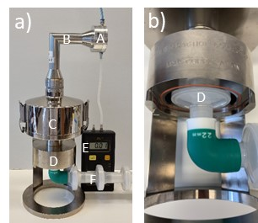
Figure 1 - a) Picture of the R-FSI setup used (without a PS). A: Inflatable inlet, giving a leak-tight seal, B: Induction port, C: FSI housing, D: FPD filter (Respirgard), E: Pressure drop meter, F: Backup filters. b) Close-up picture of the FPD filter (D) inside the FSI body.
Linear interpolation of the impactor stage results to obtain FPD were performed using two different algorithms. The first one is based on a linear interpolation of the cumulative dose vs the logarithm of the aerodynamic diameter (here named Log-Linear method), while the second algorithm assumes a Log-Normal distribution where interpolation is performed between the two stages immediately adjacent to the 5 µm (here named Log-Probit method). For the DPI study without a pre-separator, only the Log-Linear method could be applied since the distribution had a coarse fraction deposited on stage 1 and interpolation was performed between stage 2 and 3. FPF was calculated as FPD divided by the impactor dose (USP induction port + PS (if used) + all stages of the impactor + end filter).

Results
In Figure 2a the results for the FPD for the R-FSI for the two DPI formulations are shown for the setup with a pre-separator (FPD for the FSI is compared to the corresponding results for the same inhaler for the NGI + pre-separator). The FPD for the NGI is based on the calculation assuming a Log-Normal distribution. The agreement is excellent with an average FSI vs NGI ratio of 102 ± 3% (90% confidence interval). Calculating FPD for the NGI+PS not assuming a Log-normal distribution also gives good agreement with an average FSI vs NGI ratio of 105 ± 3%.
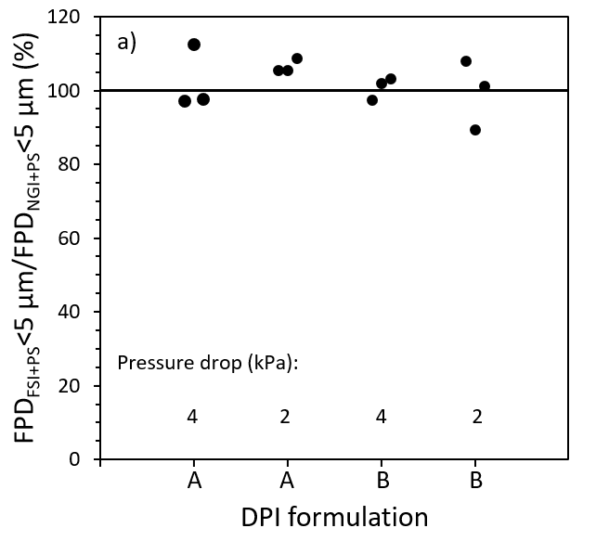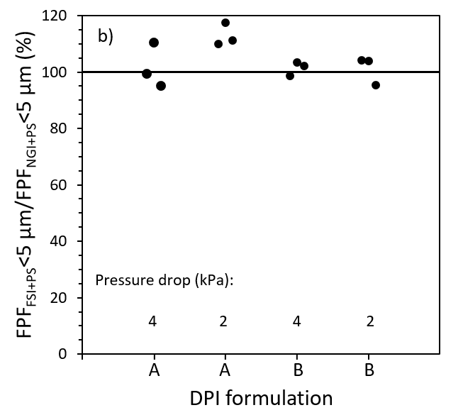
Figure 2 - a) FPD_{<5 µm} using the R-FSI + PS (in % of FPD_{<5 µm} from NGI + PS) and b) FPF_{<5 µm} using the R-FSI + PS (in % of FPF_{<5 µm} from NGI + PS). The pressure drop values are indicated.
In Figure 2b the results for the FPF_{<5 µm} for the R-FSI for the two DPI formulations are shown for the setup with a pre-separator. In this figure, FPF<5 µm for the NGI is based on the calculation assuming a Log-Normal distribution. The agreement is good with an average FSI vs NGI ratio of 104 ± 4% (90% confidence interval). Calculating FPF_{<5 µm} for the NGI+PS using the Log-Linear method also gives good agreement with an average FSI vs NGI ratio of 107 ± 4%.
In Figure 3 the FPD results for two pMDI batches are shown. The FPD for the ACI is based on the calculation assuming a Log-Normal distribution. The difference between the two batches is small and therefore both batches are included in an overall comparison between the R-FSI and the ACI. As for the DPI, the agreement is excellent for the pMDI with average R-FSI to ACI ratios of 99 ± 3% (90% confidence interval) and 100 ± 3% for component A and B, respectively. Calculating FPD using the Log-Linear distribution also give good agreement with average ratios of 100 ± 3% and 101 ± 3%, for component A and B, respectively.
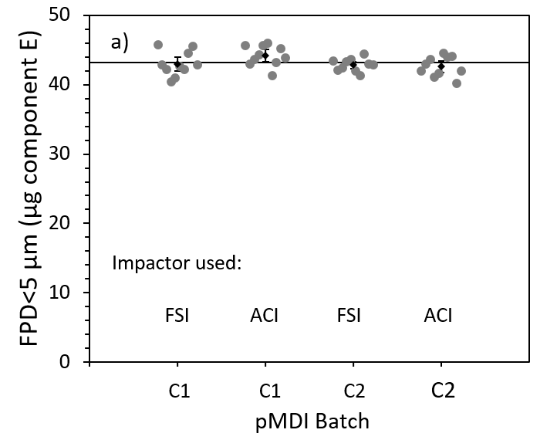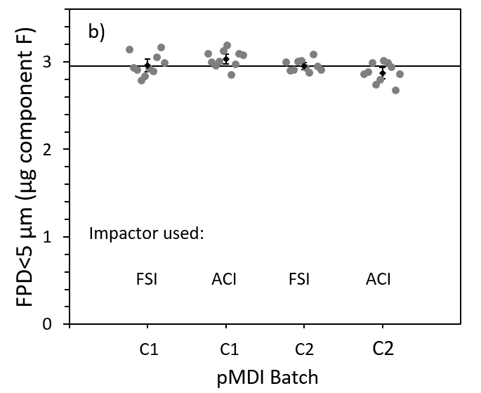
Figure 3 - FPD<5 µm for two pMDI combo batches (C1 and C2) using the R-FSI and the ACI. a) API E and b) API F. The average (with 90% confidence interval) is shown in black for each set of measurements.
A summary of all FPD comparisons between the cascade impactor and the abbreviated impactor are shown in Table 2.
Table 2. Summary of FPD<5 µm results for the different inhalers, setups and calculation methods used.
Device | API | Cascade impactor setup | Abbreviated impactor setup | FPD inter-polation method | AIM to PIM FPD ratio* (%)
DPI | D | NGI + PS | R-FSI + PS | Log-Probit | 102 ± 3
DPI | D | NGI + PS | R-FSI + PS | Log-Linear | 105 ± 3
DPI | D | NGI | R-FSI | Log-Probit | NA**
DPI | D | NGI | R-FSI | Log-Linear | 112 ± 7
pMDI | E | ACI | R-FSI | Log-Probit | 99 ± 3
pMDI | E | ACI | R-FSI | Log-Linear | 100 ± 3
pMDI | F | ACI | R-FSI | Log-Probit | 100 ± 3
pMDI | F | ACI | R-FSI | Log-Linear | 101 ± 3
*Average ± 90% confidence interval. **Not available, since FPD from NGI could not be calculated with this method at the flow rates used.

Discussion and Conclusions
Overall, excellent agreement between the R-FSI and the Cascade impactor for FPD is obtained for both the DPI and the pMDI studied. The interpolation method selected for calculating FPD<5 µm for the cascade impactors (NGI and ACI) has a small influence on the FPD<5 µm, where the method assuming a Log-normal distribution gives around 3% higher FPD<5 µm for the NGI and about 1% higher FPD<5 µm for the ACI. The smaller difference for ACI is attributed to the narrow size range on stage 2 of 4.7 – 5.8 µm at 28.3 L/min, while the size range for stage 2 of the NGI is typically larger. It is flow dependent and at e.g. 60 L/min the size range is 4.46 – 8.06 µm. So, when comparing AIM and cascade impactor results care should therefore be taken regarding the interpolation method.
By using a pre-separator on both the R-FSI and the NGI for the DPI, we obtained better agreement between for FPD as compared to omitting the pre-separator on both setups. We do not know the reason for this and additional studies are needed to determine if this is a general characteristic. However, we note that the flow profile out of the induction port is not fully symmetric around the centre of the exit due to the bent induction port while the flow profile out of the pre-separator is, which may be an advantage for accurate operation of the R-FSI. Another reason for the better results with the R-FSI+PS setup compared to the R-FSI only may be that bounce of coarse particles passing the induction port is reduced by the introduction of a pre-separator where the jet velocity is lower than in the R-FSI.
The ACI was used at 28.3 L/min while the R-FSI was used at 30 L/min. Given that a) a pMDI is an active device where the aerodynamic particle size distribution (aPSD) only changes slightly with flow rate and b) the flow rate difference (6%) is close to the generally accepted ±5%, we consider the comparison valid.
The time savings for using the R-FSI compared to the Cascade impactor is around 25% (NGI) and 65% (ACI) when also the deposit in both the induction port and the R-FSI housing is dissolved and quantified in order to obtain total mass to impactor for FPF determination. These time savings increase to around 60% (NGI) and 90% (ACI) when only the FPD is determined. The latter way of determining FPD have similarities with a DD determination (collecting the dose on a filter), which may remove the need for the current impactor mass balance criteria. Although these savings are significant, the main driver for moving towards R-FSI is automation, where hundreds of FPDs can be determined per day.
To summarize, the main conclusions of this study are:
- FPD from the R-FSI setup was in excellent agreement with the cascade impactors (NGI for the DPI and ACI for the pMDI).
- The interpolation method used for determining FPD_{<5µm} for the cascade impactors may influence the agreement between the R-FSI and the Cascade impactor, especially for the NGI (depending on flow rate).
- The use of a pre-separator in connection with an R-FSI may be considered for DPIs.
- The set-up is non-complex and therefore the impactor mass balance criteria may not be needed, enabling automated FPD determinations.

References

[] Nichols S C, Mitchell J P, Sandell D, Andersson P U, Fischer M, Howald M, Pengilley R, Kruger P: A Multi-laboratory in Vitro Study to Compare Data from Abbreviated and Pharmacopeial Impactor Measurements for Orally Inhaled Products: a Report of the European Aerosol Group (EPAG), AAPS PharmSciTech 2016; 17: pp 1383–1392.

