Enhancing the intranasal delivery of mRNA therapeutics using a novel thermosensitive polymer.

Juhura G. Almazi¹, Antonella Granata¹, Dinh B. T. Ngo¹, Simin Maleknia², Farshad Oveissi², Ali Fathi², Paul Young^{1,3,4}, Daniela Traini^{3,5}, Hui Xin Ong^{1,3,5}

¹Ab Initio Pharma Pty Ltd, Sydney, NSW, Australia

²Tetratherix Technology Pty Ltd, Sydney, NSW, Australia

³Respiratory Technology, The Woolcock Institute of Medical Research, Sydney, NSW 2037, Australia

⁴Department of Marketing, Business School, Macquarie University, Sydney, NSW 2109, Australia

⁵Macquarie Medical School, Faculty of Medicine, Health, and Human Sciences, Macquarie University, Sydney, NSW 2109, Australia

Summary
Intranasal mRNA administration is an attractive treatment modality for many diseases, including brain tumours and neurodegenerative diseases. In this study, a novel proprietary synthetic thermosensitive polymer, denoted as TP, is presented as a promising alternative drug carrier for nasal delivery of mRNA. TP has a thermogelling property, it remains in liquid state at room temperature and undergoes a phase transition to form a hydrogel with a mucoadhesive characteristic at physiological temperature. A series of studies was conducted to characterise the interaction of mRNA, coding the enhanced green fluorescent protein (EGFP), with TP to demonstrate the potential of the polymer to form nanoparticles for the intranasal administration of mRNA therapeutics. Two concentrations of TP solutions (25 mg/mL- TP25 and 35 mg/mL-TP35) were formulated with EGFP and lipofectamine lipids and was found to generate nanoparticles of approximately 40 nm. The TP formulations were also able to stabilise mRNA lipofectamine particles for at least 7 days at ambient conditions and displaying EGFP mRNA expression similar to that of the positive control, fresh mRNA formulation. When the formulation was aerosolised using the Bivax nasal spray device (Aptar), the aerosol particle size distribution was larger in formulations containing the TP polymer. Nevertheless, the formulations are appropriate for nasal delivery as most of the aerosols are above 10µm. Additionally, deposition of the 250 µL spray of TP25 and TP35 formulations was successful, while the control without the carrier showed significant nasal dripping. This further demonstrates the suitability of TP25 and TP35 as alternative drug carrier polymers.
Key Message
The use of a novel TP thermosensitive polymer shows promising result as an alternative vehicle for intranasal delivery of mRNA with improved delivery to the nasal cells, increased stability of nanoparticles at room temperature and higher retention in the nasal cavity in vitro.

Introduction
RNA-based therapeutics are a disruptive technology that is rapidly expanding, which will continue to change the standard of care for many diseases. [1-3] Current RNA therapeutics have only been delivered via the intravenous route. Nasal delivery of therapeutic RNAs presents significant potential yet remains an underexplored modality to treat many diseases i.e., locally such a COVID-19;[1] or directly to the brain through the olfactory region in the nose to treat neurodegenerative diseases [2] and brain tumours. [3] Targeted nasal delivery has many advantages including quick onset of action, reduced dosage requirements, limited side effects and ability for self-administration using a needle free approach. However, there are several challenges to delivering drugs (including nanoparticles (NPs)) through the intranasal route,[4] including: navigating the highly resistant and narrow nasal vestibule region prior to reaching the targeted region [5] and the biological barriers of the semi-permeable nasal epithelium lined with a mucus layer, enzymatic degradation and rapid mucociliary clearance (renewed every 15 min). [6]
To overcome these challenges, a common approach is to incorporate ‘thickening’ polymers as excipients into the nasal spray to increase viscosity, thus reducing formulation run-off and enhancing residency time. [7] The increased viscosity of these polymers generally comes with a trade-off, since such formulations are difficult to aerosolise using current nasal delivery systems (pumps), hampering efficient delivery of the drugs to the nasal cavity. Conversely, formulations with low viscosity have the inherent problem of dripping from the nasal passage, resulting in wastage and low bioavailability. Therefore, there is a need to develop new excipients that can be used as an aerosol vehicle to deliver RNA either alone or within NP systems to the nose with the ability to generate fine aerosols, enhanced residence time, while circumventing the biological barriers in the nose.
In this study, a novel proprietary thermosensitive polymer, poly(N-isopropylacrylamide)-co-(polylactide/2-hydroxy methacrylate)- co -(oligo (ethylene glycol), [8, 9] denoted as TP (Tetratherix), is evaluated for its potential as an alternative excipient as drug delivery carrier for intranasal mRNA delivery. The ability of TP formulated with EGFP and lipofectamine lipids to generate mRNA nanoparticles was evaluated and characterised in vitro for its stability and efficacy. In terms of its potential for nasal delivery, the TP formulations was studied in terms of its sprayability and coverage of the nasal cavity after administration into the nasal cavity.

Material and methods
Preparation of TP and mRNA formulations
A solution of 100 mg/ml TP solution (TP100) was prepared with 1 x Phosphate Buffered Saline (PBS) or Opti-MEM (Minimal Essential Media) media and left to gently mix over night at 4 °C. The TP100 solutions were stored at 4 °C until use. On the day of experiment, the mRNA was mixed with the appropriate volumes of TP100 solution, Lipofectamine™ (MessengerMAX™ Transfection Reagent, Thermo Fisher Scientific) and PBS or Opti-MEM to create the desired TP solution concentrations.
mRNA functionality study with time lapse microscopy
The functionality of the EGFP mRNA was assessed by evaluating the cellular production of the green fluorescent protein (GFP). A RPMI2650 basal nasal cell model was used. Cells were cultured onto 24-well plates for 24 h. The media of the cells were changed to Opti-MEM media and incubated for 2 h at 37 °C. The 24-well plate was kept in a humidified chamber at 37 °C in 5% CO₂ atmosphere and 95% humidity and observed using a Nikon Eclipse Ti microscope (Nikon, Tokyo, Japan) with Coolsnap ES2 camera. Photographs were taken every 2 h for 48 h using NIS-Elements (version 3.22.01) set to take images in both ‘Phase’ and ‘Fluorescent’ modes. The images were analysed using Fiji ImageJ.
Parallel mRNA functionality assay with nanoparticle measurements.
Subsequently, a study was designed to decipher if the TP formulations with mRNA and lipofectamine could form nanoparticles and if those nanoparticles were able to preserve the efficacy of the mRNA. The RPMI2650 nasal cell model was used to evaluate efficacy. The cells were cultured onto 24-well plates for 24h. The media of the cells were changed to Opti-MEM media and incubated for 2 h at 37 °C. The media was then replaced with the following:
• Negative control – Lipofectamine 0.75 µl diluted to 500 µl with fresh Opti-MEM media
• Positive control – 500 ng of mRNA mixed with 0.75 µl lipofectamine diluted to 500 µl with fresh Opti-MEM media
For the indirect exposure to the formulations, the media on the cells were replaced with fresh Opti-MEM media and Transwell inserts (5 µm, polycarbonate membrane) were placed on top of the wells carrying the following formulations:
• TP0 formulation – 500 ng of mRNA mixed with 0.75 µl lipofectamine diluted to 100 µl with fresh Opti-MEM
• TP25 formulation – 500 ng of mRNA mixed with 0.75 µl lipofectamine diluted to 100 µl with fresh Opti-MEM with 25mg/ml polymer
• TP32 formulation – 500 ng of mRNA mixed with 0.75 µl lipofectamine diluted to 100 µl with fresh Opti-MEM with 32mg/ml polymer
A parallel 24-well plate was also set alongside this cell experiment with the exact same conditions but without any cells. After 2 4h incubation at 37 °C in 5% CO2 atmosphere, the Transwell inserts were removed from all the wells and the cell plates were measured using the fluorescent plate reader. The media in the non-cell plates were analysed using the zetasizer to assess for particle size
Stability Study -mRNA encapsulation content
The nasal spray formulation stability study was conducted for mRNA stability using 2 ml Type 1 borosilicate clear glass filled vials where the formulations were added and incubated at 4 °C, 25 °C or 37 °C and measured immediately (0 h) and after 24 h, 48 h, 72 h, 120 h, and 168 h using Agarose gel electrophoresis. The samples stored at 25 °C and 37 °C were incubated for 1 h in the fridge/ice to allow the gel to transition to solution prior to analysis. The ‘leaked’ samples, measuring how much mRNA leaked out of nanoparticles, was determined by analysing the samples directly (without any detergent) and the ‘total’ mRNA content in the of the formulation was determined by adding Triton X-100 (final volume 5 %v/v) to the samples before analysing using agarose gel electrophoresis (Equation 1).
Equation 1: Percentage Encapsulated (%) = ((total mRNA-leaked mRNA)/(total mRNA )) x 100
Nasal cast deposition study
The deposition of the nasal formulations, in the human nasal cavity was assessed using an anatomical transparent silicone human nose model (Koken model). The deposition of the spray in the nasal cavity cast was visualised by covering the interior surface of the dry nose cast uniformly with 0.5 g of the Sar-Gel® paste with a dry brush. The nasal cast was then transferred to a sealed dry box containing silica gel to keep the nasal cast dry and incubated for 20 min at 32-37 °C for temperature equilibrium. The BIVAX Aptar spray device containing 500 µL of the formulations (250 µL/nostril i.e., half a dose/nostril) was inserted 5 mm into the nostril and actuated manually at a 45° angle. During actuation, the nasal cast was positioned in a standard upright pose, placed back into the sealed dry box, and incubated for a further 20 min to monitor the deposition of the sprayed formulation within the nasal cavity cast. Sequential photographs were taken every 5 min during the incubation period for up to 20 min, the images were analysed using Image J software.
Aerosol particle size distribution study
The aerosol particle size distribution was conducted for the nasal spray formulations using laser diffraction. Briefly, a Spraytec particle sizer was used for all measurements. Three particle size measurements were then conducted for each formulation by firing into the laser path at a 45° angle. The spray nozzle was adjusted so that the nozzle tip was 25 mm from the laser at an angle of 30° from the beam. All actuations were conducted by the same operator.
Results and Discussion
GFP functional assay was developed to measure the efficacy of mRNA formulations with the polymer. Time lapse microscopy was used to image the expression of green fluorescent protein for 48h. In the absence of lipofectamine, the mRNA was unable to have a functional effect on the RPMI2650 cells or in combination with TP. However, when mixed with Lipofectamine, the mRNA was functional, as evidenced by the expression of GFP. The increase in GFP plateaus at 24h (Figure 1) and hence was selected as the time point to develop a 24 well plate for parallel functional assay of EGFP mRNA and nanoparticle measurement with the addition of Lipofectamine in the formulation.

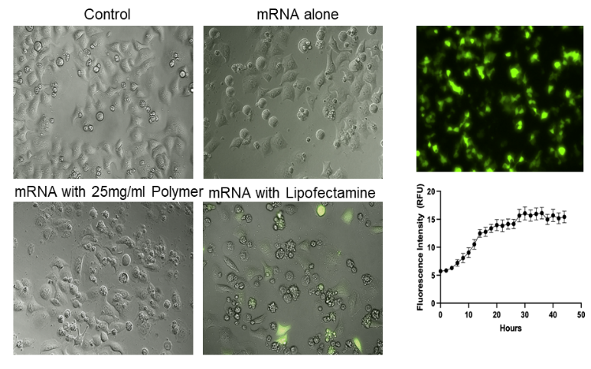
Figure 1 – Time-lapse fluorescent microscopy to detect cellular expression of green fluorescent protein (cellular product of the mRNA-Left panel) superimposed images of phase and fluorescent modes(Right-Top) and data analysis of the fluorescent signal using image J over 0-48h period (Right-Bottom_.
The formulation combination of EGFP-mRNA, lipofectamine and different concentrations of TP polymer have shown that they form nanoparticles of approximately 40 nm in diameter, while TP0 (no carrier system) did not generate particles that could be detected using the Zetasizer (Figure 2A and 2B). The formulations with TP polymer showed significant increase in GFP expression compared to negative control and was at comparable levels to the positive control, which is the maximum mRNA efficacy, demonstrating the functionality of the mRNA in the presence of the carrier. TP0 formulation showed a significant increase in GFP expression but was inconsistent and the increase was ~ ≤25% of the positive control (Figure 2C). A potential reason for this could be because no detectable nanoparticles were found in the basolateral chamber for this sample, because without the polymer the lipofectamine + mRNA complexes may not be able to pass through the 5 µm polycarbonate membrane as efficiently or could form nanoparticles. In general, the formulations of mRNA-Lipofectamine-TP can release functional nanoparticles into the media which are able to induce the maximal efficacy of the mRNA in basal RPMI2650 cell model.
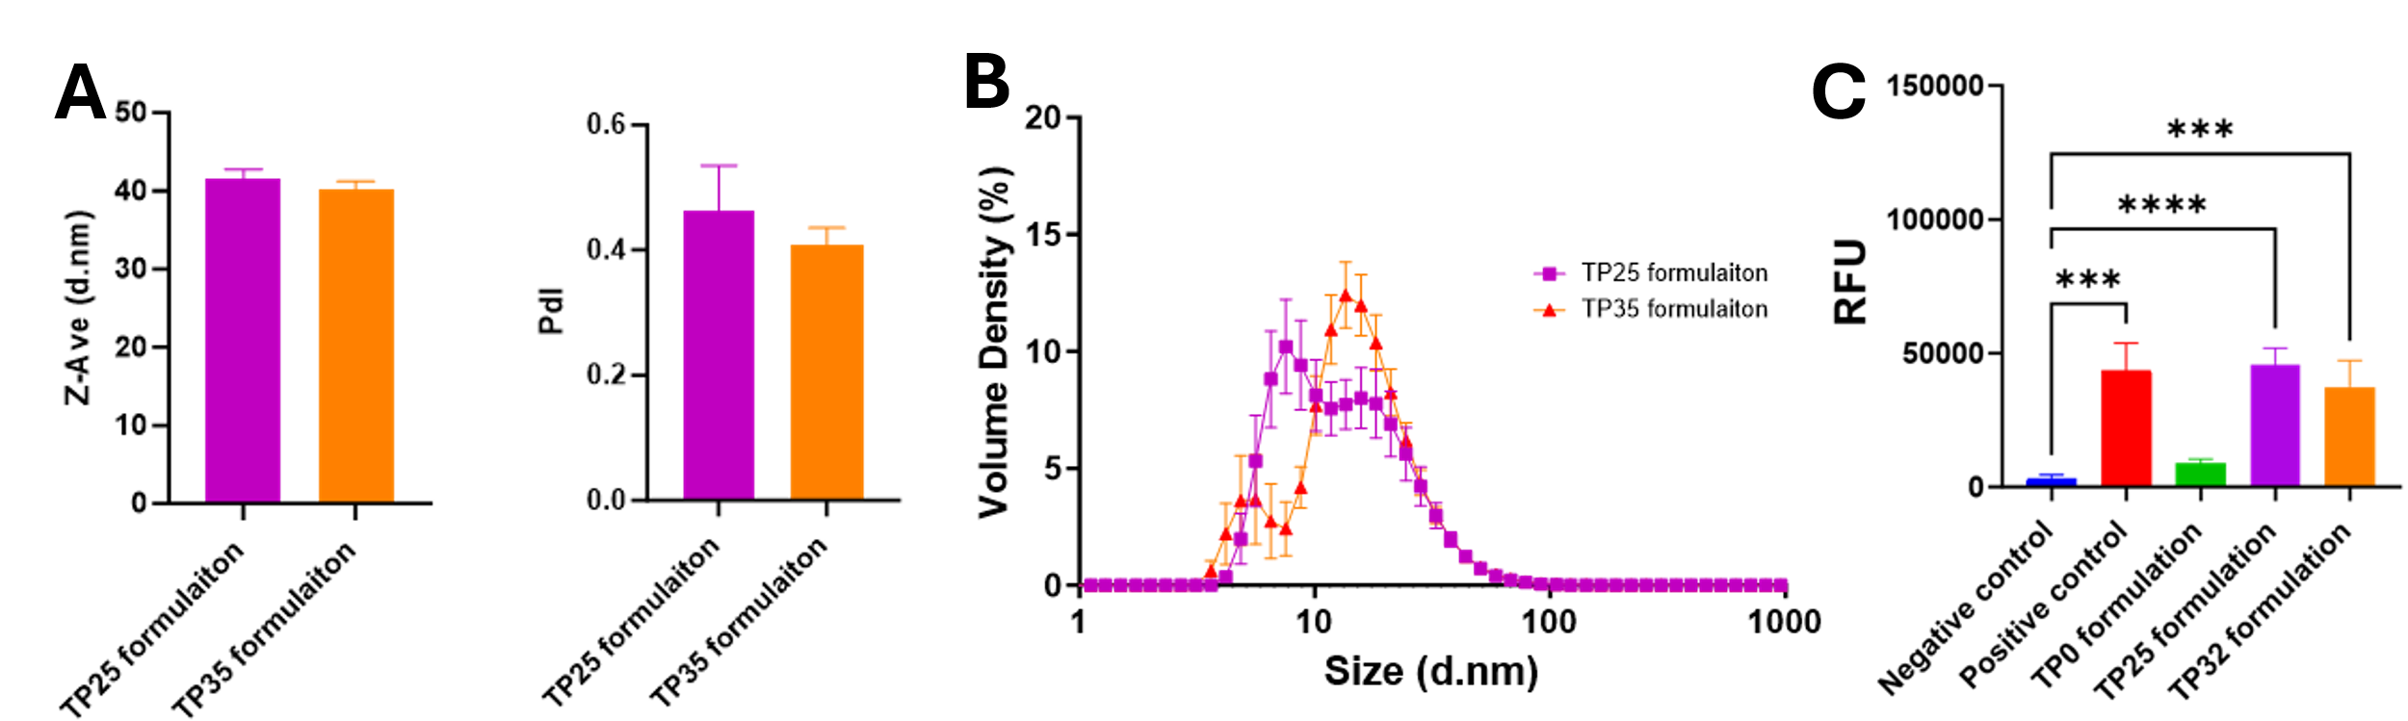
Figure 2– (A &B) Zetasizer analysis of the nanoparticle’s formation ability in the formulations and (C) Functional assay of mRNA-Lipofectamine-TP formulations (n=3; StD).
The mRNA encapsulation (ability to remain inside the lipid nanoparticles) was used as another indicator of mRNA stability, as only the encapsulated mRNA can be delivered into the cells. Encapsulated mRNA percentage was calculated by quantifying the amount of leaked mRNA and the total mRNA. The storage condition from fridge and room temperate were analysed for this study at Day 0 and Day 7. The percentage encapsulated mRNA is shown in Figure 3. There were no statistically significant differences between Day 0 and Day 7 in the formulations stored in the fridge. In the samples stored at room temperature, TP0 showed a significant reduction in encapsulated mRNA while TP25 and TP35 formulation did not show any significant changes encapsulation.
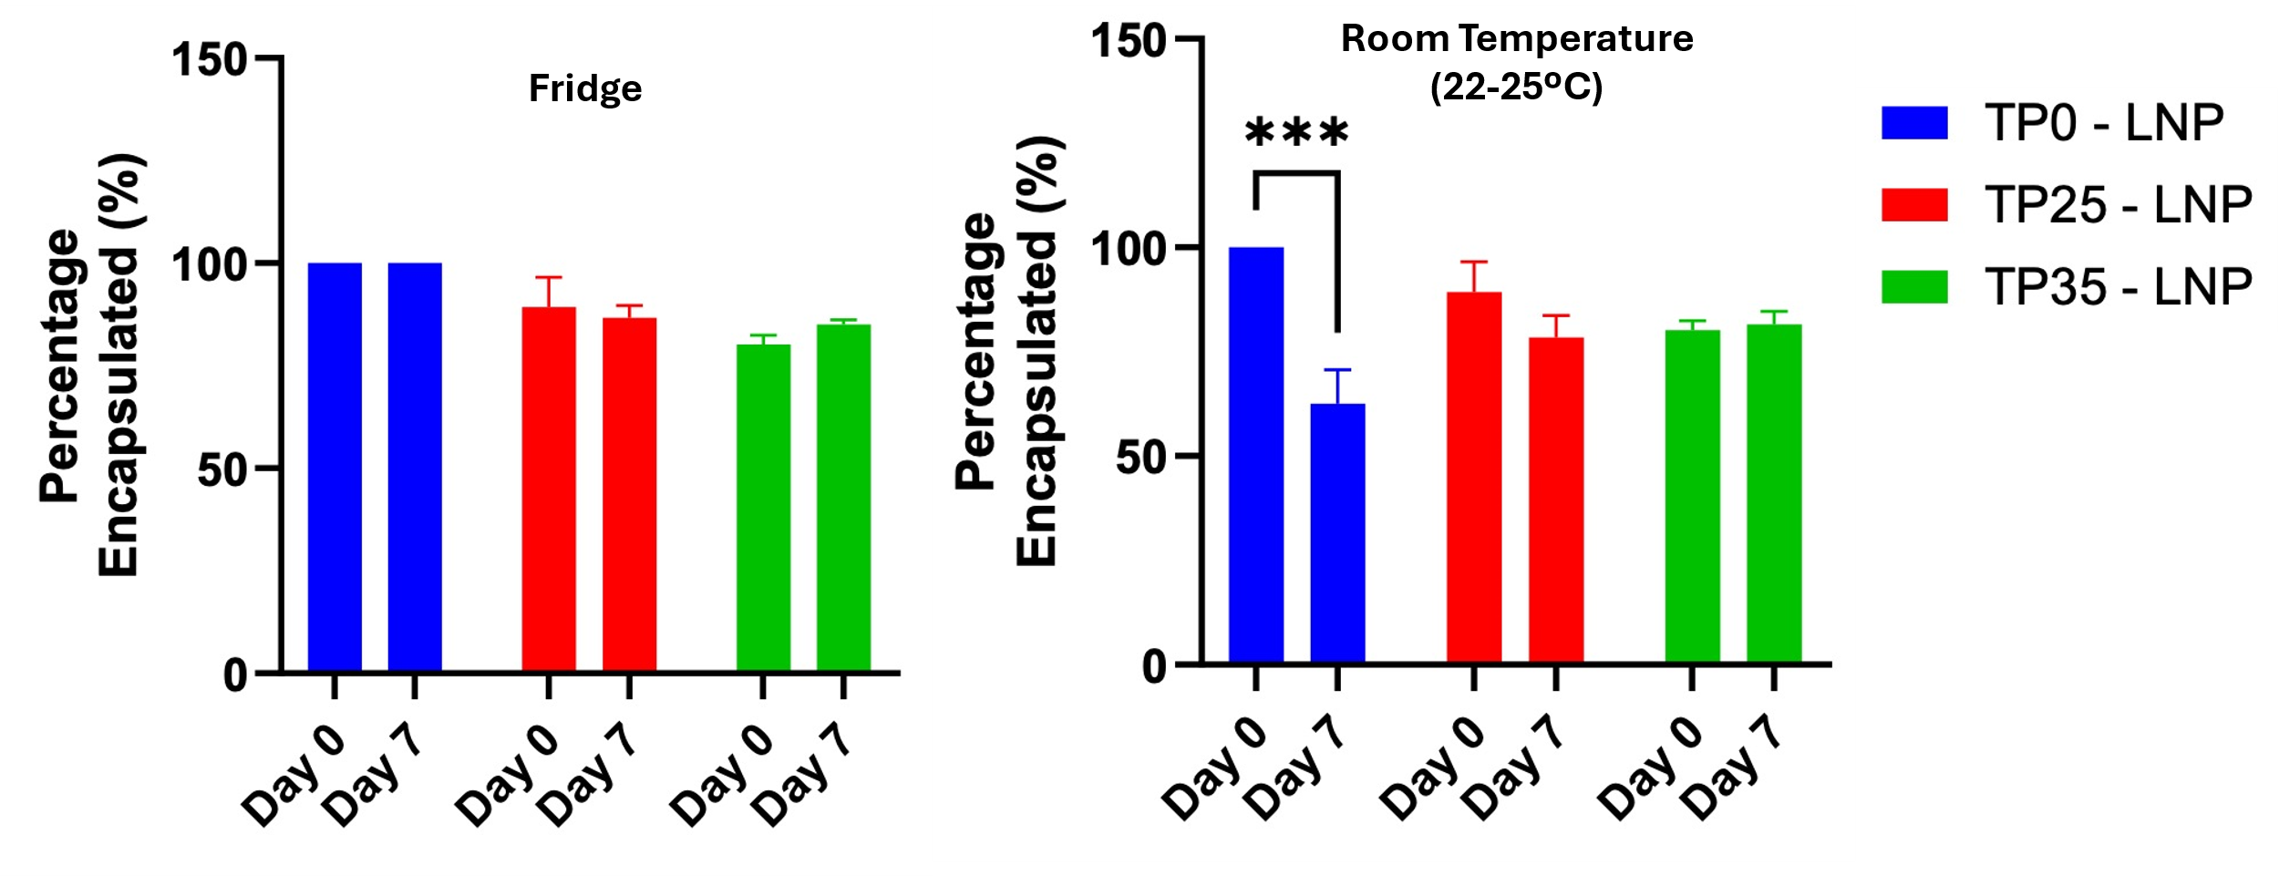
Figure 3 - Percentage of encapsulated mRNA in LNPs. Statistical analysis was conducted using 2-way ANOVA comparing Day 0 to Day 7.
The formulation was then aerosolised using the Bivax nasal spray device and the aerosol particle size distribution was determined using the Spraytec. Population curves were generated for the TP0, TP25 and TP35 formulations are presented in Figure 4 (Left). The average data of median volume-based diameter as a well as the geometric standard deviation (GSD) of aerosols are presented in Figure 4. Analysis of the particle size data showed that there were statistically significant increases between Dv10 and Dv90 when comparing TP0 to both TP25 and TP35. For Dv50 there were statistically significant differences between TP0 and TP35. The formulations are appropriate for nasal delivery as most of the particles were above 10µm.
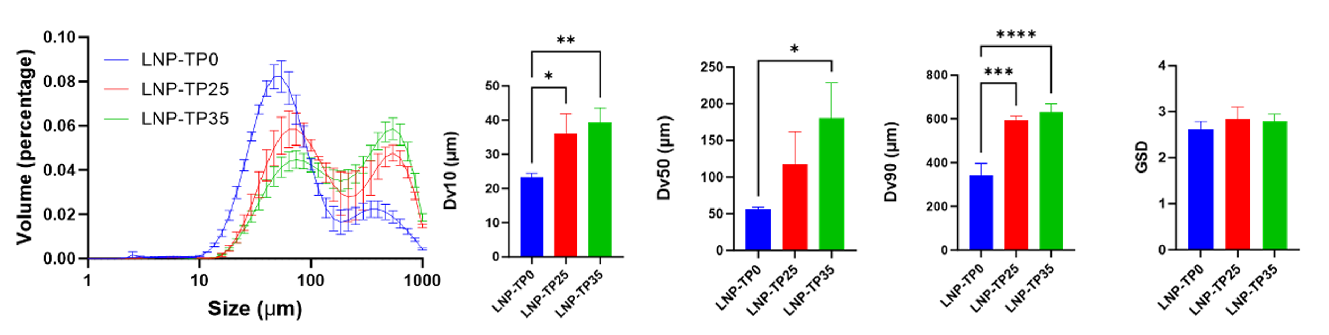
Figure 4 - Spraytec analysis of aerosol particle size population curves (Left) together with the calculated Dv10, Dv50, Dv90 and GSD graphs (Right). Statistical analysis was conducted using One-way ANOVA (n=3)
Nasal cast deposition using the BIVAX nasal spray device (Figure 5) demonstrated that the formulations with the carrier system (TP25 and TP35) were all effectively delivered to the nasal cavity and covered a large area of the cavity by 20 min. The TP0 formulation had a lesser region of deposition and coverage most likely due to a substantial amount (100 µL ± 20 µL) of nasal dripping observed immediately after delivery. the TP25 formulation did not demonstrate any dripping until the 20 min time point when some throat dripping was observed. No visible dripping was observed for TP35 formulation over the 0-20 min time points.
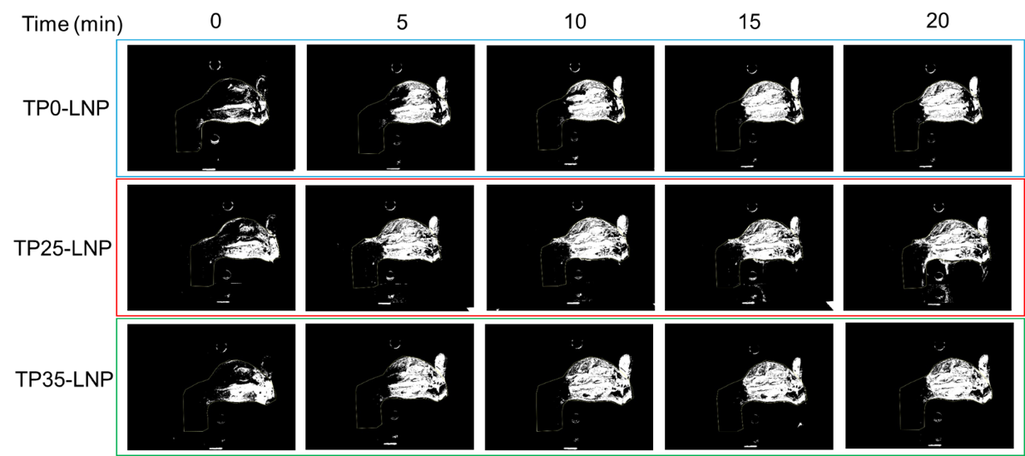
Figure 5 – Qualitative representative images of the nasal cast deposition of the formulations from 0-20min. The white area represents the area of deposition in the nasal cast.
Conclusions
The novel TP thermosensitive polymer demonstrates promising potential as an alternative excipient for mRNA delivery in the nasal cavity. It improves mRNA delivery to nasal cells, enhances nanoparticle stability at room temperature, and offers greater retention in the cast of the nasal cavity.

References
- Barik, S., & Lu, P. (2015). Therapy of respiratory viral infections with intranasal siRNAs. In RNA Interference (pp. 251-262). Humana Press, New York, NY.
- Gholizadeh, H., Cheng, S., Pozzoli, M., Messerotti, E., Traini, D., Young, P., Kourmatzis, A. & Ong, H. X., (2019). Smart thermosensitive chitosan hydrogel for nasal delivery of ibuprofen to treat neurological disorders. Expert Opin Drug Deliv. 16(4):453-466.
- Phua, K., Staats, H., Leong, K. & Nair, S. K. (2014). Intranasal mRNA nanoparticle vaccination induces prophylactic and therapeutic anti-tumor immunity. Sci Rep 4, 5128. https://doi.org/10.1038/srep05128
- Yusuf, H., & Kett, V. (2017). Current prospects and future challenges for nasal vaccine delivery. Human vaccines & immunotherapeutics, 13(1), 34–45. https://doi.org/10.1080/21645515.2016.1239668
- Keller, LA., Merkel, O. & Popp, A. (2021). Intranasal drug delivery: opportunities and toxicologicchallenges during drug development. Drug Deliv. and Transl. Res. https://doi.org/10.1007/s13346-020-00891-5
- Li, M., Zhao, M., Fu, Y., Li, Y., Gong, T., Zhang, Z., & Sun, X. (2016). Enhanced intranasal delivery of mRNA vaccine by overcoming the nasal epithelial barrier via intra-and paracellular pathways. Journal of Controlled Release, 228, 9-19.
- Young, P.M., Traini, D., Ong, H.X., Granieri, A., Zhu, B., Scalia, S., Song, J. & Spicer, P.T. (2017). Novel nano-cellulose excipient for generating non-Newtonian droplets for targeted nasal drug delivery. Drug development and industrial pharmacy, 43(10), pp.1729-1733.
- Dehghani F, Weiss AS, Wei H, Mithieux, S.M. & Fathi, A. Peptide-hydrogel composite. US Patents No. 9,546,235; 2017.
- Fathi A, Mithieux SM, Wei H, Chrzanowski, W., Valtchev, P., Weiss, A.S. & Dehghani, F. . Elastin based cell-laden injectable hydrogels with tunable gelation, mechanical and biodegradation properties. Biomaterials. 2014;35(21):5425-5435.

