Multi-sensory stimulation and reinforcement increases inhalation duration, improves inhaler technique scores and technique retention in pMDI users

Clare S Murray¹, Naomi Brooke¹ & Mark Sanders²

¹University of Manchester, Manchester, M13 9PL UK, ²University of Hertfordshire, Hatfield AL10 9AB UK

Summary
Inhaler technique is critical for pulmonary drug delivery. Poor inhaler technique is common among patients and consumes substantial health system resources in training, yet retention rates of good technique are low. In particular, the inhalation flow rate and duration taken to inhale a pressurised metered dose (pMDI) can lead to inconsistency in delivered dose. It is known that a slow inhalation results in superior drug deposition in the lung. We investigated whether a multi-sensory inhaler technique system could improve technique and retention. The group comparative study followed 59 pMDI treated asthma patients using an audible acoustic flow rate signal (Clip-ToneTM, Clement Clarke) and a visual, real-time, feedback smartphone application (Clip-Tone BuddyTM, Clin-e-cal) over a period of six months and compared them to a control group (58) of patients receiving usual care. The audio-visual enabled intervention group had a highly significant increase in inhalation duration (p<0.001) and a significant improvement in inhaler technique (p<0.001). This improvement was retained throughout the study period.
This study indicates that the use of an acoustic flow rate guidance signal coupled with a real-time feedback smartphone application may be a useful approach, not only for initial training but also for ongoing daily medication, to achieving improved technique and slower inhalations with pMDI devices, and thus improving the usability of inhaler devices.
Key Message
Use of a pMDI add-on acoustic flow rate guidance signal coupled with a real-time feedback smartphone application can improve patients’ inhaler technique scores and inhalation duration and that improvement can be sustained. Consideration to this should become part of inhaler design.

Introduction
Inhaler technique difficulties are common, and they confound the efficacy of inhaled treatments. For pMDIs, inhalation flow rate and inhalation duration are common mistakes, with patients typically inhaling with too fast inhalation flow rate and too short duration [1 ]. The result of this is impaired pulmonary drug delivery. A slow inhalation through a pMDI permits easier coordination and provides better pulmonary delivery, with some advocating an inhalation duration of 5 seconds [1], yet there is a tendency for patients, after technique training, to revert to a fast, short technique [2]. To help patients learn correct flow rate, whistle training tools (such as 2Tone Trainer (Canday), Flo-Tone and Clip-Tone (Clement Clarke), and Aerosol Inhalation Monitor (Vitalograph) have been developed and deployed, but nevertheless patients revert to bad habits, which then leads to repeated cycles of re-training [2].
In a study, funded by National Institute for Health and Care Research, invention for innovation (NIHR i4i) we explored whether the use of a flow-rate whistle signal (Clip-Tone) used on a permanently-attached basis together with a real-time flow duration visual feedback smartphone application (Clip-Tone Buddy) could serve to reinforce inhaler technique training outside of the clinic, and whether this would improve inhaler technique and retention.
Method:
A six month group comparative study was conducted among 126 patients (mean age 44.2 years), 29 male and 97 female with mild-moderate asthma receiving pMDI treatment (70 Fostair (Chiesi), 43 Clenil (Chiesi), 3 Trimbow (Chiesi), 8 Seretide (GSK), 2 Flixotide (GSK). see Table 1. 117 completed the study, 58 in the control group and 59 in the intervention group (Clip-Tone System, CTS). Patients were assessed, for primary outcome measures; inhaler technique (scored using UK Inhaler Group criteria, Table 2) and inhalation duration at the baseline visit and randomised into either control group or CTS. The control group received usual care and the CTS group were additionally provided with a Clip-Tone to match their therapy and shown how to access and use the smartphone application. Three further visits were conducted at 1 month (V1), 3 months (V2) and 6 months (V3), at which primary and secondary outcomes were assessed, visits were videoed for verification. Video recording were used to assess inhalation duration. Video recordings made at baseline and at 6 months were also used for blinded assessment by an independent assessor of inhaler technique. All inhaler technique assessments at all visits were made without the use of the CTS. The majority of patients (88%) had been using inhalers for >5yrs. Post-study focus groups were conducted to explore patient experience.

Table 1 shows baseline demographics.
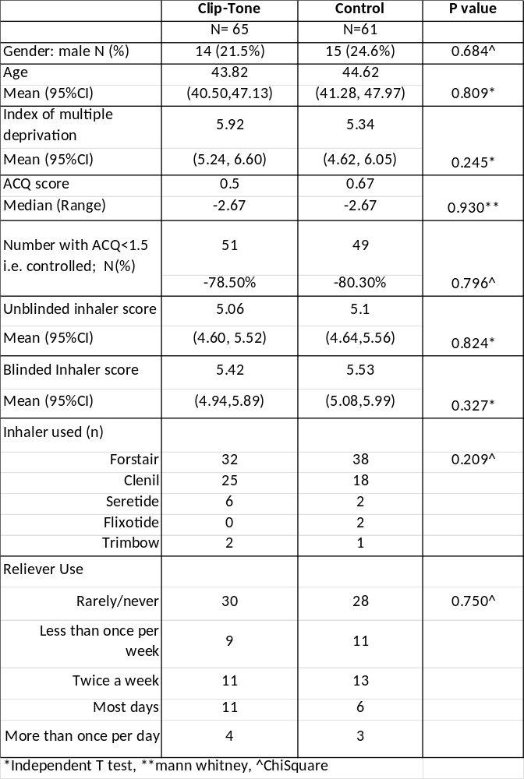
Table 2 shows inhaler technique scoring system
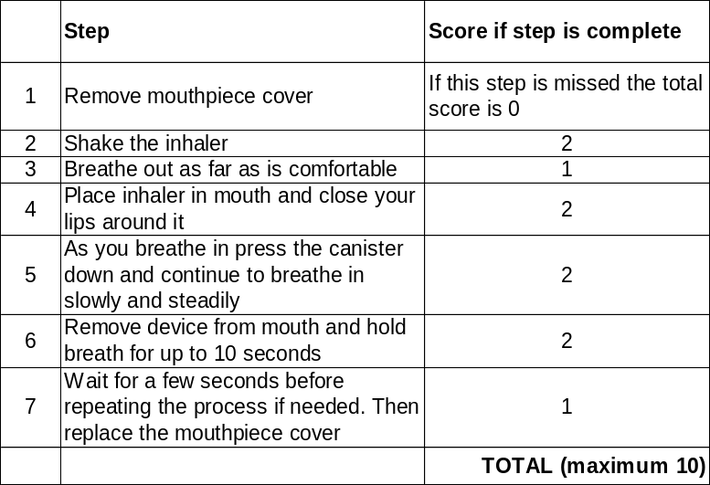

Results:
At baseline the average inhalation time for patients in both groups was similar at just over 1 second (Table 3). At the six month visit the CTS group had increased inhalation duration of over 3 seconds. This was a highly significant (p<0.001) increase.
Table 3 shows inhalation time at baseline and 6 months and change overtime
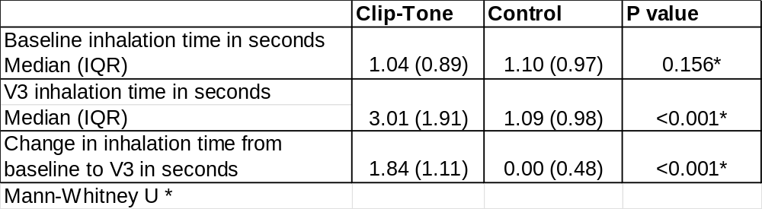
At baseline the average inhaler technique score for patients in both groups was similar at just over 5 points (out of 10) (Table 4). At the 1M, 3M and 6M visit the CTS group had increased inhaler technique score to > 7.5 points. This was a highly significant (p<0.001) increase. The unblinded scores were similar to the blinded scores.
Table 4 shows inhaler scores at study visits in Clip-Tone and Control groups (Score out of 10, higher the score the better the technique)

 | Clip-Tone | Control | P value*
Unblinded Inhaler score
Mean (95%CI)
Baseline | 5.06 | 5.1 | 0.824
Baseline | (4.60, 5.52) | (4.64,5.56) | 0.824
Visit 1 – 1 month FU | 7.69 | 5.39 | <0.001
Visit 1 – 1 month FU | (7.28, 8.10) | (4.87, 5.91) | <0.001
Visit 2 – 3 month FU | 7.7 | 5.5 | <0.001
Visit 2 – 3 month FU | (7.28, 8.13) | (5.02, 5.98) | <0.001
Visit 3 – 6 month FU | 7.68 | 5.59 | <0.001
Visit 3 – 6 month FU | (7.33, 8.02) | (5.17, 6.00) | <0.001
Blinded Inhaler score
Mean (95%CI)
Baseline | 5.42 | 5.53 | 0.327
Baseline | (4.94,5.89) | (5.08,5.99) | 0.327
Visit 3 – 6 month FU | 7.54 | 5.97 | <0.001
Visit 3 – 6 month FU | 7.14, 7.94) | (5.54, 6.39) | <0.001
Independent T-Tests*
Patients were asked about their usage of CTS through the study (Table 4), and while there was some drop-off over time there was substantial continuity of use.
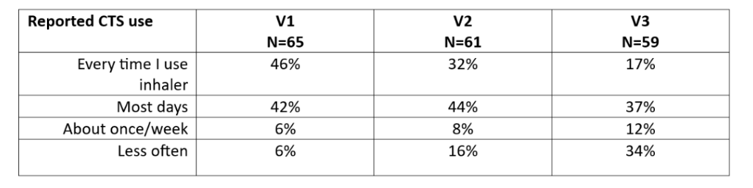
Table 4 shows reported CTS usage over time.

Discussion:
This study showed that the CTS significantly improved primary outcome measures; improving inhaler technique scores and inhalation duration. A highly significant increase in inhalation time for pMDI users has several potential benefits; a) it permits a longer window of opportunity for coordination of inhalation and actuation, b) a longer inhalation is inherently a slower inhalation which results in less oropharyngeal deposition, c) a slower inhalation is more likely to achieve better deep lung deposition, d) a longer residence time of an aerosol in the lungs gives greater opportunity for sedimentation processes to occur, e) for fine particle formulations, with lower plume speeds, a longer inhalation duration provides greater opportunity for the treatment to reach the peripheral airways. These factors have the potential to contribute to less side-effects and improved therapy. These factors are also reasons why valved holding chambers (VHC) are recommended, however, VHC use in adults is notably less than that in children.
Inhaler technique training, when it is provided, is normally limited to verbal counselling, taking place in the clinic, however, often no training is provided. Despite the availability of training tools there is relatively little opportunity for the patient to get guided hands-on experience with the inhaler in the clinic. Frequently, a reversion to poor technique happens quickly [2]. A previous study conducted in children [3] demonstrated good technique improvement from patients equipped with a 2Tone Trainer with which they could practice pMDI technique at home. The current study similarly equips patients with Clip-Tone to receive guidance on correct flow rate every time they use their inhaler and with the ability to quantitatively check it in real-time using the Clip-Tone Buddy smartphone app. The application provided feedback specifically on inhalation time and coordination of actuation. The study showed that CTS helped patients to retain a longer inhalation without reversion to previous bad habits. In contrast the control group showed no improvement.
Inhaler technique training generally relies simply on instruction, and this has been shown to have limited effect [2]. CTS uses multi-sensory real-time feedback and positive reinforcement to enable patient learning and that is a more powerful educative approach [4] [5] [6].
Patient feedback overall was positive and patients became more aware of their inhaler technique. It should be expected that patients would progressively feel more confident with inhaler technique and have less need to use the CTS system, but that notwithstanding the reported usage over time showed strong engagement.
In this study, a low-cost whistle add-on and companion app provided acoustic and visual guidance, without the necessity of electronic add-ons. It is envisaged that the acoustic feature could be integrated into the pMDI actuator thus obviating the need for an add-on.
Conclusions:
This study shows that multi-sensory stimuli provided at the time of inhaler use can guide good technique and help achievement of longer inhalation time, which has potential benefit for successful drug delivery. Ongoing guidance facilitates retention of good inhaler technique.
References:
1. Laube BL, Janssens HM, Jongh FHC de, Devadason SG, Dhand R, Diot P, et al. What the pulmonary specialist should know about the new inhalation therapies. European Respiratory Journal. 2011 Jun 1;37(6):1308–417.
2. Bosnic-Anticevich S, Bender B, Shuler M, Hess M, Kocks J. Recognizing and tackling inhaler technique decay in asthma and COPD clinical practice. The Journal of Allergy and Clinical Immunology: In Practice [Internet]. 2023 May 3 [cited 2023 May 9]; Available from: https://www.sciencedirect.com/science/article/pii/S2213219823004725
3. Ammari WG, Chrystyn H. Optimizing the Inhalation Flow and Technique Through Metered Dose Inhalers of Asthmatic Adults and Children Attending a Community Pharmacy. Journal of Asthma. 2013 Jun 1;50(5):505–13.
4. Horne, R., Weinman, J., Barber, N., Elliott, R., Morgan, M., Cribb, A., & Kellar, I. Concordance, adherence and compliance in medicine taking. NCCSDO. 2005;40(6).
5. Papadatou-Pastou M, Touloumakos AK, Koutouveli C, Barrable A. The learning styles neuromyth: when the same term means different things to different teachers. Eur J Psychol Educ. 2021 Jun 1;36(2):511–31.
6. van Atteveldt N, Murray MM, Thut G, Schroeder CE. Multisensory Integration: Flexible Use of General Operations. Neuron. 2014 Mar;81(6):1240–53.

