In vitro-In vivo Correlations (IVIVC) of Amorphous Solid Dispersions for Nasal Delivery

Patricia Henriques^{1,2}, Slavomíra Doktorovová¹, Ana Fortuna^{2,3}

¹ Hovione FarmaCiência SA, Lumiar, 1649-038, Portugal

² Faculty of Pharmacy, University of Coimbra, 3000-548, Portugal

³ CIBIT/ICNAS, Coimbra Institute for Biomedical Imaging and Translational Research, University of Coimbra, 3000-548, Coimbra, Portugal

Summary
Amorphous solid dispersions (ASD) for nasal delivery offer the opportunity to increase drug release performance, while using polymers with mucoadhesive properties. In spite of the current knowledge on formulation and characterization of nasal powders, scarce studies evaluate the potential of ASD. Additionally, the lack of translation between different in vitro methodologies and the lack of correlations between in vitro and in vivo results compromise the accurate and effective development of nasal powders. Herein, spray dried ASD were manufactured using piroxicam (PXC) as a poorly soluble drug model and evaluated regarding in vitro drug release and ex vivo permeation through porcine nasal mucosa in Franz diffusion cells. Additionally, in vivo pharmacokinetic studies were carried out in Wistar rats. The results indicated that ASD for nasal delivery of poorly soluble drugs could be a suitable strategy to provide a faster onset of action. Pharmacokinetic parameters were correlated with in vitro and ex vivo parameters, where high coefficients of determination were obtained, especially for early timepoints (R² > 0.90). This indicates that the methods employed are biorelevant and provide valuable insights into drug nasal absorption.
Key Message
In vitro-in vivo correlations (IVIVC) are a valuable tool to support the use of predictive in vitro methodologies as well as to guide formulation and process development. The IVIVC established for amorphous solid dispersions for nasal delivery, between in vitro/ex vivo and in vivo pharmacokinetic parameters (t_{max}, C_{max} and AUC_{1h}), supports the use of Franz diffusion cells to study drug release and permeation of nasal powder formulations.

Introduction

Amorphous solid dispersions can be applied as a solubility enhancement strategy for poorly soluble drugs for nasal delivery, as these can promote the supersaturated state of the drug during dissolution in the nasal mucosa, enhancing drug permeation. ASDs can be manufactured by spray-drying using mucoadhesive polymers, as hydroxypropyl methylcellulose E3 (HPMC) and polyvinylpyrrolidone/vinyl acetate (PVP/VA), which can have a dual function of stabilizing the drug's amorphous form and enhancing mucoadhesion [1]. However, one of the main challenges of nasal powder development is to accurately predict the performance of new formulations since there is a gap between in vitro and in vivo results and a lack of regulatory guidance and standardization of performance testing. Accordingly, the goal of this study was to establish in vitro-in vivo correlations (IVIVC) between in vitro drug release and ex vivo permeation performance using Franz diffusion cells and the in vivo pharmacokinetic profile, assessing the predictive potential of in vitro methodologies commonly used.

Materials and Methods

Piroxicam (abcr GmbH, Karlsruhe, Germany), a nonsteroidal anti-inflammatory drug, was selected as the model poorly soluble drug for systemic delivery, and PVP/VA (Ashland Specialties, Beveren, Belgium) and HPMC (Dow Europe, Horgen, Switzerland) as polymers. Spray-drying was performed using an ultra-sonic nozzle to produce microparticles within the nasal size range of 10 to 45 µm [2] in a Büchi model B-290 unit. Physical blend was obtained by mixing neat HPMC microparticles within the same size range with piroxicam raw material in a Turbula blender. All formulations were produced at 20% (w/w) drug load. Particle morphology was obtained by scanning electron microscopy and the crystallinity of the samples was evaluated by X-ray powder diffraction (XRPD) in an Empyrean® II diffractometer.
Drug release studies were performed to evaluate drug dissolution and diffusion through an artificial membrane using static vertical Franz diffusion cells (PermeGear, Inc., USA) with a 5 mL receptor compartment (600 rpm, 37 ºC) with Simulated Nasal Fluid (SNF, 8.77 mg/mL NaCl, 2.98 mg/mL KCl, 0.78 mg/mL CaCl₂.2H₂O, pH=6.0) and a diffusion area of 0.636 cm². Powders (1 mg PXC) were manually placed on dialysis cellulose membranes (MWCO ~ 14k). The receptor compartment was sampled (400 µL) at predetermined timepoints (up to 6 hours), and the quantification was performed by High Performance Liquid Chromatography (HPLC) with DAD absorbance detector (337 nm). Ex vivo drug permeation studies through porcine nasal mucosa were performed with a similar approach, using the same apparatus with SNF medium. The fresh mucosa from ventral nasal turbinates was provided by a local slaughterhouse (Incarpo, Condeixa, Portugal). Powders (5 mg) were manually distributed on the surface of the donor compartment and the drug was quantified by HPLC on the receptor compartment at predetermined timepoints (up to 6 hours).
In vivo pharmacokinetic studies were carried out in Wistar rats (n=3) after intranasal administration of 1.5 mg powder formulation, using a commercial device (weighed before and after administration). Blood samples (~0.3 mL) were collected into heparin-lithium tubes at 0.33, 1, 2, 4, 6, 8, 12, 24, and 30-hours post-administration, and plasma drug quantification was performed by HPLC. The pharmacokinetic profiles were plotted and submitted to non-compartmental analysis, using WinNonlin software, obtaining the following pharmacokinetic parameters: area under the curve (AUC) from time zero to one hour (AUC_{1ℎ}), AUC from time zero to time of the last measurable drug concentration (AUC_{30h}), maximum plasma concentration (C_{max}) and the corresponding time to reach C_{max} (t_{max}). Level C IVIVC was conducted according to EMA guidelines[3] by correlating the percentage of in vitro release and ex vivo permeation 0.33h (20 minutes) and at 1h with C_{max,} t_{max,} and ${AUC}_{1h}$ by linear regression analysis, where the R² was evaluated.

Results and Discussion
Spray dried microparticles (SDM) and the HPMC blend was successfully manufactured, having different particle morphologies, as represented in Figure 1. X-ray powder diffraction analysis confirmed that PXC in SDM was amorphous [4].
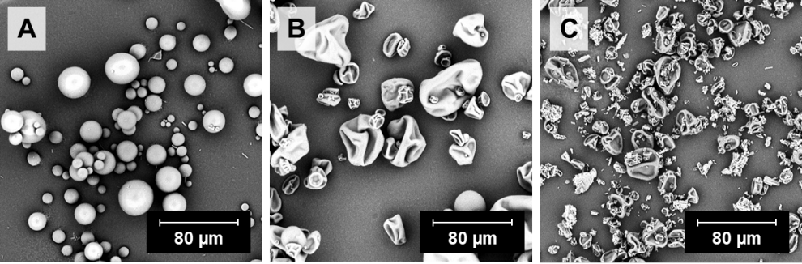
Figure 1 – Particle morphology by scanning electron microscopy (magnification of 1000x). A – Spray dried microparticles with PVP/VA, B – Spray-dried microparticles with HPMC; C – Blend with HPMC.
Franz diffusion cells were applied to study the drug release profile of the piroxicam powder formulations as well as the ex vivo permeation through porcine nasal mucosa. The percentage of drug released or permeated at 0.33h and 1h are shown in Table 1. The results evidence that ASD obtained by spray drying were able to improve drug release and permeation of a crystalline drug in a physical blend. Additionally, the HPMC based amorphous formulation showed enhanced drug release and permeation, compared to PVP/VA formulation. This polymer may sustain the supersaturated drug for a longer period of time, compared with PVP/VA.
After nasal powder administration to Wistar rats, the C_{max} of PXC was attained in plasma between 0.89 and 3.33 hours, ranging from 3.25 and 4.68 µg/mL. SDM of HPMC presented the highest C_{max} and shortest t_{max}, suggesting a faster absorption of PXC. SDM of PVP/VA provided the second shortest t_{max} and higher C_{max}, followed by the HPMC blend. This suggests that ASDs for nasal delivery of poorly soluble drugs could be an advantageous strategy to provide a faster onset of action, compared to formulations with crystalline drug. Additionally, the selection of the adequate polymer is of the utmost importance for achieving the most efficient delivery.

Table 1 - Percentage of in vitro release and ex vivo permeation at 0.33h and 1h and in vivo pharmacokinetic parameters.
In vitro and in vivo pharmacokinetic parameters | SDM PVPVA | SDM HPMC | Blend HPMC
In vitro release at 0.33h (%) | 1.223 ± 0.214 | 5.088 ± 0.113 | 0.213 ± 0.012
In vitro release at 1h (%) | 1.785 ± 0.291 | 7.234 ± 0.080 | 0.715 ± 0.047
Ex vivo permeation at 0.33h (%) | 0.240 ± 0.209 | 1.010 ± 0.304 | 0.133 ± 0.087
Ex vivo permeation at 1h (%) | 0.781 ± 0.428 | 3.737 ± 0.681 | 1.230 ± 0.543
t_{max} (h) | 2.33 ± 1.53 | 0.89 ± 0.964 | 3.33 ± 1.15
C_{max} (µg/mL)ª | 3.35 ± 0.25 | 4.68 ± 1.20 | 3.26 ± 1.08
AUC_{1h} (µg.h/mL)ª | 2.16 ± 0.30 | 3.63 ± 0.96 | 1.78 ± 0.44
AUC_{30h} (µg.h/mL)ª | 46.05 ± 9.45 | 41.06 ± 9.34 | 44.70 ± 12.69
ªPharmacokinetic parameters estimated considering a normalized PXC dose of 0.3 mg.
Figure 2 shows the level C correlations between percentage of drug release or permeation at 0.33h and 1h and pharmacokinetic parameters C_{max,} t_{max,} ${AUC}_{1h}$. Early in vitro and in vivo timepoints were selected since it was observed a fast nasal absorption for powder formulations, with the shortest t_{max} of 0.89h. The results showed that t_{max} correlates better with in vitro release results rather than ex vivo permeation. However, an inherent limitation of this correlation using a non-compartmental analysis is that formulations presented little differentiation in t_{max} due to limited blood collections at early timepoints. Correlations between in vitro parameters and C_{max} or AUC_{1h} showed a R² of 0.9969 for the correlation between ex vivo permeation at 0.33h and C_{max} and a R² of 1.0000 for the correlation between in vitro release at 0.33h and AUC_{1h.} Overall, correlations were stronger at the first timepoint of 0.33h compared with the 1h timepoint, suggesting that the fast drug supersaturation captured through the in vitro and ex vivo methods, even when maintained for short period of time, affects absorption.
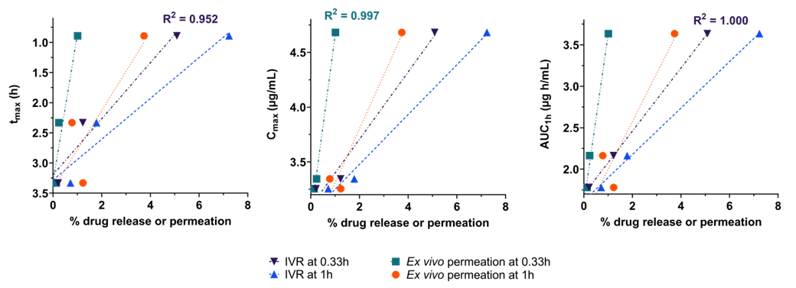
Figure 2 - Linear correlations between in vitro parameters and t_{max}, C_{max} or AUC_{1h} for the 3 nasal powder formulations, namely SDM of HPMC, SDM of PVP/VA and blend of HPMC and coefficients of correlation (R²) for the highest correlation for each pharmacokinetic parameter. AUC_{1h} – Area under the concentration time-curve from time zero to 1 hour; C_{max} – Maximum peak concentration; HPMC – hydroxypropyl methylcellulose; IVR – in vitro release; PVP/VA – polyvinylpyrrolidone/vinyl acetate; SDM – spray dried microparticles; t_{max} – time to achieve the maximum peak concentration.
In general, in vitro release and ex vivo permeation studies with vertical Franz diffusion cells showed strong correlations with C_{max}, t_{max} and AUC_{1h} for 3 formulations, suggesting that these methods are biorelevant and provide valuable insights into drug nasal absorption. Furthermore, the in vitro drug release method is simple and easier to implement in the industry than methods that require excised tissues as ex vivo permeation studies. However, ex vivo can be more accurate particularly if transporters are involved in drug permeation. For formulations without permeability modifiers, in vitro drug release testing could be preferred over ex vivo permeation studies, where a timeframe of 2 hours should be sufficient for formulation development and ranking.

Conclusions
The present work aimed at establishing IVIVC between in vitro drug release/ ex vivo permeation and in vivo pharmacokinetic profile, in order to assess the predictive potential of commonly used in vitro methodologies, namely by using Franz diffusion cells that mimic the humid environment encountered in the nasal cavity as well as the temperature and medium [5].
In vivo pharmacokinetic studies revealed fast drug absorption from nasal powders, especially from ASD, with correlations between in vitro performance and t_{max}. This indicates that ASD for nasal delivery of poorly soluble drugs could be a suitable strategy to provide a faster onset of action especially useful in therapeutic indications such as pain management, migraine or angina pectoris[6]. C_{max} and AUC_{1h} also revealed good correlation with in vitro release and ex vivo permeation studies in early timepoints where absorption largely occurs. The herein used in vitro/ex vivo performance methods proved to be biorelevant and provided valuable insights into drug nasal absorption. For poorly soluble drugs without permeability challenges, ex vivo permeation studies may not add value to in vitro release testing. Future work includes the development of integrated particle deposition and dissolution/drug release testing, that should provide better predictability and phenomena understanding in nasal powder formulation development.
____________________________________________________________________________________________________
[1] Henriques, P, Fortuna, A and Doktorovová, S. Spray dried powders for nasal delivery: Process and formulation considerations. European Journal of Pharmaceutics and Biopharmaceutics 2022; 176: 1–20.
[2] Tiozzo Fasiolo, L, Manniello, MD, Tratta, E, Buttini, F, Rossi, A, Sonvico, F, Bortolotti, F, Russo, P and Colombo, G. Opportunity and challenges of nasal powders: Drug formulation and delivery. European Journal of Pharmaceutical Sciences 2018; 113: 2–17.
[3] European Medicines Agency (EMA). Guideline on quality of oral modified release products. https://www.ema.europa.eu/en/quality-oral-modified-release-products-scientific-guidelines (2014).
[4] Henriques, P, Bicker, J, Carona, A, Miranda, M, Vitorino, C, Doktorovová, S and Fortuna, A. Amorphous nasal powder advanced performance: in vitro/ex vivo studies and correlation with in vivo pharmacokinetics. Journal of Pharmaceutical Investigation 2023 2023; 1–20 doi:10.1007/S40005-023-00630-1.
[5] Jug, M, Hafner, A, Lovrić, J, Kregar, ML, Pepić, I, Vanić, Ž, Cetina-Čižmek, B and Filipović-Grčić, J. An overview of in vitro dissolution/release methods for novel mucosal drug delivery systems. J Pharm Biomed Anal 2018; 147: 350–366.
[6] Fortuna, A, Alves, G, Serralheiro, A, Sousa, J and Falcão, A. Intranasal delivery of systemic-acting drugs: Small-molecules and biomacromolecules. European Journal of Pharmaceutics and Biopharmaceutics 2014; 88: 8–27.

