Spray-Dried Powder Nasal Vaccines: A Novel Strategy for Combating Global Infectious Diseases

Hui Wang¹, Wynton McClary², Maximilian Aisenstat¹, John Chen², Kelvin Duong¹, Alana Gerhardt², Andrew R. Martin^{1,3}, Christopher Fox^{2,4}, Reinhard Vehring^{1,2}

¹Department of Mechanical Engineering, University of Alberta, Edmonton, Canada

²Access to Advanced Health Institute, Seattle, Washington, USA

³Department of Biomedical Engineering, University of Alberta, Edmonton, Canada

⁴Department of Global Health, University of Washington, Seattle, Washington, USA

Summary
This study proposes using spray-dried dry powder nasal vaccines as an innovative approach to address global health challenges posed by infectious diseases. Three vaccine candidates ─ an adjuvanted nano-emulsion subunit vaccine for tuberculosis (TB), an adjuvanted nano-liposomal subunit vaccine for COVID-19, and a nanostructured lipid carrier saRNA vaccine for influenza ─ were formulated and successfully converted into dry powder vaccines via spray drying. Manufacturing processes guided by predictive models for spray drying effectively achieved targeted powder properties and stabilized the vaccines within the dried microparticles, demonstrated by the preserved immunogenicity of both the TB and influenza vaccines. Comprehensive characterization included particle morphology, interior structure, solid state, and moisture content, all meeting predefined formulation design targets. Stability studies under dry condition and different temperatures (25°C, 40°C) confirmed the physical integrity and antigen stability of these formulations over extended periods. Assessment of aerosol performance using nasal dry powder delivery devices and an idealized nasal inlet demonstrated favourable deposition patterns, supporting the feasibility of nasal delivery for widespread deployment and ease of administration. The proposed dry powder vaccine platform, utilizing trehalose for biologics stabilization and optional shell-formers for enhanced biologics protection and powder aerosol performance, demonstrated compatibility with diverse vaccine systems, offering a promising strategy for developing robust vaccines suitable for global deployment.
Key Message
Spray-dried powder nasal vaccines, stabilized with trehalose and optional shell-forming excipients, provide an innovative approach to address global health challenges posed by infectious diseases, offering thermostability and compatibility with diverse vaccine systems as well as the ability to be delivered nasally through a single-use device.

Introduction
Infectious diseases pose significant burden to health care systems globally and threaten societal stability. Urgent countermeasures are needed for three major challenges: rising antimicrobial resistance limiting treatment options, potential devastation from pandemics like COVID-19 and influenza, and inequities in healthcare access exacerbating disease impact in developing countries. Existing pharmaceutical approaches often fail these regions. This paper proposes a development strategy for spray-dried nasal vaccines to address these pressing global health challenges.

Dry Powder Nasal Vaccine Design Strategies
Compared with traditional intramuscularly administered vaccines, the potential advantages of nasal vaccines include mucosal immunity and prolonged effectiveness, as demonstrated by FluMist [1]. Their needle-free delivery promotes ease of use as well as reducing risks associated with needles such as needle-stick injuries, infection at injection site, and so on. In responding promptly to global health crises, nasal vaccines must be capable of global manufacturing, storage, and distribution, including in resource-limited areas lacking cold chain infrastructure. Rapid response capabilities also require scalable platforms like spray drying, which facilitate accelerated and safer product development through a mechanistic understanding of formulation and process design [2]. Dry powder vaccines resulting from spray drying also provide thermostability and can be administered intranasally using affordable, user-friendly devices, making them a practical solution for widespread deployment.
The dry powder vaccine platform design must achieve multiple critical objectives. It must ensure both physical and biochemical stability for a variety of vaccine systems, including formulations containing lipids, proteins, or nucleic acids. The resulting powder should feature an ideal particle size for effective nasal delivery (10 - 45 µm) [3] and sufficient dispersibility for administration using cost-effective, single-use delivery devices. The manufacturing process needs to preserve the integrity of antigens and adjuvants while remaining flexible enough to meet early-stage development requirements at a small scale, yet capable of seamless scale-up to ensure compliance with Good Manufacturing Practices (GMP) for large-scale production.
In this study, the formulation strategies for developing dry powder nasal vaccines involved employing glass-forming saccharides (trehalose) and optional shell-forming excipients (leucine or trileucine), guided by predictive modelling to precisely control the particle formation and powder manufacturing processes.

Nanoparticle Vaccine Systems
Three different vaccine platforms, each containing a specific antigen candidate with a different disease target, were converted into dry powder forms and tested. A schematic illustration of the nanostructure for each of the three vaccine systems is shown in Figure 1 [4, 5]. The first system, TB-(GLA-SE), is a subunit tuberculosis vaccine, which features the recombinant fusion protein ID93 combined with the GLA-SE adjuvant system. GLA-SE is a nano-emulsion incorporating glucopyranosyl lipid adjuvant (GLA), a synthetic Toll-like receptor 4 (TLR4) agonist, in a stable squalene oil-in-water emulsion (SE) stabilized by a DMPC lipid layer [6]. The second system, COVID-(GLA-3M-052), features a trimeric SARS-CoV-2 spike protein, S2P, combined with a nano-liposomal dual TLR ligand adjuvant system, GLA-3M-052, which consists of DPPC, DPPE-PEG, and cholesterol, along with GLA and 3M-052, an imidazoquinoline and TLR 7/8 agonist [7]. The third vaccine candidate, Influenza-NLC, used a nanostructured lipid carrier (NLC) to deliver self-amplifying RNA (saRNA) targeting influenza (H5N1). The saRNA is electrostatically bound to a cationic lipid, DOTAP, integrated into the surface of the NLC, which also contains polysorbate 80 and sorbitan monostearate surfactants, along with a core of liquid squalene and solid trimyristin oil [8]. Predictive models were employed to assist in formulating and designing the manufacturing process for each system, aiming for products with specific properties such as particle size, particle structure, powder moisture content, solid state, and others.
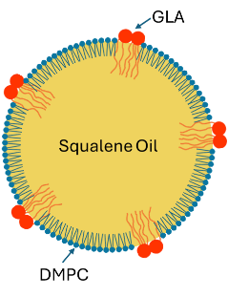 | 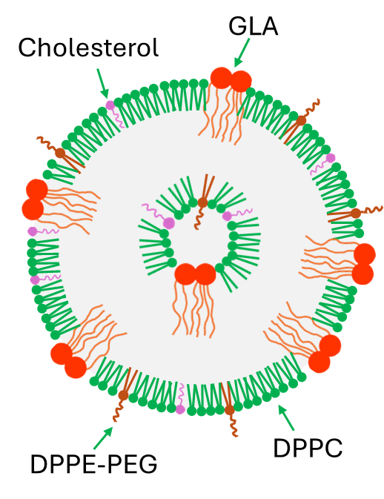 | 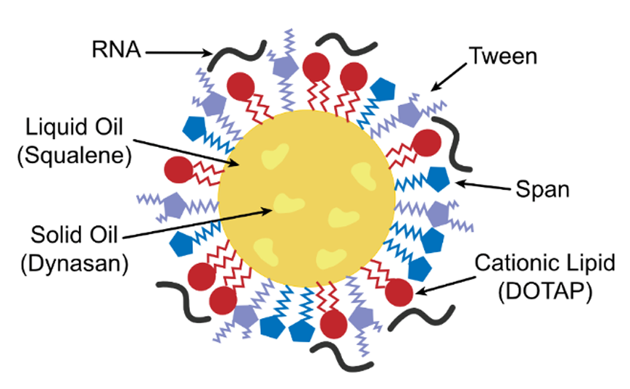
Platform: GLA-SE  Type: Nano-emulsion  Target: Tuberculosis  Size: ~90 nm | Platform: GLA-3M-052  Type: Nano-liposome  Target: COVID  Size: ~100 nm | Platform: NLC  Type: nanostructured lipid carrier (NLC) [5]  Target: Avian Influenza A (H5N1)  Size: ~70-130 nm
Figure 1. Schematic nanostructure of the vaccine systems selected for conversion to dry powder nasal formulations via spray drying.

Results and Discussion
All three vaccine formulations were spray dried into dry powder form successfully with good production rate and yield (>60%). Since the TB and influenza vaccines have a liquid squalene oil component that needs to be preserved on drying, low processing temperatures were chosen (dryer inlet temperatures in the range of 60-70°C and outlet temperatures less than 50°C). For all three vaccine candidates, formulation parameters were also chosen to ensure successful encapsulation of the lipid and protein components within the spray-dried microparticle. Figure 2 shows typical morphologies of the spray dried particles which have been intentionally broken to reveal their internal structures. In all three cases, the particles contained nanostructures (emulsion droplets, liposomes or lipid carrier particles). All dry powder vaccines were reconstituted into liquid forms, and, with the exception of the influenza-NLC vaccine which showed an expected size increase by ~60nm upon reconstitution, the sizes of the reconstituted nanostructured particles remained unchanged post-spray drying, consistent with observations from the micrographs. Successful encapsulation of the lipid and protein components of each formulation was also confirmed by subsequent content analysis of the spray-dried powders via HPLC and SDS-PAGE. Raman spectroscopy confirmed that trehalose was in an amorphous state in all three cases, while trileucine was in an amorphous state for the COVID vaccine and leucine was in a crystalline form for the influenza vaccine, as designed [9, 10].
 | 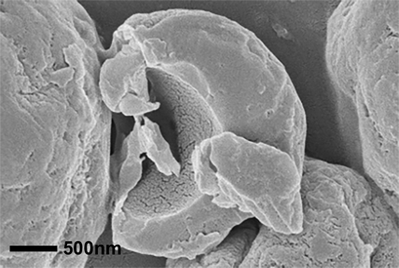
Vaccine: TB-(GLA-SE)  Trehalose: 83.6% w/w  Shell former: NA  Squalene: 14.4% w/w | Vaccine: COVID-(GLA-3M-052)  Trehalose: 97.6% w/w  Shell former: 1.0% trileucine  Squalene: NA | Vaccine: Influenza-NLC  Trehalose: 79.4% w/w  Shell former: 15.6% leucine  Squalene: 1.0%
Figure 2. Electron micrographs of fragmented vaccine particles revealing internal structure.
The outer morphology of the spray dried TB vaccine particles closely resembles that of pure trehalose particles, except that intentionally cracked particles reveal a porous structure in the shells, as shown in the left panel. The porous appearance of the shell results from liquid squalene oil in the tuberculosis vaccine, leaving voids visible under electron microscope vacuum conditions [6]. Likewise, the holes seen in the influenza particles (right panel) indicate the presence of encapsulated NLC. This particle was intentionally designed with a crystalline leucine shell to prevent NLC accumulation on the surface, which would otherwise result in increased particle adhesiveness and substantially decreased process yields. In contrast, the COVID liposomal vaccine particles in the middle panel exhibit no such holes, as they lack liquid components. These particles are enclosed by a trileucine shell to modify their surface characteristics to enhance dispersibility and physical stability. When delivered intranasally as a powder, spray dried TB-(GLA-SE) was shown to be immunogenic and protective against TB in a mouse model [11]. Similarly, reconstituted spray-dried Influenza-NLC was shown to be immunogenic in a mouse model when delivered by intramuscular injection.
Stability studies have been conducted on the manufactured dry powder vaccines, with the TB vaccine stored for more than 24 months, the COVID vaccine for more than 10 months, and the influenza vaccine for more than 6 months. Selected stability results are presented in Table 1. No solid phase nor morphological changes have been recorded in any of the formulations so far, indicating physical stability of the dry powder formulations. Other stability acceptance criteria for the vaccines, including antigen content, RNA integrity, adjuvant content, and nanoparticle size, have been successfully achieved in both TB and COVID powders. The two subunit antigens, ID93 and S2P, remained stable in the formulations after storage at room temperature and 40°C, with ID93 showing improved stability compared to liquid formulations [12] and S2P maintaining >80% content for 10 month at 40°C. Preliminary stability results have been collected for the influenza vaccines that shows promising stability at 40°C for 1 month so far. With the successful stabilization of the three selected vaccine candidates in trehalose-based spray-dried particles demonstrated in this study, along with various other vaccines successfully stabilized in the literature [13], it can be concluded that this vaccine platform approach holds excellent potential for long-term biochemical stabilization of numerous antigens and adjuvants across different vaccine systems.
Table 1. Dry powder vaccine characteristics measured during stability study and comparison with acceptance criteria (as percentage change from feedstock concentrations).
- | Vaccine | TB-(GLA-SE) |  | COVID-(GLA-3M-052) |  | Influenza-NLC
Characteristics | Criteria | 25°C,24m | 40°C,24m | 25°C,10m | 40°C,10m | 25°C, 6m | 40°C, 6m
Solid Phase | Unchanged | Unchanged |  | Unchanged |  | Unchanged
GLA | <20% change, 40°C 3m | <10%, 3m | ~40%, 3m | <10% |  | NA
Squalene | <20% change | <5% | <15% | NA |  | <5%, 3m | <20%, 3m
3M-052 | <20% change | NA |  | <10% |  | NA
Antigen | Present | Present |  | <20% |  | Present
Z-avg. size | <50% change | <10% | <20% | <20% | <30% | <3%, 1m | <1%, 1m
Another key product attribute of nasal vaccines is the aerosol performance of the dry powder in a nasal delivery device and in animal dosing systems used for pre-clinical efficacy and toxicity studies. The ID93 GLA-SE tuberculosis vaccine has already been manufactured in a wide range of mass median aerodynamic particle diameters (MMAD) from 1.7 µm for efficacy studies in a mouse model [11] to over 20 µm for nasal inhalation. A combination of particle sizing techniques, including time-of-flight aerodynamic particle sizer (TSI 3321 APS), laser diffraction (Malvern Spraytec), and the next generation impactor (Copley NGI), was used to verify particle sizes. To assess deposition patterns, vaccine candidate powders were filled into Aptar UDS nasal dry powder delivery devices at different doses (10, 20, 40mg) and then tested in a coated Alberta Idealized Nasal Inlet (AINI) at 7.5 L/min inhalation flow rate. A close to 100% emitted dose was achieved for all tested formulations. The tuberculosis vaccine with a particle size of 18 µm had a desirable deposition profile with 63% ± 12% fraction of recovered dose in turbinates and nasopharynx with minimal device retention, olfactory and lung deposition. The GLA-3M052 COVID vaccine has so far been manufactured with an intermediate MMAD of ~9 µm. The smaller particle size and additional trileucine for the COVID vaccine increased the deposition in turbinates and nasopharynx to 70% ± 4%, but also increased lung deposition to about 10 % ± 2%, a scenario that might be useful if simultaneous delivery to nose and lung is desired. No discernible degradation of aerosol performance was observed after 10 months storage at 25°C nor at 40°C for this vaccine, demonstrating excellent in-device stability. Aerosol performance assessment of the influenza vaccine is still underway.

Conclusion
Spray-dried nasal vaccines present a promising solution to global health challenges posed by infectious diseases, antimicrobial resistance, pandemics, and healthcare inequities. This study demonstrates that the proposed dry powder platform, stabilized with trehalose and optional shell-forming excipients, can help retain the immunogenicity and stability of various vaccine systems. This platform ensures effective nasal delivery, global manufacturability, and storage without cold chain dependence, making it ideal for resource-limited settings. Moreover, it offers scalable production capabilities essential for rapid pandemic response and supports needle-free administration through cost-effective devices. Thus, this technology holds significant promise for advancing global health and pandemic preparedness.

References
[1] N.J. Carter, M.P. Curran, Live attenuated influenza vaccine (FluMist®; fluenz™) a review of its use in the prevention of seasonal influenza in children and adults, Drugs, 71 (2011) 1591-1622.
[2] M. Ordoubadi, H. Wang, R. Vehring, Mechanistic Formulation Design of Spray-Dried Powders, KONA Powder and Particle Journal, (2023) 149-171.
[3] L.T. Fasiolo, M.D. Manniello, E. Tratta, F. Buttini, A. Rossi, F. Sonvico, F. Bortolotti, P. Russo, G. Colombo, Opportunity and challenges of nasal powders: Drug formulation and delivery, Eur. J. Pharm. Sci., 113 (2018) 2-17.
[4] M.T. Orr, C.B. Fox, S.L. Baldwin, S.J. Sivananthan, E. Lucas, S. Lin, T. Phan, J.J. Moon, T.S. Vedvick, S.G. Reed, Adjuvant formulation structure and composition are critical for the development of an effective vaccine against tuberculosis, J. Control. Release, 172 (2013) 190-200.
[5] M.F. Jennewein, S. Beaver, P. Battisti, J. Bakken, D. Hanson, R. Mohamath, J. Singh, N. Cross, S. Reed, A. Gerhardt, An intranasal self-amplifying RNA SARS-CoV-2 vaccine produces durable respiratory and systemic immunity, bioRxiv, (2022).
[6] M. Gomez, M. Archer, D. Barona, H. Wang, M. Ordoubadi, S.B. Karim, N.B. Carrigy, Z. Wang, J. McCollum, C. Press, A. Gerhardt, C.B. Fox, R.M. Kramer, R. Vehring, Microparticle encapsulation of a tuberculosis subunit vaccine candidate containing a nanoemulsion adjuvant via spray drying, Eur. J. Pharm. Biopharm., 163 (2021) 23-37.
[7] M.M. Abhyankar, M.T. Orr, R. Kinsey, S. Sivananthan, A.J. Nafziger, D.N. Oakland, M.K. Young, L. Farr, M.J. Uddin, J.L. Leslie, Optimizing a multi-component intranasal Entamoeba histolytica vaccine formulation using a design of experiments strategy, Front. Immunol., 12 (2021) 683157.
[8] A. Gerhardt, E. Voigt, M. Archer, S. Reed, E. Larson, N. Van Hoeven, R. Kramer, C. Fox, C. Casper, A flexible, thermostable nanostructured lipid carrier platform for RNA vaccine delivery, Molecular Therapy Methods & Clinical Development, 25 (2022) 205-214.
[9] M. Ordoubadi, F.K.A. Gregson, H. Wang, N.B. Carrigy, M. Nicholas, S. Gracin, D. Lechuga-Ballesteros, J.P. Reid, W.H. Finlay, R. Vehring, Trileucine as a dispersibility enhancer of spray-dried inhalable microparticles, J. Control. Release, 336 (2021) 522-536.
[10] M. Ordoubadi, F.K.A. Gregson, H. Wang, M. Nicholas, S. Gracin, D. Lechuga-Ballesteros, J.P. Reid, W.H. Finlay, R. Vehring, On the particle formation of leucine in spray drying of inhalable microparticles, Int. J. Pharm., 592 (2021) 120102.
[11] M. Gomez, M. Ahmed, S. Das, J. McCollum, L. Mellett, R. Swanson, A. Gupta, N.B. Carrigy, H. Wang, D. Barona, S. Bachchhav, A. Gerhardt, C. Press, M.C. Archer, H. Liang, E. Seydoux, R.M. Kramer, P.J. Kuehl, R. Vehring, S.A. Khader, C.B. Fox, Development and Testing of a Spray-Dried Tuberculosis Vaccine Candidate in a Mouse Model, Front. Pharmacol., 12 (2022) 799034.
[12] M. Gomez, J. McCollum, H. Wang, S. Bachchhav, I. Tetreau, A. Gerhardt, C. Press, R.M. Kramer, C.B. Fox, R. Vehring, Evaluation of the stability of a spray-dried tuberculosis vaccine candidate designed for dry powder respiratory delivery, Vaccine, 39 (2021) 5025-5036.
[13] M. Gomez, R. Vehring, Spray Drying and Particle Engineering in Dosage Form Design for Global Vaccines, J. Aerosol Med. Pulm. Drug Deliv., (2022).

