Optimised Lamotrigine-Loaded Nanostructured Lipid Carriers for Nose-to-Brain Delivery Reduce Seizure Time in an Epilepsy Model

Niklas Baltz¹, Rosa Rojas², Peer Wulff² & Regina Scherließ¹

¹Department of Pharmaceutics and Biopharmaceutics, Kiel University, Gutenbergstraße 76, 24118 Kiel, Germany

²Institute of Physiology, Kiel University, Hermann-Rodewald-Straße 5, 24118 Kiel, Germany

Summary
Childhood absence epilepsy (CAE) necessitates for efficient treatment due to long term effects of the disease’s comorbidities and treatments’ side effects. The majority of patients are treated with oral antiseizure drugs. However, drug delivery to the brain can be challenging because of the selectivity of the blood-brain barrier (BBB). To circumvent the BBB, a non-invasive administration route is desired, as it allows for pain-free application without the need for a healthcare professional. One option is nose-to-brain delivery of nanoparticles. This approach has the advantage of reducing the administered drug dose to children by its efficient, targeted delivery. Lamotrigine was used in this study, as it is a well-established antiseizure drug in CAE. Nanostructured lipid carriers (NLC) were selected as carrier system due to their biocompatibility and straight-forward production. NLC incorporate a liquid lipid into a matrix of solid lipids which melt above body temperature. This reduces the crystallinity of the matrix and allows for a higher and more stable drug load compared with particles made from solid lipids only. Quality target product profiles were determined following a quality-by-design approach, and the influencing factors were identified using an Ishikawa diagram. A Design of Experiments approach was applied to define the design space for the composition and production of NLC. The optimised formulation was characterised physiochemically and in vivo. An absence epilepsy rat model (GAERS) demonstrated a reduction in the time spent in seizures during hours 3-6 following intranasal administration of 28 µg encapsulated lamotrigine per rat.

Key Message
The antiseizure medication lamotrigine was formulated as nanostructured lipid carriers with suitable size, polydispersity and zeta potential for nose-to-brain delivery following a Design of Experiments approach. 28 µg lamotrigine encapsulated in NLC reduced the time spent in seizures of GAERS rats significantly in the hours 3-6 following intranasal administration.

Introduction
Epilepsy is a chronic neurological disorder with numerous clinical manifestations that affects approximately 50 million patients worldwide [1]. If an epilepsy sets on in otherwise healthy children of an age around 6 years and is characterised by daily short staring spells [2], Childhood Absence Epilepsy (CAE) is a plausible diagnosis. Although remission is likely during adolescence [2], treatment is indicated because of comorbidities ranging from learning problems to depression [3]. Evidence-based, oral antiseizure drugs (ASD), such as ethosuximide, valproate and lamotrigine (LTG), have been shown to result in freedom from seizures with acceptable side effects in 60-95% of patients [2]. The remaining cases are referred to as drug-resistant epilepsies, where trials of two adequate ASD haven been unsuccessful due to insufficient seizure control or adverse drug effects that led to treatment discontinuation [4]. All named drugs enter the brain passively, passing through the blood-brain barrier. Hence, a high blood concentration is required for relevant drug concentrations in the brain and its pharmacological effects. High peripheral drug concentrations increase the likelihood of adverse drug effects. Therefore, a more efficient application route is required. Since CAE is a children’s disease a non-invasive administration route is desirable. It allows for pain-free application without the need of a healthcare professional. One such method is the intranasal administration of nanoparticles, which is referred to as nose-to-brain (N2B) delivery. In N2B delivery small particles with a positive surface charge appear desirable [5]. Nanostructured lipid carriers (NLC) are composed of a mixture of liquid and solid lipids at body temperature. The physicochemical properties of NLC, including size and charge can be readily controlled by the process parameters and the lipid composition. The selection of appropriate excipients ensures that the particles are biocompatible and biodegradable.
The objective of this project was to develop nanostructured lipid carriers suitable for nose-to-brain delivery containing the active pharmaceutical ingredient LTG and to characterise them in vivo in a genetic epilepsy model. A Design of Experiment (DoE) approach was employed to define the design space for the developed formulation.

Definition of the development goal
Following a quality by design approach, the quality target product profile (QTPP) of the NLC was defined, and factors influencing the production of the NLC were identified (Figure 1). The physicochemical characteristics were chosen based on literature in which small (< 100 nm) and positively charged (zeta potential > 15 mV) nanoparticles were described to be favourable for brain-targeted delivery [5]. The polydispersity of the sample should be as low as possible; for NLC, a PDI below 0.3 is generally regarded to be acceptable [6]. The drug load should be as high as possible. As LTG exhibits rather low lipophilicity for NLCs (log P = 2.5, PubChem), a comparably low DL was expected.

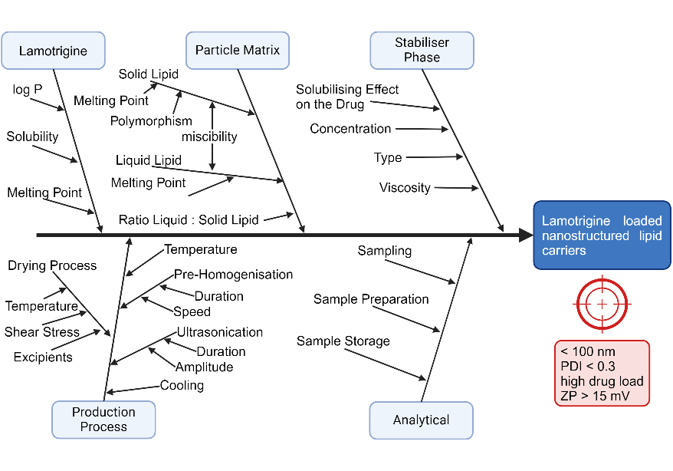
Materials and Methods
Figure 1. Factors influencing NLC quality and quality target product profile of the particles (red box). Created with biorender.

The excipients were selected based on a solubility screening of LTG in lipids. LTG was added to the excipients and agitated at 37 °C or 5-10 K above the melting point for solid lipids for 24 h. The solubility was determined using HPLC.
NLC containing lamotrigine were produced using the hot-melt emulsification method. Briefly, 250 mg of the lipid mixture of varying composition (see below) and lamotrigine were heated to 5-10 K above the melting point in a 50 ml glass centrifuge tube. The aqueous stabiliser phase (25 ml, 2% w/w Poloxamer 188) was heated to the same temperature in another vessel. The stabiliser phase was added to the tube and pre-homogenised at 8,000 rpm with an UltraTurrax for one minute. This pre-emulsion was sonicated for 10 min at 40% amplitude (Bandelin Sonoplus HD 4100, sonotrode UW100, tip T103) to obtain a slightly opalescent NLC dispersion. The temperature was kept at 5-10 K above the melting point during the process. The dispersion was then cooled to room temperature over 10 min in a water bath under gentle stirring. Excess lamotrigine precipitated during cooling and was separated by centrifugation at 1,000 rcf for 10 min at 22 °C. The supernatant containing the NLCs was used for characterisation. Particle size (z-average), polydispersity index (PDI), and zeta potential (ZP) were determined using a Zetasizer Nano ZS (Malvern Panalytical Ltd., Malvern, UK). The sample was diluted 1:30 with the stabiliser phase directly before measurement. The drug content was determined using a validated HPLC method (LichroCART 125-4, Lichrospher 60 RP-select B 5 µm with precolumn; 1 ml/min of 50% methanol and 50% aqueous 20 mM heptane sulfonic acid and 10 mM triethyl amine solution adjusted to pH 3.0 (H₃PO₄); T_{column} 40 °C; 10 µl injection volume; 220 nm). For drug load (DL) and entrapment efficiency (EE) determination, the sample was diluted 1:50 with 30% methanol. LTG solubility in the stabiliser phase was determined. The measured value of the NLC dispersion was corrected for this intrinsic solubility. The separation of the NLCs and stabiliser phase was not feasible. The DoE setup was generated with Minitab statistic software version 18 (Minitab Inc., State College, PA, USA). A mixture design and Box-Behnken-Design (BBD) were used to optimise the drug load through the lipid composition and the production process. The experiments were conducted in a randomised order with one replicate.
The in vivo experiments were performed following German law on animal protection and approved by the Animal Care and Ethics Committee of Kiel University. In this ongoing study, four male, 4-9 months old Wistar rats of the Genetic Absence Epilepsy Rats from Strasbourg (GAERS) strain were used. The rats were bred and housed under standard laboratory conditions. All efforts were made to minimise animal suffering and reduce the number of animals used. The rats were implanted with extradural EEG recording electrodes and recovered fully from surgery before further experiments. For intranasal administration, the NLC dispersion was isotonised with mannitol and sterile filtered before application. The animals were anaesthetised with isoflurane, and 50 µl of the NLC dispersion was applied per nostril in 5 µl increments. After the last application the animal remains in the supine position for 3 minutes. EEG was recorded 12 h after intranasal administration and the time spent in seizures (s) per hour, frequency of seizures per hour and mean duration of seizures (s) per hour were determined. Each animal received LTG-NLC and placebo NLC in different weeks. For a detailed description of housing, head-station-surgery, EEG recording and analysis please refer to Buschhoff and colleges (sections 2.1-2.4) [7].

Results and Discussion
Based on the defined quality target product profile (Figure 1), the first step in the development of LTG loaded NLC was a solubility screening of LTG in different liquid and solid lipids. The screening identified glycerol monolinoleate (GML) and glycerol monostearate 40-55 type I Ph.Eur. (GMS) as suitable lipids, given that lamotrigine showed the best solubility in them (16 ± 1 and 26 ± 1 mg/g, respectively). Because the particles needed to be small and should have a positive ZP, octadecyl amine (ODA) was introduced into the mixture as it exhibits an inducible positive charge at physiological pH. As the charge is non-permanent, toxicity is not expected in the applied doses [8]. The introduction of an inducible charge supports the nose-to-brain delivery concept and further increases colloidal stability by ionic repulsion. Poloxamer 188 was chosen as a stabiliser because its safety profile is well known and it stabilised the NLC well during production and storage. Furthermore, it exhibited the desired marginal increase in LTG solubility, enabling one to attribute observed effects to drug loaded particles and not drug solution.
To determine the optimal composition of the NLC core, binary thermic mixtures of GML and GMS in 10% increments of GML were prepared. These mixtures were assessed visually and placed on filter paper to investigate separation phenomena. Mixtures with up to 50% GML showed no separation after 24 h at room temperature and hence were miscible as required in Figure 1. Based on these observations, a mixture DoE was utilised to identify the optimal ratio of ODA, GML and GMS. The limits were set as follows: 2–20% for ODA, 0–50% for GML and 30–98% for GMS, with a lipid mass of 250 mg/25 ml stabiliser phase (1% w/V). A total of 13 batches of LTG-NLC were produced and subjected to physiochemical characterisation (data not shown). From this mixture DoE, the optimal composition in terms of colloidal stability and drug load was determined to be: 30% glycerol monolinoleate, 10% octadecyl amine and 60% glycerol monostearate 40-55, type I Ph.Eur. The sample had a z-average of 44 nm, PDI of 0.491, ZP of 34.27 mV (pH 6.37), and DL of 33.6 µg/mg. The size, pH, and ZP were already within the range of the defined QTPP. PDI showed a need for optimisation. The DL was already satisfactory, exceeding the anticipated loading of 20.4 µg/mL, as determined by solubility screening in single lipids.
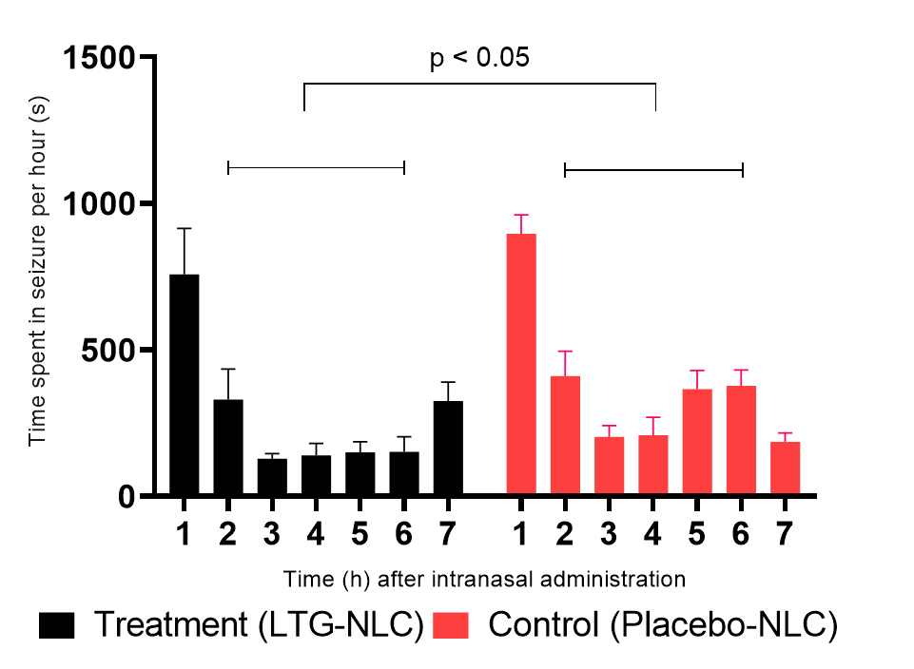As the optimal combination determined from the mixture DoE yielded NLC within the QTPP, this formulation was selected for in vivo testing with Genetic Absence Epilepsy Rats from Strasbourg. GAERS exhibit stable seizure activity after a certain age and show a pharmaco-responsiveness comparable to humans [9]. The applied LTG-NLC batch had a z-Ave of 47 nm, PDI of 0.403, and ZP of 24 mV (pH 8.80). The ZP was measured directly after production and was lower compared to the one reported above due to the higher pH leading to a lower portion of amines being protonated. The pH lowered to 6.45 after two days. Figure 2 shows the seizure activity of the rats after administration of lamotrigine-loaded NLC and drug-free NLC. The increased seizure activity during the first two hours was likely due to narcotic distress. In hours 3-6 following intranasal administration, significantly reduced seizure activity was observed in the treatment session compared to placebo. Interestingly, the cumulative time spent in seizures is reduced because the mean length of each seizure is reduced in this time period (paired t-test analysis in the best five hours, p<0.05). Meanwhile, the number of seizures remains statistically unchanged. It might be arguable that the greatest pharmacological effect is only observed after two hours due to the release kinetics of the drug from the NLCs and the transport of the particles from the nasal cavity to the brain. Hence, the required concentration for a pharmacological effect is reached after that time. The observed reduction in seizure time indicated the efficiency of the application route. However, the dose was too low to totally suppress seizures, which was the primary treatment goal. Consequently, a higher dose per applicable volume of formulation was desired. As LTG is expected to be dissolved in the particles, an increase in the total lipid concentration and an increase in the LTG quantity used are expected to increase the encapsulated LTG amount per volume of formulation.
Figure 2. Seizure activity recorded following intranasal administration of LTG-NLC (Treatment session) and placebo NLC (Control session) showing the first 7 hours of recording. This is the period where the anti-seizure effect was observed. Bars indicate mean ± SEM of n=4 animals. Statistical comparison (paired t-test) of the time spent on seizures in the best 5 hours yields a significant p value.

In order to investigate the influence of these parameters, a response surface DoE was utilised. This design type enables simultaneous investigation of the main effects and interaction effects of the factors at the same time. The sub-form employed was BBD, which permits the investigation of the factors at three equidistant levels while allowing for a trade-off between the number of runs and resolution. The factors and levels are presented in Table 1. An increase in the lipid concentration in the dispersion might increase the need for stabiliser in the aqueous phase in order to obtain particles with a defined particle size range. Hence, the stabiliser concentration was added beyond the aforementioned factors. The batches produced in BBD formed particles in every case, and the physicochemical parameters were close to or within the desired range. The z-Average was inside the QTPP (range 48 – 117 nm, mean 80 nm). The PDI was found to be in part above the defined maximum range (0.226–0.592), with a mean value of 0.378. The ZP met the QTPP (range 21.1 – 29.4 mV, mean 26.6 mV). To evaluate the data obtained from this BBD, the influence of the investigated factors on the measured parameters was described software assisted by mathematical models. Data was analysed using backwards elimination (λ=1, p=0.1 for removal). Additionally, Box-Cox transformation was performed for each parameter to obtain optimal λ. A new model was calculated utilising optimal λ and backwards elimination (p=0.1 for removal). The best describing model was reported and used for further assessment. Table 2 summarises the R² values of the respective models for each parameter. Each model was significant with a non-significant lack-of-fit. The adjusted R² value considers the number of factors used in the model to aid in reducing over-parameterised models. The predicted R² value represents the prediction force based on the data beyond those of the current model. Ideally, both values should be close to 100% and the difference should be below 20%. Therefore, good descriptive and predictive models were obtained for DL, both per volume of formulation and per mass of lipid, and EE. The models for z-Average, PDI and ZP showed medium to good descriptive power and no predictive power. This was expected, as these parameters are predominantly driven by lipid composition and production parameters which were kept constant. For the colloidal stability, an acceptable model was obtained.
Table 1. Investigated factors and levels in BBD
(coded) Factor/Level | -1 | 0 | +1
A: Poloxamer 188 concentration, % wt/wt | 1 | 3 | 5
B: lipid mass, mg | 250 | 750 | 1250
C: drug amount per lipid mass µg/mg | 50 | 100 | 150
Table 2. DoE model evaluation parameters
Parameter/R² | λ | adj. | pred.
DL, µg/ml | 1 | 92.69% | 76.81%
DL, µg/mg | 0.34 | 94.08% | 82.94%
EE, % | -1.42 | 94.86% | 80.97%
z-Average | 1 | 74.39% | 0.00%
PDI | 1 | 83.93% | 0.00%
ZP | 1 | 43.37% | 9.85%
Stability (TSI, 7d 25 °C) | -0.5 | 66.45% | 44.56%

Figure 3 (left) illustrates the influence of the factors lipid mass and stabiliser concentration on the DL per volume of formulation. The DL increased with rising lipid mass and was optimal for a medium stabiliser concentration. Notably, the DL regarded to the lipid mass decreased from 26 µg/mg at 250 mg lipid to the minimum of 11 µg/mg at 1100 mg. Following the evaluation of the obtained parameters and models, the design space of the factors was derived. Figure 3 (right) depicts this and the chosen limits. As all parameters are to be maximised, except for the stability (TSI), the lower limits there a without meaning. They are needed from the software to calculate the design space. Inside the design space, all considered QTPPs are met. A nonlinear combination of the factors describes the design space. A low-to-medium lipid mass with a medium stabiliser concentration is desirable.
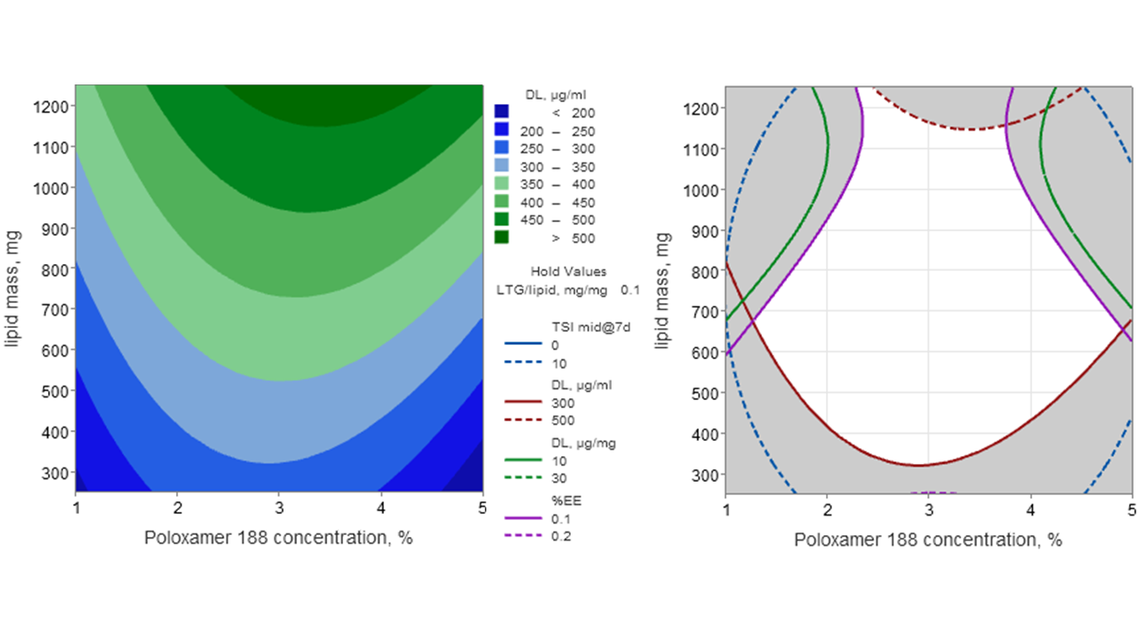
Design space
Figure 3. Left: Contour plot of the lamotrigine load per dispersion volume. Right: Design space of lamotrigine nanostructured lipid carriers. Overlaid contour plot of a part of the QTPP. Detailed explanation in the text. The TSI describes the apparent colloidal stability. A value of 10 and above is regarded to an destabilised dispersion.
Conclusion and Outlook. Low dose application of LTG-NLC showed promising effects in seizure time reduction and the NLC could be optimised. In order to advance development of a nose-to-brain LTG medicine, higher loaded LTG-NLCs are required to investigate dose dependency via intranasal administration. Increasing the lipid content of the dispersion increased the dispersions DL with the disadvantage of reducing the DL per lipid mass. Hence, further experiments will focus on increasing the applicable dose by further increasing the lipid mass per volume or spray or freeze drying of the dispersion with high DL per lipid mass with the smallest amount of excipient possible. With an increased dose, intranasal lamotrigine medication represents an interesting opportunity for epilepsy patients, as a lower dose might also result in fewer unwanted peripheral side effects. Lamotrigine is also used in the treatment of depression, where a nose-to-brain formulation is desirable as well.
Acknowledgements. Glycerol monolinoleate and glycerol monostearate 40-55 type I were kindly provided by Gattefossé.

References
- World Health Organization. Epilepsy: a public health imperative. 2019.
- Kessler SK, McGinnis E. A Practical Guide to Treatment of Childhood Absence Epilepsy. Paediatr Drugs. 2019;21(1):15–24.
- Scheffer IE, Berkovic S, Capovilla G, Connolly MB, French J, Guilhoto L, et al. ILAE classification of the epilepsies: Position paper of the ILAE Commission for Classification and Terminology. Epilepsia. 2017;58(4):512–21.
- Kwan P, Arzimanoglou A, Berg AT, Brodie MJ, Allen Hauser W, Mathern G, et al. Definition of drug resistant epilepsy: Consensus proposal by the ad hoc Task Force of the ILAE Commission on Therapeutic Strategies. Epilepsia. 2010;51(6):1069–77.
- Costa CP, Moreira JN, Sousa Lobo JM, Silva AC. Intranasal delivery of nanostructured lipid carriers, solid lipid nanoparticles and nanoemulsions: A current overview of in vivo studies. Acta Pharm Sin B. 2021 Apr 1;11(4):925–40.
- Javed S, Mangla B, Almoshari Y, Sultan MH, Ahsan W. Nanostructured lipid carrier system: A compendium of their formulation development approaches, optimization strategies by quality by design, and recent applications in drug delivery. Nanotechnology Reviews. 2022 Jan 1;11(1):1744–77.
- Buschhoff AS, Scherließ R, De Mooij-van Malsen JG, Schiffelholz T, Stephani U, Wulff P. Intrathecal application of ethosuximide is highly efficient in suppressing seizures in a genetic model of absence epilepsy. Epilepsy Research. 2022 Aug;184:106967.
- Mallén A, Narváez-Narváez DA, Pujol MD, Navarro E, Maria Suñé-Negre J, García-Montoya E, et al. Development of cationic solid lipid nanoparticles incorporating cholesteryl-9-carboxynonanoate (9CCN) for delivery of antagomiRs to macrophages. European Journal of Pharmaceutics and Biopharmaceutics. 2024 Apr 1;197:114238.
- Depaulis A, David O, Charpier S. The genetic absence epilepsy rat from Strasbourg as a model to decipher the neuronal and network mechanisms of generalized idiopathic epilepsies. Journal of Neuroscience Methods. 2016 Feb 15;260:159–74.

