Lipid Dynamics: Investigating the Impact of Compositions on RNA-Loaded Lipid Nanoparticles for Pulmonary Delivery

Simone Carneiro¹, Stina Rademacker¹, Richard Wibel², Christoph Heidecke², Peter Hölig² & Olivia Merkel¹

¹Ludwig-Maximilians-Universität München, Butenandtstr. 5-13, Munich, 81377, Germany

²Lipoid GmbH, Frigenstr. 4, 67065, Ludwigshafen, Germany

Summary
This study investigates the impact of different lipid compositions and RNA cargos of lipid nanoparticles (LNPs) on gene knockdown and expression efficiency for lung delivery. Four LNP formulations were prepared via microfluidics for siRNA and mRNA delivery, varying in helper lipids (DSPC or DOPE) and PEG-lipids (DMG-PEG or DMPE-PEG). The resulting LNPs were tested regarding their physicochemical properties, cellular uptake, and performance in vitro in both submerged and air-liquid interface (ALI) cell culture systems. The ALI model more accurately reflects lung physiology and enables the evaluation of the ability of LNP formulations to overcome the mucus barrier present in the lungs [1]. The results indicate similar physicochemical properties across different LNP formulations. Certain formulations of siRNA LNPs showed superior performance in gene silencing, attributed to the helper lipid DOPE. In contrast, DSPC-containing LNPs exhibited increased cellular uptake. The study suggests that the enhanced siRNA release into the cytosol due to DOPE´s conical structure promoting endosomal escape and probably lower RNA binding efficiency enhance gene silencing efficiency [2]. These effects were not observed in mRNA formulations or in ALI cultured cells, where LNP formulations performed similarly. The structural differences between mRNA and siRNA may explain this discrepancy. In ALI cell cultures, the mucus layer presents an important hurdle for cellular uptake, yet LNPs effectively overcame this barrier, demonstrating efficient gene knockdown. These findings showcase the potential of LNPs as a promising tool for targeted gene regulation in lung-related diseases.
Key Message

In vitro small interfering RNA (siRNA) delivery via lipid nanoparticles (LNPs) benefits from the fusogenic helper lipid 1,2-dioleoyl-sn-glycero-3-phosphoethanolamine (DOPE) for knockdown efficiency, despite reducing LNPs uptake. In air-liquid interface (ALI) cell culture, mucus penetration might level this variability out, as LNPs face additional challenges in both, endosomal escape and reaching cells through the mucus layer.

Introduction
RNA-based therapeutics offer a promising treatment option for lung diseases associated with dysregulated gene and protein expression. While messenger RNA (mRNA) facilitates specific gene or protein expression, siRNA induces the cleavage of specific mRNA, inhibiting protein biosynthesis and leading to gene silencing. However, due to its instability in biological media, RNA requires a carrier to enable an effective application. In this study, LNPs were used as delivery systems for mRNA and siRNA. We investigated the impact of varying the lipid compositions of the LNPs on the in vitro performance, focusing on expression, cellular uptake, or knockdown efficiency, respectively. LNPs were prepared using microfluidics and characterized regarding size, polydispersity index (PDI), and encapsulation efficiency. To assess the suitability of the formulations for lung administration, the LNPs were tested both in conventional cell culture models and in an ALI system. ALI cell culture systems mimic the lung physiology more realistically than conventional systems, as a pseudostratified epithelium and mucociliary differentiation can be achieved [2]. This approach enabled us to investigate the ability of LNPs to penetrate the lung mucus layer and reach the target tissue based on the formulation.

Materials
The ionizable lipid dilinoleyl-methyl-4-dimethylaminobutyrate (DLin-MC3-DMA) was purchased from MedChemExpress (Monmouth Junction, USA). The helper lipids 1,2-distearoyl-sn-glycero-3-phosphocholine (DSPC) and DOPE, as well as 1,2-dimyristoyl-rac-glycero-3-methoxypolyethylene glycol-2000 (DMG-PEG) and 1,2-dimyristoyl-sn-glycero-3-phosphoethanolamine-N-(carbonyl-methoxypolyethylene glycol-2000) (DMPE-PEG) were kindly provided by Lipoid GmbH (Ludwigshafen, Germany). Cholesterol was obtained fromSigma Aldrich (Taufkirchen, Germany). Lipofectamine 2000TM and the fluorescent dye Quant-iT™ RiboGreen™ were purchased from Thermo Fisher Scientific (Darmstadt, Germany). The dialysis was performed using either a 3.5 kDa molecular weight cutoff Pur-A-Lyzer™ Maxi or Midi Dialysis kit (Sigma Aldrich, Taufkirchen, Germany). For ALI cell culture, Transwell® polyester membrane cell culture inserts were purchased from Corning (New York, USA). PneumaCult ALI differentiation medium, heparin and hydrocortisone were purchased from Stemcell Technologies (Vancouver, Canada). siRNA and mRNA were obtained from integrated DNA Technologies (Leuven, Belgium). Human epithelial non-small cell lung carcinoma cells derived from lymph nodes (H1299), passage number 6, and Calu-3 cell line derived from a bronchial epithelial adenocarcinoma, passage number 4, were purchased from ATCC (Manassas, USA).

Experimental Methods

Formulation of siRNA and mRNA-loaded LNPs via microfluidics or pipette mixing
Four LNPs composed of an ionizable lipid (DLin-MC3-DMA), a helper lipid (DSPC or DOPE), a PEG-lipid (DMG-PEG or DMPE-PEG), and cholesterol were prepared. Lipids were separately dissolved in absolute ethanol, combined according to the respective formulation (Figure 1) and diluted to 2 mM (for siRNA) or 1 mM (for mRNA). RNA was diluted in 25 mM sodium acetate buffer at a pH of 4.0. Both solutions were mixed in a staggered herringbone chip (Fluidic 187, Microfluidic ChipShop, Jena, Germany) with syringe pumps (LA-160, 6-Channel, RS232, Farmingdale, NY, USA) at a total flow rate of 3 mL/min or via pipette mixing (RNA:lipids solution ratio: 3:1) with subsequent dialysis against phosphate-buffered saline (PBS) at pH 7.4 for pH increase and buffer exchange. The resulting LNPs were analysed regarding size and PDI via dynamic light scattering (DLS). RNA content and encapsulation efficacy were assessed by RiboGreen assay.
4 LNP Formulations
LNP2
LNP4
LNP3
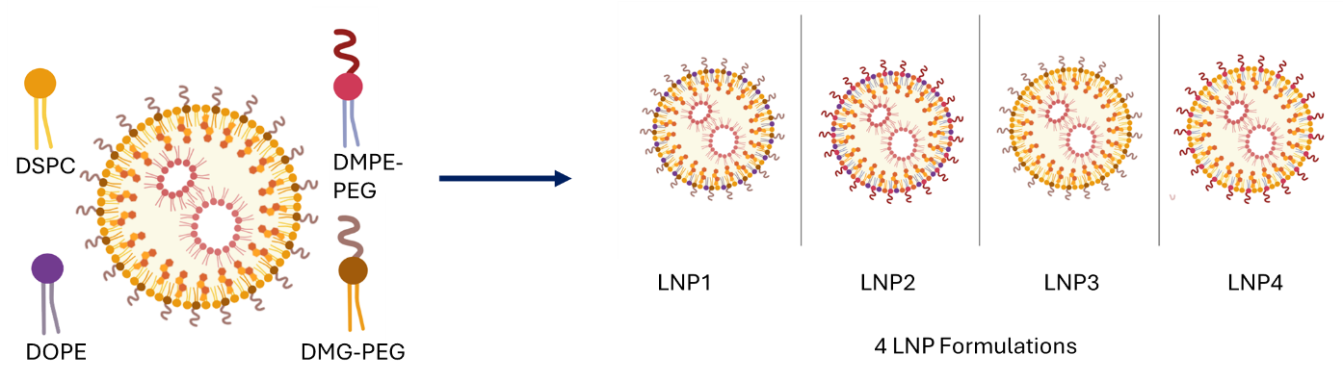
created with BioRender
Figure 1. Lipid composition of the different LNP formulations tested. LNP1 contains: DOPE and DMG-PEG, LNP2: DOPE and DMPE-PEG, LNP3: DSPC and DMG-PEG, and LNP4: DSPC and DMPE-PEG.
In vitro gene silencing and expression in submerged cell culture
Human epithelial non-small cell lung carcinoma cells (H1299) stably expressing the reporter gene for enhanced green fluorescent protein (eGFP) (H1299/eGFP) were transfected 24 h after seeding (25,000 cells/well in a 24-well plate) with either 10 pmol of free siRNA as a negative control, 10 pmol of siRNA and LipofectamineTM as a positive control or 10 pmol of siRNA encapsulated in LNP 1-4. After 48 h incubation, the median fluorescence intensity (MFI) was recorded for the quantification of eGFP levels by flow cytometry (488 nm excitation and a 530/30 nm bandpass emission filter). For gene expression experiments, the H1299 cell line without eGFP expression was transfected with 100 ng of eGFP mRNA encapsulated in the LNPs, and the incubation time was 24 h prior to the flow cytometry readout.
Preparation of the ALI cell culture model with Calu-3 cells for in vitro uptake, gene silencing and expression
For the ALI cell culture, human lung cancer cells (Calu-3), which mimic bronchial cells, form a polarized monolayer, and secret mucus at the ALI, were seeded at a density of 250,000 cells/well on transwells. After three days, the airlift was performed. One week later, the cells were transfected with the LNP formulations. To assess uptake, cells were transfected with fluorescently labelled siRNA (AF488) LNPs, labelled siRNA with Lipofectamine™ as a positive control, and labelled free siRNA as a negative control. After 24 h incubation, flow cytometry was used for analysis. For knockdown evaluation, cells were transfected with 100 pmol of glyceraldehyde-3-phosphate dehydrogenase (GAPDH) siRNA encapsulated in LNPs, and noncoding RNA-loaded LNPs as a control. After a further three days, RNA was isolated, and real-time quantitative PCR (RT-qPCR) was performed, using beta-actin as the housekeeping gene for comparison.

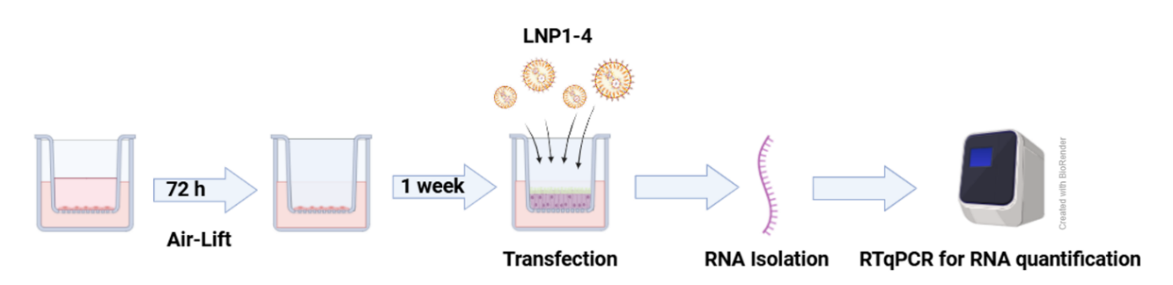
Results
Figure 2. ALI cell culture experimental setup. After seeding and airlifting and transfection of the Calu-3 cells with GAPDH siRNA-loaded LNPs, the readout for the GAPDH knockdown was performed via RNA isolation and RT-qPCR.
The different LNP formulations loaded with either siRNA or mRNA were composed of the same ionizable lipid (DLin-MC3-DMA) and cholesterol. LNP1 and 2 were prepared with DOPE as the helper lipid and DMG-PEG and DMPE-PEG, respectively. LNP3 and 4 contained DSPC as the helper lipid and DMG-PEG and DMPE-PEG, respectively, as PEG-lipids. Initially, their physicochemical properties such as particle size and PDI were assessed. It was observed that these properties were consistent within each RNA group, although siRNA LNPs tended to be slightly larger compared to mRNA LNPs. All formulations exhibited a PDI smaller than 0.2 and size around 100 nm. For gene knockdown in H1299 cells stably expressing the eGFP, LNPs were loaded with eGFP siRNA. The results showed that LNPs 1 and 2 significantly outperform LNPs 3 and 4. LNP 1 and LNP 2 induced a gene silencing effect comparable to the positive control Lipofectamine™ 2000, achieving approximately 95% gene knockdown. However, in the uptake experiment with fluorescently labelled siRNA, formulations LNPs 3 and 4 showed superior cellular uptake in H1299. The differences between these two formulation groups are attributed to their helper lipids (Figure 3). For LNPs 1 and 2, DOPE was used whereas for LNPs 3 and 4, DSPC was used. PEGylation of the siRNA LNPs utilized either DMG-PEG or DMPE-PEG, with DMPE-PEG featuring an additional carbamate and phosphate group compared to DMG-PEG, both with a C14 alkyl chain length. These variations did not remarkably impact the in vitro performance, as the differences between LNPs 1 and 2, and LNPs 3 and 4 were minor. These observed impacts of the formulations on siRNA LNP performance in submerged cell culture were not evident in mRNA expression or ALI cultured cell knockdown experiments, as the differences were not significant across different formulations.
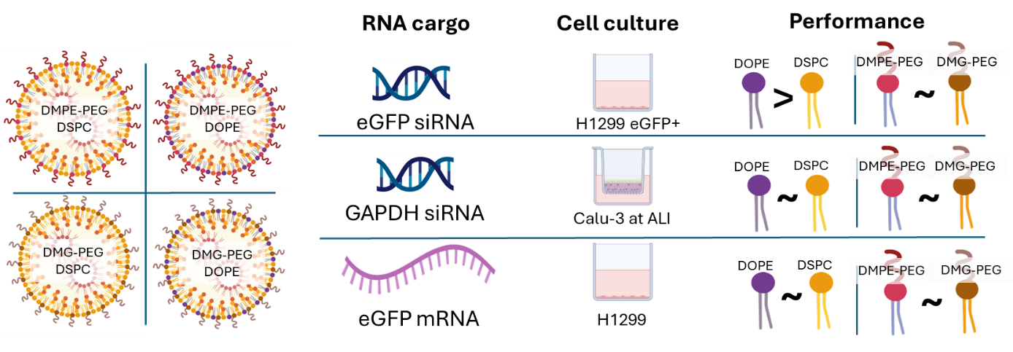
created with BioRender
Figure 3. The four different LNP formulations loaded with different cargos were tested in various cell culture systems. For knockdown efficiency in submerged cell culture, DOPE containing formulations (LNP 1 and LNP 2) outperform DSPC formulations (LNP 3 and LNP 4). For an ALI cell culture model, the performances of the different formulations are similar. There is neither a preferred helper lipid nor PEG lipid. For the expression efficiency H1299 cells were treated with eGFP mRNA loaded LNPs. Here again, the formulations perform very similar.

Discussion
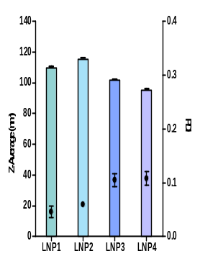
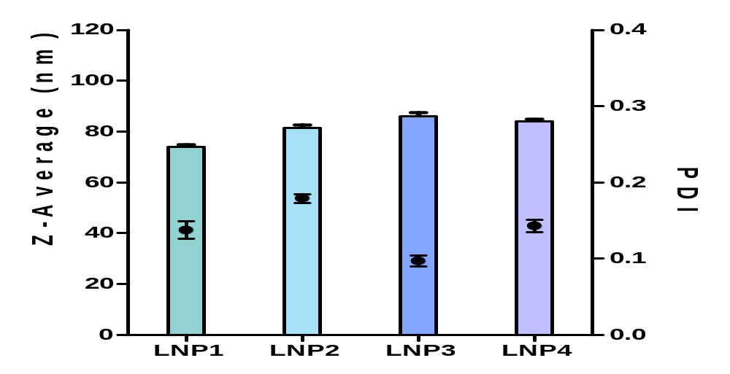
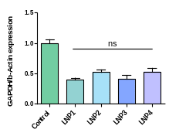
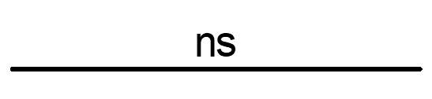
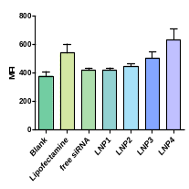
All LNP formulations exhibited a narrow size distribution, indicated by low PDI and small hydrodynamic diameters. The different formulations influenced the knockdown efficiency and uptake of siRNA-loaded LNPs in submerged cell culture. Due to its smaller headgroup and two unsaturated acyl chains, DOPE´s structure results in a conical structure, promoting the formation of a hexagonal phase that facilitates the endosomal escape [2]. However, for the mRNA-loaded LNPs, these impacts of the formulations on the in vitro performance were not observed. This difference may stem from mRNA's distinct structure compared to siRNA, with its larger size and bulkiness potentially mitigating the effects of using DOPE instead of DSPC. In pulmonary delivery, the mucus barrier represents a significant challenge for cellular uptake. Even the positive control Lipofectamine™ shows minimal uptake, leading to the assumption that lipid-based formulations are prone to mucus entrapment. Nevertheless, some LNPs manage to penetrate the mucus layer and reach the cells to successfully achieve a gene knockdown.
Particles characterization of siRNA LNPs
Particles characterization of mRNA LNPs
Particles characterization of siRNA LNPs
Particles characterization of mRNA LNPs
In vitro gene knockdown of GAPDH in Calu-3 cells in an ALI model
In vitro cellular uptake of siRNA LNPs in Calu-3 cells in an ALI model
*
A)
B)
In vitro gene knockdown of GAPDH in Calu-3 cells in an ALI model
In vitro cellular uptake of siRNA LNPs in Calu-3 cells in an ALI model
*
A)
B)

Conclusion
The various LNP formulations do not exhibit notable differences concerning physicochemical properties. Also, modifying the PEGylation of the LNPs by using DMPE-PEG instead of DMG-PEG does not affect gene knockdown or expression efficiency, although DMPE-PEG may slightly improve the uptake of LNPs into cells. The helper lipids influenced the gene knockdown and cellular uptake performance of the siRNA-LNPs. DSPC seems beneficial for cellular uptake, whereas DOPE-containing formulations outperformed gene knockdown performance in submerged cells. Therefore, we assume that DOPE's promotion of hexagonal phase formation and enhanced endosomal escape [2] play crucial roles beyond solely the uptake. Interestingly, these effects were not observed in mRNA formulations or ALI cultured cells, where the LNP performance was similar across the different formulations. The mucus layer in ALI cultures represents a major hurdle for cellular uptake and performance. However, some LNPs are capable of penetrating through the mucus, resulting in efficient gene knockdown. These findings highlight the potential of LNPs as a promising tool for RNA delivery aimed at targeted gene silencing or expression of genes related to lung diseases.
References
[1] Baldassi D, Ambike S, Feuerherd M, Cheng CC, Peeler DJ, Feldmann DP, Porras-Gonzalez DL, Wei X, Keller LA, Kneidinger N, Stoleriu MG, Popp A, Burgstaller G, Pun SH, Michler T, Merkel OM.: Inhibition of SARS-CoV-2 replication in the lung with siRNA/VIPER polyplexes. J Control Release. 2022 May; 345:661-674.
[2] Hald Albertsen C, Kulkarni JA, Witzigmann D, Lind M, Petersson K, Simonsen JB. The role of lipid components in lipid nanoparticles for vaccines and gene therapy. Adv Drug Deliv Rev. 2022 Sep; 188:114416.

