High precision determination of amorphous lactose formed during comminution processes

Ross Blezard¹, Timo Roelofs¹ & Pauline H.M. Janssen^{1,2}

¹DFE Pharma GmbH & Co. KG, Klever Str 187, Goch, 47574, Germany

²Department of Pharmaceutical Technology and Biopharmacy, University of Groningen, Antonius Deusinglaan 1, 9713 AV Groningen, The Netherlands

Summary
The presence of amorphous lactose in commercially available lactose grades used as a carrier in dry powder inhalers has been the subject of much discussion. In order to understand if the presence of amorphous lactose can impact drug performance one must first be able to measure and control amorphous lactose precisely. When formed through comminution processes such as milling or micronisation, the amorphous lactose phase is particularly unstable, making precision determination challenging. In this study an existing Differential Scanning Calorimetry (DSC) method was optimized such that the precision of the method for comminution formed lactose was improved by approximately one order of magnitude. This enables more reliable measurements and subsequently better understanding of correlations between this specific property and drug product performance.
Key Message
In this study a high precision method for amorphous content determination was developed, specifically for material containing amorphous lactose formed through comminution processes. This provides drug product developers with a better tool to understand the influence of amorphous lactose on drug product performance.

Introduction
Lactose is utilized as a carrier in many dry powder inhalers, it can be used to improve the flow and aerosolization properties of otherwise cohesive powders, namely active pharmaceutical ingredients (API). Additionally incorporation of extrinsic lactose fine particles is frequently used to optimise in vitro deposition of the API.
Lactose can be present in different crystalline forms: alpha monohydrate, alpha anhydrous (stable or unstable) and beta anhydrous. However, depending on the processing of the lactose, amorphous fractions may be formed. The presence of amorphous lactose may impact functionality as demonstrated in various studies[] The presence of an amorphous phase of lactose has been shown to influence the surface free energy of lactose (monohydrate) crystals, which in turn influences the affinity with active APIs[] . Furthermore amorphous regions are thermodynamically unstable and therefore will recrystallize over time[]. It is therefore necessary to precisely quantify the amorphous content in lactose.
Various methods exist to determine the amorphous content and extensive reviews have been previously published[]. Differential Scanning Calorimetry (DSC) can be used to measure the crystallization enthalpy upon recrystallization, the amorphous fraction can then be calculated by means of a calibration curve prepared using a sample of known amorphous content. DSC is extensively used in the industry and is readily available in many quality control laboratories. Other techniques are based on other differences in material properties between crystalline and amorphous lactose, and therefore the term apparent amorphous lactose is used in this paper when measured values are discussed.
At least two distinct types of amorphous lactose can be present in lactose intended for pharmaceutical applications. Amorphous surface layers can be formed during the crystallization process of lactose. During drying, lactose molecules do not get the time to crystallize and therefore will appear in a completely random structure. Spray dried lactose is typically used for tabletting and may contain approximately 8 - 13 %, w/w amorphous content[]. In the case of spray dried lactose the amorphous regions recrystallize to alpha lactose monohydrate above 32% relative humidity at 20ºC^{[4]}. A second type of amorphous content is present in lactose that has undergone a comminution process such as milling or micronisation. In this case, the energy that is applied to reduce the size of lactose particles disrupts the crystal phases of the molecules. Recrystallization of this type of lactose occurs over a broader temperature range and at a lower onset temperature compared to that of spray dried amorphous lactose (Figure 1). Amorphous lactose formed during spray drying and comminution are henceforth referred to as type I and type II amorphous lactose, respectively.
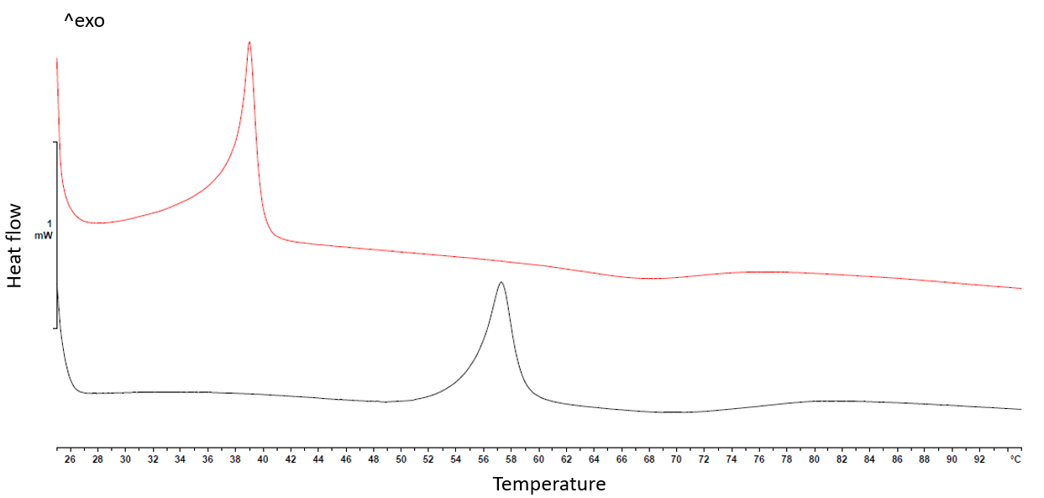
Figure 1 DSC thermograms showing the exothermic crystallization events for spray-dried lactose in black (type I) and micronized lactose in red (type II).
Both type I and II amorphous lactose are thermodynamically unstable in nature due to the high free energy associated with these forms. There is a thermodynamic drive to reduce the energy of the system typically leading to recrystallization ^{[4]}. This recrystallization is highly impacted by external conditions, such as the presence of impurities[], temperature and relative humidity[]. Packaging, transport and intermediate opening of packaging could play a crucial role in the amount of crystallization. The differing kinetics of type I and type II recrystallization can also be observed over time. Figure 2 illustrates the different recrystallization behavior of type I and type II lactose. Due to the propensity of type II amorphous to recrystallize it is far more challenging to achieve an accurate and precise measurement. Large variations over time make interpreting results challenging and subsequent correlations to drug product functionality tenuous.
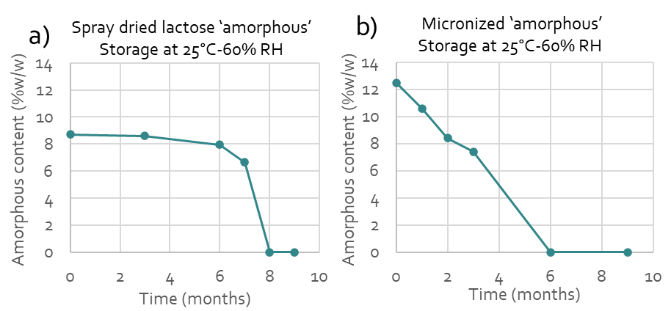
Figure 2 The amorphous content over time for a) a spray dried lactose (containing mainly type I amorphous) and b) micronized lactose (containing mainly type II amorphous from comminution), when stored in the same packaging under ICH conditions.
In order to initiate crystallization of amorphous lactose a moisture source and sufficient molecular mobility is required, typically achieved through addition of heat. Moisture also acts as a plasticiser therefore lowering the temperature at which the onset of crystallization occurs. Throughout this study it was assumed that recrystallization occurred exclusively to the monohydrate form, which can be proven with crystal water analyses of the final product. The aim of this study was to increase the precision (repeatability) of type II amorphous lactose determination with minimal modification to an existing DSC method.
Methods
Historical assessment of apparent amorphous content in commercial lactose.
The precision of apparent amorphous content determination was determined by analysis of historical batches. A spray dried and a micronized grade of lactose were selected to represent type I and type II amorphous respectively. Three milled grades and two sieved grades of lactose were included in the analysis to represent various processes.

Moisture source optimization
Based on previous internal investigations acid caseinate (AC741, NZMP Fonterra, batch: 22745007, ,moisture content 5,8 %, w/w ) was used as a moisture source and was conditioned to a specified relative humidity using Memmert HPP108 Climate chamber. For conditioning at 10% RH, a desiccator with Lithium Chloride salt (11.3%) was utilized. The acid caseinate was conditioned prior to measurement for at least 24h which was previously demonstrated to be sufficient in order to reach equilibrium.
Differential Scanning Calorimetry
The Mettler Toledo DSC 3+ (n = 2) was used with a ramp of 5 °C/min starting from 25 °C. The end temperature varied depending on the crystallization temperature of the material, to a maximum of 95 °C. A 40 µl aluminium pan lid was hermetically sealed after putting in 4-6 mg moisture source and 4-6 mg lactose. A reference pan containing 4-6 mg of the moisture source was analysed concurrently and the signal was subtracted from the resultant heat flow data.
Results and discussion
Historical assessment of apparent amorphous content in commercial lactose.
Table 1 summarizes the apparent amorphous content relative to micronized lactose and the average difference between duplicate analysis. The rank order from highest to lowest amorphous content is; micronized lactose,. spray dried lactose then sieved and milled lactose grades. Lactose monohydrate crystals were manufactured using either process A or process B. Materials from process B were observed to contain higher levels of amorphous content. For example “milled coarse (A)” had no detectable amorphous content, whereas “milled coarse (B)” contained 21% relative to the micronized lactose. This is likely due to the increased drying rate of the crystals during production however further research is required to confirm this.
It may also be inferred that lactose with low variation between duplicates contained predominately type I lactose, for example coarse milled (B) and sieved (B) showed similar duplicate variation to spray dried lactose (3 – 4 %), which is consistent with the more aggressive drying conditions of process B. Similarly fine milled (A) likely predominately contained type II amorphous as variation between duplicates was comparable to that of micronized lactose. Fine milling is a highly energetic comminution process and hence the similarities in the behaviour of this material and micronized material is consistent. However caution is advised in this conclusion due to the low number of samples of fine milled (A).
Table 1. Comparison of historic data of apparent amorphous content from lactose produced using different crystallization processes A and B in addition to spray dried material.
Lactose monohydrate | Micronized (A)  (n=49) | Sieved (A)  (n=12) | Sieved (B)  (n=56) | Coarse milled (A)  (n=25) | Fine milled (A)  (n=10) | Coarse milled (B)  (n=43) | Spray dried  (n=223)
Average apparent amorphous content relative to micronized (%, w/w) | 100% | 0% | 17% | 0% | 8% | 21% | 86%
Average difference within duplicates (%, w/w) | 20% | 0% | 3% | 1% | 27% | 4% | 3%
Moisture source optimisation
It was anticipated that pre-conditioning the acid caseinate at low RH would prevent or slow recrystallization of type II amorphous at room temperature. Figure 3 shows thermograms of type II amorphous recrystallization in the presence of acid caseinate conditioned at different RH. The onset temperature of lactose recrystallization is lower for higher RH conditioning of the acid caseinate. Crystallization at room temperature was effectively inhibited in the case of 30% RH.
Furthermore the influence of casein RH conditioning on the rate of type II amorphous crystallization during sample preparation was assessed by testing micronized lactose immediately and 5 minutes after sample preparation. The trend in Figure 3 indicated less crystallization in the 5 minutes between measurement of the two replicates as the casein was conditioned at lower RH values. At 30% RH no crystallization was observed with similar amorphous content for both analyses. At 60% RH almost all amorphous content had crystallized in the five minutes between the first and the second measurement. Despite initiating sample measurement immediately following casein addition (within 2 minutes), lower levels of amorphous content were measured in samples with casein stored at 40% RH or higher. This likely indicated that crystallization occurred prior to analysis of the first replicate.

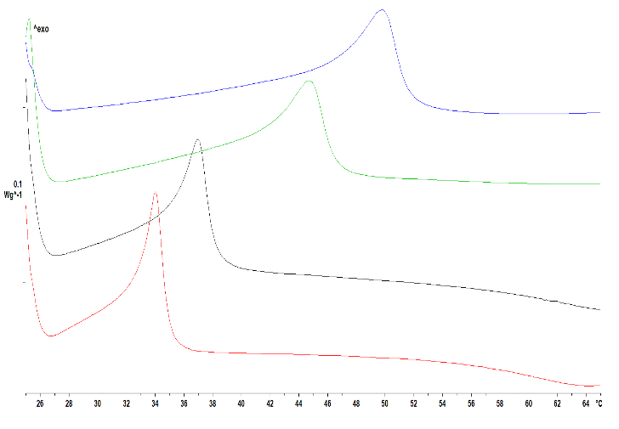
Figure 3 LEFT Type II amorphous recrystallization curves using acid caseinate that is conditioned at 30% RH (blue), 40% RH (green), 50% RH (black) and 60% RH (red). RIGHT Apparent amorphous content of micronized lactose with differently conditioned acid caseinate. Samples measured immediately (t=0) or sealed and analyzed after 5 minutes (t=5min). Error bars show the range (n=2).
Table 2 summarizes repeat determination of micronized lactose using acid caseinate conditioned at 30 % RH. The mean apparent amorphous content is 11.6 ± 0.2 %, w/w. The %RSD was determined to be 2.1 %, corresponding to an improvement of approximately one order of magnitude compared to the duplicate agreement observed in historical data for micronized lactose (Table 1).
Table 2. Apparent amorphous content of micronized lactose using high precision method
Replicate | n=1 | n=2 | n=3 | n=4 | n=5 | n=6 | n=7 | Mean (stdev)
Apparent amorphous %, w/w | 11.6 | 11.6 | 11.5 | 11.9 | 11.9 | 11.5 | 11.2 | 11.6 (0.2)

Conclusions
During this study, a DSC method for the characterization of amorphous lactose was optimized. The precision of measurement was increased for samples containing amorphous lactose formed through commination processes such as milling and micronisation. The change to method involved conditioning the moisture source, namely acid caseinate, to 30% RH. Whilst like for like comparison of method precision is challenging due to the different nature of the data sets, it is estimated the repeatability on the method has been improved by approximately an order of magnitude. This will enable more reliable datasets to be generated which in turn can be used to better understand the influence of amorphous content on drug product performance.
References

[] Grasmeijer F, Frijlink H W, de Boer A H: A proposed definition of the ‘activity’ of surface sites on lactose carriers for dry powder inhalation, Eur J Pharm Sci 2014; 56: pp. 102-104.
[] Das S, Larson I, Young P, Stewart P: Understanding lactose behaviour during storage by monitoring surface energy change using inverse gas chromatography, Dairy Sci Technol 2010; 90: pp. 271–285.
[] Huppertz T, Gazi I: Lactose in dairy ingredients: Effect on processing and storage stability, J Dairy Sci 2016; 99(8): pp. 6842-6851.
[] Lehto V P, Tenho M, Vähä-Heikkilä K, Harjunen P, Päällysaho M, Välisaari J, Niemelä P, Järvinen K: The comparison of seven different methods to quantify the amorphous content of spray dried lactose, Pow Tec 2006; 167(2): pp 85-93.
[] Pauline H.M. Janssen, Sri Sharath Kulkarni, Carlota Mendez Torrecillas, Florian Tegel, Ralf Weinekötter, Bernhard Meir, Bastiaan H.J. Dickhoff, Effect of batch-to-batch variation of spray dried lactose on the performance of feeders, Powr Tech 2022; 409: pp. 117776-117785.
[] Wijayasinghe R, Bogahawaththa D, Chandrapala J, Vasiljevic T: Crystallization behaviour and crystal properties of lactose as affected by lactic, citric, or phosphoric acid, J Dairy Science 2020; 103(12): pp. 11050-11061.
[] Clark Z, Paterson A H J, Joe R, Mcleod J S: Amorphous lactose crystallisation kinetics, Int Dairy J 2016; 56: pp. 22-28.

