Investigating effects of rotation speed and flow rate on powder evacuation from a capsule for dry powder inhalers

Athiya Azeem¹, Gajendra Singh², Hak-Kim Chan³, Runyu Yang⁴ & Agisilaos Kourmatzis¹

¹School of Aerospace, Mechanical and Mechatronic Engineering. The University of Sydney, NSW 2006, Australia

²School of Engineering, IIT Mandi, HP 175075, India
³School of Pharmacy, the University of Sydney, NSW 2006, Australia
⁴School of Material Science and Engineering, UNSW Sydney, NSW 2052, Australia

Summary
Capsule-based dry powder inhalers (DPIs) have long been commercially available, but their performance remains largely unpredictable despite the prevalence of such devices. This is due, in part, to a lack of understanding of how different device designs affect powder dispersion and evacuation. One common design configuration is a spinning capsule that utilises airflow to rotate a capsule while collisions with the wall aid in dispersion. This study aimed to better understand these mechanisms by decoupling rotation speed from the flow rate and investigating their effect on powder evacuation from the capsule at various flow rates and rotation speed conditions. For this study, two flow rates, 30SLPM (inlet: 16.67 m/s) and 60SLPM (inlet: 33.33 m/s) and two rotation speed settings of 1500 RPM (Low case) and 3750 RPM (High case) were chosen. High-speed backlit imaging further provided qualitative information about evacuation behaviour.
At 60 SLPM the rotation speed had no significant effect on the overall powder evacuation during the three second run time. Furthermore, holding the capsule stationary and in line with the flow at this speed also did not affect the amount of powder evacuated. Therefore, at this flow rate and for the formulations tested evacuation was independent of rotation speed. When tested at 30 SLPM, the lower rotation speed setting was found to improve evacuation significantly compared to the high rotation speed case. Further rotational speed cases and formulations should be analysed in combination with high-speed microscopic imaging to gain a better understanding of dispersion behaviour.
Key Message
A study was conducted to decouple the rotation speed of a capsule from flowrate. At 60 SLPM (inlet Re: 11040), the effect of rotation speed on evacuation was insignificant. At 30 SLPM (inlet Re:5520), evacuation was greater at low rotation speed, contrary to what is observed with air flow present.

Introduction
Since the development of dry powder inhalers, there have been numerous products of various designs commercially available. Several versions were developed for different methods of powder loading, dispersion, and resistance all with the aim of improving performance and consistency. DPIs offer non-invasive drug delivery with good bioavailability, however maintaining consistency and predictability from a given device, remains very challenging.
Rotating capsule based DPIs are a configuration that is popular among commercial devices. Despite the widespread use of these types of devices their performance remains highly unpredictable due to the variety of competing variables affecting evacuation behaviour. Previous studies have investigated the effect of capsules on performance in devices such as in the Aerolizer [1] and focused on understanding capsule motion in this device [2]. These studies only investigate one commercial device configuration where the capsule undergoes several simultaneous processes/mechanisms for evacuation and dispersion, and therefore it is difficult to gain an understanding of the true effects of each particular feature of the inhaler design. For example Beneque and Khinast [2] stated the importance of airflow and collisions for powder evacuation but the effects of either of these could not be isolated, and since rotation speed was found to be highly correlated to air flow rate these factors could not be independently assessed. Other studies compared the performance of different capsule based devices and their evacuation behaviour over time [3] however in all these instances it is the combined effect of a variety of mechanisms that are studied rather than isolating the underlying processes.
The aim of this study is to address this issue by removing the effect of capsule impaction and decoupling the rotation speed and the flow rate through designing a simplified experiment that allows for the active rotation of a capsule independent of the airflow. It is important to note that this is not intended to be a direct model of any particular commercial inhaler device, especially given the difference in flow orientation to the capsule. However, this experiment enables investigation of capsule rotation and air flow independently with well characterized boundary conditions enabled by having a 2-dimensional channel flow as the inlet and outlet. This also assists in model validation.

Material and Method
A simplified capsule chamber was made from clear acrylic to allow imaging of the internal geometry. The chamber geometry consisted of a single inlet and outlet with a swirl cavity located at the centre. At the centre of the swirl cavity was a rotating platform that had a groove to adhere to a size 4 capsule and facilitate its fixed axis rotation, as shown in Figure 1. Unlike commercial devices where the rotation speed of the capsule is dictated by the flowrate, this set up consisted of a drive belt that connects the platform to a motor and facilitates the independent control of the capsule’s rotation speed. The motor was driven by a 12-volt variable power supply and microcontroller to set two rotation speeds. The chosen speeds in this experiment were approximately 1500 RPM and 3750RPM, henceforth referred to as the Low and High rotation speed respectively. These were chosen to as they represent rotation speeds that are typically lower and higher than the expected rotation speed achieved by 60 SLPM in other commercial devices [2]. The exact speed of the motor was subject to fluctuations due to changes in tension in the drive belt and friction in the bearing which resulted in fluctuation of approximately 150 RPM for a given setting.
The airflow was independently controlled by an Alicat mass flow controller (MFC) placed upstream of the channel. Constant steady state flowrates were chosen at 30 standard litres per min (SLPM) (16.67 m/s inlet velocity) and 60 SLPM (33.3 m/s inlet velocity). These values were selected to be in line with previous experiments and typical inhalation flow rates [4].
The powder studied was spray dried mannitol with a medium particle size of d50 = 6.29 µm (span 1.28,). This powder was chosen as it is consistent with previous works and is well characterised. Additionally at this size mannitol demonstrate strong agglomerating behaviour that is of interest in this fundamental study. Previous studies typically include smaller particles in the sub 5 micron range as this is optimal for deep lung deposition [5] however in this configuration smaller particles of mannitol created agglomerates that were found to be too cohesive to evacuate from the capsule. For each run, 25 mg (±0.5mg) of powder was loaded into a size 4 capsule whose ends were pierced with an Osmohaler (Pharmaxis Ltd) before being adhered to the rotating bed. The experiment was conducted under two different flowrates and rotation speeds with each case being repeated five times. For each run, the powder was weighed before and after to measure the total amount of powder evacuated (±0.05 mg). Additional experiments were also conducted for cases where only the air or the rotation was being used to facilitate capsule evacuation, and these were repeated in triplicate. For each configuration of cases the air and/or rotation was on for a period of 3 seconds.
In addition to measuring the capsule weights, the capsule evacuation process was observed using high speed backlit imaging. A Photron Mini AX100 high-speed camera was used to image the optically accessible device at a rate of 10,000 frames per second. The imaging set up is shown in Figure 2. The field of view was 768 x 568 pixels with scale of 51 µm/pixel and encompasses the whole swirl chamber and the 15 mm downstream as shown in Figure 4.

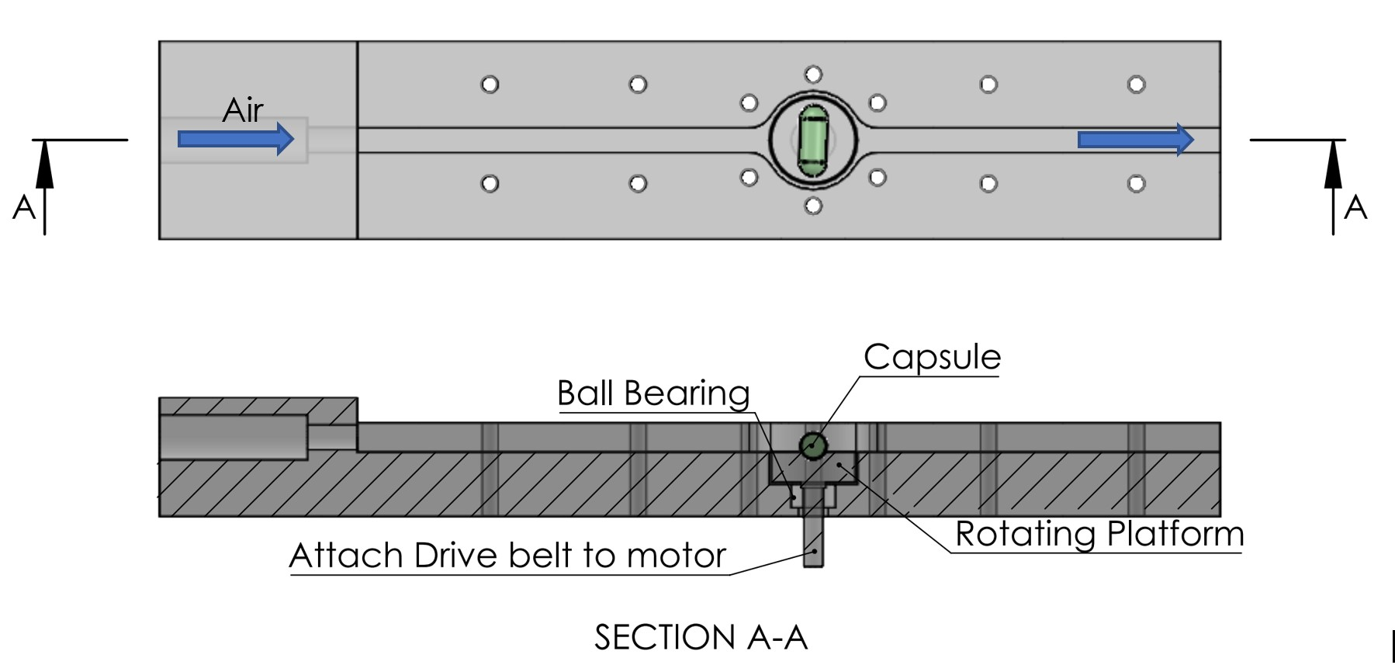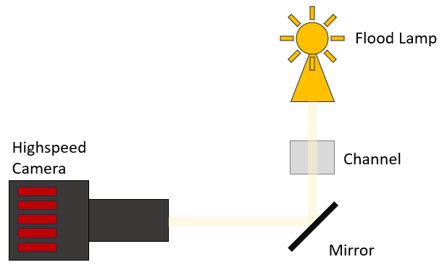
Figure 1: Optically accessible channel Figure 2: Imaging Schematic
Results and Discussion
In this study three scenarios were explored to derive the effects of the different emptying mechanisms; 1) rotating capsule in a crossflow, 2) rotating capsule with no airflow and 3) Air flow on a stationary capsule. Figure 3 shows the proportion of the powder loaded in the capsule that was evacuated after 3 seconds of rotating in a cross flow under various conditions. It was found that at higher flow rates of 60SLPM, evacuation was significantly improved for both rotational speeds. From imaging it was observed that when the capsule was in line with the air flow a larger burst of powder can be evacuated as shown in Figure 4.

Figure 3: Percentage of loaded powder evacuated from rotating capsule in a cross flow at various speeds. Means for each case stated to the nearest percentage.
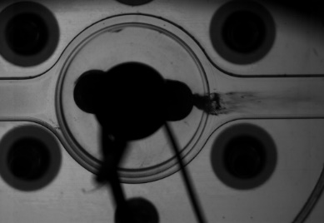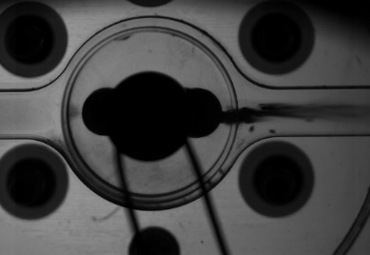
Figure 4: Capsule rotating in Low RPM Case with capsule is in line with air flow of 30SLPM (Left) and 60 SLPM (Right).
At 60SLPM the rotation speed of the capsule was found to have no statistically significant impact on the total amount of powder evacuated due to high variability. At this flowrate it is seen that a large portion of the powder evacuation occurs when the capsule is in line with the flow as shown in Figure 4 and this dominates over the effects of rotation.
At 30SLPM, however, the rotation speed has a notable effect on the degree of evacuation from the capsule. In this experiment the higher rotation speed significantly reduced evacuation compared to the low case, by 13% of the total loaded dose. This is counter to what is observed in the case of rotation without the cross flow (Figure 5) where the high rotation speed without the crossflow enhanced evacuation. The scenario of rotation without cross flow is purely theoretical but highlights the effect that a cross flow introduces compared to pure centrifugal action. Without the cross flow, the capsule rotates and evacuates out at a near uniform atmospheric pressure, whereas once air flow is added, evacuation is very effective inline to the flow (capsule parallel to the streamwise direction) however complex fluid structure interactions generate an adverse pressure gradient which impacts evacuation when the capsule is orthogonal to the flow. The precise mechanics of this require further measurements to be understood.

Figure 5: Evacuated dose from capsule rotating without airflow. Low rotation (L) is approximately 1500RPM and High rotation (H) is approximately 3750RPM.
Comparing the results from Figure 3 and Figure 5 further, it can be observed that at the low rotation speed case, powder evacuation is improved significantly by the presence of a cross-flow, from an improvement of 5% to 23% of the dose evacuated. However, for high rotation speed the presence of the cross flow reduces evacuation from 21% without air to 10% with air. At high RPMs the powder ejects from the capsule centre to the ends as it rotates and into the atmosphere with greater force than at lower rotation speeds. As discussed prior, when air is present, variations in pressure can create a resistance to evacuation, and this should be subject to further research. Regardless of the reason, the results suggest that at low rpm, evacuation strongly relies on the flow being in line with the capsule to enhance emptying.
Previous results and imaging (as shown in Figure 4) suggest an advantage in powder emptying when the capsule is in line with the air flow. Figure 6 shows the percentage of powder emptied when the capsule is held stationary in this position. At 60SLPM there is no significant improvement in powder expulsion when the capsule is orientated in this way as opposed to when it is spinning (Figure 3) in the cross flow. At 30 SLPM, without rotation, powder evacuation is consistently below 20% of the loaded dose (Figure 6). When coupled with air, the low rotation speed adds potential for a greater degree of emptying as seen in Figure 3. It’s possible that the slight variation in angle to the oncoming flow and the internal rearrangement of the powder within the capsule as a result of rotation acts favourably for evacuation when the capsule is in line with the air. Despite the controlled nature of this experiment, variability between repetitions was still large highlighting the complexity of these types of devices and the need for more systematic experiments with a broader range of formulations and conditions.

Figure 6: Evacuated dose from stationary capsule in a cross flow. Pierced capsule holes in line with the flow direction.
Conclusion
The experiment presented outlines the combined effects of rotation and flowrate on powder evacuation from a capsule using a platform containing a capsule chamber that facilitated the decoupling of these parameters that are typically linked. Flow rate appears to dominate the degree of powder evacuation while rotation assisted evacuation at 30SLPM. At 60 SLPM it was found that rotation has no significant effect on the amount of powder that is ejected from the capsule. However, at 30SLPM a low rotation speed of 1500RPM was found to improve the degree of evacuation compared to a 3750RPM case or when the capsule was held stationary in line with the flow. Further studies being conducted using high speed microscopic imaging will provide deeper understanding of powder dispersion and deagglomeration under these conditions and can be used to improve future inhaler design.
References
[1] Coates, M.S., Fletcher, D.F., Chan, H.K. and Raper, J.A., The role of capsule on the performance of a dry powder inhaler using
computational and experimental analyses. Pharmaceutical Research, 2005. 22(6): p. 923-932.
[2] Benque, B. and J.G. Khinast, Understanding the motion of hard-shell capsules in dry powder inhalers. Int J Pharm, 2019. 567:
p. 118481.
[3] Behara, S.R.B., Kippax, P., Larson, I. and Morton, D.A.V., Kinetics of emitted mass—A study with three dry powder inhaler
devices. Chemical Engineering Science, 2011. 66(21): p. 5284-5292.
[4] Azeem, A., et al., Quantifying Agglomerate-to-Wall Impaction in Dry Powder Inhalers. Pharm Res, 2023. 40(1): p. 307-319.
[5] Longest, P.W., Son, Y.J., Holbrook, L. and Hindle, M., Aerodynamic Factors Responsible for the Deaggregation of Carrier
Free Drug Powders to Form Micrometer and Submicrometer Aerosols. Pharmaceutical Research, 2013. 30(6): p. 1608-1627.

