Investigating Drug Loading on Stainless-Steel Mesh Filters used for Estimating Regional Lung Deposition

Alexander Huang¹, Scott Tavernini¹, Dino J. Farina², Warren H. Finlay¹, Andrew R. Martin¹

¹Aerosol Research Lab of Alberta, University of Alberta, 116 St & 85 Ave, Edmonton, T6G 2R3, Canada

²Proveris Scientific Corporation, 2 Cabot Rd, Hudson, MA 01749, United States

Summary
Our group has recently developed a filter-based apparatus (FBA) for in vitro estimation of regional lung deposition for dry powder and pressurized metered dose inhalers. The FBA utilizes a set of specialized stainless-steel mesh filters, positioned downstream of a mouth-throat airway model (Alberta Idealized Throat, AIT), to collect and separate the tracheobronchial fraction of the lung dose. The work presented here evaluated potential loading effects of repeated actuations of inhalers through the apparatus on the filtration efficiency of the mesh filters. Varying doses of a fluticasone propionate dry powder inhaler (DPI) were actuated through the in vitro assembly while using realistic breathing profiles. Scanning electron microscopy (SEM) provided a qualitative assessment of active pharmaceutical ingredient (API) and carrier particle deposition onto the filters with increased loading, while ultraviolet (UV) spectroscopy provided a quantitative analysis of the amount of API collected on the filters. The mass of API collected on the filters, normalized by number of actuations, was unchanged between 2, 5, and 7 repeated actuations. This study therefore demonstrated the robustness of the FBA and its potential to contribute to in vitro evaluation of orally inhaled drug products (OIDPs).
Key Message
This study demonstrated the robustness of the FBA. Estimates of regional lung deposition fractions were consistent for up to 7 repeated inhaler actuations, demonstrating no loading effect up to the specified number of actuations.

Introduction
Aerosol particles depositing in the tracheobronchial (TB) airways versus the alveolar region of the lungs experience differences in local environments that influence their subsequent disposition through regionally distinct clearance mechanisms, dissolution rates, permeability, and absorption [1, 2]. However, a simple in vitro method for estimating TB and alveolar lung deposition fractions delivered by inhalers has yet to be established. To this end, Tavernini et al. [3, 4] have developed an apparatus that incorporates stainless steel mesh filters to mimic TB deposition efficiency. Rather than a steep cutoff diameter akin to an impactor stage, the TB filters were designed to mimic the deposition efficiency of the TB airways, which demonstrates a gradual increase with impaction parameter [5]. Positioning the FBA downstream of a realistic airway geometry and upstream of an absolute filter allows for quantification of the extrathoracic, tracheobronchial, and alveolar doses, allowing for rapid in vitro estimation of regional lung deposition under clinically relevant test conditions.
The present study was conducted to investigate the robustness of the FBA when subjected to filter loading effects that could potentially impact the performance of the TB filters. Varying doses of fluticasone propionate dry power inhaler (DPI) were actuated through the in vitro apparatus while using realistic breathing profiles. The consistency of measured TB and alveolar deposition, normalized by the number of device actuations, was evaluated.

Experimental Methods and Materials
Inhaler
The DPIs used were Flovent Diskus (Lot YD5P; GlaxoSmithKline Inc., Mississauga, Canada) at a strength of 250 µg fluticasone propionate (FP). Two inhalers were used from the same lot.
Loading Studies
Ambient conditions during the experiments ranged from temperatures of 20.7 °C to 23.4 °C, pressures of 92.7 kPa to 93.6 kPa, and relative humidity of 19.1% to 59.8%. The experimental assembly, shown in Figure 1, consisted of the following components connected in series: a DPI adapted to the AIT using a custom adapter, the AIT, a flow disruptor plate, the TB filters to collect the TB dose, and an absolute filter to collect the alveolar dose. The flow disruptor plate collects any large particles remaining in the flow after the AIT. The mesh used in the TB filters (SV-26/25tw, SV-34/30tw; ASADA MESH Co., Osaka, Japan) is sieve-like, with 26 µm and 34 µm square openings. In the FBA, both meshes are used as the TB filter, with the SV-26 mesh as the top layer, and SV-34 mesh as the bottom layer. A breathing simulator (ASL 5000; Ingmar Medical, Pittsburgh, PA) was used to perform an inhalation profile for the Diskus inhaler representative of 50th percentile values for mixed gender data, based on the results of Delvadia et al. [6], namely a time to peak inspiratory flow rate of 0.49 s, an inhaled volume of 2.7 L, and a peak inspiratory flow rate of 87.7 L/min. The AIT was coated with a silicone release spray (Molykote 316; Dow Corning, Midland, MI, USA) and allowed to dry for 15 minutes prior to each experiment.

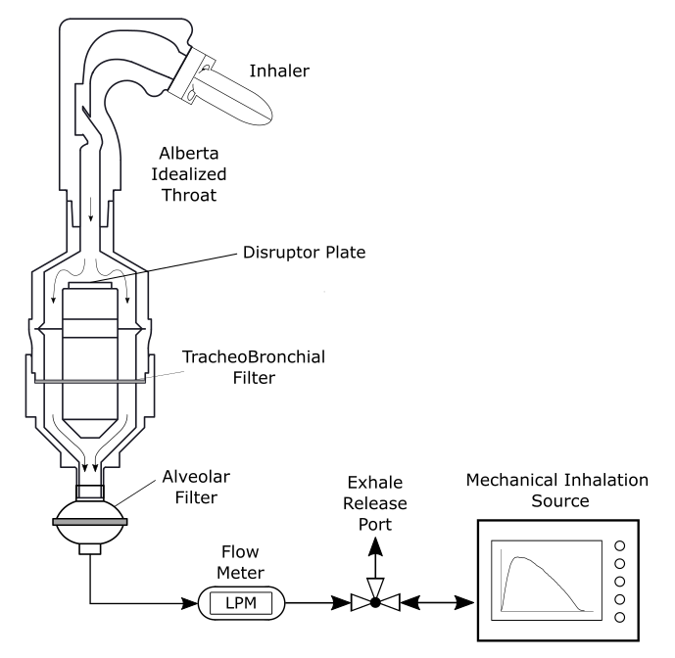
Figure 1. Schematic of the filter-based apparatus used to estimate regional lung deposition.
A varying number of repeated actuations (2, 5, and 7) of the inhaler were drawn through the assembly. Once the desired number of doses had been delivered through the assembly, each of the collection surfaces were washed with HPLC-grade methanol. A UV-spectrophotometer (Cary 8454; Agilent, Santa Clara, CA, USA) was used to quantify the mass of API collected from each surface.
For each number of repeated actuations, the amounts of drug recovered from the AIT, disruptor plate, TB filter and alveolar filter were divided by the number of actuations and then statistically compared using single factor ANOVA.
Scanning Electron Microscopy
Approximately 1 cm by 1 cm pieces of the mesh material used in the filters were cut out and placed on the TB filters, with the same mesh type being placed on the appropriate filter. The samples were then affixed to SEM stubs with carbon tape for imaging. SEM imaging was performed using a Zeiss Sigma 300 VP-FESEM. Accelerating voltage varied from 10.00 kV to 15.00 kV. Filters used for the SEM samples were assayed but not included in the loading studies considering that API would have been removed by the SEM analysis process.

Results and Discussion
Table 1 reports the regional deposition of FP on the AIT, flow disruptor plate, TB filters, and the final filter, normalized to the number of respective actuations for each set of experiments. By assaying the mass of API collected on the filters between runs, it was determined that there was no statistical evidence showing that previous collected doses impacted future amounts collected on the filters; no loading effect on filtration was evident for up to 7 doses (p > 0.05; one-way ANOVA). The amount of API collected on the filters showed a linear correlation with the number of inhaler doses actuated through the assembly.
Table 1. Average of collected mass divided by number of actuations ± standard deviation for n = 5 runs.
Collection Surface | 2 Actuations | 5 Actuations | 7 Actuations
AIT [µg] | 184.0 ± 2.0 | 179.9 ± 4.7 | 180.2 ± 3.0
Disruptor Plate [µg] | 1.3 ± 0.5 | 1.5 ± 0.7 | 1.3 ± 0.6
TB Filter [µg] | 15.8 ± 2.5 | 15.2 ± 0.5 | 15.5 ± 0.7
Final Filter [µg] | 17.4 ± 2.9 | 15.8 ± 1.0 | 17.0 ± 1.1
Total [µg] | 219.2 ± 6.2 | 212.3 ± 5.2 | 214 ± 5.2

Figure 2 depicts SEM micrographs for 2 and 7 doses administered throughout the FBA on the top filter layer, showing particles deposited on the mesh filters. In comparing the particles to the openings of the mesh, little evidence can be seen that the particles are obstructing the filter openings, suggesting that filter efficiency can be expected to remain constant for up to 7 actuations. From additional micrographs (not shown here), it is apparent that fewer particles deposit on the second TB filter layer compared with the top filter layer.
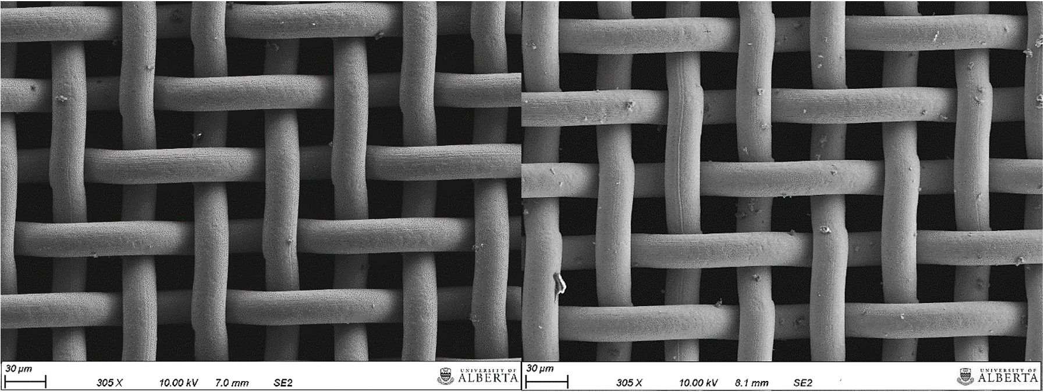
Figure 2 – SEM micrographs for 2 (left) and 7 (right) actuations from Diskus on filter mesh samples.
Results from both the loading studies on the TB filters and examination of the SEM images collectively support the conclusion that there was no apparent loading effect that would influence the performance of the mesh filters. This absence of loading effect is beneficial in scenarios where the respirable dose is difficult to quantify using certain assays because of sensitivity or of quantification limits due to a low amount of API.
Assuming that the amounts collected on the filters are linear in proportion to administered doses, multiple actuations would increase the collected amount of mass in a predictable manner. This outcome provides an advantage in terms of quantification by allowing a researcher to bring the concentration of API above the limit of detection for more accessible or inexpensive assays.
Previous Next Generation Impactor (NGI) measurements conducted by Tavernini et al. [3] provide mass median aerodynamic diameters for Diskus and other DPIs, namely Onbrez Breezhaler, Pulmicort Turbuhaler, and Asmanex Twisthaler. These DPIs have approximate MMADs; hence it would be reasonable to assume similar mechanisms at play with deposition onto the TB filters. In this study, it was concluded that that there was no loading effect for Diskus up to 7 actuations, and the amount collected on the TB filters for that number of doses is 108.6 ± 4.9 µg. A reasonable assumption could be made for other DPIs that there would be no loading effect for up to a similar collected mass of API, however this remains to be confirmed in future, along with a critical loaded drug mass which would begin to influence deposition efficiency.
Lastly, it would be safe to assume that a sufficient amount of API collected onto the TB filters would lead to a change in performance, such as in filtration efficiency. This effect is well documented and apparent in other studies [7, 8], where increased particulate matter loading such as from dust has led to efficiency drops in filters. In the present work, no critical collected mass on the TB filters was reached such that there was an influence on filtration efficiency. The question remains as to how much respirable mass from an inhaler would be required to be deposited onto the TB filters to elicit an effect. It can be seen in Figure 2 that the filter openings are large in comparison to the amount of collected drug, implying that a substantial number of doses would be required to lead to any changes in filter performance.

Conclusion
This study provides evidence that the newly developed FBA and TB mimic filters are insensitive to loading effects for up to 7 actuations of Flovent Diskus, demonstrating consistent estimates of regional lung deposition for up to 7 actuations using the FBA. These results further characterize the robustness of the FBA as an in vitro model for research and development of OIDPs.

Acknowledgements
The authors acknowledge the SEM resources provided by the Scanning Electron Microscope Lab in the Department of Earth and Atmospheric Sciences at the University of Alberta. This study was supported by funding from Proveris Scientific.

References
[1] Labiris NR, Dolovich MB. Pulmonary drug delivery. Part I: physiological factors affecting therapeutic effectiveness of aerosolized medications. Br J Clin Pharmacol 2003; 56:588-599.

[2] Hastedt JE, Bäckman P, Clark AR, Doub W, Hickey A, Hochhaus G, Kuehl PJ, Lehr C-M, Mauser P, McConville J, Niven R, Sakagimi M, et al. Scope and relevance of a pulmonary biopharmaceutical classification system AAPS/FDA/USP Workshop March 16-17th, 2015 in Baltimore, MD. AAPS Open 2016; 2.

[3] Tavernini S, Farina DJ, Martin AR, Finlay WH. Using Filters to Estimate Regional Lung Deposition with Dry Powder Inhalers. Pharm Res 2021; 38:1601-1613.

[4] Tavernini S, Farina DJ, Martin AR, Finlay WH. Using Filters to Estimate Regional Lung Deposition with Pressurized Metered Dose Inhalers. Pharm Res 2022; 39:3371-3380.

[5] Tavernini S, Kiaee M, Farina DJ, Martin AR, Finlay WH. Development of a filter that mimics tracheobronchial deposition of respirable aerosols in humans. Aerosol Sci. Technol. 2019; 53:802-816.

[6] Delvadia RR, Wei X, Longest PW, Venitz J, Byron PR. In Vitro Tests for Aerosol Deposition. IV: Simulating Variations in Human Breath Profiles for Realistic DPI Testing. J Aerosol Med Pulm Drug Deliv 2016; 29:196-206.

[7] Tang M, Chen S-C, Chang D, Xie X, Sun J, Pui D. Filtration efficiency and loading characteristics of PM 2.5 through composite filter media consisting of commercial HVAC electret media and nanofiber layer. Sep Purif Technol 2018; 195:101-109.

[8] Wang Q, Lin X, Chen D-R. Effect of dust loading rate on the loading characteristics of high efficiency filter media. Powder Technol 2016; 287:20-28.

