From formulation physicochemical properties to digital next generation impactors

Daniel Hardy¹, Jianghan Tian¹ & Jonathan Reid²

¹Microsol, 20 Wenlock Road, London, N1 7UG, UK

² ﻿School of Chemistry, University of Bristol, Bristol BS8 1TS, U.K

Summary
Simulations of next generation impactor (NGI) deposition were performed in-silico, utilising state-of-the-art aerosol kinetics models and single-particle measurements of hygroscopicity. Particle size evolution was captured for full aerodynamic particle size distributions (APSDs), and coupled with analytical models of filtration systems. This methodology was demonstrated for a soft mist inhaler aerosol with the potential to be applied to any formulation. Literature descriptions of inertial impactors were used to generate digital representations of an NGI. Experimental data of sodium chloride, salbutamol sulphate and tobramycin were used for the simulation of aqueous aerosols. The effect of formulation properties, in particular, hygroscopicity was shown to have an impact upon the size evolution of each aerosol. The effect of the gas phase relative humidity (RH) upon aerosol distributions was shown as was the corresponding effect upon NGI deposition. A larger amount of deposition is predicted at 10% ambient RH on the more distal late stages within the NGI than at 99 % RH.
Key Message

In-silico representations of coupled aerosol size evolution and deposition enable digital next generation impactor studies for optimising orally inhaled formulation properties.

Introduction
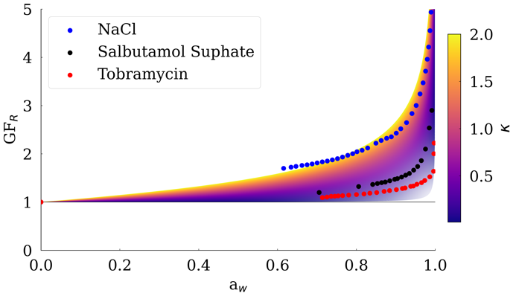
Aerosol transport and deposition within the lung is determined by the nature of gas flow and the aerodynamic particle size of particles.¹ Models of gas flows within the respiratory system are increasing in complexity and resolution.² However, the relationship between the airflow path and airway humidity on the dynamics of aerosol aerodynamic size change are less well understood and are controlled by the kinetics of mass transfer.^{3,4} It is crucial to comprehend and control the aerodynamic particle size to achieve optimal drug deposition. Evaluation of the time-resolved impact of formulation hygroscopicity on aerosol dynamics and deposition during inhalation remains challenging to implement. Hygroscopicity plays a vital role in determining the equilibrium size of aerosol particles and the rate of size change. Figure 1 presents the experimentally measured hygroscopicity of three compounds in comparison to theoretical radial growth factor (GF_{R}) values based upon κ, a coefficient which approximates GF_{R} for a given water activity.^{5,6} Without consideration of factors such as formulation hygroscopicity, simulation of aerosol transport and deposition during inhalation are limited in accuracy, irrespective of the quality of the gas phase simulations.
Figure 1. Experimentally reported growth factors for sodium chloride, salbutamol sulphate and tobramycin (points) in comparison with radial growth factors based upon kappa values (shaded lines).
In this study, we present a framework by which the time -resolved size change of aerosol particles may be accurately simulated and incorporated into analytical models of filtration systems – in-silico representations of coupled size evolution and deposition. This approach may be applied to models of the respiratory tract to gain improved understanding of likely regional deposition.⁷ Alternatively, inertial impactors, such as Next Generation Impactor (NGI) may be represented using this methodology.
The ability to simulate APSD data akin to those generated experimentally, using apparatus such as NGI, provides an opportunity to accelerate early-stage formulation development, with possible formulation properties being explored and optimised digitally, prior to laboratory trials. We here present a case study, demonstrating application of the framework to a plume of aqueous aerosol from a soft mist inhaler, for example, passing through an NGI.

Experimental Methods
In this work we demonstrate the framework’s capability using simulations of droplet size generated using an evaporation kinetics model.⁸ Such simulations require many parameterisations of solvent and solute properties, with solution density and solution hygroscopicity often not being available in the literature. The GF_{R} measurements were obtained from a single microdroplet of solution using an electrodynamic balance (EDB) as described by.⁹ These are then used to generate the required parameterisation of water activity. The density of most solutions were parameterised using experimental data and methods recommended in the literature.¹⁰ When empirical data were unavailable, such as for tobramycin solution, density was calculated using GF_{R} measurements as reported by Gregson.¹¹ Alternatively to simulations, experimental size evolution data may be used, widening the applicability of this model to all formulations – dry powders undergoing dissolution, soft mist evaporation, or volatile solvents evaporating extremely rapidly.
 | $$E_{collection}=\frac{1}{1+\exp\left(α\left(d_{particle}+d_{50}\right)\right)}$$ | Equation 1
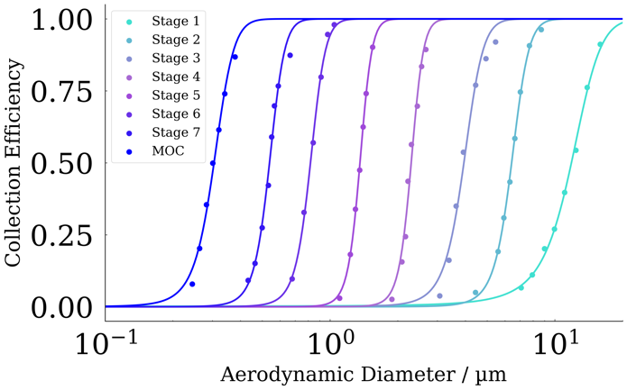
The stage collection efficiencies, E_{collection}, of an archival NGI have been reported in the literature.¹² Modified sigmoid functions, as shown in Equation 1, were fitted to these data, and used to represent each stage. In Equation 1, α is a dimensionless parameter used to control the sharpness of the sigmoid function, d_{particle} is the aerodynamic diameter of particles and d₅₀ is a fitted parameter representing the diameter at which the stage operates with 50 % efficiency. Figure 2 presents the example data and the corresponding fits achieved using this method. The time at which a plume of aerosol may pass through each stage is approximated using the internal volume of the impactor and the flow rate with the assumption that stages are evenly distributed throughout the impactor.
Figure 2. Experimental data for collection efficiencies of an NGI at a flow rate of 30 L/min (points). Corresponding fitted functions are shown with colour-matched lines.

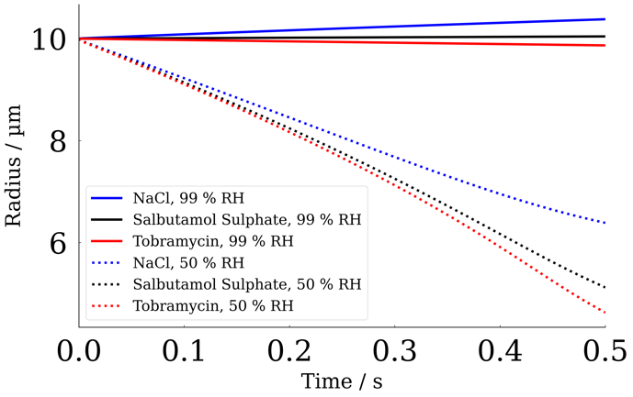
Results and Discussion
Figure 3. The temporal size evolution of aqueous solution droplets with an initial size of 10 µm and initial mass fraction solute of 5 % at 298 K and at 50 % and 99 % RH.
Figure 3 shows the simulated evaporation and condensation of sodium chloride, salbutamol sulphate and tobramycin solutions in both high and low RH, demonstrating the impact of solution hygroscopicity.
The size evolution of an example APSD, based on measurements reported by Armstrong-Green, in 99 % and 10 %RH is shown in Figure 4.⁵ It can be seen that small droplets (for example, < 1µm) reach an equilibrium size more quickly than larger (> 2µm). In high RH, the distribution shifts to the right due to condensational growth, and in low humidity, evaporation results in the distribution shifting to the left. It is also clear that evaporation occurs much more rapidly than condensation.
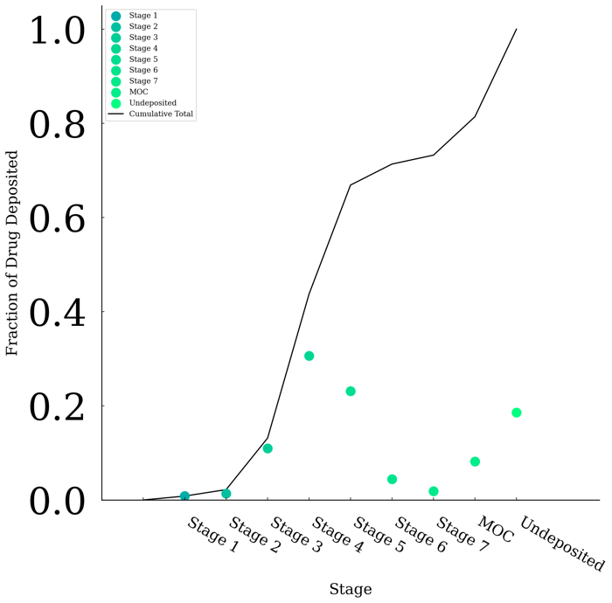
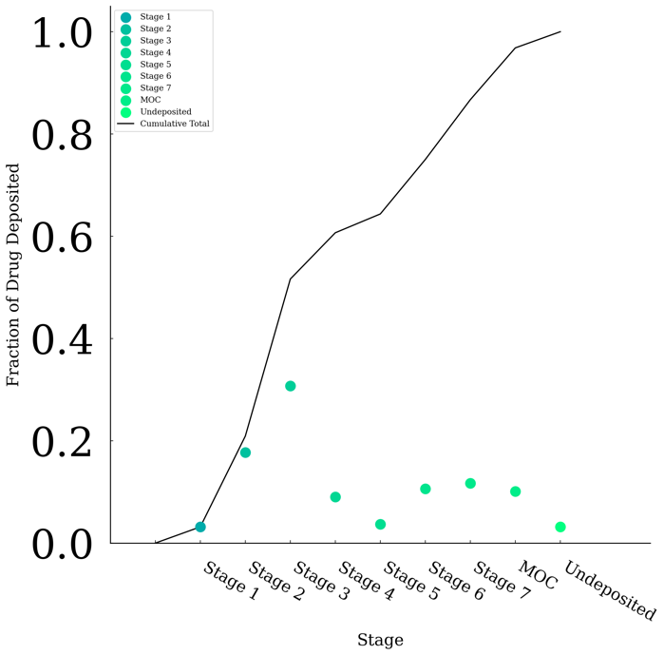
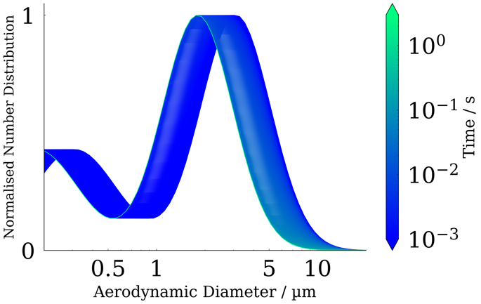
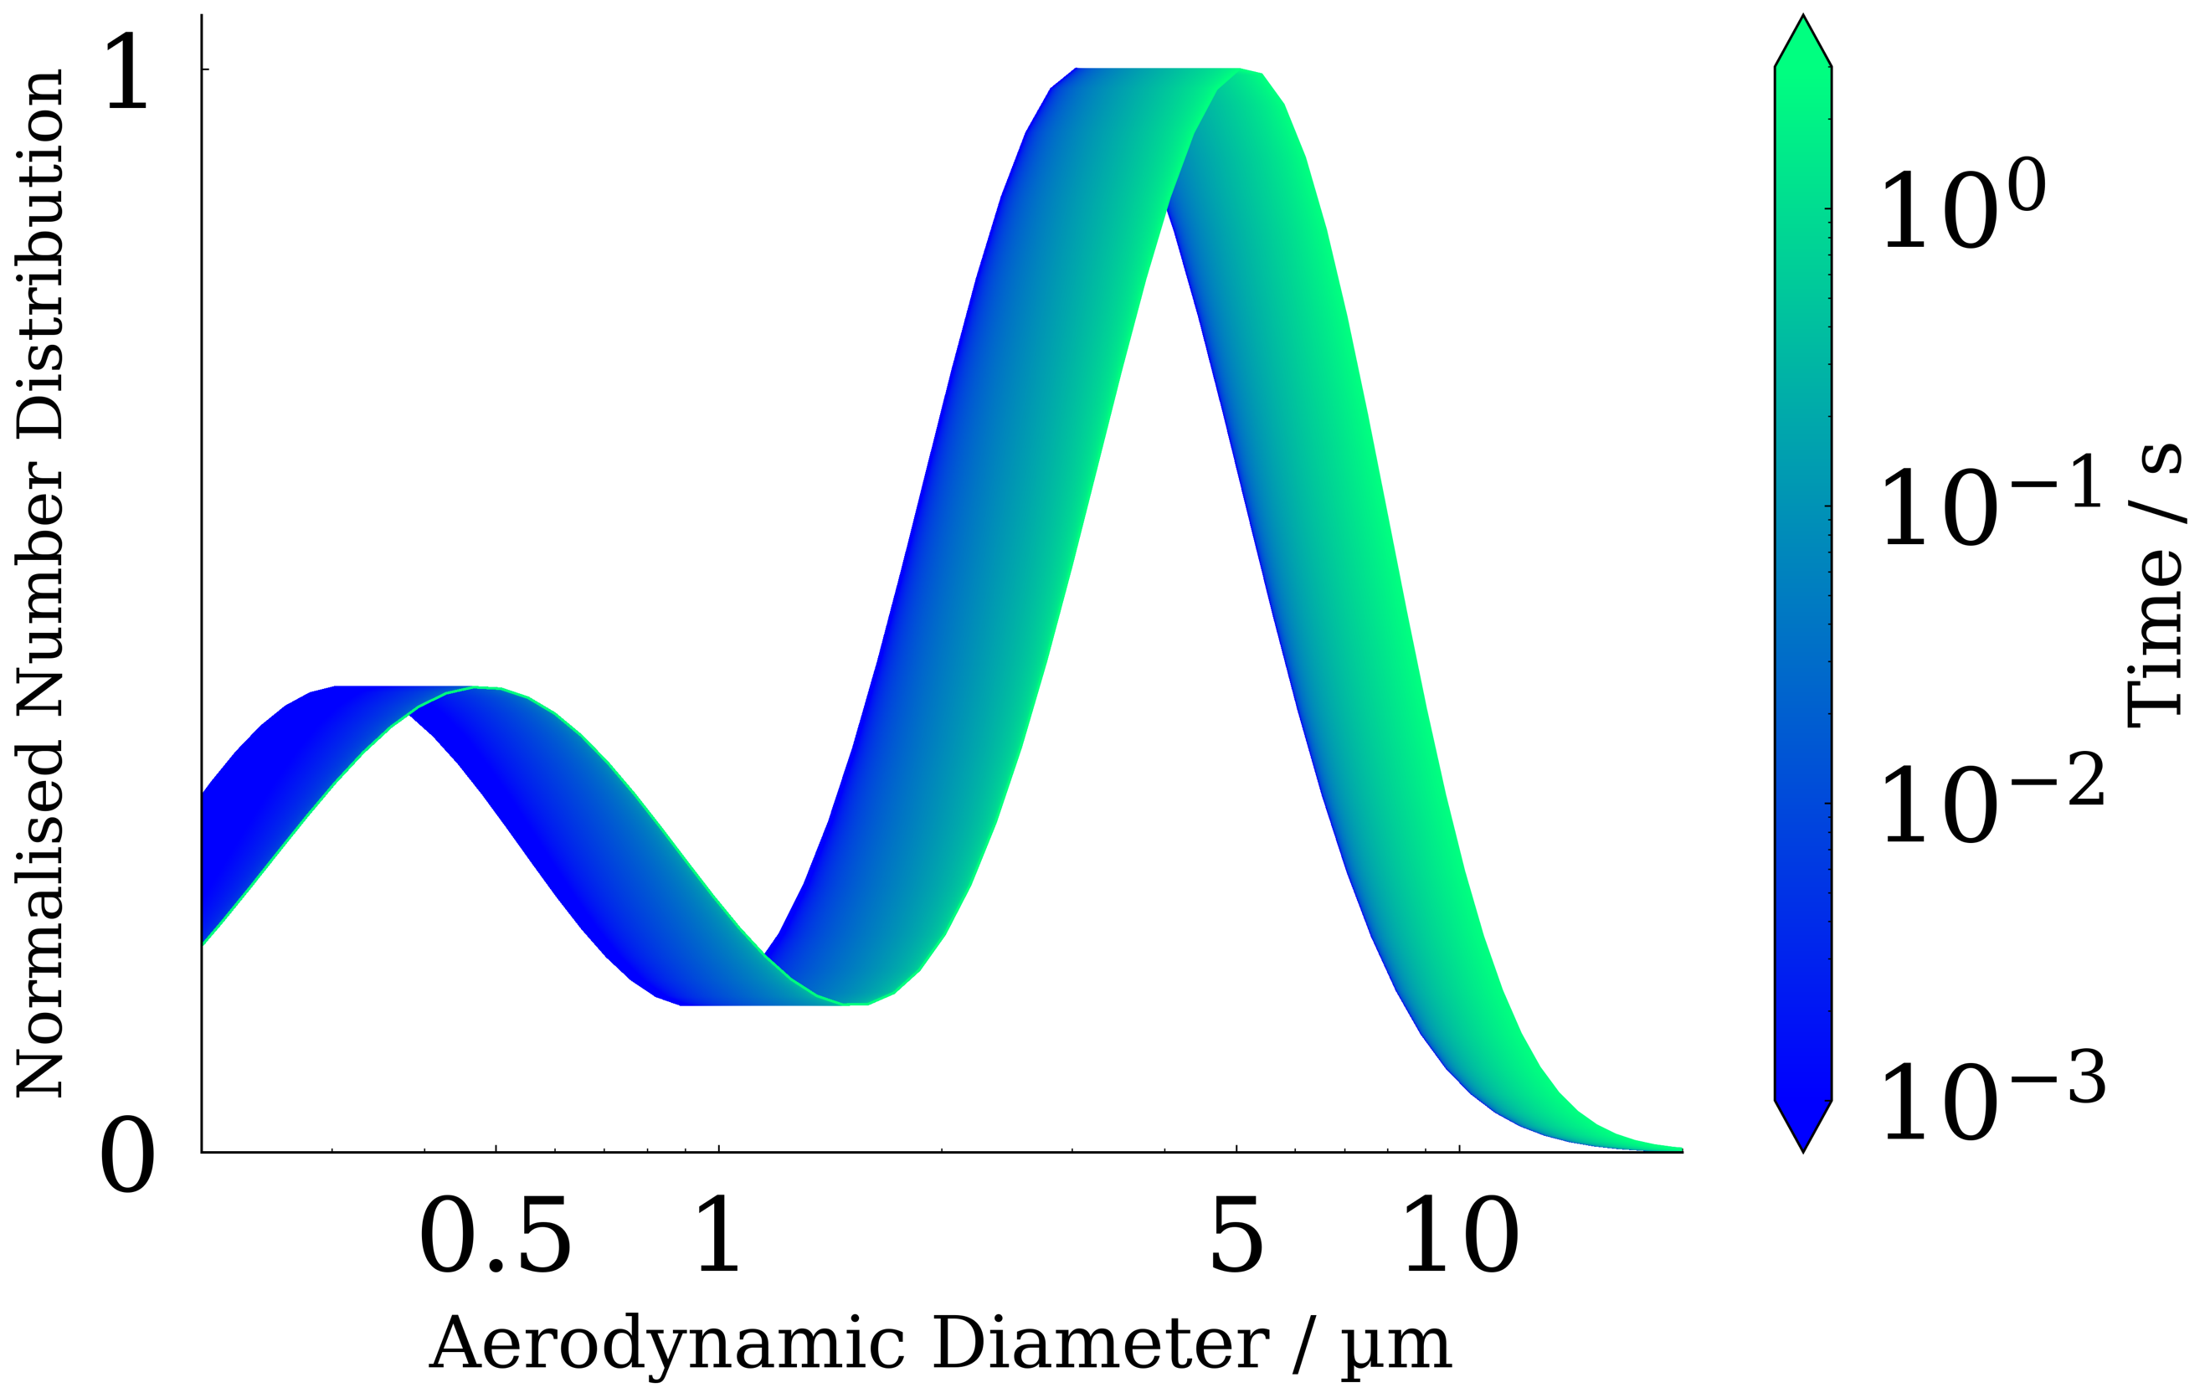
The simulated droplet evolution enables the precise drug concentration of droplets to be known over time. By coupling an evolving size distribution with the simulated NGI, the deposition upon each stage may be found. Figure 5 presents the predicted deposition upon each stage for a bimodal distribution with peak mass concentrations at 0.3 µm and 3 µm as reported for soft mist inhalers, at 99 % and 10 % RH.¹³ At a low RH, droplets evaporate and are deposited on later stages in the NGI. Conversely, in high RH, deposition occurs upon earlier stages due to the larger size of droplets. The undeposited fraction is comprised of particles which pass fully through the NGI and would not be expected to be measured in experiments.
Figure 5. Predicted NGI deposition for a dispersion of aqueous sodium chloride solution droplets in air at a RH of 10 % (left) and 90 % (right).
Figure 4. The evaporation (left) and condensational growth (right) of a distribution of aqueous sodium chloride aerosol exposed to 10 % and 99 % RH, respectively.
Figure 3 and Figure 5 demonstrate the significant impact of formulation properties and environmental conditions in controlling deposition in an NGI, a key tool in formulation development. Digital representations of impactors provide an opportunity to optimise formulations in-silico. Optimal properties, such as solute concentration and hygroscopicity, may be identified using the methods described and the impact of size distribution upon deposition may be explored.

Conclusion
A coupled aerosol evolution and deposition framework is described and demonstrated for aqueous aerosol such as those generate by soft mist inhalers passing through an NGI. Simulations of droplet evolution are generated, using EDB measurements of hygroscopicity. The dependence of NGI deposition upon environmental RH is shown for sodium chloride aerosol, demonstrating the importance on controlling the conditions in experimental work and highlighting the application of computational approaches for the exploration of formulation behaviour in physiological conditions. Such an approach enables deposition behaviour of formulations to be optimised prior to laboratory NGI studies being performed though guided modulation of formulation properties.
Future work includes the application of this framework to drugs relevant to respiratory medicine and the incorporation of analytical models of the lungs, such as the ICRP human tract model, for the evaluation of regional deposition.¹⁴ The approach shown offers a route to exploring aerosol plume dynamics and deposition in physiologically relevant conditions, without experimental challenges such as maintaining temperature and RH. Such steps will enable better prediction of drug delivery and allow formulation properties to be modulated for the optimisation of controlled deposition.

References
1. Hickey AJ, Martonen TB, Yang ’ Y. Theoretical relationship of lung deposition to the fine particle fraction of inhalation aerosols. Phannaceutica Acta Helvetiae 1996;7:18–190.
2. Lin CL, Tawhai MH, Hoffman EA. Multiscale image-based modeling and simulation of gas flow and particle transport in the human lungs. Wiley Interdiscip Rev Syst Biol Med 2013;5(5):643–655; doi: 10.1002/wsbm.1234.
3. Martonen TB, Katz IM. Deposition Patterns of Aerosolized Drugs Within Human Lungs: Effects of Ventilatory Parameters. Pharmaceutical Research: An Official Journal of the American Association of Pharmaceutical Scientists 1993;10(6):871–878; doi: 10.1023/A:1018913311788.
4. E. Haddrell A, F. Davies J, P. Reid J. Dynamics of Particle Size on Inhalation of Environmental Aerosol and Impact on Deposition Fraction. Environmental Science &amp; Technology 2015;49(24):14512–14521; doi: 10.1021/acs.est.5b01930.
5. Green NCA. Dynamic Response of Hygroscopic Pharmaceutical Aerosol on Inhalation. 2021;(November).
6. Petters MD, Kreidenweis SM. A single parameter representation of hygroscopic growth and cloud condensation nucleus activity-Part 3: Including surfactant partitioning. Atmos Chem Phys 2013;13(2):1081–1091; doi: 10.5194/acp-13-1081-2013.
7. Legh-Land V, Haddrell AE, Lewis D, et al. Water Uptake by Evaporating pMDI Aerosol Prior to Inhalation Affects Both Regional and Total Deposition in the Respiratory System. Pharmaceutics 2021, Vol 13, Page 941 2021;13(7):941; doi: 10.3390/PHARMACEUTICS13070941.
8. Hardy DA, Robinson JF, Hilditch TG, et al. Accurate Measurements and Simulations of the Evaporation and Trajectories of Individual Solution Droplets. Journal of Physical Chemistry B 2023;127(15):3416–3430; doi: 10.1021/acs.jpcb.2c08909.
9. Rovelli G, Miles REHH, Reid JP, et al. Accurate Measurements of Aerosol Hygroscopic Growth over a Wide Range in Relative Humidity. Journal of Physical Chemistry A 2016;120(25):4376–4388; doi: 10.1021/acs.jpca.6b04194.
10. Cai C, Miles REH, Cotterell MI, et al. Comparison of methods for predicting the compositional dependence of the density and refractive index of organic-aqueous aerosols. Journal of Physical Chemistry A 2016;120(33):6604–6617; doi: 10.1021/acs.jpca.6b05986.
11. Gregson FKA. Evaporation Kinetics and Particle Formation from Aerosol Solution Microdroplets, PhD Thesis. PhD Thesis. 2020.
12. Marple VA, Olson BA, Santhanakrishnan K, et al. Next Generation Pharmaceutical Impactor (a new impactor for pharmaceutical inhaler testing). Part II: Archival calibration. Journal of Aerosol Medicine: Deposition, Clearance, and Effects in the Lung 2003;16(3):301–324; doi: 10.1089/089426803769017668.
13. Ke WR, Wang WJ, Lin TH, et al. In vitro evaluation of aerosol performance and delivery efficiency during mechanical ventilation between soft mist inhaler and pressurized metered-dose inhaler. Respir Care 2020;65(7):1001–1010; doi: 10.4187/respcare.06993.
14. ICRP. Human Respiratory Tract Model for Radiological Protection. Ann ICRP 1994;24(66).

