Evaluation of impurities, degradation products and foreign particles arising in an unwashed valved holding chamber (VHC) used with a pressurised metered dose inhaler (MDI)

Justine Bloch^{1,2} & Yannick Baschung¹

¹ Drug Delivery and Physical Characterization, Solvias AG, Kaiseraugst, Switzerland

² Department of analytical chemistry, Université Claude Bernard Lyon 1, Lyon, France

Summary
We aimed to investigate the potential accumulation of impurities and degradation products that could arise from the misuse of a pressurised MDI (Symbicort® Rapihaler® Budesonide / Formoterol 160 ug/4,5 ug, AstraZeneca) when used in combination with a VHC (AeroChamber Plus®, Sandoz). To simulate real-life scenarios, we subjected the spacer to six actuations per day over a three-month period without any cleaning. Following this simulated usage, we distributed two doses in a collection tube through the VHC and extracted all components to identify any impurities. A noticeable increase in budesonide, formoterol and their degradation products were detected both in the VHC and in the collection tube during the extraction process. This finding emphasizes the importance of regular cleaning and maintenance to prevent substantial build-up over time. The notable increase in impurities and APIs levels within the collection tube raises possible concerns about the potential impact on patient safety when cleaning is neglected for an extended period. These results underscore the necessity for vigilant cleaning practices and highlight the limitations of the VHC in preventing impurity transfer over extended periods of misuse and provide valuable insights into the behavior of MDI spacers under misuse conditions.
Key Message

Regular cleaning of MDI spacers or VHCs is crucial to prevent the accumulation of drug substance and impurities and degradation products. The findings of this study underscore the importance of rigorous cleaning protocols to ensure patient safety. Neglecting cleaning over time can lead to potential risks, thus emphasizing the need for strict adherence to cleaning instructions.

Introduction
Patient non-adherence to medication instructions is a common challenge in healthcare, and it poses challenges for children due to their unique characteristics and circumstances, especially when using medical devices such as spacers or a valved holding chamber (VHC) []. VHCs are important devices that accompany respiratory medications for individuals who may have difficulties coordinating inhalation with actuation and come with specific instructions to be followed for optimal use and regular cleaning procedures to follow [2]. Children may struggle with remembering medication schedules and instructions, and although parental involvement and support play a crucial role in ensuring pediatric adherence, parents themselves may face challenges in remembering and following medication instructions []. It is essential to measure the potential outcomes of patient non-adherence as, given the unique needs of these patient populations, proper cleaning and maintenance practices for VHCs are paramount in reducing the risk of impurity-related complications. Moreover, children, especially younger ones, may have limited ability to communicate discomfort or adverse reactions caused by impurities [], [3]. Therefore, understanding the consequences of non-adherence is crucial for optimizing the usage and maintenance of VHCs, ensuring patient safety and treatment efficacy.
To address these concerns, we investigated the occurrence and potential transfer of impurities and degradation products resulting from the misuse of a VHC. A VHC (AeroChamber® Plus Flow-Vu, Sandoz), which patients are instructed to clean weekly, was used in combination with a pressurised MDI (Symbicort® Rapihaler® 200/6, AstraZeneca) and subjected to continuous usage over a three-month period without cleaning, before proceeding to a delivered dose analysis and to the identification of the impurities present in the VHC and in the collection tube.

Materials and methods
To mimic the use of a spacer, 6 actuations of a Symbicort® Rapihaler® 200/6 per day for 5 days per week (total 120 actuations/month) were performed into a VHC at a 20 L/min flow rate. The VHC was extracted with 50 mL diluent (H₂O/ACN, 70/30 v/v). The emitted dose was collected using the Dosage Unit Sampling Apparatus (DUSA) sampling at a flow rate of 28 L/min and a volume of 2 L. All determinations were evaluated by reverse-phase Ultra High-Performance Liquid Chromatography. Data were evaluated using the chromatographic software Chromeleon 7.2.10. An LC-ESI-MS method to simultaneously separate and identify both budesonide and formoterol degradation products within the same method has been developed for this purpose (Table 1). The impurities were identified using the software freestyler and Compound Discoverer 3.3.
Table 1 Chromatographic conditions
Parameters | Method
Mobile phase A | 5 mM ammonium bicarbonate buffer, pH 8.2
Mobile phase B | Acetonitrile
Column | Acquity UPLC BEH C18 10 cm × 2.1 mm × 1.7 µm
Column temperature | 35°C
Flow rate | 0,6 mL/min
Injection volume | 20 uL
Run time | 48 minutes
Detection | UV (214 nm and 244 nm)

Optical microscopy (Olympus BX53 with the Clemex software) has been used to assess the presence of foreign particles in the extracts obtained from the collection tubes. The particles (>100 um) have then been isolated and analysed using FT-IR microscope (Perkin Elmer Spotlight 400) and electron microscopy (FEI Nova Nano SEM 230).
Results
An overlay of the impurities and degradation products obtained from a clean and from the unclean VHCs after 3 months of simulated use during delivered dose testing can be seen in Figure 1. An overlay of the impurities and degradation products extracted from the collection tubes connected to the clean and to the unclean VHCs can be seen in Figure 2.
Figure 3 illustrates the increase in peak area for budesonide, formoterol, formoterol impurity I and budesonide impurities I obtained from a collection tube connected to an unwashed VHC in comparison to the results obtained from a collection tube connected to a cleaned VHC.
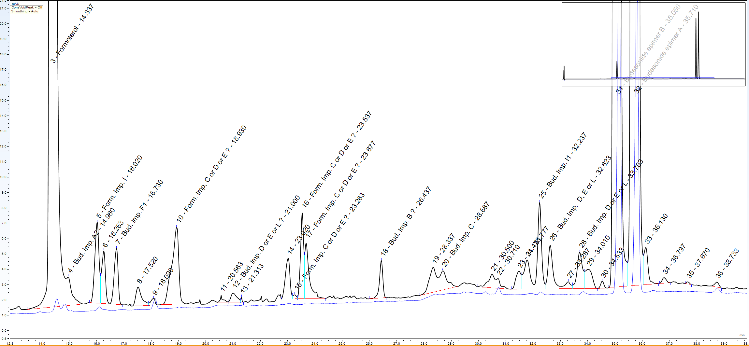
Figure 1 Chromatogram (244 nm) of the extraction obtained from a clean VHC (in blue) and an unclean VHC (in black) after delivered dose testing.

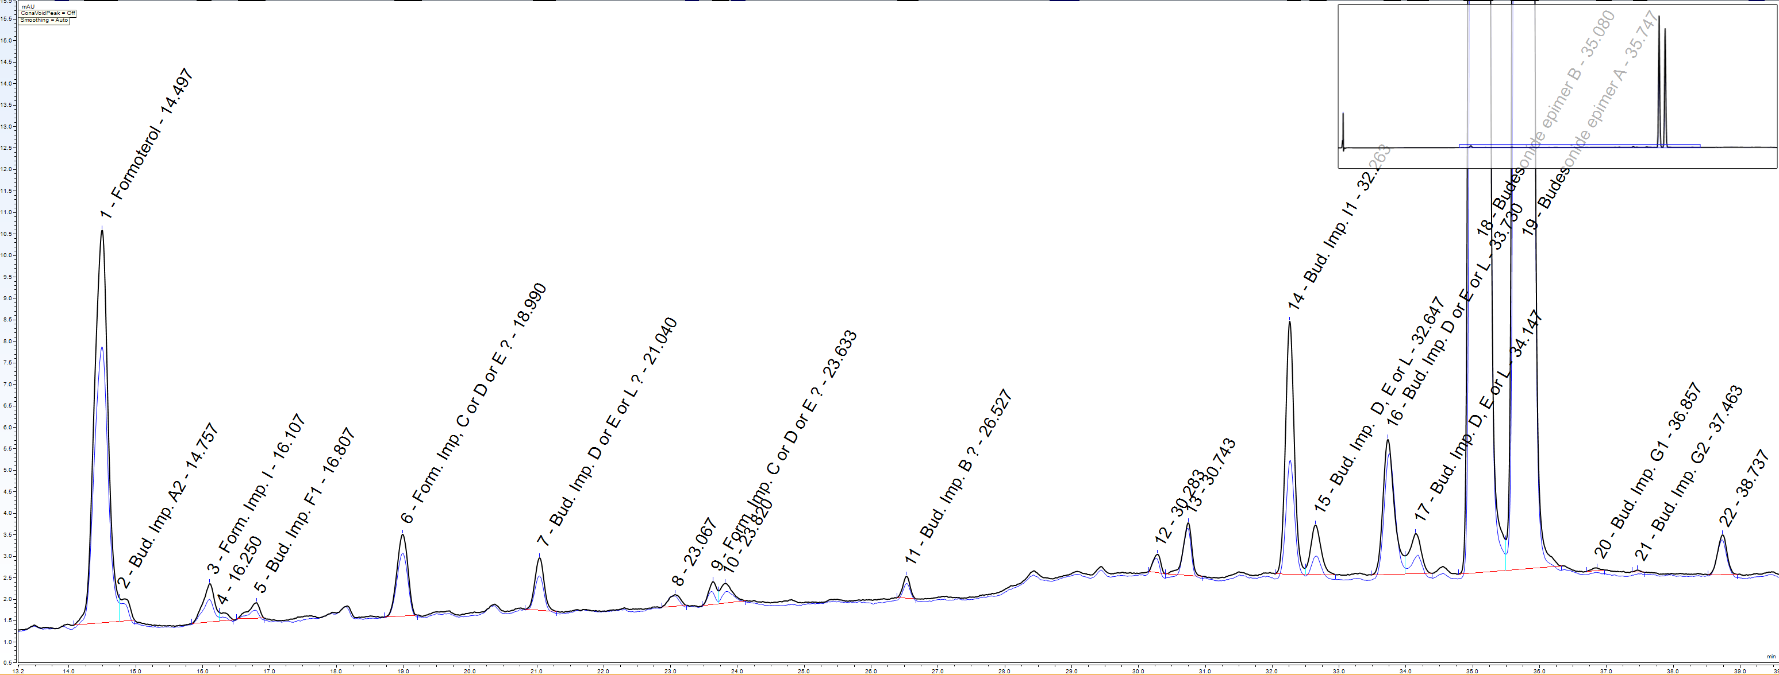
Figure 2 Chromatogram (244 nm) obtained from the collection tube after delivered dose testing with a clean VHC (in blue) and with an unclean VHC (in black).

Figure 3 Increase in peak area (%) of compounds obtained from a collection tube connected to an unwashed VHC in comparison to the results obtained from a collection tube connected to a cleaned VHC.
Images obtained by optical microscopy from foreign particles identified in the collection tube connected to the unwashed VHC are shown in Figure 4.
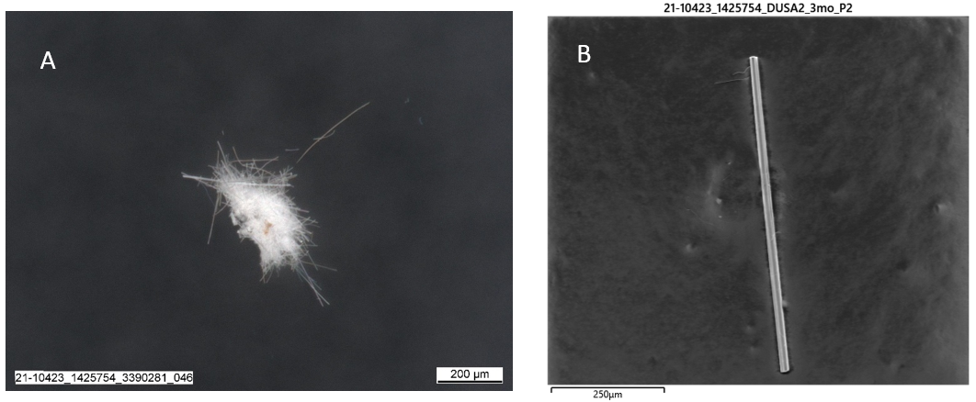Figure 4 Foreign particles identified in the collection tube connected to the unwashed VHC. A: Crystalline particle. B: Fiber particle.

Results from Energy-dispersive X-ray (EDX) spectroscopy analysis on the fiber particle (Figure 4B) is shown in Figure 5.
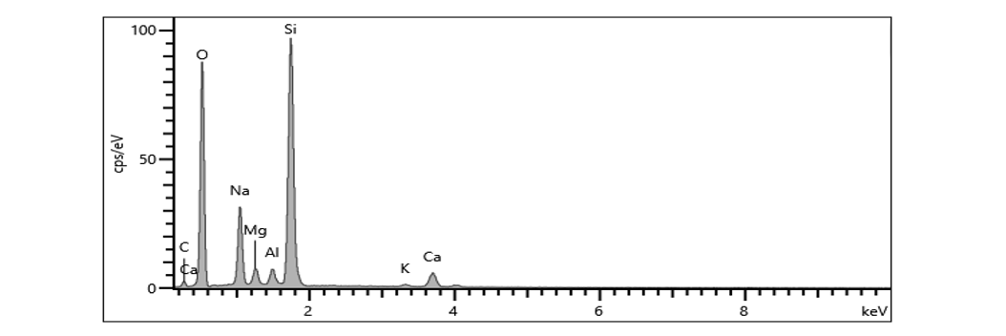
Figure 5 Energy-dispersive X-ray (EDX) spectroscopy analysis on the fiber particle (Figure 6B).
Discussion and conclusion
In Figure 1, a substantial increase in budesonide, formoterol, and their degradation products is evident in the unwashed VHC compared to the clean VHC after delivered dose testing. While a rise in main compounds and related substances is expected over prolonged VHC use, Figures 2 and 3 reveal a concerning 27% and 26% increase in formoterol and budesonide, respectively, in the collection tube used with the unwashed VHC. Additionally, there is a significant rise of 37% and 52% in formoterol impurity I and budesonide impurities I, respectively, in the same collection tube. These findings emphasize that the accumulation of active pharmaceutical ingredients and degradation products extends beyond the VHC itself, possibly impacting the medication collected for delivery and thus raising concerns about the quality and safety of the delivered medication due to prolonged VHC misuse.
Furthermore, the analysis of the extracted collection tube revealed the presence of particles primarily composed of carbohydrate-based materials, likely originating from the canister composition or contaminants as the VHC has been exposed to the atmosphere for several months. While such particles are not causing significant concerns, two distinct particles were identified. A crystalline inorganic fiber (Figure 4A) was identified as silicate through FT-IR microscopy, though its origin remains unknown. A fiber-like particle (Figure 4B) with a composition analogous to the glass fiber filter used for delivered dose testing. The presence of this particle is attributed to the filter and does not pose safety concerns.
These findings underscore the necessity for rigorous cleaning protocols, not only to maintain the VHC integrity but also to safeguard the delivered dose from contamination. Caregivers and healthcare providers should exercise caution in educating children and their families about cleaning protocols to promote optimal therapeutic outcomes and potentially minimize risks associated with inhaler use in pediatric populations. While these results provide valuable insights, further studies should be performed on the chromatographic method employed to identify remaining unknown impurities. Moreover, exploring the minimum duration of VHC neglect, after which safety concerns emerge, would be essential to deepen our comprehension of VHC safety standards.

References
[] Ahrens, R C, The role of the MDI and DPI in pediatric patients: Children are not just miniature adults, Respiratory care 2005, 50: pp 1323-1330.
[2] Instruction for use from the Spacer AeroChamber® Plus Flow-Vu, Sandoz.
[3] Schüepp K G, Devadson S, Roller C, Wildhaber J H: A complementary combination of delivery device and drug formulation for inhalation therapy in preschool children, Swiss Medical Weekly 2004; 134: pp 198-200.

