Anti-biofilm activity of aerosolized phage vs. ciprofloxacin using an in vitro lung deposition platform

Mathura Thirugnanasampanthar^{1,2}, Mellissa Gomez^{1,2}, Myrna Dolovich^{1,3,4} & Zeinab Hosseinidoust^{1,2,5,6,7}
¹McMaster University, Hamilton, ON, L8S 4L8, Canada
²Department of Chemical Engineering
³Faculty of Health Sciences, Department of Medicine
⁴St. Joseph’s Healthcare, Firestone Research Aerosol Laboratory, Hamilton, ON, L8N 4A6, Canada
⁵School of Biomedical Engineering
⁶Michael DeGroote Institute for Infectious Disease Research
⁷Farncombe Family Digestive Health Research Institute

Summary
Pseudomonas aeruginosa is a bacterial pathogen frequently implicated in recurring, antibiotic-resistant airway infections. Aerosolized treatments for lower respiratory tract infections should include fine droplets <5 µm in aerodynamic size that can effectively penetrate and deposit at distal sites within the lungs. An in vitro platform composed of a six-stage viable cascade impactor fitted with transwell inserts containing P. aeruginosa biofilms was used to model different sites of infection within the airways. Biofilms were subsequently exposed to size-fractioned droplets of nebulized bacteriophage (phage) or the fluroquinolone antibiotic ciprofloxacin. Exposure to phage, regardless of the dose delivered by size-fractioned droplets, resulted in significant reduction of free-floating and adherent bacteria as compared to negative control samples. Conversely, antibacterial efficacy of ciprofloxacin exhibited a strong dose dependence. Only biofilms that received the highest dose of ciprofloxacin of 2.5 µg, delivered by ≥7 μm sized droplets, exhibited significant reduction in viability as compared to negative control samples. The superior performance of phage may be attributed to its self-replicating nature, allowing for on-site amplification from repeated cycles of infection, propagation, host cell lysis, and progeny virion release. Lacking this characteristic, intervention with nebulized ciprofloxacin proved to be dose restrictive. This study demonstrates the promise of inhaled delivery of lytic phages for tackling persistent deep lung infections as compared to conventional antibiotics.
Key Message
Biofilms were exposed to aerosols containing anti-Pseudomonas phage or ciprofloxacin. Significant reduction in bacterial viability was noted 24-hrs after phage challenge despite dose differences. Conversely, only biofilms exposed to the highest dose of ciprofloxacin were significantly reduced. Self-replicating ability of phages offers a clear advantage as compared to dose-dependent antibiotics.
Introduction
Antimicrobial resistance (AMR) development in lower respiratory tract infections (LRTIs) was linked to 1.5 million deaths globally in 2019.¹ The gram-negative bacterial pathogen, P. aeruginosa, was identified among the most common species implicated in AMR-related mortalities.¹ Biofilm mode of growth, wherein bacteria reside within a hydrated exopolysaccharide matrix, allows P. aeruginosa to evade host immune surveillance, resist bactericidal agents, and establish chronic airway infections.²
Bacteriophage (phage): Bacteria-specific virus
Biofilm: Protective matrix composed of secreted polysaccharides and embedded bacteria
Planktonic bacteria: Free-floating bacteria
Sessile bacteria: Surface-bound bacteria
Phages are bacterial viruses that exhibit targeted antibacterial activity, low inherent toxicity, and the capacity to self-propagate within host cells.³ In this work, we compared antibacterial efficacy of aerosolized phage with that of aerosolized ciprofloxacin against 24-hrs biofilm cultures of P. aeruginosa. Biofilms were placed within an impactor platform to model infection sites at varying depths within the airways. Bactericidal effects of nebulized phage and antibiotic were assessed 24-hrs post-exposure and discussed in relation to dose distribution.
Experimental Materials and Methods
Solutions. Tryptic soy broth (TSB), tryptic soy agar (TSA) media, and phosphate buffered saline (PBS) solution was prepared according to manufacturer’s instructions. Saline solution was 9 g/L of sodium chloride. Due to pH dependent solubility of ciprofloxacin (increased solubility at low pH)⁴, stock antibiotic solution (10 mg/mL) was prepared by dissolving 1 g of ciprofloxacin (Enzo Life Sciences ALX-380-287-G025) in equal parts 0.1 M HCl and ultrapure water. Phage suspension (7×10⁸ PFU/mL) and ciprofloxacin solution (7.5 mg/mL) were prepared in carrier solutions consisting of 25% TSB and 75% ultrapure water. The antibiotic solution had a final pH of 3.15 while phage suspension had a pH of 7.4. Consequently, both a ciprofloxacin-free carrier (pH of 3.15) and a phage-free carrier (pH of 7.4) were prepared as negative controls. XTT reaction solution consisted of 79%, 20%, and 1% (v/v) of TSB, 1 mg/mL XTT (Sigma-Aldrich X4626) in PBS, and 10 mM menadione (ThermoScientific AC127181000) in 100% acetone, respectively. Solutions were sterilized with 0.22 µm-pore-sized filters or autoclaved.
Pseudomonas aeruginosa PAO1 bacterial cultures. P. aeruginosa strain PAO1 (DSM 25641) were cultured in TSB for 18 hrs at 37°C under agitation (180 rotations per minute or rpm). Bacterial cultures were stored at 4ºC prior to use. Overnight bacterial culture was diluted 1:100 in fresh TSB to a concentration of 5×10⁷ CFU/mL and 500 µL aliquots were added to transwell inserts (BRAND 782730). Transwells were placed into 12-well plates (VWR 10861-556) and incubated for 24-hrs (37°C, 120 rpm). Spent media was removed (250 µL) from biofilms before aerosol exposure. Exposed biofilms received fresh media (250 µL) and were returned to the incubator for an additional 24-hrs.
Phage propagation and enumeration. Overnight culture of P. aeruginosa was diluted 1:100 in fresh TSB and incubated for 4-hrs at 37°C and 180 rpm. A single plaque of vB_Pae-Tbilisi32 (DSM 25635) (Figure 1d) was added to the subculture and incubated for an additional 3-hrs. The resulting crude lysate was centrifuged for 20 mins at 7000×g, and the supernatant was sterile filtered. The concentration of the phage suspension was determined using a standard plaque assay method.⁵
Generation and collection of aerosol droplets. A previously developed exposure platform⁶, similar to Cooney et al.⁷, was used to generate and size fraction aerosol droplets (Figure 1a). Aerosols were generated using the single-jet Blaustein fitted with the 10-40 expansion plate and operated in atomizer mode. Feed flow rate of 700 µL/min, compressed air flow rate of 1.5 L/min, and humidified air flow rate of 26.8 L/min remained constant across all trials. Placement of transwell inserts (foil-lined or biofilm-containing) within the impactor followed an odd-even arrangement with glass petri dishes containing 27 mL of agar (Figure 1d) which also remained constant across all trials.
Dose distribution profiles. Transwell inserts lined with foil (Figure 1b) were used to collect carrier, ciprofloxacin, and phage deposits below each impactor stage. Phage-free or ciprofloxacin-free carrier solutions containing 10 mg/mL of sodium fluorescein were aerosolized for 1 minute. To improve detection in the absence of a fluorescent tracer, phage suspension (1×10⁹ PFU/mL) was aerosolized for two minutes, while ciprofloxacin solution (7.5 mg/mL) was aerosolized for three minutes. Foil substrates were removed from transwell inserts and placed into Eppendorf tubes containing 1 mL of ultrapure water (fluorescein or ciprofloxacin) or 1 mL of TSB (phage) and vortexed. Fluorescein wash samples were added to black, 96-well microplate (Greiner Bio-One 655086) in triplicates (200 µL/well) and detected a gain of 100 and λ_{ex}/λ_{em} of 490±5/515±5 nm (Biotek Synergy Neo2). Ciprofloxacin was detected at a gain of 150 and λ_{ex}/λ_{em} of 270±5/445±5 nm.⁸ Percent ciprofloxacin dose deposited into each transwell was calculated according to Equation 1. Phage wash samples were diluted in TSB as needed and 100 µL was plated on bacterial lawn plates. Plaque counts were used to determine the percent infectious phage dose deposited into each transwell according to Equation 2.
Equation 1 – Ciprofloxacin dose % = $\frac{\left[Wash sample intensity\right]}{[Feed intensity× Feed flow rate \left(\frac{mL}{min}\right)×Aerosolization period \left(min\right)]}×100$
Equation 2 – Phage dose % = $\frac{\left[\frac{PFU}{Wash sample volume (mL)}×Dilution factor\right]}{[Feed concentration \left(\frac{PFU}{mL}\right)×Feed flow rate \left(\frac{mL}{min}\right)× Aerosolization period \left(min\right)]}×100$

Bacterial viability assay. Metabolic activity of planktonic and sessile bacteria was quantified 24-hrs post exposure. Free-floating bacteria (planktonic) in the liquid portion was transferred into 10 mL of 0.9% (w/v) saline, vortexed to disperse the bacteria, and centrifuged at 7000×g for 20 mins. Bacterial pellet was isolated by decanting the supernatant. XTT reaction solution (4 mL) was added to washed, planktonic bacteria and adherent (sessile) bacteria (remaining on transwell insert membrane). Bacteria was incubated with the reaction solution at 37°C and 120 rpm for 1 hr. After the incubation period, 200 µL samples were added to clear 96-well microplate (Greiner Bio-One 655090) in triplicate and measured at λ_{abs} of 490 nm (Biotek Synergy Neo2). Absorbance values of samples incubated with the XTT reaction solution was normalized by subtracting absorbance values resulting from the reaction solution alone.
Microscopy. Ciprofloxacin was mounted onto a copper-taped aluminium stub and gold sputter coated to 15 nm before imaging via scanning electron microscopy. Phage stock was stained with 1% uranyl acetate and then imaged via transmission electron microscopy on a copper coated formvar grid.
Statistical analysis. GraphPad PRISM 9 was used for statistical analysis using multiple unpaired t-tests; p-value ≤ 0.05 was considered statistically significant.
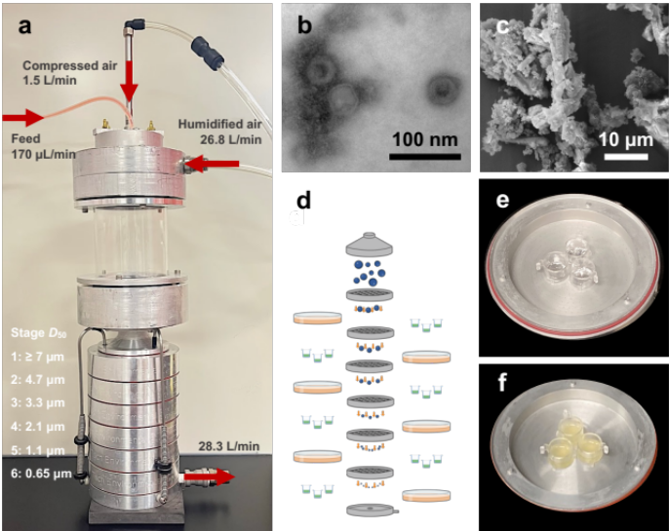
Figure 1 – In vitro platform for the exposure of P. aeruginosa biofilms to size-fractioned droplets of phage or antibiotic. Aerosol exposure platform consists of a 10-cm-high glass mixing chamber and a 6-stage viable cascade impactor wherein droplets are separated according to aerodynamic cut-off size (a). TEM image of anti-Pseudomonas phage virions (b). SEM image of ciprofloxacin flakes (c). Transwell inserts lined with foil or containing 24-hrs biofilm cultures were placed below alternate stages of the impactor and exposed to nebulized phage suspension (7×10⁸ PFU/mL) or ciprofloxacin solution (7.5 mg/mL) (d-f).

Results
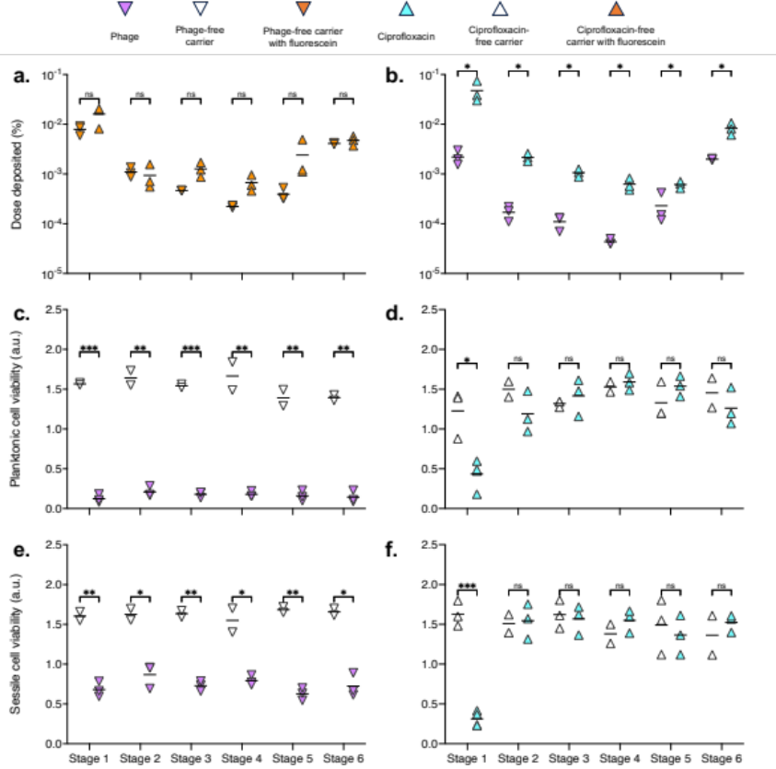
Experimental results are presented in Figure 2. Fluorescein was added to carrier media to calculate dose distribution profiles of inert droplets (Figure 2a). In addition, distribution of bactericidal droplets was determined using the plaque assay method to detect infectious phage virions and spectrofluorimetric method to detect ciprofloxacin (Figure 2b). Data presented in Figure 2a illustrates similar dose distribution profiles for both carriers across all stages. Results presented in Figure 2b illustrates significantly higher doses of ciprofloxacin are deposited into transwells as compared to infective phage across all stages. Lower than expected phage dose distribution can result from damage incurred during nebulization, as reported in previous literature.⁹ P. aeruginosa biofilms cultured at 37ºC for 24-hrs were placed below odd or even numbered impactor stages in triplicates and exposed to size-fractioned droplets (Figure 2c-f). Bacterial viability was determined 24-hrs post-exposure using the XTT metabolic activity assay. Significant reduction in planktonic (Figure 2c) and sessile (Figure 2e) cell viability was observed in phage-exposed samples across all exposure sites. Meanwhile, only samples exposed to ciprofloxacin below the first stage exhibited significant reduction in planktonic (Figure 2d) and sessile (Figure 2f) cell viability as compared to negative control samples.
Figure 2 – Dose and antibacterial efficacy of nebulized phage and ciprofloxacin. Dose distribution profiles phage- and ciprofloxacin-free carrier solutions containing 10 mg/mL of fluorescein (λ_{ex}/λ_{em}, 490±5/515±5 nm) (a). Dose distribution profiles of phage and ciprofloxacin determined using the plaque assay and spectrofluorimetric method, respectively (λ_{ex}/λ_{em}, 270±5/445±5 nm) (b). Viability of biofilm bacteria quantified 24-hrs post-exposure to size-fractioned droplets of phage and phage-free carrier (c, e) or ciprofloxacin and ciprofloxacin-free carrier (d, f). Viability was based on metabolic activity measured using the XTT assay (λ_{abs}, 490 nm), where high absorbance corresponds to high metabolic activity. Statistical significance was based on multiple unpaired t-tests: ns indicates not significant, *– p<0.05, **– p≤0.01, and ***– p≤0.001. Each symbol represents a technical (a, b) or biological (c-f) replicate data point. Stages 1-6 cut-off values: ≥7, 4.7, 3.3, 2.1, 1.1, 0.65 µm.
Discussion
In this work, an impactor platform was used to study dose distribution profiles of nebulized phage and antibiotic in relation to antibacterial efficacy against 24-hrs biofilm cultures of P. aeruginosa. Approximately 5×10⁸ plaque forming units (PFU) of phage or 5.25 mg of ciprofloxacin was introduced via nebulization into the system. These values were calculated based on the concentration of each bactericidal agent (7×10⁸ PFU/mL or 7.5 mg/mL), feed delivery rate (700 µL/min), and dosing time (1 min). Deposited doses of phage and ciprofloxacin within the impactor, determined using the plaque assay and spectrofluorimetric method, respectively, were found to be unequal across the stages (Figure 2b). Biofilms exposed below the first stage received the highest dose of phage and ciprofloxacin, equivalent to 1×10⁴ PFU and 2.5 µg, respectively (Figure 2b). These doses significantly reduced both planktonic (Figure 2c, d) and sessile (Figure 2e, f) cell viability 24-hrs post-exposure.
An effective antibiotic dose of 2.5 µg was delivered to biofilms exposed below the first impactor stage. Conversely, biofilms exposed below the sixth stage, representing the distal-most airway region, only received 0.5 µg of ciprofloxacin (Figure 2b). The reduced antibiotic dose failed to significantly deplete either the planktonic or the sessile bacterial fraction (Figure 2d, f). Using the biofilm seeding volume of 0.5 µL, effective and ineffective ciprofloxacin concentrations were found to be 5 µg/mL and 1 µg/mL, respectively. Effective ciprofloxacin dose determined in this study is consistent with previously reported values shown to reduce biofilm biomass formed by clinical strains of P. aeruginosa by ≥90%.¹⁰ Collectively, these results indicate, given the tested nebulizer and dosing time, ciprofloxacin dose deposited at distal infection sites would be ineffective against established biofilms.
The lowest phage dose was delivered to samples exposed below the fourth stage, corresponding to 2×10² PFU (Figure 2b). Despite a 50-fold reduction in phage dose, antibacterial efficacy was comparable to that of samples that received the highest dose below the first impactor stage (Figure 2c, e). The ability of lytic phages to undergo on-site amplification and eradicate bacteria in a dose-independent manner was previously demonstrated in a murine model of P. aeruginosa lung infection.¹¹ However, the study did not investigate aerosolized delivery or biofilm eradication as the phage was administered intratracheally via pipette only two hours after bacterial infection. In comparison, our work illustrates dose-independent activity of nebulized phage against established biofilm cultures.
Conclusion
High efficiency devices or longer dosing times may be required to deliver effective doses of ciprofloxacin to lower airway infection sites, thereby increasing treatment times for patients as well as expense. Exposure to sub-inhibitory doses of antibiotic can increase the risk of AMR development. On-site, self-amplifying nature of phages allows doses as small as a few hundred infectious virions to effectively deplete biofilm bacterial loads. Nebulized delivery of lytic phages can be a promising strategy for treating distal airway infections where minimum effective antibiotic concentration is difficult to achieve.
References

- Murray, C.J., Ikuta, K.S., Sharara, F., Swetschinski, L., Aguilar, G.R., Gray, A., Han, C., Bisignano, C., Rao, P., Wool, E. and Johnson, S.C., 2022. Global burden of bacterial antimicrobial resistance in 2019: a systematic analysis. The Lancet, 399(10325), pp.629-655.
- Costerton, J.W., Stewart, P.S. and Greenberg, E.P., 1999. Bacterial biofilms: a common cause of persistent infections. science, 284(5418), pp.1318-1322.
- Chan, B.K. and Abedon, S.T., 2015. Bacteriophages and their enzymes in biofilm control. Current pharmaceutical design, 21(1), pp.85-99.
- Ross, D.L. and Riley, C.M., 1990. Aqueous solubilities of some variously substituted quinolone antimicrobials. International Journal of Pharmaceutics, 63(3), pp.237-250.
- Ács, N., Gambino, M. and Brøndsted, L., 2020. Bacteriophage enumeration and detection methods. Frontiers in microbiology, p.2662.
- Thirugnanasampanthar, M., Rhem, R. G., Dolovich, M. B. & Hosseinidoust, Z., 2022. Investigating the Effects of Fluid Composition on Bacterial Aerosol Production. Journal of Aerosol Medicine and Pulmonary Drug Delivery, 35(2), pp.A3–A3.
- Cooney, D., Kazantseva, M. and Hickey, A.J., 2004. Development of a size-dependent aerosol deposition model utilising human airway epithelial cells for evaluating aerosol drug delivery. Alternatives to Laboratory Animals, 32(6), pp.581-590.
- Navalon, A., Ballesteros, O., Blanc, R. and Vı́lchez, J.L., 2000. Determination of ciprofloxacin in human urine and serum samples by solid-phase spectrofluorimetry. Talanta, 52(5), pp.845-852.
- Leung, S.S.Y., Carrigy, N.B., Vehring, R., Finlay, W.H., Morales, S., Carter, E.A., Britton, W.J., Kutter, E. and Chan, H.K., 2019. Jet nebulization of bacteriophages with different tail morphologies–Structural effects. International Journal of Pharmaceutics, 554, pp.322-326.
- Chang, R.Y.K., Das, T., Manos, J., Kutter, E., Morales, S. and Chan, H.K., 2019. Bacteriophage PEV20 and ciprofloxacin combination treatment enhances removal of Pseudomonas aeruginosa biofilm isolated from cystic fibrosis and wound patients. The AAPS journal, 21, pp.1-8.
- Chang, R.Y.K., Chow, M.Y., Wang, Y., Liu, C., Hong, Q., Morales, S., McLachlan, A.J., Kutter, E., Li, J. and Chan, H.K., 2022. The effects of different doses of inhaled bacteriophage therapy for Pseudomonas aeruginosa pulmonary infections in mice. Clinical Microbiology and Infection, 28(7), pp.983-989.

