Transitioning pMDIs to SMIs: salbutamol as a case study

Dylan Antoniak¹, Philippe Rogueda¹, Adam Stuart¹ & Graham Purkins¹

¹Merxin Ltd, 1 Innovation Drive, King’s Lynn, Norfolk, PE30 5BY, United Kingdom

Summary
There is significant potential benefit in moving from pressurised metered dose inhalers (pMDIs) to soft mist inhalers (SMIs); SMIs are easy to use, may deliver a higher dose to the deep lung and do not require propellant. This paper examines the delivery of salbutamol as a case study to demonstrate how a pMDI can be transitioned to an SMI. It compares the pMDIs Ventolin® (GSK) and Salamol® (Teva) with an SMI – MRX004 (Merxin Ltd) loaded with a commercial 5 mg/mL aqueous salbutamol nebule solution (Aliud). Aerodynamic particle size distribution (APSD) by next generation impactor (NGI), delivered dose (DD), and droplet size distribution (DSD) by laser diffraction were analysed and compared. The results show that the slower plume velocity of MRX004 compensates for its higher median mass aerodynamic diameter (MMAD) – 3.2 µm compared with 2.4 µm for Ventolin® and 2.1 µm for Salamol® – leading to MRX004 to have lower throat deposition, higher fine particle fraction (FPF) and a fine particle dose (FPD) close to that of the pMDIs, despite a much lower total DD than the pMDIs. The FPF was 63.2% for MRX004, 33.6% for Ventolin® and 40.7% for Salamol®; the DD was 56 µg for MRX004, 128 µg for Ventolin® and 108 µg for Salamol®; and the FPD was 35.1 µg for MRX004, 41.4 µg for Ventolin® and 44 µg for Salamol®. MRX004 has a much smaller metering chamber than the pMDIs. MRX004 has a significantly lower deposition in the throat than the pMDIs. When compared to the DSD results, the Dv(50) measurements were 4.7 µm, 2.1 µm and 4.1 µm for MRX004, Ventolin® and Salamol® respectively. This shows that the high-velocity spray of a pMDI in comparison to the slow mist produced by MRX004 results in impaction that reduces the efficiency of the delivery to the deeper parts of the lungs. These results suggest that MRX004, an SMI, can potentially match or better the performance of pMDIs with additional tuning of the device and formulation. This performance match linked with the lack of propellant makes an SMI option preferable for a low carbon footprint future.
Key Message
The transition of inhalable drug delivery from pMDIs to SMIs, such as MRX004, is a natural, logical progression. This is because SMIs can achieve a similar dose delivery, but with a higher deep lung deposition than pMDIs, alongside superior ease of use and a lower carbon footprint.

Introduction
Pressurised metered dose inhalers (pMDIs) are the standard method for delivering salbutamol for the relief of symptoms of asthma and COPD. pMDIs account for roughly 50% of the market share for portable inhalers, along with dry powder inhalers (DPIs) and, to a much lesser extent, soft mist inhalers (SMIs). A review of the literature shows that salbutamol pMDIs have a fine particle fraction (FPF) in the range of 40%–75% [1], and a fine particle dose (FPD) in the range of 30–60 µg [1,2], and, in some cases, can be as low as 26 µg [3]. An SMI like MRX004 may prove a preferable alternative, should they be able to deliver equivalent therapeutic doses.
Such an outcome is desirable, due to the many advantages MRX004 offers over pMDIs. MRX004 is more patient-friendly and much easier to use than pMDIs – many patients find proper pMDI administration technique notoriously difficult, needing to coordinate their inhalation with actuating the device’s short duration spray [4]. MRX004, on the other hand, delivers its formulation as a slow-moving mist over a longer duration, reducing the criticality of inhalation timing. MRX004 is handheld, as well as being a multidose device, making it a natural, practical alternative to pMDIs. Formulations in MRX004 are aqueous or ethanolic and do not use hydrofluoroalkane (HFA) propellants nor external power sources.
pMDIs require that the API be formulated with a propellant. Currently, HFAs are used as standard, the most popular of which are major greenhouse gases, resulting in pMDIs having a much higher carbon footprint than other devices. For example, in a database compiled for the UK NHS [5], Salamol® is listed as having a carbon footprint of 60 g eqCO₂/dose and Ventolin® 141 g eqCO₂/dose. APIs in MRX004 are formulated as an aqueous or ethanolic solution requiring no propellant, with no complex pressurised filling equipment. As a result, SMIs have a much lower carbon footprint than pMDIs, with a commercial tiotropium SMI having a carbon footprint of 13 eqCO₂/dose [5]. While work is ongoing to formulate using suitable alternative propellants for pMDIs, a simpler, more readily available solution is to switch to using MRX004, an SMI.
This study aims to demonstrate the feasibility of switching from pMDIs to SMIs using salbutamol as an example, comparing the delivered dose (DD), FPF and FPD of two pMDIs with an SMI, Merxin Ltd’s MRX004 (www.mrx004.com). The study uses Ventolin® and Salamol® as the pMDI examples and a commercially available salbutamol nebule solution in MRX004 as the SMI. The aerodynamic particle size distribution (APSD) and DD were determined using a next generation impactor (NGI) to enable comparison of the products. Droplet size distribution (DSD) was also performed using a Spraytec measurement system (Malvern) to compare to the APSD data.

Materials and Methods

Materials
This study used a Ventolin® (GSK) inhaler and a Salamol® (Teva) inhaler as the sample pMDIs. A commercially available salbutamol sulfate nebule solution, Salbutamol Inhalat® (Aliud), 5 mg/mL) was filled into an MRX004 cartridge and sealed for use in the MRX004 (Merxin Ltd) SMI device as the SMI example.

Methods
An assay of the salbutamol in each sample was obtained using an isocratic HPLC method using a Dionex Ultimate instrument, conducted on samples recovered from the NGI tests.
For the APSD tests, both the Ventolin® and Salamol® pMDIs were tested using the same procedure on three NGIs. First, the device was primed by actuating until an aerosol was visible, then a further five additional actuations were performed. After priming, the device was shaken for 5 seconds, after which the mouthpiece was connected to the NGI adaptor with a continuous flow rate of 30 L/min. The weight of the device was determined before and after each NGI, with each device being actuated 5 times and shaken prior to each actuation. For Ventolin®, the temperature was 24(±1)°C and the relative humidity (RH) was 48(±1)%; for Salamol®, the temperature was 24(±1)°C and the relative humidity (RH) was 47(±1)%.
The MRX004 was tested using the following procedure. First, the cartridge was filled with salbutamol solution and inserted it into the device prior to use. Next, the device was primed by turning the base clockwise until it clicked, and the dose-release button was pressed until a mist was visible and fired an additional three times. This device was not shaken as the formulation is a solution. The device was then attached to the NGI and actuated. For MRX004, the temperature was 24(±1)°C and the relative humidity (RH) was 48(±1)%.
The DD was calculated using the sum of the recovered drug from each NGI.
A droplet size distribution (DSD) assessment of the pMDIs and MRX004 was also performed via laser diffraction with a Spraytec measurement system (Malvern) with the inhalation cell accessory in the horizontal position with no USP throat attached. This testing used a 28.3 L/min continuous flow rate.

Results and Discussion
The aerosol-specific parameters for each sample were calculated using a validated Excel spreadsheet according to Pharm. Eur. specifications and are shown in Table 1, with NGI induction port (IP) and stage data shown in Table 2, with relative standard deviations in parentheses.
Table 1 - APSD data derived from NGI measurements, 3 NGIs per product, 5 shots per NGI.
Measurement | MMAD  (µm) | DD  (µg) | FPD < 5 mm  (µg) | FPF < 5 mm  (%)
Ventolin® | 2.4  (±2.8%) | 127.7  (±6.0%) | 41.4  (±4.7%) | 32.4  (±2.2%)
Salamol® | 2.1  (±1.4%) | 107.9  (±1.0%) | 44.4  (±2.8%) | 41.1  (±1.9%)
MRX004  5 mg/mL salbutamol | 3.2  (±2.2%) | 55.5  (±0.8%) | 35.1  (±2.5%) | 63.2  (±2.1%)

Table 2 - APSD NGI data, 3 NGIs per product, 5 shots per NGI.
Inhaler | IP (µg) | Stage1  (µg) | Stage2  (µg) | Stage3  (µg) | Stage4  (µg) | Stage5  (µg) | Stage6  (µg) | Stage7  (µg) | MOC  (µg)
Ventolin® | 391.2  (±7.1%) | 18.8  (±17.0%) | 10.8  (±11.0%) | 20.8  (±12.2%) | 77.9  (±7.9%) | 83.5  (±6.2%) | 25.9  (±6.6%) | 5.5  (±14.9%) | 3.9  (±25.9%)
Salamol® | 301.1 (±0.7%) | 4.8 (±3.2%) | 3.8 (±4.0%) | 15.1 (±3.3%) | 79.3 (±1.2%) | 93.7 (±4.5%) | 26.6 (±5.9%) | 8.0 (±17.8%) | 7.1 (±10.4%)
MRX004  salbutamol | 26.1 (±8.2%) | 14.1 (±4.2%) | 31.8 (±2.7%) | 57.7 (±0.4%) | 57.3 (±1.2%) | 33.2 (±2.4%) | 22.5 (±3.9%) | 16.9 (±3.3%) | 18.0 (±7.8%)

The results show that the DD for the pMDIs (127.7 µg for Ventolin® and 107.9 µg for Salamol®) were significantly higher than that for MRX004 (55.5 µg) and that the MMAD for the pMDIs (2.4 µm for Ventolin® and 2.1 µm for Salamol®) are lower than that for MRX004 (3.2 µm). The higher dose of the pMDIs is consistent with them having larger metering chambers, with pMDIs typically ranging from 25 µL to 100 µL [6] vs 15 µL for MRX004. These parameters would suggest that the MRX004 would have a lower effective dose than its pMDI counterparts. However, when looking at the FPD (< 5 µm), the effective dose from MRX004 is not as low as may be expected and is proportionally higher than for the pMDIs in relation to DD. MRX004 achieves an FPD (< 5 µm) of 35.1 µg, and Ventolin® and Salamol® achieving and FPD of 41.4 µg and 44.4 µg respectively, translating to MRX004 having the highest FPF. The pMDIs in this study had FPFs at the lower end of, or even below, those seen in the literature study. This is because the DDs recorded in this study were much higher than those in the literature, which were in the region of 85 µg [1]. The lower dose delivered in the MRX004 than the pMDIs is predominantly due to the reduced size of the metering chamber and the use of an off the shelf salbutamol nebule solution. The measuring chambers sizes are understood to be 63 µL for Ventolin® [7], 28 µL for Salamol® [8] and 15 µL for MRX004.
The higher performance of MRX004 is evidenced in its substantially higher FPF, with the MRX004 achieving an FPF of 63.2%, compared with 33.6% and 40.7% for Ventolin® and Salamol® respectively. This higher FPF is a result of the difference in delivery method, with the pMDIs creating a high-velocity spray [4] and the MRX004 creating a low-velocity mist. For pMDIs, this results in a significant amount of the dose being left on the IP (representing the throat) and less making it to the lower parts of the lungs, whereas MRX004 has a lower throat deposition, and a larger fraction of the dose deposited around Stages 3 and 4, with a much greater proportion making it all the way down the NGI to the micro-orifice collector (Figure 1). The DSD data derived from the laser diffraction measurement may have indicated a different predicted outcome (Figure 2). Where Dv(50) measurements were 4.7 µm, 2.1 µm and 4.1 µm for MRX004, Ventolin® and Salamol® respectively. These results would suggest the pMDIs would outperform the MRX004 until factoring in the change in velocity of the sprays.
Figure 1 - Comparison of the NGI stage deposition of the sampled salbutamol products. Salamol® and Ventolin® are pMDIs, and MRX004 is an SMI.
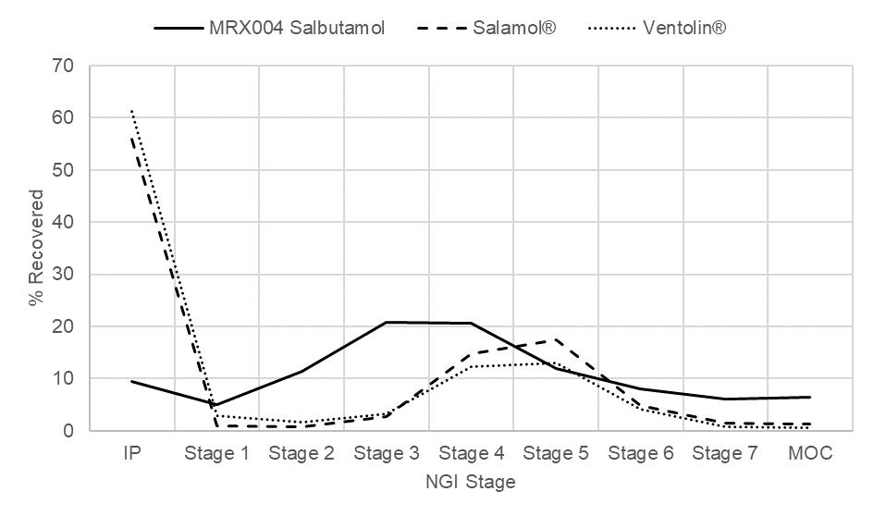
Figure 2 - Comparison of the DSD as measured by laser diffraction. Salamol® and Ventolin® are pMDIs, and MRX004 is an SMI.
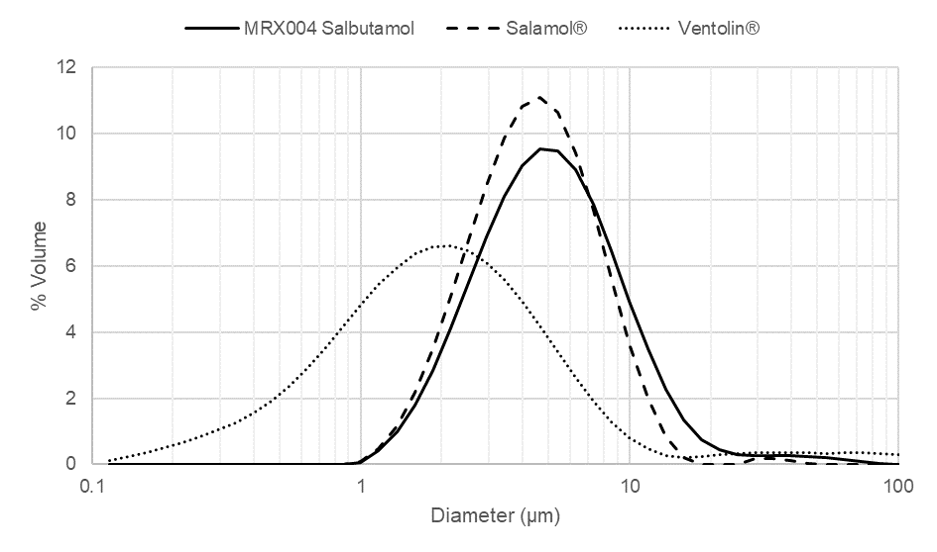
Conclusion
The FPF of MRX004 was greater than that of the pMDIs, where a smaller dose of salbutamol gave a FPD close to that of the pMDIs. The pMDIs FPDs were within the range established by the literature study [1,2,3]. This demonstrates that SMIs, such as MRX004, are a viable alternative to pMDIs, where for this study a nebule solution could be used resulting in no significant efforts for reformulation. The study used a commercially available salbutamol solution to fill the MRX004 cartridge – SMIs do not require propellant, eliminating the need for specialist propellant filling equipment and resulting in a much lower carbon footprint than is typical for pMDIs [5].
Given these results, the transition from pMDIs to SMIs is a natural progression for respiratory drug delivery. SMIs, such as MRX004, offer a number of advantages over pMDIs, including superior ease of use, no propellant, higher FPF, much lower throat deposition, increased patient friendliness and a significantly reduced carbon footprint. Over time, SMIs are likely to take up an increasing proportion of the respiratory market, potentially reaching, and even exceeding, a 50% market share. Early adopters who take the initiative to master this technology may achieve a significant advantage.
________________________________
[] Bezuglaya E, Lyapunov N, Bovtenko V, Zinchenko I, Stolper Y: Study of pressurised metered dose inhalers for the purpose of standardization of quality attributes characterizing uniformity of dosing, ScienceRise: Pharm Sci 2021; 4(32): pp 11–23.
[2] Slator L, Von Hollen D, Hardaker L E A: In vitro fine particle dose of drug formulation used in asthma & COPD, Eur Respir J 2020; 56: 3185.
[3] Ammari W G, Mohammad M K, Tayyem R F, Martin G P, Royall P G: Delivered Lung Dose and Aerodynamic Particle Size Distribution of Salbutamol Pressurized Metered Dose Inhaler After Living Under Patients' Realistic Retention Environments, J Aerosol Med Pulm Drug Deliv 2019; 32(6): pp 386–395.
[4] Anderson P. Use of Respimat Soft Mist inhaler in COPD patients. Int J Chron Obstruct Pulmon Dis. 2006;1(3):251-9.
[5] PrescQIPP, Bulletin 295: Inhaler carbon footprint, December 2022.
[6] Stein SW, Sheth P, Hodson PD, Myrdal PB. Advances in metered dose inhaler technology: hardware development. AAPS PharmSciTech. 2014 Apr;15(2):326-38.
[7] Brambilla G, Church T, Lewis D, Meakin B. Plume temperature emitted from metered dose inhalers. Int J Pharm. 2011 Feb 28;405(1-2):9-15.
[8] Salamol PIL, Teva, Leaflet Date; 21 October 2015

