Evaluating the Impact of a Volume and Flow Resistance Compensator on Flow Rate Rise-Time Profiles in Dose Uniformity Testing and Aerodynamic Particle Size Distribution Measurement Apparatus for a Dry Powder Inhaler

Ben Bradley¹, Clair Brooks¹ & Mark Copley¹

¹Copley Scientific Ltd, Colwick Quays Business Park, Road No 2, Nottingham, NG4 2JY, UK

Summary
Differences in the internal volume of dose uniformity sampling apparatus (DUSA) relative to the cascade impactor set-ups used for aerodynamic particle size distribution (APSD) measurement are potentially problematic in dry powder inhaler (DPI) testing due to the influence of inspiratory flow rate rise-time on measured characteristics. A variable volume and flow resistance compensator (VRC) enables the matching of flow rate rise-time profiles to address this issue, thereby helping to ensure mass balance in compendial APSD measurement methods. Flow rate rise-time with a DPI DUSA was successfully matched to both the Andersen Cascade Impactor (ACI) and Next Generation Impactor (NGI) to illustrate this approach. The results demonstrate the utility of a VRC for laboratories seeking to minimize sources of variability in DPI testing.
Key Message
Using a device for volume and flow resistance compensation helps scientists to ensure comparable conditions for passive DPI device activation in compendial DUSA and cascade impactor test set-ups thereby removing a potential source of variability in impactor mass balance reconciliation.

Introduction
Compendial methods for APSD measurement via multistage cascade impaction are specified for all orally inhaled products (OIPs) and linked with dose uniformity testing via the requirement to establish acceptable impactor mass balance [,]. To demonstrate validity the total mass of active drug substance recovered from a cascade impactor test set-up lies within 75 – 125% of the average delivered dose as determined by dose uniformity testing [1] or 85 – 115% of the target-delivered label claim [2]. Discrepancies between dose capture with a DUSA and with a cascade impactor set-up have the potential to impact this requirement.
DPIs are typically passive devices with device emptying and dose dispersion driven by the inhalation profile applied by the patient during use. Compendial methods are correspondingly differentiated from those of other OIPs, incorporating a specification to test at the air flow rate required to produce a 4 kPa pressure drop over the device, rather than at specific air flow rate values. In DPI testing air flow through a DUSA or cascade impactor is initiated via the switching of a solenoid valve connected to a vacuum pump. The flow rate ramps-up quickly to a target value, is maintained at a constant rate to sample a total volume of, typically 4L, and then shut off by the solenoid valve closing. This results in the application of a rectangular flow profile that tests DPIs under reproducible and somewhat realistic conditions though there is growing recognition of the issue of variability associated the transient conditions applied prior to constant flow establishing [,].
Recently published data from an extensive study of this variability indicate that flow rate rise-time to 90% of target flow, T₉₀, decreases linearly with decreasing apparatus test volume, with observed values ranging from >400 ms for an NGI with preseparator to <50 ms for a DUSA [4]. These tests were carried out using a surrogate DPI to generate a 4kPa pressure drop at 30, 60 and 90 L/min with a range of set-ups applied routinely for DPIs, for delivered dose testing and APSD measurement. Test flow rate was also shown to influence T₉₀ with lower flow rates resulting in longer rise times. The implications for drug delivery of this variability have not been rigorously assessed though there is published data indicating a link between shorter rise times and more complete device emptying, especially for certain device types []. Minimising discrepancies in flow rate rise-time profile between DUSA and cascade impactor to ensure that initial device emptying and dose dispersion occur under directly comparable conditions may therefore be desirable for those addressing poor mass balance, or more generally, looking to maximise the integrity of DPI data.
In this study a VRC accessory was used to match the flow rate rise-time profile of a DPI DUSA to an ACI and separately to an NGI, using a technique involving both flow resistance and volume modification.

Experimental methods
The flow resistance of an ACI with preseparator and an NGI with preseparator was determined using the test set-up shown in figure 1 with flow meter and filter in place (model DFM 2000/FRS). Other air flow control components included a critical flow controller (model TPK 100i-R) and a vacuum pump (model HCP6), as shown; unless otherwise stated all equipment is from Copley Scientific, Nottingham, UK.
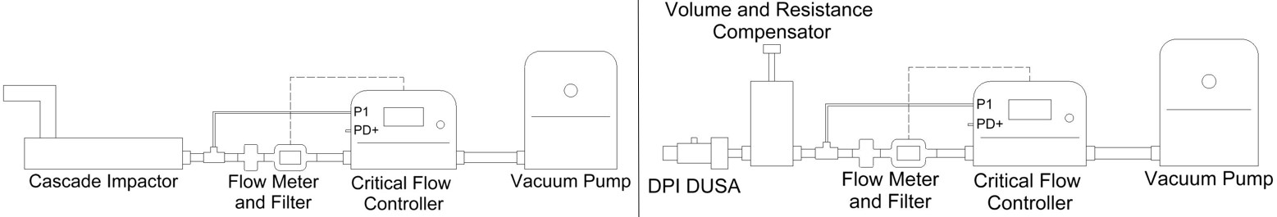
Figure 1 - Test set-ups for matching the flow resistance of cascade impactors (left) and a DPI DUSA (right)
Testing was carried out at 60 L/min, the specified test flow rate for the Symbicort® Turbohaler® used in later testing. A standard eight-stage, 60 L/min version of the ACI was used with a 60 L/min ACI preseparator and USP/Ph. Eur. induction port; the NGI was used with an NGI preseparator and NGI induction port. An attempt was then made to match the flow resistance of a standard DPI DUSA with glass fibre filter in place to the measured values for the ACI and NGI using a comparable test set-up (see figure 1, right) via manipulation of the changeable choke plates within a VRC (see figure 2).
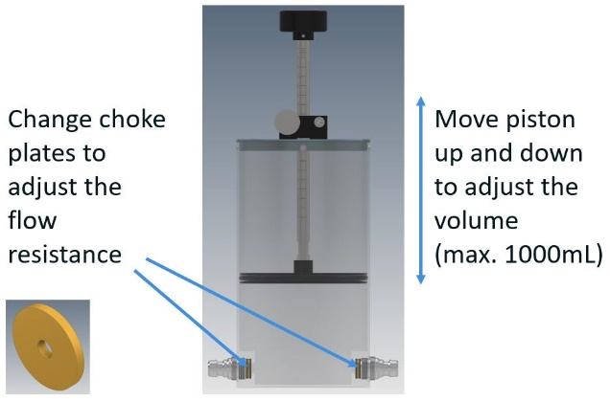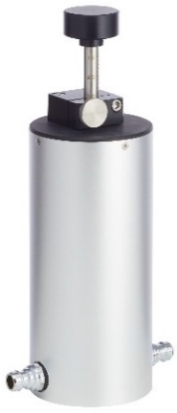
Figure 2 - A VRC incorporating choke plates and an adjustable piston for the independent manipulation of flow resistance and internal volume in DPI testing.
The flow rate rise-time profile with each cascade impactor was then logged by connecting the critical flow controller to a PC (as shown in Figure 3), and monitoring P1 pressure at the inlet to the impactor, at 10 ms intervals. Under the sonic flow conditions applied during DPI testing P1 is a sensitive surrogate for flow rate and can therefore be used to guide precise adjustment of the VRC piston to tune the flow rate rise-time profile of the DPI DUSA.
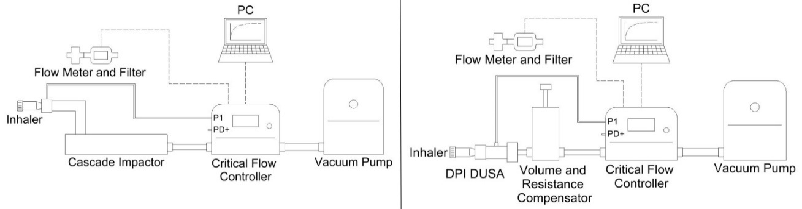
Figure 3 - Test set-ups for measuring the flow rate rise-time profiles of cascade impactors (left) and matching the DPI DUSA (right)
Results
The DPI DUSA + VRC was found to exert higher flow resistance than either impactor (see figure 4). The VRC contributed negligible flow resistance in this configuration. As the VRC was originally designed for use with low flow resistance abbreviated impactors [6], all choke plates had to be removed from the VRC and flow rate rise-time profiles were subsequently manipulated via volume control alone.
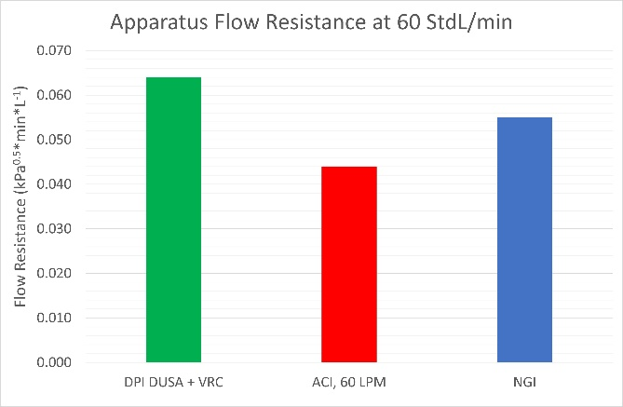
Figure 4 - All choke plates were removed from VRC since the flow resistance of the DPI DUSA + VRC was found to be higher than that of either cascade impactor.
Despite the DUSA + VRC exerting relatively high flow resistance, the DPI DUSA itself has a comparatively small volume that gives rise to a more rapid rise in P1 than that observed with either impactor (see figure 5). In the absence of the VRC, t₉₀ for the DUSA is 0.05s compared with values of 0.21s for the ACI and 0.37s for the NGI respectively. This ranking of t₉₀ correlates with the relative internal volume of the three set-ups since the NGI/preseparator/induction port has a volume of 1904mL compared with 1077mL for the ACI/preseparator/induction port (both figures taken from reference 3) and 123mL for the DPI DUSA (calculated in house).
Matching with the ACI was achieved by using the VRC to add 300mL of additional volume into the DPI DUSA test set-up; the equivalent figure for the NGI was 700 mL. These figures indicate that the additional volume required is not simply the difference between two set-ups.
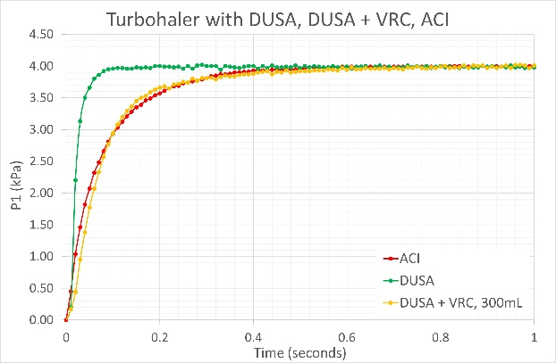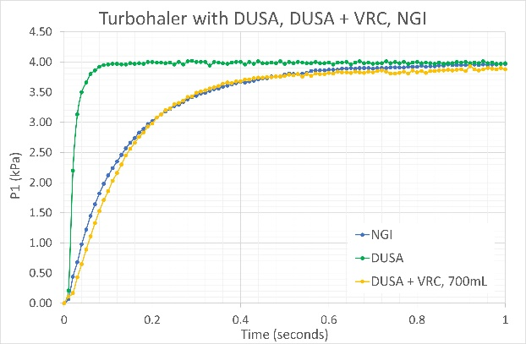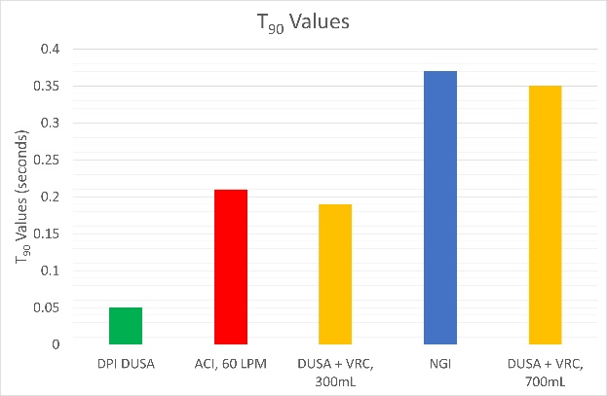
Figure 5 - The flow rate rise-time profile with the DPI DUSA was closely matched to that of the ACI with preseparator (top left) and NGI with preseparator (top right) bringing T90 values into far closer parity (bottom)
Discussion
These results provide further evidence of differences in the flow rate rise-time profiles applied to DPIs during dose uniformity testing and APSD measurement with different cascade impactors. Such differences occur in the earliest stages of drug delivery as dose dispersion and device emptying are initiated making it reasonable to consider their possible impact with respect to differentiating overall dose delivery. The limited data available suggests that longer rise times may be associated with less complete device emptying [5] which is potentially important because of the compendial requirement to use dose uniformity data in the calculation of a mass balance to confirm the validity of APSD measurements. If testing with a DUSA produces values that are inherently inconsistent with dose delivery to an impactor due to longer rise times and a corresponding reduction in device emptying, then an out-of-specification mass balance cannot be securely linked with a problem in the APSD measurement. Rather the scope for variability afforded by the mass balance specification is essentially eroded, especially for devices sensitive to flow rate rise-time profile.
While further study is required to quantify the magnitude of any impact, the work presented here illustrates a straightforward solution for eliminating concern. By adding in volume to match flow rate rise-time profiles scientists can eliminate this source of variability. Though this might be particularly useful in the event of a poor mass balance it is more generally helpful to maximise the integrity of DPI data.
This work follows earlier studies of the use of a VRC to match flow rate rise-time profiles between full resolution cascade impactors and abbreviated impactor measurement (AIM) test set-ups []. Just as in the earlier study the volume required for matching is not simply the difference in internal volume between the test set-ups and as before we can conclude that further work is required to understand why, taking account of possible issues such as mal-distributed flow and or the impact of test set-up geometry. That said, the empirical nature of close matching draws attention to the value of having a flexible tool for flow resistance and volume manipulation when it comes to matching flow rate rise-time profiles.
Conclusion
Matching the flow rate rise-time profiles applied in dose uniformity testing and APSD measurement for DPIs helps to minimise the risk of an out of specification mass balance in cascade impactor measurements. Such matching can be readily achieved using an accessory that allows for independent volume and flow resistance manipulation. The results presented here illustrate this approach and how DPI DUSA flow rate rise-time profiles can be closely matched to those associated with relevant cascade impactor test set-ups to enhance the integrity of DPI test data.

[1] European Directorate for Quality in Medicines and Healthcare (EDQM). European Pharmacopoeia 11.0, 2023. Monograph 2.9.18. Preparations for inhalation: Aerodynamic assessment of fine particles. EDQM, Strasbourg, France.
[] US Pharmacopeial Convention. United States Pharmacopeia NF 2023, Issue 1, 2023. Chapter <601>, Aerosols, Nasal Sprays, Metered-Dose Inhalers and Dry Powder Inhalers. USP, Rockville, MD, USA.
[] Roberts DL, Chambers F, Copley M, & Mitchell JP: Internal Volumes of Pharmaceutical Compendial Induction Port, Next Generation Impactor With and Without Its Pre-separator, and Several Configurations of the Andersen Cascade Impactor With and Without Pre-separator. Journal of Aerosol Medicine and Pulmonary Drug Delivery Volume 33, Number 0, 2020 Pp. 1–16 DOI: 10.1089/jamp.2019.1590
[4] Greguletz R, Andersson P U, Cooper A, Chambers F, Copley M A, Daniels G, Hamilton M, Hammond M, Mohammed H, Roberts D L, Shelton C, Versteeg H K & Mitchell J P (2020): A cross-industry assessment of the flow rate-time profiles of test equipment typically used for dry-powder inhaler (DPI) testing: Part 1 – compendial apparatuses, Aerosol Science and Technology, DOI: 10.1080/02786826.2020.1792824.
[5] Chavan V, & Dalby R: Effect of rise in simulated inspiratory flow rate and carrier particle size on powder emptying from dry powder inhalers. AAPS PharmSci 2000;2(2):E10. DOI 10.1208/ps020210.
[6] Bradley, B & Copley, MA Evaluating a Variable Volume and Flow Resistance Compensator for the Matching of Flow Rate Rise-Time Profiles between Full Resolution and Abbreviated Impactors when Testing Dry Powder Inhalers (DPIs) Presented at Drug Delivery to the Lungs 2022 7th – 9th Dec 2022. Conference proceedings Vol 22.

