A Novel Mathematical Model to Predict The Particle Size Distribution of pMDI Aerosols

H Chizari¹, HK Versteeg², W Malalasekera² & B Gavtash¹,

¹Kindeva Drug Delivery, Derby Road, Loughborough, LE11 5SF, UK

²Wolfson School of MEME, Loughborough University, Ashby Road, Loughborough, LE11 3TU, UK

Summary

This paper introduces a fundamental method to estimate droplet size distribution in aerosols from pressurised metered dose inhalers (pMDIs). Accurate droplet size representation is vital for estimating drug deposition. Using the instability equation by Reitz et al., we calculate droplet size based on fast-growing wave modes. The slip velocity, a crucial parameter, is adjustable in our model. Comparing predictions with experimental data shows good agreement for HFA134a and HFA227ea aerosols with minor slip velocity adjustments. This model is essential for predicting droplet distribution and calculating drug deposition in the USP-IP throat.

Key Message
Our study provides an important solution for predicting the temporal droplet size distribution (DSD) of pMDI aerosols. By accurately modelling the instability equation for liquid ligaments, we achieved good agreement between predicted DSD and PDA data for HFA134a and HFA227ea aerosols. Crucially, our research identifies the slip velocity, the relative speed between propellant liquid and gas phases, as the key factor shaping DSD. This insight is pivotal for the industry, especially during the transition to greener propellants. Understanding DSD is essential for passing bridging studies and ensuring the equivalence of products. By elucidating the core factors governing DSD, our research empowers the industry to meet regulatory standards and produce environmentally friendly inhalers without compromising efficacy.

Introduction
The generation of fine therapeutic droplets is the main characteristic of a pressurized metered-dose inhaler (pMDI) enabling precise lung delivery. This unique characteristic maximizes the therapeutic benefits while minimizing the systemic effects, enabling the pMDI to remain the mainstay technology for the treatment of lung disorders. Recent developments suggest that CFD can play a role in the study of inhalation aerosols [1, 2], but an accurate definition of the spray source has remained a key challenge. The prediction of pMDI aerosol characteristics requires an accurate model of the temporal distribution of droplet size for current and future low-GWP pMDI product formulations. The aim of this study is to introduce a numerical model for analysing droplet size distribution from the first principles.

Instability Solution
The starting point of this work is the instability equations developed by Reitz and Bracco [4, 5]. This analysis is widely used in atomization theory to generate estimates of droplet size. We solve the full instability equation in cylindrical coordinates to study the disintegration of liquid ligaments in the spray orifice of a pMDI. This is an improvement to our previous work [3] where we solved a simplified stability equation in Cartesian coordinates. References [4, 5], explain the approach taken in this work, which is based on linear theory of first order to study the amplification of disturbances on cylindrical liquid surfaces. The analysis studies the growth of initially small, axisymmetric disturbances (equation 1) of the surface of a liquid ligament, as schematically illustrated in Figure 1.
$$η=R\left(η_{0}e^{ikz+ωt}\right)$$ | (1)

In equation (1), $k$ and $ω$ are the instability wave number and instability frequency, respectively. The $η_{0},η$ are the initial and final instability amplitude.
$λ=\frac{2π}{k}$
$D=2B_{0}λ$
$η=η_{0}e^{ωt}$
$Z$-Axis (Radial)
$R$-Axis (Axial)
Initial Oscillations
Spray Orifice Flow Direction
Break-up

Figure 1 - Schematic view of a spray orifice liquid ligament (liquid phase shown in blue)
and growth of an initial surface disturbance leading to break-up and droplet formation.
Figure 1, illustrates how these concepts can be applied to the vapour/liquid flow in the spray orifice of a pMDI actuator. High-pressure flow will enter the spray orifice and oscillations on the liquid surface will develop and grow. As the flow emerges from the spray orifice, the liquid will break up into small droplets. The size of the final droplets produced by this process will be closely related to the spatial and temporal frequencies of the disturbance of the emerging liquid. If the temporal frequency is large, the probability of droplet detachment from the liquid is high. The size of such droplets will be directly proportional to the spatial wavelength of the relevant disturbances.
Following Reitz and Bracco [4, 5] an instability equation is solved to understand the relationship between the spatial and temporal wavelengths for typical liquid ligaments in a pMDI spray orifice. The instability analysis yields the following dispersion equation, which relates the disturbance frequency ω to the disturbance wave number k, pMDI formulation, and actuator parameters:
$$ω^{2}+2ν_{1}k^{2}ω\left(\frac{I_{1}^{'}\left(ka\right)}{I_{0}\left(ka\right)}-\frac{2kL}{k^{2}+L^{2}}\frac{I_{1}\left(ka\right)}{I_{0}\left(ka\right)}\frac{I_{1}^{'}\left(La\right)}{I_{1}\left(La\right)}\right)=\frac{σk}{ρ_{1}a^{2}}\left(1-k^{2}a^{2}\right)\left(\frac{L^{2}-k^{2}}{L^{2}+k^{2}}\right)\frac{I_{1}\left(ka\right)}{I_{0}\left(ka\right)}+\frac{ρ_{2}}{ρ_{1}}{\left(w-\frac{iω}{k}\right)}^{2}k^{2}\left(\frac{L^{2}-k^{2}}{L^{2}+k^{2}}\right)\frac{I_{1}\left(ka\right)K_{0}\left(ka\right)}{I_{0}\left(ka\right)K_{1}\left(ka\right)}$$ | (2)
Where:
$ν_{1}:$ liquid viscosity, $a:$ jet radius, $L^{2}=k^{2}+\frac{ω}{ν_{1}}$, $σ:$ surface tension, $ρ_{1}:$ liquid density, $w:$slip velocity | (3)
We define the following:
$$Y=\frac{ωa}{U},X=ka,Z^{2}=X^{2}+\frac{Y}{R}, W=\frac{ρ_{1}U^{2}a}{σ},R=\frac{Ua}{ν_{1}},Q=\frac{ρ_{2}}{ρ_{1}}, W=\frac{w}{U}$$ | (4)
Equation (2) is multiplied by ${a^{2}}/{U^{2}}$ to give the non-dimensional dispersion equation that is used in this work:
$$Y^{2}+\underset{b}{\underbrace{\left(\frac{2X^{2}}{R}\left(\frac{I_{1}^{'}\left(X\right)}{I_{0}\left(X\right)}-\frac{2XZ}{X^{2}+Z^{2}}\frac{I_{1}\left(X\right)}{I_{0}\left(X\right)}\frac{I_{1}^{'}\left(Z\right)}{I_{1}\left(Z\right)}\right)\right)}}Y-\underset{c}{\underbrace{\left(\frac{X}{W}\left(1-X^{2}\right)+Q{\left(WX-iY\right)}^{2}\frac{K_{0}\left(X\right)}{K_{1}\left(X\right)}\right)\left(\frac{Z^{2}-X^{2}}{Z^{2}+X^{2}}\right)\frac{I_{1}\left(X\right)}{I_{0}\left(X\right)}}}=0$$ | (5)
To solve this equation, we used the following numerical approach:
Figure 2 - Flowchart of the numerical steps to solve.
$$Error>{10}^{-6}$$
Initialize
$$Y$$
Calculate
$$Z,b,c$$
Solve
$$Y^{2}+bY-c=0$$
Calculate
$$Y_{new}$$
Calculate
$$E=\left|Y_{new}-Y\right|$$
In this work we propose that a range of disturbances centred around the most unstable disturbance should be considered as relevant to droplet production. We assume that the probability of production of aerosol of a particular droplet size will be related to the growth rate of the disturbance leading to the formation of these droplets.
The following steps are used to compute the droplet size of pMDI aerosols:
- Get the input information needed from the pMDI internal flow model [1]:
  - The material properties such as density (both liquid and gas), viscosity, surface tension.
  - The flow properties such as flow velocity, slip velocity, jet diameter.
- Solve the instability equation using the algorithm in Figure 2 and generate the non-dimensional wave growth rate $Y$ vs. non-dimensional wave number $X$ for trial values of $X$ (the range of trial values is chosen to all growth rates around the maximum responsible for droplet production).
- Convert the growth rate-wave number curve to normalized probability curve using the following probability function:
$$P\left(X\right)=Y^{2}$$
This directly relates the growth rates $Y$ to the probability $P$ of formation of droplets of a particular size $X$.
- Calculate the droplet size based on the non-dimensional wave number $X$ [4, 5],
$$\begin{matrix}D\left(X\right)=2B_{0}λ=\left(2B_{0}\right)\frac{2π}{k}=\left(2B_{0}\right)\frac{2πa}{X}=\frac{4B_{0}πa}{X} & B_{0}=0.61\end{matrix}$$
- Use the probability distribution of step 3. to determine the total liquid mass that is coming out of the spray orifice at a given time, the number of droplets of each size.
$$\begin{matrix}\begin{matrix}m\left(X\right)=ρ_{l}\left(\frac{π{D\left(X\right)}^{3}}{6}\right) & ⟹ & P_{m}\left(X\right)=m\left(X\right)P\left(X\right)\end{matrix} & ⟹ & \begin{matrix}m_{l}\left(X\right)=\left(\frac{P_{m}\left(X\right)}{\int{P_{m}\left(X\right)}}\right)m_{l} & ⟹ & n_{l}\left(X\right)=\frac{m_{l}\left(X\right)}{m\left(X\right)}\end{matrix}\end{matrix}$$
- Finally, the calculations are moved to the next time step and droplet size distributions are compiled as a function of time.

Results and Discussion
Figure 3a shows the amplification factor range that is responsible for most of the atomization is shown in selected times (based on the emitted percentage mass indicated in the legend in Figure 3b). At start of the actuation (blue and red traces) the amplification factor is generally higher. Within the model (step 3.), this affects the number of droplets produced. Figure 3c (blue and red traces) confirms that the mass of droplets is highest initially. As time progresses, the amplification factor gradually reduces and, hence, the mass of droplets produced also reduces. The peak amplification factor is initially located (blue and red traces) at higher values of non-dimensional wave number X. Consequently, smaller droplets will be created initially, and the droplet size will increase towards the end of the actuation event. This is confirmed by Figure 3(b), which shows the range of droplet sizes produced during each of the phases of the actuation event.
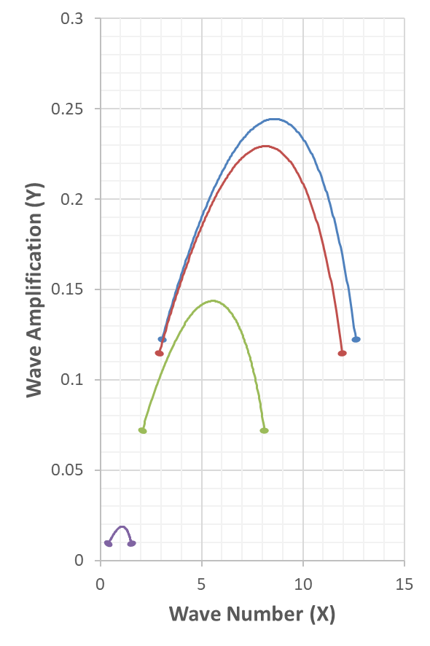  (a) | 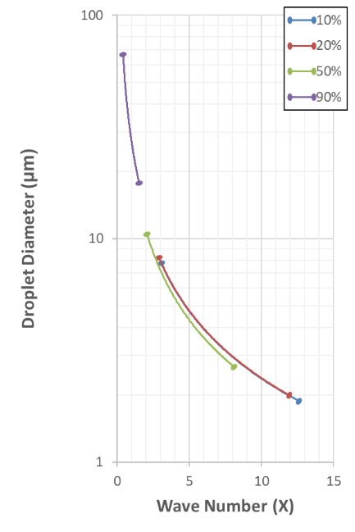  (b) | 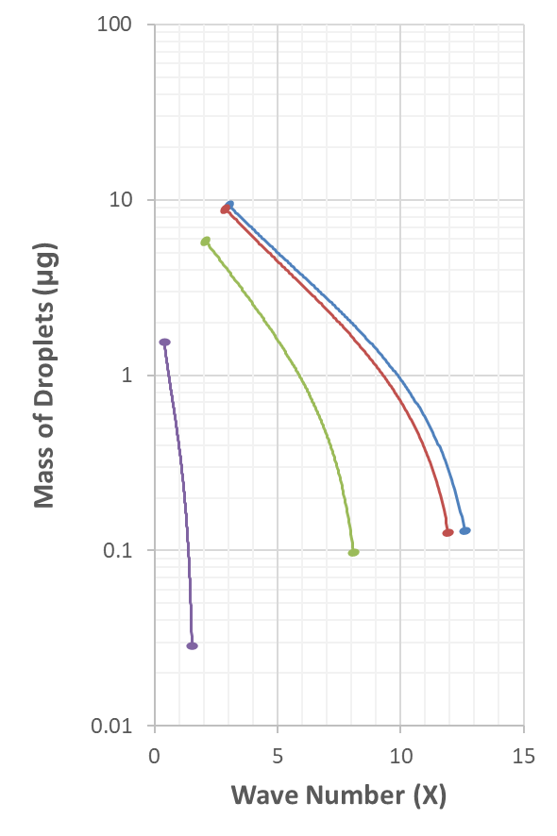  (c)
Figure 3 – (a): The amplification factor as a function of wave number at four different instants selected based on the percentage of aerosol mass emitted from the actuator (10%, 20%, 50%, 90%). (b): Predicted droplet diameter range as function of wave number at four instants. (c): Droplet mass vs wave number at four instants of time.
The slip velocity $W$ is the relative velocity between the liquid and gas phase. It is crucial to estimate the slip velocity because it will have a large effect on the atomization. The slip velocity ($W$) is not yet well-understood in a pMDI. Slip velocity will push the surface of the liquid-phase forward and created more probability for smaller droplets to be made. Slip velocity will push the surface of the liquid ligament forward and will promote the formation of small droplets. In our model, atomisation is assumed to occur predominantly within the spray orifice. It may occur close to the walls; in which case the dimensionless slip velocity W will be close to unity. If the atomization occurs far away from the walls the dimensionless slip velocity may be as low as zero, but, without slip velocity, atomization is unlikely. The actual value is expected to be between 0 and 1, so a value around 0.5 might be reasonable.
In Figure 4, the results from the model are compared to PDA data for HFA134a and HFA227ea propellant aerosols [6]. The PDA data is taken on the nominal horizontal axis of the pMDI aerosol at a distance 15 mm away from the spray orifice. The cumulative distribution is shown in Figure 4 were computed for two values of the non-dimensional slip velocity: $W=0.5 \& 0.7$. For $W=0.5$, the HFA134a droplet distribution is in good agreement with the PDA data, however, for HFA227ea the $W=0.7$ is generating a closer distribution to the experiments.

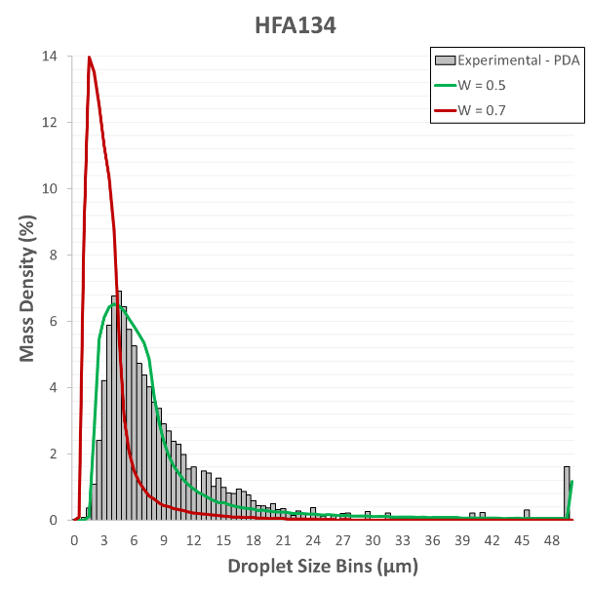 | 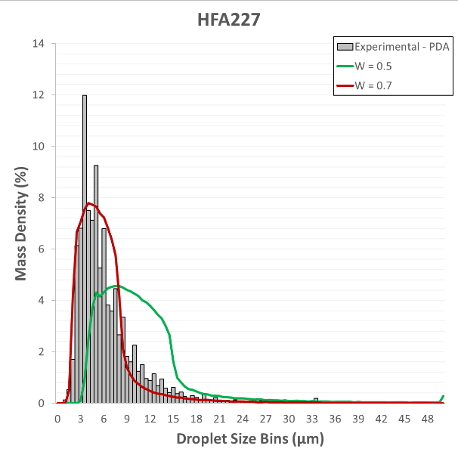
Figure 4 - Comparing the PDA data [6] (experimental data) with the model prediction of mass density for HFA134 and HFA227. The considered non-dimensional slip velocity ($W$) is 0.5 and 0.7.

Conclusion
In this study, we introduced a novel method to accurately predict droplet size distribution near the orifice of a pMDI (5 mm) using HFA134a and HFA227ea propellants, demonstrating good agreements. Our approach, solving the instability equation in cylindrical coordinates for various slip velocities, addresses a significant challenge in estimating this parameter. Although our estimations indicate a range, further comprehensive research is needed to fully understand this parameter from first principles. By economically predicting time-dependent droplet size distribution from a pMDI, our method provides a valuable tool for pharmaceutical companies. This predictive capability is crucial for our understanding of inhaler designs, ensuring precise drug delivery, and minimizing production costs when it comes to matching performance of new products.

Acknowledgment:
The authors gratefully acknowledge the financial support of Innovate UK in the form of funding of Knowledge Transfer Partnership KTP012178.

References
[1] | B. Gavtash, H. K. Versteeg, G. Hargrave, B. Myatt, D. Lewis, T. Church and G. Brambilla, “Multi-physics theoretical approach to predict pMDI spray characteristics,” in DDL, 2016.
[2] | P. W. Longest and S. Vinchurkar, “Effects of mesh style and grid convergence on particle deposition in bifurcating airway models with comparisons to experimental data,” Medical Engineering & Physics, pp. 350-366, 2007.
[3] | R. D. Reitz and F. V. Bracco, “Mechanism of Atomization of a Liquid Jet,” The Physics of Fluids, vol. 25, p. 1730–1742, 1982.
[4] | R. D. Reitz, “Modeling Atomization Processes in High-Pressure Vaporizing Sprays,” Atomization and Spray Technology, vol. 3, pp. 309-337, 1987.
[5] | H. Chizari, B. Gavtash, B. Myatt, W. Malalasekera and H. K. Versteeg, “Development of a Mathematical Model To Estimate Droplet Size Distribution of a Pressurized Metered Dose Inhaler in the Near-Orifice Region,” in DDL, 2022.
[6] | B. Myatt, A fundamental study of the primary atomisation mechanism and aerosol plume development of the pressurised metered dose inhaler (PhD Thesis), Loughborough University, 2017.

