A device screening method for predicting delivery of inhaled mRNA via a nebuliser

Imco Sibum¹, Bernhard Mullinger¹ and Nicolas A. Buchmann¹

¹Resyca BV, Colosseum 23, Enschede, 7521 PV, the Netherlands

Summary
A device screening method is presented for initial comparison of full-length mRNA lung delivery via nebulisation route. To this end, aerosol data was collected based on manufacturer information and subsequently used in deposition modelling. Several nebuliser systems with different aerosolisation technologies were included into the study. Aerosol data shows that the MMAD was slightly larger for the soft mist spray chip technology as compared to the vibrating mesh devices. However, deposition modelling results indicated that lung deposition is higher for the soft mist nebuliser. Using mRNA post nebulisation integrity data, reported for these three devices, predicted full-length mRNA lung deposition could be calculated. This calculation shows that the Pulmospray™ results in 51.3% mRNA lung deposition compared to eFlow’s 2.3% and Solo’s 11.7 %, as percentage of fill dose. Deposition of full-length mRNA is critical, as only full-length mRNA results in the wanted biological-active protein and efficient full-length mRNA deposition depend on the choice of the delivery device.

Key Message
A device screening method is presented which takes aerosol parameters, deposition modelling, and post aerosolisation mRNA integrity data to predict lung deposition of functional mRNA as a percentage of fill dose. In the screening performed here, the Aerogen Solo, Pari eFlow, and the Resyca Pulmospray™ result in 11.7%, 2.3% and 51.3% lung deposition respectively.

Introduction
In 2019 COVID-19 emerged, being first identified in Wuhan China [1]. It would lead to a world-wide pandemic, being classified as a “public health emergency of international concern” by the the WHO from the 30th of January 2020 until the 5th of May 2023 [2-3]. The medical / pharmaceutical world sprang into action in an effort to alleviate and/or prevent COVID-19 infection. This concerted effort led to the first approved mRNA vaccine, with BioNTech and Moderna both obtaining approval for their mRNA-based vaccines [4]. Following these approvals, mRNA technology had been accelerated considerably. A disadvantage of mRNA-based products, and biopharmaceuticals as a whole, is the delivery route to the patient. With most biopharmaceuticals being destroyed when delivered via the gastrointestinal route. Currently most biopharmaceuticals are given parenterally, with all the disadvantages this route entails. A different administration route is needed. Pulmonary administration may be a route capable of delivering biopharmaceuticals, without the disadvantages of parental administration. Selection of effective and efficient delivery devices is key when biological drug products as mRNA need to be delivered. This study provides a method for initial screening of nebuliser technologies for use with mRNA formulations, considering aerosol performance, lung deposition and product integrity after the nebulisation process. In this abstract, the Pulmospray™, a propellant-free low shear stress nebuliser, is compared to the Pari eFlow® rapid and the Aerogen Solo® nebuliser systems for delivery efficiency of full-length mRNA to the lungs.

Materials and Methods
This study uses previously published data on post nebulisation integrity of mRNA [5] and device performance data published by manufacturers. Within this study lung deposition modelling was performed based on pre-existing data, which was then combined with product integrity of mRNA published for the different aerosolization technologies.
Aerosol particle size distributions for the Pulmospray (Resyca, Enschede, the Netherlands) are obtained by measurement with the Next Generation Pharmaceutical Impactor (NGI). Particle size distributions for the eFlow® rapid (Pari Pharma, Munich, Germany) are taken from the eFlow® rapid nebuliser system instruction for use leaflet 2022-07. For the Aerogen Solo® the Aerogen Solo/Pro instruction for use leaflet 2021-04-30 by Hamilton Medical was used. For all devices a salbutamol formulation is used as test solution. Aerosol data were obtained according to ISO 27427 Anaesthetic and respiratory equipment – nebulizing systems and components for the Pulmospray and eFlow. Aerogen Solo® data was obtained according to EN 13544-1 Nebulizing systems and their components.
Predicted lung deposition was calculated for all devices based on the aerosol data collected. For this Mimetikos Preludium software (ver 1.1.7) from Emmace (Lund, Sweden) was used. This model models airway generations as described in the symmetrical Weibel A model with aerosol transport modelled according to Findeisen – Landahl formalism [7]. Table 1 shows the modelling parameters used in this study. These parameters are set to closely mimic the flows users attain when using these devices.
Rijn et al. [5] has shown that the nebulisation process can rupture LNP carrier vehicles and degrade the mRNA molecules inside. Results indicate that the fraction of intact mRNA after nebulisation varies greatly with different nebuliser systems and that LNP degradation generally increases with increasing nebulisation energy. Table 2 summarises the fraction of intact mRNA after nebulisation for the different nebulisers systems as extracted from the work of Rijn et al. [5].
Total delivery efficiency of full-length mRNA to the lung $η_{tot}$ is calculated as $η_{tot}=η_{neb}∙η_{mRNA}∙η_{lung}$ Where $η_{neb}$ is the nebuliser output as percentage of fill volume as given by the manufacturer (Table 3), $η_{mRNA}$ the fraction of intact mRNA after nebulisation (Table 2) and $η_{lung}$ the fraction of lung depositions as determined by the deposition model. From equation (1), the active mRNA lung dose (LD) for a given fill dose (FD) may be estimated as $LD={FD∙η}_{tot}$.
To compare the delivery of intact mRNA to the lungs, equivalent amounts of intact mRNA delivered by the Solo with a fill volume of 4 mL was calculated and used as benchmark. For the eFlow and Pulmospray, this benchmark was then used to calculate the equivalent amount of fill volume needed to get equivalent intact mRNA lung deposition. Based on aerosol output and aerosol output rate for the three devices, total nebulisation time to achieve equivalent dose was also calculated.
Table 1 - The inhalation parameters used as input in the depostion model for both devices. Parameters set to closely mimic flows attained by users of these devices.
Parameter | Pulmospray | eFlow rapid | Solo
Model | Weibel A | Weibel A | Weibel A
Tidal breath | 1000 mL | 500 mL | 500 mL
Inspiratory flow rate | 15 L/min | 15 L/min | 15 L/min
Flow pattern | rectangular | sinus | sinus
Breath hold | 1 sec | 0 sec | 0 sec
I/E ratio | 1:1 | 1:1.5 | 1:1.5
Bolus volume | 950 mL | 500 | 500
Delay volume | 50 mL | 50 | 50
Breathing frequency | N/A | 15/min | 15/min

Table 2 – Approximate fraction of intact mRNA after nebulisation based on data taken from Rijn et al. [5].
 | Pulmospray | eFlow rapid | Solo
mRNA1 | 0.88* | 0.12 | 0.64*
mRNA2 | 0.73 | 0.19* | 0.64
*Fractions used for subsequent calculations.

Results
Table 3 shows the cascade impaction data for the three devices, obtained with salbutamol as test solution. As shown, the MMAD of the Pulmospray device is larger than the eFlow and Solo, and above 5 μm which is usually assumed as cut-off for inhalable fraction. Geometric Standard Deviation (GSD) is considerably smaller for the Pulmospray, meaning its particle / droplet size distribution is narrower compared to the other two devices.

Table 3 - Comparison between the Pulmospray soft mist inhaler, eFlow rapid nebuliser system, and Solo, with salbutamol as test formulation. Data according to ISO 27427 or EN 13544-1.
 | Pulmospray | eFlow rapid | Solo
MMAD (μm) | 5.90 | 4.70 | 3.10
GSD (-) | 1.50 | 1.70 | 2.20
Aerosol output (% of fill volume) | 84.1 | 26.8* | 51.0**
Aerosol output rate  (mg formulation / min) | 238*** | 430 | 300***
*Calculated based on an aerosol output of 0.67g and fill volume of 2.5mL.
**Calculated based on aerosol output of 1.02 mL emitted of 2.0 mL dose
*** Calculated based on aerosol output rate of salbutamol and a formulation concentration of 0.1% W/W.
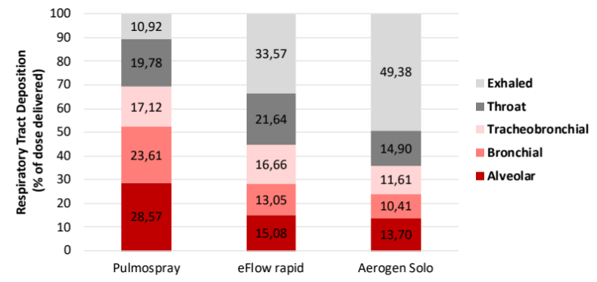
Figure 1 shows the modelled aerosol deposition results for the devices when aerosolizing the salbutamol test solution. As can be seen, a higher lung deposition fraction $η_{lung}$ is achieved with the Pulmospray (69.3%) device compared to the eFlow (44.8%) and Solo (35.7%) devices, even with the larger MMAD of the Pulmospray.
Figure 2A shows the predicted full-length mRNA delivery efficiency to the lung $η_{tot}$ by the Pulmospray, eFlow rapid, and Solo devices, as percentage of fill dose. As can be seen, the Pulmospray delivers substantially higher quantities of intact mRNA to the lung compared to the eFlow rapid and Solo. Shown in Figure 2B, delivery time of an equal dose of 0.05 mg intact mRNA to the lungs differs markedly between devices.
Figure 1 – Modelled regional lung deposition for the devices in percentage of delivered dose using the aerosol data obtained with salbutamol as test solution.
B
A
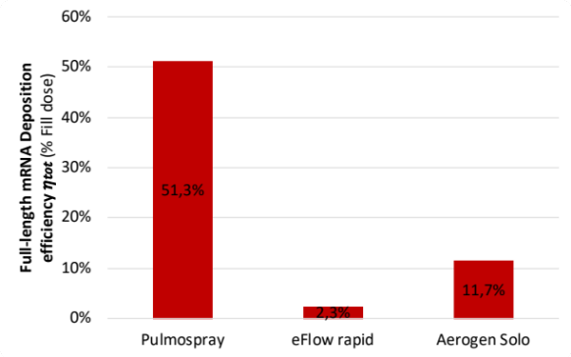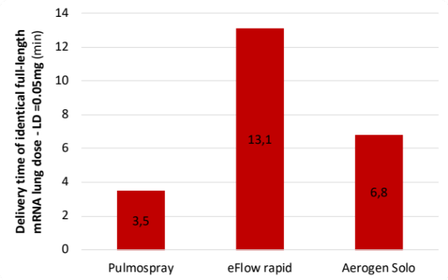
Figure 2 – (A) The calculated total intact full-length mRNA dose efficiency $η_{tot}$ as a percentage of the fill dose of the three devices. (B) The calculated time required to deliver an identical full-length mRNA dose of 0.05 mg to the lungs, using the Solo (fill volume = 4ml) as benchmark.

Discussion
Based on device performance data stated by their respective manufacturers, post nebulisation mRNA integrity results reported [5], and numerical aerosol deposition simulations using parameters to closely mimic flows attained by users, a prediction model of the full-length mRNA lung deposition for different nebulisers is established. The simplified model considers the device specific deliver efficiency, the degradation of the sensitive LNP based mRNA formulations during nebulisation, and the aerosol lung deposition efficiency based on the device specific aerosol performance.
Applying the model demonstrated that the Pulmospray may deliver intact mRNA to the lung with an delivery efficiency of up to 51.3% based on its fill volume. This is substantially greater than the total full-length mRNA delivery efficiency of the Pari eFlow (2.3%) and the Aerogen Solo (11.7%). The main difference between the studied devices is the marked differences in yield of intact mRNA chains post nebulisation $η_{mRNA}$ (eFlow: 0.11 – 0.21; Solo: 0.64; Pulmospray: 0.73 – 0.88) as well as the lower drug output efficiency of the mesh nebulisers $η_{neb}$ (eFlow: 0.26; Solo: 0.51; Pulmospray: 0.84). Lastly, lung deposition efficiency $η_{lung}$ is different between the devices (eFlow: 0.45; Solo: 0.36; Pulmospray: 0.69) due to different aerosol characteristics.

The MMAD is one of the parameters describing the behaviour of an aerosol and its deposition after inhalation. Based on this, one would expect that the Pulmospray would perform substantially worse than the eFlow and Solo. However, as Figure 1 clearly shows, the Pulmospray is modelled to have a higher lung deposition. Throat deposition is about equal for the Pulmospray and eFlow, and lower for the Solo. An MMAD above 5 μm does thus not result in high throat, and low lung, deposition. Throat deposition is governed by inertial impaction and is linearly proportional to the inhalation flow rate and quadratically to the particle size. The Pulmospray promotes a slower and deeper inhalation due to its build-in flow resistance, which results in a lower inspiratory peak flow compared to the other two devices. The lowered inhalation flow rate will lead to a lower throat deposition with a slightly larger particle size. This larger particle size does improve subsequent lung deposition.
This effect is corroborated by data shown in [8], where throat deposition for the Pulmospray device is 20.7% and 25.3% and lung deposition is 67.0% and 57.1% at inhalation flow rates of 15 and 30L/min, respectively. Furthermore, the Solo device exhibits a markedly larger exhaled fraction (~50%) compared to the other devices due its smaller particle size and relatively wide size distribution (GSD = 2.2).

Together with the established parameters, the above model can be applied to estimate the fill dose required of any device to achieve an equivalent active mRNA lung dose. As shown in Figure 3, the active mRNA lung dose of the Aerogen Solo, when filled with 4mL formulation (0.1mg/mL) is approximately 0.05mg. The treatment time to reach this dose is approximately 6.8min. Contrary, the same equivalent active mRNA lung dose (0.05mg) can be achieved by the Pulmospray with only 1mL fill volume (0.1mg), thus providing a 75% reduction in drug usage for the same lung dose. Treatment time with the Pulmospray is also markedly reduced by almost 50% down to 3.5min to achieve the equivalent active lung dose.
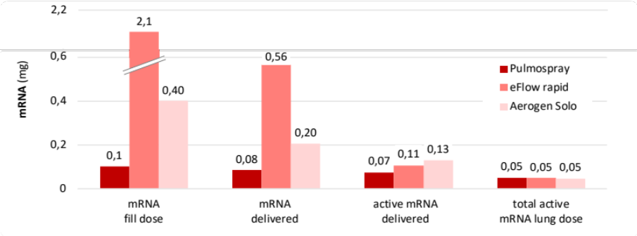
Salbutamol was used as test formulation in the screening method due to the cost prohibitive nature of screening multiple devices with expensive mRNA formulation. Screening devices with salbutamol aerosol data, together with deposition modelling and with a correction on mRNA degradation post the specific aerosolisation process to select suitable device candidates for detailed characterisation. Also the results present in here are based on the public available data and do not include device specific optimisations or adjustments by the manufacturer.
Figure 3 - Quantities of mRNA at each stage (filled in device, mRNA delivered by device, intact mRNA delivered) to obtain an equal modelled lung dose of 0.05 mg full-length mRNA.

Conclusion
The delivery of full-length mRNA is important, as only full-length mRNA results in the translation of the wanted biological active protein. When selecting a drug delivery device for the inhalation of sensitive biologics, such as mRNA formulations, the device specific drug delivery characteristics must be considered. Based on nebuliser fill volume, large differences in active mRNA delivery efficiently may exist and careful selection of the device is recommended. Particularly for biological compounds that carry high costs, substantial cost savings may be realised when selecting an efficient delivery device. The Resyca Pulmospray™ device is such an efficient device that may provide up to 50% of the filled mRNA to the deep lung intact.

References
[] World Health Organization “https://www.who.int/emergencies/disease-outbreak-news/item/2020-DON233” Accessed 6 July 2023
[2] World Health Organization COVID 19 Public Health Emergency of International Concern (PHEIC) Global research and innovation forum. WHO 2020
[3] World Health Organization “https://www.who.int/news/item/05-05-2023-statement-on-the-fifteenth-meeting-of-the-international-health-regulations-(2005)-emergency-committee-regarding-the-coronavirus-disease-(covid-19)-pandemic” Accessed 6 July 2023
[4] European Medicines Agency “https://www.ema.europa.eu/en/human-regulatory/overview/public-health-threats/coronavirus-disease-covid-19/covid-19-medicines#safety-updates-for-authorised-covid-19-vaccines-section” Accessed 6 July
[5] Cees J. M. van Rijn, Killian E. Vlaming, Reinout A. Bem, Rob J. Dekker, Albert Poortinga, Timo Breit, Selina van Leeuwen, Wim A. Ensink, Kelly van Wijnbergen, John L. van Hamme, Daniel Bonn, Teunis B. H. Geijtenbeek. Low energy nebulization preserves integrity of SARS‐CoV‐2 mRNA vaccines for respiratory delivery. Sci Rep 2023 13:8851
[6] R. A. Wessel, J. Righi. Generalized Correlations for Inertial Impaction of Particles on a Circular Cylinder, Aerosol Science and Technology 1988 9:1, 29-60
[7] B. Olsson and S. C. Kassinos. On the Validation of Generational Lung Deposition Computer Models Using Planar Scintigraphic Images: The Case of Mimetikos Preludium, J. of Aerosol Medicine and Pulmonary Drug Delivery 202134:2
[8] Muellinger, B.; Buchmann, N.A.; Bockenstedt, D.; Mao, L.; Pant, N.; de Kruif, W.; Effect of Inspiratory Flow Rate on Particle Size Distribution and In Silico Deposition Within the Respiratory Tract using a Soft Mist Inhaler (SMI). Respiratory Drug Delivery 2022, 343-348

