In Silico Modelling to Aid Product Development Strategies for Low Global Warming Potential Metered Dose Inhalers

Neha Patel¹ & Alexander Richford¹

¹Kindeva Drug Delivery Ltd., Derby Road, Loughborough, Leicestershire, LE11 5SF, United Kingdom

Summary
The current expectation is that new metered dose inhalers (MDIs) containing existing drug substances re-formulated with alternative low global warming potential (GWP) propellants (HFA-152a and HFO-1234ze) will have similar in-vitro and/or pharmacokinetic (PK) performance to the already-approved HFA-134a and HFA-227 reference products. In-silico PK modelling provides a development tool for predicting which new product configurations are most likely to be comparable to existing products. Preludium™ has been used to calculate lung regional deposition from clinically relevant in-vitro cascade data, which in turn has been used to develop an inhalation PK model for salbutamol products that can predict PK plasma profiles, differentiate product strengths and different inhalation dosage forms. An exponential error model has then been applied to the PK model to simulate expected between (BSV) and within subject variability (WSV).
In-silico simulation has been used to compare various low GWP MDI test product configurations in terms of predicted PK performance. Using the exponential error model, it is possible to simulate variance that could be expected in a PK study and establish which test product configuration is most likely to achieve PK bioequivalence (BE) compared to a reference product. This may be particularly useful for the development of bioequivalent new low GWP MDI products.
Key Message
A pharmacokinetic (PK) model has been developed for inhaled salbutamol that is benchmarked against actual PK data. In addition, an exponential error model has been applied for simulating expected clinical study subject variability and the use of the model for screening potential low global warming potential (GWP) metered dose inhaler (MDI) product configurations is demonstrated.

Introduction
As the metered dose inhaler (MDI) industry is preparing to transition to low low global warming potential (GWP) MDIs, the current expectation is that new MDIs containing existing drug substances re-formulated with alternative low GWP propellants (HFA-152a and HFO-1234ze) will have similar in-vitro and/or PK performance to the already-approved HFA-134a and HFA-227 reference products []. In-silico PK modelling provides a useful development tool for predicting which new product configurations are most likely to be comparable to existing products in terms of PK performance. PreludiumTM (Emmace Consulting, AB) [] is a physiologically based pharmacokinetic (PBPK) software package that has a lung regional deposition and PK module that can be utilised for this purpose. Validated PBPK models may also be useful, as part of an in-vitro package, to enable alternative approaches in lieu of clinical end point studies to be justified for generics, and in the future possibly for the transition to low GWP MDIs.
In addition to knowing the expected PK response it is useful to know if PK bioequivalence (BE) is likely to be achieved. In this work, the development of a PK model for inhaled salbutamol is described, including the application of a potential method to simulate expected subject variability, and the subsequent use of the model to evaluate expected PK outcomes for a range of different low GWP MDI test product configurations.

Experimental Method
In-Silico Regional Deposition and PK Modelling
Clinically relevant aerodynamic particle size distribution (APSD) data were generated via Next Generation Impactor (NGI, Copley, UK) utilising a medium anatomical throat model (Emmace Consulting, AB) for 3 dual active MDI test product variants and a soft mist inhaler (SMI) reference product, all of which were included in a prior PK study, without a charcoal block []. The data for the salbutamol component only were utilised for this work. The resulting Mass Median Aerodynamic Diameter (MMAD), Geometric Standard Deviation (GSD), and Coarse % (defined as % of drug deposited on the throat apparatus) are inputs required for PreludiumTM to model regional lung deposition. Patient breath profile is also an input, for which the training parameters used in the clinic were employed. Thoracic deposition is then calculated within PreludiumTM, as a % of the ex-actuator delivered dose (dose), based upon the work from the National Council on Radiation Protection & Measurements (NCRP) [].
To develop the PK model, physiochemical properties of the drug substance are used to model dissolution and permeation, with parameter estimates taken from the literature, calculated from the PK study data, or calculated in PreludiumTM. Salbutamol data from the regional lung deposition and prior PK study were used to develop and verify the PK model [3].
A visual comparison of the simulated and the actual PK profiles was performed and parameters such as volume of distribution, elimination rate, distribution rate into the peripheral compartment and distribution rate out of the peripheral compartment, were adjusted to fit the actual data from one of the test products. The PK simulation was then optimised with nonlinear regression using the Levenberg-Marquardt algorithm [4] to fit to the PK study data. To confirm that the PK model was not overfitted, simulations were performed using the dose and APSD inputs from the remaining test and reference products in the PK study and visually compared to the PK study data.
Variability Assessment
Variability in clinical trials can occur from a variety of sources including between (BSV) and within subject variability (WSV) []. To simulate BSV, an exponential error model was applied, based upon the work of Weber & Hochaus []. This assumes that PK parameters follow a multivariate normal distribution, and that each PK parameter is independent and has the same variance. We simulated 20 different subject responses by applying the error model with 20% coefficient of variation (CV) to the volume of the central compartment, systemic elimination rate, distribution rates to and from the peripheral compartments, and the absorption rate from the gastrointestinal (GI) compartment. Since PK studies are closely controlled, regional deposition and dose were unchanged between subject responses. The goal was to generate replicates with an average that is comparable to the initial simulation with a CV of 20%. To simulate WSV, the exponential error model was also applied at a subset of time points to each PK profile, assuming a crossover study design.

Results
In-Silico PK Simulation and Variability Assessment
Figure 1 demonstrates that the PK model for salbutamol can predict PK plasma profiles for a variety of product strengths and dosage forms with good alignment to actual PK study data, whereby the reference product is an SMI and the MDI test products A to C delivered different doses.
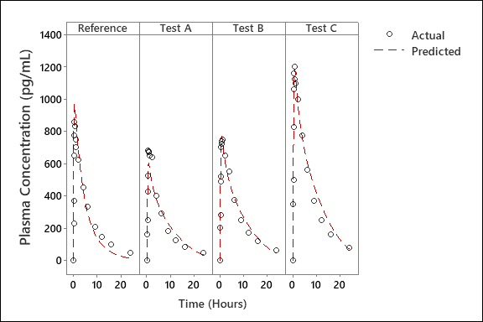
Figure 1: Average Salbutamol Plasma Concentration Over Time Showing Predicted vs Actual Data for an SMI Reference Product and Different MDI Test Products

Figure 2a is a semi log plot of the predicted plasma profile for Test B from Figure 1, with simulated data against 20 replicates and the resulting average profile. A clear overlap of the original and average replicate data is observed. The application of WSV, presented in Figure 2b, also results in the average of all replicates overlapping.
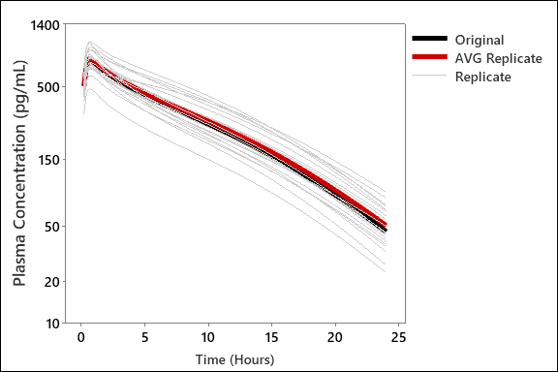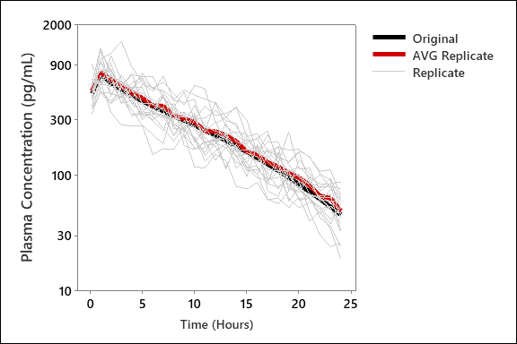
Figure 2: Average Salbutamol Plasma Concentration Over Time for Test B Simulated Data with (a) BSV and (b) BSV and WSV Applied.

Using the model, average PK parameters, including CV, were calculated for each replicate generated, refer to Table 1. The average and CV for BSV and WSV replicates are comparable for AUC₀₋₂₄. A higher average Cmax is predicted for WSV replicates, and for Tmax, the CV is lower than expected for BSV replicates and the average and CV is higher than expected for WSV replicates.
PK Parameter | Original Simulation | BSV Replicates |  | WSV Replicates
PK Parameter | Original Simulation | Average | CV % | Average | CV %
AUC₀₋₂₄ (pg mL⁻¹ h) | 6483.4 | 6769.1 | 22.9 | 6840.6 | 23.3
Cmax (pg mL⁻¹) | 772.0 | 789.3 | 18.4 | 1000.2 | 18.6
Tmax (h) | 0.66 | 0.67 | 5.4 | 1.26 | 52.8
Table 1: Predicted PK Parameters and CV for Test B Simulation with BSV and WSV Replicates

Application of In-Silico PK Modelling to Low GWP MDI Product Development
Clinically relevant APSD data generated for a variety of low GWP propellant MDI test product configurations (LGWP Test A to LGWP Test F) were used in conjunction with the inhaled salbutamol PK model, both with and without the inclusion of a charcoal block, to determine which test product was likely to result in the closest overall average PK performance compared to a reference salbutamol MDI.
Test Product | No Charcoal Block (T/R Ratio) |  |  | Charcoal Block (T/R Ratio)
Test Product | AUC₀₋₂₄ | Cmax | Tmax | AUC₀₋₂₄ | Cmax | Tmax
LGWP Test A | 0.95 | 1.62 | 0.95 | 1.59 | 1.62 | 0.94
LGWP Test B | 1.01 | 1.46 | 0.95 | 1.44 | 1.46 | 0.95
LGWP Test C | 1.05 | 1.16 | 0.96 | 1.14 | 1.16 | 0.96
LGWP Test D | 0.99 | 1.07 | 0.98 | 1.07 | 1.07 | 0.98
LGWP Test E | 1.01 | 1.23 | 0.96 | 1.21 | 1.23 | 0.96
LGWP Test F | 0.92 | 1.09 | 0.97 | 1.08 | 1.09 | 0.97
Table 2: Simulated Average PK Predictions for Different Low GWP Test MDI Configurations (Test (T)/Reference(R) Ratios)

The simulated data presented in Table 2 indicate that LGWP Test D is predicted to have the closest overall average PK performance compared to the reference. Using the previously outlined error model, BSV was applied to the simulations of LGWP Test D and reference. An average BE assessment was applied to assess the expected outcome as presented in Figure 3a. For BSV only the without charcoal block Tmax is predicted to be outside the acceptance range. When WSV is applied, Figure 3b, Tmax is predicted to be outside the acceptance range, both with and without charcoal block.

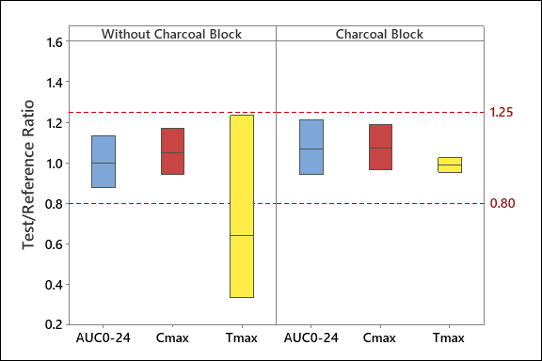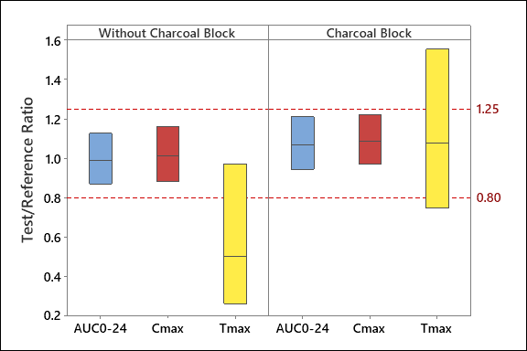
Figure 3: Simulated PK BE Predictions Showing Average Test/Reference Ratio (with 90% confidence intervals) for LGWP Test D with (a) BSV and (b) BSV and WSV Applied, both With and Without a Charcoal Block

Discussion
The inhalation salbutamol PK model developed can reasonably predict clinical data. In addition, the simulation of BSV can produce replicates with an average comparable to the original simulation. In this case, the CV is within expectation for AUC_{t} and Cmax, however the CV of Tmax is lower than expected, which is most likely attributable to Tmax being primarily influenced by absorption and permeation rates in the lung which were not varied in this simulation.
The PK simulations for LGWP Test D, with the application of both BSV alone and with BSV and WSV combined, indicate that BE would be expected to be achieved for AUC_{t} and Cmax compared to the reference salbutamol MDI. For both simulations without charcoal block the Tmax ratio is predicted to be outside the BE criteria, with Tmax for LGWP Test D predicted to be lower than the reference product. This is attributed to the reference MDI product having higher in-vitro throat deposition, leading to greater GI absorption and hence a delayed Tmax for some replicates. When the PK model is run with a charcoal block, eliminating GI absorption, the Tmax ratio is predicted to be within the BE criteria for both simulations, with significantly less variability for the BSV simulation. The wider Tmax confidence interval for the BSV and WSV simulation is attributed to the application of WSV to the model.

Conclusion
A PK model for inhaled salbutamol has been developed using Preludium® that is able to predict PK plasma profiles and differentiate product strengths and different inhalation dosage forms. With the utilisation of an exponential error model, it is possible to simulate variance that could be expected in an actual PK study and establish which test product configuration is most likely to achieve PK BE compared to a reference product. This may be particularly useful for the development of bioequivalent new LGWP MDIs. Further model refinement could be made to enable better estimation of expected variability for Tmax, for example including variation in absorption and permeation rates for BSV.

References

[] Pritchard J: Change is in the air – the new pressurized metered-dose inhalers. (Abstract). Presented at: Drug Delivery to the Lungs (DDL2022), 2022, Edinburgh, UK
[] Olsson B, Bäckman P: Mimetikos PreludiumTM: A New Pharma-friendly Aerosol Drug Deposition Calculator, in RN Dalby, PR Byron, D Traini, SJ Farr, JD Suman and A Watts (eds), Respiratory Drug Delivery 2018, Virginia Commonwealth University, pp 103-111, 2018
[] Patel N, Slowey A, Harrison L: The Technical Challenges of the Developing Existing Inhalation Drug Products into New Metered Dose Inhaler Designs. (Abstract). Presented at: Drug Delivery to the Lungs (DDL2018), 2018, Edinburgh, UK
[] Olsson B: Mimetikos Preludium - PK Module User Manual Main, Emmace Consulting, 2022
[] Hochhaus G, Horhota S, Hendeles L, Suarez S, Rebello: Pharmacokinetics of orally inhaled drug products. AAPS J. 2015; 17(3): pp 769–775.
[] Weber B, Hochhaus G: A pharmacokinetic simulation tool for inhaled corticosteroids. AAPS J. 2013; 15(1): pp 159-171

