Mucoadhesion and cytotoxicity of powders for nasal drug delivery

Alison B Lansley, Xiaoqian Ding, Oluwatosin S Adelowo & Matthew Ingram

Biomaterials and Drug Delivery Research and Enterprise Group, University of Brighton, Lewes Road, Brighton, BN2 4GJ, UK

Summary
The mucoadhesiveness and cytotoxicity of a range of powders was studied to test the hypothesis that mucoadhesive powders can be used safely in the nasal cavity to aid in the retention of the nasal formulations and improve the effectiveness of nasal products.
The mucoadhesiveness of a range of powders (hydroxypropyl methyl cellulose (HPMC 400 and 4000), pectin, carboxymethylcellulose, sodium salt (CMC) and colloidal microcrystalline cellulose (cMCC)) was measured using a Texture Analyser and their toxicity to a human bronchial epithelial cell line (16HBE14o-) was measured using an MTT assay.
The mucoadhesiveness of the powders studied tended to decrease in the following order with HPMC 400 > HPMC 4000 > CMC > Pectin > cMCC > no sample. Generally, HPMC 400, HPMC 4000 and CMC were more mucoadhesive than cMCC (P<0.05). The cytotoxicity of the powders appeared to depend on the volume of cell culture medium available to hydrate the powder. Apart from cMCC, which was not cytotoxic in the presence of 0, 50 and 100 μL medium, all powders were toxic in the absence of medium (p<0.05). All powders, apart from pectin, were non-toxic in the presence of 50 and 100 μL medium.
The mucoadhesiveness and cytotoxicity of different polymers, when applied in powdered form, is variable. Therefore, the choice of powdered polymer is important in optimising the retention of powdered nasal formulations while avoiding toxicity to the nasal epithelium.
Key Message
Mucoadhesive powders can be used safely in the nasal cavity to aid in the retention of the nasal formulation and improve the effectiveness of nasal products. However, the choice of powdered polymer is important to maximise this effect and to avoid toxicity to the nasal epithelium.

Introduction
The World Health Organisation (WHO) and the United Nations Sustainable Development Goal (SDGs) have identified and highlighted the importance of improving access to essential medicines and improving health and quality of life as a crucial step towards achieving global health equity [1]. There is an increasing interest in investigating alternative routes of delivery, such as the nasal route. Most drugs currently administered intranasally are small molecules. However, there is an expectation that many more biologics (peptides, proteins, monoclonal antibodies, mRNA medicines, etc.) will become available in the future [2]. These biologics tend to be costly and have poor stability often requiring refrigeration/reconstitution into a solution/suspension immediately prior to administration. Reconstitution is typically performed by a healthcare professional rather than the patient, which limits the use of these products in a home environment. Additionally, these biologics are usually administered by injection. Hence this study explores the use of nasally administered dry powders to increase stability, improve patients’ adherence and help achieve health equity by making biologics more accessible [3].

The intranasal route can be used for the local treatment of diseases such as allergic rhinitis. It can also be used to deliver drugs to the systemic circulation and to provide access to the olfactory region and, from here, direct access to the brain. Further, the versatility of the nasal route extends to the delivery of vaccines. However, mucociliary clearance in the nasal cavity, critical in protecting the airway against inhaled substances, will clear pharmaceutical formulations and potentially limit their effectiveness [4, 5]. Nasal products are usually in the form of solutions and suspensions and typically exit the nasal cavity within approximately 15 minutes. To improve retention, mucoadhesive polymers can be added to the liquid, and it is hypothesised that retention could be further improved by delivering the product in the form of a dry powder [6-8]. However, it is crucial that any prolongation of a product's residence time in the nasal cavity is reversible, as a persistent reduction in the effectiveness of mucociliary clearance could make patients more susceptible to disease [9-12].
Powders offer several advantages over solutions and suspensions, including increased stability and the potential to administer larger doses and increase nasal retention time. This increased retention time can enhance the effectiveness of the drug [13-15].
The mucoadhesiveness and cytotoxicity of a range of powders was studied to test the hypothesis that mucoadhesive powders can be used safely in the nasal cavity to aid in the retention of the nasal formulation and improve the effectiveness of nasal products.

Experimental Methods
Materials: Hydroxypropyl methyl cellulose (HPMC 400 and 4000) (ShinEtsu, Chiyoda, Japan); Pectin (Herbstreith & Fox, Werder, Germany); Carboxymethylcellulose, sodium salt (CMC) medium viscosity; Colloidal microcrystalline cellulose (cMCC) which is a mixture of MCC and CMC (10 – 20%); (3-(4,5-dimethylthiazol-2-yl)-2,5-diphenyltetrazoliumbromide (MTT), dimethyl sulfoxide (DMSO) (all from (Merck Life Science UK Ltd., Gillingham, UK). Minimum Essential Medium (MEM), Non-Essential Amino Acids (NEAA) and foetal bovine serum (FBS) (Gibco, Thermo Fisher Scientific, Loughborough, UK).
All powders were sieved to a size range of 38-150 μm. The powders were applied to the mucosa or cells from a container with mesh top and a four-figure electronic balance was used to ensure that the mass applied was accurate.
Mucoadhesion: Mucoadhesion studies were performed on the powders using an ex-vivo method employing a Texture Analyser (Model TA.XT plus, Stable Micro System, Surrey, UK). This method determined the maximum force and work needed to separate moistened powders from the surface of a layer of mucosa and were measured by recording force versus displacement curves.
Pig oesophagi (WetLab-Medmeat Ltd., Warwickshire) were stored at -20 °C. Prior to use, an oesophagus was defrosted, cleaned using simulated nasal fluid (SNF: NaCl (7.45 g/L), KCl (1.29 g/L), CaCl₂.2H₂O (0.32 g/L)) in double distilled water (pH 6.4)) [16] and the mucosa was detached from the underlying tissue. Pieces of mucosa (~ 1.5 cm²) were fixed to the lower support of the tensile tester using cyanoacrylate glue and moistened with 100 μL SNF. Powder (5 mg) was applied to the surface of the tissue only. This was left for either 1 minute or 15 minutes then a pre-load of 0.5 N was applied to the powder plus tissue by the upper probe for a contact time of 60 s. The upper probe was then raised from the surface at a constant speed of 0.5 mm s⁻¹. Each powder was tested on at least six different pieces of mucosa at both 1 minute and 15 minutes and the average values for force of detachment and work of detachment were calculated. Initial studies were undertaken to establish the optimum mass (3, 4, 5 and 6 mg CMC with 100 μL SNF) of powder and volume (10, 20, 50 and 100 μL with 5 mg CMC) of SNF to apply.
Cytotoxicity: The 16HBE14o- human bronchial epithelial cell line was cultured in MEM supplemented with 10% v/v FBS and 1% NEAA (medium). Cells were seeded at a density of 2 x 10⁵ cells cm⁻² in 12-well plates and used experimentally 24 hours after seeding. Medium was carefully aspirated from the cells and then replaced with 0 μL, 50 μL or 100 μL fresh medium. The medium of the control cells was replaced with 1800 μL medium. Powder (5 mg) was applied to the cells in each test well for 60 minutes. Three wells were used for each test condition and each experiment was performed in triplicate. After the incubation period the viability of the cells was determined using the MTT assay. MTT (0.5 mg/mL) solution in medium (2000 μL) was applied to each well (200 μL MTT (5 mg/mL) added to control wells) and the cells incubated at 37 °C for two hours. The supernatant was then aspirated from the cells and the insoluble formazan present within the cells was solubilised with DMSO (1 mL per well). After 24 hours, the absorbance of each well was measured at 540 nm using a multiwell scanning spectrophotometer (Multiskan FC Microplate Photometer, Thermoscientific) with SkanIt software. The absorbance of the wells containing cells exposed to the powders was divided by the mean absorbance of the wells containing cells exposed to medium (defined as 100 % viability) and the % viability of the cells in each well was calculated.
Statistics: The adhesive properties of the powders and their cytotoxicity were compared using a non-parametric equivalent of ANOVA (Kruskal-Wallis) (Graph Pad Prism software (version 9.5.1)) to assess the statistical significance of any differences observed. p<0.05 denotes significance.
Results
Mucoadhesion: In preliminary studies using CMC, there was no significant difference (p>0.05) in the maximum force of detachment or work of detachment when applying masses ranging from 3 – 6 mg. A mass of 5 mg was selected for subsequent studies. There was a tendency for force and work of detachment to increase when CMC was applied to the tissue in the presence of 100 μL SNF compared to lower volumes. However, this was only significant when comparing 100 μL with 10 μL (p<0.05). A volume of 100 μL SNF was used in subsequent studies.
The mucoadhesiveness of the powders tended to decrease in the following order with HPMC 400 > HPMC 4000 > CMC > Pectin > cMCC > no sample (Figure 1). Only pectin showed a difference in mucoadhesiveness at the two time points for both force and work of detachment. These increased for the 15-minute samples (p<0.05).
One-minute contact time: Both force and work of detachment indicated that the mucoadhesiveness of HPMC 400, HPMC 4000 and CMC was significantly greater than that of cMCC (p<0.05). cMCC and pectin were not significantly different to ‘no sample’ (p>0.5).
Fifteen-minute contact time: Both force and work of detachment indicated that the mucoadhesiveness of HPMC 400 and CMC was significantly greater than that of cMCC (p<0.05). Work of detachment indicated that CMC was significantly more mucoadhesive that cMCC (P<0.05). cMCC and pectin were not significantly different to ‘no sample’ (p>0.5).
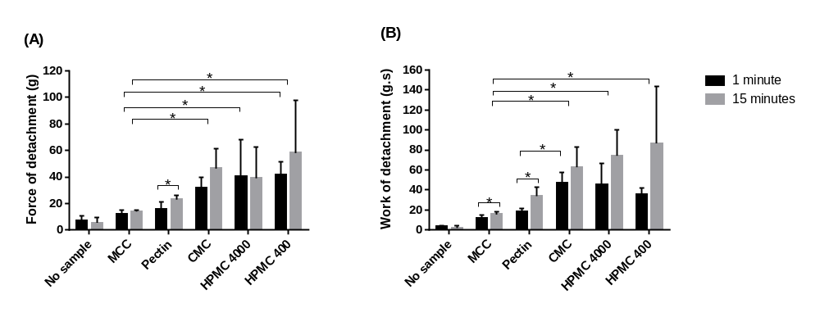Figure 1: The mucoadhesiveness of a range of powders indicated by force (A) and work (B) of detachment. Powders (5 mg) were in contact with the moistened (100 L simulated nasal fluid) mucosa for 1 or 15 minutes prior to the test. The mucoadhesiveness of the powders studied tended to decrease with HPMC 400 > HPMC 4000 > CMC > Pectin > cMCC > no sample. Mean ± SD; n=6.
Cytotoxicity: cMCC was not cytotoxic under any conditions, while pectin decreased cell viability under all conditions. CMC, HPMC 400 and HPMC 4000 only decreased cell viability in the absence of medium (p<0.05). Apart from pectin, the presence of 50 and 100 μL medium was sufficient to prevent toxicity (p>0.05).
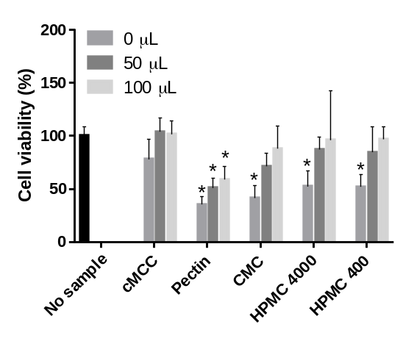
Figure 2: The effect of 5 mg of powders on cell viability. Apart from cMCC, the powders were toxic to the cells when applied in the absence of added medium (0 μL) (p<0.05). Apart from pectin, the presence of 50 and 100 μL medium was sufficient to prevent toxicity (p>0.05). Mean ± SD; n=3

Discussion and Conclusion
Dry polymer powders are not mucoadhesive and become mucoadhesive as they hydrate. Over hydration leads to a loss of adhesive properties (lubrication). The range of volumes of SNF explored suggested that 100 μL was optimal for further studies. Polymers were allowed to hydrate for 1 minute or 15 minutes before measuring their mucoadhesiveness. This time difference had no impact on the results except for pectin; it is possible that pectin takes longer to hydrate than the other polymers. cMCC was included as powder that was not expected to form a gel in SNF [16]. Therefore, the difference in mucoadhesion between HPMC 400, HPMC 4000, CMC and cMCC was to be expected. With a longer hydration time, pectin may also have been more mucoadhesive.
When cells are exposed to mucoadhesive polymers the polymers will draw water from the cells [17] if additional water is unavailable in the form of cell culture medium. This is likely to explain the toxicity of the mucoadhesive polymers in the absence of medium. Interestingly, a slower hydration rate for pectin might explain its toxicity even when 100 μL of medium was available as it might have a continued need for water. This finding suggests that it is important not to overload the nasal epithelium in vivo with a powdered mucoadhesive formulation such that the available secretions are exceeded.
This study indicates that mucoadhesive powders can be used safely in the nasal cavity to aid in the retention of the nasal formulation and improve the effectiveness of nasal products.

References
[1] World Local Production Forum (WLPF): enhancing access to medicines and other health technologies, report of the first WLPF, 21-25 June 2021 World Health Organisation
[2] Comment: Biological sales forecast to pass innovative small molecules sales in next five years. Pharm Tech 2022; April 29:
[3] Makurvet F D: Biologics vs. small molecules: Drug costs and patient access. Med Drug Disc 2021; 9 100075
[4] Lansley A B: Mucociliary clearance and drug delivery via the respiratory tract. Adv Drug Deliv Rev 1993; 11: pp 299–327.
[5] Ugwoke M, Agu R, Verbeke N, Kinget R: Nasal mucoadhesive drug delivery: Background, applications, trends and future perspectives. Adv Drug Deliv Rev 2005; 57: pp 1640–65.
[6] Tiozzo Fasiolo L, Manniello MD, Tratta E, Buttini F, Rossi A, Sonvico F, Bortolotti F, Russo P: Opportunity and challenges of nasal powders: Drug formulation and delivery. Eur J Pharm Sci 2018; 113: pp 2–17.
[7] Tanaka A, Furubayashi T, Matsushita A, Inoue D, Kimura S, Katsumi H, Sakane T, Yamamoto A: Nasal absorption of macromolecules from powder formulations and effects of sodium carboxymethyl cellulose on their absorption. PLoS ONE 2016; 11: e0159150.
[8] Tanaka A, Furubayashi T, Tomisaki M, Kawakami M, Kimura S, Inoue D, Kusamori K, Katsumi H, Sakane T, Yamamoto A: Nasal drug absorption from powder formulations: The effect of three types of hydroxypropyl cellulose (HPC). Eur J Pharm Sci 2017; 96: pp 284–9.
[9] Kirtsreesakul V, Somjareonwattana P, Ruttanaphol S: The correlation between nasal symptom and mucociliary clearance in allergic rhinitis. Laryngoscope 2009; 119: pp 1458–62.
[10] Schuhl J F: Nasal mucociliary clearance in perennial rhinitis. J Invest Allerg Clin Immunol 1995; 5: pp 333–6.
[11] Vlastos I, Athanasopoulos I, Mastronikolis NS, Panogeorgou T, Margaritis V, Naxakis S, Goumas P: Impaired mucociliary clearance in allergic rhinitis patients is related to a predisposition to rhinosinusitis. Ear Nose Throat J 2009; 88: pp E17-19.
[12] Guan W-J, Peng Y, Zi X-X, Tan KS, He T-T, Zhong N-S, Wang D: Motile Ciliary Disorders in Chronic Airway Inflammatory Diseases: Critical Target for Interventions. Curr Allergy and Asthma Rep 2018; 18: pp 48
[13] Fransén N, Bredenberg S, Björk E: Clinical study shows improved absorption of desmopressin with novel formulation. Pharm Res 2009; 26: pp 1618–25.
[14] Ishikawa F, Katsura M, Tamai I, Tsuji A: Improved nasal bioavailability of elcatonin by insoluble powder formulation. Int J Pharm 2001; 224: pp 105–14.
[15] Ishikawa F, Murano M, Hiraishi M, Yamaguchi T, Tamai I, Tsuji A: Insoluble powder formulation as an effective nasal drug delivery system. Pharm Res 2002; 19: pp 1097–104.
[16] Trenkel M, Scherließ R: Nasal powder formulations: In-Vitro characterisation of the impact of powders on nasal residence time and sensory effects. Pharmaceutics 2021; 13: pp 385.
[17] Mortazavi S A, Smart J D: An investigation into the role of water movement and mucus gel dehydration in mucoadhesion. J Control Release 1993; 25: pp 197-203

