Impact of protein aggregation on the immunogenicity of a human monoclonal antibody following pulmonary administration in mice
Sohaib Mahri¹, Céline Cassiers ¹, Gracin Sandra², Francine Uwambayinema⁵, François Huaux⁵, Mariam Ibrahim³, Sian Piper⁴, Antonio Llinas², Markus Fridén^{2,6}, Rita Vanbever¹
¹ Université catholique de Louvain (UCLouvain), Louvain Drug Research Institute (LDRI), Advanced Drug Delivery & Biomaterials (ADBB), Brussels 1200, Belgium.
² AstraZeneca; Pharmaceutical Technology & Development; Inhalation Product Development; Gothenburg, Sweden
³ AstraZeneca; R&D Biopharmaceuticals; Biopharmaceuticals Development; Gaithersburg, US
⁴ AstraZeneca; R&D Biopharmaceuticals; Bioscience Asthma, Early R&I; Cambridge, UK
⁵ UCLouvain, Institut de Recherche Expérimentale et Clinique, Louvain Centre for Toxicology and Applied Pharmacology, Brussels, Belgium
⁶ Uppsala University, Department of Pharmacy, Uppsala, Sweden

Summary
Spray drying is commonly used to produce dry powder formulations for inhalation. However, this process subjects proteins to stresses likely resulting in the formation of protein aggregates. These aggregates can cause a loss of activity and an increased risk of immunogenicity. The impact of aggregates on the immunogenicity of therapeutic proteins delivered via the pulmonary route is not well understood. Therefore, our study aimed to specifically assess the effect of different levels of aggregates on the immunogenicity of the human monoclonal antibody NIP228 after repeated intratracheal administration in mice. NIP228 was labelled with NHS-rhodamine and then aggregate-free rhod-NIP228 solution (No_agg) was spray-dried both with and without 1% polysorbate 80 surfactant, to generate powders with high and low levels of NIP228 aggregates (referred to as Hi_agg and Lo_agg, respectively). Following repeated intratracheal administration of the No_agg, Lo_agg, or Hi_agg in mice, anti-NIP228 antibody (ADA) levels in both sera and bronchoalveolar lavage fluids (BAL) were measured. The incorporation of PS80 significantly reduced the aggregate formation associated with spray drying and increased FPF < 5 μm (78% for Hi_agg vs 87% for Lo_agg ). Interestingly, the level of aggregates did not significantly impact the magnitude of the anti-drug antibody response in sera or BAL and the pulmonary route induced a stronger immune response compared to subcutaneous administration.

Key Message
The study found that the pulmonary route induced a stronger immune response compared to subcutaneous administration and that the level of aggregates did not significantly impact the magnitude of the anti-drug antibody response.

Introduction
While traditionally administered through injections, inhalation has emerged as a promising route for delivering therapeutic proteins to the lungs, particularly for respiratory diseases. Spray drying is a cost-effective method for producing inhalable dry powders that offer improved stability and convenient delivery. However, this process can subject proteins to physical stresses that may lead to unfolding and aggregation, potentially affecting their bioactivity and causing immunogenicity [1]. The impact of aggregates on immunogenicity when administered via the pulmonary route is still under discussion. Some preclinical studies have raised concerns about high immunogenicity and microscopic changes in the airways when using inhaled biotherapeutics [2]. To further understand the immunogenicity of proteins delivered through inhalation and the influence of aggregates generated during spray drying, we conducted this study using a human monoclonal antibody (NIP228) in mice. The antibody was intratracheally administered in different formulations with varying levels of protein aggregates and levels of anti-NIP228 anti-drug antibody (ADA) were assessed in sera and bronchoalveolar lavage fluids (BAL). In addition, the pulmonary route was also compared with the subcutaneous route for the aggregate-free solution.
Materials and methods

Materials. The monoclonal antibody (mAb) NIP228 was obtained from Medimmune (AstraZeneca Cambridge, UK), NHS-Rhodamine from Life Technologies (#46406, Gent, Belgium), and polysorbate 80 from Sigma-Aldrich (St. Louis, MO, USA). Crystalline D-(+)-trehalose dihydrate was bought from Hayashibara Co (Japan), and raw crystalline trileucine was bought from Bachem, UK (Cat. No. H-3915). Other chemicals and reagents were purchased from Sigma-Aldrich.

NIP228 fluorescent labeling. NIP228 solution (9.69 mg/ml) in a storage solution was exchanged against phosphate buffer saline (PBS, pH 7.45). NHS-rhodamine was added to NIP228 solution at a 2:1 molar ratio and left to react for 2 hours at 4 °C in the dark. Unreacted dye was removed by dialysis, and the final labeled NIP228 solution was stored at -20 °C.

Spray-drying. Two dry powders, with and without polysorbate 80 (Lo_agg and Hi_agg, respectively), were prepared using a modified Büchi B-290 spray dryer. The feed solutions were prepared using MilliQ water with a total solid content of 30 mg/ml: NIP228 (10 % w/w), trileucine (5% w/w), polysorbate 80 (1% or 0% w/w for Low_Agg and High_agg respectively) and topped to 100% with trehalose. Spray-drying created a physically stable and inhalable amorphous powder. The dry powder was collected and stored at 2% relative humidity.

Characterization of dry powders. The morphology, particle size distribution, and aerodynamic characteristics of the spray-dried powders were evaluated using a scanning electron microscope (SEM) and Next Generation Impactor (NGI) operating at a pressure drop of 4 kPa corresponding to a flow rate of 60 L/min for the Plastiape RS01 device used to aerosolize the capsule powder.

Aggregate characterization of rhod-NIP228 formulations. The hydrodynamic size of rhod-NIP228 in the solution or the reconstituted powders was measured using DynaPro II/III Plate Reader DLS instrument from Wyatt Technologies. Soluble aggregates and oligomers were analyzed by size exclusion chromatography (SEC) using a Superdex 75 Increase 10/300 GL column. Subvisible particles were quantified using a Micro-Flow Imaging (MFI) system from Brightwell Inc.

Immunogenicity of rhod-NIP228 for different formulations and administration routes. Animal experiments were approved by the Institutional Animal Care and Use Committee of the Université catholique de Louvain (Permit number 2019/UCL/MD/044). Female RjOrl SWISS mice (n = 10) received 5 weekly administrations of 50 µg of rhod-NIP228 via intratracheal instillation (25 µl solution), intratracheal insufflation (~0.55 mg dry powder), or subcutaneous injection (100 µl solution). A control group received saline by intratracheal instillation (n = 4). After 18 days of the last injection, mice were euthanized, and blood and bronchoalveolar lavage fluid (BAL) were collected. Sera and BAL were stored at -20°C for anti-drug antibody (ADA) quantification. ADA against NIP228 were measured in sera and BAL using an in-house enzyme-linked immunosorbent assay (ELISA). Titer was determined as the reciprocal of the dilution that yielded an OD equal to the predefined cut-off (0.1 for sera, 0.03 for BAL). A titer of zero was assigned to samples with ODs below the cut-off. Samples were analyzed on the same day under the same conditions.

Statistics. ANOVA was used for multiple group comparisons (n ≥ 3). Log-transformed data were used for ADA titers. Results are presented as mean ± sem. Statistical significance was set at * p < 0.05, ** p < 0.01, and *** p < 0.001. GraphPad Prism software was used for analysis.
Results

Spray drying of rhod-NIP228.

SEM analysis showed corrugated particles (< 1 µm to about 5 µm) for Hi_agg and Lo_agg, without significant differences (Fig. 1 a&b). NGI data revealed comparable in vitro deposition patterns between Hi_agg and Lo_agg, except for a higher FPF < 5 μm in Lo_agg (87%) compared to Hi_agg (78%) (p = 0.01) (Table 1). Both powders exhibited high delivered doses, with 88.5 ± 6.6 % for Hi_agg and 92.9 ± 5.3 % for Lo_agg. MMAD values were similar between Hi_agg (2.41 ± 0.26 µm) and Lo_agg (2.69 ± 0.01 µm) (p > 0.05).
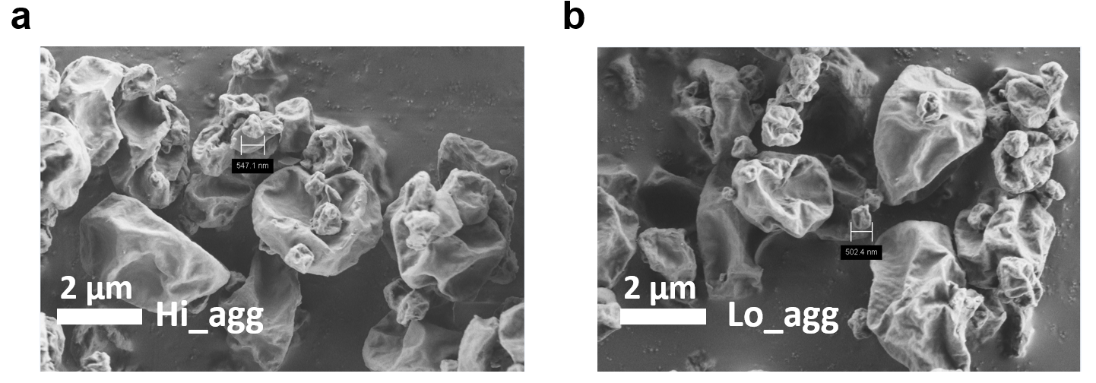 | Fig 1. Dry powder characterization. Scanning electron microscope (SEM) micrographs of spray dried powders Hi_agg (a) and Lo_agg (b). Scale bar 2 μm.

Table 1. Aerodynamic characteristics of rhod-NIP228 dry powder aerosols.
Aerodynamic characteristics | % delivered dose (RSD%) | FPF < 5 µm  (RSD%) | FPF < 3 µm  (RSD%) | MMAD (RSD%) | GSD (RSD%)
Hi_agg | 88.5 (6.6) | 78.3 (2.1) | 51.7 (8.8) | 2.41 (10.65) | 1.79 (6.12)
Lo_agg | 92.9 (5.3) | 88.6 (0.3) | 57.8 (0.0) | 2.69 (0.07) | 1.53 (1.03)
FPF, fine particle fraction as % of delivered dose < 5 µm; GSD, geometric standard deviation; MMAD, mass median aerodynamic diameter (MMAD); RSD, relative standard deviation
Protein aggregates characterization.
DLS analysis of the rhod-NIP228 solution showed a monodisperse peak corresponding to monomers (Fig 1 a,d,c). Confocal microscopy and SEC confirmed the absence of insoluble and soluble aggregates (Fig 1 b,e,h). Both reconstituted dry powders (Hi_agg and Lo_agg) exhibited protein aggregates by DLS. Hi_agg had higher levels of particles in the 100-1000 nm size range and particles >1 µm compared to Lo_agg.
Confocal images showed insoluble aggregates in both dry powders, but no soluble aggregates or degradation products were detected by SEC (Fig 1 c,f,i). Micro-flow imaging confirmed the aggregate particles in the micrometer range (Fig 1 k). In summary, reconstituted Hi_agg had 9.7% aggregates, while Lo_agg had only 0.7%, and the solution had none. No soluble aggregates were detected in any formulation.

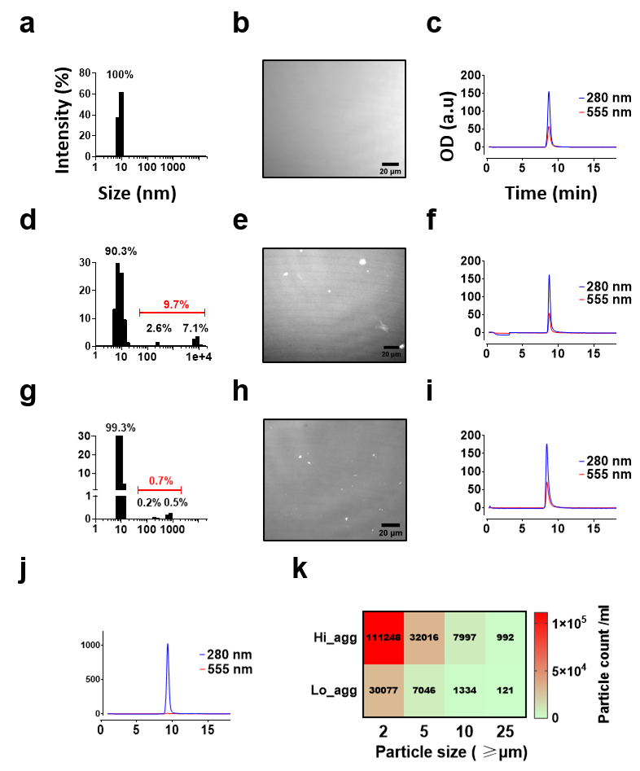 | Fig 2. Assessment of protein aggregates of different rhod-NIP228 formulations: rhod-NIP228 solution (a-c), reconstituted Hi_agg (d-f) and reconstituted Lo_agg (g-i) in distilled water. The hydrodynamic size distributions were measured by dynamic light scattering for rhod-NIP228 solution, Hi_agg, and Lo_agg (a,d,g respectively). Insoluble aggregates were imaged by fluorescence confocal microscopy. Images were acquired using laser line 561 nm and presented in grayscale. Protein aggregates appear as bright spots in micrographs corresponding to the reconstituted Hi_agg (e) and reconstituted PS PS80 (h) but not the rhod-NIP228 solution (b). c,f,I, and j, chromatograms of size exclusion chromatography (SEC) of rhod-NIP solution, reconstituted Hi_agg and reconstituted Lo_agg, and unlabeled NIP228 after centrifugation at 10,000g for 10 min. The column was eluted using phosphate buffer saline and peaks were monitored at 280 nm (protein) and 555 nm (fluorescent label). (k) Micro-flow imaging (MFI) of reconstituted dry powders of Hi_agg and Lo_agg in water at a protein concentration of 5 mg/ml. a.u, arbitrary unit.

Immunogenicity of rhod-NIP228 solution and dry powders by inhalation and subcutaneous injection
The immunogenicity of rhod-NIP228 was evaluated in mice through pulmonary and subcutaneous delivery. There were no significant differences in ADA levels among groups receiving rhod-NIP228 via the pulmonary route, regardless of formulation (Fig. 3). All mice receiving Rhod-NIP228 by pulmonary delivery developed significant ADA, while only 4 out of 10 mice in the subcutaneous group showed a response. If non-responding mice were excluded from the analysis, no significant differences were found compared to intratracheal administration. Similar trends were observed in BAL. ADA titers in sera before the 4th dose were slightly lower but not significantly different from the end of the experiment. Body weight and tolerance to rhod-NIP228 and administration procedures were similar across groups.
Discussion
This study compared the immunogenicity of the monoclonal antibody rhod-NIP228 when administered via the pulmonary and subcutaneous routes in mice. The presence of anti-drug antibodies (ADA) against rhod-NIP228 did not differ among various formulations, regardless of the absence (solution), low levels (Lo_agg), or high levels (Hi_agg) of insoluble aggregates.
The incorporation of PS80 surfactant significantly reduced insoluble aggregate formation during spray drying. The wrinkled particle shape was attributed to the evaporation rate at the droplet surface and the presence of trileucine, which enhances aerosol performance [3].
Despite the varying levels of protein aggregates in the solution and both dry powders, the immunogenicity of rhod-NIP228 following pulmonary delivery was not affected. This finding contradicted the notion that aggregates are inherently more immunogenic than monomers [4]. Studies in mice suggested that aggregate dose, dosing frequency, and possibly particle size could impact immunogenicity [5]. The solution formulation exhibited similar immunogenicity compared to the dry powders although deposition was likely deeper in the lungs and more uniformly distributed. ADA levels in bronchoalveolar lavage (BAL) fluid mirrored those in serum for both delivery routes. The transport of antibodies and proteins from serum to the lung is a known phenomenon [6]. In addition, the pulmonary route resulted in a higher incidence of ADA compared to the subcutaneous route. Available clinical data for other biotherapeutics also indicated higher immunogenicity with inhalation compared to parenteral routes [2, 7].
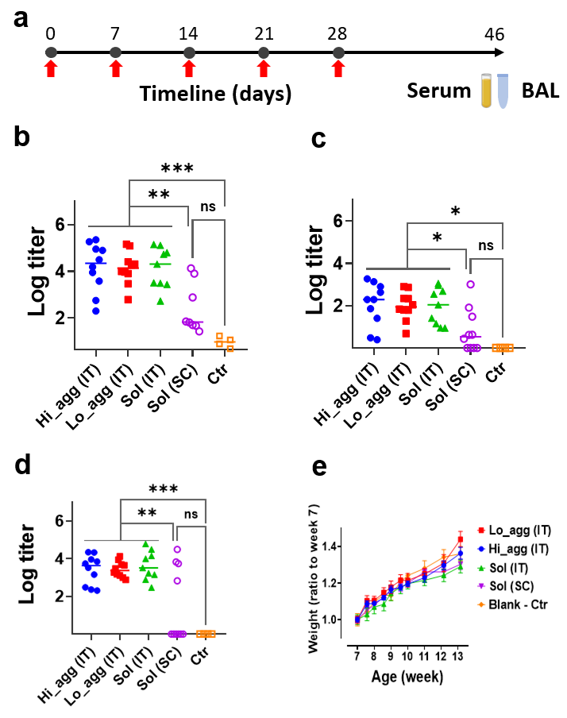
Fig 3. Immunogenicity of different rhod-NIP228 formulations by the pulmonary and subcutaneous routes. a, 50 µg (0.33 nmol) of rhod-NIP228 was administered to mice by intratracheal instillation (SOL), intratracheal insufflation of dry powders (Hi_agg or Lo_agg), or subcutaneous injection of rhod-NIP228 solution (SC). Mice were given 5 once-weekly administrations and were sacrificed 18 days after the last administration and serum and BAL were collected for ADA quantification. Control group (Ctr) received a saline solution by intratracheal instillation. ADA against rhod-NIP228 were detected by ELISA in serum (b) and BAL (c). d, ADA titers in sera at day 20, one day before the fourth dose of rhod-NIP228. e, Percentage of weight change normalized to the average weight of each mice group at the beginning of administration on week 7. Note that titers in sera and BAL are not comparable as different thresholds were used. Ssignificant differences are indicated by * p < 0.05, ** p < 0.01, or *** p < 0.001 (b-d, one-way ANOVA on log titers followed with Tukey’s post hoc test. e, two-way repeated measures ANOVA followed with Bonferroni post hoc test). ADA, anti-drug antibody.
Conclusion
The study's findings highlight the potential for increased immunogenicity with the pulmonary route and suggest that the role of protein aggregates in immunogenicity needs further investigation. Monitoring ADA levels is crucial, especially when strong immunogenicity is observed in animal studies. In our studies, a higher level of insoluble protein aggregates did not correlate with a higher ADA response. From a vaccination perspective, the inhalation route shows promise in eliciting a robust immune response.
References
[1] Chang, R.Y.K., et al., Dry powder pharmaceutical biologics for inhalation therapy. Advanced Drug Delivery Reviews, 2021. 172: p. 64-79.
[2] Hall, A.P., et al., BSTP Review of 12 Case Studies Discussing the Challenges, Pathology, Immunogenicity, and Mechanisms of Inhaled Biologics. Toxicol Pathol, 2021. 49(2): p. 235-260.
[3] Lechuga-Ballesteros, D., et al., Trileucine improves aerosol performance and stability of spray-dried powders for inhalation. J Pharm Sci, 2008. 97(1): p. 287-302.
[4] Rosenberg, A.S., Effects of protein aggregates: an immunologic perspective. Aaps j, 2006. 8(3): p. E501-7.
[5] Jiskoot, W., et al., Mouse Models for Assessing Protein Immunogenicity: Lessons and Challenges. J Pharm Sci, 2016. 105(5): p. 1567-1575.
[6] Patton, J.S., Mechanisms of macromolecule absorption by the lungs. Advanced Drug Delivery Reviews, 1996. 19(1): p. 3-36.
[7] Fahy, J.V., et al., effect of aerosolized anti-IgE (E25) on airway responses to inhaled allergen in asthmatic subjects. Am J Respir Crit Care Med, 1999. 160(3): p. 1023-7.

