Development of pulmonary formulations with gallium siderophores against Aspergillus fumigatus lung infections

B. Grassiri^{1,2}, M. Piatek^{3,4}, L. More O’Ferrall^{3,5}, S. Esin⁶, J. A. Sake², G. Batoni⁶, C. Ehrhardt², D. M. Griffith^{3,5}, K. Kavanagh^{3,4}, A. M. Piras¹, A. M. Healy^{2,3}

¹University of Pisa, Department of Pharmacy, 56126 Pisa, Italy

²School of Pharmacy and Pharmaceutical Sciences, Trinity College Dublin, Dublin 2, Ireland

³SSPC, The Science Foundation Ireland Research Centre for Pharmaceuticals, Ireland

⁴Department of Biology, Maynooth University, Maynooth, Ireland
⁵Department of Chemistry, Royal College of Surgeons in Ireland, Dublin 2, Ireland

⁶Department of Translational Research and New Technologies in Medicine and Surgery, University of Pisa, 56123, Pisa, Italy

Summary
The lack of available drugs for the treatment of fungal infections, along with the emergence of drug-resistant strains, results in millions of deaths each year [1]. The World Health Organization has categorised Aspergillus fumigatus (A. fumigatus) in the critical priority group of fungal pathogens associated with serious risk of mortality and morbidity in humans. Pulmonary aspergillosis is particularly severe in patients with cystic fibrosis (CF) in which it is clearly associated with airway damage and lung function decline. In this work, the novel gallium-siderophore complex, GaS1, was selected as the most active against A. fumigatus (ATCC strain 26933), while having low toxicity in NCI-H441 distal lung epithelial cells. A formulation study was performed, resulting in a solution for nebulisation and three different dry powder inhaler (DPI) formulations, prepared by spray-drying GaS1 with different concentrations of L-leucine. Physicochemical characterisation of all the formulations was undertaken (i.e. SEM, PXRD, laser diffraction for the powders, and osmolality for the solution) and their aerodynamic deposition profiles were determined using the next generation impactor (NGI). All formulations showed suitable aerodynamic characteristics for GaS1 delivery to the lungs. Ultimately, the GaS1 based solution for nebulisation (namely GaS1-sol) was assessed against clinical lung isolates of A. fumigatus within an in vitro lung infection model. This model was also employed to replicate fungal infections in the context of cystic fibrosis (CF) airway conditions, utilizing clinically isolated conidia, the NCI-H441 cell line, and an artificial sputum medium (ASM). A marked dose dependent antifungal activity was observed, confirming the future potential lung delivery of gallium-siderophores for fungal infection treatments.
Key Message

The novel gallium-siderophore complex, GaS1, is selectively toxic against A. fumigatus, and non-toxic to NCl-H441 cells. All GaS1 formulations (i.e., powders and solution for nebulisation) were shown to be suitable for pulmonary drug delivery, and the solution was effective in an in vitro lung infection model mimicking the conditions found in the CF airways.

Introduction

In late 2022, Aspergillus fumigatus (A. fumigatus) was included by the World Health Organization in the critical priority group of fungal pathogens that are associated with serious risk of mortality and morbidity in humans. Pulmonary aspergillosis is particularly severe in patients with CF, in which it is clearly associated with airway damage and lung function decline. Azole-resistant A. fumigatus is an emerging threat that hampers our ability to successfully treat patients with aspergillosis, demanding for the identification of new treatment options against azole-resistant isolates. An unconventional approach to fight microbial infection is to exploit nutritional vulnerabilities of microorganism metabolism. The metal gallium can disrupt iron metabolism in bacteria and cancer cells. Various Ga³⁺ related agents, e.g. gallium nitrate (GaN), gallium maltolate (GaM), gallium chloride, and gallium citrate (GaC), have shown bacterial growth inhibitory effects [2, 3]. Despite its known antibacterial and antitumoral activity, there are few reports of the antifungal effect of gallium [4, 5]. Bastos et al. demonstrated the fungistatic effect of GaN against azole-sensitive and -resistant A. fumigatus strains and also a synergistic effect with caspofungin [4]. Siderophores are molecules that are able to sequester Fe³⁺ from the environment, forming Fe-siderophore complexes. The aim of the current research is to develop an innovative gallium siderophore-based therapy against azole-resistant A. fumigatus infections, which can be efficiently delivered to the lungs as a dry powder inhaler (DPI) formulation or a solution for nebulisation.

Materials: Six water soluble gallium salts/complexes were evaluated: GaN (also the starting material for synthesis of other compounds), GaM (neutral), GaC (charged) and three novel gallium siderophores, GaS1, GaS2 and GaS3 (charged complexes).
Methods: Gallium compound fungal toxicity evaluation: Gallium compounds in a concentration range of 4-500 μg/mL were tested in 96-well plates containing Sabouraud dextrose (SAB) broth and A. fumigatus (5×10⁵ conidia/mL). Growth was measured in a plate reader (Bio-Tek Synergy HT) at 600 nm after 24 h and 48 h incubation at 37°C.
Agar diffusion test: A. fumigatus spore suspensions (1×10⁵ spores/mL) were spread over SAB agar. Fifty microlitres of all compound stock solutions or deionised water were introduced in a hole punched out of the agar. The diameters of the zones of inhibition were measured after 24 h incubation at 37°C.
Fungicidal/fungistatic assay: A. fumigatus (5×10⁵ spores/mL) was incubated in SAB broth supplemented with GaS1, GaS2 or GaS3 (0.500 mg/mL) at 37°C in an orbital shaker. Aliquots (100 μL) were removed after 2 h, 4 h, 6 h, 8 h and 24 h and spread on SAB agar plates. The level of growth was photometrically assessed after incubation at 37°C for 24 h.
Cytotoxicity evaluation: NCI-H441 cells (1.65×10⁴ cells/well) were grown for 6 days until confluency. Cells were serum starved 24 h before the experiment. All compounds, and later the formulated powders and solutions, were tested in a concentration range of 0.005–5 mg/mL. After 4 h or 24 h of incubation, media was removed, and the cell viability was assessed with alamarBlue reagent.
Preparation of spray-dried GaS1/L-leucine: Composite powders containing different L-leucine (LL) and GaS1 weight ratios (0:100; 20:80, 30:70 w/w, LL:GaS1) were spray dried as a 0.5% (w/v) solution in water using a Büchi B-290 Mini spray dryer operating in the open mode.
Particle morphology, size and solid state: SEM micrographs of spray-dried materials were acquired using a Zeiss Supra Variable Pressure Field Emission Scanning Electron Microscope (Oberkochen, Germany) [6]. Particle size distributions were obtained using a Mastersizer 3000 laser diffraction instrument (Malvern Instruments, Malvern, UK) with a dry powder dispersion accessory (Malvern Aero S). The solid state nature of the powder was determined by X-ray powder diffraction measurements using a Rigaku Miniflex instrument (Rigaku, Neu-Isenburg, Germany).
Formulation of a solution for nebulisation and In vitro deposition profile determination: A GaS1 solution for nebulisation (GaS1-sol) was prepared by dissolving 5 mg/mL of GaS1 in a 0.9% sodium chloride solution. The final osmolarity of the solution was evaluated using a Vapro 5520 Vapor Pressure Osmometer (Wescor, South Logan, USA). The pH of the solution was also measured. A Next Generation Impactor (NGI) (Copley Scientific, Notinghan, UK) was used to determine the aerodynamic properties of GaS1 solution for nebulisation and the GaS1 based powders. For the solution, 2 mL was loaded in an Aerogen Solo mesh nebuliser (Aerogen, Galway, Ireland) whereas the powders (20 ± 1 mg) were loaded in a size 3 capsule in a RS01 (Plastiape, Osnago, Italy) device. In both cases the NGI was set to operate according to the European Pharmacopoeial conditions [7]. The GaS1 deposited on each stage was determined by UV analysis. The mass median aerodynamic diameter (MMAD), fine particle fraction less than 5 μm (FPF) and geometric standard deviation (GSD) were determined as previously described [6].
GaS1 toxicity evaluation on clinical isolates: Three A. fumigatus strains (AF1, AF2 and AF3) were isolated from respiratory samples of patients attending Pisa University Hospital and their susceptibility profiles to antifungals were assessed by standard methods. To reproduce the CF lung conditions, the MIC values of GaS1 were preliminarily tested in a host-cell compatible medium (RPMI 1640, 2 mM glutamine) in the presence of 20% artificial sputum medium (ASM). GaS1 was tested in a concentration range: 0.5-0.016 mg/mL. A. fumigatus conidia suspensions, 1x10⁵ conidia/mL were incubated at 37°C for 48 h in static condition. Growth was measured in a microplate reader at 405 nm.
GaS1 activity against lung isolates of A. fumigatus in an in vitro air-liquid interface lung infection model: Monolayers of NCl-H441 cells (human distal lung epithelium) were grown on Transwell inserts at the air liquid interface (ALI) as previously described [8]. Differentiated monolayers were infected with 5×10³ AF3 conidia/well and treated with four different concentrations of GaS1 (1 mg/mL; 0.500 mg/mL; 0.250 mg/mL; 0.125 mg/mL). After 48 h, plates were fixed and stained with hematoxylin-eosin. In a second experimental setup, fungal load was evaluated by plating serial dilutions of treated and untreated samples on Sabouraud agar. Agar plates were observed after 48 h incubation.
Results
Antifungal activity of gallium compounds and toxicity to NCI-H441 cells: The IC₅₀ on A. fumigatus and NCI-H441 lung epithelial cells were determined for GaN, GaM, GaC, GaS1, GaS2 and GaS3. Ga-siderophore complexes were selectively toxic to A. fumigatus, showing an IC₅₀ on A. fumigatus of 0.04 mg/mL and of 2 mg/mL on NCI-H441 lung epithelial cells. In the agar inhibition study, only 0.5 mg/mL GaS1 and GaS2 showed a clear 2 ± 0.1 cm zone of inhibition. Moreover, GaS1 was found to be fungicidal at 0.5 mg/mL and was therefore selected as the lead compound. Characteristics of GaS1/LL spray dried powder for inhalation: All spray-dried composites were obtained in good yield (≥ 70.9 %). The PXRD diffractograms of the formulations showed a diffuse halo pattern, characteristic of amorphous material (Figure 2 A), while the particle size (Table 1) indicated suitability for pulmonary drug delivery, with geometric median diameters of around 2-3 µm for all composites powders. All particles presented corrugated surfaces (Figure 2B), a morphology which increases the distance between particles, reducing the true area of contact and their tendency to agglomerate, which can improve the MMAD and FPF [9].
Table 1: Particle size and in vitro deposition (NGI) characteristics of spray dried formulations
LL:GaS1 | Dx10 (µm) | Dx50 (µm) | Dx90 (µm) | MMAD (µm) | FPF (%) | GSD
0:100 | 1.1±0.1 | 2.9±0.2 | 7.4 ±1:0.4 | 3.3±0.3 | 65±6 | 1.8±0.1
20:80 | 1.0±0.2 | 2.4±0.2 | 4.9±0.4 | 2.9 ± 0.1 | 76±3 | 1.7±0.1
30:70 | 1.1±0.1 | 2.7±0.2 | 5.6±0.4 | 2.4 ± 0.4 | 78±2 | 2.3±0.1
GaS1-sol | - | - | - | 5.0 ± 0.4 | 53±1 | 2.9±0.1

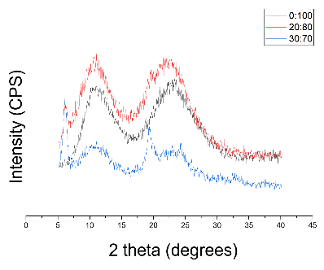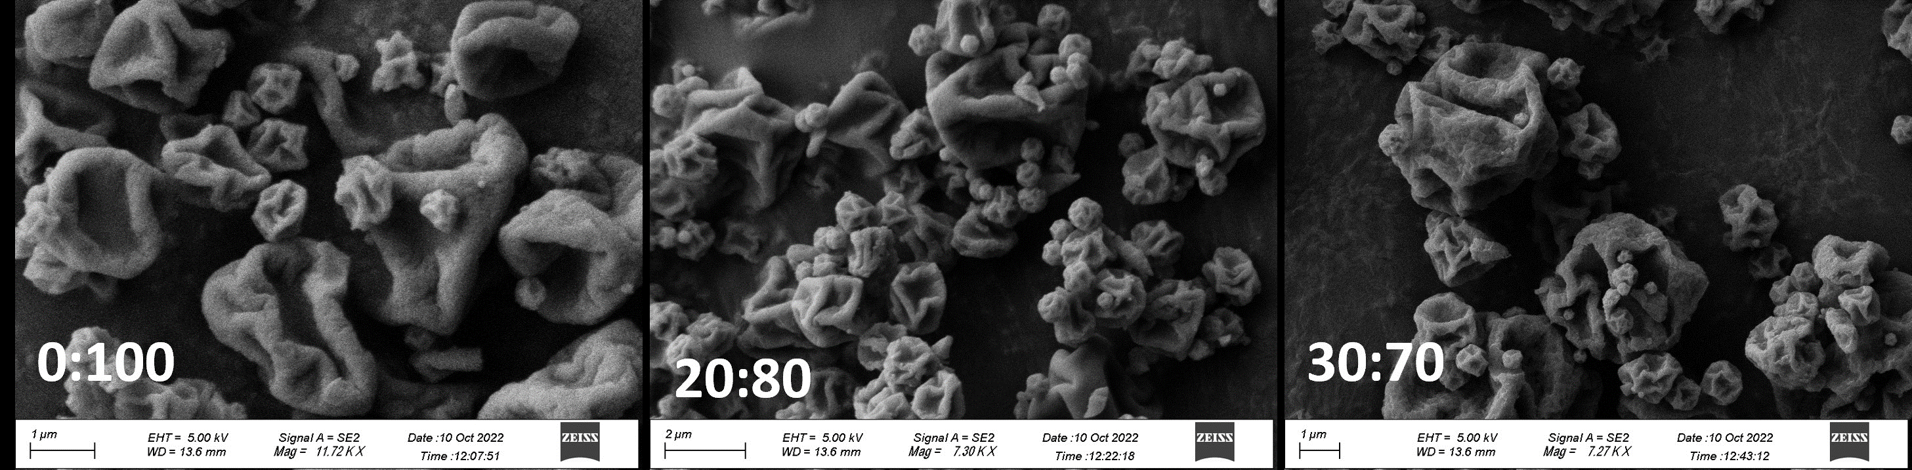
[B]
[A]
Figure 2: [A] PXRD diffractograms of 0:100 (black) 20:80 (red) 30:70 (blue) LL:GaS1 (w/w) spray dried powders [B] SEM micrographs of the spray dried composites LL:GaS1 0:100; 20:80; 30:70 w/w.
Toxicity of GaS1 formulations to A. fumigatus and NCI-H441 cells: The IC₅₀ of the formulated GaS1 remained unchanged on both A. fumigatus and NCI-H441 cells.
In vitro deposition profiles of GaS1 formulations: The solution for nebulisation and all spray dried composites showed suitable characteristics for pulmonary drug delivery with FPFs <5 μm between 67% and 87% and MMADs of approximately 3 μm for the powders or 5 μm for the nebulised solution (Table 1). A trend of improved in vitro deposition in the NGI with increasing concentration of LL in the spray dried formulations was observed.
GaS1 activity against clinical lung isolates of A. fumigatus in a lung infection model: When tested in a concentration range of 0.016-0.5 mg/mL GaS1 inhibited the growth of all three A. fumigatus isolates in a complex host-environment mimicking medium at 0.063 mg/mL (Figure 3A). This data confirmed the MIC of GaS1, previously assessed on A. fumigatus ATCC strain. Monolayers of NCI-H441 cells in the presence of 20% ASM supported the growth of the clinical isolate, AF3, at levels even higher than those observed in the same medium without cells. Once the activity of the GaS1-sol formulation on AF3 in the presence of ASM was assessed, the solution was tested in an in vitro ALI lung infection model. GaS1-sol exhibited a marked antifungal activity against AF3 in the presence of both un-differentiated and differentiated lung epithelial cells at the ALI. In both experimental systems evident hyphal growth was visible following 48 h of culture in untreated samples, while in GaS1-treated samples nearly no growth of AF3 was detected at the macroscopic and microscopic level (Figure 3B). The serial dilutions plating of treated and untreated samples, showed a dose dependent 3 to 6 log₁₀ growth inhibition for 0.125, 0.250, 0.5 and 1mg/mL GaS1-sol dilutions, respectively.
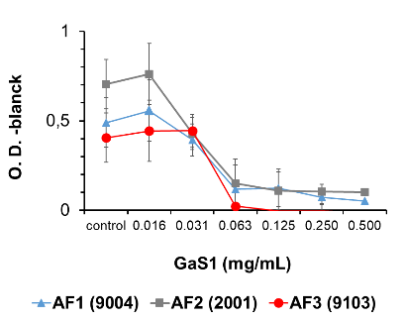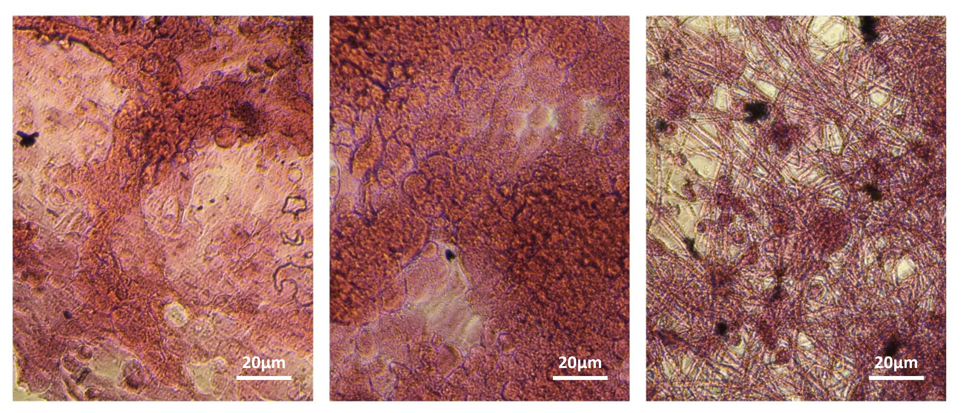
[B]
[A]
Figure 3: [A] Determination of MIC values of GaS1 against three A. fumigatus isolates (AF1, AF2, AF3) in host cell medium (RPMI + glutamine without FBS) added with 20% ASM. [B] Differentiated monolayers fixed and stained with hematoxylin-eosin. From left to right: Negative non-infected control, infected treated control with GaS1-sol treatment, infected untreated control.
Discussion and Conclusions
Currently, there are few drugs available for the treatment of severe fungal infections. The efficacy of gallium compounds, GaN, GaM and GaC, on bacterial strains has been previously described [4] and an ongoing phase 1/2a clinical trial (NCT03669614) is investigating the safety and pharmacokinetics of inhaled GaC in P. aeruginosa-infected CF patients. All three newly synthesised Ga-siderophore compounds showed selective efficacy against A. fumigatus. GaS1 was selected as the lead compound, for its marked antifungal effect at 0.5 mg/mL (at which concentration it was found to be non-toxic to human lung epithelial cells). Therefore, both a solution for nebulisation and three different powders for inhalation were assessed. DPI formulations comprised of GaS1 and L-leucine were prepared by spray-drying, and showed suitable characteristics for effective pulmonary delivery, with FPFs < 5 μm between 65% and 78% and MMADs of approximately 3 μm. A trend of improved aerodynamic properties with increased concentration of L-leucine in the powder formulation was observed. A solution for nebulisation was also assessed, and its deposition profile after nebulisation using an Aerogen mesh nebuliser, showed good aerodynamic characteristics, with FPFs < 5 μm of 53%. Considering the nebulisation of GaS1 to be a promising tool for hospitalised infected CF patients, the GaS1 solution formulation was tested against clinical lung isolates of A. fumigatus in an in vitro lung infection model mimicking the conditions found in the CF airways. The results showed that, although A. fumigatus growth is more consistent in the presence of cells and ASM, GaS1-sol confirmed its marked and dose-dependent antifungal activity against clinical isolates at concentrations compatible to human cell viability.
In conclusion, a novel gallium siderophore formulation that efficiently delivers the siderophore-gallium complex to the lungs could be a promising adjuvant therapy for the treatment of A. fumigatus infections, also in extreme conditions as for CF patients.

Acknowledgements
This work was supported by Science Foundation Ireland, co-funded by Regione Toscana, Ministero della Università e della Ricerca della Repubblica Italiana,- PAR FSC 2007–2013, AEROPLAS-19 CUP I55F20000600007, Italy and under the European Regional Development Fund under grant number 12/RC/2275_P2 and PNRR THE—Tuscany Health Ecosystem; Spoke 7—Innovating Translational Medicine-Sub-project 5 Project code: ECS00000017; CUP I53C22000780001.
_________________________

References
[1] C. Thornton, Breaking the mould – novel diagnostic and therapeutic strategies for invasive pulmonary aspergillosis in the immune deficient patient, Expert Rev. Clin. Immunol. 10 (2014) 10.
[2] Y. Kaneko, M. Thoendel, O. Olakanmi, B.E. Britigan, P.K. Singh, The transition metal gallium disrupts Pseudomonas aeruginosa iron metabolism and has antimicrobial and antibiofilm activity, J Clin Invest 117(4) (2007) 877-88.
[3] E. Peeters, H.J. Nelis, T. Coenye, Resistance of planktonic and biofilm-grown Burkholderia cepacia complex isolates to the transition metal gallium, J Antimicrob Chemother 61(5) (2008) 1062-5.
[4] R.W. Bastos, L. Rossato, C. Valero, K. Lagrou, A.L. Colombo, G.H. Goldman, Potential of Gallium as an Antifungal Agent, 9 (2019).
[5] A. Evans, K.A. Kavanagh, Evaluation of metal-based antimicrobial compounds for the treatment of bacterial pathogens, J Med Microbiol 70(5) (2021).
[6] S. Focaroli, G. Jiang, #039, P. Connell, J.V. Fahy, A.-M. Healy, The Use of a Three-Fluid Atomising Nozzle in the Production of Spray-Dried Theophylline/Salbutamol Sulphate Powders Intended for Pulmonary Delivery, 12(11) (2020) 1116.
[7] E. Pharmacopoeia, Preparations for inhalation: aerodynamic assessment of fine particles, European Pharmacopoeia (2014) 276-286.
[8] L. Vizzoni, C. Migone, B. Grassiri, Y. Zambito, B. Ferro, P. Roncucci, F. Mori, A. Salvatore, E. Ascione, R. Crea, S. Esin, G. Batoni, A.M. Piras, Biopharmaceutical Assessment of Mesh Aerosolised Plasminogen, a Step towards ARDS Treatment, 15(6) (2023) 1618.
[9] N. Alhajj, N.J. O'Reilly, H. Cathcart, Leucine as an excipient in spray dried powder for inhalation, Drug Discov Today 26(10) (2021) 2384-2396.

