Automated Process Development on the Vacuum Drum Filling of DPI Formulations

Isabel Gallego^{1,2}, Thomas Brinz¹, Bernhard Wagner¹ & Martin Sommerfeld²

¹Syntegon Technology GmbH, Stuttgarter Str. 130, 71332 Waiblingen, Germany

²Institute of Process Engineering, Multiphase Flow Systems, Otto-von-Guericke-University Magdeburg, Hoher Weg 7b, 06120 Halle (Saale), Germany

Summary
Automated process development (APD) combines design of experiments (DoE) with automated experiment execution. This method allows to reduce the number of experiments needed to optimize the process in a fast and efficient way. The filling of capsules for dry powder inhalation (DPI) applications using vacuum drum was investigated using the APD method. Due to the low amount of powder dosage for DPI applications, accurate fill weight and content uniformity are very important. The set of machine parameters with which the capsules are to be produced must be carefully chosen according to the formulation to be filled. A DoE was performed to investigate the effect of different factors (stirrer geometry, stirrer speed, stirrer direction, powder bed height and machine speed) on mean capsule fill weight and relative standard deviation (RSD) of the fill weight. Additionally, the content uniformity of the capsules was investigated, in which the coarse particles of a mixture (d₅₀=136 µm) were previously dyed with methylene blue, to be able to measure their concentration in the capsules with spectrophotometry after each run. The concentration of coarse particles, as well as the RSD of the concentration were taken as two additional responses on the DoE. The results indicate that the direction and the interaction between direction and stirrer speed have the highest effect on the responses. It was concluded that when choosing the optimal set of parameters, it is necessary to consider not only minimizing the RSD of the fill weight, but also minimizing segregation, by analysing concentration and its RSD.
Key Message
APD allows to optimize the capsule filling process in an efficient way. When choosing the optimal set of parameters, the fill weight, RSD and content uniformity should be considered to improve the quality and avoid segregation. The stirrer direction and its interaction with stirrer speed have a high effect on these responses.

Introduction
Process development for pharmaceutical capsule filling requires finding the optimal set of machine parameters, which depends on the complexity and the properties of the formulation []. Capsules for DPI formulations can be filled using a vacuum drum, which allows to fill low doses down to 1 mg. Due to the low amount of powder dosage, accurate fill weight and content uniformity are very important [].
Wagner et al. [1] introduced a rapid APD approach for a continuous capsule-filling process. Automated process development can be defined as a method that combines DoE with automated experiment execution (automation of process parameter change and measurement of target responses). This method allows to reduce the number of experiments needed to optimize the process in a fast and efficient way.
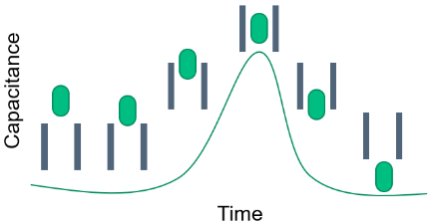
In this study, a capsule filling machine with vacuum drum was investigated. The machine is equipped with a Net Weight Detection System (NWDS) and a gravimetric scale used as an In-Process Control (IPC) system. The NWDS is located between the vacuum drum and the capsule segment. The system measures the permittivity by applying an electromagnetic field. When the powder falls through the system, the permittivity changes in comparison to air. Figure 1 shows a representation of how the capacitance (correlated to permittivity) varies in response to the dosed mass. Through an adjustment process, each signal generated by the NWDS corresponds to a specific mass value, allowing to monitor the fill weight of every capsule produced. Meanwhile, the IPC system gravimetrically monitors the fill weight, determining the tare and gross weight of a subset of capsules during a test run.
Figure 1 - Signal response when doses pass through the NWDS
The APD method was investigated on the vacuum drum filling system to analyse the impact of different process parameters on the fill weight of capsules and the content uniformity. For this, a DoE was performed on the vacuum drum filler with a mixture of lactose for inhalation, which contained a fraction of dyed particles, allowing quantitative measurement of the uniformity of the capsule content.

Materials and Methods
Three lactose grades were provided by DFE-Pharma, Germany: Lactohale 100 (LH100, d₅₀=136 µm), Lactohale 206 (LH206, d₅₀=80 µm) and Lactohale 210 (LH210, d₅₀=17 µm). LH100 was dyed with methylene blue in a fluid bed at a concentration of 0.12%. A mixture of these lactose was prepared, consisting of 10% fine (LH210), 80% medium (LH206), and 10% coarse particles (LH100 blue). The mixture has the following characteristics: d₁₀=12 µm, d₅₀=75 µm, d₉₀=158 µm, Hausner ratio=1.33.
Experiments were performed on the GKF 720 with vacuum drum (Syntegon Technology GmbH, Waiblingen, Germany). The bores of the drum have a volume of 7.2mm³, which results in a capsule fill weight of approximately 5.6 mg. The powder chamber was filled manually with the powder mixture. The machine ran for 15 minutes, during which the NWDS recorded the fill weight of each dose throughout the time. The fill weight of subsets of capsules were additionally controlled using the IPC system. At the end of each experiment, 8 dosages from each bore were taken and analysed with the UV-Vis spectrophotometer SPECORD 200 Plus (Analytik Jena, Germany).
A DoE was performed by varying five critical factors. A quadratic D-optimal model was taken, in which three points were defined for each factor, except for the machine speed, for which two points were defined (see Table 1). The vacuum and the transfer pressure in the drum were kept constant during all the experiments with values of -0.6 bar and 0.6 bar, respectively. Four responses were analysed, namely the mean fill weight of the capsules and its RSD, and the mean concentration of coarse particles after 15 minutes and its RSD. The mean fill weight used for the DoE analysis was the weight obtained with the IPC at the end of each experiment. The option of additional filter cleaning on this machine was not used to increase the difference between stable and unstable process parameters.
Table 1 - Critical factors that were varied for the DoE
Stirrer geometry | Machine speed (cycles/min) | Powder bed height (mm) | Stirrer  speed* | Stirrer direction
Wire, spike,  3-wire | 80, 120 | 25, 38, 50 | 0.5x, 1x, 2x | Right, left, oscillating
*The stirrer speed is related to the machine speed, so 0.5x would be half of the machine speed.

Results and discussion
As part of the DoE, 34 experiments were conducted. Two representative experiments, denoted as “Run 1” and “Run 2”, showcasing both favourable and unfavourable outcomes, are depicted in Figure 2 and Figure 3. The parameters of Run 1 were 3-wire (stirrer), left (direction), 0.5x (stirrer speed), 120 cycles/min (machine speed) and 50 mm (powder bed height). For Run 2 the parameters were wire, oscillating, 1x, 80 cycles/min and 38 mm. With both experiments a deviation of less than 5% of the average mass (5.6 mg) was obtained. The set of parameters used for Run 1 produced capsules with a mean fill weight of 5.53 mg and 1.07% RSD (weight). Run 2 produced capsules with a mean fill weight of 5.60 mg and 2.03% RSD (weight). The NWDS allows to monitor the single capsule weights from each bore. Run 1 has a better RSD (weight) than Run 2. Fill weights of Run 2 are stable over time, however, the fill weight of bore 4 drifted away from the other bores, resulting in a higher RSD. This is an undesired effect that should be corrected by performing the DoE. The IPC results were used to control the NWDS weights and ensure that the capacitive results matched the gravimetric results over time.

Figure 2 - Run 1 (a) mean fill weight NWDS (capacitive) of each bore separately, (b) mean fill weight NWDS (capacitive) and mean fill weight IPC (gravimetric)

Figure 3 - Run 2 (a) mean fill weight NWDS (capacitive) of each bore separately, (b) mean fill weight NWDS (capacitive) and mean fill weight IPC (gravimetric)
The data obtained with the 34 experiments was analysed with the software Cornerstone (CamLine, Germany). Figure 4 shows the orthogonal scaled effects of the terms in the model, with a significance level of p<0.05, on the responses. The factors are forced to vary from -1 to 1, to be able to compare the effects (scaled). The direction is the factor with highest effect on the fill weight, RSD (weight) and concentration, while the interaction between direction and stirrer speed is the term with highest effect on the RSD (concentration), as well as the only term with a significance level of p<0.05 on this response.

Figure 4 - Orthogonal scaled effects of the model terms (significance level of p<0.05) on the responses
Figure 5 shows the predicted response graph of the RSD (weight). When the target is to minimize the RSD (weight), the optimal set of parameters are the ones presented in Figure 5. However, when the target is to improve the content uniformity of the capsules, in this case by ensuring a concentration of 10% of coarse particles, and minimizing the RSD of the concentration, the set of parameters is different (see Figure 6). If the parameters of Figure 5 were chosen, it would result in a concentration of 9.51% and RSD (concentration) of 3.31%. The RSD of the concentration helps to analyse segregation between the bores, and the mean concentration helps to analyse segregation over time. For DPI applications, both accurate fill weight and content uniformity are important, and therefore the machine parameters should be optimized by targeting both RSDs (weight and concentration) as well as the concentration. For specific applications, the mean fill weight can also be a target, however in this case the optimization was based only on the other responses. Figure 7 shows the set of parameters when optimizing the responses together (excluding mean fill weight).
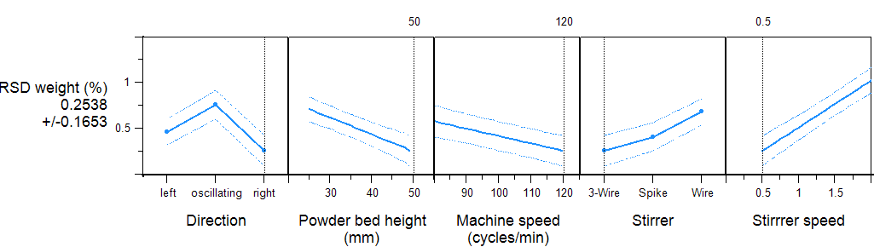
Figure 5 - Predicted response graph of RSD (weight) and set of parameters when optimizing this response
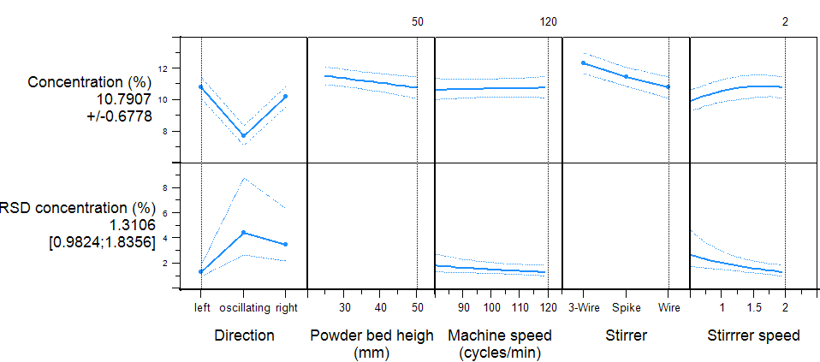
Figure 6 - Predicted response graph of concentration of coarse particles and RSD (concentration), and set of parameters when optimizing these responses
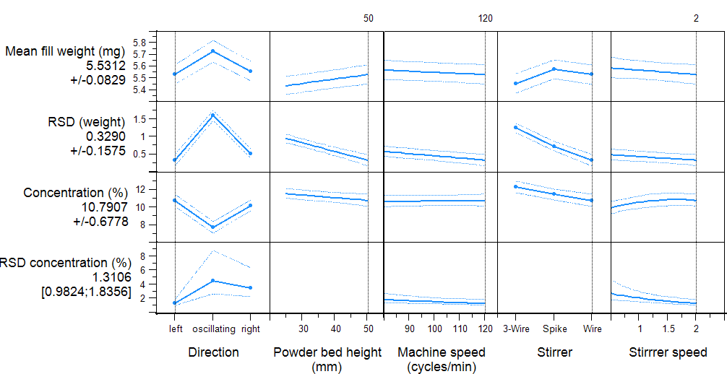
Figure 7 - Predicted response graph of all responses and set of parameters when optimizing the concentration and RSDs (weight and concentration)

Conclusion
APD allows to find the set of parameters that result in lower RSD as well as lower segregation. Each formulation is different and therefore it is important to find the specific optimized parameters. In this study, it could be observed that the machine parameters have a significant influence on the concentration of coarse particles in the capsules. This proves that segregation in the machine can occur and that choosing a combination of parameters can prevent particle segregation. For this reason, besides the fill weight and RSD of the weight in the capsules, the content uniformity should also be considered when choosing the optimal set of parameters. It was identified that the direction and interaction between direction and stirrer speed are the terms with highest effect on the responses. Future work will investigate the same mixture but dyeing the fine particles, to analyse the effect of the different parameters on the segregation of fine particles and compare it with the segregation of coarse particles. Additionally, a validation run with the obtained optimized parameters is going to be carried out.

[] Wagner, B., Brinz, T., Otterbach, S., & Khinast, J. (2018). Rapid automated process development of a continuous capsule-filling process. International Journal of Pharmaceutics, 546(1-2), 154-165.
[] Faulhammer, E., Fink, M., Llusa, M., Lawrence, S. M., Biserni, S., Calzolari, V., & Khinast, J. G. (2014). Low-dose capsule filling of inhalation products: critical material attributes and process parameters. International journal of pharmaceutics, 473(1-2), 617-626.

