Stability Evaluations of Salbutamol Sulphate Propellant-Dispersible Tablets (Respitab™) for Formulation with HFA-152a.

Simon Warren¹, Chen Zheng¹, Sylwia Fowler¹, Aneta Obirek¹, Rachael Kay² & Cuong Tran³

¹i2c Pharmaceutical Services, Cardiff Medicentre, Cardiff CF14 4UJ. UK, current affiliation ²PCI Pharma Services, ³Nanopharm Ltd.

Summary
Respitab™ is a novel approach for manufacturing pressurised metered dose inhalers (pMDIs) using propellant-dispersible tablets. In this production process a tablet is dispensed into the canister, the metering valve crimped and the propellant pressure filled. This innovation circumvents manufacturing challenges associated with flammable gasses e.g. hydrofluoroalkane 152a (HFA-152a) by reducing the number of essential operator interventions associated with production and cleaning during traditional single-stage or two-stage filling. Dispensing propellant-dispersible tablets into canisters and crimping valves, independently of gassing provides greater flexibility in the manufacturing process. For example, active pharmaceutical ingredient (API) handling can be performed separately from propellant filling which as a consequence may be greatly simplified enabling significant savings in terms of investment in manufacturing equipment and modification of production facilities.
In this study Respitab propellant-dispersible tablets containing salbutamol sulphate (SS) were dispensed into plain aluminium canisters and metering valves were crimped to seal. Canisters were subjected to accelerated stability conditions (up to 3 months at 40°C / 75% RH, no foil overwrap) prior to addition of HFA-152a. Following gassing, aerosol characteristics i.e. fine particle fraction (FPF) and dose content uniformity (DCU) through canister life were determined. The moisture level within the formulation was also assessed.
FPF and DCU data were consistent over 3 months’ storage. DCU showed the mean metered dose was within acceptable limits i.e. all within ±35% of target and 90% of results within ±25% of target. FPF indicated consistent and efficient aerosol generation, with mean FPF values ranging from 62% to 66%.

Key Message
Exposure to accelerated stability conditions of Respitab salbutamol sulphate propellant-dispersible tablets, stored in unprotected, crimped plain aluminium canisters, prior to addition of propellant HFA-152a did not influence indicators of physical stability. Aerosol performance i.e. FPF and DCU through canister life were consistent over the storage period of 3 months.

Introduction
Due to the global-warming potential (GWP) of propellants commonly used in pMDIs i.e. HFA 134a and 227ea, the pharmaceutical industry is actively transitioning to low GWP alternatives. Currently, pMDI development activities are focussed on HFA-152a (Koura, UK) and hydrofluoroolefin 1234ze(E) (HFO-1234ze, Honeywell, USA) [1].
In a previous study [2], we reported a novel approach for manufacturing pMDIs using propellant-dispersible tablets (Respitab™) containing SS as the API. Suspension pMDI formulated from propellant-dispersible tablets in HFA-152a demonstrated highly efficient aerosol performance characteristics following 6 months accelerated stability storage in plain canisters with no overwrap at 40°C / 75% RH. In this process the tablet is dispensed into the canister, the metering valve crimped and the propellant pressure filled, although propellant need not be immediately added to the canister.
This study investigated the stability of SS propellant-dispersible tablets stored as solid dosage forms in crimped canisters, prior to suspension in HFA-152a. The possibility of dispensing propellant-dispersible tablets into canisters and crimping valves, prior to gassing provides greater flexibility in the manufacturing process. For instance, all API handling can be performed at a separate site from propellant addition which as a consequence can be greatly simplified providing significant savings in terms of procurement of equipment and possible modifications to production facilities.
SS tablets were dispensed into plain aluminium canisters, the valves crimped prior to storage at 40°C / 75% relative humidity (RH), without foil overwrap for up to 3 months. Following evaluations at release (0 months), samples were withdrawn at 1 and 3 months, HFA-152a added and aerosol performance and moisture content were assessed. Reference product consisted of Respitabs that were dispensed into canisters and propellant filled immediately after tablet compression. Storage conditions were the same as those for the non-dispersed tablets.

Experimental Methods
Micronised SS (Jayco Industries, India), a disintegrant i.e. menthol (Sigma-Aldrich, UK), and inhalation grade lactose (SV003, DFE pharma, Netherlands) were blended together by low shear mixing (Turbula®, Willy A. Bachofen, Switzerland). The resulting powder underwent quantitative analysis of SS for content uniformity. A single punch tablet press (LFA Machines Oxford Ltd, UK) was used to produce 100 mg tablets, each sufficient for delivering 200 actuations of 100 µg of salbutamol (as SS).
Tablets were dispensed into plain aluminium canisters (19 mL, Presspart Manufacturing Ltd, UK), crimped with 50 µL metering valves (Aptar Pharma, France) and stored in the absence of propellant (Test product). The canisters were stored upright without foil overwrap at 40°C / 75% RH. Baseline performance (T0) was established by immediately dispersing tablet samples (n=3) in HFA-152a. These pMDIs were stored inverted for two weeks at 25°C / 60% RH, i.e. industry standard quarantine period, prior to testing. Following 1 (T1) and 3 (T3) months’ storage, pMDI canisters containing the solid dose forms were filled with HFA-152a prior to quarantine and thereafter assessments of aerosol performance, DCU through canister life, and moisture levels were conducted.
The Reference product was Respitab tablets that were dispensed into canisters immediately after compression and dispersed in HFA-152a. Baseline performance (T0) was conducted following quarantine as described above. Remaining samples were stored under comparable conditions to the Test product i.e. inverted, 40°C / 75% RH, no foil overwrap, and evaluated at T1 and T3.
The aerosol characteristics i.e. aerodynamic particle size distribution (APSD), FPF, mass median aerodynamic diameter (MMAD) and geometric standard deviation (GSD), through canister life were determined using a next generation impactor (NGI) at a flow rate of 30 L/min. A dose unit sampling apparatus (DUSA) was employed at a flow rate of 28.3 L/min to measure DCU. Quantitative analysis of SS from the NGI and DUSA components was accomplished using a validated high-performance liquid chromatography method (HPLC). Analysis was conducted using a Grace Vydac Genesis® C18 column (150 x 4.6 mm, 4 µm) with a flow rate of 1.0 ml/min. The mobile phase consisted of 40% methanol and 60% buffer. A 30 µl injection volume was used, with UV detection at 278 nm. To determine moisture levels within the pMDI canisters Karl Fischer titration (Metrohm UK) was performed at the specified time points.

Results and Discussion
Quality control checks of SS content uniformity in the powder blend was performed before tableting. SS content of the samples (n=5) was consistent (relative standard deviation 1.70%).
Figure 1 presents the DCU data for Reference and Test products, obtained at T0 and after storage at 40°C / 75% RH i.e. T1 and T3. The graph includes limits of ±25% and ±35% around the target of 100 µg per actuation. The metered dose complied with the acceptance limits, with 9 out of 10 results from each pMDI canister falling within ±25%, and all results within ±35% of the target. Additionally, a one-way analysis of variance (ANOVA) of the through canister life DCU for Test product pMDIs showed no significant differences during accelerated stability storage (p>0.05). Overall, both Test and Reference products showed reproducible dosing through canister life.
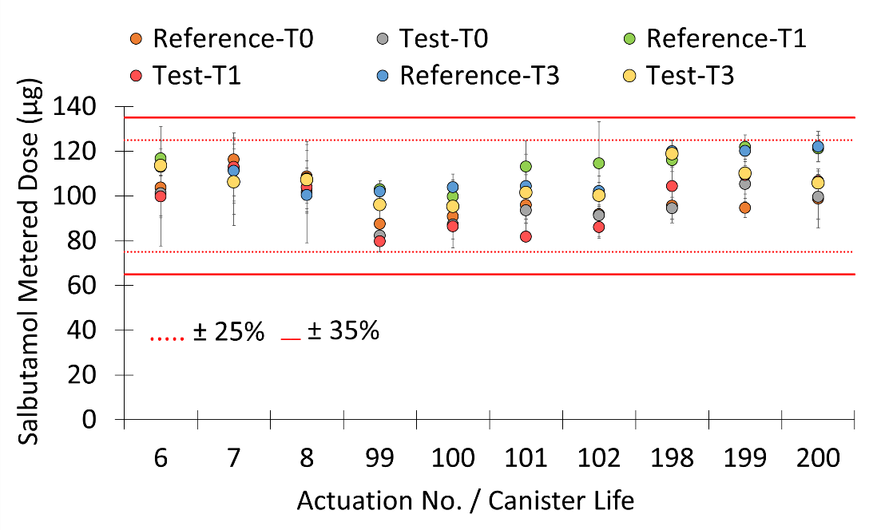
Figure 1. Through canister life DCU (µg) of Respitab SS pMDIs following accelerated stability storage over 3 months (Reference n=5, Test n=3, mean ± SD).
Figure 2 shows the mean salbutamol APSD throughout canister life after undergoing accelerated stability storage for up to 3 months. Both Reference and Test product canisters demonstrated good APSD characteristics, moreover, a one-way ANOVA of the APSD characteristics (FPF, MMAD, and GSD) for the Test product revealed no significant differences during storage (p>0.05).
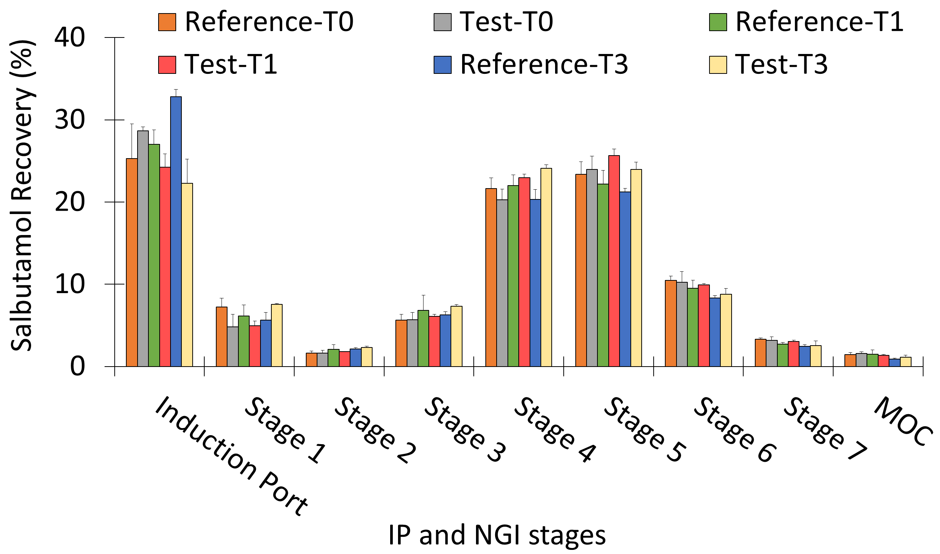
Figure 2. Through canister life aerosol deposition (% recovered SS) from Test and Reference pMDIs following accelerated stability storage over 3 months (Reference n=5, Test n=3, mean ± SD).
Although the Reference pMDI canisters showed a small but statistically significant decrease (p<0.05) in FPF after 3 months (Table 1) compared to the Test product, in all cases the aerosol characteristics remained highly efficient, with FPF ≥ 56%.
Table 1. Summary of key through canister life aerosol parameters of salbutamol from Test and Reference Respitab SS pMDIs following accelerated stability storage (Reference n=5, Test n=3, mean ± SEM).
Stability Storage Time (Month) | FPF (% < 5 µm) |  | MMAD (µm) |  | GSD
Stability Storage Time (Month) | Reference | Test | Reference | Test | Reference | Test
0 | 63.3 ± 3.64 | 62.3 ± 2.58 | 2.32 ± 0.10 | 2.08 ± 0.29 | 2.01 ± 0.03 | 1.99 ± 0.21
1 | 61.6 ± 2.01 | 66.2 ± 1.58 | 2.38 ± 0.12 | 2.22 ± 0.02 | 1.92 ± 0.12 | 1.78 ± 0.03
3 | 56.5 ± 1.16 | 64.4 ± 2.81 | 2.35 ± 0.02 | 2.44 ± 0.05 | 1.86 ± 0.06 | 1.90 ± 0.02
In Figure 3, moisture content of Reference and Test products are shown, in general, the moisture levels showed a tendency to increase over time, with Reference canisters averaging approx. 162 ppm at release rising to 414 ppm after 3 months, while initial Test canisters of approximately 218 ppm at release increased to 448 ppm after 3 months. However, a two-sample t-test revealed no statistically significant difference in moisture levels between the Reference and Test products at the 3-month time-point (p>0.05).
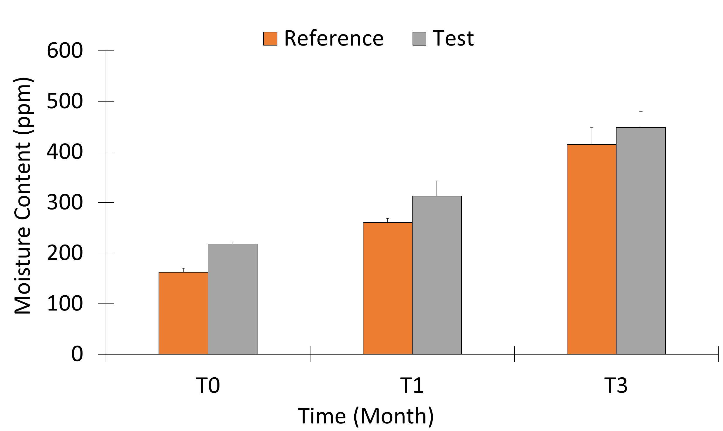
Figure 3. Moisture content (ppm) of Reference and Test HFA-152a salbutamol pMDIs following accelerated stability storage (Reference n=5, Test n=3, mean ± SD).

Conclusion
Exposure to accelerated stability conditions of Respitab SS propellant-dispersible tablets, stored in crimped plain aluminium canisters, prior to addition of propellant HFA-152a did not influence indicators of physical stability. Aerosol performance i.e. fine particle fraction and delivered dose through canister life were consistent with reference products that were stored as suspension pMDIs. In addition, moisture levels in all pMDIs were acceptable.
The possibility of dispensing propellant-dispersible Respitab tablets into canisters and crimping valves, independently of gassing provides greater flexibility in the manufacturing process. For example, API handling can be performed separately from propellant addition which, as a consequence may be greatly simplified enabling significant savings in terms of investment in manufacturing equipment and modifications to production facilities in order to handle flammable low GWP propellants. The propellant-dispersible tablet approach is also compatible with vacuum crimping, a process that can be important for product stability.

References
[1] Pritchard J N: Change is in the air – the new pressurized metered-dose inhaler propellants, Drug Delivery to the Lungs 2022, Edinburgh UK.
[2] Kay R, Obirek A, Wegrzyn W and Tran C: Accelerated Stability Studies with pMDIs of Respitab HFA-152a Propellant-dispersible Salbutamol Tablets, Drug Delivery to the Lungs 2022, Edinburgh UK.

Acknowledgements
The authors would like to thank Koura, Aptar Pharma and DFE Pharma for the supply of HFA 152a, metering valves, and lactose, respectively.

