Spray Pattern and Plume Geometry Measurements of Current and Low GWP Propellants HFA152a and HFO1234ze(E) pMDIs With and Without Ethanol

Holly Dowdle¹, Benjamin Myatt¹

¹Kindeva Drug Delivery, Charnwood Campus, Loughborough, UK

Summary
As the pressurized metered dose inhaler industry is making the switch to lower global warming potential propellants, more understanding is needed on how the new propellants perform in pMDI products using existing characterisation techniques. This study characterises the spray pattern and plume geometry of propellant and propellant with 12% w/w ethanol formulations of the current and new propellants. Standard spray pattern tests at 30 mm, 60 mm and plume geometry in line with industry guidance were performed using an Oxford Lasers EnVision Pharma R&D system. These tests revealed that both HFA134a and HFA152a had the largest spray pattern areas at 30 mm and 60 mm, with HFA227ea having the smallest area, due to the differences in propellant saturated vapour pressure. The spray pattern areas were proportional to vapour pressure at 30 mm distance. However, for HFA152a the plume expanded at a greater rate than that of HFA134a, which could be due to the lower density of HFA152a. When adding ethanol to the propellants, the spray pattern area reduced for most of the propellants and the shot-to-shot variability reduced; this would indicate that adding ethanol stabilises formulations. These results present the need for formulators to understand more about the physical properties of the propellants, so that similar product performance can be achieved when it comes to reformulating with the new propellants.
Key Message
Spray pattern and plume geometry of current and low GWP propellant formulations were characterised. It was found that the spray pattern area was generally proportional to the propellant vapor pressure. The addition of 12% w/w ethanol reduced the spray pattern area and reduced shot to shot variability.

Introduction
At present, the pharmaceutical industry is focused on lowering the impact pressurized metered dose inhalers (pMDIs) have on CO₂ equivalent emissions. One way this is being achieved is by switching from the current propellants HFA134a and HFA227ea to lower global warming potential (GWP) propellants HFA152a and HFO1234ze(E) [1].
These low GWP propellant’s chemical and physiochemical properties are different to the current propellants, with the key parameters of concern for this work summarised in Table 1. However, these different properties could mean that ensuring similar product performance to marketed pMDIs when switching propellant is difficult.
Table 1 - Properties of current HFA propellants compared to HFA152a and HFO1234ze(E)
Property | HFA134a[2,3] | HFA227ea[2,3] | HFA152a[4] | HFO1234ze(E)[5]
Density (liquid) at 20°C (g/ml) | 1.23 | 1.41 | 0.91 | 1.17
Saturated Vapor Pressure at 20°C (bar) | 5.72 | 3.9 | 5.12 | 4.27
Boiling Point (°C) | -26.1 | -16.5 | -24 | -19

Ethanol is commonly added to formulations to improve product performance, such as dissolving drug into a solution or to reduce drug deposition in suspension formulation systems. More recently, research has been undertaken to optimise the spray performance of the low GWP propellants using ethanol [6]. The changes caused by adding ethanol are due to the reduction of saturated vapour pressure (SVP) of the formulation which influences the droplet size of the spray [7].
One way to assess the product performance of pMDIs is to analyse the spray pattern (SP) and plume geometry (PG). SP and PG are measurement techniques required by the US FDA in the draft guidance on the development of metered dose inhalers [8]. These tests are also important for assessing the spray performance and aerosolization of a pMDI during the development stage of a product [9].
The SP and PG of formulations using the current propellants, both with and without ethanol, has been widely researched [10] but less data is available for SP and PG of low GWP propellant formulations. Jordan et al. (2023), performed SP and PG measurements of HFA134a and HFA152a formulations both with and without ethanol. They found little variation between each formulation tested at SP distance of 30 mm. However, at 60 mm there were more clear differences, with HFA152a having a much higher area than the HFA134a formulation. The addition of ethanol resulted in a more continuous and intense HFA134a plume [11]. Despite previous work, it is still unclear how and why the SP and PG both with and without ethanol differ between the current and low GWP propellants.
This study aims to measure the SP and PG of the current propellants and the low GWP propellants both with and without ethanol, and subsequently seek to understand the differences in trends in SP area and PG observed between propellants with and without ethanol.

Experimental Materials and Method

Materials
Placebo pMDIs containing formulations of all propellants from Table 1 with and without 12% w/w ethanol were manufactured using 16 mL canisters (Kindeva Drug Delivery, Clitheroe, UK) with 50 µL Bespak BK357 valves (Bespak by Recipharm, UK). Standard Kindeva Mk6 actuators with specifications 0.3 mm spray orifice diameter and 0.65 mm orifice length (a.k.a. jet length) (Kindeva Drug Delivery, Loughborough, UK) were used to conduct the testing.

Method
An Oxford Lasers EnVision Pharma R&D system was used to conduct SP measurements at both 30 mm and 60 mm from the actuator orifice as well as PG measurements. All pMDI aerosols units were actuated through the Kindeva Mk6 actuator. Three aerosol units were tested per formulation and each unit was tested three times. The study was randomised to mitigate the effect of any changes in laboratory conditions may have had on the results. Data from the Oxford Lasers EnVision system was exported into Minitab® Statistical Software (Version 21.3.1) where student’s T-Test statistical analysis was performed.

Results and Discussion
HFA134a and HFA152a have similar SVP, with HFA134a being slightly larger (Table 1). From previous work, the pressure of the formulation in the expansion chamber (as measured in the actuator sump) follow the same trend [12]. SVP is one of the main driving forces for spray plume formation; greater sump pressures will produce larger plumes. This is shown in Figure 1 at 30 mm as propellants HFA134a and HFA152a both have the two largest spray pattern areas (SPA) with HFA134a having the greatest area (mean area percentage difference +7.7% larger than HFA152a plume, p-value = 0.114), followed by HFO1234ze(E) and HFA227ea which have lower vapour pressures.
Despite HFA134a having the largest SVP and highest peak expansion chamber pressure, at 60 mm the plume area for HFA152a units without ethanol is greater than that for HFA134a units (mean area percentage difference +3.5% larger than HFA134a plume, p-value = 0.58). This shows that the HFA152a plume expands at a greater rate than HFA134, in line with the observations of Duke et al (2023). One explanation for this could be the difference in densities of the propellants, which affects the plume spreading rate. HFA152a has a much lower liquid phase density at 0.91 g/ml compared to HFA134a at 1.23 g/ml (Table 1).
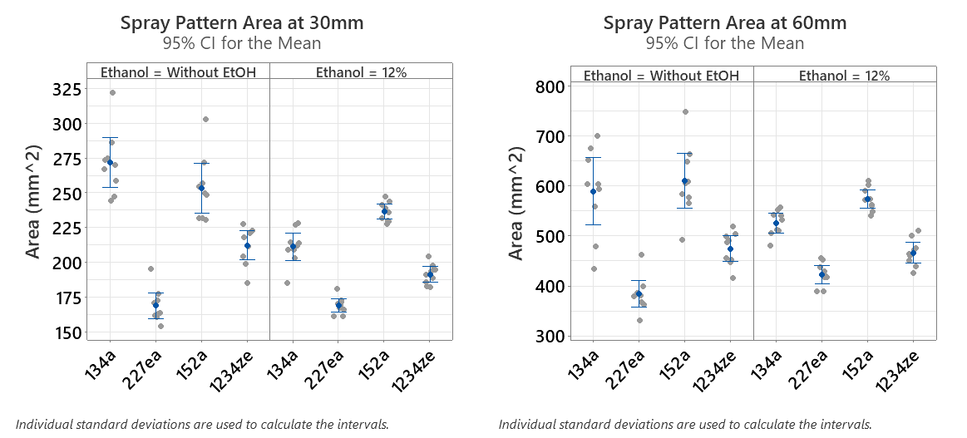
Figure 1 - Spray pattern area at 30mm and 60mm of current and low GWP pMDI propellants with and without 12% w/w Ethanol (N=3 units, n=3 shots per unit)
Incorporating ethanol into the formulations decreases the variation in SPA between the different propellants, as seen at both 30 mm and 60 mm measurement distances. SPA for all propellants other than HFA227ea decreased in size, whereas HFA227ea slightly increased. Propellant only formulations have a wider spread of SPA data than formulations with ethanol. This may be due to changes in the internal flow structure, which in propellant only systems can be described as a vapour rich slug flow, creating a spray with greater dynamic variability. The addition of ethanol to the formulation reduced the shot-to-shot variability of SPA of each formulation as evident in the reduction of the 95% confidence interval for units containing ethanol. When ethanol is added to placebo formulations the internal flow structure changes to a dispersed bubbly flow. This may result in a much more stable and repeatable plume and could explain the change in SP area [13,14].
For plume geometry, Figure 2 shows both the plume width and cone angle. Similar to the spray pattern data, it is also evident that there is a reduced variability both between formulations and between shots of each formulation for plume width and cone angle for the units containing 12% w/w ethanol. There may be a greater variability in propellant only formulations due to the nature of the measurement technique which measures a thin planar slice of the plume.
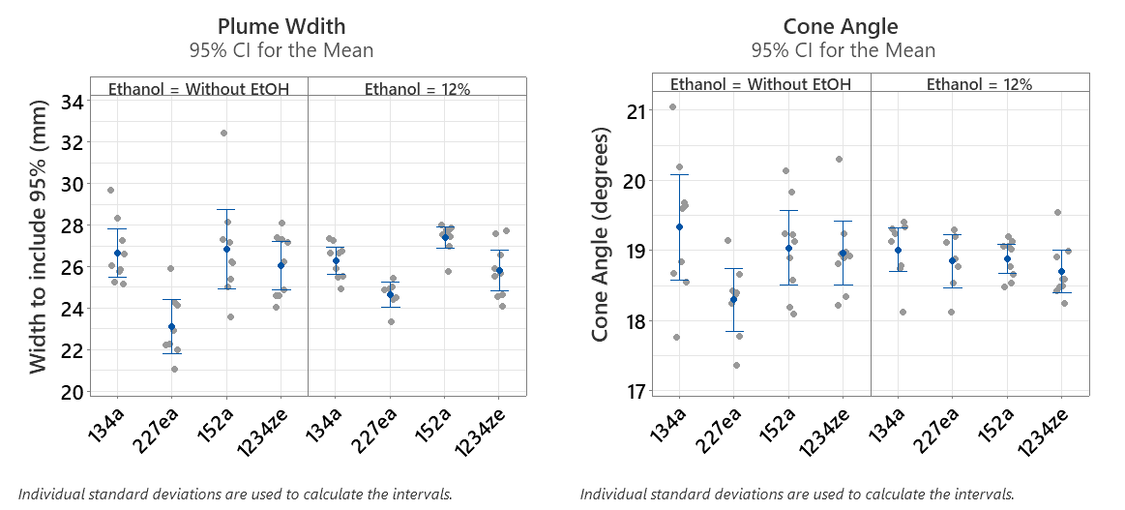
Figure 2 - Plume width and cone angle of current and low GWP pMDI propellants with and without 12% w/w ethanol (N=3 units, n=3 shots per unit)

Conclusions
This study characterised the spray pattern and plume geometry of placebo units of current and new low GWP propellants with and without 12% w/w ethanol. It was found that HFA134a and HFA152a, the propellants with the highest saturated vapour pressure, produced the largest plumes. This is due to the higher SVP increasing the peak pressure at the orifice exit leading to wider spray plumes. The results also indicate that HFA152a spray plumes expand more rapidly that the other propellant gasses. These findings suggest that spray pattern area and plume spreading rate of pMDI formulations are governed by propellant/formulation physical properties other than simply SVP, for instance propellant liquid density. The addition of 12% w/w ethanol to the propellants generally decreased the SP area, reduced the variability between propellants and created more stable plumes. The addition of ethanol or minor adjustments to ethanol concentration when formulating with the low GWP propellants could help ensure similar product performance to the current products on the market.

References
[1] J.N. Pritchard, F-Gas Regulations and Beyond: Clinical and Economic Factors that will Drive Propellant Transition, in: Respiratory Drug Delivery, 2020.
[2] Daikin, SOLKANE 227 pharma and 134 a pharma Product Information. Available at: https://www.daikinchem.de/sites/default/files/pdf/Propellants/Daikin%20Propellants%20-%20Solkane%20227,%20134a%20pharma.pdf. Accessed June 2023.
[3] Koura, HFA Medical Propellants. Available at: https://www.kouraglobal.com/wp-content/uploads/K20_Zephex-HFA-Medical-Propellants-Brochure-2.pdf. Accessed June 2023.
[4] Koura, 152a Physical Properties. Available at: https://www.kouraglobal.com/wp-content/uploads/K20_Zephex-HFA-Medical-Propellants-Brochure-2.pdf. Accessed June 2023.
[5] Honeywell, Solstice ® ze Refrigerant (HFO-1234ze (E)). Available at: https://www.honeywell-refrigerants.com/europe/wp-content/uploads/2018/11/Honeywell-Solstice%AE-ze-Brochure_EN.pdf. Accessed June 2023.
[6] D. Duke, B. Myatt, L. Rao, S. Vutlapalli, N. Marasini, H. Dowdle, P. Cocks, D. Schmidt, H.X. Ong, P. Young, Optimizing Spray Formation in Solution and Suspension Low GWP Metered Dose Inhalers, in: Respiratory Drug Delivery, 2023.
[7] B. Gavtash, B. Myatt, H. O’Shea, F. Mason, D. Lewis, T. Church, H.K. Versteeg, G. Hargrave, G. Brambilla, Saturated vapour pressure (SVP) measurement of ethanol/HFA binary mixtures, in: Drug Delivery to the Lungs, 2015.
[8] FDA, Metered Dose Inhaler (MDI) and Dry Powder Inhaler (DPI) Products-Quality Considerations Guidance for Industry, (2018). https://www.fda.gov/Drugs/GuidanceComplianceRegulatoryInformation/Guidances/default.htm.
[9] L. Liao, H. Chauhan, A. Newcomb, T. L’ecuyer, S.N. Liu-Cordero, C. Leveille, Spray pattern: A rapid and sensitive early development tool for respiratory drug products Utilizing spray performance measurements to accelerate OINDP development, October 2017 Inhalation. (2017). www.inhalationmag.com.
[10] B. Myatt, S. Stein, B. Gavtash, A Study of Effect of pMDI Formulation on Spray Pattern Area, in: Respiratory Drug Delivery, 2020.
[11] L. Jordan, S. Johnson, R. Chand, G. Thurston, D. Jones, V. Webster, S. Stanford, Comparison of Spray Characteristics of P-134a and Low GWP P-152a pMDIs With and Without Ethanol, in: Respiratory Drug Delivery, 2023.
[12] B. Myatt, S. Stein, B. Gavtash, Pressure and temperature measurements of current and future low GWP pMDI propellants in the actuator sump, in: Drug Delivery to the Lungs, 2020.
[13] N. Mason-Smith, D.J. Duke, A.L. Kastengren, D. Traini, P.M. Young, Y. Chen, D.A. Lewis, D. Edgington-Mitchell, D. Honnery, Revealing pMDI Spray Initial Conditions: Flashing, Atomisation and the Effect of Ethanol, Pharm Res. 34 (2017) 718–729. https://doi.org/10.1007/s11095-017-2098-2.
[14] B. Myatt, R. Newton, D. Lewis, T. Church, G. Brambilla, G. Hargrave, H. Versteeg, B. Gavtash, & E. Long, PDA and High Speed Image Analysis of HFA/Ethanol pMDI Aerosols: New Findings, in: Drug Delivery to the Lungs, 2015.

