The Effect of Elastomer Type on Stem-Diaphragm Leakage from pMDIs filled with Propellant 152a

Howard Bleazard, Lee Hodges

Kindeva Drug Delivery Ltd, Upbrooks, Clitheroe, BB7 1NX

Summary
Leakage from a pressurised metered dose inhaler (pMDI) comes from two sources: the valve-to-canister crimp region and the metering valve’s stem-diaphragm interface. Both regions of the pMDI typically use elastomeric components to create an effective seal. Whilst the valve-to-can crimp is a static seal the stem-diaphragm interface is dynamic, in that the stem slides through the diaphragm each time the pMDI is actuated.
Initial evaluation of propellants 152a and 1234ze on pressure fill metering valves designed for use on propellants 134a and 227 has shown a much-increased leakage rate, especially so with propellant 152a. In the study summarised below, an evaluation of the effect of elastomer material on stem-diaphragm leakage has been performed using placebo formulations comprising propellant 152a with and without ethanol. Three types of elastomer materials have been evaluated: nitrile, EPDM and chlorobutyl under two temperature regimes. Weight loss was determined by weighing units on an analytical balance initially and then again after increasing time periods (in a temperature-controlled environment) ranging from 7 days to 6 months. An annual leakage rate was calculated by linear extrapolation.
Results indicate a clear difference in stem-diaphragm leakage dependent on the type of elastomer used to manufacture the diaphragm component; in the worst-case scenario of a 40°C storage regime and units filled with propellant 152a and 10% (w/w) ethanol, maximum leakage from a pMDI with a chlorobutyl diaphragm was 56 mg/year, compared to 225 mg/year with an EPDM diaphragm and 1076 mg/year with a nitrile diaphragm.

Key Message
Chlorobutyl elastomer is extremely effective as a diaphragm component within a metering valve used as part of a pMDI filled with formulations containing “green” propellant 152a. It is relatively insensitive to ethanol within the formulation and performs robustly even at an elevated storage temperature of 40°C.

Introduction
The Kigali amendment of the Montreal protocol calls for the phase down of HFA134a and HFA227 due to their comparatively high global warming potential (GWP). There is therefore a need to transition to alternative low GWP propellants from an environmental perspective, also recognising that as the use of the current HFA propellants is phased down, this will lead to rising material costs.
Initial evaluation of propellants 152a and 1234ze(E) on pressure fill metering valves designed for use on propellants 134a and 227 has shown a much-increased leakage rate, especially so with propellant 152a (based on internal, unpublished data). Leakage from all pressurised Metered Dose Inhalers (pMDIs) comes from two sources: the valve-to-can crimp (the red region in Figure 1 below) and the stem-diaphragm interface (the blue region in Figure 1 below).
Valve-to-can sealing is accomplished via a gasket, O-ring or both a gasket and an O-ring. These components are typically made from elastomeric materials. Different elastomer materials can be used to suit different formulations, in respect of both leakage performance and compatibility with the active pharmaceutical ingredient(s) within the formulation. In addition to elastomer materials, valve-to-leakage can also be impacted by various valve-to-can crimping parameters, such as crimp height, crimp diameter and the axial load applied by the crimp head during the crimping process.
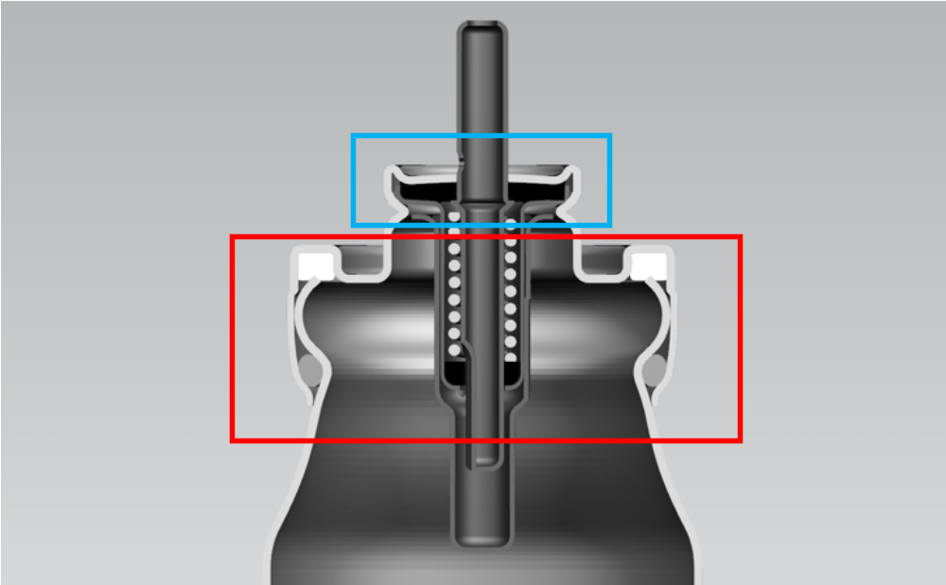
Figure 1 Sources of Leakage from a pMDI
Valve leakage is via the stem-diaphragm interface. Again, elastomer material is a key parameter in respect of both leakage and formulation compatibility. Leakage performance for a given diaphragm elastomer material is typically controlled via the diaphragm dimensions and the tightness of the valve crimp, albeit these parameters may all impact other elements of the performance of the metering valve in day-to-day operation. In the study summarised below, an evaluation of the effect of elastomer material on stem-diaphragm leakage has been assessed.

Experimental Method
Diaphragm material: Chlorobutyl v ethylene propylene diene monomer (EPDM) v Nitrile
Propellant system: 100% propellant 152a v 90% propellant 152a with 10% ethanol (w/w)
Storage temperature: 25°C v 40°C
Storage time: Units tested progressively over a six-month period
Sample size = 10 units for each diaphragm / formulation / storage temperature combination
Leakage rate determination: Annual leakage (mg/year) = (365)(24/T)(W1- W2) where T = storage time (hours), W1 = initial weight (mg) and W2 = final weight (mg)
All diaphragms, whose dimensions are typically defined by their outside diameter, inside diameter and thickness, were made to the same dimensions but differed only in respect of material type. Valve crimp tightness was also consistent across all valves, allowing a direct comparison to be made of diaphragm material.
For all three valve lots under evaluation, the valve-to-can sealing system was comprised of a low-density polyethylene gasket in conjunction with a chlorobutyl O-ring. This combination was selected as previous evaluations (based on internal, unpublished data) showed that this combination produced extremely low levels of valve-to-can leakage (typically less than 10mg/year at 25°C with 100% 152a).

Results
The raw data depicted below in Figure 2 show total leakage from the pMDIs (i.e. valve-to-can leakage plus stem-diaphragm leakage). Differences in leakage results between the three data sets can be attributed to leakage from the stem-diaphragm interface. Summary statistics from the raw data are presented below in Table 1:
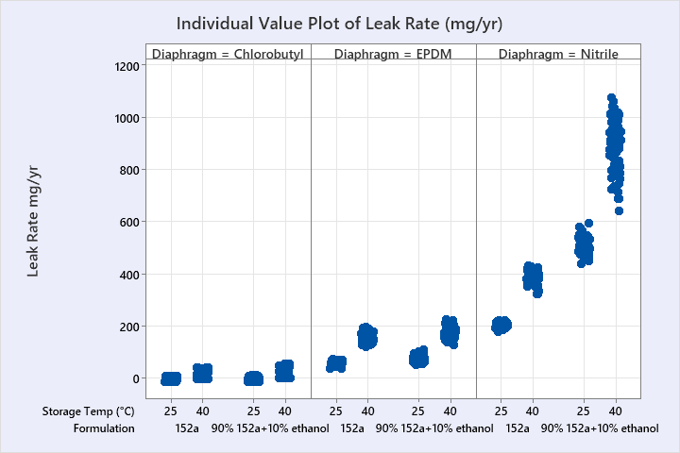
Figure 2 Raw Leak Data, Split by Diaphragm Elastomer Material

Diaphragm Material | Storage Temperature (°C) | Formulation | Leak Rate (mg/year)
Diaphragm Material | Storage Temperature (°C) | Formulation | Mean | Maximum
Chlorobutyl | 25 | 100% 152a | 1 | 10
Chlorobutyl | 40 | 100% 152a | 20 | 43
Chlorobutyl | 25 | 90% 152a + 10% ethanol | 2 | 14
Chlorobutyl | 40 | 90% 152a + 10% ethanol | 26 | 56
EPDM | 25 | 100% 152a | 59 | 74
EPDM | 40 | 100% 152a | 152 | 198
EPDM | 25 | 90% 152a + 10% ethanol | 75 | 109
EPDM | 40 | 90% 152a + 10% ethanol | 175 | 225
Nitrile | 25 | 100% 152a | 205 | 224
Nitrile | 40 | 100% 152a | 385 | 431
Nitrile | 25 | 90% 152a + 10% ethanol | 513 | 596
Nitrile | 40 | 90% 152a + 10% ethanol | 881 | 1076
Table 1 Leak Rate Summary Statistics

Overall statistical analysis from the study are summarised in Figure 3 below in a “main effects” plot:
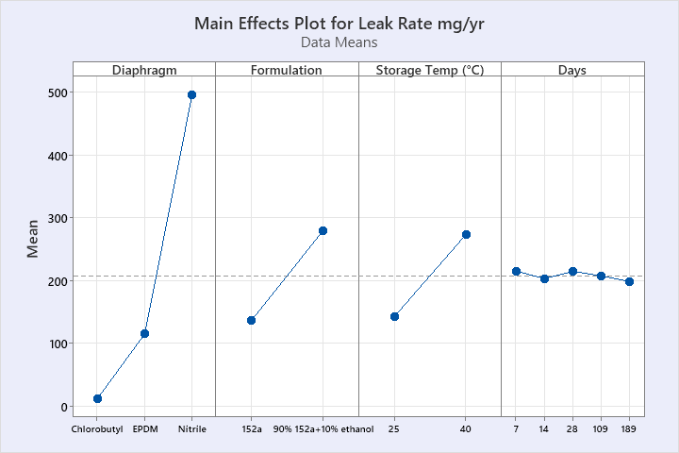
Figure 3 Main Effects Plot

Discussion and Conclusion
Overall, the study shows that leakage is significantly increased when the formulation contains 10% w/w ethanol. This is likely because ethanol causes the elastomers to swell (albeit by different amounts depending on the elastomer type) and this swell typically increases the porosity of the elastomer, resulting in an increased rate of leakage. Similarly, higher storage temperature increases the vapour pressure of the formulation, resulting in an increase in the leak rate. The various pMDIs were weighed for determination of leakage from 7 days after filling all the way through to 6 months after filling, with no significant difference in the calculated leak rates.
The most significant factor in respect of leakage was the diaphragm material. With a chlorobutyl diaphragm, in conjunction with a chlorobutyl O-ring as part of the valve-to-can sealing system, total leakage from the pMDI is extremely low, in all combinations of propellant system and storage temperature. Even in the worst-case scenario, i.e., a storage temperature of 40°C and the formulation containing 10% ethanol, the maximum leak rate measured over the 6 months of testing was only 56 mg/year.
Replacing the chlorobutyl diaphragm with one made from EPDM causes leak rate to increase significantly, with the worst-case scenario described above resulting in maximum leakage increasing from 56 mg/year to 225 mg/year.
When assessing the pMDI incorporating the nitrile diaphragm, the highest leak rates were observed. Not only the highest in absolute terms but the effect of higher storage temperature and ethanol in the formulation is much greater with a nitrile diaphragm. The addition of 10% ethanol to the formulation more than doubles both mean and maximum leak rates when stored at 25°C to levels in excess of 500 mg/year and a further significant increase occurs as storage temperature is increased to 40°C, not only in terms of mean and maximum leak rate, but also to the variability within the dataset.
Whilst pharmacopeial specifications for leakage at 25°C are typically mean leakage ≤ 525 mg/year and individual maximum leakage ≤ 750 mg/year, actual product specifications for current formulations are lower than this, and valves made with a nitrile diaphragm would be unlikely to meet current product specifications if filled with a 152a based formulation using ethanol.

References

Amendment To The Montreal Protocol On Substances That Deplete The Ozone Layer; Kigali, 15 October 2016
John N Pritchard. Change is in the air - the new pressurized metered-dose inhaler propellants. Drug Delivery to the Lungs, Volume 33, 2022
United States Pharmacopeia <604>

