Pathway of Construction and Characterization of a Salbutamol Sulphate HFA152a pMDI Suspension
- Giulia Carretta¹, Caterina Antiga¹, Alberto Colombo², Giovanni Motta², Massimo Carrara², Francesca Buttini¹
¹ Food and Drug Department, University of Parma, Parco Area delle Scienze 27/A, 43124 Parma, Italy.

² RxPack s.r.l, Via Mognago 47, 23848, Oggiono (LC), Italy.

Summary
The work illustrates the development of a suspension of Salbutamol Sulphate (SS) in HFA152a using an open chamber design valve manufactured by RxPack, commercially known as KHFA. Ethanol was used as a co-solvent and the product target dose was 122 µg of SS (corresponding to 100 µg/shot of salbutamol base). The object of this work was not to make a product copy of the Ventolin® but to develop a good performing product and to be aware of how each factor investigated affects the performance of the system.
Preliminary studies were conducted with a full factorial DoE evaluating the impact of Critical Material Attributes (CMAs), such as ethanol content, valve metering volume, and actuator orifice diameter (AOD), on the critical quality attributes of the products in terms of Emitted Dose (ED) and Fine Particle Fraction (FPF). These initial studies led to identify the lead product consisting of: 50 µL valve, 0.3 mm AOD and 6% ethanol content. The lead product proves to have good respirability thus obtaining FPF values of 45.5% and MMAD of 2.55 µm. So, in conclusion, always paying attention to respecting both the environment (e.g. by making more sustainable choices that lead to less use of propellant and ethanol), and the characteristics that make an inhalation product effective, it is possible to obtain a pMDI with good inhalation characteristics using this new eco-friendly propellant HFA152a.
Key Message
The project led to the development and complete characterization of an pMDI SS suspension with the use of the new eco-sustainable propellant HFA152a. It has been demonstrated that it is therefore possible to obtain an inhalation product that has good adherence with the various components of the device and with a good FPF.

Introduction
The pMDIs currently on the market are based on two greenhouse gases: HFA134a and HFA227 which have Global Warming Potentials (GWP) values of 1300 and 3350, respectively. Indeed, the attention has recently shifted to low GWP propellants such as HFA152a (commercially known as Zephex®) and HFO1234ze (commercially known as Solstice®), in such a way that to reduce the greenhouse gas emissions associated with inhaler use and their clinical implications. The GWP100 (GWP over a time horizon of 100 years) of the HFA152a propellant, has been significantly lowered to 138. HFA-152a (GWP100, 138), which would cut GWP of the present propellants in pMDIs, HFA-134a and HFA-227ea by 89% and 96%, respectively, and this would result in carbon emissions within the DPI range [1, 2]. The type of propellant influences the dispersion of aerosol droplets and the characteristics of the generated plume. The impact of the physico-chemical properties of new propellants on the quality of the atomized aerosol have recently been described in a review [3]. HFA 152a, due to its lower vapor pressure and higher surface tension compared to HFA 134a, deliver larger particles and has a higher solvent capacity towards lipophilic drugs. Moreover, the addition of the ethanol to the formulations causes changes in many physico-chemical parameters thus leading variations in the atomization process [4].
For the pMDI production we performed a salbutamol sulphate suspension with the use of ethanol as a co-solvent (122 µg which correspond to 100 µg/shot of salbutamol base) filled into an uncoated canister by a two-stage filling process. The aim of the study was to assess the effect of formulation composition (ethanol content) and hardware critical components (valve volume and AOD) on the product quality.

Materials and Method
The pMDI products have been prepared using the following components:
- 19 mL uncoated aluminium canisters manufactured by PressTeck (IT)
- KHFA MDI valves manufactured by RxPack (IT)
- long sleeve MDI actuators manufactured by RxPack (IT)
The effect of critical material attributes (CMAs), such as ethanol content, valve metering chamber volume, and actuator orifice diameter on the critical quality attributes of the products in terms of EmitteED) and FPF was examined using an experimental full factorial design (DoE). Table 1 illustrates the CMAs that were overall evaluated in order to obtain the lead product.

Table 1: Factors and levels investigated to study the effect of the formulation and the device in obtaining a product SS_HFA152a

Factors | Levels Investigated
Ethanol Content (% w/w) | 1-6-12-15
Valve Volume (µL) | 50-63
Actuator Orifice Diameter (mm) | 0.25-0.30-0.48

The ED test involved collecting 10 doses of each product from 5 different cans using a Unit Sampling Collecting Apparatus (USCA) operated at flow rate of 28.3 L/min (as indicated in USP44). Instead for the determination of the respirable fraction has been used Next Generation Impactor (NGI) which operated at 30 L/min. HPLC quantified drug mass, and MMAD was calculated according to USP44 <601>. Fine Particle Mass (FPM, drug < 5 µm) and Extra Fine Particle Mass (EFPM, drug < 2 µm) are drug masses, calculated from log-probability plots. The FPF and extra-fine particle fraction (EFPF) are the ratio between FPM or EFPM and ED in percent, respectively. Various characterization tests were conducted on the lead product. In particular ED test, carried out through the use of USCA, to evaluate the Delivered Dose Uniformity through container life, to demonstrate the consistency of the minimum delivered dose to the first one until the last labelled. This test was carried out using two different canisters, to evaluate the inter-canister variability, and for each one was evaluated 3 doses at the Beginning of Life (BoL), 4 doses at the Middle of Life (MoL) and 3 doses at the End of Life (EoL) for a total of n=20. Furthermore, its Aerodynamic Particle Size Distribution (APSD) was also evaluated on the lead product, using three different inhalers to also consider the inter-canister variability.

Results

A detailed preliminary examination was conducted to determine the effects of critical formulation (ethanol concentration) and device (valve metering volume and AOD) factors on important quality characteristics including FPF and ED. It is worth considering that the KHFA is an “open chamber” valve, the design of which, differs from capillary retention valves. The KHFA valve is intended to ensure complete filling of the metering chamber upon use eliminating the loss of prime. The access channels of the formulation to the chamber are in fact sufficiently open, so that the formulation itself can easily displace any vapor bubbles.

From the first DoE carried out, in which 8 different products were analyzed, it emerged that the AOD and valve volume factors had a significant (Model p value < 0.0172) influence on the Emitted Fraction value, as can be seen in the Pareto Chart illustrated in Figure 2a. These two parameters had a positive influence, because as their value increased, the value of Emitted Fraction significantly increased. Figure 2b illustrates the graph that represents how the relationship between AOD and SS impacts on the FPF value, obtained following an ANOVA analysis which shows that it is a significant model (model p value < 0.0031).

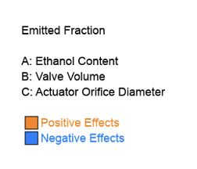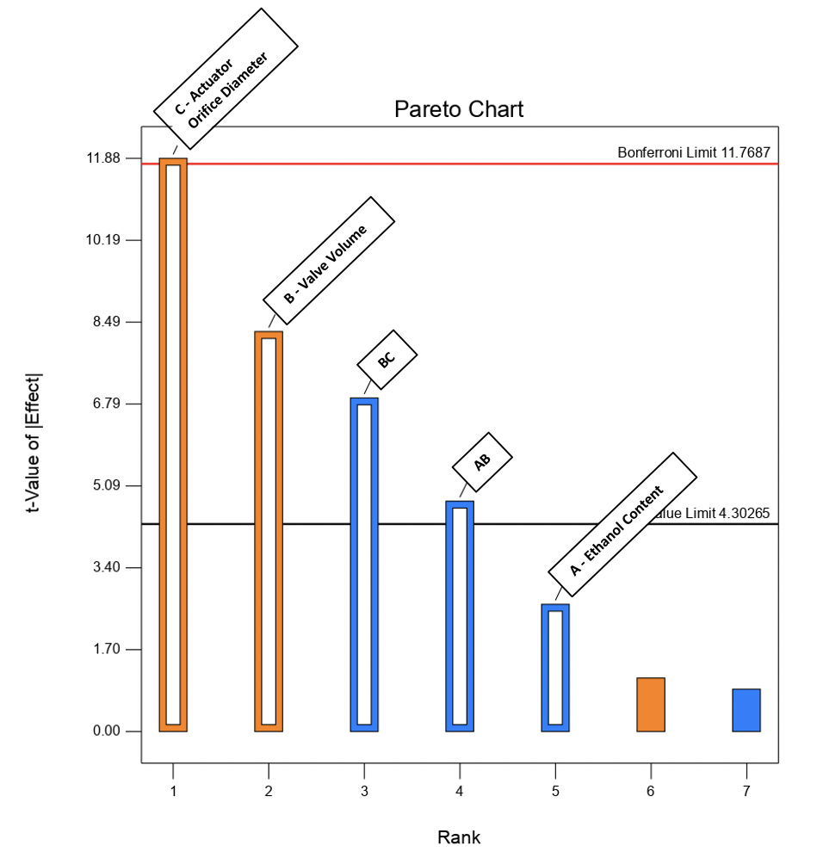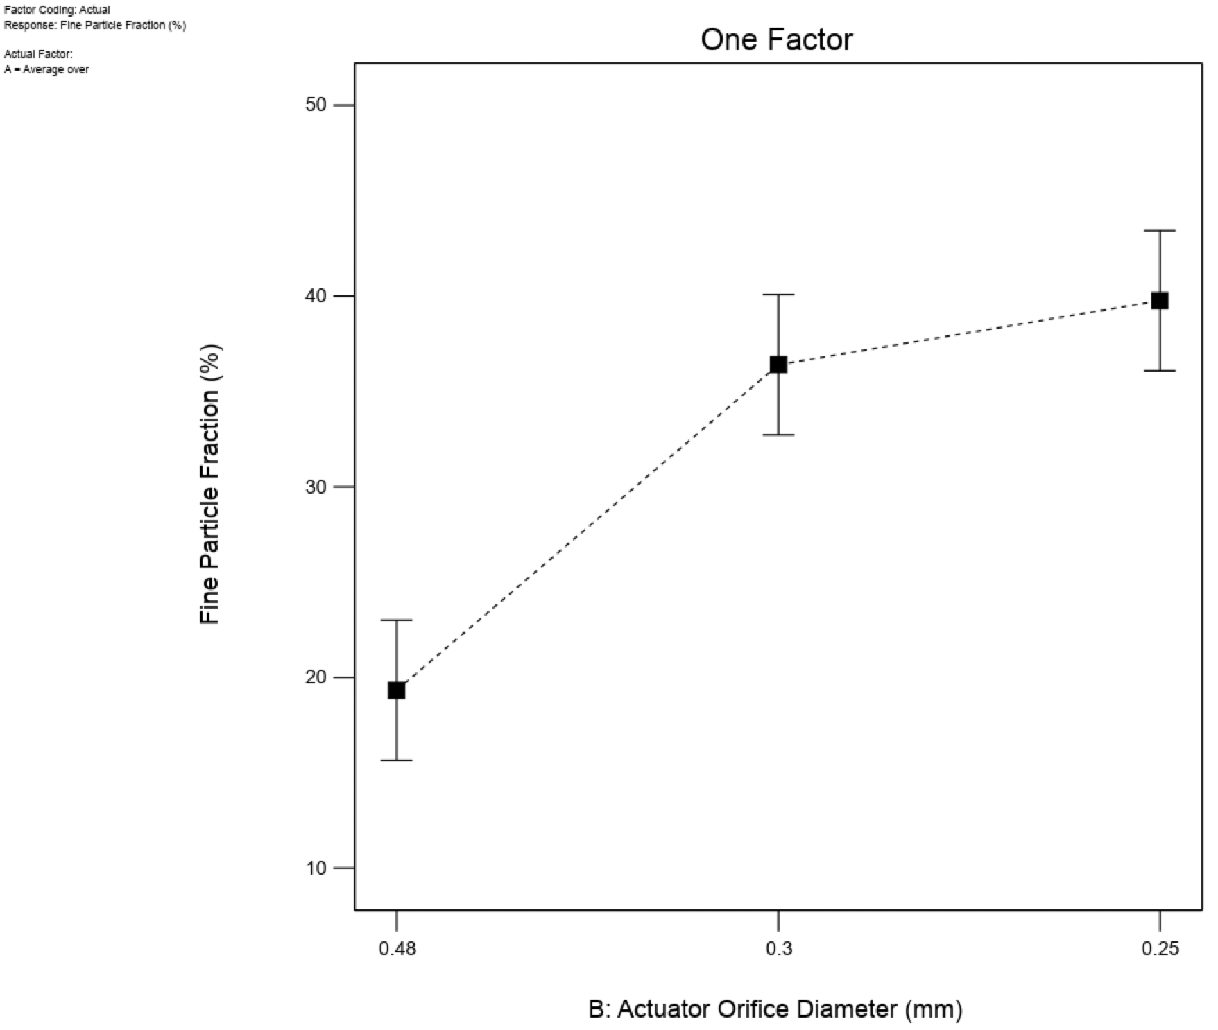

A B

Figure 2: (A) Pareto Chart illustrating the effect of the parameters investigated on the emitted fraction and (B) the perturbation plot indicating the relationship between the fine particle fraction and the actuator orifice diameter.

Although the valve volume is a quality attribute which, if increased, leads to an increase in the ED, it was nevertheless decided to continue with the analysis and construction of the product using a 50 µL valve volume in order to limit the amount of propellant to be used and create a more sustainable product.
With regard the AOD, although an increase in size leads to an increase in ED, this penalized the Respirable Fraction which, on the other hand, has an inverse trend with respect to the increase in diameter. Consequently, the analyses continued by equally studying the values of 0.48 and 0.3 mm and adding a value of 0.25 mm, however reducing the quantities of ethanol (12, 6 and 1 %), which, from the previous experimental design, was observed not to bring any variation to either the ED or the FPF.
Interestingly, the ethanol addition improved the ED in the range 1-12%, on the other hand it was not significant between 12 and 15%. Similarly, if the actuator orifice increases, it leads to an increase in ED.
On the other hand, the FPF was maximum as both factors decreased. However, in the construction of the product it is necessary to find a compromise that maintains high respirability without affecting ED. From the illustrated data, it was set the configuration of the lead product consisting of 50 µL valve volume in favor of sustainability, 0.3 mm AOD to favor the deposition of the product in the lungs, and 6% ethanol content in order to limit the use of this solvent since a higher value does not lead to differences in critical quality attributes. Regarding the in vitro aerodynamic assessment carried out on the lead product, shows a high respirability of FPF of 45.5% and MMAD of 2.55 µm as illustrates in Table 2.

Table 2: Aerodynamic parameters obtained by carrying out the complete characterization of the SS_HFA152a lead product, valve volume 50 µL, ethanol content 6%w/w, actuator orifice diameter 0.3 mm (n=9 ± st dev).
Emitted Dose (µg) | Fine Particle Mass (µg) | Fine Particle Fraction (%) | Extra-Fine Particle Mass (µg) | Extra-Fine Particle Fraction (%) | MMAD (µm) | GSD
82.0 ± 3.9 | 37.4 ± 3.1 | 45.5 ± 2.8 | 14.1 ± 0.9 | 17.2 ± 0.8 | 2.55 ± 0.04 | 1.78 ± 0.03

In addition to evaluating the aerodynamics of the selected leader product, its ED through the life of the canister was also studied. Figure 3 represents the trend of the ED through the life of the lead product for two inhalers, to also evaluate the inter-canisters variability. The ED remains constant from the first dose to the last and ED values varied in fact between 70.1 and 100.7%. All data were within the acceptable range although there is a trend towards less variability moving from BoL to EoL. This shows that the dose taken by the patient will agree with the labelled ex-valve dose and it should be able to satisfy the desired effect of the therapy.

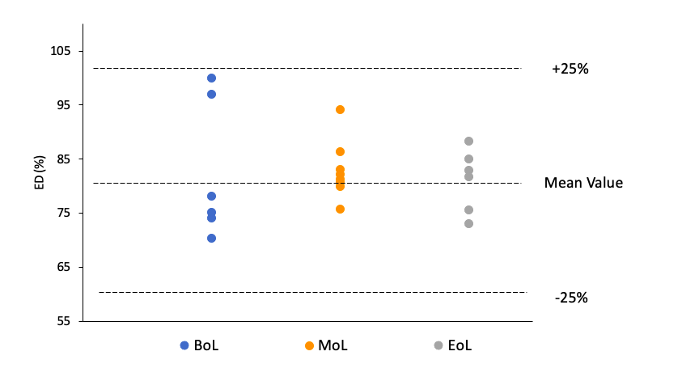
Figure 3: SS_HFA152a in which it is evident that all the doses (two inhalers, n=20) have a similar behavior and fall within the limits indicated by the Ph.Eur of 75 and 125% of the mean value.

Conclusions

Always paying attention to respecting both the environment, making more sustainable choices that lead to less use of propellant and ethanol, and the characteristics that make an inhalation product effective, it is possible to obtain a salbutamol sulphate product with high respirability (FPF = 46%) using the new eco-friendly propellant HFA152a. Additionally, the product's ability to maintain the ED during all the product life assures the patient to receive the therapeutic dose.

References
[1] D. Pernigotti et al., ‘Reducing carbon footprint of inhalers: Analysis of climate and clinical implications of different scenarios in five European countries’, BMJ Open Respir Res, vol. 8, no. 1, Dec. 2021, doi: 10.1136/bmjresp-2021-001071.
[2] Pritchard, J. N. The Climate is Changing for Metered-Dose Inhalers and Action is Needed. Drug Des Dev Ther Volume 14, 3043–3055 (2020).
[3] F. Buttini, et al., Metered dose inhalers in the transition to low GWP propellants: what we know and what is missing to make it happen. Expert Opin. Drug Deliv. In press, 2023, doi:10.1080/17425247.2023.2264184.
[4] S. W. Stein and P. B. Myrdal, ‘The relative influence of atomization and evaporation on metered dose inhaler drug delivery efficiency’, Aerosol Science and Technology, vol. 40, no. 5, pp. 335–347, May 2006, doi: 10.1080/02786820600612268.

