Influence of Fluid Physiochemical Properties on Aerosolization Performance of a Novel Soft Mist Inhaler

Varsha Komalla¹, Imco Sibum³, Bernhard Muellinger³, Wietze Nijdam⁴, Vishal Chaugule⁵, Julio Soria⁵, Nicolas A. Buchmann³, Hui Xin Ong^{1,2}, and D. Traini^{1,2}

¹Respiratory Technology, Woolcock Institute of Medical Research, Sydney, NSW 2037, Australia

²Macquarie Medical School, Department of Biological Sciences, Faculty of Medicine, Health and Human Sciences, Macquarie University, NSW 2109, Australia

³Resyca B.V., Enschede, the Netherlands

⁴Medspray B.V., Enschede, the Netherlands

⁵Laboratory for Turbulence Research in Aerospace and Combustion (LTRAC), Department of Mechanical and Aerospace Engineering, Monash University, Clayton Campus, Melbourne, VIC 3800, Australia

Summary
The purpose of this work is to provide a better understanding of the effects of different levels of excipients affecting fluid properties and inhalation flow rates on the aerosol performance of the novel Soft Mist Inhaler (SMI), PulmosprayTM. Water for injection (WFI) was used as a solvent and the excipients included were varying concentrations of ethanol (5 to 50% v/v), glycerol (5 to 30% w/v), sodium chloride (0.3 to 9% w/v) and span 20 (0.01 and 0.05% v/v). The excipients were evaluated to elucidate the impact of these additions to the solution formulation properties on inhalation aerosol variables (Particle Size Distribution, PSD, Dv10, Dv50 and Dv90) at two different flow rates (15 and 30 L/min). In general, an increase in the concentration of any excipients added increased osmolality. The addition of Span 20 and ethanol individually to WFI resulted in a decrease in surface tension, and the addition of glycerol increased viscosity. In summary, the characteristic of aerosol generation and the performance of the SMI did not change significantly over the range of tested surface tension (75 – 28mN/m), viscosity (1 – 2.4mPas) and osmolality, thus showing the robust aerosol delivery of the SMI over a relevant range of rheological properties used in inhalation solutions.
Key Message
In this study, the impact of different fluid properties on the aerosol generation of the PulmosprayTM soft mist inhaler (SMI) was assessed. Considering the current interest in delivering proteins, peptides and biologics to the respiratory tract, our study shows the flexibility of this SMI as a viable option for a wide range of therapeutic solutions and consequently could be translated to the delivery of different drug formulations, potentially improving patient treatments.

Introduction
Soft mist inhalers (SMIs) are propellant-free inhalers that are gaining interest in the delivery of drugs, especially proteins and biologics, due to the low shear stress [1] they produce during aerosolization and low carbon footprint [2]. The physical processes associated with drug atomization and aerosol delivery to the respiratory tract require continuous improvement to achieve high efficiency to be applicable across the different formulations used in SMI for inhalation therapy. The effectiveness of the SMI inhalation therapy relies on many factors, including the device manufacture and physicochemical properties of the inhalation solution [3]. The viscosity and the surface tension of the fluids to be nebulised are crucial factors that may influence the particle size distribution of the aerosol droplets [4,5]. The Aim of the study was on the influence of fluid physiochemical properties on droplet size distribution using the PulmosprayTM SMI device, (Resyca B.V, Enschede, Netherlands). Specifically, we will evaluate the following properties: (1) fluid viscosities, (2) ionic strength and (3) surface tension of different fluid mixtures and study their particle size distribution at two different inhalation flow rates.

Experimental methods
A series of fluid mixtures with variable viscosities, ionic strengths and surface tension were prepared by mixing different WFI with concentrations of 0.3%, 0.6%, 0.9%, 9% w/v of NaCl, glycerol 0, 5%, 10%, 20% and 30% w/v, ethanol 5%, 10%, 20%, 30%, 40%, and 50% v/v and Span 20 (0.01% and 0.05% v/v). These fluids were characterized for their corresponding physiochemical properties and their effect on aerosol performance was assessed by measuring the geometric size distribution using the PulmosprayTM SMI device.
Fluid viscosity was evaluated using a rotational rheometer AR2000 (TA instruments, New Castle, USA) connected to the Rheology Advantage software (version V7.20). The rheometer was equipped with an aluminum cone/plate geometry –diameter 40 mm, angle 2°, 64 μm truncation, and with a solvent trap to prevent sample dehydration. Shear rate sweep tests were carried out under steady-state conditions: after 1-min equilibration time, the shear rate was progressively increased from 0.01 to 1000 s⁻¹ at 25 °C. The ionic strength of all liquids was evaluated by measuring their osmolality using an ELITech Freeze Point osmometer. 300 and 850 mOsmol/kg solutions of sodium chloride were used as standard solutions. Surface tension was evaluated using a Sigma 703D tensiometer. with WFI used as a reference for all measurements.
In situ, real-time measurement of the droplet size distribution was performed by laser diffraction using a Spraytec particle sizer (Malvern Instruments, Worcestershire, UK). Experiments were conducted using the fluid mixtures listed above with 1 mL of the mixture being loaded into the PulmosprayTM SMI. The flow rate through the Spraytec was set at 15 (low) or 30 (high) L/min and calibrated using a flow meter, with the device in-line during setup. All measurements were performed in triplicates at room temperature (25°C, 50% RH). The RespiLever DriveTM of the SMI needed to actuate the device was held for 3 sec for each inhalation and 3 inhalations were actuated per measurement, resulting in a total aerosolisation time of 10s -12s. The particle size distributions of the aerosolized mixtures were analyzed using the Malvern software V.5.51 (Malvern Instruments, Worcestershire, UK).
All data are expressed as Mean ± S.D. and were analyzed using two-way ANOVA, followed by post hoc Tukey tests. n = 3-7. ** p < 0.01; * p < 0.05; **** p < 0.0001.

Results
The physicochemical properties of different concentrations of sodium chloride, glycerol, ethanol, and Span 20 are presented in Table 1.
Table 1. Effects on physicochemical parameters of WFI with the addition of different concentrations of sodium chloride, glycerol, ethanol, and span 20.
Physical-chemical properties | Solution Mixture | Surface Tension (mN/m) | Osmolality (mOsmol/kg) | Viscosity at a Shear rate 100 (1/s) (mPa.s)
Control | WFI | 71.60 (0.36) | 0.25 (0.5) | 1.05 (1.8E-02)
Ionic Strength | 0.3% w/v NaCl | 71.99 (0.27) | 97.50 (1)**** | 1.06 (2.2E-02)
Ionic Strength | 0.6% w/v NaCl | 72.52 (0.13) | 197.75 (1.26)**** | 1.07 (3.7E-02)
Ionic Strength | 0.9% w/v NaCl | 72.32 (0.86) | 288.33 (1.15)**** | 1.05 (6.0E-03)
Ionic Strength | 9% w/v NaCl | 74.53 (0.20) | 3522.75 (63.68)**** | 1.19 (5.3E-03)
Viscosity | 5% w/v glycerol | 71.18 (0.22) | 533.67 (4.04)**** | 1.23 (2.3E-02)
 | 10% w/v glycerol | 68.38 (0.40)** | 1334.33 (3.50)**** | 1.3 (1.7E-02)
 | 20% w/v glycerol | 67.90 (1.23)*** | 3516.00 (1)**** | 1.59 (2.3E-02)
 | 30% w/v glycerol | 68.10 (0.95)** | - | 1.91 (8.9E-03)
Surface tension | 5% v/v ethanol | 58.62 (0.01)**** | 736.33 (12.90)**** | 1.19 (3.0E-02)
Surface tension | 10% v/v ethanol | 50.48 (0.09)**** | 1934.33 (42.74)**** | 1.33 (6.3E-02)
Surface tension | 20% v/v ethanol | 40.83 (0.13) **** | 4069.33 (0.58)**** | 1.71 (7.9E-02)
Surface tension | 30% v/v ethanol | 34.30 (0.50) **** | - | 1.99 (4.6E-02)
Surface tension | 40% v/v ethanol | 31.05 (0.03) **** | - | 2.28 (6.6E-02)
Surface tension | 50% v/v ethanol | 28.20 (0.71)**** | - | 2.36 (1.9E-02)
Surface tension | 0.01% v/v Span 20 | 27.88 (0.11) **** | 0.5 (0.57) | 1.08 (5.6E-03)
Surface tension | 0.05% v/v Span 20 | 28.5 (0.5) **** | -0.6 (0.57) | 1.08 (1.6E-02)
Data are expressed as Mean ± S.D. and were analyzed using one-way ANOVA, followed by post hoc Tukey tests. n = 3-4. ** p < 0.01 vs. WFI; * p < 0.05 vs. WFI; **** p < 0.0001 vs. WFI. Note: Readings could not be obtained above 20% w/v glycerol and above 20% v/v ethanol in WFI as crystallization did not take place, which is a fundamental step in freeze point osmolality measurements.
To vary the ionic strength of the solution, varying concentrations of NaCl from 0.3 to 9% w/v were evaluated (Figure 1). Increasing the ionic strength increases the osmolality of the solution (Table 1). A slight decrease in mean particle size (Dv50) with increasing NaCl concentrations can be observed which is consistent with previous observations [6]. Overall, however, ionic strength does not influence the aerosol performance of the SMI significantly within the studied range of NaCl concentrations at these specific flow rates.
Figure 1. Dv10, Dv50 and Dv90 aerosol particle size data of 0.3-9% w/v NaCl in WFI sprayed using Pulmospray and b) particle size distribution curves at flow rates of 15 and 30 L/min.
To evaluate the effect of viscosity, varying concentrations of glycerol from 5-30 % w/v were tested (Figure 2). However, while viscosity measurements did not show a significant difference between the different concentrations of glycerol, increasing glycerol concentration also increases osmolality and decreases surface tension, reflecting the interdependency of the different liquid characteristics (Table 1). In this study, it was found that viscosity did not affect the aerosol performance of the SMI in a significant manner at the specific flow rate of either 15 or 30 L/min.
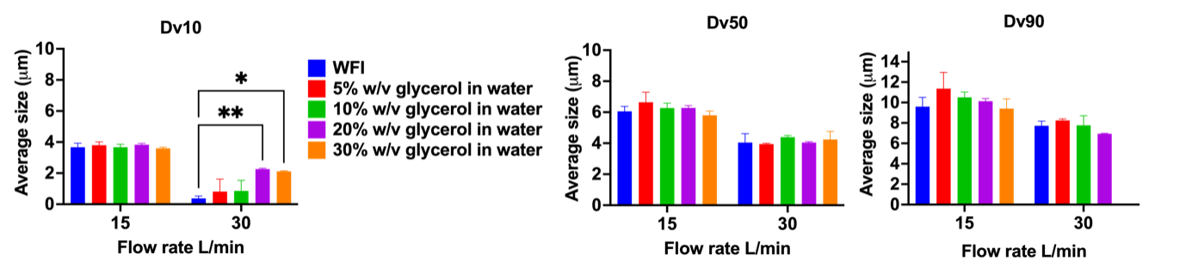
Figure 2. Dv10, Dv50 and Dv90 aerosol particle size data of 5-30% w/v glycerol in WFI sprayed using Pulmospray and b) particle size distribution curves at flow rates of 15 and 30 L/min.
To modify the surface tension of the solution, different ethanol concentrations were evaluated from 5 - 50 % v/v (Figure 3). Increasing ethanol concentrations also increase the osmolality of the solution (Table 1). Overall, decreasing surface tension (e.g., increasing ethanol concentration) did not affect the aerosol performance of the SMI in a significant manner at either flow rate.
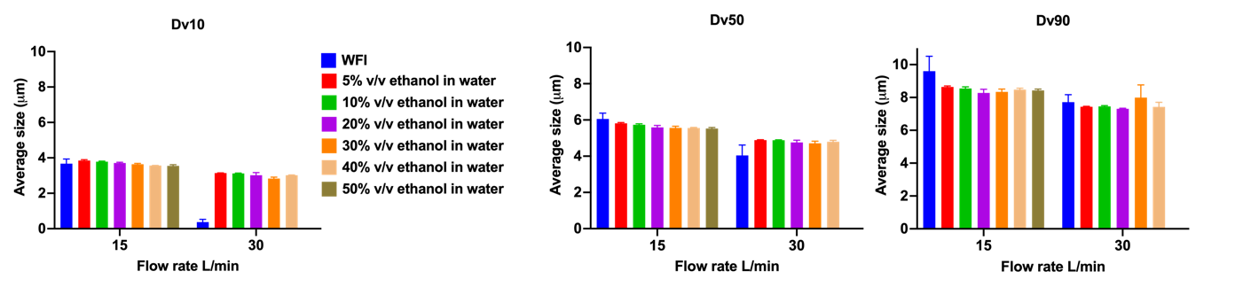
Figure 3. Dv10, Dv50 and Dv90 aerosol particle size data of 5-50% w/v ethanol in WFI sprayed using Pulmospray and b) particle size distribution curves at flow rates of 15 and 30 L/min.
Finally, to investigate the impact of surface tension, Span 20 was used at a concentration of 0.01 and 0.05 % v/v in WFI while keeping the other factors such as osmolality and viscosity constant (Figure 4). Here, some notable changes in Dv50 were overserved at the higher flow rate (30L/min), but not at the lower flow rate (15L/min)
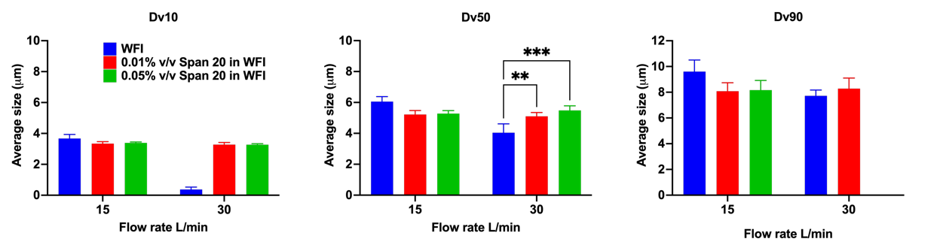
Figure 4. Dv10, Dv50 and Dv90 aerosol particle size data of 0.01-0.05% w/v Span 20 in WFI sprayed using Pulmospray and b) particle size distribution curves at flow rates of 15 and 30 L/min.

Discussion
Previous studies have shown that aerosol properties from nebulizers are dependent on fluid physicochemical properties such as viscosity and surface tension [4, 5. Similar dependencies can be thought of for the novel PulmosprayTM SMI device and are consequently studied in this work.
Results demonstrate that reliable aerosol generation over a wide range of viscosity and surface tension can be achieved with the PulmosprayTM device without a significant effect on the quality of the generated aerosol. Irrespective of physicochemical properties, median aerosol diameter (Dv50) ranges between 5 – 6µm for inhalation flow rates of 15L/min and between 4 – 5µm for inhalation flow rates up to 30L/min, indicating an aerosol quality suitable for efficient inhalation. Most notably, solutions with very high viscosities up to 2.5 times that of water and very low surface tensions could be nebulised without significant impact on the aerosol quality and output rate.

In general, the PulmosprayTM device produces smaller aerosol droplets at higher flow rates compared to lower flow rates across the different solution mixtures. This is attributed to the mechanisms of aerosol generation relying on the combination of airflow through the device interacting with the fluid properties and the physical droplet generation by Rayleigh breakup [2].
The Dv50 is one of the parameters describing the behaviour of the aerosol and the deposition of inhaled particles. Consequently, for the PulmosprayTM device lower lung deposition and increased throat deposition at lower inhalation flow rates compared to higher inhalation flow rates would be expected. However, throat deposition is governed by inertial impaction and is linearly proportional to the inhalation flow rate and quadratically to the particle size, but independent of the physicochemical properties of the drug solution. Thus, lowering the inhalation flow rate, albeit at a slightly higher particle size will lead to a lower throat deposition and improved lung deposition. This effect is corroborated by data shown in [2], where throat deposition for the PulmosprayTM device is 20.7% and 25.3% and lung deposition is 67.0% and 57.1% at inhalation flow rates of 15 and 30L/min, respectively.
Conclusions
In this study, it was shown that the characteristic of aerosol generation and resulting lung deposition from the Pulmospray SMI is independent of the physiochemical properties of the inhalation solution and the inhalation flow rate. In conclusion, the single-use PulmosprayTM SMI device is an efficient inhaler for the delivery of drug products to the lungs with varying physiochemical properties of the inhalation solution and inspiratory flow rates.

Acknowledgements
This work was funded by an Australian Research Council grant: LP190100917.

References
[1] van Rijn, C, Vlaming, KE , Bem, RA., Dekker, RJ., Poortinga, A., Breit, T., van Leeuwen,S., Ensink, WA., van Wijnbergen, K., van Hamme ,JL., Bonn, D., Geijtenbeek, TBH. Low energy nebulization preserves integrity of SARS-CoV-2 mRNA vaccines for respiratory delivery, Sci Rep 2023, 31;13:8851
[2] Komalla, V.; Wong, C. Y. J.; Sibum, I.; Muellinger, B.; Nijdam, W.; Chaugule, V.; Soria, J.; Ong, H. X.; Buchmann, N. A.; Traini, D., Advances in soft mist inhalers. Expert Opinion on Drug Delivery 2023, 1-16.
[3 Broniarz-Press, L.; Sosnowski, T. R.; Matuszak, M.; Ochowiak, M.; Jabłczyńska, K., The effect of shear and extensional viscosities on atomization of Newtonian and non-Newtonian fluids in ultrasonic inhaler. D1rnational Journal of Pharmaceutics 2015, 485 (1), 41-49.
[4] Ochowiak, M.; Matuszak, M.; Włodarczak, S., The analysis of pneumatic atomization of Newtonian and non-Newtonian fluids for different medical nebulizers. Drug Development and Industrial Pharmacy 2017, 43 (12), 1999-2010.
[5] Simones, M. P.; Loyalka, S. K.; Duffy, C.; MacLoughlin, R.; Tatham, A.; Power, P., Measurement of the size and charge distribution of sodium chloride particles generated by an Aeroneb Pro® pharmaceutical nebulizer. 2014, 6 (1), 29-36.
[56 Mao, L.; Pant, N.; Bockenstedt, D.; Simple and Efficient Delivery of Inhaled Soft Mist Aerosols Using the Hand-Held PulmosprayTM. Respiratory Drug Delivery 2022, 339 - 341
[7 Muellinger, B.; Buchmann, N.A.; Bockenstedt, D.; Mao, L.; Pant, N.; de Kruif, W.; Effect of Inspiratory Flow Rate on Particle Size Distribution and In Silico Deposition Within the Respiratory Tract using a Soft Mist Inhaler (SMI). Respiratory Drug Delivery 2022, 343-348

