In Vivo Biodistribution of Inhaled Colistin-Endolysin Combination

Pengfei Zhang¹, Ping Zeng¹ & Sharon S. Y. Leung¹

¹ School of Pharmacy, Faculty of Medicine, The Chinese University of Hong Kong, Hong Kong SAR

Summary
The rapid emergence of multidrug-resistant (MDR) bacteria, particularly the gram-negative (G-ve) ones, has significantly increased the medical challenges in managing their associated pneumonia. Combination therapy of colistin with bacteriophage-derived endolysins (lysins) has recently attracted significant attention to combat infections caused by MDR G-ve bacteria. To maximize the synergy of the combination treatment, it is essential to maintain the two agents at an optimal mixing ratio at the infection sites. In the present study, we investigated the lung retention time of colistin and LysAB2 lysin in healthy BALB/c mice via intratracheal (IT) aerosolization and intravenous (IV) injection. Anaesthetized mice were dosed with fluorescence-labelled colistin (with sulfo-cy5) and LysAB2 (with sulfo-cy7). At designated time points (1, 2, 4, 8, and 24 h), the distribution of both agents was monitored through fluorescence measurement with an in-vivo animal imaging system (IVIS). Our results showed colistin and LysAB2 shared similar biodistribution profiles regardless of the administration routes. Compared with IV injection, colistin and LysAB2 delivered via IT aerosolization had apparently higher and longer lung exposure. The promising data suggest that the optimal mixing ratio of the two agents from in-vitro setting can be applied for in-vivo experiments with minimum adjustment.
Key Message
The biodistribution of colistin and LysAB2 proved the feasibility of their combinational use in-vivo through pulmonary delivery. IT aerosolization of the combination could not only increased the drug concentrations in the lungs, but also prolonged their lung retention time.

Introduction
Pneumonia caused by multidrug-resistant (MDR) gram-negative (G‒ve) bacteria has posed significant global medical challenges. Bacteriophage-encoded endolysins (lysins), which are peptidoglycan (PG) degrading enzymes, have emerged as promising next-generation antibacterials [1]. They target the PG layer, the essential and immutable molecules within the bacterial cell wall, making resistance development rare [2]. However, the presence of an outer membrane renders most native lysins ineffective in killing G‒ve bacteria. Co-administration with outer membrane permeabilizers (OMPs) has been considered as an effective strategy to extend the paradigm of this new class to target G‒ve bacteria [3]. Colistin, a peptide-based antibiotic disrupting the bacterial membranes has been demonstrated to be an effective OMP to facilitate the bactericidal activity of lysins [4]. The synergistic effect of lysin and colistin combination was found to relys on an optimal mixing ratio of the two antibacterial agents.
Inhaled colistin has been used successfully to treat cystic fibrosis patients colonized with G‒ve Pseudomonas aeruginosa [5]. Pulmonary delivery of lysins was also demonstrated to be a superior route in managing bacterial lung infections compared with parental-delivered lysins in animal models [6]. Therefore, co-delivery of the colistin-lysin combination via the pulmonary route is believed to hold the greatest promise in achieving the optimal doses of both agents with minimum systemic exposure. However, one of the key aspects of the proposed treatment strategy requiring investigation is the residence time in the lungs of both agents after inhalation. The present study employed, LysAB2, derived from A. baumannii phage ϕAB2a as a model lysin to assess the biodistribution of colistin-lysin combination after administered via the intratracheal (IT) route and intravenous (IV) routes in mice. The collected data will provide important insights to guide suitable dosing regimen design for in-vivo efficacy in managing bacterial pneumonia.
Experimental methods
To trace the two agents after administration by in-vivo imaging, two water-soluble near-infrared fluorescence dyes, sulfo-cy5 (Scy5) and sulfo-cy7 (Scy7) with an amine-reactive succinimide ester (NHS ester), were used to label colistin and LysAB2, respectively (Figure 1A). After labelling, colistin-Scy5 was purified by HPLC and harvested by freeze-drying, LysAB2-Scy7 was purified and harvested by ultracentrifugation. Labelled antibacterial agents were quantified by BCA assay. The success of labelling was verified by HPLC (Figure 1B) and SDS-PAGE (Figure 1C). Then, a mixture of colistin-Scy5 (25 μg/mouse) and LysAB2-Scy7 (50 μg/mouse) was administered via IT aerosolization or IV injection to healthy BALB/c mice (n = 3) to determine their biodistribution (Figure 1D). The doses of colistin and Lysins were adopted from previous research [7, 8]. A mouse administered with PBS served as the blank control. At designated time points (1, 2, 4, 8, and 24 h) after dosing, the distribution of colistin and LysAB2 was monitored through fluorescence measurement (Ex/Em_{colistin-cy5} = 640/700 nm, Ex/Em_{LysAB2-cy7} = 745/800 nm) with an in-vivo animal imaging system (IVIS). After 24 h, mice were euthanized for organ collection. Ex-vivo imaging of all collected organs was also performed with the IVIS to check the distribution of residual colistin and LysAB2.
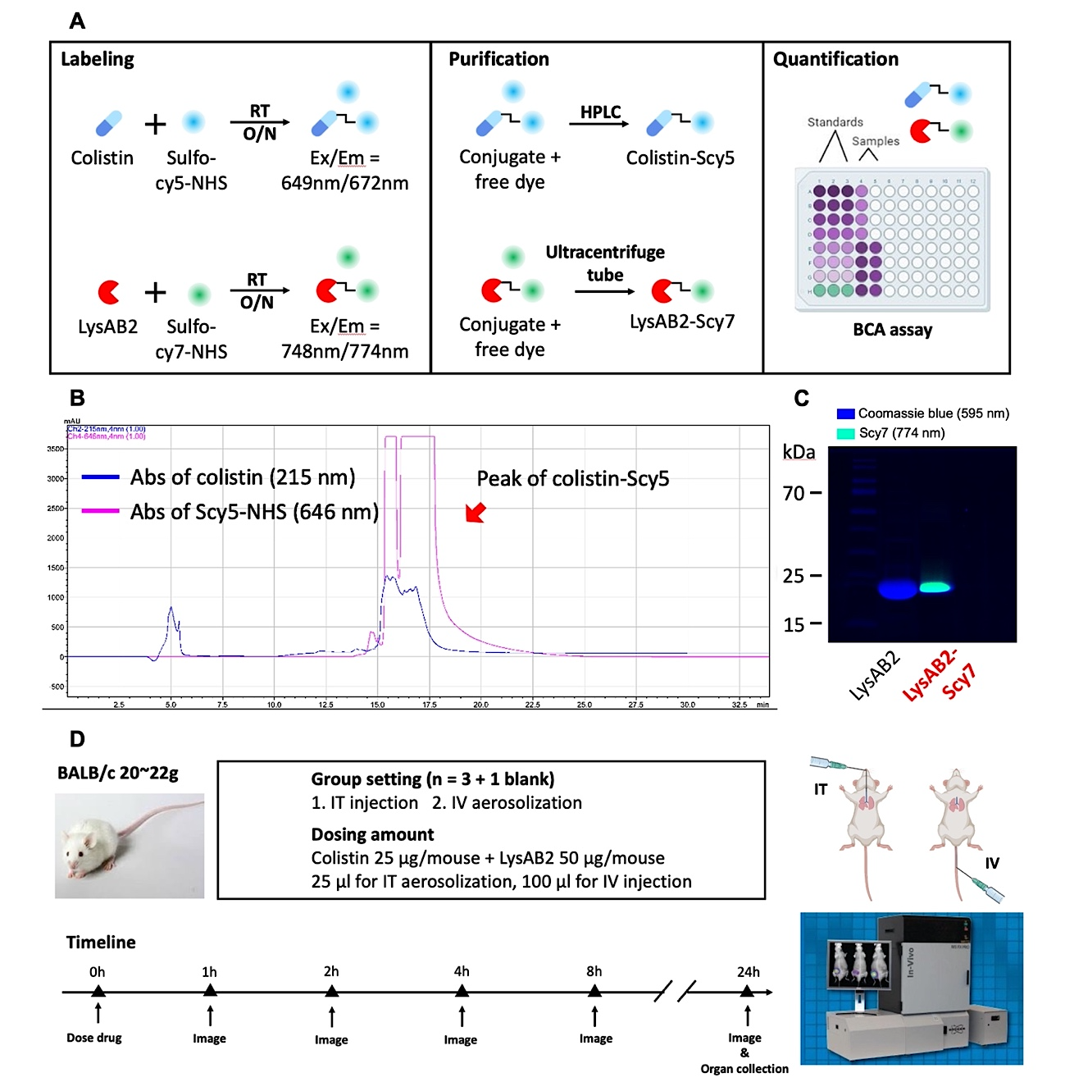
Figure 1 - Drug labelling and study design. (A) The procedure of drug labelling, purification, and quantification. (B) HPLC spectrum of colistin-Scy5. (C) SDS-PAGE image of LysAB2 and LysAB2-Scy7. (D) The study design for investigation on biodistribution of colistin-LysAB2 combination.
Results and Discussion
The biodistribution profiles of colistin and LysAB2 were similar, regardless of the administration routes, IT aerosolization (Figure 2A) and IV injection (Figure 2B). At the 1 h time point, the IT aerosolized colistin and LysAB2 were mainly localized in the oral cavity, chest region and intestinal region (Figure 2A). This is because some of the administered drugs backflowed to the oral cavity and get into the Gastrointestinal tract. Systematic distribution of the two agents was noted after 2 h with fluorescence signals peaked for the whole body and chest region (Figure 2C). Then, fluorescence signals started to fade, indicating that drugs are gradually metabolized and/or eliminated from the body. Overall, colistin and LysAB2 could retain in the lungs for a long time after IT aerosolization and have comparable biodistribution.
Comparing the two administration routes, higher fluorescence signals from both colistin-Scy5 and LysAB2-Scy7 were detected in the chest region during the 24 h monitoring period. The ratio of chest radiance to total radiance from the whole mice body after IT aerosolization was also relatively higher than that after IV injection for both colistin and LysAB2 (Figure 2D).
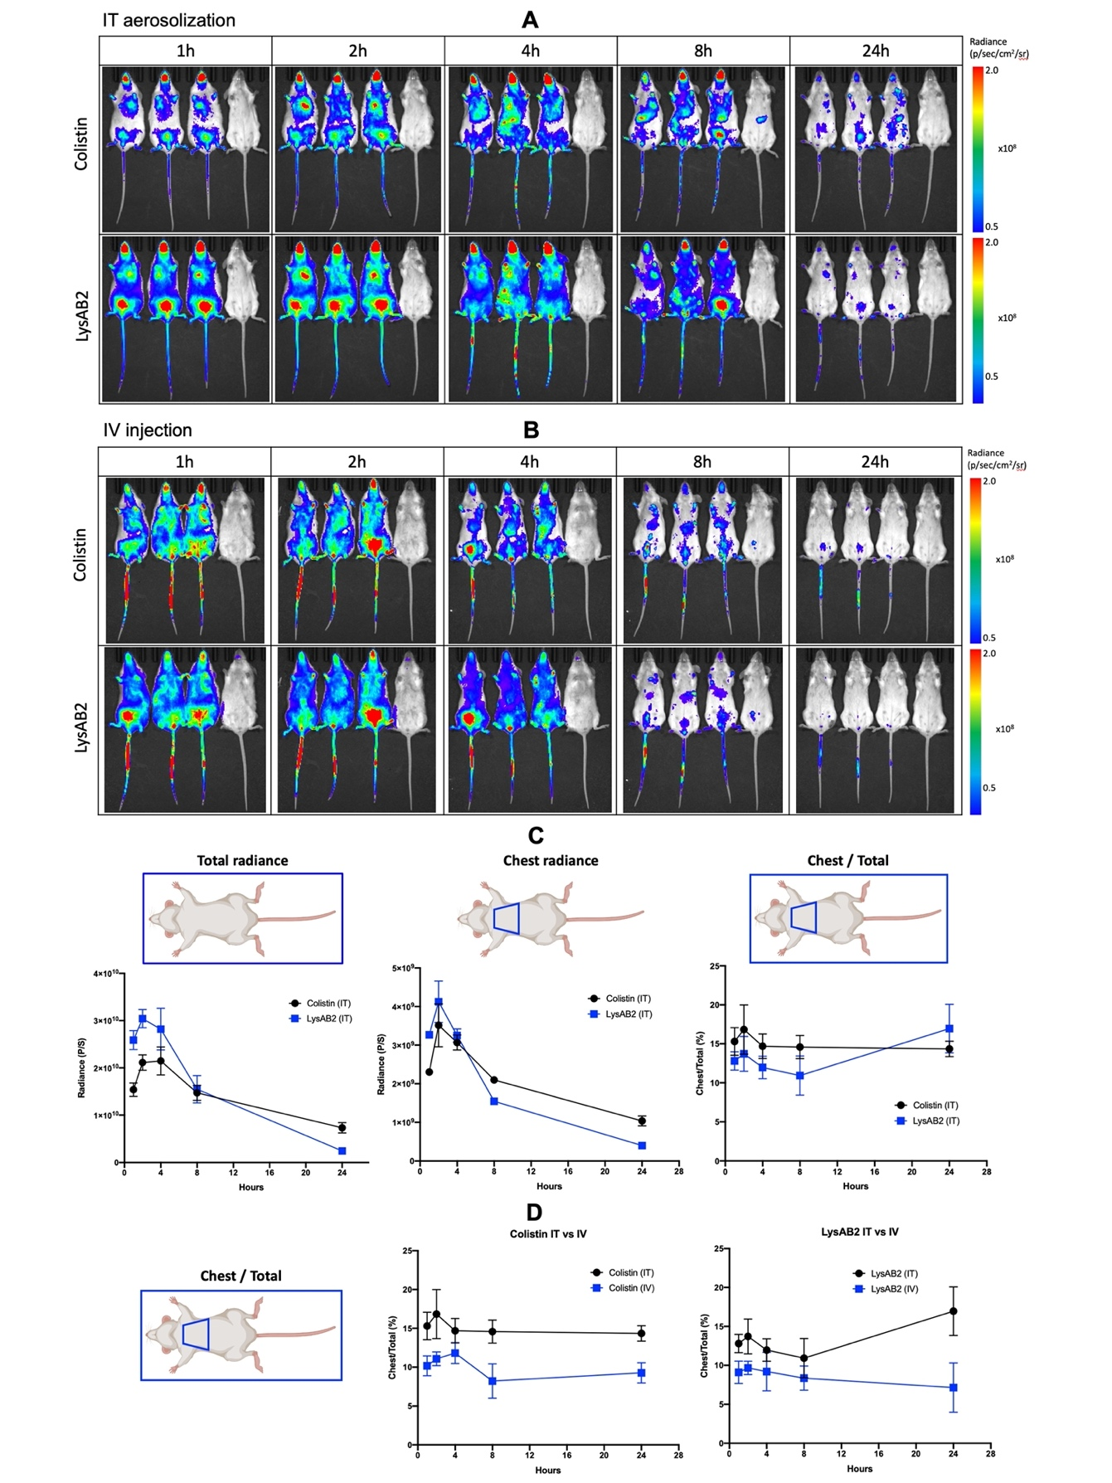
Figure 2 - Biodistribution of colistin and LysAB2. (A) Fluorescence images of whole mice body after IT aerosolization in 24 h. (B) Fluorescence images of whole mice body after IV injection in 24 h. (C) Graphs of radiance quantification on the fluorescence images of IT aerosolization(D) Graphs of the ratio of chest radiance to total radiance from whole mice body.
Similar to the whole body imaging, the organ distribution of residual colistin and LysAB2 obtained via ex-vivo imaging were also similar for the same route of administration (Figure 3A and 3B). As expected, the amounts of colistin and LysAB2 remaining in the lungs were much higher via IT aerosolization than those administered through IV injection. While strong fluorescence signals in the lungs were detected for mice received IT aerosolization (Figure 3A), fluorescence signals could barely be detected for mice received IV injection (Figure 3B). After quantifying the radiance (Figure 3C and 3D), the difference in lung retention (dark blue area) between these two administrations was also very apparent.
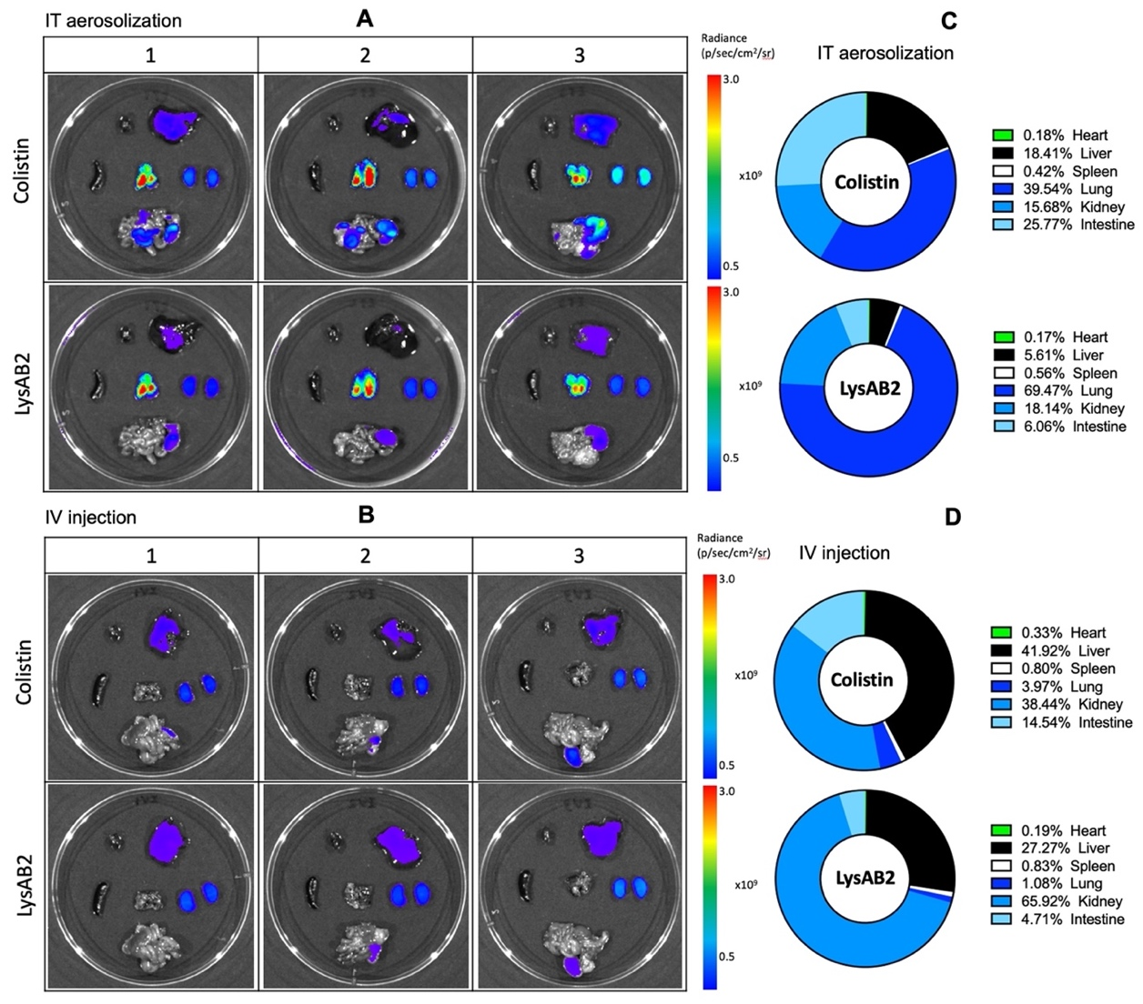
Figure 3 - Organ distribution of the residual colistin and LysAB2. (A) Fluorescence images of different mice organs after IT aerosolization. (B) Fluorescence images of different mice organs after IV injection. (Top row: heart, liver; Middle row: spleen, lung, kidney; Bottom row: Intestine) (C) Percentage of radiance generated from different organs after IT aerosolization. (D) Percentage of radiance generated from different organs after IV injection.
Conclusion
In summary, our preliminary finding of the biodistribution profile of colistin and LysAB2 support IT aerosolization to be an effective way to deliver the combination to lungs for infection management. Both agents could retain in the lungs for a long time. A minimum adjustment of the mixing ratio of the two antibacterial agents from the in-vitro findings is required to achieve optimized treatment outcomes.

References
[1] M.K.Y. Ho, P. Zhang, X. Chen, J. Xia, S.S.Y. Leung, Bacteriophage endolysins against gram-positive bacteria, an overview on the clinical development and recent advances on the delivery and formulation strategies, Critical Reviews in Microbiology, 48 (2022) 303-326.
[2] H. Gerstmans, B. Criel, Y. Briers, Synthetic biology of modular endolysins, Biotechnology advances, 36 (2018) 624-640.
[3] W.C.B. Lai, X. Chen, M.K.Y. Ho, J. Xia, S.S.Y. Leung, Bacteriophage-derived endolysins to target gram-negative bacteria, International Journal of Pharmaceutics, 589 (2020) 119833.
[4] L. Blasco, A. Ambroa, R. Trastoy, I. Bleriot, M. Moscoso, L. Fernández-Garcia, E. Perez-Nadales, F. Fernández-Cuenca, J. Torre-Cisneros, J. Oteo-Iglesias, In vitro and in vivo efficacy of combinations of colistin and different endolysins against clinical strains of multi-drug resistant pathogens, Scientific reports, 10 (2020) 7163.
[5] E.M. Westerman, P.P. Le Brun, D.J. Touw, H.W. Frijlink, H.G. Heijerman, Effect of nebulized colistin sulphate and colistin sulphomethate on lung function in patients with cystic fibrosis: a pilot study, Journal of Cystic Fibrosis, 3 (2004) 23-28.
[6] J.M. Doehn, K. Fischer, K. Reppe, B. Gutbier, T. Tschernig, A.C. Hocke, V.A. Fischetti, J. Löffler, N. Suttorp, S. Hippenstiel, Delivery of the endolysin Cpl-1 by inhalation rescues mice with fatal pneumococcal pneumonia, Journal of Antimicrobial Chemotherapy, 68 (2013) 2111-2117.
[7] Y.-W. Lin, Q.T. Zhou, S.-E. Cheah, J. Zhao, K. Chen, J. Wang, H.-K. Chan, J. Li, Pharmacokinetics/pharmacodynamics of pulmonary delivery of colistin against Pseudomonas aeruginosa in a mouse lung infection model, Antimicrobial agents and chemotherapy, 61 (2017) e02025-02016.
[8] A. Raz, A. Serrano, A. Hernandez, C.W. Euler, V.A. Fischetti, Isolation of phage lysins that effectively kill Pseudomonas aeruginosa in mouse models of lung and skin infection, Antimicrobial agents and chemotherapy, 63 (2019) e00024-00019.

