Effects of cyclodextrins and human serum albumin on solubilising and aerosolising cannabidiol

Waiting Tai¹, Jonathon Carl Arnold², Hak-Kim Chan¹ & Philip Chi Lip Kwok¹

¹Advanced Drug Delivery Group, Sydney Pharmacy School, Faculty of Medicine and Health, The University of Sydney, NSW 2006, Australia

²Lambert Initiative for Cannabinoid Therapeutics, Brain and Mind Centre, The University of Sydney, NSW 2050, Australia ³Discipline of Pharmacology, Sydney Pharmacy School, Faculty of Medicine and Health, The University of Sydney, NSW 2006, Australia

Summary
Inhaled cannabidiol (CBD) has attracted much interest due to its promising therapeutic potential. The major formulation challenge is its low aqueous solubility, so solubilisers are required. In this study, the effects of three cyclodextrins (881 µM β-cyclodextrin, methyl-β-cyclodextrin, and 2-hydroxypropyl-β-cyclodextrin) and 15 µM human serum albumin on CBD solubility were evaluated by the shake-flask method. The highest CBD saturated concentration was achieved by methyl β-cyclodextrin at 14.6 ± 0.2 µg/mL, followed by human serum albumin at 9.7 ± 0.1 µg/mL. Methyl-β-cyclodextrin and human serum albumin were then spray freeze dried with CBD to obtain amorphous Formulations M and H, respectively. The aerosol performance of the two formulations was determined using the Next Generation Impactor. Although the mass median aerodynamic diameter of Formulation M was significantly smaller than that of Formulation H (3.7 ± 0.1 µm vs 4.2 ± 0.3 µm), but both had comparable geometric standard deviations (2.3 ± 0.0 vs 2.4 ± 0.1). With about 90% CBD emitted from both formulations, the fine particle fraction < 5 µm of Formulation M was significantly higher than that of Formulation H (53.5 ± 1.5% vs 30.2 ± 1.00%). Since methyl-β-cyclodextrin achieved higher CBD solubility and better powder dispersion performance, it may be used to deliver other cannabinoids.
Key Message
Methyl-β-cyclodextrin and human serum albumin could act as solubilisers to enhance the aqueous solubility of cannabidiol and as carriers to disperse cannabidiol powders with acceptable aerosol performance.

Introduction
Cannabidiol (CBD) is a non-psychoactive cannabinoid that has been widely investigated for its potential therapeutic actions. It is most effective in reducing the frequency of refractory epilepsies in Dravet and Lennox-Gastaut Syndromes and tuberous sclerosis complex, which are also the approved indications of Epidiolex®, a CBD-only oral solution [1]. However, oral administration of CBD is inefficient due to the extensive first-pass metabolism and erratic absorption, resulting in low oral bioavailability (4-20%) [2]. On the other hand, pulmonary delivery is better for delivering drugs systemically, with more regular absorption, higher bioavailability, and faster onset of action [3]. Inhaled CBD in a Phase I clinical trial showed a 9.1-fold higher bioavailability and an earlier, higher maximum concentration than Epidiolex [2].
CBD can be degraded by heat, light, and oxidation. Solid formulations are thus preferred for better chemical stability [4] but CBD is poorly soluble (0.1 µg/mL solubility in water) [5]. Complexing it with cyclodextrins or human serum albumin (HSA) may improve its solubility. Previous studies showed that albumin is a good solubiliser for prednisolone [6] and indomethacin [7]. However, no studies have used it on CBD. On the other hand, cyclodextrins have long been used for solubility enhancement. Although the effects of β-cyclodextrin (bCD) and its derivatives on CBD solubility have been reported [5, 8], none of those studies were intended for pulmonary delivery.
The current study aimed to formulate inhalable CBD powders with improved solubility. The effects of bCD, methyl (methyl-β-cyclodextrin; mbCD), hydroxypropyl (2-hydroxypropyl-β-cyclodextrin; 2HPbCD), and HSA on CBD solubility were first investigated. The cyclodextrin that achieved the highest CBD solubility and HSA were spray freeze dried with CBD. The crystallinity and aerosol performance of the resultant powders were then determined.

Materials and methods
Materials
CBD was purchased from THC Pharm (Frankfurt, Germany). Methanol, tert-butanol, bCD, 2HPbCD, mbCD, and HSA were from Sigma-Aldrich Inc. (St. Louis, United States). Phosphate buffered saline tablets were from ThermoFisher Scientific (Waltham, United States), while ethanol was from Chem-Supply Pty Limited (South Australia, Australia). Water was purified with a Millipore Milli-Q lab water system (Massachusetts, United States).
Solubility test
The effect of bCD, 2HPbCD, mbCD, and HSA on CBD solubility was investigated using the shake flask method. Three hundred microlitres of 900 µg/mL CBD in 85:15 (v/v) methanol:water solution was added into an aluminium canister (Presspart Manufacturing Ltd, Lancashire, UK) and dried in a vacuum oven under ambient temperature to obtain 270 µg of CBD. Five millilitres of PBS pH 7.4 with or without a solubiliser were then added to the canisters. The concentration of cyclodextrins and HSA in PBS was 881 µM and 15 µM, respectively. These were calculated based on a hypothetical scenario in which 10 mg of bCD or HSA (the loaded powder mass in the capsule in a Phase I CBD clinical trial [2]) was to be dissolved in 10 mL of lung fluid after inhalation [9]. The suspensions were shaken continuously at 37°C in a shaking incubator at 150 rpm for 32 h and centrifuged at 4255 x g for 10 min at the same temperature. The supernatants were transferred by stainless steel straws and weighed in glass high performance liquid chromatography (HPLC) autosampler vials. Since the supernatant is aqueous based, the density of the solution is approximately 1, and hence the volume of the solution can be derived from its mass. The solutions were dried in a vacuum oven under ambient temperature and subsequently reconstituted with 85:15 (v/v) methanol:water for CBD quantification. Triplicate experiments were conducted.
Powder production
Spray freeze drying was employed to produce two formulations (Formulation M: CBD + mbCD; Formulation H: CBD+HSA). A mixture of 50:50 (v/v) water:tert-butanol containing CBD and the excipient (20:80 by mass) at a total solute concentration of 20 mg/mL was made. While the co-solvent completely dissolved CBD and mbCD, HSA was suspended due to its low solubility. The mixture was peristaltically pumped into an ultrasonic nozzle (Sono-Tek, New York, United States) at 0.5 mL/min and atomised by a Sono-Tek ultrasonic generator at 48 kHz and 3 W. The droplets were collected in stainless-steel cups containing liquid nitrogen, which was allowed to evaporate before lyophilising in a Buchi Lyovapor L-300 freeze dryer (Flawil, Switzerland) at about -140 ºC for 72 h.
X-ray powder diffraction (XRD)
The crystallinity of the powders was examined on an X-ray diffractometer (X’Pert Powder; Malvern Panalytical Ltd., United Kingdom) using Cu Kα radiation (voltage at 40 kV, current at 45 mA), scanning from 5 to 50° 2θ at 0.04° per second.
Aerosol performance
The Next Generation Impactor (NGI) with the United States induction port (Copley, Nottingham, United Kingdom) was utilised to determine the aerodynamic particle size distributions (APSDs) of the powders. The impactor stages were coated with 0.6% Tween 80 in ethanol to avoid particle bounce. A Size 3 hydroxypropyl methylcellulose capsule (Capsugel, New South Wales, Australia) containing 3 ± 0.4 mg of powder was loaded into a low resistance Osmohaler® for dispersion. The flow rate and duration of dispersion were 100 L/min and 2.4 s, respectively. After dispersion, all parts of the setup were thoroughly rinsed with 85:15 (v/v) methanol:water for CBD quantification by HPLC. The recovered CBD mass was used to calculate the emitted fraction (EF), fine particle fraction (FPF), mass median aerodynamic diameter (MMAD), and geometric standard deviation (GSD). The EF and FPF were the percentage of the emitted dose and fine particle dose < 5 µm relative to the recovered dose, respectively. MMAD was the aerodynamic diameter that divided the particle size distribution in half by mass. GSD was the ratio of the 84% undersize mass aerodynamic diameter to the MMAD. The NGI runs were conducted in triplicate.
Statistical analysis
Statistical analyses were performed using Jamovi (New South Wales, Australia). ANOVA with Tukey post hoc test and Student’s t-test were used to analyse the significance of the effect of excipients on CBD solubility and aerosol performance, respectively. A p value < 0.05 was deemed significant.
Results and discussion
The solubility results are depicted in Figure 1. CBD solubility in PBS was 1.2 ± 0.1 µg/mL (n = 12). All four excipients significantly enhanced the solubility of CBD in PBS. The highest CBD concentration was achieved by mbCD at 14.6 ± 0.2 µg/mL, indicating the strong inclusion ability of mbCD. This was potentially due to the more favourable binding of CBD via increased hydrophobic interactions with the expanded core formed by the methyl substituents [10]. In contrast, the hydroxyl and hydroxypropyl groups in bCD and 2HPbCD formed more polar cavities, which were less suitable to complex with the non-polar CBD. Hence, the level of solubility improvement by 2HPbCD (5.4 ± 0.3 µg/mL) was significantly lower than that of mbCD but was comparable to the native bCD (5.5 ± 0.3 µg/mL). On the other hand, HSA significantly increased CBD solubility to 9.7 ± 0.1 µg/mL. This could be explained by the complexation of CBD to HSA via formation of hydrogen bonds with surrounding amino acids at its binding sites [11].
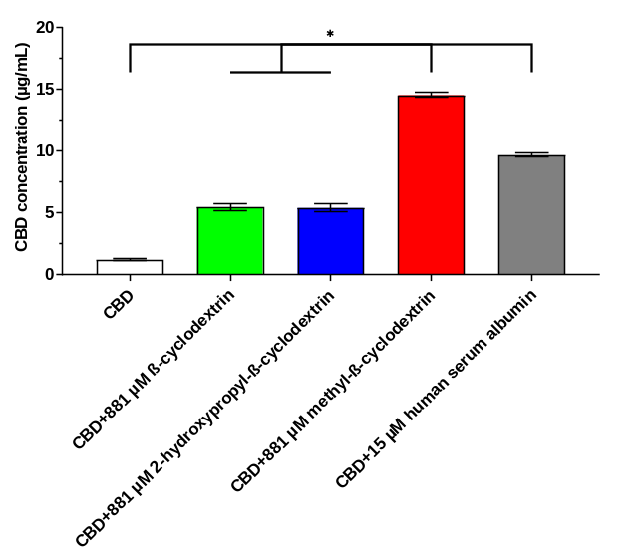
Figure 1. Effect of β-cyclodextrin (green), 2-hydroxypropyl-β-cyclodextrin (blue), methyl-β-cyclodextrin (red), and human serum albumin (grey) on solubility enhancement of cannabidiol (CBD; white). (n = 3, mean ± standard deviation; *p ≤ 0.05)
The production yield of the two spray freeze dried powders was > 80%, typical for spray freeze drying. The XRD pattern of raw CBD had distinct peaks, indicating high crystallinity (Figure 2). The halo patterns of the other raw materials and the two formulations indicate amorphicity. Thus, CBD changed from crystalline to amorphous after spray freeze drying with the excipients, which may improve its solubilisation due to its higher free energy and disordered solid-state structure.
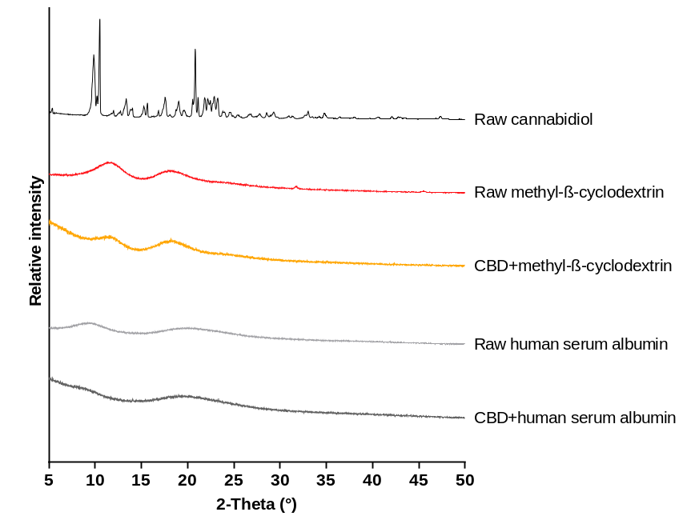
Figure 2. X-ray diffraction patterns of the raw materials and spray freeze dried formulations.
Figure 3 shows the NGI data of the two formulations. Both had comparable capsule and inhaler retention, hence similar EFs (Formulation M vs H: 92.2 ± 1.5% vs 92.3 ± 1.9%). More CBD from Formulation H deposited in the throat so the FPF of Formulation H was significantly lower than that of Formulation M (53.5 ± 1.5% vs 30.2 ± 1.0%), suggesting that Formulation M could deliver more CBD into the deep lung. This is reflected in the smaller MMAD of Formulation M (3.7 ± 0.1 µm vs 4.2 ± 0.3 µm). The GSDs of the formulations (2.3 ± 0.0 vs 2.4 ± 0.1) were comparable.
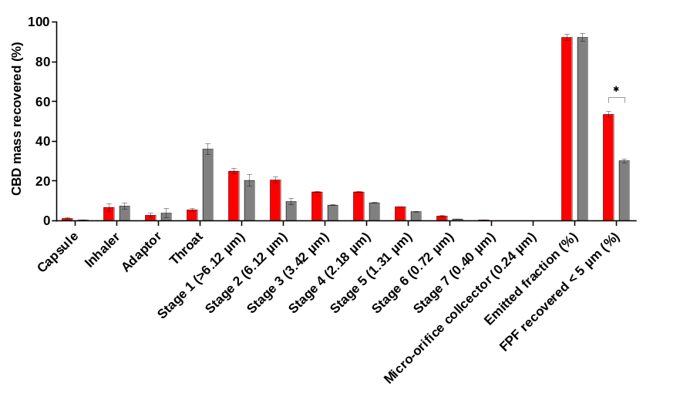
Figure 3. The aerodynamic particle size distribution, emitted fraction, and fine particle fraction of Formulation M (red) and Formulation H (grey). (n = 3; mean ± standard deviation; *p ≤ 0.05)
Conclusion
The effect of four solubilisers on CBD aqueous solubility was investigated. The best two (mbCD and HSA) were spray freeze dried individually with CBD. Both significantly improved CBD solubility and produced amorphous powders with acceptable aerodynamic performance. The stronger CBD solubility improvement and higher FPF by mbCD showed that it was the more effective excipient and may be used to formulate other cannabinoids for inhalation in the future.

References
[1] Thiele E A, Bebin E M, Filloux F, Kwan P, Loftus R, Sahebkar F, Sparagana S, Wheless J: Long-term cannabidiol treatment for seizures in patients with tuberous sclerosis complex: An open-label extension trial, Epilepsia 2022; 63: pp 426-439.
[2] Devinsky O, Kraft K, Rusch L, Fein M, Leone-Bay A: Improved bioavailability with dry powder cannabidiol inhalation: A phase 1 clinical study, J Pharm Sci 2021; 110: pp 3946-3952.
[3] Tai W, Kwok P C L: Recent advances in drug delivery to the central nervous system by inhalation, Expert Opin Drug Deliv 2022; 19: pp 539-558.
[4] Kosovic E, Sykora D, Kuchar M: Stability study of cannabidiol in the form of solid powder and sunflower oil solution, Pharmaceutics 2021; 13: pp 412.
[5] Koch N, Jennotte O, Gasparrini Y, Vandenbroucke F, Lechanteur A, Evrard B: Cannabidiol aqueous solubility enhancement: Comparison of three amorphous formulations strategies using different type of polymers, Int J Pharm 2020; 589: pp 119812.
[6] Khoder M, Abdelkader H, ElShaer A, Karam A, Najlah M, Alany R G: The use of albumin solid dispersion to enhance the solubility of unionizable drugs, Pharm Dev Technol 2018; 23: pp 732-738.
[7] Khoder M, Abdelkader H, ElShaer A, Karam A, Najlah M, Alany R G: Efficient approach to enhance drug solubility by particle engineering of bovine serum albumin, Int J Pharm 2016; 515: pp 740-748.
[8] Mannila J, Jarvinen T, Jarvinen K, Jarho P: Precipitation complexation method produces cannabidiol/beta-cyclodextrin inclusion complex suitable for sublingual administration of cannabidiol, J Pharm Sci 2007; 96: pp 312-319.
[9] Liang W, Pan H W, Vllasaliu D, Lam J K W: Pulmonary delivery of biological drugs, Pharmaceutics 2020; 12: pp 1025.
[10] Zhou Q, Wei X, Dou W, Chou G, Wang Z: Preparation and characterization of inclusion complexes formed between baicalein and cyclodextrins, Carbohydr Polym 2013; 95: pp 733-739.
[11] Liu C, Cai A, Li H, Deng N, Cho B P, Seeram N P, Ma H: Characterization of molecular interactions between cannabidiol and human plasma proteins (serum albumin and gamma-globulin) by surface plasmon resonance, microcalorimetry, and molecular docking, J Pharm Biomed Anal 2022; 214: pp 114750.

