Investigation and Resolution of Particle Re-entrainment in NGI Analysis of a Spray Dried Formulation Emitted from a Dry Powder Inhaler

Eric Peterson¹, Cameron Kadleck¹, Jordan Oliver¹, Adam Schneiderhan¹, Maureen Kadleck¹, Karina Joyce², Max Allsworth², Jacob Harker³

¹Lonza AG, 63045 Corporate Place, Bend, Oregon 97701, United States of America

²Owlstone Medical, 183 Cambridge Science Park, Milton Rd, Cambridge CB4 0GJ, UK

³BnL Pharma Solutions, 15 Davies Meadow, Wantage, Oxon, OX12 0GG, UK

Summary
Aerodynamic Particle Size Distribution (APSD) is a key metric for pharmaceutical products intended for inhalation delivery, primarily determined using multistage cascade impactors like the Next Generation Pharmaceutical Impactor (NGI). Particle re-entrainment can severely affect measurement of the aerosol size profile, inhibiting design and engineering of respirable particles. In this study, several industry-standard pan coating solutions displayed high degrees of re-entrainment during NGI testing of a spray-dried intermediate (SDI) designed as a lung cancer diagnostic. Instead of allowing the coating solution to dry before testing, loading the pans with an aqueous solution was found to greatly reduce re-entrainment, enabling more accurate APSD determination. In our study, the commercially available high resistance RS01 Dry Powder Inhaler (DPI) was used to aerosolize a powder engineered to have an almost entirely respirable aerodynamic particle size distribution. The liquid loading method performed well with 10 or 40mg capsule fill-weights, while more typical impactor adhesive coatings gave significantly different results, which were also dependent on capsule fill-weight.
Key Message
Particle re-entrainment during NGI analysis of engineered particles using a commercial DPI was observed for a variety of industry-standard stage coating approaches. This was subsequently minimized or removed entirely when pans were loaded with an aqueous solution.

Introduction
Recent industry trends have targeted a higher respirable dose through particle and device engineering. Along with emitted dose, APSD is a critical quality attribute for engineered particles intended for lung delivery. NGIs were designed for precise particle size determination using sequential stages for particle impaction and collection []. This approach relies on a tacky adhesive coating meant to trap particles upon impacting the NGI stage. However, particle re-entrainment or ‘bounce’ can significantly impact accurate APSD determination. A wide variety of stage coatings are used in the industry, intended to minimize re-entrainment with an equal variety of application practices including pipetting, painting, spraying, dipping, and flooding []. Standardization of industry practices is certainly desirable and has been called for previously in attempts to minimize measurement variability [], but would require a robust method broadly applicable to different formulations and doses. Inspired by fundamental work by Rissler and co-workers in 2009 using micronized insulin [], this study tested several NGI stage coatings using a high resistance RS01 DPI to aerosolize a spray-dried powder intended for pulmonary delivery and early lung cancer detection. Several commonly-used adhesive coatings suffered from substantial particle re-entrainment even at low capsule fill-weights, whereas an aqueous solution greatly minimized bounce.
Materials and Methods
The SDI was spray dried on a custom lab-scale spray dryer at Lonza-Bend with 35 kg/hour of nitrogen drying gas capacity, using a two-fluid 1650/64 atomizer nozzle with parameters targeting ~2µm aerodynamic diameter. Geometric Particle Size Distribution (PSD) was determined using a Mastersizer3000 (Malvern), 1.25mm hopper gap, Aero S dry powder disperser, 3 bar dispersive air pressure.
An NGI equipped with a USP induction port and a post-filter (glass fibre, Advantec, 75mm) downstream of the NGI was used to obtain the APSD using different stage coatings. Deposition was examined at a single flow rate (60 L/min) sufficient to achieve 4.0kPa pressure drop across the inhalation device (Berry RS01 DPI High Resistance) using a mouthpiece adapter. NGI testing was done in a ClimateZone environmental chamber (Containment Technology Services) at 23±1°C, 35±5% RH. During testing, air flow was set, measured, and controlled using a Critical Flow Controller TPK 100i (Copley Scientific, Nottingham, UK) and 4043 Flow Meter (TSI Inc., Shoreview, MN USA). Three replicates were run for each coating solution, with each replicate consisting of 2 actuations, 4 sec each.
Capsules (Capsugel Zephyr, Vcaps Plus DPI 2.0, Size 3) were hand-filled with 10 or 40mg powder ±3% and stored in glass vials in heat-sealed mylar bags with desiccant at 5°C. Two capsule fill weights were used to address possible differences in aerosolization efficiency of the DPI and stage overloading. The bags were removed from storage before testing and allowed to equilibrate to ambient conditions prior to opening.
Collection stage coating solutions:
- Tween20: 10g/L w/v Tween20 (Sigma-Aldrich), ethanol (Pharmco)
- 5x Tween20: 50g/L w/v Tween20 (Sigma-Aldrich), ethanol (Pharmco)
- Brij 35/glycerol: 50g/250g/1L w/w/v Brij 35 (Merck), glycerol (Sigma-Aldrich), ethanol (Pharmco)
- Aqueous: 0.1g/L w/v Tween20 (Sigma-Aldrich), Milli-Q H₂O (Millipore, Advantage A10 Water System)
- Aqueous + Filter: 0.1g/L w/v Tween20 (Sigma-Aldrich), Milli-Q H₂O (Millipore, Advantage A10 Water System), Glass microfibre filter (VWR, 693, 5.5cm)
In Tween20 trials, the first pan and the Micro-Orifice Collector (MOC) were nutated with 2mL coating solution and pans 2-7 with 1mL, then allowed to dry under laboratory conditions. When using Brij 35/glycerol, excess solution was added to the pans which were nutated and then poured off, and the pans were dried under lab conditions. In Aqueous and Aqueous + Filter trials, the pans were nutated with solution immediately prior to testing to minimize evaporation: 3mL in pan 1, 1.5mL in pans 2-7. The volume of solution correlates to the difference in pan size. The MOC was left uncoated. Solution was added on top of the pan filters.
After device actuation, 10mL diluent was added to each NGI pan. The capsule and post-filter were each covered in 10mL solution and placed on a shaker table 5 min. The induction port was rinsed with 10mL solution. Mouthpiece adapter and DPI were rinsed with 5 and 10mL solution, respectively. The amount of powder in each pan and piece of apparatus was determined using high-performance liquid chromatography (HPLC) by UV detection. Capsules contained <5% of nominal doses after DPI actuation. Percent Recovery can be found in Table 1.
Scanning Electron Microscope (SEM) images were acquired using an SU3500 SEM (Hitachi). During one replicate of NGI testing using 5x Tween20 and Aqueous coating solutions, the MOC was left uncoated and SEM sample carbon sticky pads were pressed onto the MOC and post-filter until material was visibly collected. Samples were coated with Au/Pd using the Hummer 6.2 Sputter System (Anatech) prior to imaging. Pieces of the post-filter were also cut out and loaded onto sample stubs for both coating solutions. The images closely matched those of the pressed post-filter samples and the results are not discussed.
Results and Discussion
The APSD was remarkably unchanged with Brij 35, Tween20, and 5x Tween 20 coating solutions using 40mg-filled capsules (Fig. 1, top). The three coatings resulted in high deposition in the MOC and post-filter, where we would expect to collect particles <0.34µm in aerodynamic diameter, for the given 60 L/min. In contrast, the powder’s geometric PSD of D(v 0.5) = 1.6µm, D(v 0.1) = 0.8µm, span = 1.4 suggested that minimal deposition on these later stages was likely. Reducing the mass of encapsulated powder from 40 to 10mg resulted in a distribution even more weighted toward post-filter deposition, suggesting that for this powder, stage overloading and/or particle re-entrainment appears to occur even at the relatively low capsule fill weight of 10mg (Fig. 1, bottom). By contrast, Aqueous and Aqueous + Filter coating methods resulted in little or no deposition in stage 7, the MOC, and post-filter.
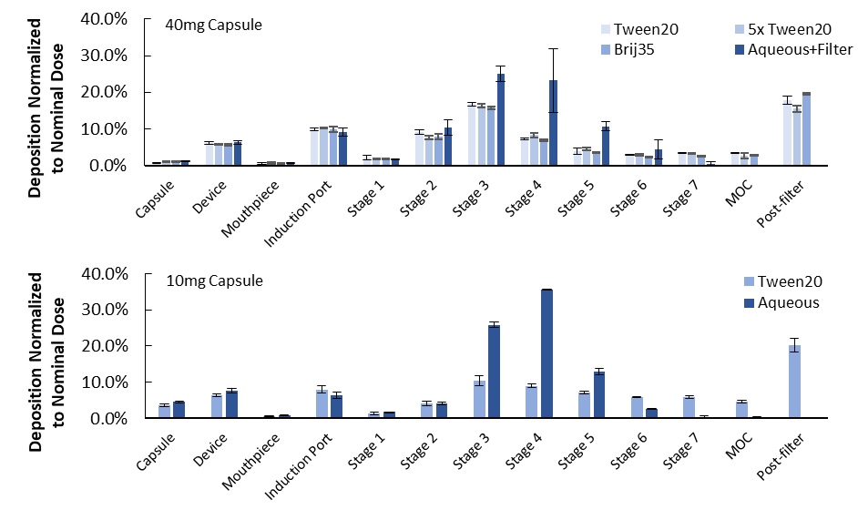
Figure 1 - Comparison of the NGI stage deposition profiles with five coating materials using capsules filled with 40mg (top) and 10mg (bottom) powder, n=3.
The low Geometric Standard Deviation (GSD) with Aqueous and Aqueous + Filter coatings agrees with the narrow span (1.4) measured for the geometric PSD (Table 1). On the other hand Brij 35, Tween20, and 5x Tween20 gave broader distributions, with the 10mg-capsule Tween20 measurements having GSD = 4.5. Interestingly, the measured Mass Median Aerodynamic Diameter (MMAD) was quite different, 0.8 vs 1.9µm when testing with 10- and 40mg-capsules, respectively, using Tween20 coating. The Aqueous and Aqueous + Filter coatings were tested with 10- and 40mg-capsules, respectively, and gave more commensurate MMADs. Therefore, the large difference observed for Tween20 is unlikely to arise substantially from poorer aerosolization in capsules containing more powder, and more likely is a result of inefficient stage capture.
The engineered particles in this study were designed to have a narrow size distribution ~2µm diameter. In NGI testing, the majority of particles were collected and defined as Fines (≤5µm). The very-Fine Particle Fraction (% ≤0.5µm) is more indicative as a measure of particle re-entrainment in this case, as few particles should have an aerodynamic diameter less than 0.5µm and be collected in the MOC or post-filter. In that regard, Aqueous and Aqueous + Filter coating solutions show minimal re-entrainment (vFPF = 1.1% and 0.9%, respectively). The other coatings captured substantially fewer particles and the calculated vFPFs were 28-38%. Additionally, the mass balance when using Tween20 and Brij 35/glycerol coatings with 40mg-capsules was less than the accepted threshold of 85% for all replicates []. Use of the Aqueous and Aqueous + Filter coating solutions increased total recovery significantly. This improvement in collected mass is also indicative of reduced re-entrainment because particle bounce is expected to result in more off-target particle deposition, such as on the nozzles and in the inter-stage airways, which were not assayed.
Table 1 - The MMAD, GSD, FPF ≤5µm, vFPF ≤0.5µm, and total active content recovery measured with the NGI with various stage coatings. Measured using hand-filled capsules, n=3.
Coating Solution | Capsule Fill Weight (mg) | MMAD (µm) | GSD | FPF (%) |  | vFPF (%) | Total Recovery (%)
Tween20 | 10 | 0.8 ± 0.2 | 4.5 | 83.3 | 38.2 |  | 87.6
Aqueous Solution | 10 | 2.5 ± 0.0 | 1.5 | 75.2 | 1.1 |  | 103.1
Tween20 | 40 | 1.9 ± 0.1 | 2.4 | 75.2 | 30.9 |  | 84.5
5x Tween20 | 40 | 2.0 ± 0.1 | 2.2 | 75.7 | 28.1 |  | 81.2
Brij 35/glycerol | 40 | 1.8 ± 0.1 | 2.5 | 86.7 | 33.2 |  | 80.8
Aqueous + Filter | 40 | 2.8 ± 0.1 | 1.6 | 78.0 | 0.9 |  | 93.5
To investigate the possibility that fragile particles were fractured during aerosolization, in which case high deposition in the MOC and post-filter would be expected, SEM stubs were used to sample from the MOC and post-filter after DPI actuation using 5x Tween20 and Aqueous coating solutions (Fig. 2). Using 5x Tween20, many 1-2µm particles were collected from the MOC and post-filter indicating poor collection efficiency and high particle re-entrainment. The post-filter showed such high loading that it was difficult to observe glass fibres from the filter. Using Aqueous coating, samples show few 1-2µm particles collected from the MOC. We were not able to find any particles sampled from the post-filter (Fig. 2D).
Figure 2 - SEM images of samples taken from the MOC (A,B) and from pressing SEM stub into the post-filter (C,D). Many 1-2µm particles were collected in the MOC and the post-filter when using 5x Tween20 coating (A, C) and particles were sparingly observed with SEM when using Aqueous coating (B,D).
Conclusions
Particle bounce can convolute ASPD measurement, adding extra challenge to developing therapeutics and diagnostics based on lung delivery. An aqueous pan coating consisting of 0.1g/L Tween20 in Milli-Q water successfully minimized particle re-entrainment during NGI testing of a spray-dried intermediate. This greatly outperformed several industry-standard coating approaches of varying composition and thickness. Two aqueous methods (with and without filters in the NGI pans) performed very similarly, in agreement with the work published by Rissler. Promisingly, this approach worked with a range of doses delivered using a commercial DPI. The current study tested engineered particles as opposed to carrier-based formulations and highlights the importance of proper pan-coating selection during NGI analysis.

References

[] Marple V, Olson B, Santhanakrishnan K, Mitchell J, Murray S, Hudson-Curtis B: Next Generation Pharmaceutical Impactor (A New Impactor for Pharmaceutical Inhaler Testing). Part II: Archival Calibration, J of Aerosol Med 2003; 16, pp 301-324.
[2] Mitchell J: Practices of Coating Collection Surfaces of Cascade Impactors: A Survey of Members of the European Pharmaceutical Aerosol Group (EPAG), Drug Delivery to the Lungs 2003; XIV: pp 75-78.
[3] Bonam M, Christopher D, Cipolla D, Donovan B, Goodwin D, Holmes S, Lyapustina S, Mitchell J, Nichols S, Petterson G, Quale C, Rao N, Singh D, Tougas T, Van Oort M, Walther B, Wyka B: Minimizing Variability of Cascade Impaction Measurements in Inhalers and Nebulizers, AAPS PharmSciTech 2008; 9: pp 404-413.
[4] Rissler J, Asking L, Kisbye Dreyer J: A Methodology to Study Impactor Particle Reentrainment and a Proposed Stage Coating for the NGI, J Aerosol Med Pulm Drug Deliv 2009; 22: pp 309-316.
[] U.S. Department of Health and Human Services, Food and Drug Administration, Center for Drug Evaluation and Research (CDER): Metered Dose Inhaler (MDI) and Dry Powder Inhaler (DPI) Products – Quality Considerations, Guidance for Industry, Draft Guidance 2018; rev 1: pp 25.

