The role of mechanical properties in DPI Carriers

Zeredescht Majid¹, Constanze Mueller², Ricarda Leister² & Regina Scherließ¹

¹Department of Pharmaceutics and Biopharmaceutics, Kiel University, Gutenbergstrasse 76, 24118 Kiel, Germany

²Meggle GmbH & Co.KG, Megglestr. 6-12, 83512 Wasserburg am Inn, Germany

Summary
The aerodynamic performance of interactive blends is known to be influenced by mixing time and energy, but reasons remain poorly understood. The leading hypothesis as to explain why the fine particle fraction (FPF) decreases over increasing mixing time is based on the effect of so-called press-on forces. Plastic deformation of particles is seen a requirement for press-on forces to have an effect. If this hypothesis holds true, it follows that interactive powder mixtures comprising carriers with a higher propensity for plastic deformation would exhibit a higher sensitivity to these press-on forces compared to mixtures with carriers possessing a lower tendency for plastic deformation (brittle materials). Building upon this notion, we explored the idea by developing model carriers of different mechanical properties using Eudragit RL and varying amounts of PEG 4000 as a plasticiser. By adjusting plasticiser content, we were able to control the deformability of the carriers. To assess deformability, we fabricated films from these microspheres and determined their Young's modulus under the assumption that the tensile deformation behaved similarly to the particles experiencing compressive stress. Utilising these model carriers, we created mixtures using a high shear mixer, took samples at different intervals of mixing time, and subsequently evaluated their aerodynamic performance. Through this systematic investigation, we successfully identified a correlation between the mechanical properties of the carrier and the maximum attainable FPF, as well as the decrease in FPF with mixing time.
Key Message
Mechanical properties of carriers in interactive blends influence the maximum achievable fine particle fraction as well as the steepness of the decline in FPF with mixing time. Plastic deformations are seen as a reason. An inadequate mixing process using to high energies can lead in amorphisation of the surface of brittle material and thus regions which are prone for plastic deformations.

Introduction

Interactive powder mixtures constitute the largest market share among DPIs, yet their understanding remains relatively inadequate. Specifically, the dynamics of aerodynamic performance in binary mixtures concerning mixing time have been explored, but no clear causal relationships have emerged regarding the decline in fine particle fraction over mixing time. According to the current state of knowledge, the reduction in fine particle fraction is attributed to press-on forces, causing plastic deformation of particles [1,2]. The decline in fine particle fraction follows an exponential function for binary mixtures [3]. Following the current hypothesis, the associated rate constant k ought to correlate with the propensity of particles to undergo plastic deformation. This study wants to establish a correlation between the aerodynamic performance of interactive powder mixtures and the mechanical properties of the carrier particles involved.

Methods
Carrier Engineering
The model carrier was produced by solvent evaporation. Eudragit RL PO (Evonik, Darmstadt, Germany) was dissolved in acetone, and varying quantities of Macrogol 4000 (Clariant GmbH, Sulzbach, Germany) were added (0%, 10% and 25%). Span 80 (Croda Ibérica, S.A, Spain) was dissolved in liquid paraffine (Caesar & Loretz GmbH, Hilden, Germany). The hydrophilic phase (i.e Acetone) was rapidly dispersed into the lipophilic phase under stirring (using a magnetic stirrer at 500 rpm). The acetone took approximately 90 minutes to evaporate. Subsequently, the particles (batch size 2.5g) were collected by vacuum filtration and washed three times with petroleum ether.
High Shear Mixing
The Picoline® (Picomix®, Hosokawa Alpine, Augsburg, Germany) was employed to generate binary powder blends. A combination of 2% API (glycopyrronium) and the carrier (20 g) were weighed using the sandwich technique. The rotational speed was set to 500 rpm and blending was performed for 15 minutes in total. Samples were taken after 1, 3, 5, 7, 10, 12, and 15 minutes to assess blend homogeneity and aerodynamic performance. Amorphisation over time due to high energy input was tested with InhaLac70 (Meggle, Wasserburg, Germany) as carrier model. It was treated for 15 minutes at 1500 rpm using a high shear mixer.
Laser Diffraction
Laser diffraction utilising a Helium Neon Laser Optical System (HELOS®, Sympatec GmbH, Clausthal-Zellerfeld, Germany) served as a method for determination of the fraction of particles < 5 µm of the interactive blends. For this, the INHALER module was used. A pressure drop of 4kPa was set and the Novolizer served as the inhaler device. All measurements using the INHALER module were conducted using the R2 lens. Fraunhofer theory was used to calculate mean of particle sizes. The RODOS unit was used to determine the carrier size and a dispersion pressure of 3 bar was applied. The VIBRI unit was used for feeding and the R5 lens for measurement. Measurements were conducted in triplicates.
Film preparation
A film possessing an identical composition to that of the microspheres was fabricated by solvent casting the same components in methanol. The resulting viscous dispersion was uniformly spread across a non-cohesive surface utilising a scraper and a predetermined thickness of 0.5 mm was confirmed by a gauge. Following a drying period of 24 hours under standard laboratory conditions, the film was ready for subsequent examination and analysis.
Texture Analysis
The Texture analyser TA.XT.plus (Stable Micro Systems, Godalming, United Kingdom) was used to determine the Young's modulus of the prepared films under tensile stress. A test velocity of 1mm/s was applied and the Young’s modulus was determined from the linear, ideal-elastic part of the stress-strain diagram via the slope of this same section. Films with a length of 4 cm and a width of 1.2 cm were prepared for the test. Measurements were conducted in triplicates.
Raman Microscopy
Confocal lense raman microscopy (HORIBA SCIENTIFIC, Kyoto, Japan) with a 532 nm excitation laser was used to study the surface amorphization of the lactose carrier under high shear mixing. An acquisition time of 1 s was used with 2 accumulations. The lens with 50x magnification was selected to acquire the image. The database was fed with a spray-dried amorphous lactose reference. In addition, references of the different crystal facets of the Tomahawk lactose crystal were included and used for evaluation.
Scanning Electron Microscopy
Particle morphology imaging was performed utilising scanning electron microscopy (SEM, Phenom XL, Phenom-World BV, Eindhoven, The Netherlands). The samples were affixed onto carbon stickers and subsequently gold-sputtered using the BAL-Tec SCP 050 Sputter Coater (Bal-Tec, Liechtenstein). The acquired images were captured employing an acceleration voltage of 10 kV and a backscatter detector.
Results
Three different formulations with different percentages of PEG (0%, 10% and 25%) were generated. Representative SEM images of the formulations are depicted in Figure 1. F1, F2 and F3 refer to increasing PEG content of produced microspheres. Laser Diffraction confirmed no relevant differences in PSD of batches with varying PEG content. For the sake of completeness, the particle size distribution of the API is also listed in Table 1.
Microspheres were used to generate films that were successfully analysed in the Texture Analyzer for their deformation behaviour under tensile stress. The respective Young's moduli for formulation 1 (F1), 2(F2) and 3(F3) are 621.3 ± 44.12 MPa, 188.2 MPa ± 17.1 and 3.1 MPa ± 0.7 respectively.

Table 1 - Particle size distributions. * The particle size data of the API is taken from the certificate of analysis from the manufacturer.
Formulation | X10 [µm] | X50 [µm] | X90 [µm]
1 | 219.85±1.11 | 297:51±0.93 | 352.28±1.14
2 | 220.18 ±0.88 | 299.01±0.99 | 351.51±1.136
3 | 219.55 ±1.41 | 298.13±1.01 | 351.77±1.77
API* | 0.609 | 3.25 | 6.91
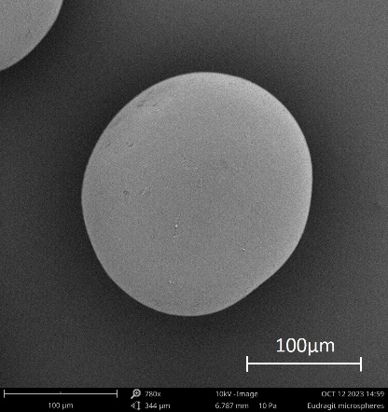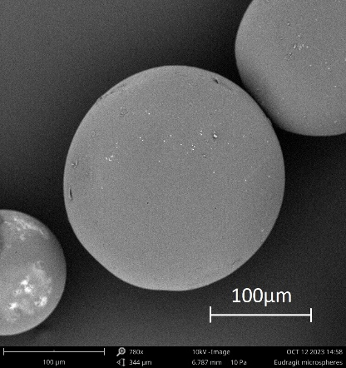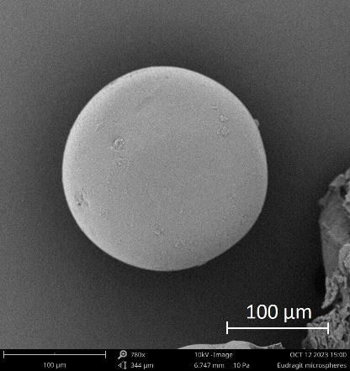
Figure 1 – SEM images of formulation 1, 2 and 3. Particles of similar dimension, sphericity and smoothness, irrespective of PEG content were found.
The amount of detachable fine material of their respective blends as a function of mixing time is depicted in figure 2 including the respective exponential regressions. Analogous mixtures with INH70 as well as testing of aerodynamic performance by impactor measurements are ongoing. It is known from the literature, that FPF decreases pronouncedly with mixing time [3].

Figure 2 - Particle fraction < 5 µm (FPF) of blends as a function of mixing time. Model Carriers with varying deformation behaviour were investigated (increasing PEG content from F1 (grey) to F2 (blue) to F3 (orange)). A strong dependency of decreasing FPF from the composition was observed: the lower the young’s modulus the higher the decrease in FPF; n=3; Error bars depict standard deviation. Increasing PEG content increases the constant k.
In Figure 3 the results of the Raman microscopy investigation are shown. Shown is a section of agglomerated lactose quality (INH70) after intensive shear stress in the Picomix. The investigation served to verify an amorphisation of the surface, which is supposed to be causal for the decrease of FPF in the case of brittle carrier material.
Discussion
Model carriers with similar morphology, particle size and surface topography, but different mechanical properties based on PEG content, were created as indicated by SEM images. The data provides a correlation between a carrier’s sensitivity to press-on forces and the rate at which the fine particle fraction (FPF) decreases with mixing time. The carrier with the highest Young’s modulus, indicating the lowest tendency for plastic deformation, exhibits the least steep decrease in FPF as mixing time progresses.
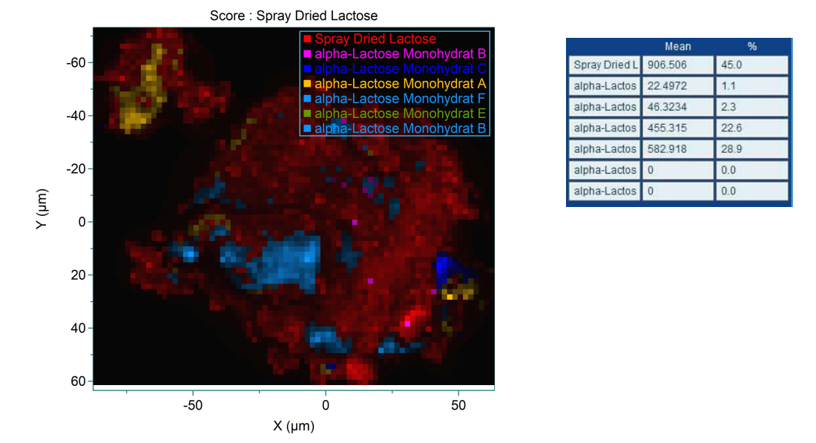
Figure 3 - Raman mapping from INH70 carrier after shear stress in the mixer, red areas were recognised by the system as amorphous (matching the spray-dried amorphous reference), all other colours represent different crystal facets of the lactose Tomahawk shaped crystalline reference
This trend continues as the tendency for plastic deformation increases, with increasing PEG content in the model carriers. The mechanical properties of the carrier not only affect the steepness of the FPF decrease but also potentially impact the maximum achievable fine particle fraction. This consistency can be explained by the fact that press-on forces already come into play at the beginning of the mixing process, and the detachment behaviour of the API from the carrier is also influenced by inertial forces. The deformation behaviour of the particles plays into the so-called practical adhesion between the particles. According to this view, adhesion is therefore not only reduced to the work of adhesion (i.e. surface energy), but also includes the true contact area in the adhesion consideration, which is indeed dependent on the deformability of the particles [4]. Inertial forces cause variability depending on the attenuation upon particle collision, which differs between plastically deformable particles and brittle particles. The lactose, being a brittle and hard carrier, undergoes crushing, abrasion and surface amorphisation when subjected to shear stress, as indicated by Raman microscopy. This amorphisation of the surface potentially results in an increase in surface energy and thus a change in aerodynamic performance. Additionally, this amorphisation raises concerns about potential stability issues arising from recrystallisation. The practical conclusion lies in the intensive study and control of the blending process. Thus, it can be postulated that for soft materials press-on forces cause a change in the aerodynamic performance due to plastic deformation of the particles, whereas for hard materials abrasion, friction and surface amorphization are more likely to cause a change in the profile. Further research in this area is needed to fully elucidate the impact of mechanical properties.
Conclusion
While the mechanical properties have been extensively considered in other pharmaceutical processes like tableting and hold significant importance, they have often been neglected in the context of inhalation. Our work aims to shed light on this crucial factor that can greatly influence the aerodynamic performance of DPIs when closely controlled. The applicability of our findings to inhalation-relevant excipients will be determined in future studies.

References
[1] Podczeck F, Newton JM. Development of an ultracentrifuge technique to determine the adhesion and friction properties between particles and surfaces. J Pharm Sci. 1995;84(9):1067–1071
[2] Hertel M, Schwarz E, Kobler M, Hauptstein S, Steckel H, Scherliess R. The influence of high shear mixing on ternary dry powder inhaler formulations. Int J Pharm. 2017;534(1–2):242–250
[3] Thalberg K, Åslund S, Skogevall M, Andersson P. Dispersibility of lactose fines as compared to API in dry powders for inhalation. Int J Pharm. 2016;504:27–38.
[4] Dillard David A. Advances in Structural Adhesive Bonding, 13 - Improving adhesive joint design using fracture mechanics. Woodhead Publishing in Materials, 2010:350-388

