Evaluation of the Performance of a Blister Unit Dose Nasal Powder Device

Gregoire Deraime¹, Cristina Rey-Blanes², Gonçalo Farias¹, Gerallt Williams¹, Nathalie Hauchard¹, Reanne Beaird², Eddie J French³, Irene Rossi²

¹Aptar Pharma, Route des Falaises, Le Vaudreuil, 27100, France
²Nanopharm Ltd, An Aptar Pharma Company, Grange Road, Cwmbran, NP44 3WY, United Kingdom
³TEKH Consulting Ltd, Queen Street, Deal, CT13 6EY, United Kingdom

Summary
A novel single dose nasal powder (UDSp) passive device incorporating a blister dosing chamber was developed. The assessment of the performance of the device was carried out by using a model spray dried formulation, which was filled semi-automatically by drum technology using the Omnidose Drum TT. The device performance was tested applying three flow rates: 15, 30 and 45 L/min. Shot weight and emitted dose uniformity reported a very high percentage of powder mass and active ingredient emitted, 96% and 99% of the loaded powder, respectively, independently of the flow rate applied. In addition, the emitted particle size distribution results obtained showed a D_{v}50 of about 40 µm, suitable for nasal delivery with less than 2% of particles < 10 μm, once again with no correlation with the flow rate applied. This was also reflected on the aerodynamic particle size distribution results, which reported 95% of the active deposited in the mouthpiece, induction port and stage 1. Generally, this novel UDSp blister device proved to be capable of delivering a consistent dose and a suitable particle size for nasal delivery with no dependency on flow rate employed to actuate the device. Therefore, this relatively simple device can potentially be easily employed for different applications, such as nasal vaccination. Next step in the device characterisation will be focused in determining its performance in combination with powders with different physical characteristics, exploring different filling processes and fill weights.
Key Message
The performance of a novel UDSp passive device incorporating a blister as dosing chamber was evaluated. A model spray dried formulation was drum-filled into the blister pockets. The results obtained showed a high emitted dose with a particle size optimal for nasal delivery, independently of the flow rate applied.

Introduction
Recently, there has been an increasing interest in nasal powder therapies as witnessed by the release on the market of treatments such as Baqsimi® (Eli Lilly and Company, USA), a unit dose intranasal powder medication to treat hypoglycaemia in diabetic patients. Generally, nasal drug delivery offers many advantages especially over systemic administration [1], such as avoidance of injections for needle-phobic patients as well as elimination of possible needle stick injuries. It can provide fast onset of action and bypass possible gastrointestinal degradation of active ingredients. Nasal sprays and powders can be dosed by patients, carers or family members and do not necessarily require administration by professional health care workers.
Moreover, powder formulations are more stable than their liquid counterparts and do not require cold chain protection with the advantage of simplifying logistics and costs out on the field for applications such as mass vaccination in developing countries. In the case of vaccines, nasal powders are particularly interesting as they can potentially offer efficient mucosal immune response in both the nasal cavity and the lungs to ward off respiratory infections such as COVID-19 [2].
The aim of this work was to carry out a performance assessment of a novel UDSp blister passive device which incorporates a blister dosing chamber into a simplified version of the traditional active UDSp device. The system was tested in combination with a model spray dried formulation filled semi-automatically by drum technology, namely by filling a volume of a pre-compressed powder into a drum cavity. The drum cavity is then rotated, and dosed powder is dispensed using pressurized air into the blister pocket as a single pellet or plug. The aerodynamic performance, shot weight, dose content uniformity and emitted particle size distribution were assessed.

Materials and methods
A unit dose nasal powder blister device (UDSp blister) was developed (Figure 1). It is manufactured from polypropylene, and the dose is contained within a heat-sealed aluminium blister.
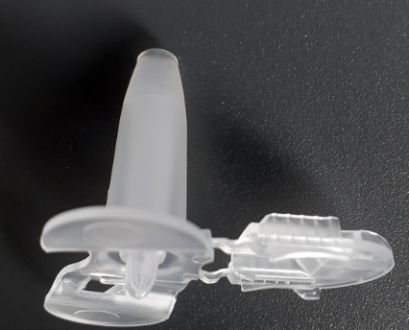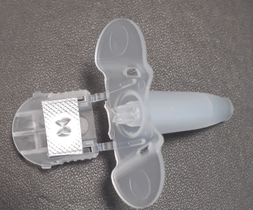
Figure 1 - UDSp blister device (left) and loaded UDSp blister device (right) after actuation.
A model spray dried powder comprising 1% w/w of Caffeine, 20.5% w/w of Mannitol, 70.5% w/w of Hydoxypropyl-β-Cyclodextrin (HPβCD) and 8% w/w of Leucine was manufactured using a GEA Niro Mobile Minor (GEA, DE) spray dryer by Upperton Pharma Solutions (UK). Bulk and tapped density were measured with a tapped density tester JV2000 (Copley, UK) and Hausner ratio and compressibility index determined as per USP Pharmacopeia <1174>. Bulk Particle Size Distribution (PSD) of the powder manufactured was obtained using a Sypmatec HELOS (Sypmpatec, UK) applying 1.0 bar of dispensing pressure.
The powder was filled into blister pockets (dose capacity around 40 mm³) semi-automatically using the Omnidose Drum TT (Harro Höfliger, DE) employing a 25 mm³ drum and setting up the pressure at 0.3 bar. The target fill weight was kept consistent at 15 mg. An example of filled blister pockets prior to sealing is shown in Figure 2. After filling, the blisters were sealed using the EZ Blister table top blister packaging machine (Sepha, UK).
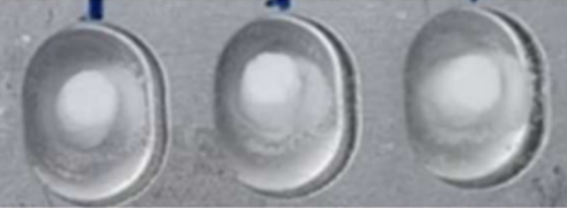
Figure 2 - Filled blister pockets prior to sealing.
As per recommendations by FDA on the guidance on Sumatripan Succinate nasal powder [4], three different flow rates were used to assess the device performance: 15 L/min, 30 L/min and 45 L/min during 8.0, 4.0 and 2.7 seconds respectively, for a total delivered volume of 2L.
Shot weight was determined gravimetrically by recording the weight before and after a single actuation during the emitted particle size distribution (ePSD) test employing 5 different devices. Results presented include restitution rate (%) calculated as the percentage of mass emitted on the loaded amount. In addition, ePSD was evaluated using a Malvern Spraytec system (Malvern Panalytical, UK) coupled with the inhalation cell. Volume diameter D_{v}10, D_{v}50, D_{v}90, percentage of particles < 10 µm and span (width of the distribution) were reported.
Dose content uniformity (DCU) was carried out using a dose uniformity sampling apparatus (DUSA, Copley Scientific, UK). Mass balance (%) presented was calculated as percentage of the active ingredient emitted by the device and quantified by high performance liquid chromatography (HPLC) versus the loaded dose into the blister.
Finally, aerodynamic particle size distribution (APSD) was performed using a next generation impactor (NGI, Copley Scientific, UK) with coated cups (ethanol: glycerol 99: 1% v/v). Cumulative deposition (%) on mouthpiece, induction port and stage 1 was reported.

Results and discussion
According to Pharmacopeial methods, the bulk and tapped density results were 0.615 and 0.7 g/mL, respectively. The calculated Carr’s index and Hausner ratio were 12.4 and 1.1, respectively, indicating a good flow character.
The shot weight results showed a high, consistent restitution rate (%) obtained, of about 96 ± 3.3% independently of the flow rate applied, as presented in Figure 3. This reflected in the mass balance (%) recovered from the DCU analysis, which was 99 ± 1%, 100 ± 1% and 98 ± 2% at 15, 30 and 45 L/min, respectively (Figure 4). These results sustained that the flow rate had no impact on the powder mass and dose emitted. In addition, regardless of the flow applied, all powder was emitted in less than 1 second.
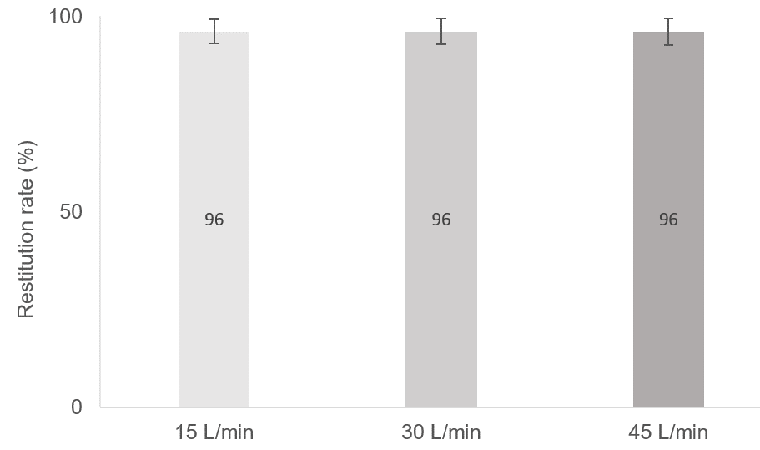
Figure 3 - Restitution rate (%) results, presented as average (n=5) with standard deviation as error bars.
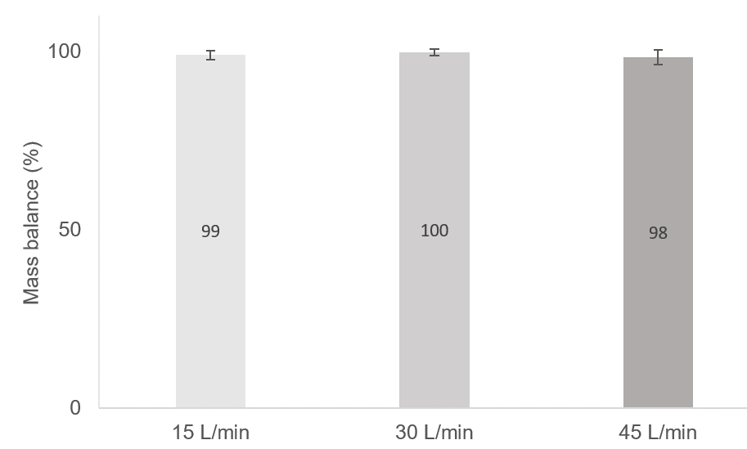
Figure 4 - Dose Content Uniformity results (mass balance in percentage), presented as average (n=10) with standard deviation as error bars.

The ePSD data presented in Table 1 shows a D_{v}50 ranging from 37.26 to 40.29 μm, obtained with no apparent correlation between ePSD and flow rate applied. Percentage of particles < 10 μm was always below 2% for all flow rate settings tested. These results align with the desired PSD for a nasal dosage form (D_{v}50 from 15 to 45 µm) [3] with less of 2% of particles emitted smaller than 10 μm which will avoid unwanted lung deposition. In addition, a similar PSD to the bulk powder was obtained.
Table 1 - ePSD results, presented as average (n=5) ± standard deviation.
Flow Rate | D_{v}10  (µm) | D_{v}50  (µm) | D_{v}90  (µm) | Particles < 10 µm  (%)
15 L/min | 21.48 ± 0.93 | 39.64 ± 0.96 | 69.14 ± 0.94 | 1.85 ± 0.37
30 L/min | 19.39 ± 0.58 | 37.26 ± 1.41 | 66.45 ± 2.53 | 1.46 ± 0.27
45 L/min | 22.04 ± 0.65 | 40.29 ± 1.05 | 71.00 ± 1.59 | 1.96 ± 0.10
Bulk Powder PSD | 14.22 | 34.59 | 59.25 | 5.87

APSD analysis (Figure 5) confirmed the ePSD results highlighting active ingredient deposition mainly in the mouthpiece, inlet port and stage 1. Once again, the flow rate applied did not have any significant effect on the deposition pattern obtained.
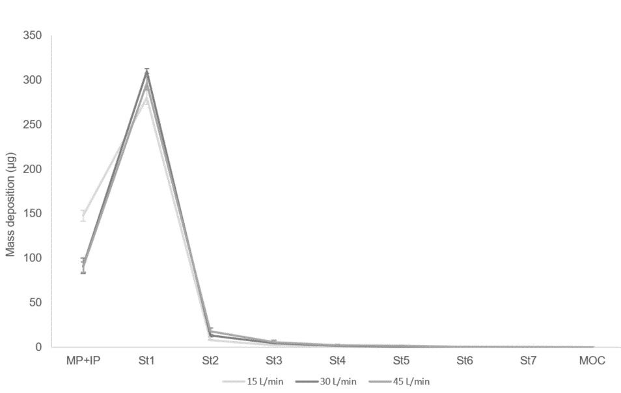
Figure 5 – APSD mass deposition (µg) results, presented as average (n=5) with standard deviation as error bars.

Conclusions
A novel USDp blister passive device was developed and its performance was evaluated in vitro in combination with a model spray dried powder. The full mass of powder and active ingredient loaded by drum technology into the blister pockets was emitted by the device in a single shot, independently of the flow rate applied. Moreover, a suitable ePSD and APSD for nasal delivery was obtained, which again was independent of flow rate, ideal for a passive device as it will minimise inter-patients variability. Further characterisation of the device will focus on studying its performance with powders manufactured with various formulation technologies and presenting different physical properties, particularly particle size, solid state, bulk and tapped density, residual moisture content and flowability. These will be tested at various fill weights employing different filling processes [5].

References
[1] Williams G, Suman J, Marx D: The Potential of Dry Powder Vaccines for Intranasal Immunization, Current Trends in Vaccines and Vaccinology, 2021, Vol 4.1, 10.31021/CTVV.20214115 (open access)
[2] Suman J: Intranasal Vaccination: Rationale, Progress and Challenges, Respiratory Drug Delivery, 2023, pp 19-26
[3] Henriques P, Formtuna A, Doktorovova S: Spray Dried Powders for Nasal Delivery: Process and Formulation, Considerations, Eur J Pharm Biopharm 2022, 176(0): pp 1-20
[4] FDA Draft guidance on Sumatriptan Succinate, March 2020. https://www.accessdata.fda.gov/drugsatfda_docs/psg/PSG_206099.pdf. Accessed on 21 July 2023.
[5] Rey-Blanes C, Farias G, Beaird R, Hauchard N, Consalvo A, Daggs T, Shields P, Rossi I: Investigation of the Performance of a Novel Unidose Powder Blister Device for Nasal Delivery. (Abstract). Presented at: Drug Delivery to the Lungs, 2023, Volume 34, Edinburgh, United Kingdom, December 6-8, 2023.

