In Vitro Characterisation of Octreotide Microspheres Formulated for Nose to Brain Delivery
- Reanne Beaird¹, Elisavet Dimosthenous¹, Katie Bamsey², Zoe Rees², Rhian Davies², Irene Rossi¹

¹Nanopharm Ltd, an Aptar Pharma Company, Grange Road, Cwmbran, NP44 3WY, United Kingdom

²Biodexa Pharmaceuticals, Caspian Way, Cardiff, CF10 4DQ, United Kingdom

Summary
Octreotide is a metabolically stable analogue of a somatostatin, a potent inhibitor of secretory processes, and has promising results against the neurological condition idiopathic intracranial hypertension when delivered subcutaneously. Delivery of octreotide intranasally to the brain by bypassing the blood brain barrier and targeting the central nervous system through the olfactory region of the nasal cavity can increase its efficacy. Biodexa Pharmaceuticals have developed Q-SpheraTM octreotide loaded poly(lactic-co-glycolic acid) (PLGA) microspheres that could be promising for nose-to-brain delivery by increasing residence time, controlling the release of the encapsulated drug and reducing systemic side effects. The aim of this study was to formulate and assess the suitability of delivering the Q-SpheraTM for nose-to-brain with Aptar VP7 coupled with 232-NE actuator. A suitable formulation for nasal delivery was prepared as indicated by the pH value of 5.05 and osmolality value of 491 mOsm/kg. No effect of shear stress on the microspheres was observed with the same PSD obtained before and after spraying. The microsphere formulation displayed a large median droplet size (134 µm) due to its higher viscosity (3.7 cps) in comparison to an octreotide nasal solution (66 µm). Despite the larger droplet size, the in vitro nasal cast deposition study indicated a significantly higher deposition in the nasal region of interest, the olfactory area, for the microspheres’ nasal formulation, due to the narrower plume emitted. These results indicate that the microspheres can be successfully formulated for nasal administration showing spray characteristics that are suitable for nose-to-brain delivery.
Key Message
The in vitro performance of a nasal formulation of octreotide Q-SpheraTM coupled with Aptar VP7 pump was assessed. Spray performance presented a narrower plume with statistically significant higher deposition in the olfactory area when compared to an octreotide solution, indicating its suitability for the treatment of idiopathic intracranial hypertension.
Introduction
Idiopathic intracranial hypertension (IIH) is a rising condition within the population characterised by elevated intracranial pressure with main symptoms of chronic headaches, sight disturbances and potential visual impairment [1]. Somatostatins, also known as somatropin-release inhibiting factors (SRIFs), are a family of native cyclopeptides that act as potent inhibitors on secretory processes, such as the endocrine secretion of growth hormones which has been known to play a role in the development of IIH [1, 2]. Native SRIFs have a significant disadvantage to its practical use as a therapeutic due to their short half-lives (~3 minutes for SRIF-14) which limits their duration of action within the body [1]. Octreotide is a metabolically stable cyclo-octapeptide analogue of SRIF that has a 40-fold greater half-life than the parent drug somatostatin [3], and has shown to be effective in the treatment of IIH when delivered subcutaneously [1, 4].
Currently, octreotide is delivered by intramuscular injection for the treatment of IIH. However, in order to directly target the site of action, the central nervous system (CNS) and cerebrospinal fluid (CSF), non-invasive nasal administration is of great interest [1]. The blood brain barrier presents significant challenges in the delivery of drugs to the brain when administrated intravenously (IV) or intramuscularly (IM), due to tight endothelial capillary cell junctions restricting the paracellular route [5]. Administering a drug intranasally can infiltrate the CNS and deliver to CSF through the olfactory region to directly bypass the blood brain barrier (BBB), increasing the efficacy of octreotide [3]. Biodexa Pharmaceuticals have developed Q-SpheraTM octreotide microspheres with improved structural homogeneity and manufacturing consistency, through a micro particle ‘printing’ technique, for localised drug delivery. In general, the spheres have a smooth solid surface, with an internal porous-sponge like matrix to allow a rapid and even influx of water after the surface has been broken down via hydrolysis [5]. These polymeric (PLGA) microspheres could be promising for nose-to-brain delivery by improving residence time of the particles and allowing a sustained release of the encapsulated octreotide whilst reducing systemic side effects by decreasing delivery to the non-targeted areas [4].
The aim of this study was to formulate the octreotide Q-SpheraTM for nasal delivery, combining it with a multidose nasal pump. A comparison of the in vitro performance was then carried out between the nasal formulations of the octreotide microspheres and a simple nasal solution of octreotide.
Materials and Methods
The Q-SpheraTM microspheres (Biodexa Pharmaceuticals, UK) loaded with octreotide were prepared using a piezoelectric 3-D printing technique to encapsulate the drug in a PLGA-based bioresorbable microsphere. Morphology of the spheres can be controlled by optimisation of the printing parameters, choice of solvent, and process flow temperatures [5]. The spheres had a size of 28.30 µm (Laser Diffraction as per Ph.Eur. 2.9.31) and were presented as a lyophilised cake containing the excipients; mannitol (0.17% w/w), carboxymethylcellulose (0.03% w/w) and Kolliphor 188 (0.01% w/w). The nasal formulation was prepared by mixing 5.0% w/v of hydroxypropyl beta cyclodextrin, and 2.0% w/v polysorbate 80, a non-ionic surfactant, both are reported to enhance nasal adsorption [6], in 0.01 M citrate buffer, pH 4.5 (Sigma Aldrich, USA). The Q-SpheraTM were reconstituted with the buffered excipient solution to a target concentration of 20.0 mg/mL of octreotide (Formulation A). Pure octreotide acetate (Cambridge Bioscience, UK) was dissolved (Formulation B) in the same excipient buffered solution, with the addition of 2.5% w/v mannitol, a tonicity-adjusting agent to ensure a suitable osmolality for nasal delivery [7].
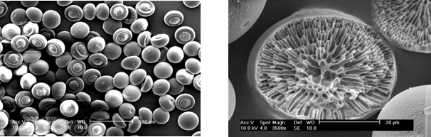
Figure 1 - SEM images of Q-SpheraTM microspheres (500x and 3500x magnification for images on the left and on the right, respectively).
Quantification of octreotide acetate was determined employing a reverse-phase high performance liquid chromatography (RP-HPLC; Agilent Technologies, UK) assay method [5]. Octreotide acetate was released from the microspheres by using dimethyl sulfoxide (Sigma Aldrich, USA) and vortexing until complete dissolution. The nasal formulations were loaded into the Aptar VP7 multidose pump with a 232-NE actuator and 100 µL spray volume (Aptar Pharma, FR). pH (SevenCompact™ pH meter, Mettler Toledo, UK) and osmolality (Löser Messtechnik, DE) of the nasal formulations were measured in order to assess if they were suitable for nasal delivery (Suitable ranges to avoid nasal irritation: pH 4 – 7.5 and 290-500 mOsm.kg [7]). Particle size distribution (PSD) of the microspheres before and after actuation was characterised by Spraytec wet cell (Malvern Panalytical, UK). Formulation-device combination was characterised in terms of droplet size distribution (DSD) by Spraytec (Malvern Panalytical, UK) in an open bench configuration, spray pattern (SP) and plume geometry (PG) were tested using Oxford Laser’s envision system (Oxford laser, UK). In vitro nasal regional deposition of the formulations was characterised in an adult male nasal cast (AeronoseTM, Aptar Pharma, FR) and quantified by RP-HPLC. The device was manually actuated into both nostrils of the nasal cast with an insertion depth of 10 mm, a delivery angle (horizontal plane) of 45° and a fixed angle from the centre wall of 5°.
Results and Discussion
The concentration of octreotide acetate in the nasal formulations, quantified by RP-HPLC, was determined to be 21.73 ± 0.09 mg/mL and 19.60 ± 0.29 mg/mL corresponding to 108.65% and 98.00% of the target concentration for Formulation A and Formulation B, respectively. Formulations A and B presented similar pH values of 5.05 and 5.15, respectively; however, Formulation A exhibited a much higher osmolality of 491 mOsm/kg compared to 298 mOsm/kg for Formulation B, due to the higher concentration of mannitol in the lyophilised microspheres employed to prepare the nasal formulation (5.0% w/v for Formulation A vs. 2.5% w/v for Formulation B). This was used as cryoprotectant for the microspheres’ lyophilisation step. Both formulations display suitable pH and osmolality values for nasal delivery [7]. The particle size distribution of Formulation A reported Dv50 and span values of 28.07 ± 0.07 µm and 0.85 ± 0.01 before spraying and 28.20 ± 0.22 µm and 0.86 ± 0.07 after spraying from Aptar VP7 pump, matching the value obtained after their production. No change was observed between the PSD upon actuation, indicating preservation of the microsphere structure (Figure 2).
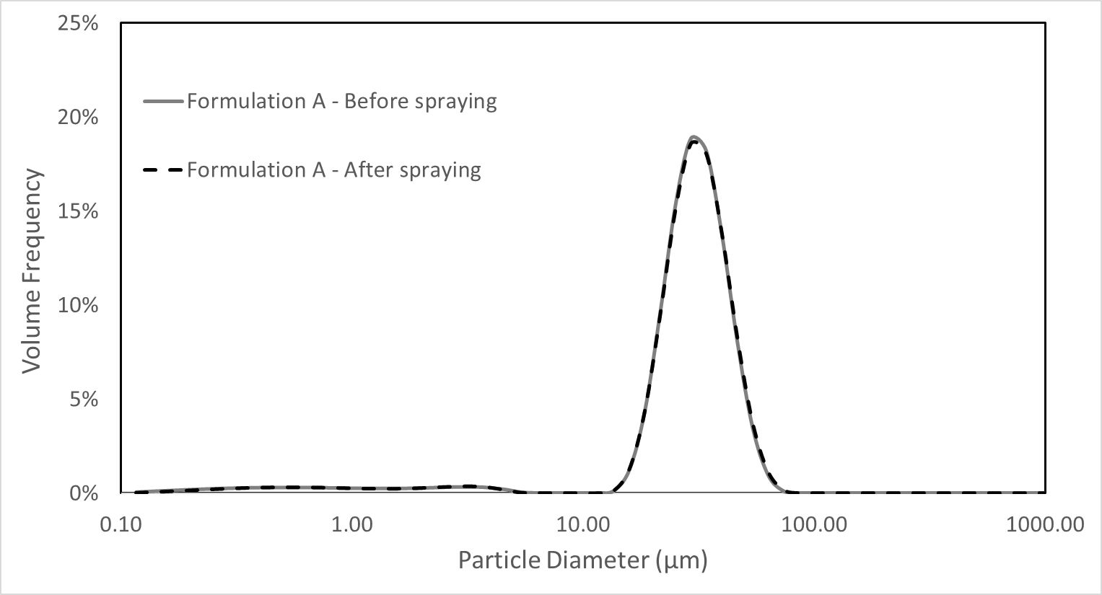
Figure 2 – PSD of Formulation A before and after spraying with Aptar VP7 pump (n=2).
The Dv50 obtained by DSD analysis was higher for Formulation A (Table 1). The increase in droplet size was a result of an increased viscosity of Formulation A due to the presence of carboxymethyl cellulose, a mucoadhesive polymer (3.7 cps vs.1.2 cps for Formulation A and B, respectively) [8]. The region of deposition in the nasal cavity, however, depends also on the spray geometry. Both formulations exhibited narrow sprays with plume angles < 20°, which have been shown to penetrate through the nasal valve increasing posterior deposition [8]. Formulation A displayed a more ‘jet-like’ spray, narrower plume with smaller cross sectional area 4.1 ± 0.3 cm² vs 6.5 ± 0.6 cm² at 6 cm from the laser for Formulation A and B, respectively (Table 1 and Figure 3).
Table 1 - Average values of spray performance: DSD at 6 cm and SP (n=3, standard deviation in brackets).
Formulation | DSD |  |  |  |  | SP
Formulation | D_{V}10 (µm) | D_{V}50 (µm) | D_{V}90 (µm) | Span | Dmin (cm) |  | Dmax (cm) | Area (cm²) | Ovality Ratio
Formulation A - Microspheres | 52.07 (2.34) | 134.28 (4.22) | 264.41 (14.39) | 1.58 (0.07) | 1.4  (0.1) |  | 3.5  (0.2) | 4.1  (0.3) | 2.4  (0.3)
Formulation B – Octreotide solution | 29.14 (0.83) | 66.30 (1.84) | 169.83 (5.10) | 2.12 (0.06) | 2.3  (0.2) |  | 4.2  (0.2) | 6.5  (0.6) | 1.9  (0.3)
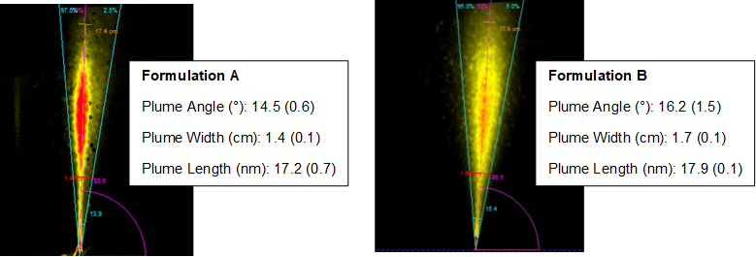
Figure 3 – PG results: images depict one repeat, values reported are n=3, standard deviation in brackets.

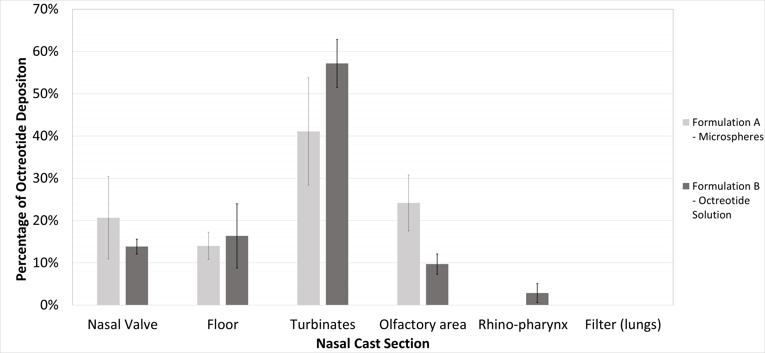
Figure 4 - In-vitro percentage deposition of Formulation A and Formulation B sprayed with Aptar VP7 pump in the Aeronose™ nasal cast (n=3, error bars represent standard deviation).
For optimal nose-to-brain delivery, the drug must be deposited in the olfactory area in the upper posterior region of the nasal cavity [4]. Figure 4 presents the regional nasal deposition of the two formulations. Both have a negligible post-nasal deposition (< 5% in the rhino-pharynx and filter). Different deposition profiles were observed for Formulation A vs Formulation B, with Formulation A displaying a statistically significant higher deposition in the targeted olfactory area (p<0.05) but comparable depositions in the turbinates and anterior region (nasal valve and nasal floor). The higher deposition in the olfactory for Formulation A can be attributed to the narrower plume with a smaller cross-sectional area.
Conclusion
This study reports the characterisation and in-vitro nasal deposition of octreotide encapsulated in Q-SpheraTM microspheres (Formulation A) and as a simple solution (Formulation B) delivered by Aptar VP7 multi-dose pump. The results indicate that the microspheres could be successfully formulated for nasal administration showing spray characteristics that were suitable for nose-to-brain delivery, particularly a higher deposition in the olfactory region. Biodexa Pharmaceuticals recommend delivery of the microspheres intramuscularly within 30 minutes of reconstitution due to degradation of the spheres surface by hydrolysis, therefore, further investigation into the stability of the microspheres in the liquid nasal formulation will be required. An alternative formulation strategy to enhance the stability could be to spray or freeze dry the microspheres and deliver them as a nasal powder for nose-to-brain delivery.
References
[1] House P M, Stodieck S R G: Octreotide: The IIH therapy beyond weight loss, carbonic anhydrase inhibitors, lumbar punctures and surgical/interventional treatments, Clin. Neurol. Neurosurg. 2016, 150: pp 181-183
[2] Weckbecker G, Lewis I, Albert R, Schmid H A, Hoyer D, Burns C: Opportunities in somatostatin research: biological, chemical and therapeutic aspects, Nat. Rev. Drug Discov. 2003; 2 (12): pp 999-1017
[3] Wang Z, Xiong G, Tsang W C, Schätzlein A G, Uchehbu I F: Nose-to-Brain Delivery, J. Pharmacol. Exp. Ther. 2019; 370: pp 598-601
[4] Panagopoulos G N, Deftereos S N, Tagaris G A, Gryllia M, Kounadi T, Karamani O, Panagiotidis D, Koutiola-Pappa E, Karageorgiou C E, Piadites G: Octreotide: a therapeutic option for idiopathic intracranial hypertension, Neurol Neurophysiol Neruosci 2007; 10, 1.
[5] Palmer D, Bamsey K, Groves R, Patil P, Jones H, McAleer L, Seaman P: Printing particles: A high-throughput technique for the production of uniform, bioresorbable polymer microparticles and encapsulation of therapeutic peptides, Chem. Eng. Sci. 2017; 166: pp 122-129
[6] Maggio, ET: Absorption enhancing excipients in systemic nasal drug delivery, J. Excipients and Food Chem. 2014; 5 (2): pp 100- 112
[7] Bitter C, Suter-Zimmerman K, Surber C: Nasal drug delivery in Humans, Curr. Probl. Dermatol. Basel 2011; 40, pp 20-35
[8] Gao M, Shen X, Mao S: Factors influencing drug deposition in the nasal cavity upon delivery via nasal sprays, J. Pharm. Investig. 2020; 50, pp 251 – 259

