Targeted drug delivery to the olfactory cleft: In vitro deposition study using prototype jet nozzles.

Alain Regard¹, Benjamin Ogier² & Laura Berard¹
¹Nemera La Verpillière, 63-65 Avenue Tony Garnier, Lyon, 69007 – Lyon, France
² Abylsen for Nemera La Verpillière, 63-65 Avenue Tony Garnier, Lyon, 69007 – Lyon, France

Summary
Nasal treatments using nose to brain pathway are a promising way of addressing CNS diseases. One challenge of the nose to brain treatments remains the targeted administration of the drug formulation to the olfactory cleft. Nemera is exploring the ability of a narrow and straight jet to deliver drug to the olfactory cleft.

Seven prototype devices have been designed and manufactured with the aim to produce a highly stable jet. In vitro deposition tests have been performed with these prototype devices on two different nasal casts with a liquid placebo formulation. Qualitative data and quantitative data related to the deposition in the nasal cavity have been produced.

The results from these two casts are significantly different: high level of deposition in the olfactory area (65 to 88 %) and extremely low variability have been observed with the Athena nasal cast; with the FAN II nasal cast, the deposition levels are significantly lower with a high difference in the mean values and an important variability.

These contradictory results open a field of investigations regarding the effect of the potential gaps between the two experimental conditions such as different anatomies, differences in the method of extraction of the formulation from the casts and quality of the surface of the nasal casts.

This study shows how critical it is to confront different nasal cast models to assess the deposition performance of nasal devices.

Key Message
In vitro deposition testing with prototype device targeting the olfactory region produced in two different nasal casts led to very different deposition results. This study shows the impact of the nasal cast models in deposition results.

Introduction
The neurological disorders such as neuro-degenerative diseases and mental disorders need delivery of neurotherapeutics to the brain for effective treatments. However, drug delivery to brain remains a great challenge because of the poor bioavailability from the blood due to the nature of the endothelial membrane called Blood-Brain Barrier (BBB). The current strategy to carry drug with poor bioavailability to the Central Nervous System (CNS) is intrathecal, intracerebroventricular or intraparenchymal injections that deliver drugs directly to the cerebrospinal fluid. The last decades have witnessed a considerable interest in exploring the possibility for neurotherapeutics directly to the CNS by adopting the potential direct transport pathway from the nose to the brain via the olfactory region.[1]

The nasal sprays commonly used for nasal treatments show low levels of drug delivered to the olfactory cleft, i.e. 2.9% in a study conducted by Djupesland [2]. Considering a spray, a narrow plume geometry will be favourable to a deeper administration in the nasal cavity. An in vivo deposition study carried out by University of Dresden Medical School in Germany, has shown the superiority of a jet like delivery compared to spray and drop delivery [3]. Some devices, aiming a targeted delivery to the olfactory cleft, being commercial or still under development, are based on non-invasive nozzle providing a narrow spray or jet-like delivery [4,5,6]. Nemera® is exploring the ability of a narrow and straight jet to deliver drug to the olfactory cleft.

Seven prototype nozzles have been designed and manufactured with the aim to produce a highly stable jet. These nozzles have been associated with the SP270+ pump from Nemera®. In vitro deposition tests have been performed with these prototype devices on two different nasal casts.

Materials

Seven prototype nozzles with different design variations (F, G ,H, I, J, K, L, M) have been coupled with Nemera® SP270+ pump 100 µL. These devices have been filed with a placebo formulation (water, Xanthan Gum 0.1% w/w, Fluorescein 5 g/L used as a model drug).

Two different nasal casts, presented in figures 1 and 2, have been used in this study: 1) The Athena nasal cast developed by Nemera® from a female anatomy (Left side only). This nasal cast has been designed specifically to study the deposition in the olfactory area (Insert for olfactory area) 2) The FAN II nasal cast developed by University of Tours from a female anatomy (Complete model, left & right nasal cavities + sinus cavities). On both models, the olfactory area is defined in a similar manner as the upper third of the nasal cavity.

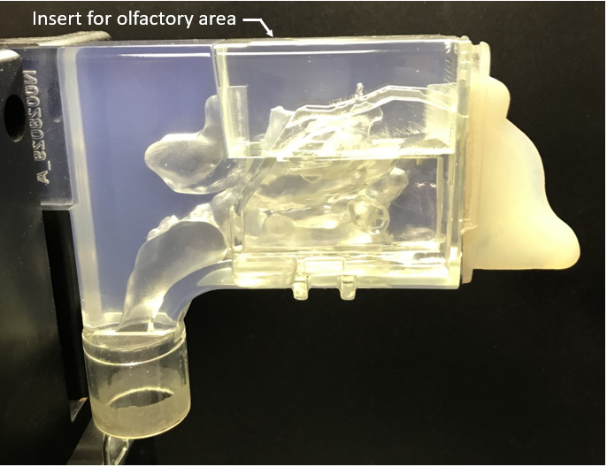  Figure 1: Athena nasal cast | 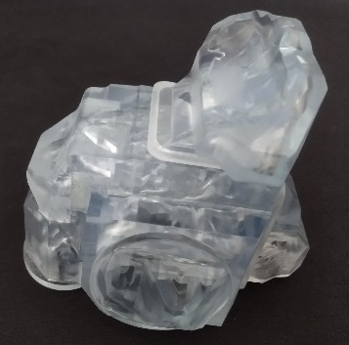  Figure 2: FAN II nasal cast
An automated actuator Proveris® Vereo® NSx was used to actuate the devices. The angle of administration and insertion depth have been controlled via an in vitro deposition testing bench.

Purified demineralised water was used as solvent for extraction of the deposited placebo formulation from the nasal casts. The fluorescein extracted from the nasal cast was quantified with Agilent UV Spectro photometer Cary 60 UV-Vis.

Experimental method

The administration has been done on Athena nasal cast (left side only) and on the right side of FAN II nasal cast. These nasal casts were dry (no coating), at room temperature and no airflow was applied.

The placebo has been administered using the automated actuator with an actuation speed of 85 mm/sec. The insertion depth of the nozzle tip in the nostril was 8 mm. The device orientation was set-up with following angles: 30° from vertical in sagittal plane, 10° towards the nasal cavity in the frontal plane.

The extraction of the formulation form the nasal cast has been performed by rinsing with purified water. For both nasal casts the areas of interest were defined as follows: 1) Front nose, 2) Olfactory area (upper third of nasal cavity), 3) Rest of the nasal cavity. For Athena nasal cast, the three areas of interest are disassembled and the extraction is conducted on each area. For the Fan II nasal cast, the front nose is disassembled for extraction, then for the main body of the cast the extraction is done on the rest of the nasal cavity and finally on the olfactory area.

The quantification of fluorescein as model drug extracted from the various regions of interest has been performed via UV spectrophotometry.

The experiment has been repeated twice. The above method has been applied first on the Athena nasal cast (lead nasal cast for nose to brain development) and then in a second part of the study on the FAN II nasal cast.

Experimental results

In addition to the quantitative results, videos and pictures of the deposition have been recorded with the Athena nasal cast. The structure and the material of this cast allows a good visualisation from the nasal wall perspective. Figure 3 shows localised depositions in the roof of the olfactory cleft.

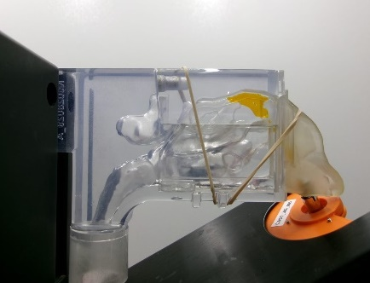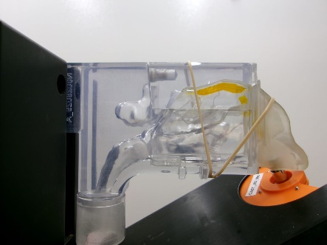

Figure 3: Typical deposition patterns observed on Athena nasal cast
Quantitative deposition results have been produced with both nasal casts.

The deposition results in the olfactory area produced with the Athena nasal cast are globally very good with a high level of deposition (65 to 88 %) and an extremely low variability.

The deposition results generated with the FAN II nasal cast are significantly lower with a high deviation in the mean values and an important variability for most of the configurations.

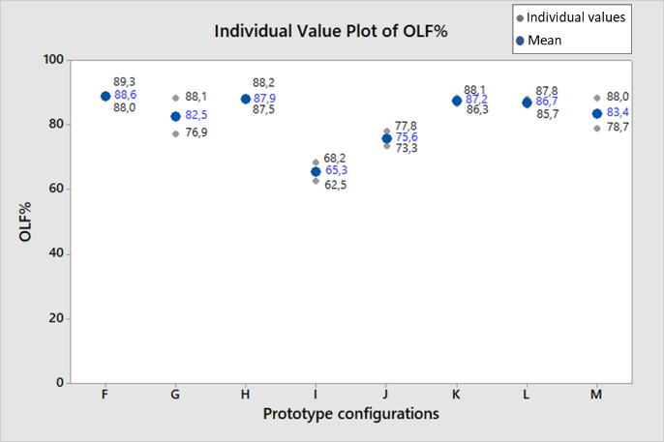 Figure 4: Deposition (*) in the olfactory area for Athena nasal cast. I | 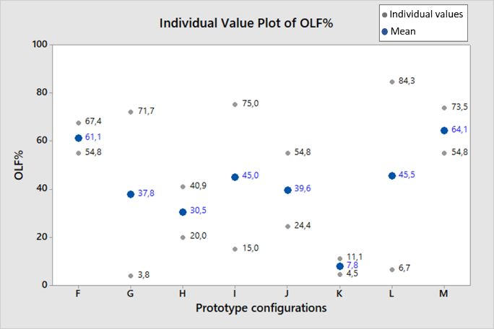Figure 5: Deposition (*) in the olfactory area for FAN II nasal cast
* Results expressed as percentage of the collected mass of fluorescein

Discussion

From the two above sets of results it is difficult to draw any conclusion in terms of jet nozzle design efficiency to target the olfactory region. These inconsistent results are opening a wide range of questions regarding the impact of the experimental conditions that differs from one experimental setting to the other:
-Two different nasal anatomies were used. How could this affect the deposition variability to such an extend?
-Does the formulation deposit differently in the cast or is the issue cause by dripping of the formulation in the FAN II nasal cast? Unfortunately, FAN II doesn’t allow a good qualitative visualisation of the deposition profile. On the Athena nasal cast, the presence of an insert corresponding to the olfactory area eases the extraction phase where the FAN II cast requires more rinsing manipulation for the extraction. What is the impact of the residence time, the gravity, manipulation, and orientation of the cast during rinsing operation?
-The FAN II nasal cast presents surface irregularities probably due to the quality of the original scan used to produce this nasal cast. In comparison the Athena nasal cast presents a smooth surface. What is the impact of this surface finish on the results?

Conclusions

The jet nozzle prototype configurations tested in this study look promising regarding their ability to deliver a liquid formulation in a targeted manner to the olfactory area. However, this study cannot lead to robust conclusions regarding the definition of the optimal nozzle design.

The Athena nasal cast combined with the placebo formulation and repeatable administration conditions led to high level of deposition in the olfactory area with remarkably low level of variability.

The same experimental conditions applied to the FAN II cast showed lower deposition scores and highest variability of formulation deposited in the olfactory area. Further investigation needs to be conducted to understand the root causes. This study shows the importance of not using one single nasal cast for the development a nasal combination product. Nemera® intends to do more work to integrate the variability of the nasal cavities in up-coming development programs.

References
[] Illum L.: Nasal drug delivery- possibilities, problems, solutions, J Control Release 2003;87(1-3):187-98
[2] Djupesland PG , Messina JC, Mahmoud Newman RA: Breath powered nasal delivery: a new route to rapid headache relief. Headache 2013 Sep;53 Suppl 2:72-84.
[3] Scheibe M, Bethge C, Witt M, Hummel T: Intranasal Administration of Drugs, Arch Otolaryngol Head Neck Surg. 2008;134(6):643-646
[4] Hoekman J.D., Hite M., Brunel A., Relethford J.: Nozzles for nasal drug delivery, US patent application US20140083424 A1
[5] Shahaf D., Shicor I., Napchi D.: Device and method for aerosolized delivering of substance to a natural orifice of the body, US patent application US20160129205 A1
[6] Farias G., Hauchard N., Dufresne X., Cazzola C.: Development of a Novel Device Targeting Drug Delivery into the Olfactory Region of the Nasal Cavity, RDD 2023, Poster

Nemera is a registered trademark of Financière N ; Vereo and Proveris are a registered trademark of Proveris Scientific Corporation

