Identifying determinants of capsule emptying

Mark Sanders¹ & Darragh Murnane¹

¹University of Hertfordshire, College Lane, Hatfield, AL10 9AB, UK

Summary
Single dose capsule inhalers are a popular dry powder delivery system, and a number of advantages for the patient and manufacturer; there is a positive reinforcement rattle sound that implies delivery. The ERS/ISAM Task Force report (1) explains that the dose from a capsule DPI is emitted slower than that of a reservoir or blister DPI and that therefore inhalation volume is an important parameter for patients using capsule inhalers. A UH project has investigated what other parameters may be relevant determinants of efficient capsule emptying and found that duration of inhalation, flow rate of inhalation, power generated and device resistance all make a contribution to capsule emptying.
Key Message
Understanding the interplay of determinants of capsule emptying may contribute to more efficient capsule inhaler delivery devices.

Introduction

Single dose capsule inhalers are a popular dry powder delivery system, and have been in use for over five decades. They have a number of advantages for the patient and manufacturer; there is a positive reinforcement rattle sound that implies delivery, the capsule can be visually checked to ensure emptying has taken place, in low economic communities purchasing of a single day’s therapy can be accommodated, and capsule filling can be done on standard industry equipment. But, like all inhalers, the user technique is important for delivery. The ERS/ISAM Task Force report (1) explains that the dose from a capsule DPI is emitted slower than that of a reservoir or blister DPI and that therefore inhalation volume is an important parameter for patients using capsule inhalers. Furthermore, it suggests that patients should repeat the inhalation manoeuvre to ensure that they receive the full dose. The report also notes that some capsule inhalers have a high resistance (e.g. Handihaler) while others have a low resistance (e.g. Cyclohaler).

A UH project has investigated what other parameters may be relevant determinants of efficient capsule emptying.

Materials and methods
Three manufacturers kindly contributed materials; Berry/Plastiape provided samples of its production RS01 capsule inhalers (covering low, medium, high and ultra-high resistances), Lonza provided capsules, and 3Pinnovation provided the capsule filling capability (R500 fill by weight) at it’s UK production site. Capsules were filled with Lactohale 200 to a nominal weight of 15mg.
Testing was conducted at the University of Hertfordshire using a BRS3000 breath simulator connected via a DUSA to the inhaler. The extent of capsule emptying was determined using pre/post gravimetric measurements on a Sartorius Secura26-1S balance measuring to 0.002mg. Experimental set-up shown in Figure 1. Two waveforms were used; a square waveform defined by flow rate (20, 30 and 60 LMin⁻¹) and duration (1, 2, 3 s), and a human derived waveform for Cyclohaler from 34 year male (2) used in full and partial duration segments; 0.15, 0.25, 0.5 s). Waveform and partial elements shown in Figure 2. Simple static mitigation and desiccated capsule storage were conducted.
Inhalers; Berry/Plastiape RS01 low resistance 4kPa@100 LMin⁻¹, RS01 medium resistance 4kPa@80 LMin⁻¹, RS01 high resistance 4kPa@65 LMin⁻¹, RS01 ultra-high resistance 4kPa@40 LMin⁻¹, at least three of each device were tested, each 3 times for square waveform testing. For human derived waveforms a single device was used with three repeat measurements.
Capsules; Lonza HPMC Vcaps Plus DPI batch 5417340 Size 3, transparent.
Filling; 3Pinnovation, all capsules filled using R500 fill by weight system with +/- 0.5mg tolerance set on fill weights of 15mg.
For human derived waveforms, inspiratory effort (airWatts per inhalation, aW) was calculated as volume (m3 .sec-1) x pressure (kPa) x duration (seconds).
Figure 1 Capsule emptying experimental set-up
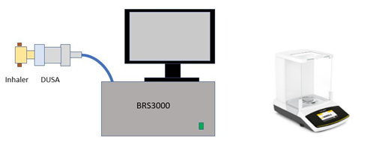
Results
The results of 15mg capsule emptying using square waveforms of different flows and durations are shown in Table 1. At least 3 devices of each resistance were each tested 3 times. Capsule type Vcaps Plus DPI batch 5417340.
Table 1 Powder emission from capsule presented as mass and percentage emitted as a function of airflow duration using square waveform airflow
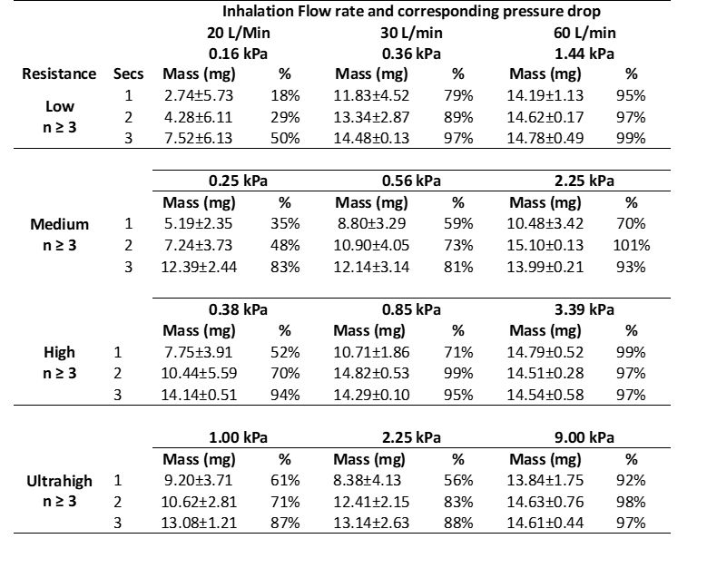

Figure 2 Human waveform and partial segments together with % capsule emptying and power (air Watts) results in panel from RS01 of low and high resistance inhalers.
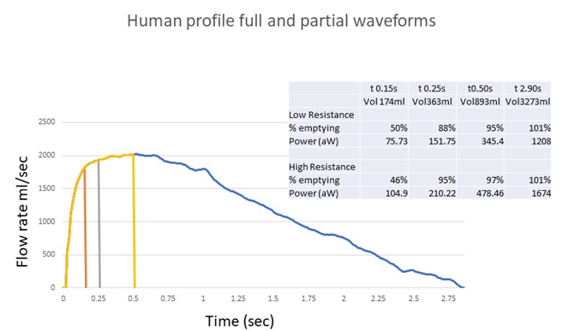
Statistical analysis of square waveform results was conducted in MiniTab to assess the statistically significant relationships between % emptying, device resistance, air flow rate and duration for a range of DPI resistances. A General Linear Model Analysis ANOVA was performed with significance level of 0.05. The model gave a statistically significant fit, with no lack of fit and an R-sq of 0.5925. There was no significant lack of fit of the linear model fit by regression (p = 0.997). It showed that capsule emptying is significantly influenced by; resistance, with low and medium resistance decreasing capsule emptying and high and ultrahigh increasing capsule emptying; flow rate, with 60 LMin⁻¹having a greater impact on capsule emptying than 30 LMin⁻¹ and 20 LMin⁻¹ having least effect; duration, with longer durations favouring capsule emptying over shorter durations. In order to standardize comparisons between devices of different resistances, the % emptying as a function of pressure drop and duration was also assessed by ANOVA. This revealed at p<0.05 significance, that for efficient emptying of the DPI regardless of the device resistance a pressure drop of >1.00-1.44 kPa; >0.85-1.00 kPa; and >0.38-0.56 kPa is required for a 1, 2, or 3 s inhalation time, respectively.
Statistical analysis of the human profile waveforms pulled through high and low resistance devices, showed that the key determinant of capsule emptying was the volume inhaled expressed as the % of the total inhaled volume (essentially inhaled volume fraction). The % released increased with inhaled volume (IV) fraction (p < 0.05), but there was no difference between this emptying rate between high and low resistance devices (p = 0.948 for resistance and p = 0.879 for Resistance X % IV). It also showed that inspiratory effort (power) had a significant effect on emptying. At full profile, for both low and high resistance devices complete emptying was observed, an extended rattle was audible confirming spinning of the capsule in the chamber. For partial profile segments, it was noted that at 0.15 s there was a very, very short rattle audible and only partial emptying. This increased at 0.25 s and by 0.5 s there was virtually complete emptying. It appears that for very short durations volume may be a greater determinant of emptying than power, but thereafter power becomes more important until finally they are the same.

Discussion and Conclusion

Capsule emptying investigations need to be conducted with rigorous consistency. Small deviations of technique can result in variations. The capsules were rested post-filling for 4 weeks to allow dissipation of any filling induced energies, and simple anti-static and desiccant storage methods were applied. There are certain elements that cannot be totally standardised (such as powder dispersal within the capsule) and so variations are to be expected. Immediately after testing each capsule was inspected to check that visual appearance correlated with weight results and that capsule piercing had been successful. To avoid static in the inhaler device only short testing runs with each device were made.

From this investigation we conclude that: Device Resistance, Airflow Rate and Duration of Inhalation all affect the % emptied from the capsule/devices.

There is a significant interaction between Resistance and Flow, and between Flow and Duration, but there is no statistical interaction between Resistance and Duration. It would appear that extending the duration of the airflow impacts all devices to the same extent, regardless of their resistance. But Airflow and Duration impacts some devices more than others.

Comparisons:

• Resistance – % emptied is ranked High = Ultrahigh > Low = Medium

• Flow - % emptied is ranked 60 LMin⁻¹ >30 L/min > 20 LMin⁻¹

• Duration - % emptied is ranked 3 s = 2 s > 1 s

Flow X Resistance –

• At 60 LMin⁻¹ – no difference between Low, Med, High or Ultrahigh % emptied.

• At 30 LMin⁻¹ – no difference between High, Ultrahigh and Low, all are greater than Medium.

• At 20 LMin⁻¹ – no difference between Low and Medium, both lower than High and Ultrahigh.

Flow X Duration

• At low flow rate – 1, 2 s have the same emptying but less than 3 s.

• At medium flow rate no difference between 1, 2, or 3 s.

• At High flow rate no difference between 1, 2 or 3 s.

Volume was identified as an important parameter for capsule emptying in the ERS/ISAM Task Force report, but it is not the only important parameter. This investigation has identified a number of other factors that contribute to device emptying; they include; duration of inhalation, flow rate of inhalation, power generated and device resistance. The results indicate that the impact of device resistance may not be a linear relationship, indeed it may be something that needs to be considered with regard to the ease of aerosolization of the formulation.

Of course, capsule emptying in not in itself an end objective, because it does not reveal the quality of the particle cloud and its ability to reach the lung, but it is a starting point. Another limitation is that this work used a human inspiratory profile of a 34 years old male generated using a Cyclohaler, it would be desirable to have insights from the use of asthma and COPD patient profiles, calculate the power in the efforts and apply these to create waveform reflective of patient capability. Patient relevant metrics are of most interest, and asking a patient to inhale for 3 s at 60 LMin⁻¹ (a volume of 3 litres) is demanding, however, these data suggest that a shorter inhalation (1 or 2 s) can produce almost complete capsule emptying, which would be less demanding of patients.

References
[] Laube BL, Janssens HM, Jongh FHC de, Devadason SG, Dhand R, Diot P, Everard ML, Horvath I, Navalesi P, Voshaar T and Chrystyn H.. What the pulmonary specialist should know about the new inhalation therapies. European Respiratory Journal. 2011 Jun 1;37(6):1308–417.
[2] Murnane D, Parisini I, Symons DD. Patient-Centred Performance Testing of a Dry Powder Spacer: A Pilot Study Using Inhalation Profiles from Healthy Volunteers to Assess Drug Delivery Performance. DDL 2014.

