Digital tool development - Modelling Recrystallization of Amorphous Lactose.

Elsa Björling¹, Henrik Berggren¹, Ingela Niklasson Björn¹, Julien Giovannini¹, Duy Nguyen¹

¹AstraZeneca Gothenburg, Pepparedsleden1, 431 84, Mölndal, Sweden

Summary
The need for more digital tools to support development and manufacturing has increased a lot in all types of industries in the last decades, the pharma industry is no exception. In this study, a modelling tool has been developed to support the process of recrystallization of amorphous powders. This is of particular interest for inhalation due to the impact of residual amorphous on stability or aerosolization performance of products.

In this work, the crystallization of amorphous lactose was simulated and compared with isothermal microcalorimetry, TAM (Thermal Activity Monitor) experiments. The driving force for recrystallization used the difference between the glass transition temperature (T_{G}) of the amorphous lactose and the operating process temperature, T. The Gordon & Taylor equation is used to describe the composition dependence of the transition temperature. The Guggenheim–Anderson–de Boer (GAB) equations with parameters fitted for the different states of lactose are utilized in this study to estimate saturated moisture content at different humidity levels. The crystallization kinetics used are the ones proposed by Bronlund [1], namely Avrami-Bronlund.

Key Message
The model describes the main phenomena of the sorption and recrystallization processes well. Namely, changes in factors such as weight or relative humidity and their impact are well captured by the model. The detailed description of particle phase behavior of amorphous or partly amorphous systems will enable inclusion into other types of process modelling.

Introduction
When producing powders within the inhalable range, larger particles are often micronized e.g., by jet-milling, to achieve the requested size range. During this process, an amorphous structure is introduced on the surface of particles. As the amorphous form of lactose is a higher energy state than the crystalline one, such particles tend to recrystallize over time especially when powders are exposed to elevated temperature and/or humidity. During this recrystallization, unwanted properties such as stickiness, caking and particle growth may occur.

If the properties of amorphous and crystalline lactose, as well as the crystallization process, could be mathematically understood and described, digitalization of such physical changes in regards to specific process parameters would facilitate their introduction into broader process modeling software and as such, would increase quality of the simulation and at the same time optimize material intensive manufacturing efforts, saving time- and resources, thanks to simulation using computer programs.

There have been many studies in literature aimed towards describing different aspects of crystalline and amorphous lactose, and the recrystallization process, see [2 - 6]. Moisture sorption behavior and glass transition temperatures have been thoroughly examined, the various crystalline forms of lactose have been mapped and different approaches to modeling crystallization kinetics have been proposed.

The goal of this work was to, mathematically, combine all contributing phenomena into one model, with the aim to understand and predict sorption behaviors and recrystallization at different conditions of temperature and humidity. With a “fit for purpose modeling tool” available, the required number of experiments could be decreased and the lead time to scale up from small scale investigations to production quantities can be drastically decreased.

Mathematical model
The main usage of the model, from a process point of view, is to determine the process conditions to recrystallize the particles in an as efficient, cost effective and environmentally friendly way as possible. As previously mentioned, the procedure is multi-dimensional and changing factors such as relative humidity can have a drastic impact on the processing time, as shown in figure 1. For a specific relative humidity, the amount of moisture absorbed by the amorphous lactose at equilibrium, M, can be determined from the Guggenheim-Anderson-de Boer equation,
$$M=\frac{M_{0}cfa_{w}}{(1-fa_{w})(1-\left(1-c\right)fa_{w})}.$$
Here the constants c, f and M₀ are properties of the material and in this study, suitable values has been used derived in previous studies [1]. Note that the relative humidity is directly related to the water activity, a_{w}, by a factor 100. The unitless moisture fraction can be used to determine the glass transition temperature of the mixture of lactose and lactose according to the Gordon-Taylor equation:
$$T_{G, mix}= \frac{w_{1}T_{G, 1}+qw_{2}T_{G, 2}}{w_{1}+qw_{2}},$$
essentially a weighted average of the glass transition temperatures, T_{G,1} and T_{G,2}, of lactose and water respectively. Where weights w₁ and w₂ are respective weight fractions and q is an additional weight parameter derived from experiments in [10]. At this stage it is possible to understand the recrystallization kinetics through the Avrami-Bronlund equation, an ordinary differential equation linking the fraction of the unchanged substance, Y, to the driving force of the difference in process temperature and glass transition temperature, T-T_{G}:
$$\frac{d(1-Y)}{dt}= n_{A}K_{A}Y{\left(\frac{-log(Y)}{K_{A}}\right)}^{\frac{n_{A}-1}{n_{A}}}.$$
Where $K_{A}=C_{3}{\left(exp\left(\frac{-C_{1}}{R\left(C_{2}+T-T_{G}\right)}\right)\right)}^{3}$. Usually, full recrystallization is desired related to pharmaceutical production and figure 1 shows the time for fully recrystallized lactose as a function of the relative humidity in the process setup.
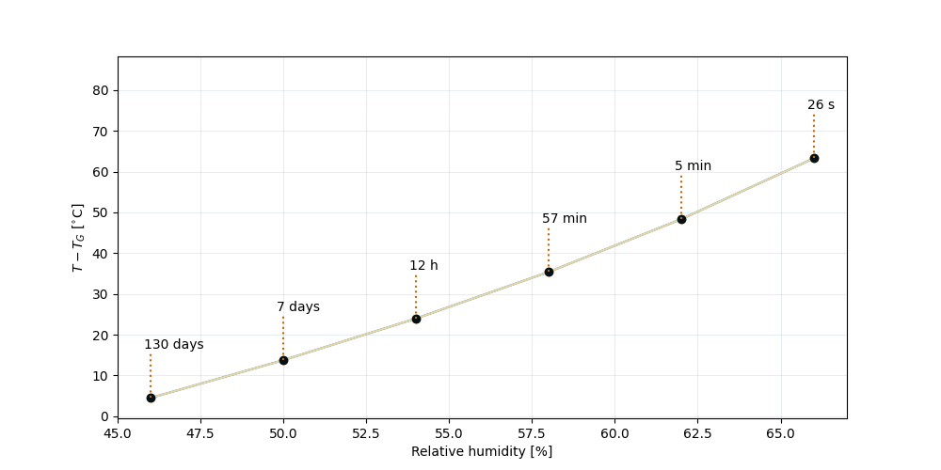
Figure 1 - Rate of full crystallization of amorphous lactose as a function of the equilibrium relative humidity

TAM Experiments
Isothermal microcalorimetry, TAM, is a useful technique to study phase transformations in a controlled environment. In a typical TAM experiment, a sample of partly amorphous lactose is placed in the bottom of a sealed ampoule, called the powder bed. Included in the ampule is also a hygrostat with a salt solution for a constant humidity. The ampoule is kept in a controlled environment and the heat exchange is monitored with high precision. For lactose with some amorphous content the expected outcome of a TAM experiment would exhibit two main exothermic peaks [7- 9].
Firstly, the powder sorbs water from the humid air. Water will also be vaporized from the hygrostat to keep relative humidity constant. The TAM will measure resulting heat exchanges, expelled to, or absorbed by, the sample, the hygrostat and the surrounding environment. The heat of vaporization from the hygrostat, the heat of sorption from the powder are then registered by the TAM. In second event, a larger source of heat generation is registered by the TAM for a lactose sample with amorphous content, this will reflect the crystallization that takes place. As the crystalline form of lactose is a lower energy state, heat will be liberated during the exothermic crystallization process. Another effect could be linked to excess of water emitted during the crystallization process leading to excess moisture in the surrounding environment immediately equilibrated by the presence of the hygrostat [7].
Adding to the previous description of the mathematical model with a delayed water sorption, a more realistic recreation of the experiment setup, the water vapor is subject to diffusion from the hygrostat into the power bed with a certain diffusivity related to material properties of different phases of lactose. To gain additional understanding of the process, information which is difficult to gather from corresponding physical experiments figure 2 was created.
Equivalently to the experimental setup, the moisture diffuses into the system and is absorbed by the particles, which results in the increase of total water W, as shown in the top-left plot. This corresponds to the increase in water activity and T −T_{G} value as shown in the bottom-left and top-right plots respectively. As crystallization begins, moisture is expelled from the amorphous particles and diffused out of the system until the total water of the system equals the water content of fully crystalline particles. As water activity of amorphous particles is limited to 0.6, the T −T_{G} stabilizes at about 42 °C when water activity exceeds that value. The conversion of amorphous to crystalline lactose is the sigmoid in the bottom right plot.

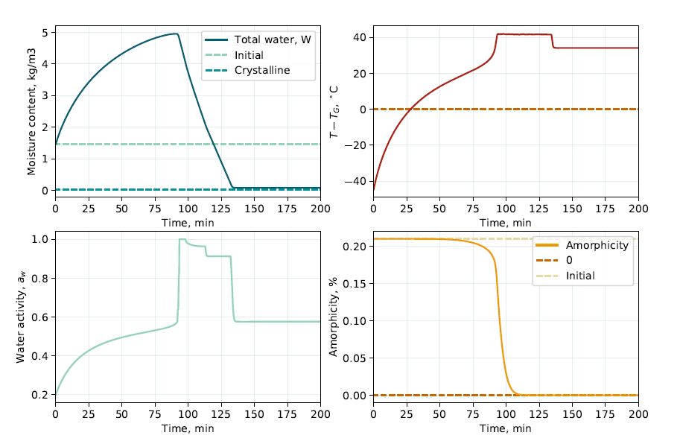
Figure 2 - Recreation of physical experiment (RH 58%, 150 mg), providing additional insight.

Conclusion
To conclude, a modelling tool has been developed to support the process of recrystallization of amorphous powders. From figure 3 it is possible to confirm that the model has the ability to capture key behaviors of the true process, observed with high precision instruments. In figure 3 we can see that the difference in total crystallization time is as low as 3%. Concept such as the main crystallization event is relatively well captured by the model. Simulated crystallization peaks are, however, typically higher and narrower than what is observed in corresponding experiments. In general, there is also slight differences in the sorption phase. From further comparisons to experimental results, it is also possible to conclude that adjusting process factors, such as weight and amorphicity, gives expected outcome in the simulations. Here differences with respect to crystallization time and peak heat flow is preserved compared to equivalent experimental modifications.

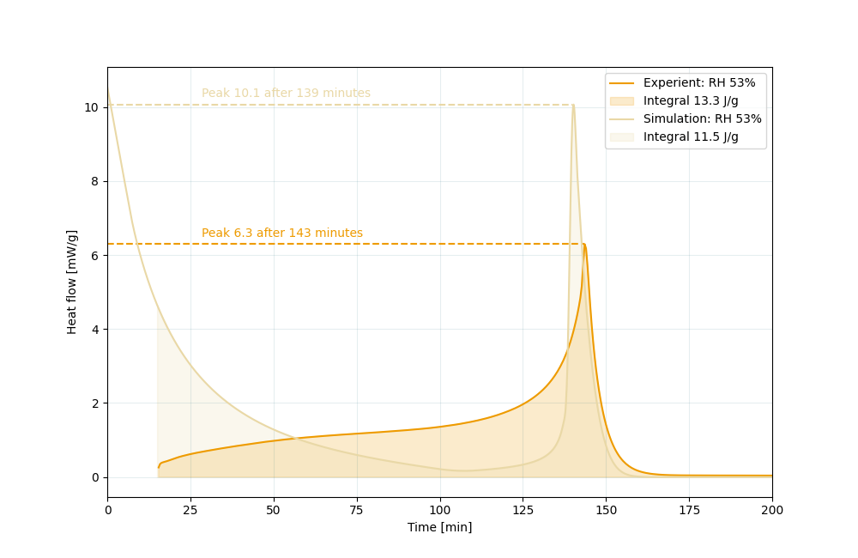
Figure 3 - Performance of the model in comparison to the TAM experiment with equivalent setup.
The ability to describe the particle phase behavior of amorphous, or partly amorphous systems, using efficient algorithms, will as next steps be combined with and implemented into process flowsheet simulations and computational fluid dynamics to generate digital twins of different types of powder contacting equipment. This is also a general model that can be applied to pharmaceutical substances with different properties, for instance, differences in hydrophobicity with modifications of plasticisers, as shown in [11]. Packed powder beds or fluidized beds are examples of manufacturing equipment of interest.

References
[1] John Bronlund. The modelling of caking in bulk lactose. PhD thesis, Massey University, Manawatu, New Zealand, October 1997.
[2] Marc Descamps and Emeline Dudognon. Crystallization from the Amorphous State: Nucleation–Growth Decoupling, Polymorphism Interplay, and the Role of Interfaces. Journal of Pharmaceutical Sciences, 103(9):2615–2628, September
2014.
[3] T. A. G. Langrish. Assessing the rate of solid-phase crystallization for lactose: The effect of the difference between material and glass-transition temperatures. Food Research International, 41(6):630–636, July 2008.
[4] Yrjö Roos and Marcus Karel. Plasticizing Effect of Water on Thermal Behavior and Crystallization of Amorphous Food Models. Journal of Food Science, 56(1):38–43, 1991.
[5] Nicholas Ibell-Pasley. Directional Amorphous Lactose Crystallization. Master’s thesis, Massey University, Manawatu, New Zealand, 2018.
[6] John E. Bronlund and (AHJ) Tony Paterson. Mathematical modelling of temperature induced moisture migration in bulk powders. Chemical Engineering Science, 63(9):2330–2340, May 2008.
[7] Tesfai Sebhatu, Maria Angberg, and Claes Ahlneck. Assessment of the degree of disorder in crystalline solids by isothermal microcalorimetry. International Journal of Pharmaceutics, 104(2):135–144, April 1994.
[8] Lars-Erik Briggner, Graham Buckton, Katarina Bystrom, and Patricia Darcy. The use of isothermal microcalorimetry in the study of changes in crystallinity induced during the processing of powders. International Journal of Pharmaceutics,
105(2):125–135, May 1994.
[9] Sarah Hogan. Investigation of the amorphous and crystalline properties of lactose and raffinose. PhD thesis, University of London, London, January 2002.
[10] Jouppila, K., & Roos, Y.H. Glass Transitions and Crystallization in Milk Powders. Journal of Dairy Science, 77(10), 2907-2915, October 1994.
[11] Samra RM, Buckton G. The crystallisation of a model hydrophobic drug (terfenadine) following exposure to humidity and organic vapours. Int J Pharm, 284(1-2): 53-60, October 2004.

