Development and Optimisation of a Particle Sizing Methodology for Early Screening of DPI Carrier Based Formulations using Laser Diffraction.

James McNeill¹, Jim Clay¹, Olivia Brittain¹

¹Kindeva Drug Delivery Ltd Loughborough, Leicestershire, LE11 5RB, UK

Summary
Aerodynamic Particle Size Distribution (APSD) is recognised as a Critical Quality Attribute (CQA) in the in vitro characterisation of Orally Inhaled and Nasal Drug Products (OINDPs). The established instrumentation for measuring APSD of inhaled products is the multistage cascade impactor (CI). Use of laser diffraction for Particle Size Distribution (PSD) measurement offers an efficient and simplified alternative approach for early screening of Dry Powder Inhaler (DPI) formulations; however, the lack of component specificity may be a drawback. It is therefore essential to have a suitable separation strategy. In this study, a Next Generation Impactor (NGI), DPI preseparator and throat were interfaced with a Sympatec HELOS with INHALER adapter. This test configuration enabled a comparison of mean diameter (D₅₀) from laser diffraction PSD data against mass median aerodynamic diameter (MMAD) data generated by NGI. The correlation between D₅₀ and MMAD was improved when the standard DPI preseparator insert was coated with 1% w/v Brij® 35 in 20/80 %v/v ethanol/glycerol solution, and then further enhanced by replacing the standard insert with a 30 L/min, 5 µm cut-off insert. Further development showed that using two stacked preseparators in series, each containing a coated 30 L/min, 5 µm cut-off insert, generated the closest correlation between D₅₀ and MMAD. This novel methodology could enable efficient early screening of formulations in DPI product development.

Key Message
A method for testing DPI carrier-based formulations for PSD has been developed to increase efficiency during early formulation screening. Initial findings present a promising trend against established APSD methods, with optimisation of the methodology being performed to establish closer equivalence whilst maintaining the benefits that using laser diffraction provides.

Introduction
During the development of OINDPs, APSD is recognised as a CQA in the in vitro characterisation. The preferred instrument of choice for measuring the APSD of inhaled products for both regulators and pharmacopoeias alike is the multistage CI¹. For early screening and feasibility studies, PSD by laser diffraction is a possible alternative with numerous benefits over the aerodynamic counterpart, including simplified operation, reduced solvent usage, and significantly increased productivity; all of which were observed during this study. Whilst there are benefits of a laser diffraction PSD method over an APSD method, one drawback is the lack of specificity. With the common use of excipients or carrier materials within a DPI formulation, this methodology will size the excipients as well as the API but will not differentiate between the two. Therefore, separating the excipient/carrier material from the API is key to generating data that will be beneficial during the screening of formulations in early stage and feasibility studies.
The purpose of this study was to develop, optimise, and evaluate potential methodology for determining a meaningful PSD method for carrier-based DPI products.

Methodology
Analyses were performed using a Sympatec HELOS laser diffractometer, with an R3 (100 mm focal length) lens, combined with the Sympatec INHALER adapter, both from Sympatec Ltd, UK.
Previous work showed that using an NGI USP throat and preseparator, from MSP, Minnesota, USA, attached to the Sympatec INHALER, enhanced the deagglomeration and separation of the API from the carrier material².
Additionally, coating the standard DPI insert located in the preseparator also improved the separation of API and carrier, shown by the reduction of the D₅₀ value measured during PSD analysis by the laser diffractometer. This study used these findings to assess whether altering the preseparator insert would further reduce the D₅₀ value, bringing the data closer to the NGI-measured MMAD for the same product.
A further study assessed whether enhanced deagglomeration would occur if two preseparators were stacked in series. See Figure 1 for the modified instrument configurations used during analysis.
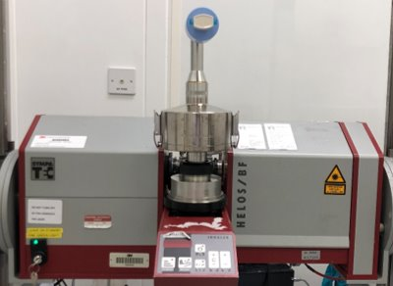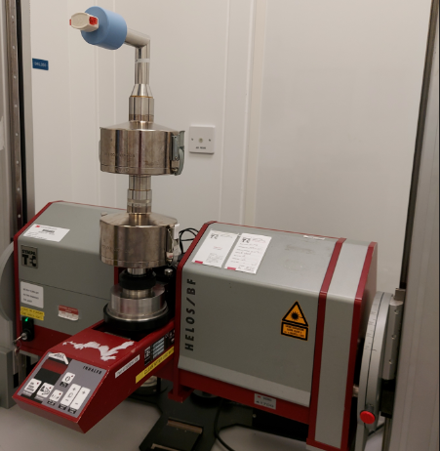
Figure 1 – Modified Sympatec Setups for Method Development.
A lactose carrier-based formulation containing salbutamol sulphate as the API was used throughout the study. Powder was harvested from commercially available DPI devices, transferred to capsules, and tested using a high resistance RS01 DPI (Berry, Osnago, Italy).
The separation of the API from the carrier was evaluated by monitoring:
- The change in the D₅₀ value generated by the Sympatec; this value representing the volume (mass) median particle diameter (in µm).
- The change in cumulative size distribution, a sharper gradient indicating a decrease in large particles passing through the detector, signalling improved separation of API from carrier.
Previous data showed that when comparing different coatings on the standard preseparator insert, a 1% w/v Brij® 35 in 20/80 %v/v ethanol/glycerol coating solution provided the closest correlation of D₅₀ result to MMAD result². Using this knowledge as a starting point, a series of different preseparator inserts were coated with the 1% Brij® solution and used to generate PSD data. The different inserts evaluated had 5 µm cut-off sizes for sampling at 30, 45, and 60 L/min. Testing was conducted over three pressure drops: 2, 4 and 8 kPa, with the data generated compared against data generated with the standard (coated) insert and MMAD data generated by NGI. DPI testing is carried out at a given pressure drop (e.g. 4 kPa) following instructions in the pharmacopeial compendia, therefore, analysis with the inserts could not be conducted at their stated nominal cut-off sizes. Increasing the airflow through these inserts increased the proportion of large particles impacted on the insert, allowing a correspondingly greater proportion of the smaller particles through to the detector and thus reducing the D₅₀ value.

Results and Discussion
The 30 L/min, 5 µm cut-off insert generated D₅₀ values closest to the corresponding MMAD (Table 1), indicating that the largest amount of lactose carrier was being captured by this insert.
Pressure (kPa) | MMAD (µm) NGI | D50 (µm)
Pressure (kPa) | MMAD (µm) NGI | Uncoated | 1% Brij® 35 coated
Pressure (kPa) | MMAD (µm) NGI | Standard Insert | Standard Insert | 30 L/min Insert | 45 L/min Insert | 60 L/min Insert
2 | 2.14 | 5.44 | 4.33 | 2.84 | 3.00 | 3.12
4 | 1.79 | 4.25 | 3.33 | 2.44 | 2.53 | 2.77
8 | 1.68 | 3.54 | 2.86 | 2.11 | 2.28 | 2.28
Table 1 – Comparison of D₅₀ Values for the Preseparator Inserts vs MMAD Observed from NGI Testing with a 1% Brij® 35 Coating Solution.
The same experiment was then conducted with multiple coating solutions to assess if different coating solutions affected the different inserts in the same way. 1% Tween® 80 %w/v in ethanol, 1% Brij® 35 %w/v in 20/80 %v/v ethanol/glycerol, 50/50 %v/v glycerol/methanol (G:M) and 12% fructose %w/v in 75/25 %v/v ethanol/water solutions were evaluated, and the analysis was conducted at 4 kPa, as before.
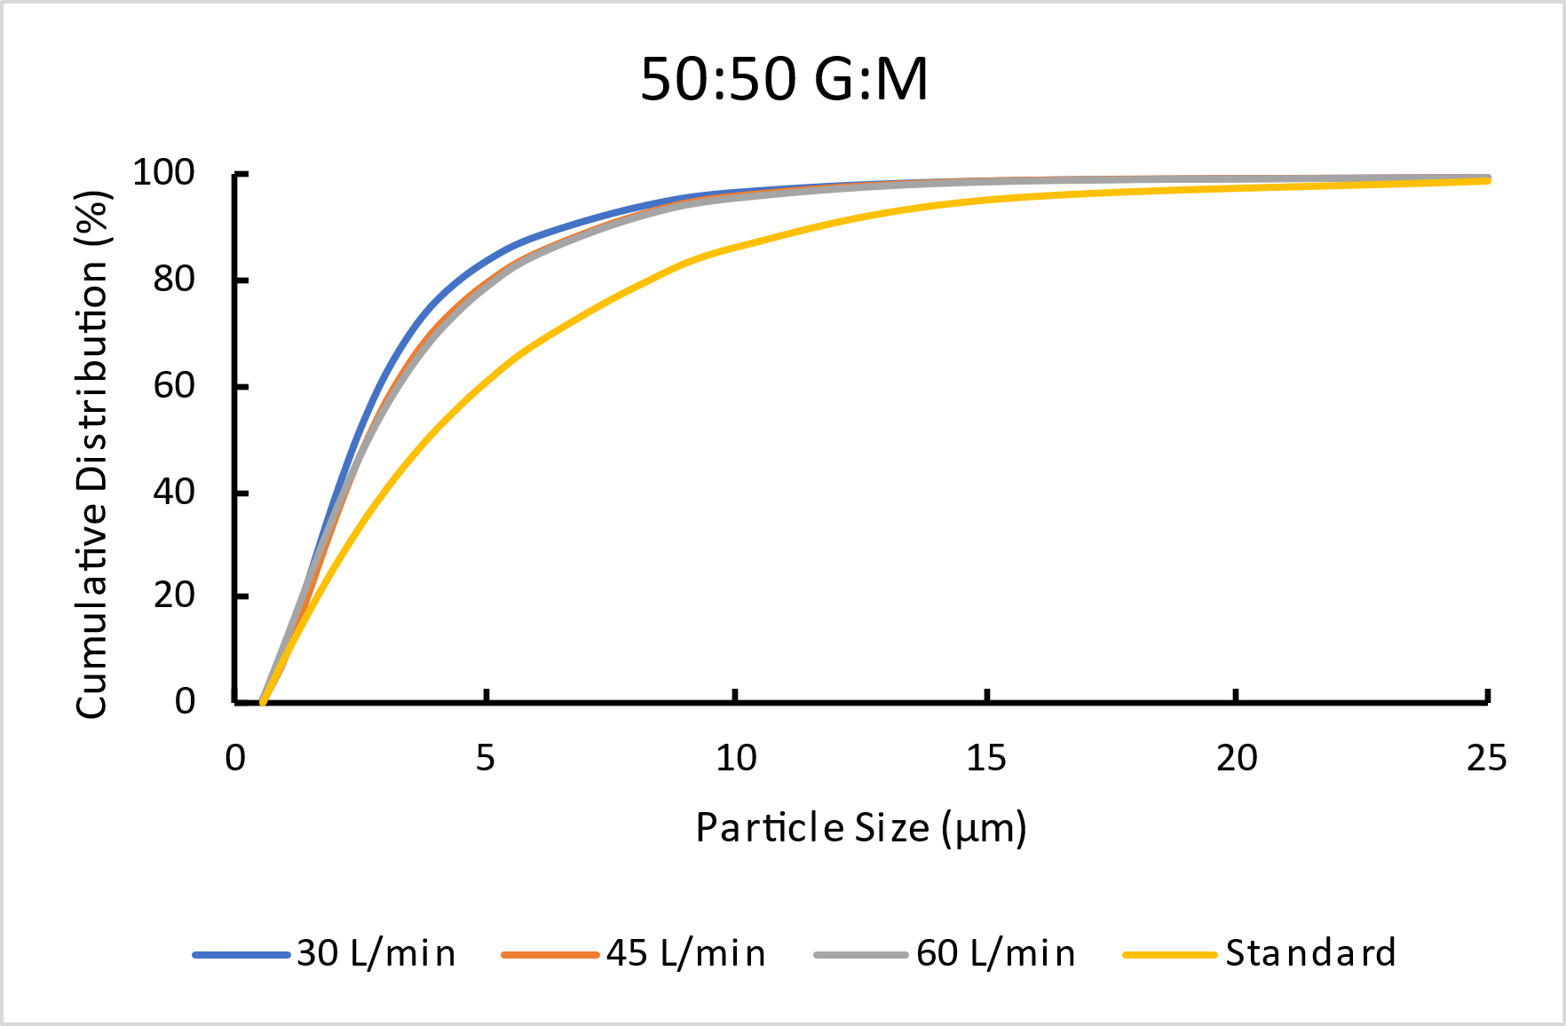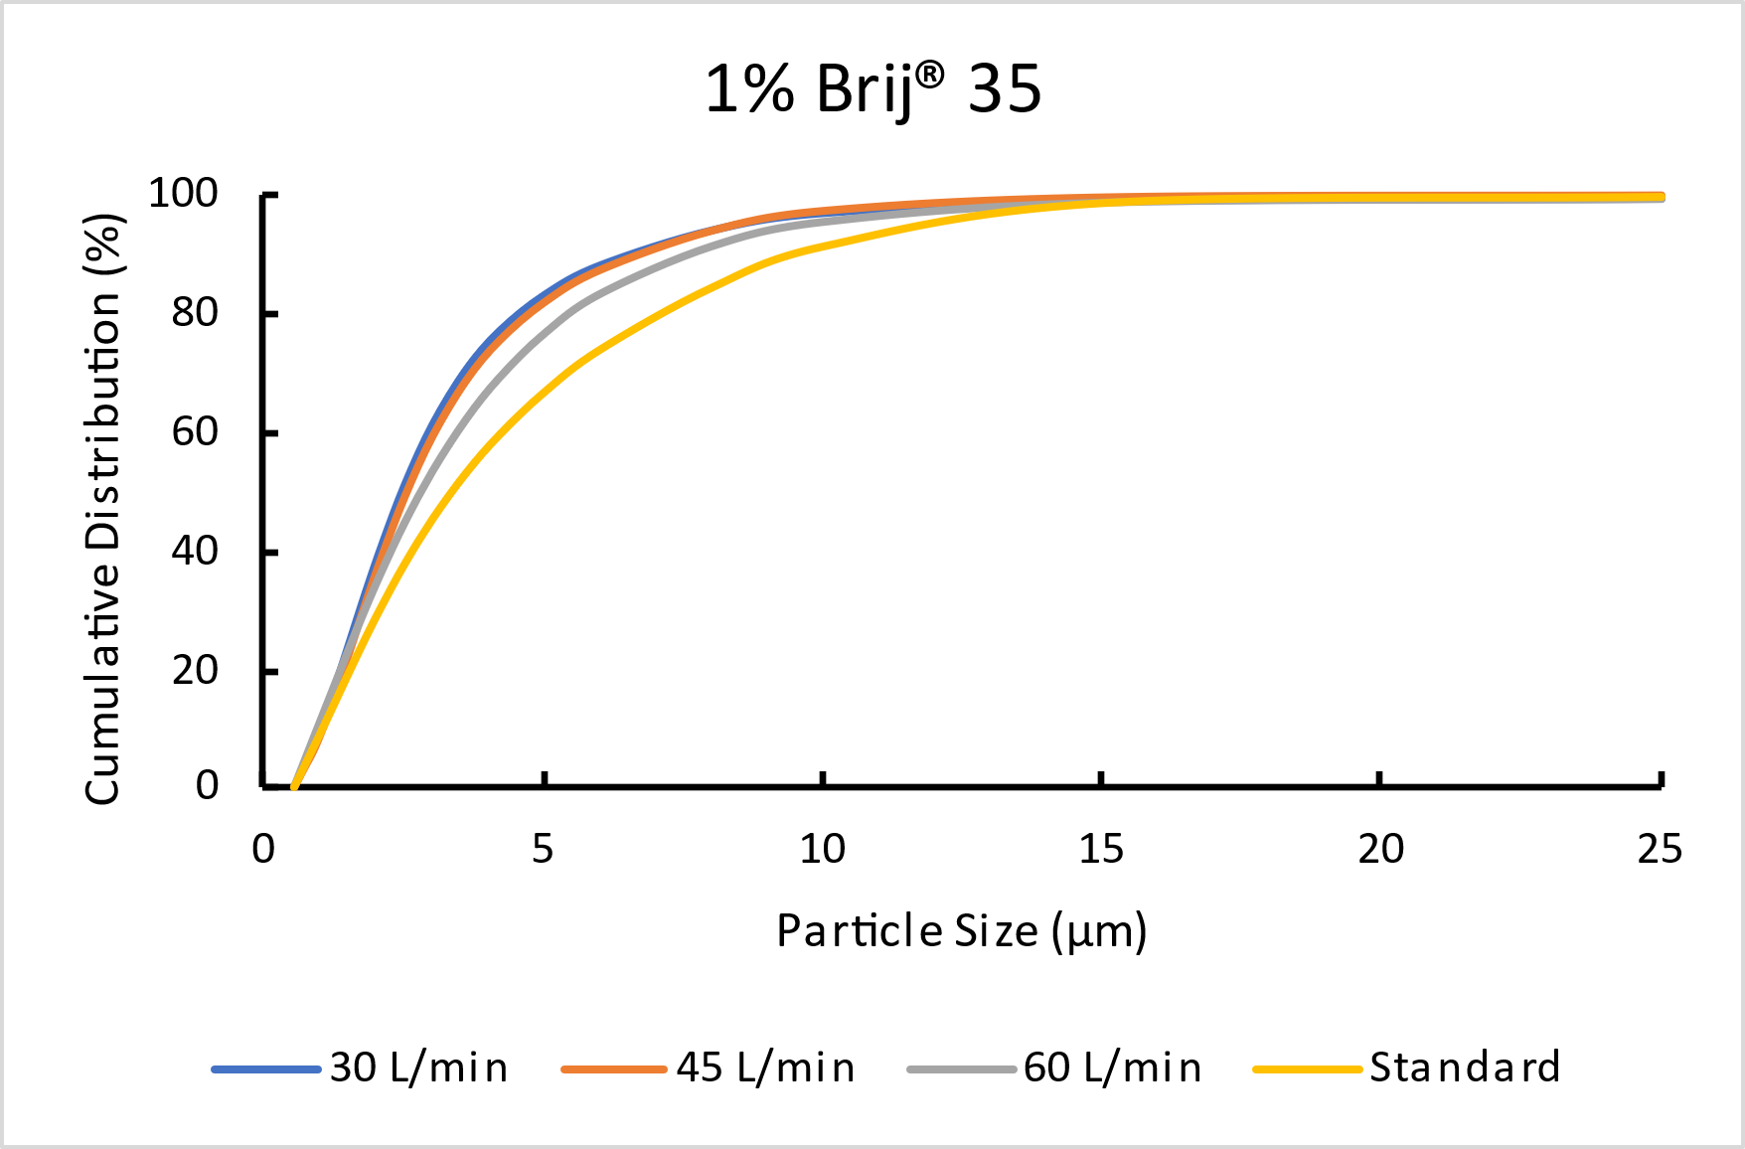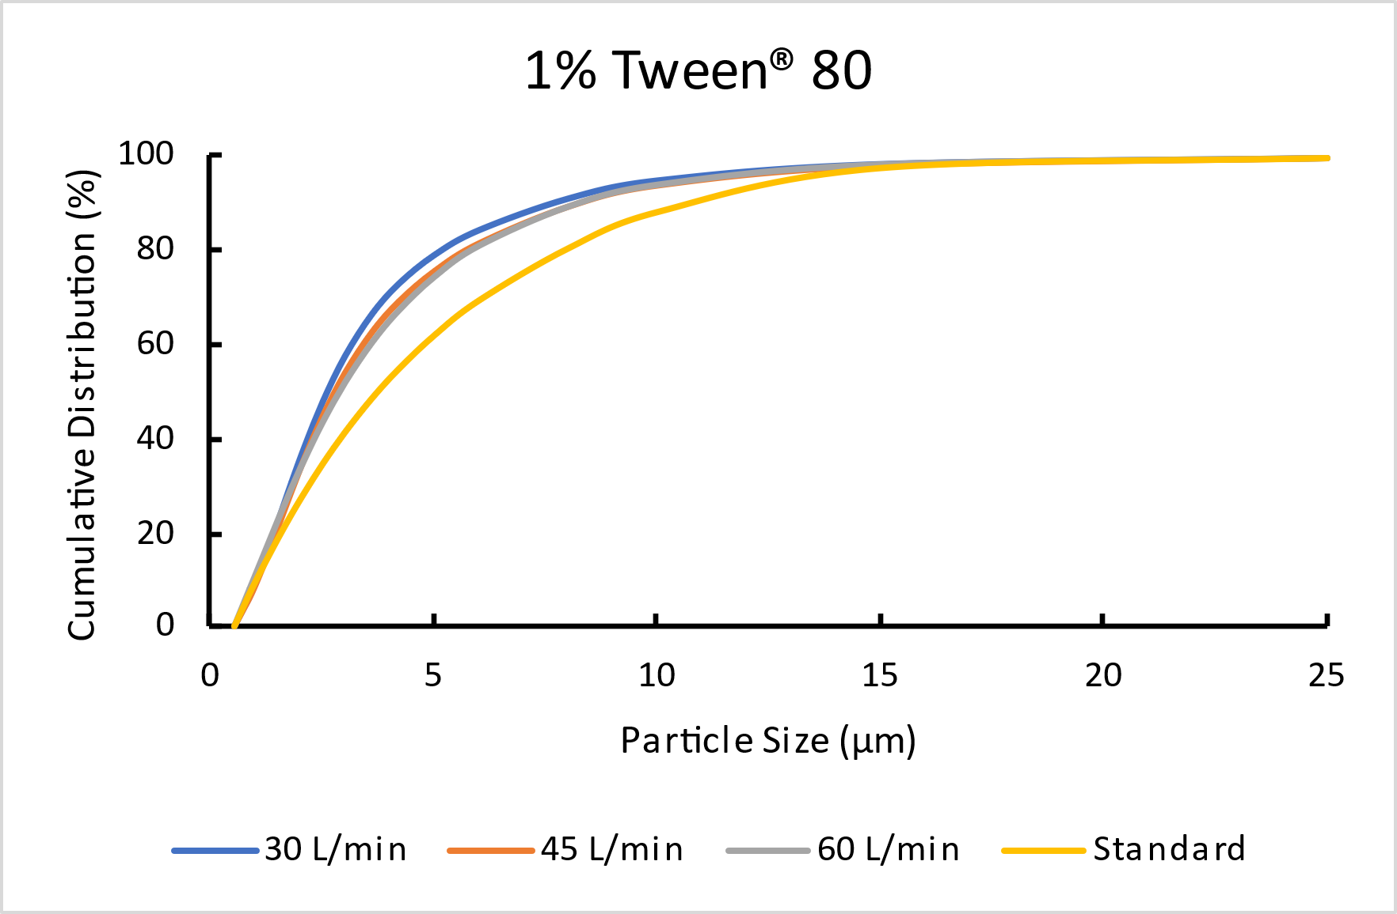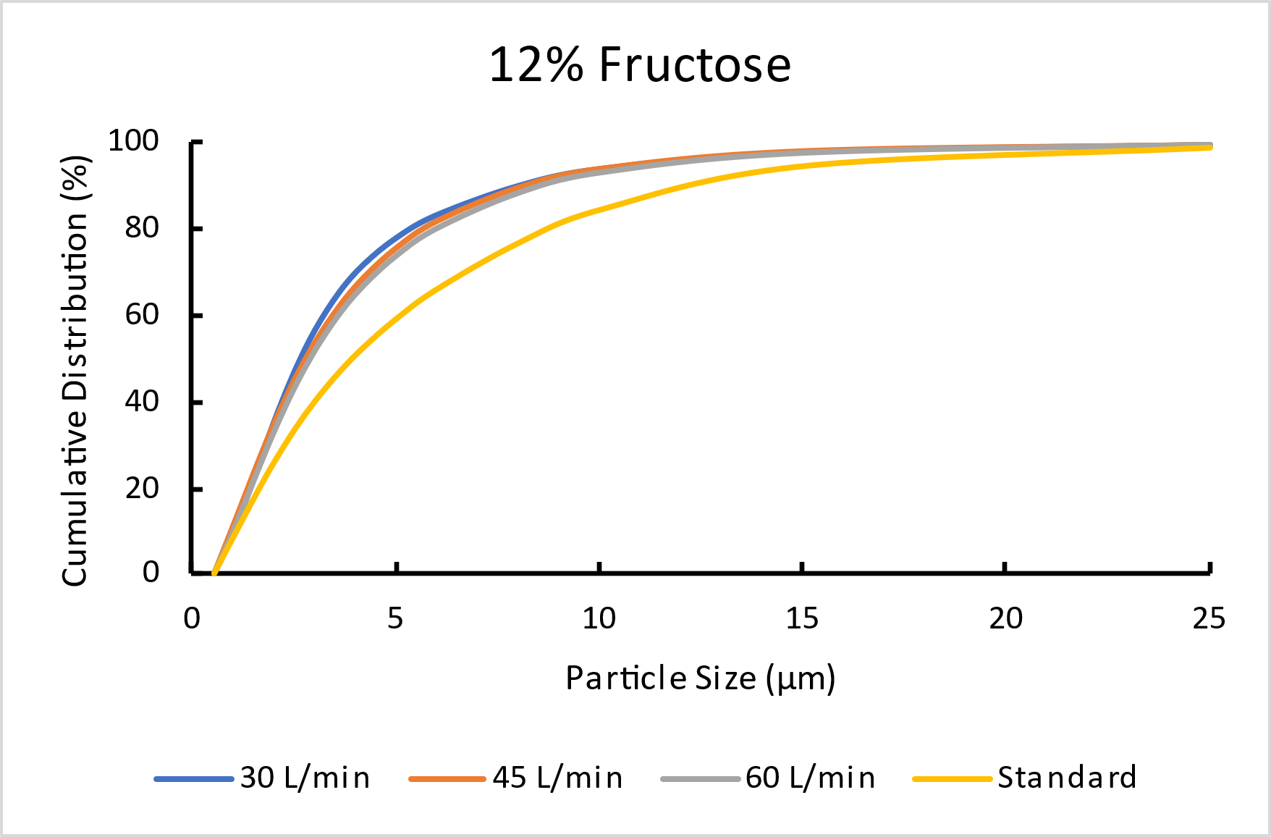
Figure 2 – Comparison of Preseparator Inserts Coated with Different Solutions at 4kPa.
Irrespective of the coating solution used, all 5 µm cut-off inserts performed better than the standard DPI insert (Figure 2). Universally, the 30 L/min, 5 µm cut-off insert generated the sharpest gradient, followed by the 45 L/min insert and then the 60 L/min insert. The standard insert’s cumulative distribution gradient was shallower than the other inserts and this finding fitted the expected trend, as the holes in the standard DPI insert are far larger than the orifices of the other inserts, thus reducing the acceleration of the incoming particles and thereby keeping them entrained within the airstream. As expected, the 30 L/min insert performance was optimum, as it provided the greatest acceleration change, allowing the capture of particles larger than 5 μm at a comparatively low flow rate. The difference between the inserts was greatest at 8 kPa and smallest at 2 kPa. The fructose and Tween® coating solutions were the worst performing in this experiment, with the Brij® 35 and G:M coating solution performing marginally better.
Two preseparators were stacked (as shown in Figure 1, right image) on to the Sympatec INHALER attachment to enhance further the correlation between D₅₀ and MMAD. A variety of insert stacking configurations were assessed in combination with different coating solutions. As predicted, based on data generated during the previous experiments, the combination of two 30 L/min inserts produced the best results (Figure 3). Note that the insert in the uppermost preseparator was coated with the first named solution in the combination.
With two preseparators used in series, a greater correlation was found between D₅₀ and MMAD.
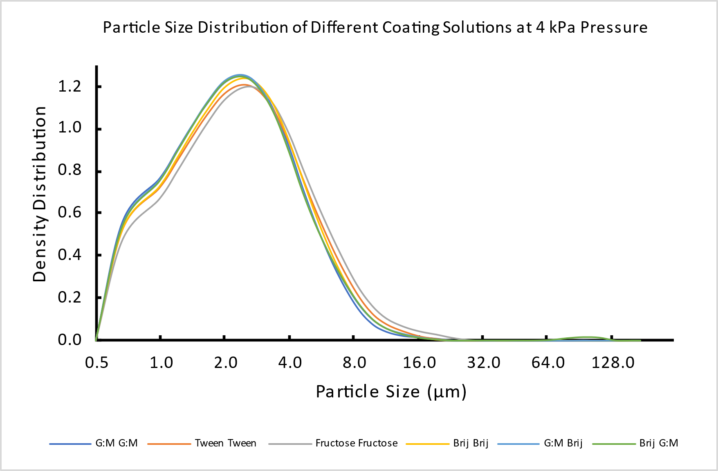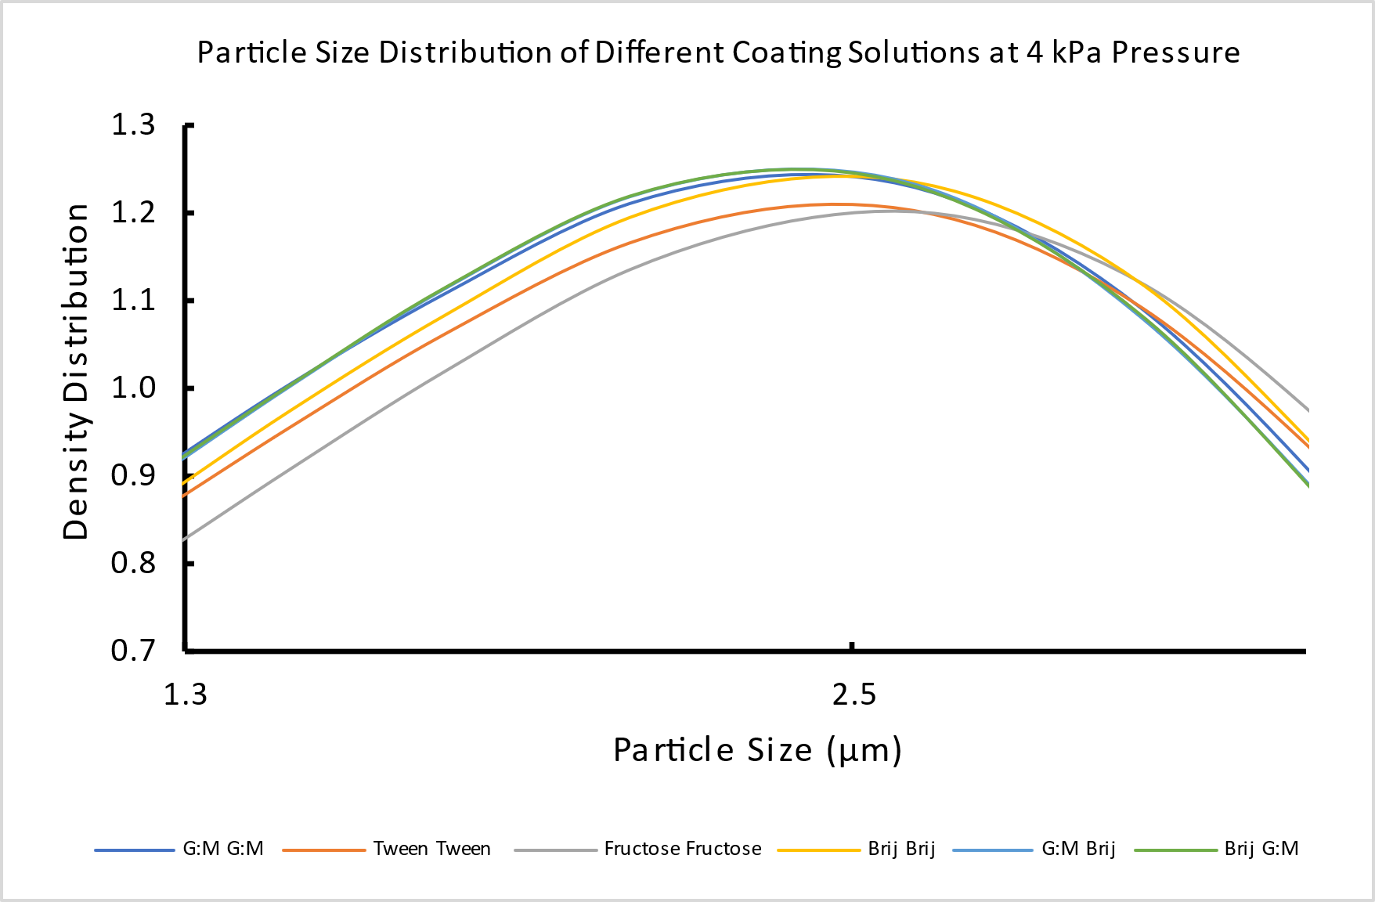
Figure 3 – Particle Size Distribution Curves of the Coating Combinations on the 30 L/min – 30 L/min Preseparator Stack (Left). A Close Up at the Peak Apex of Distribution Density (Right).
The Tween® 80 and fructose coated inserts generated the largest values of D₅₀, whilst any combination of Brij® or G:M coating generated similar D₅₀ values. See Table 2 for the progressively optimised D₅₀ results compared to the MMAD values. Also see Figure 4 for an illustrative comparison.
MMAD (µm) | Insert | Standard DPI | Standard DPI | 30 L/min Insert |  | Stacked: 30 L/min Inserts
MMAD (µm) | Coating | None | Brij® 35 | Brij® 35 | G:M | Brij® 35 | G:M | Brij® 35 | G:M
 |  |  |  |  |  | Brij® 35 | G:M | G:M | Brij® 35
1.79 (0.01) | D50 (µm) (Std Dev) | 4.25 (0.04) | 3.33 (0.06) | 2.44 (0.04) | 2.39 (0.02) | 2.16 (0.02) | 2.09 (0.04) | 2.11 (0.02) | 2.10 (0.03)
Table 2 – Comparison of D50 Values (at 4 kPa) for Preseparator Insert Combinations Containing Brij® 35 and G:M coatings Vs. the MMAD from NGI Testing.

Figure 4 – Cumulative Size Distribution Plot Illustrating the Stacked Preseparators with Brij® 35 Coating Against Previous Analyses.

Conclusions
Two preseparators, stacked in series and each containing a coated 30 L/min, 5 µm cut-off insert, were found to improve the capture of large particulates in this investigation, thus separating the API and carrier more efficiently. We conclude that more meaningful PSD data can be generated with improved separation of the API from the carrier material, thereby reducing the potential impact of the carrier particles on these size distribution measurements.
This methodology could be used to screen formulations in feasibility or early-stage development to predict potential MMAD value and MMAD trending behaviour under various stressors, to eliminate unsuitable formulations prior to moving to the more traditional and regulatory required APSD analysis.

Future Work
Whilst good correlation between D₅₀ and MMAD has been achieved, it is acknowledged that:
- additional optimisation may further improve this correlation.
- this study focussed on a lactose carrier-based formulation containing Salbutamol Sulphate, therefore an assessment of alternative carriers and alternative APIs is required.
- enhanced engineering solutions to attach the preseparators to the Sympatec could be devised to further improve the accuracy and robustness of the data generated.

Acknowledgments
We would like to acknowledge Edward Harrison for his efforts in the generation of the experimental data.

References
[1] USP-NF <601>, Inhalation and Nasal Drug Products: Aerosols, Sprays, and Powders – Performance Quality Tests
[2] McNeill J, Clay J: Development of a Particle Sizing Methodology for Early Screening of DPI Carrier Based Formulations using Laser Diffraction. RDD 2023 p235 - 238

