Assessment of the Delivery Performance of a Novel Soft Mist Inhaler Using a Pre-Filled Syringe Based Container Closure System

Pragathi Gurumurthy¹, Knut Sommerer², Imco Sibum¹, Nicolas A. Buchmann¹ & Bernhard Müllinger¹

¹ Resyca BV, Colosseum 23, Enschede, 7521 PV, The Netherlands

² Actarmo Medical GmbH, Robert-Koch-Allee 29, Gauting, 82131, Germany

Summary
Novel drug developments (e.g. biologics) are primarily delivered as water-based liquid formulations. Soft Mist Inhalers (SMIs) deliver the water based liquid formulations through a slow-moving cloud of aerosol that is generated solely by mechanical energy. Resyca’s novel soft mist inhaler with a pre-filled syringe (PFSI) delivers high doses of liquid drugs that can be aseptically filled. This inhaler has high delivery efficiency leading to a high lung deposition. The particle size distribution measured by laser diffraction gives a VMD of 4.27 µm with a high FPF of 65.20% at 30 L/min. The average emitted dose measured gravimetrically at 30 L/min over multiple devices was 30.41 ±0.24 mg. The regional respiratory deposition calculated from the obtained aerosol data shows a high lung deposition of 62.88%.
Key Message
Biological drugs are primarily delivered as water-based liquid formulations and require efficient liquid delivery platforms when being delivered via the inhalation route. The soft mist inhaler tested within this study uses a container closure system that is compatible with biological drug products and achieves a high lung deposition of about 62%.

Introduction
Novel drug products are primarily delivered as water-based liquid formulations []. This necessitates the use of inhalers capable of delivering larger amounts of liquid drugs and providing container closure systems that allow aseptic filling compatible with available technologies like pre-filled syringes or cartridges. Over the past few decades, there has been significant development in new device technologies. One of the innovations in inhaler technology is the soft mist inhaler (SMI). Soft Mist Inhalers (SMIs) deliver liquid formulations through a slow-moving cloud of aerosol generated solely by mechanical energy [2,3]. In addition to the currently marketed SMIs developed for the treatment of respiratory diseases with small molecules [4], novel SMIs are now being developed for larger molecules and biological drug products that require the delivery of higher amounts of the drug.
The objective of this study is to characterize the delivery performance and evaluate the efficiency of lung deposition of the Resyca’s novel soft mist inhaler, which utilizes a container closure system based on a pre-filled syringe [5].
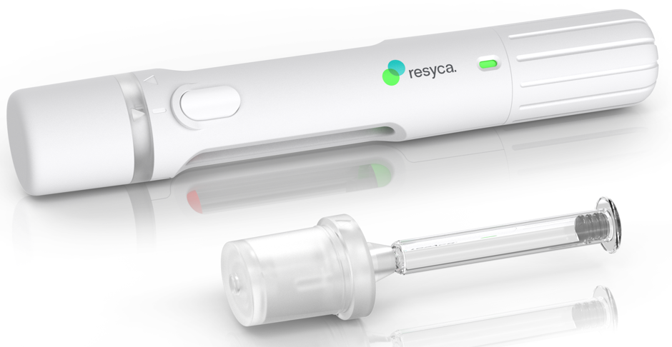
Figure 1- Pre-filled Syringe Inhaler (PFSI) with the multi-use cartridge.

Materials and Methods
The device under test is the PFSI (Resyca BV, Enschede, Netherlands), see Figure 1. The PFSI is a mechanical, pocket sized, portable device used with a cartridge providing 10 to 30 dosages depending on the filled amount. This multi-use cartridge is based on a pre-filled glass syringe containing the drug solution, to which a spray nozzle and a mouthpiece are attached. The formulation is aerosolised by the micro spray nozzle with a low shear force by utilising the Rayleigh breakup. Upon applying pressure to the liquid reservoir, micronized liquids jets forms that breaks into droplets of roughly twice the pore size due to Rayleigh instability. This technique allows the generation of nearly mono-disperse droplets under very low shear condition, ideally suited for sensitive biological formulations [6]. The tested device technology delivers metered dose of up to 50 µL per actuation and provides a dose indicator window. The primary packaging of the device uses the Alba® EZ®-fill glass syringes and can be filled under aseptic conditions in conventional pre-filled syringe tray filling lines.
Particle size distribution and emitted mass were measured with the PFSI Soft Mist Inhaler using a cartridge with a target dosing volume of 30 µL. The particle size distribution of the PFSI was measured using a Malvern Spraytec laser diffraction system with Malvern inhalation cell (positioned horizontally) at 30 L/min. The PFSI was manually charged and actuated. Volume Median Diameter (VMD), Geometric Standard Deviation (GSD) and Fine Particle Fraction (FPF) were calculated and averaged over a total of 20 individual devices. Emitted dose was measured with the device being connected to the Dose Uniformity Sampling Apparatus (DUSA) via a mouthpiece adapter at inspiration flow rate of 30 L/min. Single doses were assessed with 10 dose repetitions per device for a total of 10 individual devices and assessed by weight loss of the device using an analytical balance after manual actuation. Both the performance tests were conducted with 2.5% sodium chloride solution.
Based on the obtained aerosol data, the predicted lung deposition for the device at 30 L/min was calculated with a validated lung deposition model (Mimetikos Preludium software version 1.1.7, Emmace Consulting, Lund, Sweden) [7,8]. This computer-based model uses the symmetrical Weibel A model of airways. The parameters used for the lung deposition calculation are given in Table 1.
Table 1 - The inhalation parameters used as input in the depostion model for the device.
Deposition Model Parameter | PFSI
Model | Weibel A
Tidal breath volume | 1000 mL
Inspiratory flow rate | 30 L/min
Flow pattern | Rectangular
Breath hold | 1 sec
I/E ratio | 1:1
Bolus volume | 950 mL
Delay volume | 50 mL

Results
The mean VMD, GSD and the FPF (Percentage of the total volume in aerosol particles with a diameter < 5 µm, measured by laser diffraction) at 30 L/min is presented in Table 2. The mean particle size of the PFSI is 4.27 µm with a very low GSD of 1.44 and a high FPF of approximately 65%. An example of the particle size distribution of the aerosol generated by a single PFSI is given in Figure 2.
Table 2 - Results of the particle size distribution measurement at 30 L/min; Mean (SD).
Parameter | VMD (µm) | GSD (-) | FPF <5µm (%)
PFSI | 4.3 (0.3) | 1.4 (0.04) | 65.2 (6.2)

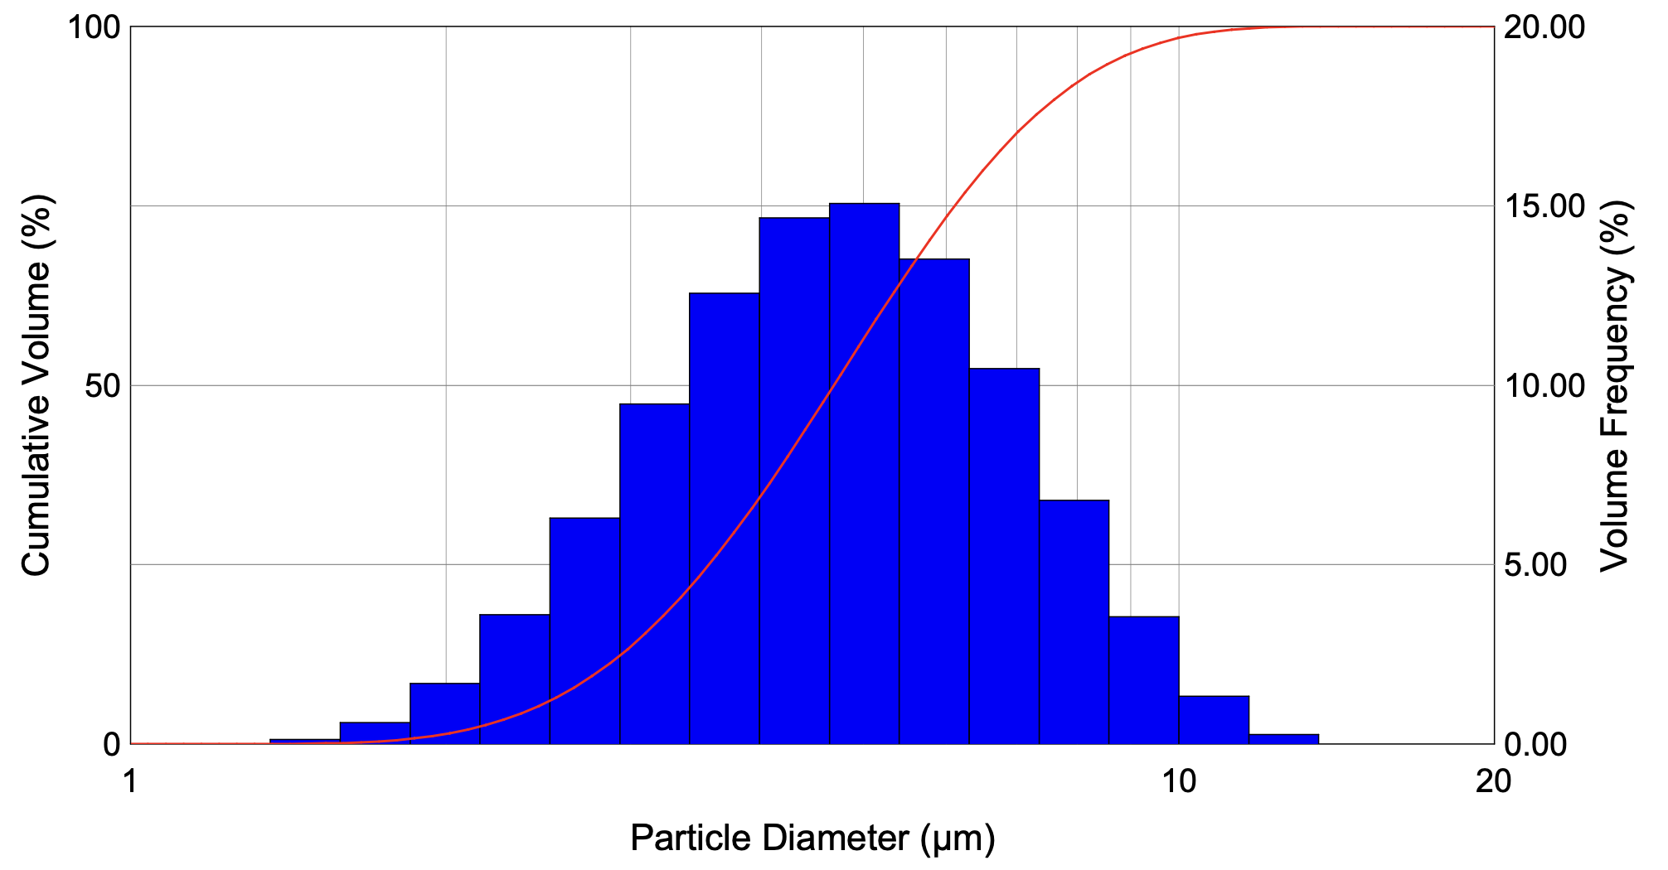
Figure 2 - Example of particle size distribution of PFSI at 30 L/min for a single device
The average emitted metered dose measured gravimetrically is 30.4 mg (95% confidence intervals, 30.18 – 30.65 mg). Figure 3 presents the inter- and intra-device dose uniformity. The device exhibits a good inter-device variability with all individual dose being within the 75 – 125% interval across all devices. Likewise, show to shot variability (after priming) is also low with again all individual metered dose falling between the 75 – 125% interval.
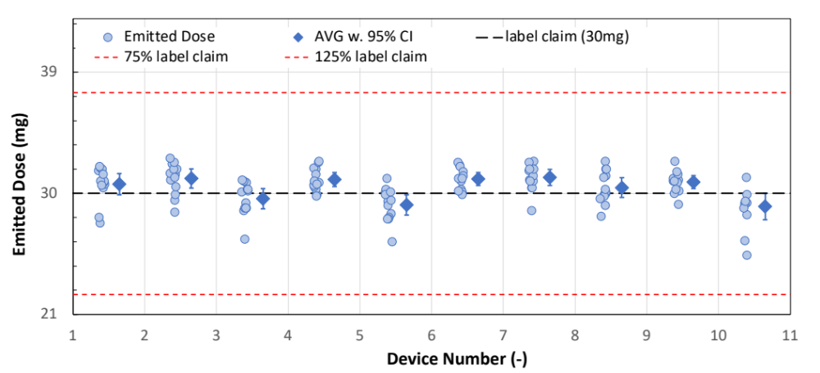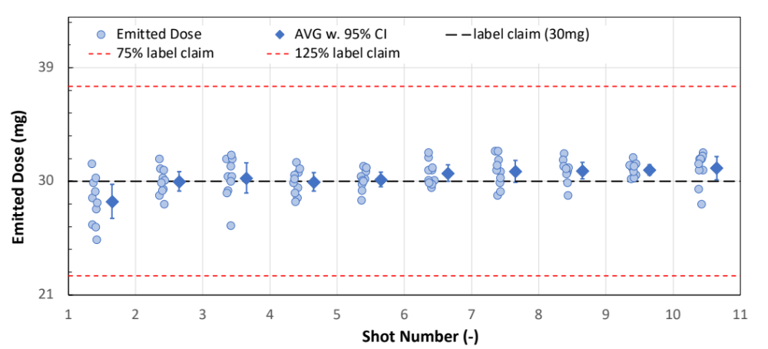
(A)
(B)
Figure 3 - Distribution of individual and mean (95% CI) emitted dose; (A) inter device comparison; (B) Shot to shot comparison for all devices.
Table 3 shows the predicted (modelled) lung deposition results in different regions at 30 L/min.
Table 3 - Results from lung deposition modelling within the respiratory tract regions.
Deposition region | Regional deposition (%)  at 30 L/min
Throat | 20.2
Lung | 62.9
Tracheobronchial | 17.3
Bronchial | 13.7
Peripheral | 31.9
Exhaled | 16.9

Discussion
Particle size, emitted dose and inhalation flow rate play a crucial role in determining the delivery efficiency and the lung deposition. Test results from aerosol characterisation of the PFSI device show a volumetric median diameter of 4.3 µm with a narrow size distribution (GSD of 1.4) and FPF of 65.2%. Results from emitted dose measurements confirm that the targeted dose of 30 mg was reached with 30.4 ± 0.24 mg over 10 dose actuations and across different devices. The uniformity of single doses fulfils dose uniformity requirements are in the range of 75%–125% of the label claim. Regional respiratory lung deposition modelling shows a high deposition in the lung and the lung periphery of 62.9% and 31.9%, respectively.

Conclusion
The results of the delivery performance testing of the Soft Mist Inhaler with an integrated container closure system show that the device is efficient in delivering liquid drug products. The device can deliver metered doses consistently (30.4 ±0.24 mg) with a lung deposition of delivered dose (62.9%).

References

[1] Liang W, Pan H W, Vllasaliu D and Lam J K: Pulmonary delivery of biological drugs, Pharmaceutics 2020; 12(11): pp1025.
[2] Sorino C, Negri S, Spanevello A, Visca D, Scichilone N: Inhalation therapy devices for the treatment of obstructive lung diseases: the history of inhalers towards the ideal inhaler, European Journal of internal medicine 2020; 75: pp 15 – 8.
[3] Hickey AJ: Emerging trends in inhaled drug delivery, Advanced Drug Delivery Reviews 2020; 157: pp 63 – 70.
[4] Dalby R, Spallek M, Voshaar T: A review of the development of Respimat® Soft Mist™ Inhaler, International journal of pharmaceutics 2004; 283(1-2): pp 1-9.
[5] Komalla V, Wong CY, Sibum I, Muellinger B, Nijdam W, Chaugule V, Soria J, Ong HX, Buchmann NA, Traini D: Advances in soft mist inhalers, Expert Opinion on Drug Delivery 2023; 10: pp 1 – 6.
[6] van Rijn CJ, Vlaming KE, Bem RA, Dekker RJ, Poortinga A, Breit T, van Leeuwen S, Ensink WA, van Wijnbergen K, van Hamme JL, Bonn D: Low energy nebulization preserves integrity of SARS-CoV-2 mRNA vaccines for respiratory delivery, Scientific Reports 2023;13(1): pp 8851.
[7] Olsson B, Kassinos SC: On the validation of generational lung deposition computer models using planar scintigraphic images: the case of Mimetikos Preludium. Journal of Aerosol Medicine and Pulmonary Drug Delivery, 2021; 34(2): pp 115 – 23.
[8] Sonnenberg AH, Herrmann J, Grinstaff MW, Suki B: A Markov chain model of particle deposition in the lung, Scientific Reports, 2020;10(1): pp 13573.

