Comparing The Aerosol Front Velocity Of Dry Powder Inhalers With The Corresponding Velocity Of Pressurised Metered Dose Inhalers And Soft Mist Inhalers

Herbert Wachtel¹, Rachel Emerson-Stadler¹

¹Boehringer Ingelheim Pharma GmbH & Co. KG, Binger Str. 173, Ingelheim, 55218, Germany

Summary
The core task of an inhaler is to generate a pharmaceutical aerosol. Observing the aerosol leaving the mouthpiece helps the engineer, the doctor and finally the patient. The latter benefits from optimized efforts by the healthcare professionals, providing better inhalers and detailed instructions as well as training. In the past, only aerosol plumes leaving active inhalers, e. g. pressurised metered dose inhalers (pMDIs) and soft mist inhalers (SMIs) have been investigated. This study adds the air flow which is generated by the patient during intended use. Dry powder inhalers (DPIs) were included. Experimental: For simplicity, rates of 30, 60, and 90 L/min of constant air flow were selected. Instead of sealing the mouthpieces by the patients’ lips now the inhalers were enclosed and sealed to the enclosure where the lips are located. These enclosures were filled with air at the selected flow rate. Results: At 10 cm distance of the mouthpiece, the Respimat SMI had the slowest front velocity (0.99 m/s) and the longest spray duration (1447 ms) compared with pMDIs (velocity: 3.65–5.09 m/s; duration: 227–270 ms) and DPIs (velocity: 1.43–4.60 m/s; duration: 60–757 ms). With increasing flow rates, SMI aerosol velocity increased (maximum 2.63 m/s), the duration was not affected; pMDI aerosol velocity and duration were unaffected, and DPI aerosol velocity tended to increase, with a more variable impact on duration. Limitations: pushing air instead of sucking modifies the air density. This is of low relevance as the inhalers are operated at ambient pressure approximately.
Key Message
Relevant air flow through the inhalers during measurement of the aerosol front velocities provides a visual impression of the size of the aerosol plumes. The need for realistic throat models becomes evident and device developers may reduce the exit velocities of all inhalers trying to match the plume size to the throat geometry. The study promotes active inhalers with low aerosol front velocity which may enable low throat deposition and increased efficiency.

Introduction
In the past, active inhalers like SMIs and pMDIs have been released into quiescent air and the front of the resulting aerosol plumes was characterised with respect to the aerosol front velocity and spray duration [], []. On the way to a more complete aerodynamic description of the aerosol fate after leaving the mouthpiece, the present work adds the air flowing through the inhaler. While this additional experimental feature may modify the known aerosol output characteristics of SMIs and pMDIs, it now enables the study of DPIs which previously have been ignored in this respect. Our aim is the visual and quantitative comparison of the aerosol front velocity and spray duration of all relevant inhaler types.
Experimental Methods
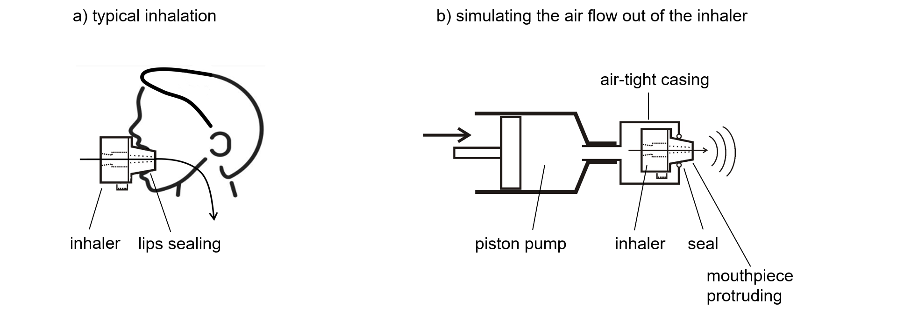
Figure 1 - a) Air is sucked into the patient’s lungs - b) Using a piston pump, air is pushed into an air-tight
casing from where it enters the inhaler and leaves
it through the mouthpiece.
Figure 1 shows the experimental settings which enable the generation of a relevant air flow through the inhalers. As the mouthpiece protrudes out of the enclosure, optical access is provided and all kinds of inhalers can be investigated applying the relevant air flow rates. For a first characterisation the flow rates of 30, 60, and 90 L/min have been selected. Video sequences have been captured during aerosol delivery at 120 frames per second. The aerosol front was delineated manually using a software called “skill spector” which converts the pixel position into distance and the frame number into time after suitable calibration. A fit procedure as given in Hochrainer et al. [1] was used to finally extract the velocity at 10 cm distance of the mouthpiece from the video data.
The different inhalers investigated are listed in Table 1 below. The selection consisted of one SMI (Respimat Spiolto), three pMDIs (Bevespi Aerosphere, Trimbow, and Trixeo Aerosphere) and five DPIs (Anoro Ellipta, Brimica Genuair, Trelegy Ellipta, Trimbow NEXThaler, and Ultibro Breezhaler). All inhalers were tested with their genuine drug formulation.
Results
Table 1 gives an overview of the aerosol front velocities as determined for different inhalers at a distance of 10 cm from the mouthpiece and depending on the air flow rate which is passing through the inhalers.
For the sake of comparison, the cross section areas of the mouthpiece openings were determined and the corresponding mean velocities were calculated. The SMI and the pMDIs result in relatively low calculated mean exit velocities due to their large cross sections. In contrast most DPIs show smaller exit geometries and this results in higher calculated mean exit velocities.

Discussion and conclusion
Figure 2 gives a graphical overview of the aerosol front velocities as determined for different inhalers at a distance of 10 cm from the mouthpiece. The new class of SMIs provides the opportunity of delivering slow aerosol plumes to the patient. All pMDIs show relatively high front velocities. Forced, fast and deep inhalation maneuvers (as used in DPIs) favour elevated exit velocities of the aerosol front and therefore contribute to deposition in the throat. Considering that all inhalers were tested with their own formulations and all drug specific MMADs were below 5 µm, it is expected that the API particles will make their way into the lung while the larger particles consisting of excipients will deposit by impaction in the oropharynx.

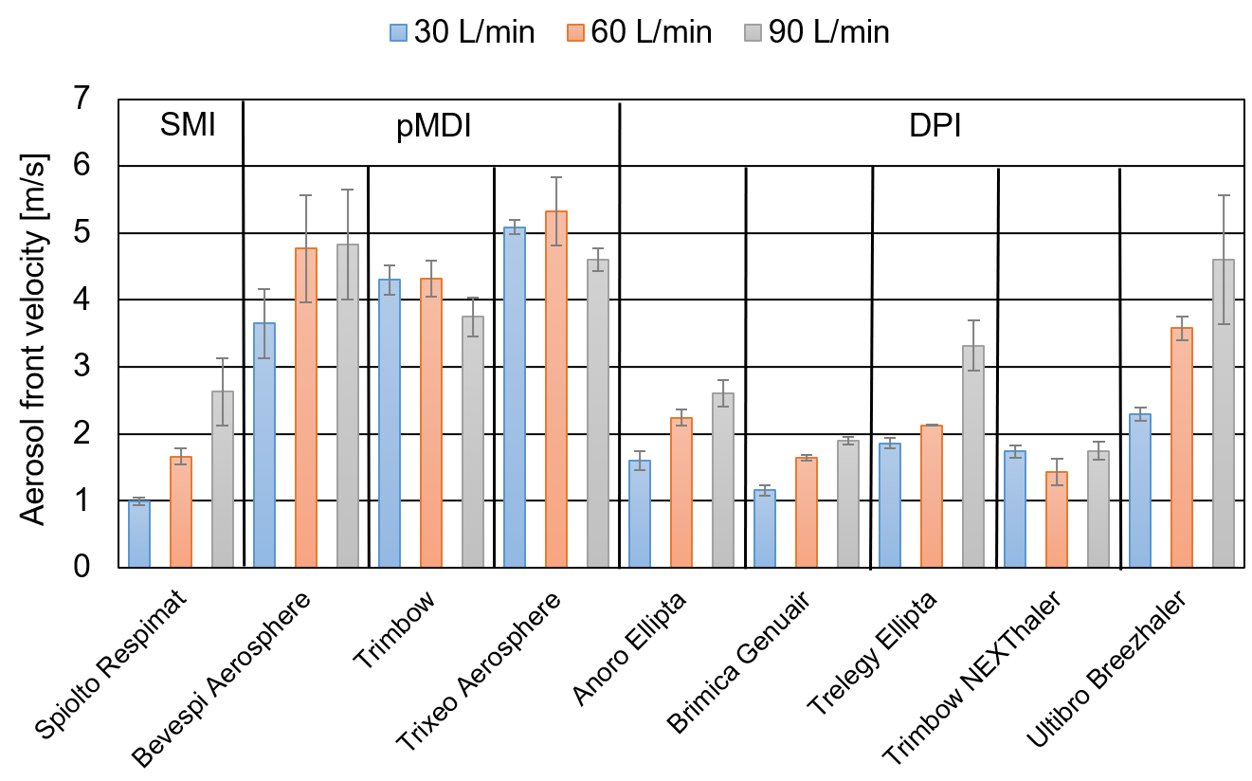
Figure 2 - Mean aerosol front velocity at 10 cm distance of the mouthpiece using the indicated inhalers with their own formulation. The inhalers were tested at the flow rates of 30, 60, and 90 L/min.
Table 1 - Mean aerosol front velocity at 10 cm distance of the mouthpiece and spray duration at all experimental air flow rates. For comparison, the theoretical mean air exit velocity at the mouthpiece exit is given in the last column.
Product | Device | Air flow rate (L/min) | Mean velocity at 10cm from mouthpiece (m/s), ± SD | Mean duration of plume (ms), ± SD | Cross section of mouthpiece  (mm²) | Calculated mean velocity at exit cross section (m/s)
Spiolto Respimat | SMI | 30 | 0.99 ± 0.06 | 1447 ± 25 | 283 | 1.8
Spiolto Respimat | SMI | 60 | 1.66 ± 0.12 | 1457 ± 25 | 283 | 3.5
Spiolto Respimat | SMI | 90 | 2.63 ± 0.50 | 1420 ± 10 | 283 | 5.3
Bevespi Aerosphere | pMDI | 30 | 3.65 ± 0.52 | 253 ± 6 | 273 | 1.8
Bevespi Aerosphere | pMDI | 60 | 4.77 ± 0.80 | 223 ± 15 | 273 | 3.7
Bevespi Aerosphere | pMDI | 90 | 4.83 ± 0.82 | 207 ± 12 | 273 | 5.5
Trimbow | pMDI | 30 | 4.30 ± 0.22 | 270 ± 0 | 256 | 2.0
Trimbow | pMDI | 60 | 4.32 ± 0.27 | 273 ± 12 | 256 | 3.9
Trimbow | pMDI | 90 | 3.75 ± 0.29 | 280 ± 10 | 256 | 5.9
Trixeo Aerosphere | pMDI | 30 | 5.09 ± 0.11 | 227 ± 21 | 271 | 1.8
Trixeo Aerosphere | pMDI | 60 | 5.32 ± 0.51 | 220 ± 10 | 271 | 3.7
Trixeo Aerosphere | pMDI | 90 | 4.60 ± 0.17 | 203 ± 6 | 271 | 5.5
Anoro Ellipta | DPI | 30 | 1.60 ± 0.14 | 143 ± 21 | 52.6 | 9.5
Anoro Ellipta | DPI | 60 | 2.24 ± 0.12 | 70 ± 10 | 52.6 | 19.0
Anoro Ellipta | DPI | 90 | 2.61 ± 0.20 | 60 ± 17 | 52.6 | 28.5
Brimica Genuair | DPI | 30 | 1.16 ± 0.08 | 137 ± 15 | 38.5 | 13.0
Brimica Genuair | DPI | 60 | 1.64 ± 0.04 | 163 ± 32 | 38.5 | 26.0
Brimica Genuair | DPI | 90 | 1.90 ± 0.06 | 153 ± 6 | 38.5 | 39.0
Trelegy Ellipta | DPI | 30 | 1.86 ± 0.08 | 73 ± 6 | 52.6 | 9.5
Trelegy Ellipta | DPI | 60 | 2.13 ± 0.01 | 60 ± 10 | 52.6 | 19.0
Trelegy Ellipta | DPI | 90 | 3.32 ± 0.37 | 47 ± 6 | 52.6 | 28.5
Trimbow NEXThaler | DPI | 30 | 1.74 ± 0.09 | 63 ± 6 | 51.5 | 9.7
Trimbow NEXThaler | DPI | 60 | 1.43 ± 0.20 | 100 ± 0 | 51.5 | 19.4
Trimbow NEXThaler | DPI | 90 | 1.75 ± 0.13 | 167 ± 6 | 51.5 | 29.1
Ultibro Breezhaler | DPI | 30 | 2.30 ± 0.10 | 1213 ± 189 | 88.2 | 5.7
Ultibro Breezhaler | DPI | 60 | 3.58 ± 0.18 | 750 ± 66 | 88.2 | 11.3
Ultibro Breezhaler | DPI | 90 | 4.60 ± 0.96 | 757 ± 410 | 88.2 | 17.0

[] Hochrainer D, Hölz H, Kreher Ch, Scaffidi L, Spallek M, and Wachtel H: Comparison of the Aerosol Velocity and Spray Duration of Respimat® Soft Mist™ Inhaler and Pressurized Metered Dose Inhalers, Journal of Aerosol Medicine 2005; 18(3): pp 273-282.
[] Houlden J, Jeanneret M, Cunha D & Ramjeeawon: Plume Front Velocity and Force to Actuation Characterisation of Pressurised Metered Dose Inhalers and Soft Mist Inhalers. Presented at: Drug Delivery to the Lungs 32, 2021 virtual conference, Dec 8-10, 2021; Drug Delivery to the Lungs 32, 2021, digital proceedings, pp 223-226.

