Assessment of Aerosol Characterisation and Delivery Performance of a Solution Using Different Configurations of a Breath-Actuated Mesh Nebuliser

Edgar H. Cuevas Brun, Ciou-Ting Wang, Yen-Ting Chen, Chih-Tsen Liu, Yu-Hsuan Lin & Yuan-Ming Hsu

HCmed Innovations Co. Ltd., Rm. B, 10F., No.319, Sec.2, Dunhua S. Rd., Taipei City, 10669, Taiwan

Summary
Delivery performance of a formulation using a mesh nebuliser is dependent on the physical chemical properties of the liquid substance. Several factors such a viscosity and surface tension can influence the performance of a delivery system affecting its effectiveness. Therefore, counting with a set of customisation approaches within a nebuliser platform can allow to explore and compute the outcome for parameters with different configurations. These customisation approaches could extend not only to hardware modifications, but also firmware changes within the algorithm of the nebuliser. The latter one being of particular significance for newer smart breath-actuated mesh nebulisers that are equipped with novel functions. In this study, a commonly nebulised bronchodilator was used to explore the delivery performance of the AdheResp smart breath-actuated mesh nebuliser platform, focusing on a two-stage study to demonstrate the influence of customisation capabilities. The first stage consisted of a hardware adjustment, by testing a selection of mesh pore sizes and recording its impact on droplet size distribution. At the second stage, firmware modifications in triggering span during inhalation were also tested to collect data on the delivery performance and implications for each configuration that generated information about the correlation between triggering span and treatment time, and its later influence on delivery rate through delivered dose assessment. Consequently, the overall scope of the study presents the benefits of an exploratory work at the development stage of a new drug-nebuliser combination product, aiming to identify the most suitable pair for the targeted delivery requirements.
Key Message
Customisation of a breath-actuated mesh nebuliser at the hardware and firmware levels can greatly benefit the exploration and identification of a suitable drug-nebuliser system, considering a formulation’s properties and the targeted performance.

Introduction
Direct delivery of a drug substance to the site where the therapeutic effect is required has been reported to enhance efficacy with lower dosage requirements and reduce potential systemic side effects [1]. When it comes to conditions affecting the respiratory system, the use of inhalers and nebulisers allow the prompt delivery of active pharmaceutical ingredients to the respiratory airways reaching the lungs. However, due to the variety in properties of liquid formulations, which may include solutions, liposomal suspensions and macromolecules, the appropriate aerosol characterisation performance and delivery can be highly dependent on the drug-device interaction [2].
Currently, mesh nebulisers are among the preferable devices to deliver new liquid formulations due to their lower shear forces and heat generation when compared to other nebulisers [3]. Nonetheless, formulations’ physicochemical properties, such as viscosity and surface tension, can considerably influence delivery performance [4]. To resolve this issue, customisation of a delivery system to better fit the formulation’s properties along with the identification of fundamental delivery factors to effectively target performance requirements is increasingly being considered in the development of new combination products.
When it comes to mesh nebulisers, the mesh membrane constitutes one of the key components of the delivery platform, hence modifications to its structure can lead to different performance outcomes, where pore size is commonly linked to the aerosol droplet size. Additionally, for breath-actuated nebulisers, the aerosol triggering span during inhalation can be associated to the treatment time and delivery rate, making of it another fundamental customisable element to adapt a delivery system to the formulations’ properties and targeted requirements. The mentioned factors are among a series of potential customisations that could allow an exploratory work to identify a desirable drug-device pairing.
In this study, a customisable breath-actuated mesh nebuliser platform was used to deliver a commonly prescribed bronchodilator in order to assess drug-nebuliser performance with different device configurations, which included a selection of mesh pore sizes and activation key tags for triggering span at two testing stages. The scope was set to demonstrate the influence of a delivery system customisation in aerosol characterisation and delivery performance to provide insights on the drug-nebuliser combination output.

Experimental Method
A standard breath-actuated mesh nebuliser (AdheResp®, HCmed Innovations Co. Ltd., Taiwan) was used as the delivery system in the study (Figure 1). In order to test different configurations within the standard platform, twelve main units with twelve medication reservoirs and three activation key tags were tested (Figure 2). The medication reservoirs were identified by pore size in three groups, 3.7µm, 3.9µm, and 4.1µm, with four reservoirs in each group. Moreover, as the AdheResp platform operates with a lock-and-key activation function to start treatment, each activation key tag was configured with a different inhalation triggering span algorithm, which included 40%, 60%, and 80%. The droplet size distribution tests were performed loading 0.5mL of albuterol 0.1% (M/V) concentration in 0.9% sodium chloride solution, while the delivered dose and treatment time studies were assessed loading 2mL of the same solution, which corresponds to an albuterol loaded dose of 2mg.
A two-stage study was applied to mimic an exploratory drug-nebuliser feasibility study. Droplet size distribution was conducted in the first stage of the study using a laser diffraction particle size analyser (Spraytec; Malvern, UK). The nebuliser was connected to a USP induction port, which was linked to an inhalation cell and pump, operating at a flow rate of 15L/min. Volumetric median diameter (DV50), fine particle fraction (FPF, <5µm), and geometric standard deviation (GSD) were recorded, aerosolising with the twelve reservoirs in triplicates. Similarly, a breath simulator (BRS 200i, Copley Scientific, UK), operating according to the US Pharmacopoeia (USP) <1601> for the adult breathing pattern (volume: 500 mL; frequency: 15 cycles/min; waveform: sinusoidal; Inspiration/Expiration ratio = 1:1) was used to assess the delivered dose, treatment time, delivery rate, and respirable dose (<5µm) of the same reservoirs in triplicates. Quantification of albuterol was evaluated with a ultraviolent-visible (UV-Vis) spectrophotometer (Lambda 365, Perkin Elmer, US) at wavelength 276 mm. Activation of the main unit during stage one was carried out with the 60% activation key tag.
For the second stage, the mesh pore size group that generated the smallest DV50 was selected arbitrarily, and the three activation key tags were used to assess delivered dose with the same breath simulator setup as in stage one. Three replicates were performed for each of the four reservoirs to deliver albuterol.
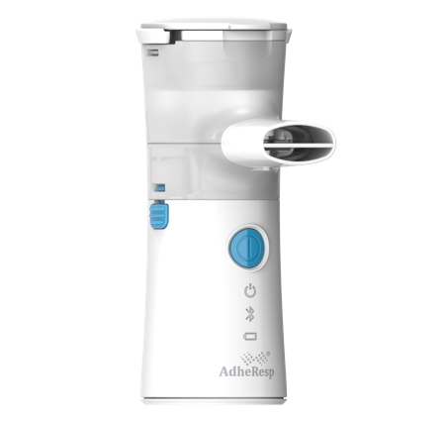
Figure 1 - AdheResp Smart Breath-actuated Mesh Nebulizer
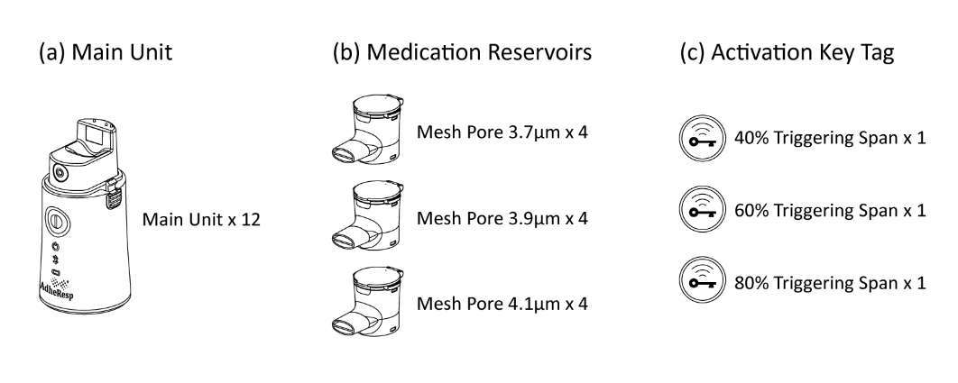
Figure 2 - AdheResp Nebulizer Components Used in the Study

Results
In stage one, droplet size distribution data for the three groups of AdheResp reservoirs is displayed in Table 1. DV50 ranged from 3.59 to 4.58 µm, showing increasing average particle size with increasing pore size as expected. FPF was inversely proportional to pore size, ranging from 55.7 to 70.9%, while the GSD ranged from 1.70 to 1.82. The summarised data for the testing with the breath simulator is shown in Table 2. The results present a clear inverse correlation between pore size and treatment time.
Table 1 - Aerosol characterisation conducted with laser diffraction particle size analyser, nebulising 0.1% albuterol with the 60% triggering span activation key (n=4, triplicates)
Pore Size | DV50 (µm) |  | FPF (%) |  | GSD
Pore Size | Mean | SD | Mean | SD | Mean | SD
3.7 µm | 3.83 | 0.16 | 67.1 | 2.6 | 1.75 | 0.03
3.9 µm | 4.27 | 0.24 | 60.4 | 3.6 | 1.74 | 0.03
4.1 µm | 4.41 | 0.11 | 58.3 | 1.6 | 1.75 | 0.03

Table 2 - Collected data with the breath simulator for different pore size groups under 60% triggering span, nebulising 0.1% albuterol (n=4, triplicates)
Pore Size | Treatment Time (mm:ss) |  | Delivered Dose (%) |  | Delivery Rate (mg/min) |  | Respirable Dose (mg)
Pore Size | Mean | SD | Mean | SD | Mean | SD | Mean | SD
3.7 µm | 11:31 | 01:20 | 81.9 | 4.2 | 0.14 | 0.01 | 1.10 | 0.09
3.9 µm | 09:05 | 00:39 | 81.8 | 1.4 | 0.18 | 0.01 | 0.99 | 0.05
4.1 µm | 07:16 | 00:27 | 77.6 | 4.1 | 0.22 | 0.01 | 0.91 | 0.05

As the mesh group 3.7µm generated the smallest DV50, it was arbitrarily selected for the second stage in which the four medication reservoirs were tested with the three activation key tags. Table 3 summarises the delivery performance for the three spans, displaying an inverse correlation between the triggering span and the treatment time. Figure 3 shows the delivery rate, respirable dose, and delivered dose results for tests perform with the breathing simulator.
Table 3 - Collected data with the breath simulator for different triggering spans, using the 3.7µm pore size mesh group and nebulising 0.1% albuterol (n=4, triplicates)
Key Tag | Treatment Time (mm:ss) |  | Delivered Dose (%) |  | Delivery Rate (mg/min)
Key Tag | Mean | SD | Mean | SD | Mean | SD
40% | 17:26 | 01:39 | 84.2 | 3.4 | 0.10 | 0.01
60% | 11:31 | 01:20 | 81.9 | 4.2 | 0.14 | 0.01
80% | 08:34 | 00:57 | 71.9 | 4.1 | 0.17 | 0.01

A. B.

Figure 3 – (A) Delivery rate and respirable dose for different pore size groups with a triggering span of 60%;
(B) Delivery dose and delivery rate using 3.7 µm pore size meshes with different triggering spans

Discussion
Customisation of a nebuliser system can be made at hardware and software levels. For a mesh nebuliser’s membrane, there are several aspects that govern its configuration, with material, pore shape, thickness, pitch, and pore size, being among the most commonly stated. In this study, the influence of mesh pore size on droplet size distribution and delivery rate was demonstrated. An increase in droplet size can be directly attributed to the increase in pore size as the orifices for liquid to pass through the mesh membrane to generate aerosol enlarge. At the same time, the effect can also be reflected in the treatment time, where larger openings allow for more aerosol release at a single unit time, reducing the overall treatment duration, while modestly increasing the delivery rate as the delivered dose is lightly affected by the difference in pore size.
The second factor covered in this study addressed firmware modifications for the breath-actuated platform. Breath-actuated nebulisers have been reported to enhance drug delivery and reduce fugitive aerosol emission, generating aerosol only during a specific fraction of the inhalation phase [5]. The triggering span at each inhalation affects delivery efficiency aspects, resulting in variations of treatment time and efficiency. Based on the results, within approximately a 3-minute treatment time difference, the 60% triggering span delivered 10% higher dose than the 80% span, although the latter one had a higher delivery rate. Moreover, a much higher delivered dose was achieved with the 40% triggering span but at the cost of considerably extending the treatment time. By defining the requirements and performance parameter priorities, it is possible to identify and select a combination that better suits the expectations of the drug-nebuliser system. This strategy does not only generate a useful pool of data sets demonstrating the performance for each configuration, but also benefit the early development of the combination product.

Conclusion
The interaction between formulations and drug delivery systems can lead to a broad number of outcomes. Nonetheless, counting with a range of customisable approaches within a single platform, such as a nebuliser, to deliver a formulation allows to identify the most suitable drug-nebuliser combination pair within the specified target requirements. Moreover, by conducting feasibility and exploratory tests with mesh components and firmware configuration, it is possible to create a matrix that allows the selection of a fine-tuned combination system.
For the development of highly efficient drug-nebuliser combination products, defining performance requirements is a common practice that can be fulfilled by recognising the propriate configuration of the system. Although this study focused on commonly delivered solutions, its scope can also be referenced to difficult-to-deliver formulations that may include higher levels of viscosity or sensitive molecules, which could require even more highly selective tuning. Furthermore, formulation selection and adjustments can also be considered at the development stage to add to the flexibility in customisation of the delivery system in new drug-nebuliser combination products.

References
- Borghardt J M, Kloft C, Sharma A: Inhaled Therapy in Respiratory Disease: The Complex Interplay of Pulmonary Kinetic Processes, Can Respir J 2018; 2732017.
- Sala V, Murabito A, Ghigo A: Inhaled Biologicals for the Treatment of Cystic Fibrosis, Recent Pat Inflamm Allergy Drug Discov 2019; 13(1): pp 19–26
- Matthews A A, Ee P L R, Ge R: Developing Inhaled Protein Therapeutics for Lung Diseases. Mol Biomed 2020; 1(1): 11.
- Dobrowolska K, Miros, M, Sosnowski T R: Impact of Natural-Based Viscosity Modifiers of Inhalation Drugs on the Dynamic Surface Properties of the Pulmonary Surfactant. Materials (Basel) 2023; 16(5); 1975.
- Cuevas Brun E H, Wang C T, Chen Y T, Chen J S, Hsu Y M: Assessment of Fugitive Aerosol Emission During Actuation of a Breath-actuated Mesh Nebuliser. Presented at: Drug Delivery to the Lungs 2022, Edinburgh, Scotland, December 7-9; Volume 33.

