Do In-vitro dissolution rates differ between beclomethasone dipropionate particles generated from solution-based pMDIs formulated with HFA134a, HFA152a and HFO1234ze(E) propellants?

Hui Xin Ong^{1,2}, Nirmal Marasini¹, Lingzhe Rao³, Daniel Duke³, Damon Honnery³, Stephen W. Stein⁴, Benjamin Myatt⁵, Phil Cocks⁵ & Paul Young^{1,6}

¹ Respiratory Technology, Woolcock Institute of Medical Research, Glebe, Sydney, NSW 2037, Australia

²Macquarie Medical School, Faculty of Medicine, Healthy and Human Sciences, Macquarie University, Sydney, NSW 2109, Australia

³Laboratory for Turbulence Research in Aerospace & Combustion (LTRAC), Department of Mechanical & Aerospace Engineering, Monash University, Melbourne, Australia

⁴Kindeva Drug delivery, 11200 Hudson Road, Woodbury, MN 55129

⁵Kindeva Drug Delivery, Charnwood Campus, 10 Bakewell Road, Loughborough, United Kingdom, LE11 5RB

⁶Department of Marketing, Macquarie Business school, Macquarie University, Sydney, NSW 2109, Australia

Summary

The switch from Hydrofluoroalkane 134a (HFA134a), with relatively high global warming potential (GWP), traditionally used in pressurised metered-dose inhalers (pMDI) to low GWP propellants HFO1234ze(E) and HFA152a is currently underway, posing numerous scientific questions and challenges to formulation development. This study aims to investigate the morphological properties of maturated beclomethasone dipropionate (BDP) particles generated from solution-based pMDIs formulated with three different propellants and the impact of these characteristics on in-vitro drug dissolution. To achieve this, a modified Andersen Cascade Impactor (ACI) that incorporates SnapwellTM inserts on a 3D-printed ACI plate was used to deposit and study the aerosol particles of specific aerodynamic size ranges produced from the three different pMDI formulations. The Snapwell insert was then used as a micro-dissolution apparatus. The dissolution rate of the drug particles over four hours showed the following rank order: HFA134a > HFO1234ze(E) > HFA152a. This could be attributed to the morphologies of the drug particles found on stage 5 of the ACI where HFA134a produced maturated particles with the smallest geometric size of both the corrugated/rough (1.45 µm) and smooth/spherical particles (0.78 µm) with a higher percentage (53%) of rough/irregular particles in comparison with HFO1234ze(E) and HFA152a formulations. From these initial findings, a thorough investigation into the morphology and dissolution performance in combination with detailed physicochemical profiles and aerosol performance of the particles is required to understand the effect of the new propellants when formulating next the generation low GWP pMDIs.
Key Message
Transitioning from current HFA to new low GWP propellants can influence maturated aerosolised particle morphology and geometric particle size that may in turn affect in-vitro particle dissolution behaviour.

Introduction

As the transition towards more environmentally friendly low GWP propellants is underway the inhalation pharmaceutical industry has been presented with unique technical challenges due to the differences in the physicochemical properties of these next generation propellants compared to HFA134a [1]. These challenges include reformulation of existing drugs into new propellants resulting in aerodynamic and physicochemical product differences that could potentially lead to differences in pharmacokinetics and pharmacodynamics. While most current studies [2,3] have been focused on understanding the physicochemical properties of the propellants, the aerodynamic behaviour and morphology of maturated particles generated from solution-based drug pMDIs, using low GWP propellants, such as HFA152a and HFO1234ze(E) is poorly understood. Variation in maturated particle morphology, geometric size, and physico-chemical characteristics could potentially lead to differences in absorption and efficacy in-vivo. Hence, the aim of this study is to understand the impact of the new propellants on drug particle morphology, specifically geometric particle size, surface roughness and drug dissolution kinetics.

While impactors are highly accredited tools by US and British Pharmacopoeia to study the aerodynamic behaviour of aerosols generated from inhaler products (including pMDIs), they lack information on the processes that occur after the aerosols deposit in the airways, including drug wetting, dissolution, diffusion, and bioavailability. In a recent study by Haghi et al. [4] and Ong et al. [5], an ACI was modified to integrate air-liquid interface (ALI) cultures of Calu-3 cells, on reusable 3D-printed ACI plates to evaluate the effects of particle size of commercial pMDI formulations and different devices on drug transport. The modified ACI plate could be placed on any stage of the impactor to collect aerosol particles of specific aerodynamic size ranges for drug transport studies on cells. The present study will modify the use of this setup by omitting the use of the cellular model to produce an in-vitro micro-dissolution apparatus for the dissolution study of inhaled aerosol particles generated from pMDI formulations with different propellants. The use of wetted Snapwell membranes as a particle capture surface closer represents the physiological lung conditions to that of conventional dissolution apparatus and provides a more realistic approach to better understand drug particle dissolution, where there is a limited volume of solution for dissolution to occur. This modified ACI setup, coupled with the in-vitro micro-dissolution apparatus, could prove to be a useful tool to better understand formulation behaviour after aerosolization and subsequent deposition in the airways, and provide an insight into the most important variables that could influence clinical performance.

Materials and methods
Materials
pMDI aerosols containing BDP (an inhaled corticosteroid) and ethanol (HPLC grade, Sigma-Aldrich, Castle Hill, New South Wales, Australia) were manufactured. Propellant HFA134a was supplied by Ineos Fluor Ltd. (Cheshire, UK). Technical grade HFA152a and industrial grade HFO1234ze(E) were supplied from Ace Cryogenic (Kings Park, New South Wales, Australia). Phosphate buffer saline (PBS) was supplied by Sigma-Aldrich (Castle Hill, New South Wales, Australia). Milli-Q water (Milli-Q, Millipore France) was used where required.
Preparation of solution-based pMDIs
pMDIs were formulated at 2 mg/mL BDP which was solubilised in 8% w/w ethanol which was directly dispensed into 19 mL aluminium canisters (H&T Presspart, UK). The canisters were immediately crimped with 50 µL metering valves (Bespak, UK). The canisters were pressure-filled with different propellants using a Pamasol Laboratory plant P2016 (Pamasol Willi Maäden AG, Paffikon, SZ). The filled pMDIs were sonicated for five minutes and stored for at least three days to allow for valve equilibrium before testing. An actuator (Kindeva Drug Delivery, UK) with a spray orifice diameter of 0.3 mm and orifice length of 0.8 mm was used for testing.
Evaluation of particle dissolution
A modified ACI was used to deposit and study the dissolution of maturated BDP particles generated from each of the pMDI formulations. Briefly, a custom-made ACI plate that could accommodate eight SnapwellTM inserts (12 mm diameter, 0.4 µm pore, polyester membrane, Corning, USA) was designed and manufactured using a 3D printer, as previously described [4]. The modified plate, containing the inserts, replaced stage 5 of the ACI, which was operated at a flow rate of 28.3 L/min to collect aerosolised maturated particles. To prevent particle bounce on the cell-free Snapwells, the inserts were wetted with phosphate buffered saline (PBS). Following one actuation from each of the pMDI formulations, the modified ACI plate was removed and two Snapwells were carefully transferred into a six-well plate, containing 2 mL of fresh, pre-warmed PBS. The setup was maintained at 37°C in 5% CO₂ and 95% humidity throughout the experiment. Samples of 200 μL were drawn at pre-determined timepoints from the basolateral chamber and an equal volume of fresh PBS was added to replace the sample that was withdrawn. At the final time point, the insert was transferred to an empty well and the surface of the membrane was gently washed with PBS to collect any remaining drug on the membrane and samples analysed using HPLC [6]. The total amount of drug deposited on the inserts was considered as the cumulative sum of drug that permeated across the Snapwell membrane and the drug recovered from the membrane surface at the final time point. Four separate replicates of the experiments were performed (total Snapwells investigated n=8)
Morphology of the particles
The morphology of maturated BDP particles emitted from each pMDI which had deposited on the Snapwells on the modified ACI Stage 5 plate were visually inspected using scanning electron microscopy (SEM) (JCM-6000PLUS Neoscope, JEOL, Japan). Circular carbon-coated adhesive discs were mounted on the centre of the Snapwell insert to capture the particles deposited after actuation of each pMDI. The ACI was operated as described in the previous section. The adhesive discs were then collected, mounted on a brass stub and sputter coated (Smart Coater, JEOL, Japan) with gold for 2 minutes, prior to SEM analysis. SEM images were taken at a magnification of 3,000 X and analysed using Image J (Version 1.53, NIH).
Statistical analysis
The differences among groups of SEM results were determined using one-way analysis of variance (ANOVA) followed by post-hoc Tukey tests using Prism 9 (GraphPad Software, USA). The difference was considered significant if the p-value was ≤ 0.05. Across all tests, unless otherwise stated, measurements were conducted in triplicate and the average ± standard deviation is reported.
Results and Discussion
Dissolution of the aerosolised maturated particles
Figure 1A shows the dissolution profiles of maturated BDP drug particles emitted from pMDIs containing different propellants, collected on stage 5 of a modified ACI operating at a flow rate of 28.3 L/min, over a four-hour period (Figure 1). Stage 5 was chosen for this study based on the aerodynamic deposition profiles (data not shown) that showed the highest BDP deposition with no significant differences in mass deposition between the different propellant formulations. The average mass of BDP deposited on each Snapwell was approximately 0.36 ± 0.09 μg across the different formulations. The in-vitro dissolution kinetics of the BDP particles, with respect to propellant, showed the following rank order from highest to lowest: HFA134a > HFO1234ze(E) > HFA152a. The dissolution kinetics of the maturated particles from the different pMDI formulations were statistically analysed and compared using Moore and Flanner’s Fit Factors (Figure 1B) [7], as was adopted by the Food and Drug Administration guidance for industry dissolution testing [8]. The Fit Factor model has independent approaches to compare release profiles for a test and reference formulation using a difference factor (f₁) and a similarity factor (f₂). For curves to be considered different, limits with f₁ ≥ 15 and f₂ ≤ 50 were chosen for analysis [8]. It was found that the in-vitro dissolution kinetics of the maturated particles produced from the HFA134a formulation were different to particles from the HFA152a formulation, while the dissolution kinetics of particles from the HFO1234ze(E) formulation were similar to particles from the HFA152a formulation. However, the differences in dissolution profiles of particles produced from HFA134a and HFO1234ze(E) formulations were not as explicit (f₁ > 15 and f₂ > 50), which is likely due to their similarities in dissolution rates at the earlier time points up to 120 minutes (p value >0.05), which then deviate significantly beyond 150 minutes (p-value < 0.05, as analysed using ANOVA for a specific time point comparing the groups). Differences in the dissolution profiles of the maturated BDP particles produced from the different formulations could be attributed to their morphologies [9, 10], which will be explored in the following section.
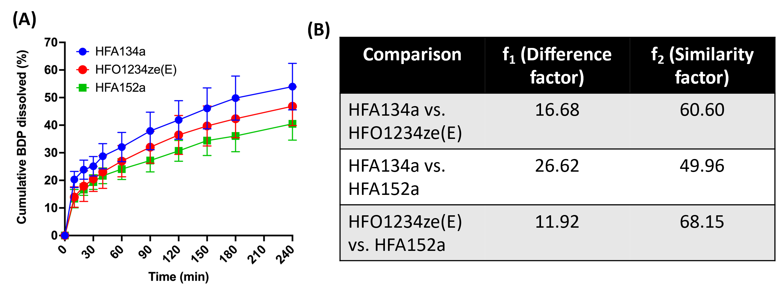
Figure 1. (A) Dissolution profiles of BDP particles deposited on stage 5 of the modified ACI measured over four hours. Results are reported as average ± SD, (n=8). (B) Comparison of difference (f₁) factor and similarity (f₂) factor of the dissolution profiles
Particle morphology
The morphologies of the maturated BDP particles collected on stage 5 of the modified ACI for the different pMDI formulations were evaluated using SEM (Figure 2). A total of at least 500 particles were counted for the analysis over 4 independent depositions. In general, all pMDI formulations produced a mixture of particles with either corrugated/rough or smooth/spherical surfaces.
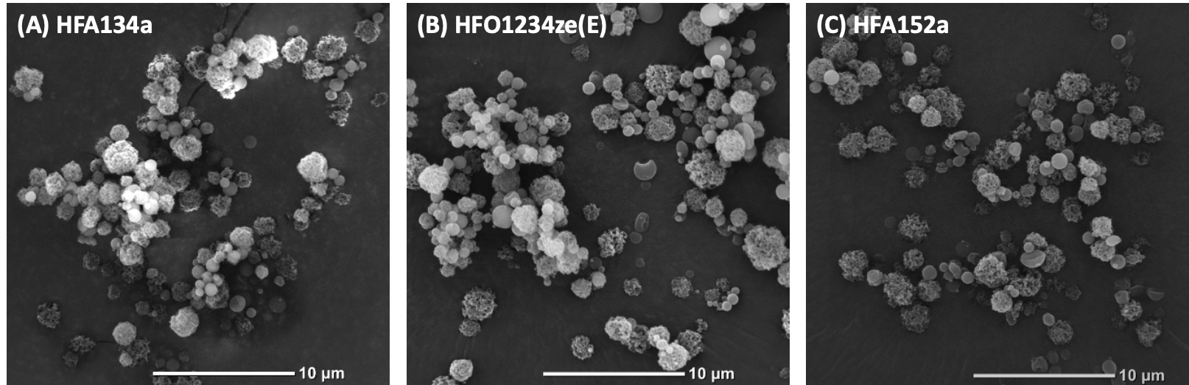
Figure 2. Scanning electron micrographs (SEM) of the maturated particles collected on stage 5 of the modified ACI from pMDI formulations produced using different propellants at a magnification of 3000X.
The SEM micrographs were further processed in Image J using a threshold algorithm to locate the BDP particles and determine their surface characteristics and geometric size (Figure 3). pMDI formulations of HFA152a and HFA134a produced a similar ratio of corrugated/rough to smooth/spherical particles while the HFO1234ze(E) pMDI formulation produced a significantly higher percentage of smooth/spherical particles and a corresponding lower percentage of corrugated/rough particles (p-value= 0.002). Despite having the same aerodynamic particle size characteristics, further geometric particle size analysis of the particles emitted from each formulation revealed that the corrugated/rough particles were significantly larger (1.45-1.72 µm) than the smooth/spherical particles (0.78-0.86 µm) (Figure 3B). Moreover, it was found that the HFA134a formulation generated BDP particles with smaller geometric size for both smooth/spherical and corrugated/rough particles compared to both low GWP propellant formulations. Indeed, the corrugated particles emitted from HFA134a were smaller (~1.45 µm) compared to HFO1234ze(E) (~1.71 µm) and HFA152a (~1.72 µm), while the smooth/spherical surface particles emitted from the HFA134a and HFO1234ze(E) formulations were also significantly smaller (~0.78 µm and ~0.80 µm respectively) compared to HFA152a (~0.86 µm).
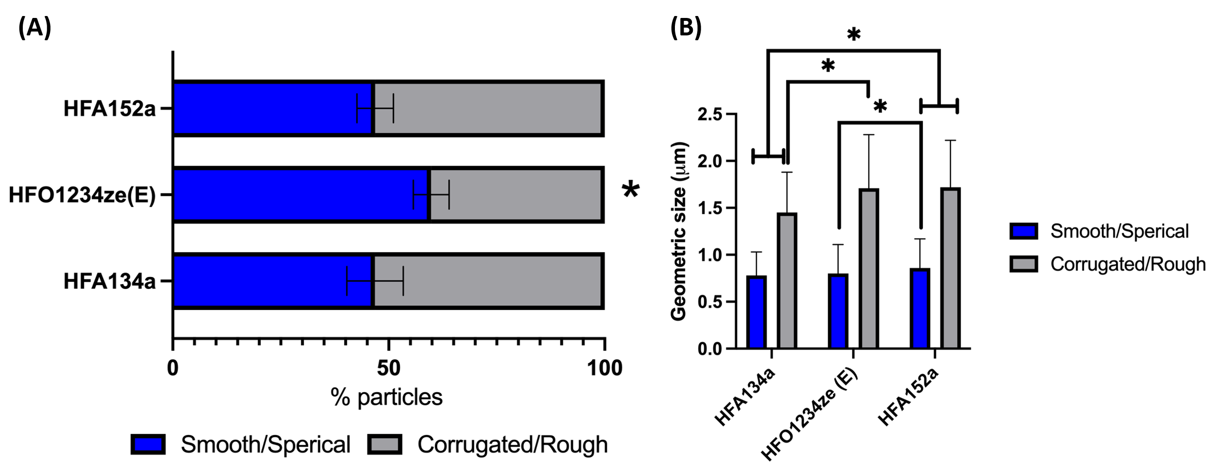
Figure 3. SEM analysis of maturated drug particles morphologies in terms of: (A) percentage of smooth and corrugated particles and (B) geometric size of the particles. *p-value <0.05

While geometric particle size and morphology have been shown to affect the solubility and dissolution characteristics of poorly soluble drugs in general, this is the first study to show that the in-vitro dissolution rates of inhalable maturated particles produced from pMDIs formulated with the new low GWP propellants may be affected by these properties [9, 10]. Our findings showed that maturated BDP particles produced from the HFA134a formulation had the smallest geometric size of both corrugated/rough and smooth/spherical particles and a higher percentage of corrugated/rough particles, which could have led to the faster dissolution rate observed. This contrasted with the HFO1234ze(E) formulation that produced a higher proportion of smooth/spherical particles and the HFA152a formulation which produced larger geometric particles. It is important to note that particles collected on stage 5 of the ACI represent an aerodynamic particle size distribution between 1.1 µm and 2.1 µm at a flow rate of 28.3 L/min. For a given aerodynamic particle size, this study shows that a decrease in geometric particle size and an increase in the proportion of corrugated/rough particles produced resulted in faster dissolution. This is likely due to an increase in the surface area of each particle and decrease in diffusion layer thickness around each particle [10].

Conclusions: Our findings in this study revealed that changing the propellant in a pMDI formulation influenced the morphology (corrugated/rough vs smooth/spherical) as well as the mean geometric size of the emitted maturated particles from the BDP solution formulations tested, suggesting these properties had a statistically significant impact on the rate of in-vitro drug dissolution.

Acknowledgement
This work is funded by the Australian Research Council (LP190100938).

References
[] Wilkinson A, Woodcock A: The environmental impact of inhalers for asthma: A green challenge and a golden opportunity. Br J Clin Pharmacol 2022, 88 (7), 3016-3022.
[2] Baron C, Ganley W: Navigating pMDI Reformulation 2.0. ONdrugDelivery, Issue 145 (Apr 2023), pp 12–17.
[3] Rossi I, Ganley WJ, Kwok PC, Zadrazil I, Hassall G, Michelet O, Sarrailh S, Brouet G, Price R, Shur J, Sheth P:Fundamental properties of propellant aerosols can guide transition to low global warming potential pMDIs: size, velocity and surface charge. Drug Delivery to the Lungs. 2021;33.
[4] Haghi M, Traini D, Young P: In vitro cell integrated impactor deposition methodology for the study of aerodynamically relevant size fractions from commercial pressurised metered dose inhalers. Pharmaceutical research. 2014 Jul;31:1779-87.
[5] Ong HX, Traini D, Loo CY, Sarkissian L, Lauretani G, Scalia S, Young PM: Is the cellular uptake of respiratory aerosols delivered from different devices equivalent?. European Journal of Pharmaceutics and Biopharmaceutics. 2015 Jun 1;93:320-7.
[6] Zhu B, Traini D, Cha H-K, Young PM: The effect of ethanol on the formation and physico-chemical properties of particles generated from budesonide solution-based pressurized metered-dose inhalers. Drug Dev. and Ind. Pharm. 2013, 39 (11), 1625-1637.
[7] J.W. Moore, H.H. Flanner: Mathematical comparison of dissolution profiles, Pharm. Tech., 20 (1996) 64-74.
[8] F.a.D. Administration: Guidance for Industry; Dissolution Testing of Immediate Release Solid Oral Dosage Forms, in, August 1997.
[9] Khadka P, Ro J, Kim H, Kim I, Kim JT, Kim H, Cho JM, Yun G, Lee J: Pharmaceutical particle technologies: An approach to improve drug solubility, dissolution and bioavailability. Asian journal of pharmaceutical sciences. 2014 Dec 1;9(6):304-16.
[10] Chu KR, Lee E, Jeong SH, Park ES: Effect of particle size on the dissolution behaviors of poorly water-soluble drugs. Archives of pharmacal research. 2012 Jul;35:1187-95.

