Potential use of cannabinoids to combat against methicillin-resistant Staphylococcus aureus pneumonia: A pre-formulation study

Pancy Tsz Hei Kwong¹, Theerthankar Das², Jonathon Carl Arnold³, Hak-Kim Chan¹ & Philip Chi Lip Kwok¹

¹Advanced Drug Delivery Group, Sydney Pharmacy School, Faculty of Medicine and Health, The University of Sydney, NSW 2006, Australia

²Ingham Institute for Applied Medical Research, Microbiology and Infectious Diseases, School of Medicine, Western Sydney University, NSW 2170, Australia

³Lambert Initiative for Cannabinoid Therapeutics, Brain and Mind Centre, The University of Sydney, NSW 2050, Australia

Summary
Methicillin-resistant Staphylococcus aureus (MRSA) is a major cause of hospital-acquired lung infections. MRSA is likely to form a biofilm in the lungs, rendering the infection more difficult to eliminate which often results in treatment failure. Due to the challenges in treating MRSA pneumonia, the administration of high doses of antibiotics frequently leads to severe adverse effects. In this study, potentially more tolerable, non-psychoactive cannabinoids – cannabidiol (CBD), cannabigerol (CBG), and cannabinol (CBN) were investigated for their activity against a MRSA isolate cultured in a biofilm. CBN was discovered to be the most potent candidate with anti-MRSA biofilm activity, shown by reductions in biofilm biomass and bacterial viability. In particular, CBN exhibited efficacy in killing more than 80% of the bacteria in the biofilm at 1 µg/mL, whereas CBD and CBG were less effectively, with 10% and 60% reduction in viability, respectively. Only CBN demonstrated significant biofilm dispersal effect at all concentrations. With their penetration through the extracellular matrix and potent antibiofilm activity against MRSA, cannabinoids present an exciting opportunity for the development of inhalable formulations to treat bacterial pneumonia.
Key Message
Cannabinoids showed activity against MRSA biofilms in vitro by reducing biofilm biomass and bacterial viability. They have the potential to be formulated as an inhalable formulation that is locally effective against MRSA pneumonia.

Introduction
Methicillin-resistant Staphylococcus aureus (MRSA) is a prominent cause of nosocomial pneumonia and is frequently linked to illness, death, extended hospital stays, and financial burdens¹. Patients who have had a hospital stay, require the use of a ventilator, or suffer from cystic fibrosis have higher risks in developing MRSA pneumonia². According to The World Health Organization, patients with MRSA infection are 64% more likely to die than those with drug-sensitive infections³. In particular, MRSA is a well-known pathogen causing a variety of biofilm-associated pneumonia by releasing surface proteins⁴. Eliminating biofilms from the airways is 10 – 1000 times more difficult than eliminating planktonic cells⁵. Linezolid and vancomycin are the conventional drugs for treating MRSA pneumonia⁶. However, the use of linezolid is associated with potential severe adverse effects, including haematological disorders⁷. On the other hand, vancomycin is nephrotoxic⁷. Furthermore, there are emerging cases of resistance to vancomycin and even linezolid in hospitals⁸. Hence, the discovery of new antimicrobial agents for MRSA pneumonia is urgently needed to fight the threat.
Cannabinoids have a good potential as new antibiotic candidates. They are isolated from the Cannabis sativa L plant, which has been used to treat infectious diseases for centuries⁹. The most common cannabinoids are Δ⁹-tetrahydrocannabinol (THC), cannabidiol (CBD), cannabigerol (CBG), and cannabinol (CBN). All of them exert modest antibacterial effect against different MRSA strains with a minimum inhibitory concentration (MIC) from 1 – 4 µg/mL¹⁰. More importantly, they have low propensity to induce resistance, which makes them appealing choices for treating MRSA pneumonia¹⁰.
Considerable research has been conducted on their antimicrobial properties against planktonic bacterial cells but their activity on biofilm is little known. Therefore, the antibiofilm activity of CBD, CBG, and CBN against MRSA was investigated in this study. THC was not included in this study because it is psychoactive and may cause related side effects when used in vivo.

Materials
CBD, CBG, and CBN were purchased from THC Pharm (Frankfurt, Hesse, Germany). Cation-adjusted Mueller Hinton broth (MHB), bacteriological agar, and tryptone soy broth (TSB) were bought from Amyl Media (Adelaide, South Australia). Dimethyl sulfoxide (DMSO), acetic acid, crystal violet and resazurin sodium were purchased from Sigma-Aldrich (St. Louis, Missouri, United States), while phosphate buffered saline (pH 7.4) was supplied by Thermo Fisher Scientific (Waltham, MA, United States). Ultra-purified water (resistivity 18.2 MΩ·cm) was obtained from a Milli-Q water system (Millipore, Bedford, MA, USA).
Method
Bacterial strain
MRSA ATCC 43300, a reference strain, was used. Before the experiment, the bacteria were subcultured from a -80°C frozen stock on agar plates and incubated at 37°C until colonies were formed.
MIC assay
The MIC of CBD, CBG, and CBN were determined using a microtiter plate method with two independent biological replicates with three technical repeats each¹⁰. Cannabinoids were dissolved and diluted in DMSO to concentrations ranged from 0.1 - 3.2 mg/mL. MRSA was cultured in MHB for 18 h at 37°C with continuous shaking at 150 rpm. The overnight culture was diluted with fresh MHB and incubated at 37°C at 150 rpm until it reached early-log phase. The early-log cultures were harvested by centrifugation (3200 g, 10 min) and resuspended in PBS with optical density at 600 nm (OD₆₀₀) adjusted to 0.4 ± 0.01. The resulting bacterial culture was further diluted to achieve 5 x 10⁵ cfu/mL. Afterwards, 1 µL of cannabinoid was added to 199 µL of bacterial culture in a 96-well plate, resulting cannabinoid concentrations from 0.5 – 16 µg/mL. The microplates were incubated for 18 h at 37 °C with continuous shaking. OD₆₀₀ was then measured by a microplate reader (Victor multilabel Plate Reader, Perkin Elmer, United States) to determine the MIC, which was the lowest concentration of the cannabinoid at which the culture showed no turbidity.
Crystal violet biofilm biomass assay
Crystal violet assay was performed in 24-well plates. Cannabinoid solutions were prepared as for the MIC assay but with concentrations from 100 – 800 µg/mL. MRSA was grown in TSB for 24 hours at 37°C with continuous shaking at 150 rpm and harvested by centrifugation (3200 g, 10 min). The bacterial pellet was resuspended in fresh TSB. The resulting bacterial culture (60 µL) was added to the wells of a 24-well plate containing 940 µL of fresh TSB and incubated for 24 h at 37 °C with continuous shaking to initiate biofilm growth. After incubation, the supernatant was cleared out carefully and replaced with 995 µL of PBS, followed by 5 µL of cannabinoid solution to achieve the desired concentrations (0.5 – 4 µg/mL). The plates were incubated for a further 24 h under the same conditions. After 24 h treatment, the supernatant was removed and stained with 0.1% w/v crystal violet for another 24 hours. The wells were washed multiple times with Milli-Q water to ensure the complete removal of the free dye and then allowed to air dry. To dissolve the crystal violet, 1 mL of 30% v/v acetic acid in water was added into each well and incubated for 1 h at room temperature. Lastly, OD₆₀₀ was measured by a microplate reader to determine the relative biofilm biomass. Two biological replicates with four technical repeats each were performed.
Resazurin biofilm viability test
Biofilm and cannabinoids treatment were prepared in the same manner as for the crystal violet assay. After 24 h treatment, the supernatant was removed and 1 mL of PBS added. Seventy-five microlitres of 0.05% w/v resazurin solution was added to the wells and the plates were incubated for 4 more hours at 37°C with continuous shaking. The fluorescent intensity was measured by a microplate reader with an excitation wavelength at 550 nm and an emission wavelength of 590 nm to determine the relative biofilm viability. The experiment was conducted with two biological replicates with four technical repeats each.
Statistical analysis
The collected data was statistically analysed using ANOVA (analysis of variance) followed by a Tukey post hoc test. The analysis was conducted at a confidence level of 95% to determine significant differences. A probability (p) value < 0.05 was considered statistically significant.

Results and Discussion
Antibiofilm activity of CBD, CBG, and CBN was observed in this study. The MIC assay was conducted to screen the antibacterial potency of the cannabinoids against the MRSA reference isolate. CBD and CBG exhibited the same MIC (2 µg/mL), whereas that of CBN was 1 µg/mL, indicating its higher potency. Despite the similar chemical structures of the cannabinoids (Figure 1), a small difference in their structure may affect their antibacterial potency.
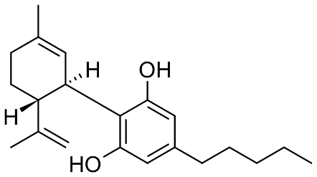  Cannabidiol | 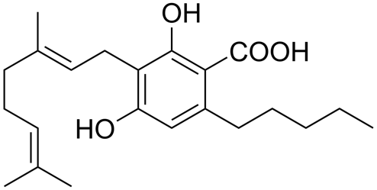  Cannabigerol | 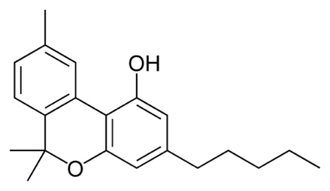  Cannabinol
Figure 1 – The chemical structures of cannabidiol, cannabigerol, and cannabinol.
Figure 2 shows the biofilm biomass of MRSA after 24 h treatment with CBD, CBG, and CBN. CBN showed a consistent dispersal effect across all concentrations, with the maximum response at only 0.5 µg/mL. CBG had a slightly weaker biofilm disruption effect than CBN, with no significant difference observed with the growth control. The biofilm biomass reduced with increasing CBG concentration, reaching maximum effect at 2 µg/mL (30.4% reduction). Surprisingly, despite sharing the same core structure (Figure 1), CBD had minimal dispersal effect on MRSA biofilm. It even stimulated biofilm growth at 0.5 µg/mL (0.25 times MIC), which was not observed in the literature^{8,10}. The discrepancies may be due to the different bacterial strains in the assays or difference in cannabinoid purity. CBG was known to have a stronger antimicrobial and biofilm dispersal potential than CBD on other bacteria¹¹. Aqawi et al demonstrated that CBG affected bacterial membrane integrity by inducing membrane hyperpolarization and subsequent cell death². It also interfered with the quorum sensing mechanism, which is vital for biofilm formation and communication. No antibiofilm activity of CBN has yet been reported but it was found to be the most potent antibiofilm cannabinoid in this study.
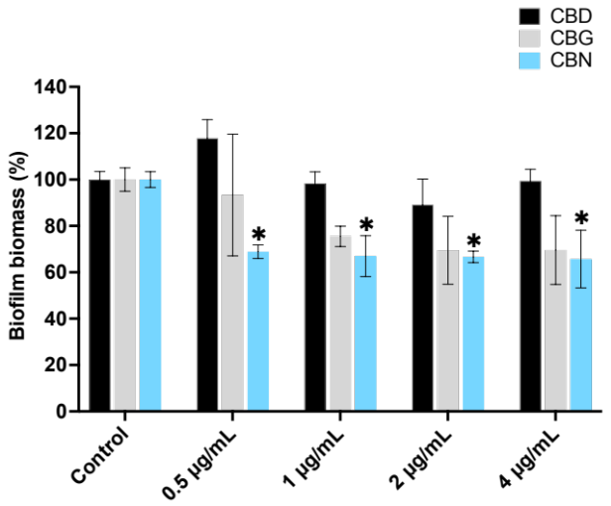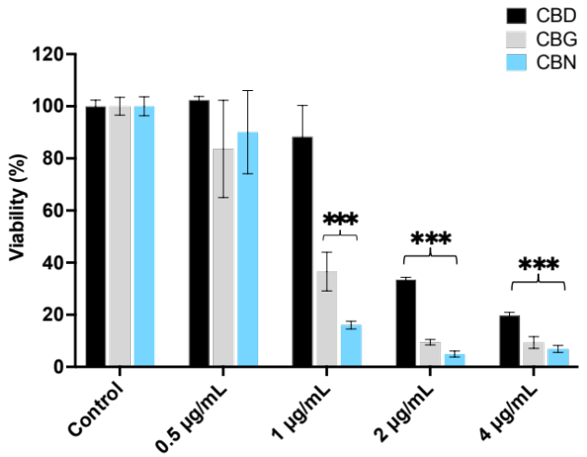
b
a
Figure 2 – Biofilm biomass (a) and biofilm viability (b) of methicillin-resistant Staphylococcus aureus ATCC 43300 after 24 h treatment with cannabidiol, cannabigerol, and cannabinol. Statistically significant differences (p < 0.05 and p < 0.001) between the treatment and the growth control are indicated by * and ***, respectively (n = 8, two biological replicates with four technical repeats each).
In terms of biofilm viability, CBN demonstrated the highest bactericidal activity across most of the tested concentrations, followed by CBG and CBD (Figure 3). Notably, CBN and CBG displayed similar killing efficacy at 2 and 4 µg/mL, resulting in an approximately 90% biofilm viability reduction, with CBN exerting a more pronounced effect. Consistent with the trend observed in the biofilm dispersal assay, CBD showed a relatively weaker effect than CBG and CBN in biofilm viability reduction, despite having a similar MIC. In particular, CBD had minimal antibacterial activity (11.7% reduction) at 1 µg/mL while CBN and CBG at the same concentration already eradicated 83.4% and 63.4% of the bacteria in the biofilm, respectively. Overall, the cannabinoids demonstrated higher effectiveness in penetrating the extracellular matrix and targeting the bacteria in the biofilm than actively dispersing the biofilm structure. Treating biofilm bacteria with antibiotics often requires the use of 10 – 1000 times the MIC⁵. All tested cannabinoids in this assay exhibited bactericidal activity near their MIC, indicating their high potency. Cannabinoids have low oral bioavailability (10-20%) due to extensive intestinal and first pass metabolism¹³. It is more efficient to inhale them to directly treat biofilm-associated MRSA lung infections. Besides producing inhalable formulations of cannabinoids, their mechanism of action on the bacterial membrane of, and oxidative stress in, MRSA should be further studied.
Conclusion
The activity of CBD, CBG, and CBN was examined against a MRSA reference strain cultured in a biofilm. All tested cannabinoids showed significant antibacterial effect against the MRSA within its biofilm. CBN showed stronger antimicrobial and biofilm dispersal effects than CBD and CBG. With antimicrobial near their MIC demonstrated in an in vitro biofilm model, cannabinoids offer much potential for inhalable formulation development to treat biofilm-associated MRSA lung infections.
Reference
[1] A.H. Siddiqui, J. Koirala, Methicillin-resistant Staphylococcus aureus, StatPearls, Treasure Island (FL), 2023.
[2] C. De la Calle, L. Morata, N. Cobos-Trigueros, J.A. Martinez, C. Cardozo, J. Mensa, A. Soriano, Staphylococcus aureus bacteremic pneumonia, European Journal of Clinical Microbiology & Infectious Diseases, 35 (2016) 497-502.
[3] Antimicrobial resistance, World Health Organization, 2021.
[4] A. Boudet, P. Sorlin, C. Pouget, R. Chiron, J.P. Lavigne, C. Dunyach-Remy, H. Marchandin, Biofilm formation in methicillin-resistant Staphylococcus aureus isolated in cystic fibrosis patients is strain-dependent and differentially influenced by antibiotics, Front Microbiol, 12 (2021) 750489.
[5] D. Sharma, L. Misba, A.U. Khan, Antibiotics versus biofilm: an emerging battleground in microbial communities, Antimicrobial Resistance & Infection Control, 8 (2019) 76.
[6] J. Pham, T. Asif, M.S. Hamarshi, Community-acquired pneumonia with methicillin-resistant Staphylococcus aureus in a patient admitted to the intensive care unit: A therapeutic challenge, Cureus, 10 (2018) e2019.
[7] H. Thirot, C. Briquet, F. Frippiat, F. Jacobs, X. Holemans, S. Henrard, P.M. Tulkens, A. Spinewine, F. Van Bambeke, Clinical use and adverse drug reactions of linezolid: a retrospective study in four Belgian hospital centers, Antibiotics (Basel), 10 (2021).
[8] A. Azhar, S. Rasool, A. Haque, S. Shan, M. Saeed, B. Ehsan, A. Haque, Detection of high levels of resistance to linezolid and vancomycin in Staphylococcus aureus, Journal of Medical Microbiology, 66 (2017) 1328-1331.
[9] M.S. Mahmud, M.S. Hossain, A. Ahmed, M.Z. Islam, M.E. Sarker, M.R. Islam, Antimicrobial and antiviral (SARS-CoV-2) potential of cannabinoids and cannabis sativa: A comprehensive review, Molecules, 26 (2021).
[10] M.A.T. Blaskovich, A.M. Kavanagh, A.G. Elliott, B. Zhang, S. Ramu, M. Amado, G.J. Lowe, A.O. Hinton, D.M.T. Pham, J. Zuegg, N. Beare, D. Quach, M.D. Sharp, J. Pogliano, A.P. Rogers, D. Lyras, L. Tan, N.P. West, D.W. Crawford, M.L. Peterson, M. Callahan, M. Thurn, The antimicrobial potential of cannabidiol, Communications Biology, 4 (2021) 7.
[11] M. Luz-Veiga, M. Amorim, I. Pinto-Ribeiro, A.L.S. Oliveira, S. Silva, L.L. Pimentel, L.M. Rodriguez-Alcala, R. Madureira, M. Pintado, J. Azevedo-Silva, J. Fernandes, Cannabidiol and cannabigerol exert antimicrobial activity without compromising skin microbiota, International Journal of Molecular Sciences, 24 (2023).
[12] M. Aqawi, R. Gallily, R.V. Sionov, B. Zaks, M. Friedman, D. Steinberg, Cannabigerol prevents quorum sensing and biofilm formation of Vibrio harveyi, Front Microbiol, 11 (2020) 858.
[13] Guidance for the use of medicinal cannabis in Australia: Overview, Therapeutic Goods Administration, 2017

