Design of in vitro lung mucus-microbiota model to assess efficacy of inhaled antibiotics

Mahmoud H. Abu Elella¹, Simon Andrews², Glyn Barrett², Vitaliy Khutoryanskiy¹, Hisham Al-Obaidi¹

¹School of Pharmacy, University of Reading, Reading, RG6 6UR, UK

²School of Biological Sciences, University of Reading, Reading, RG6 6UR, UK

Summary
Over a few decades, many scientific experiments worldwide consumed huge number of animals for the testing of various inhaled drugs. Among them, several studies require to scarify animals to extract mucosal tissues for examining the action of inhaled powders. Recently, designing alternative methods instead of animal models is an attractive strategy. For instance, some synthetic 3D polymeric hydrogels have similarities to the chemical structure of the mucus that lines-mucosal tissues. Here, we aim to design mucus-mimicking hydrogels, simulating lung-microbiota layer, and adapted a Andersen cascade impactor (ACI) to assess the deposition of aerosolised ciprofloxacin powders. Ciprofloxacin powders were prepared using two and three fluid nozzle spray dryers. Moreover, via free-radical polymerisation technique, hydrogels were synthesised by copolymerising N-acryloyl-glucosamine with 2-hydroxyethylmethacrylate. In our model, we used E. coli, as a bacterial model, to simulate the lung’s mucus-microbiota layer and modified Gamble’s solution with dipalmitoylphosphatidyl choline, and citrate as simulated lung fluid (SLF). The findings revealed successful preparation of highly porous mucosa-mimetic hydrogels via the elucidation of the surface structure with Cryo-SEM techniques. After mixing the hydrogels with SLF, the in vitro mucus-microbiota-ACI model was validated by administering lactose. The deposition results showed minimal differences in deposition between a control and modified ACI, and bacteria were completely eradicated for samples treated with ciprofloxacin, demonstrating the diffusion of deposited ciprofloxacin within porous hydrogel layers.
Key Message
Using our in vitro mucus-microbiota-ACI model, the deposition of aerosolised ciprofloxacin powder resulted in diffusion of drug within the simulated mucus hydrogel layer resulting in bacterial eradication. Development of in vitro models such as the one described contribute to replacing testing of inhaled drug candidates in animals.

Introduction
In the UK in 2021, there were 3.05 million scientific experiments carried out on living animals, of which 15,000 involved the testing of inhaled drugs [1]. These statistics do not include basic research experiments, which may include lung toxicity studies. According to statistics issued by the European Commission, in 2020, approximately 43,000 animals were used for studying human lung conditions via the administration of inhaled drugs, and around 42,000 were used in basic research on inhaled chemicals[2, 3]. Many studies employed animal models that required scarifying animals to obtain their mucus tissues to study the actions of antibiotics [4].
While animal models have been used in the development of inhaled drugs and formulations, there is agreement that animal models have a variety of limitations. Recently, alternative methods/ models have been used to replace the use of animals, reduce the number of tested animals, or to refine the methods for testing to reduce suffering to the animals (this is the basis of the 3Rs principles) [5].
Mucus is a viscoelastic hydrogel composed of glycoproteins (mucins), proteins, lipids, and mucopolysaccharides. Mucin is the main component of mucus, which has a molecular size of approximately 1–40 MDa. It is composed of branched carbohydrate components such as glucosamine, which account for around 80% of the total molecular weight, and the remaining (around 20%) of glycoprotein is a linear protein. Therefore, the surface of mucosal tissues has different functional groups, such as hydroxyl (-OH), amino (-NH₂), and carboxylate (-COO⁻) groups[6]. Its semipermeable nature allows diffusion of smaller particles, providing exchange of water, gases, and nutrients [7]. Mucins have a mesh-like structure, which regulate the movement of particulates and microbes, and controls diffusion towards the underlying epithelium [8]. The similarity between mucosal membranes and synthetic hydrogels can be seen in the side chain groups. Like mucins, hydrogels are three-dimensional hydrophilic polymeric networks that are synthesised via polymerisation of hydrophilic monomers or crosslinking of water-soluble polymers. The presence of lung microbiota has been linked to altered mucus function [9]. Hence, it is reasonable to suggest that any model to simulate the lung should include microbiota [10].
Current in vitro methods to assess the deposition efficacy of inhaled products are based on cascade impaction. Therein, the powder is recovered from each stage of the Andersen cascade impactor (ACI), followed by content analysis. The lung microenvironment contains lung surfactants which can also contribute towards the dissolution process and antimicrobial activity. The role of mucus studied widely for its role in facilitating initial adhesion of planktonic bacteria and subsequent biofilm formation. Hence, incorporating mucus within a lung model as the first point of contact for inhaled particles represents an improved system for the assessment of the impact of inhaled particles [5].
The aim of this study was to design an in vitro lung model that simulates the lung mucosa using mucus-mimicking hydrogels, and simulated lung fluid (SLF) with microbiota to assess the deposition efficiency of inhaled ciprofloxacin powder via ACI.
Experimental methods: The proposed in vitro lung model in this study comprises two major components: a mucus-mimicking hydrogel and a lung-microbiota simulating layer, as well as the development of the in vitro ACI that was used to assess the deposition efficiency of inhaled ciprofloxacin powders (Fig 1).
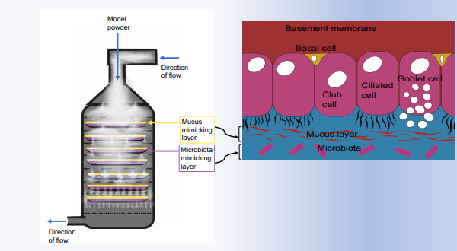
Figure 1: Schematic diagram (left) illustrates in vitro lung mucosa model based on mucus-mimicking hydrogel, lung-microbiota simulating layer, and ACI to assess the deposition of inhaled antibiotic powder. The model comprises 8 stages, each stage from 1 to 7 contains a 6cm Petri agar dish inoculated with lung microbiota and covered by a layer of the hydrogel; to achieve the cut-off value at 60 L/min, stage 0 is not used. While schematic cartoon (right) demonstrates analogy of our artificial model system with the lung epithelium
Materials: MBEC Assay®‘s Biofilm Inoculator (peg lid with 96-well microtiter plate base or corrugated trough base), Reagents for mucosa-mimicking polymer synthesis: glucosamine, acryloyl chloride, 2-hydroxyethylmethacrylate, N,N′-methylenebisacrylamide, and 2,2′- Azbis(2-methylpropionitrile) (Sigma-Aldrich).
Preparation of mucosa-mimetic hydrogels: Mucosa-mimetic hydrogels were synthesised via thermally initiated free radical polymerisation by copolymerisation of biocompatible monomers, such as AGA with HEMA. Firstly, N-acryloyl-glucosamine was prepared via the interaction between glucosamine and acryloyl chloride at 0ºC for 2h. After that, the hydrogels, according to our previous study [11], were prepared by copolymerisation of N-acryloyl-glucosamine with 2-hydroxyethylmethacrylate in the presence of 2,2′- Azobis(2-methylpropionitrile) as an initiator and N,N′-methylenebisacrylamide as a crosslinking agent at 60ºC for 6h. The surface porosity of the prepared hydrogel was evaluated via Cryo-SEM technique.
Powder particles preparation: Inhaled ciprofloxacin powder was prepared by two fluid nozzle spray drying according to our pervious reported work [12].
Deposition experiments: The deposition efficiency of inhaled ciprofloxacin powder was assessed by ACI (Copley Scientific, Nottingham, UK). ACI is a purely physical model that assesses deposition efficiency based on particle inertia. It simulates the main components of the lungs’ fluids. Therefore, it can also mimic the deposition process of deposited powder. The ACI is owned by university and part of our lab equipment. In a typical experiment, capsules (hydroxypropyl methylcellulose (HPMC)) will be filled with ciprofloxacin powder (30mg) to be loaded in DPI device (RS01). A flow meter will be used to check desired flow rate (60 L/min and inhaled volume 4L). In addition, our model considers the role of microbiota as part of the prediction, therefore, the model bacterial species that is used in our studies is E. coli (bacterial model) to simulate the processes of interaction between the deposited powder, mucus mimicking layer and the bacteria. Notably, Gamble’s solution with pH value of 7.4 can be used as SLF [13]. Nevertheless, recently, many reported studies have been used modified Gamble’s solution with surfactants (such as dipalmitoylphosphatidyl choline, DPPC, mimic lung surfactant) and proteins to mimic SLF [14]. Consequently, in this study, we used Gamble’s solution modified with DPPC and citrate (which is used instead of proteins to avoid foaming and organic acids) as simulated lung fluid. Bacteria on LB agar in Petri plates (6cm) will be exposed to treatment via dispensation of antibiotic in ACI either as lawns or known numbers of colony forming units (CFUs) from given calculated volumes of overnight cultures. Antimicrobial activity will be assessed through observation of bacterial lawns and via total colony enumeration. Fluorometric detection of viable and dead bacteria can be conducted using a number of readily available kits (e.g., Promokine Bacteria Live/Dead Staining Kit) which generally depend on two probes DMAO and EtD-III to provide two-colour fluorescence staining allowing differentiation between live (green) and dead (red) bacteria.
Results
Preparation of the hydrogel: the surface porosity was evaluated via Cryo-SEM technique (Fig 2)
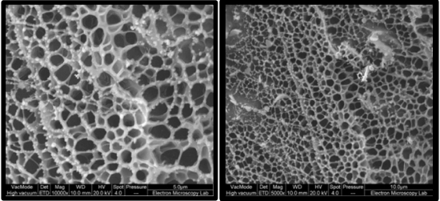
Figure 2: Cryo-SEM images of hydrogels at magnification x 10000 (left) and x 5000 (right).
Validation of deposition
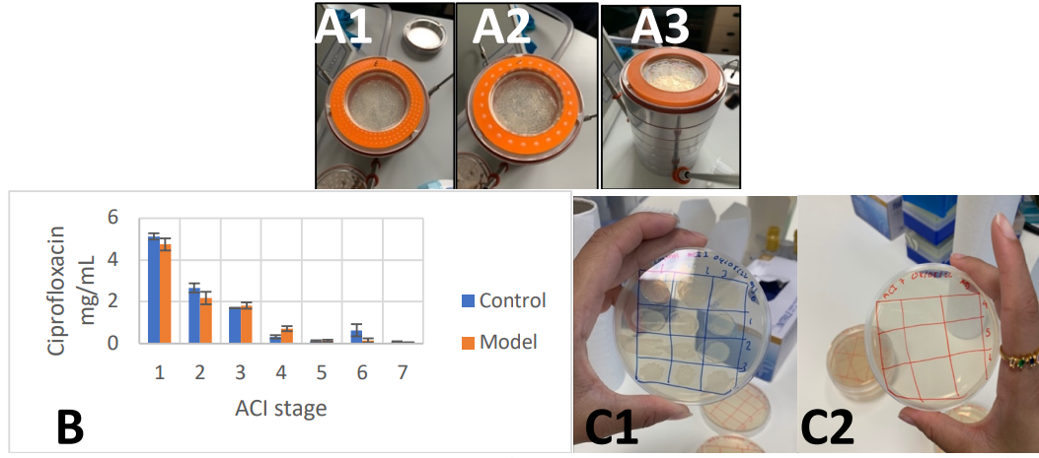
Figure 3: The modified model shows deposition of the powder (white spots) on the orange separating rings showing different pattern depending on the stage (A1,2,3). The relation between ciprofloxacin concentration and ACI stages for the proposed model and the original ACI model (B), and bacterial growth was not affected for control samples treated with lactose monohydrate (C1) while bacterial growth was completely eradicated for samples treated with the antibiotic drug ciprofloxacin (C2).
Discussion
The findings showed successful preparation of the three-dimensional mucus-mimetic hydrogels via copolymerisation of ACA with HEMA using MBA as a cross-linking agent. The surface morphology of the chemical structure of the prepared hydrogel was examined via Cryo-SEM technique (Fig 2) at magnification x 5000 and x 10000.Fig 2 showed porous surface for the prepared mucus-mimetic hydrogel with pore size of approximately 1-2 µm.The deposition efficiency method was assessed by ACI model included 3D printed plastic separators which were designed to hold Petri dishes containing the mucus mimicking material whilst allowing air flow between layers (Fig 3 A1). The petri dish contained 2 mL of the hydrogel mimicking mucosa and then mixed with the SLF (Fig 3 A2). As can be seen in (Fig 3 A3), the model was validated by administering lactose to compare the flow rate with the original ACI setup. We found that there ware minimal differences when operating at 60 L/min indicating that the design was successful. We did not observe any drop in pressure when the mimicking system was used. The validation deposition results showed similarity in deposition for adapted and control ACI with the deposition of inhaled ciprofloxacin powder at a flow rate 60 L/min (Fig 3 B). Survival dynamics of inoculated bacteria were assessed in the mucus mimicking layer. Petri dishes were inoculated with E. coli cells for 24 h and incubated following exposure to the powder in the ACI. Our studies confirmed the hydrogel did not have any impact on E. coli survival. The antibiotic (ciprofloxacin) drug powder was used to confirm that the powder can indeed penetrate the mucus mimicking layer. The results (Fig 3C) provide preliminary data indicating that our approach was successful as the mucus mimicking layer allowed penetration of the deposited drug. This was confirmed through plate-based assays whereby no bacterial colonies were observed from all ACI stages (1 -7) following incubation for 24 h.
Conclusion
Our mucus-microbiota-ACI model based on mucus-mimetic hydrogels with pore size around 1-2 µm was used for assessing the deposition of aerosolised ciprofloxacin powder. The results confirmed penetration of ciprofloxacin through the porous surface layer of hydrogels to eradicate E. coli colonies in all plates assayed in the ACI stages. Therefore, our results confirmed that the developed model provides progress in developing promising alternative to testing in animals.
References
[1] M.J.A.t.L.A. Hudson-Shore, Statistics of Scientific Procedures on Living Animals Great Britain 2015—Highlighting an ongoing upward trend in animal use and missed opportunities for reduction, 44(6) (2016) 569-580.
[2] H.-C. YEH, M.B. SNIPES, R.D.J.A.I.H.A.J. BRODBECK, Nose-only exposure system for inhalation exposures of rodents to large particles, 48(3) (1987) 247-251.
[3] K.J. O’Malley, J.D. Bowling, E.M. Barry, K.R. Hazlett, D.S.J.I. Reed, Immunity, Development, characterization, and standardization of a nose-only inhalation exposure system for exposure of rabbits to small-particle aerosols containing Francisella tularensis, 87(8) (2019) 10.1128/iai. 00198-19.
[4] D. Chang, L. Sharma, C.S.D.J.C. Cruz, Harnessing murine microbiome models to study human lung microbiome, 157(4) (2020) 776-778.
[5] J.D. Crapo, S.L. Young, E.K. Fram, K.E. Pinkerton, B.E. Barry, R.O.J.A.R.o.R.D. Crapo, Morphometric characteristics of cells in the alveolar region of mammalian lungs, 128(2P2) (1983) S42-S46.
[6] D. Mukherjee, B. Srinivasan, J. Anbu, M. Azamthulla, V.T. Banala, S.J.D.d. Ramachandra, i. pharmacy, Improvement of bone microarchitecture in methylprednisolone induced rat model of osteoporosis by using thiolated chitosan-based risedronate mucoadhesive film, 44(11) (2018) 1845-1856.
[7] S.K. Lai, D.E. O'Hanlon, S. Harrold, S.T. Man, Y.-Y. Wang, R. Cone, J.J.P.o.t.N.A.o.S. Hanes, Rapid transport of large polymeric nanoparticles in fresh undiluted human mucus, 104(5) (2007) 1482-1487.
[8] C.-M. Lehr, F.G. Poelma, H.E. Junginger, J.J.J.I.j.o.p. Tukker, An estimate of turnover time of intestinal mucus gel layer in the rat in situ loop, 70(3) (1991) 235-240.
[9] O.W. Meldrum, S.H.J.B. Chotirmall, Mucus, microbiomes and pulmonary disease, 9(6) (2021) 675.
[10] A. Swidsinski, B.C. Sydora, Y. Doerffel, V. Loening-Baucke, M. Vaneechoutte, M. Lupicki, J. Scholze, H. Lochs, L.A.J.I.b.d. Dieleman, Viscosity gradient within the mucus layer determines the mucosal barrier function and the spatial organization of the intestinal microbiota, 13(8) (2007) 963-970.
[11] M.T. Cook, S.L. Smith, V.V.J.C.C. Khutoryanskiy, Novel glycopolymer hydrogels as mucosa-mimetic materials to reduce animal testing, 51(77) (2015) 14447-14450.
[12] A. Mohammed, J. Zurek, S. Madueke, H. Al-Kassimy, M. Yaqoob, C. Houacine, A. Ferraz, R. Kalgudi, M.G. Zariwala, N. Hawkins, Generation of high dose inhalable effervescent dispersions against pseudomonas aeruginosa biofilms, Pharmaceutical research 37 (2020) 1-14.
[13] H. Weggeberg, T.F. Benden, E. Steinnes, T.P.J.E.C. Flaten, Ecotoxicology, Element analysis and bioaccessibility assessment of ultrafine airborne particulate matter (PM0. 1) using simulated lung fluid extraction (artificial lysosomal fluid and Gamble's solution), 1 (2019) 26-35.
[14] A. Calas, G. Uzu, J.M. Martins, D. Voisin, L. Spadini, T. Lacroix, J.-L.J.S.r. Jaffrezo, The importance of simulated lung fluid (SLF) extractions for a more relevant evaluation of the oxidative potential of particulate matter, 7(1) (2017) 11617.

